Intended Career
By Jagpreet Kaur








2112515
MODULE CODE:
BMSW4001
Joana Walsh





SENCO - What is it?
- SENCo, or special education needs coordinator responsible for assessing, planning and monitoring the progress of children with special education needs and disabilities.

Notes - SENCo , or special education needs coordinator is a school teacher responsible for assessing, planning and monitoring the progress of children with special education needs and disabilities.

Characteristics of a SENCo

- Working with class teachers, school management teams, parents, and relevant external agencies to create, implement, and monitor individual support / learning plans
- Managing teaching assistants
- Coordinating provision for children with
SEND
- Liaising with parents of children with
SEND
Notes - Working with class teachers, school management teams, parents, and relevant external agencies to create, implement, and monitor individual support / learning plans
Managing Teaching Assistants
Coordinating provision for children with SEND
Liaising with parents of children with SEND

Strengths and Weaknesses …
Strengths Weaknesses
Passionate
about working
with kids
Caring nature
Experience
working with
teachers

- Lack of SENCo qualification
- Lack of proper understanding of non verbal children
- Lack of experience in communicating with parents
- Not a lot of opportunities for working as a SENCo
Notes - I will first present the strengths of a SENCO which are: being passionate about working with kids; have a caring nature; and have experience working with teachers. The weaknesses are that some lack proper understanding of non verbal children, lack of SENco qualifications, lack of experience communicating with parents and may not have a lot of opportunities working as a SENCo

Job adverts for SENCo
Recruiting:

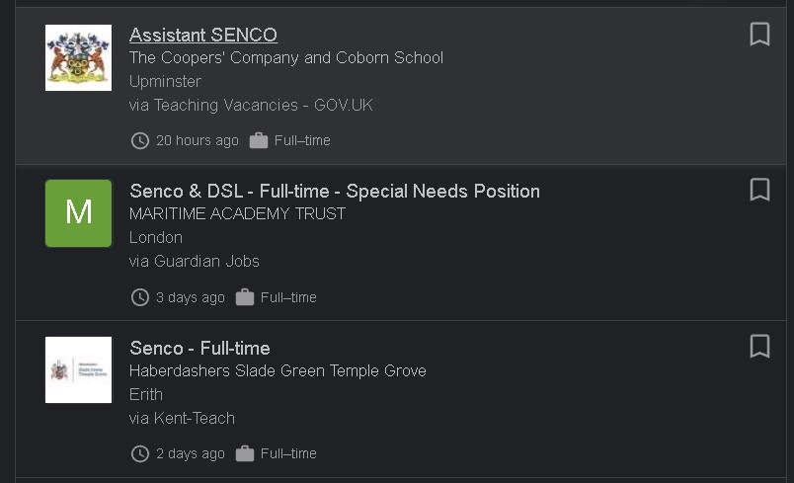
I called for the role of “Assistant SENCo” vacancy to ask if they were recruiting. They asked me if I was a qualified SENCo and replied, “I am working towards being a SENCo” along with further questions.






What are the requirements of being a SENCO:

- You need to be a qualified teacher
- You need to have experience working with special needs children
- CRB checks
- Good communication skills with parents, teachers and external agencies
Notes - I will first present the strengths of a SENCO which are: being passionate about working with kids; have a caring nature; and have experience working with teachers. The weaknesses are that some lack proper understanding of non-verbal children, lack of SENco qualifications, lack of experience communicating with parents and may not have a lot of opportunities working as a SENCo

Opportunities of becoming a SENCo
- Making a difference to the lives and education of the neediest children every day
According to Stacy, “I love being a SENCO and how the role lets me really get to know the children in our school and be able to make a meaningful impact on their day to day lives and their progress in school.”
- The SENCO plays a vital role in supporting your child's teacher to ensure that their educational needs are met.
- Strong relationships with children meaning they trust you
- Transformation meaning make them more confident in life and resilient
Notes- As a SENCO, you can make an impact or difference to the lives of children in their daily lives. You can also build strong relationships with children and transform their lives by helping them become more confident and resilient.

^{Threats of SENco}
- Relentless paperwork for children with EHCP plan
- ^{A lot of competition}
- ^{Extra work to form groups}
- IEPs plan and intervention groups to plan
- Endless meeting take away time meaning there is no time to spare

^{REFERENCES}
- Opportunities :
https://tabularasaeducation.wordpress.com/2015/04 /11/senco/
- Threats:
https://www.teachwire.net/news/what-are-a-sencosbiggest-challenges • Meaning of SENCo:
https://www.goodschoolsguide.co.uk/specialeducational-needs/schools-and-sen/senco
- Requirements:
https://www.totaljobs.com/advice/specialeducational-needs-coordinator-senco-job-description
- Job adverts:
https://teaching-
vacancies.service.gov.uk/jobs/assistant-senco-thecoopers-company-and-cobornschool?utm_campaign=google_jobs_apply&utm_sour ce=google_jobs_apply&utm_medium=organic

