Nero and Agrippina statue analysis
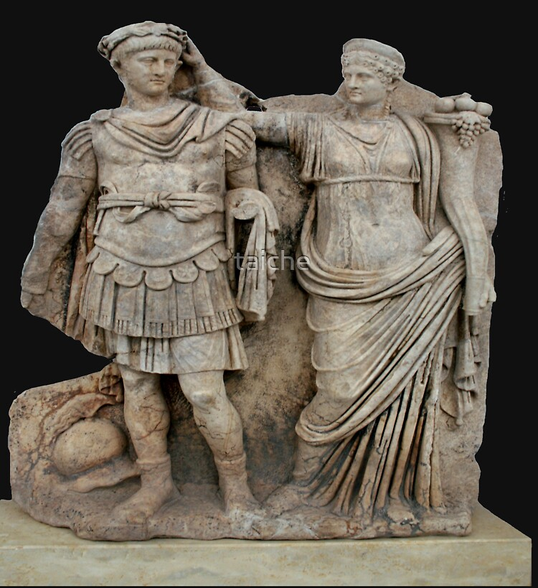
I’m going to analyse a statue depicting both Nero and Agrippina seeing the meaning behind the statue, the material it is/could be made out of, symbolism within the artwork and comparing it to some other pieces of artwork that involve Nero.
The first thing you notice with the statue would be what Agrippina is holding up towards Nero’s head as it seems to be a wreath used to symbolise the emperor of Rome and with the statue most likely being created at the start of Nero’s reign where Agrippina held significant power over the child. The motion depicts his mother crowning him as if she is the one passing power onto him even though it would have been his adopted father Claudius. This could be due to the fact of Agrippina showing that at the time she has the power since her hand still holds onto the wreath symbolizing her grasp on power is still strong. To the left of Nero by his foot we can see a helmet which could signify authority as there is a crest on this helmet signifying a higher rank and it could also outline him taking the helmet off for him to put on the wreath and becoming emperor. On the left of Agrippina, we can see a cornucopia that depicts fruitful harvests and fertility with Nero becoming emperor. The cornucopia could also link into the fertility of Agrippina herself as she was the one to birth Nero solidifying the narrative of his fertility also. We can also see the clothing that Nero is wearing is similar to that of his predecessors like Augustus and Caligula as examples. The cuirass could be seen as him showing authority through him wearing this alongside the helmet on the floor as in other depictions Nero is typically seen in a toga. The toga or tunic that Agrippina is wearing would most likely have had a stripe of purple in actuality and not in the statue however the toga is very long which could have a meaning of longevity of Agrippina. The statue only contains the motion of Agrippina crowning Nero which has an active role with Nero being completely static giving him a sense of passivity showing the control of Agrippina. The statue would most likely have been made just after the coronation of Nero as emperor but before the assassination of his mother, to show him getting the power to be emperor but emphasise that his mother is still in the power position as she is within the statue alongside the young Nero. The materials that the romans used during this time would most likely be some type of marble since by this time marble sculptures would have been what most were in Rome. However, this sculpture was found in Aphrodisias a city of the roman empire yet in the Asia province (modern day east turkey). This could have an effect on the material used as the marble could’ve been sourced from the Greek islands rather than the mines in the Italian peninsular.
With this statue its irregular for a woman to be alongside an emperor crowning them as during the times of the roman people it could signify weakness as Nero was already seen as feminine for a male so adding his mother there also could give off the impression of weakness as he can’t be alone without Agrippina. If we were to look at Nero’s other statues, he would be portrayed alone without his mother on his side possibly due to him wanting to distance himself from her as after her assassination he wouldn’t want to be associated since it could bring up suspicion of him killing her if he was to go about it wrong. This here could help solidify the fact that the sculpture was made before her death and most likely ordered by her for someone to make it as a way of her again showing her power that she can have statues sculpted like this. The armour that Nero is wearing and the helmet to his side is somewhat satirical as at this point its unlikely that Nero would have much experience with military campaigns due to him being young while the statue was made but it could have been a way to try and bolster how people thought of his military skill as it makes him look more like the general of a roman legion or army. Another thing that may not be so typical of most roman statues is that Agrippina is showing her body where usually women in statues would be covered unless the sculpture or artwork was explicitly sexual. The flow of the dress flowing upwards at a stretch could symbolise Nero’s reign being good and prosperous.

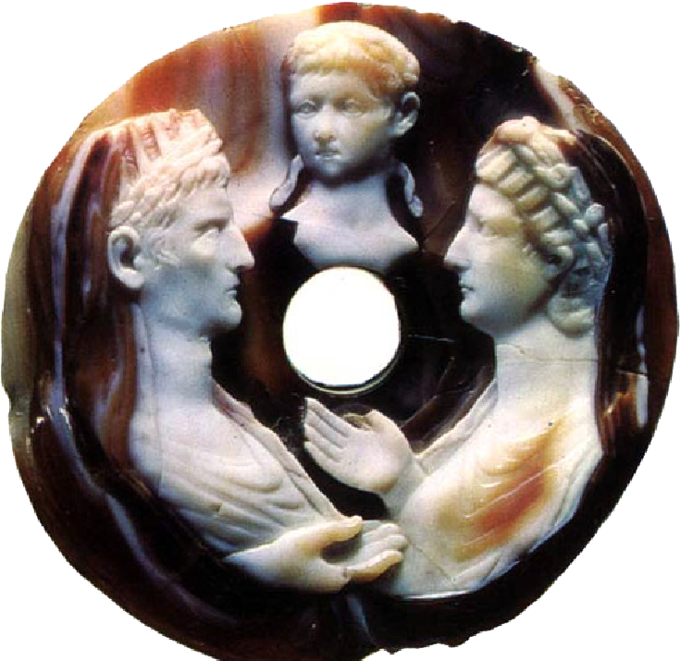
If we were to compare some aspects of the first statue and this cameo, we would see that the two adults on the left and right, left being Augustus and right being Livia his wife and the child in the centre is Nero as a child. There are a few similarities with this piece as again it has a woman in the artwork who had a large impact on the empire through her husband Augustus. The biggest difference I see is that Augustus and Livia are equal and take up equal parts of the cameo whereas in the statue although Nero is the authority figure I still think that Agrippina is the centrepiece of the artwork since she is holding the cornucopia and still has a grasp on the wreath like she’s holding onto power and not giving it up so easily. Finally, I feel the meanings are slightly similar as in the cameo as if its artist is telling us that Nero when he is emperor will be just as great as the greatest emperor Augustus and his wife Livia, yet the statue shows Nero becoming emperor and with the attire Nero is wearing it is comparable to the attire Augustus wears in his statues found in Rome and across the empire.
In conclusion the statue of Nero and Agrippina I find to have a large amount of symbolic meaning with the most prominent being Nero getting crowned by Agrippina and her holding onto the wreath. I find the statue to be well crafted and looks amazing for the age of the art piece.

