Trainee Health and Safety Officer
Student: Olivia Regan (2506729)
Module/Course- Health, Safety and Welfare
Word Count: 2048

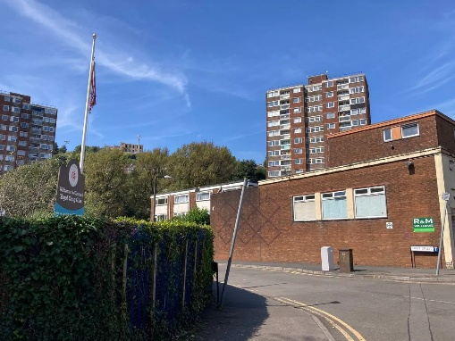
Proposed Existing

Table of Contents
- Introduction
- Building Safety Legislation
  - The Building Safety Act
  - The Building Safety (Wales) Bill
  - Relevance and Impact on Croft Street Blocl 2
- Key Health and Safety Legislation and Managerial/Compliance
  - Health and Safety at Work etc. Act 1974
  - Management of Health and Safety at Work Regulations 1999
  - Construction (Design and Management) Regulations 2015
  - Compliance Procedures, Polices, and Training
  - Beyond Compliance: Best Practice
  - Summary Table: Core H&S Legislation
- Hazards and Risks in Retrofit Projects
  - Main Hazards
  - Hazard and Control Summary Table
  - Risk Minimisation: Legan Duties and Best Practice
  - Practical Examples for Risk Reduction
  - Resident Engagement Table
- Continuous Process Management Loop
- Conclusion
- References
- Glossary

- Introduction
The United Kingdom’s built environment sector has undergone significant reform in response to tragic event such as Grenfell Tower, highlighting the importance of robust health and safety legislation and practice (Hackitt, 2018). For complex residential retrofit projects like Croft Street Block 2, achieving high standards of safety, demonstrating legal compliance, and engaging transparently with residents are paramount. This report evaluates the latest building safety laws, core health and safety obligations, contemporary managerial approaches, and risk management best practice. Through legislative review, practical examples, and tabulated summaries, it provides a professional roadmap for delivering a first-class, complaint retrofit project.
This assignment outlines the key legislative frameworks applicable to Croft Street Block 2, with a focus on Building Safety Act, the Building Safety (Wales) Bill, and principal health and safety statutes. It evaluates how these regulations translate into practical compliance, risk management, and resident engagement strategies. Recommendations and process diagrams are included to support a robust, proactive safety culture throughout the project.

- Building Safety Legislation
  - The Building Safety Act
The Building Safety Act 2022 (BSA) marks a profound shift in UK building regulation, with an emphasis on outcomes, transparency, and culture change (HM Government, 2022). The Act applies to all high-rise residential buildings—those above 18 meters, with more than seven storeys, or more than two residential units.
Key provisions are:
- Creation of the Building Safety Regulator (BSR) (HSE, 2023).
- Requirements for a digital “golden thread” of safety- relevant building information (HM Government, 2022).
- Duty holder obligations for clients, designers, and contractors at every project phase.
- Safety case regime and routine engagement with residents.
- Criminal liability and stop work orders for non-compliance.

Timeline of the Building Safety Regulator’s (Grenfell 2017, Hackitt 2018, BSA 2022)
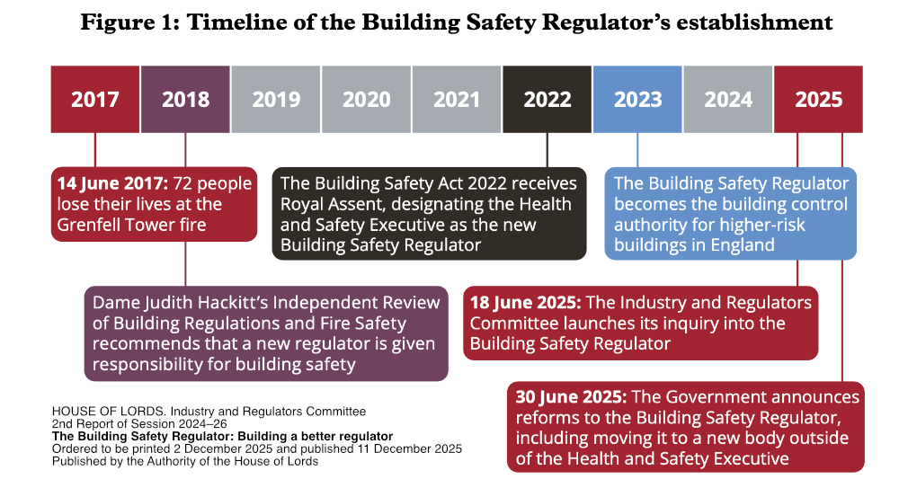
  - The Building Safety (Wales) Bill
The Building Safety (Wales) Bill adapts BSA principles for Wales while introducing a broader risk-based regime and enhanced resident rights (Welsh Government, 2023). The introduction of these laws marks a shift from reactive to proactive safety management, with enhanced requirements for resident liaison, competence verification, and evidence-based decision making. Managers must now prioritise ongoing compliance recording and transparent communication, fundamentally changing the day-to-day approach to building safety.

Unique features include:
- A Welsh Building Safety Regulator with powerful enforcement tools.
- Obligatory resident participation in safety decisions (Welsh Government, 2023).
Feature | Building Safety Act (England) | Building Safety (Wales) Bill
Regulator | Building Safety Regulator (HSE) | Welsh Building Safety Regulator
Height Scope | 18m+ / 7+ storeys | 11m+ or risk-based
Resident Engagement | Statutory requirements | Strong statutory requirements
Enforcement Powers | Stop-work orders, fines | Improvement/prohibition notices
Golden Thread of Data | Mandatory | Mandatory, Welsh requirements
Competence Standards | Yes | Yes
- Transparent routes for information sharing and complaints.

  - Relevance and Impact on Croft Street Block 2
As a high-rise, multi-occupancy building, Croft Street Block 2 falls under the full scope of these regulations. In practice, this means that Croft Street Block 2’s management must establish fit-for-purpose reporting systems, undertake more frequent safety review, and ensure clear audit trails for resident engagement. Training programmes and safety plans should reflect both national and local requirements, directly addressing the realities of a densely occupied high-rise environment.

Projects impacts include:
- Pre-works regulatory approval.
- Appointment and competence checks for all duty holders.
- A maintained and accessible safety case and golden thread file.
- Mandatory resident consultation on all major changes and anticipated disruptions. Non-compliance exposes the contractor and client to stop-work orders, substantial fines, or prosecution (HM Government, 2022).

- Key Health and Safety Legislation and Managerial Compliance
Successful compliance is not achieved by documentation alone. Regular refresher training, on-the-job supervision, and staff feedback loops are essential to maintain high standards and adapt to changing risks on site. Managers must demonstrate not just technical compliance, but visible leadership and active participation in all aspects of site safety.

  - Health and Safety at Work etc. Act 1974
The Health and Safety at Work etc. Act 1974 (HSWA) is the central piece of legislation covering occupational safety in the UK, requiring employers to safeguard employers and anyone affected by their work—especially pertinent for retrofit projects in occupied buildings (HSE, 2021a).

  - Management of Health and Safety at Work Regulations 1999
These regulations require comprehensive risk assessments, competence review, and tailored employee training and information for all workplace hazards (HSE, 2021b)
  - Construction (Design and Management) Regulations 2015 (CDM)
CDM outlines legal responsibilities for clients, designers, principal contractors, and workers, emphasising risk management, explicit communication, and record-keeping throughout the project lifecycle (HSE, 2023b)

  - Compliance Procedures, Policies, and Training
Effective compliance at Croft Street Block 2 requires:
- Dynamic method statements and risk assessments (RAMS)
- Induction and ongoing training on project-specific hazards.
- Regular toolbox talks and site audits.
- Empowerment for staff to stop work on safety grounds.
- Clear records of all procedures, decisions, and incidents.

  - Beyond Compliance: Best Practice
Best practice goes beyond law, including:
- Resident engagement strategies (Kashyap et al., 2021).
- Active leadership by management.
- Lessons learned incorporated into training and policy (Wilson & McCutcheon, 2020).
For Croft Street Block 2, adopting best practice could involve the use of digital resident portals for updates, pre-works workshops with affected households and independent third-party safety audits. These measures go beyond compliance to demonstrate genuine commitment to safety and build trust with the resident community. For instance, publishing monthly “You Said, We Did” summaries in communal areas shows residents how their feedback is acted upon, building trust and encouraging ongoing cooperation.

  - Table 2: Summary of Core Health & Safety Legislation
Legislation/Regulation | Main Requirements | Application to Croft Street Block 2
Health and Safety at Work etc. Act 1974 | General duty of care, risk elimination | Mandates overall site and resident safety
Management of Health & Safety at Work Regs 1999 | Risk assessment, training | Requires RAMS, ongoing training
Construction (Design & Management) Regs 2015 | Duty holders, planning, H&S management | Clear roles, H&S file, phase plans
Control of Asbestos Regulations 2012 | Survey/controlled removal | Must survey, manage, or remove ACMs
Working at Height Regulations 2005 | Safe systems, permits | Scaffolding, barriers, regular inspections
RIDDOR 2013 | Incident reporting | Formal reports of incidents/near-misses to HSE

- Hazards and Risks in Retrofit Projects
  - Main Hazards
Croft Street Block 2 retrofit involves multiple hazards:
- Asbestos (exposure/inhalation risk)
- Working at height
- Fire ( especially hot works and compartmentation changes)
- Manual handling injuries
- Live electric/gas services
- Noise, dust, vibration
- Site security/public access

  - Table 3: Hazard and Control Summary Table
Hazard | Typical Risks | Control Measures
Asbestos | Inhalation/cancer | Survey, licensed contractors, air monitoring
Fire | Injury/fatality/property | Hot work permits, fire marshals, alarms
Working at heigh | Falls | Scaffolding, harnesses, exclusion zones
Live services | Electrocution/explosion | Lock/tag-off, certified electricians
Manual handling | Injury | Team lifts, handling aids, training
Noise/dust/vibration | Health | PPE, dust suppression, resident consultation
Site security | Trespass/injury | Secure perimeter, CCTV, access control

For example, during initial site preparation, discovering degraded fire-stopping required the team to halt work, reassess the programme, and communicate additional protections to residents—illustrating the importance of early risk discovery.

  - Risk Minimisation: Legal Duties and Best Practice
Risk reduction follows a hierarchy (HSE, 2021b)
- Elimination (off-site manufacture, full ACM removal pre-works)
- Substitution (safest material/process)
- Engineering (edge protection, temporary hoarding)
- Administrative (toolbox talks, phase work, signage)
- PPE (always last resort)
Information flows from the Client to key duty holders (Principal Designer and Principal Contractor), then to Contractors and Workers, Residents are engaged directly by both the Client and Principal Contractor, reflecting statutory duties for consultation and updates (CDM, 2015 best practice).

  - Practical Examples for Risk Reduction
- Asbestos: Pre-works survey, only licenced removers, air monitoring (HSE, 2022b)
- Fire: Temporary alarms, designated marshals, permit systems (HM Government, 2022).
- Resident engagement: Notice boards, letters, consultation meetings.

  - Table 4: Resident Engagement Actions Table
The table below demonstrates that resident engagement must extend beyond initial notifications. Best practice includes regular feedback opportunities—such as drop-ins, digital surveys, and post-work meetings—ensuring the project adapts continuously to real concerns and lived experiences.
Action | Method | Outcome
Advance notification | Letter drop, meetings, signage | Early warning, builds trust
Feedback sessions | Drop-ins, surveys, focus groups | Address concerns, shape programme
Emergency contact | 24/7 helplines, on-site point | Quick response to urgent issue

Engaging residents is not a one-off activity but should be integrated throughout the project Lifecyle. Regular feedback sessions and transparent follow-up on raised issues to help build trust, improve project outcomes, and can highlight unforeseen safety concerns unique to the lived experience of residents.

- Continuous Process Management Loop
This continuous loop underpins both technical health and safety management and effective communication with all stakeholders, ensuring lessons are rapidly acted on persistent issues do not go unnoticed. This cycle is not theoretical but should be embedded in daily routines—such as daily briefings, recorded site inspections, regular toolbox talks, and feedback sessions with both workers and residents. Maintaining documented evidence of each stage supports compliance and rapid identification of persistent or emerging risks.

Step | Description
Identify | Spot Hazards/issues and gather feedback
Assess | Evaluate risks and priorities
Communicate | Share actions, information, and consult all duty holders
Control | Put measures in place and record responsibility
Monitor& review | Inspect, audit, and verify control
Feedback | Learn from outcomes, update process, involve everyone

- Conclusion
In conclusion, effective management of health, safety, and resident engagement is fundamental to delivering compliant and successful construction projects. The continuous process management loop—encompassing identification, assessment, communication, control, monitoring, and feedback—ensures that risks are systematically managed and all stakeholders remain informed and involved. By applying these principles, organisations demonstrate alignment with the requirements of CDM 2015 and current HSE best practice, reducing the likelihood of incidents and regulatory breaches.

The integration of regular risk assessments, transparent communication with residents, and rigours processes for monitoring and reviewing control measures provides both practical and legal benefits. It not only fosters a culture of safety but also builds trust among residents and project participants, improving cooperation and overall project delivery.

Continuous improvement, informed by lessons learned and ongoing engagement with both staff and residents, ensures your management system remains responsive to new challenges and legislative updates.

For complex retrofit projects like Croft Street Block 2, sustained compliance relies on strong leadership, continuous staff development, and genuine partnership with residents. By embedding best practice and ongoing improvement, the project can set a positive benchmark for others in this sector—ensuring safety, building trust, and delivering lasting value.
- References
- Hackitt, J. (2018) Building a Safer Future: Independent Review of Building Regulations an Fire Safety. London: HMSO. Building a safer future: UK government proposals for reform of the building safety regulatory system - The Institution of Structural Engineers
- HM Government (2022) Building Safety Act 2022 Building Safety Act 2022
- Health and Safety Executive (2021a) Health and Safety at Work etc. Act 1974 Health and Safety at Work etc. Act 1974
- Health and Safey Executive (2021b) Management of Health and Safety at Work Regulations 1999 The Management of Health and Safety at Work Regulations 1999
- Health and Safety Executive (2023a) Leading Health and Safety at Work Leading health and safety at work - HSE
- Welsh Government (2023) Building Safety (Wales) Bill Building Safety Programme | GOV.WALES
- Kashyap, A., Vasan, A. & Srivastava, S. (2021) ‘Resident Engagement and Safety in Social Housing Retrofits’, Building Research & Information, 49 (7), pp.876-890 Residents’ values: Co-designing social housing retrofit

- Glossary
- ACM: Asbestos Containing Material
- BSA: Building Safety Act
- BSR: Building Safety Regulator
- CDM: Construction (Design & Management) Regulations 2015
- HSE: Health and Safety Executive
- HSWA: Health and Safety at Work etc. Act 1974
- PPE: Personal Protective Equipment
- RAMS: Risk Assessments and Method Statements

