

BMSW 4004- Problem Solving and Decision Making

Mr. Chijioke Uba Ionut Viorel Nenciu
Student id:2132392

Table of Contents
Introduction 2
A Research-Informed Discussion on the Nature and Impact of the Complex Problem on Employees and Their Organisations. 2
Nature of Stress 2
A PESTLE Analysis of the Macro-Environmental Factors Contributing To the Complex Problem. 3
Political 3
Economic 3
Social 3
Legal 3
Technological 4
Environmental 4
A Research-Informed Cause-And-Effect Analysis, Using Fishbone Diagram, Of the Complex Problem. 4
An Evaluation of Alternative Solutions to the Problem with the aim of choosing the Most Appropriate Solution among These Alternatives. 5
Plan To Implement the Decision 6
Improve Communication Network 6
Feedback 6
Success Indicators to Measure the Effectiveness 7
Conclusion 7
References 9

Introduction
The nature and impact of stress on employees and organisations can be defined as both positive and negative terms, which can bring competence or high turnover among employees (Green and Dallery, 2019). This report will entail the nature of stress and its positive and negative impact in terms of stress and eustress on employees and their organisation. This report will embrace a PESTLE analysis of the macro-environmental factors contributing to stress, especially during COVID-19. The alternate solution has been provided in this report in terms of open communication and flexibility at work with increased motivation and high morale among employees. An action plan to implement the decision using the MBO framework and feedback box has been presented. The measure of effectiveness in terms of increased productivity, morale, and customer satisfaction index has been discussed in the report. The report aims to analyse these environments to monitor the causes of declining profits for TM Lewin Company using a fishbone diagram of work-related stress.

A Research-Informed Discussion on the Nature and Impact of the Complex Problem on Employees and Their Organisations.

Nature of Stress
The term stress means the mental, physical, and chemical reaction of a body to a circumstance/situation that confuses, frightens, and creates irritation. The nature of this complex problem entails that this term is a neutral word which means stress itself is not bad; however, it brings undesirable outcomes which cause distress (Coccia, 2018). Eustress is a positive nature of stress which brings development in terms of future improvements (Green and Dallery, 2019). The nature of stress is demanding rather than constraints (Tripathy, 2018). The main detriment of stress is its uncertainty over the outcome (the outcome must be important). The term burnout in organisations is mostly associated with stress (Saudi et al., 2021).
Job stress due to the pandemic has led employees and their organisations to perform poor, more prone to error, burnout, mental health issues, and conflict in the office. Stress due to pandemic unemployment and closures brought job insecurities to a high level, and also employees were forced to leave their jobs. In this essence, the company had to pay the price at high rates in terms of high employee turnover, absenteeism, and disengagement. Stress in the workplace has a tendency to bring difficulties in meeting deadlines, concentrating, and utilising creativity. Stress tends to trigger mental concerns in employees that can impact job productivity with increased anxiety, depression, burnout, and conflict (Hui and Aye, 2018).

A PESTLE Analysis of the Macro-Environmental Factors Contributing To the Complex Problem.

Political
The separate regulations for HCWM during Covid 19 outbreak had restrained employees and organisations from operating and using the method they have been using for years. Change in regulations takes time, which demands people at work to plan properly. However, the global supply chain has been disturbed due to Covid 19; the same has been applied to UK businesses; material shortage, the decline in demand, and the EU exit all brought stress to the companies and tended them to take steps like terminations and cutting extra curriculum costs. The same has been applied to retail businesses, especially retailers of non-essential goods and/or those limited to being brick-and-mortar (Baliyan, 2021). However, Pressure to ensure good environmental performance brings eustress, which can improve the reputation; high calibre staff recruitment (Saudi et al., 2021).

Economic
The first and foremost stress-boosting factor for the employees and retailing businesses was the split and rotation of shifts that brought an exponential impact on infection rates. Unemployment and the rise in commodities prices were at their peak. Another stress factor advocated that people were frightened of Test-Track-Isolate; the government had announced the closure of businesses and imposed 14-day complete isolation throughout the country on June 8, 2020, bringing stress to the companies, and many of them faced complete closure and bankruptcy (Coccia, 2018). An increase in energy costs has brought an opportunity to diversify towards advanced technology (Green and Dallery, 2019).

Social
Perceived concerns and threats, financial, occupational, and social distancing behaviours, impacts on psychological stress and social life changes had brought a change in lifestyle and behaviour patterns, which tended to decline purchasing power of the customers, especially on items that are not associated with psychological needs. Thus, a decline in the tourism industry and apparel industries were apparent (Baliyan, 2021). For example, People, due to working from home, do not demand formal dresses, which has highly impacted businesses like TM Lewin.

Legal
The coronavirus act 2020 in the UK introduced new laws to protect public health, strengthen social care and support, and increase NHS capacity. The public taking the right action at the right time and prosecution for non-compliance have been some of the particular threats to the retail and apparel industries (Odey, 2021). People take Brexit as a threat. However, this has declined the costs and fines in terms of legislative compliance for UK businesses.

Technological
This factor has supported many industries in terms of advanced technologies and social of social media. For employees, working at home contained both stress reduction and also stress appraisal factors. The lack of facilitation in terms of advanced technologies had made it a threat to the employees. However, businesses with a physical presence are highly impacted due to advancements in technology (Baliyan, 2021). Shirt-making company like TM Lewin had to face the consequences in terms of demand and production. This factor has an opportunity for production to solve issues.

Environmental
Disruption in energy consumption has brought a change in the global climate. Some areas after Covid 19 faced extreme flooding and heat; however, other areas faced opportunities like the green revolution. This has increased the awareness of environmental sustainability importance. However, stress or opportunity for companies to implement eco-friendly strategies in their operations (Hui and Aye, 2018).

A Research-Informed Cause-And-Effect Analysis, Using Fishbone Diagram, Of the Complex Problem.
A Fishbone diagram helps in brainstorming to identify the causes/reasons for issues to sort ideas into useful categories. It is a visual way to audit the cause and effects (Green and Dallery, 2019). The causes were job security, lack of autonomy, heavy workload, strict deadlines, boring workplace, and lack of motivation are the bones that create work stress among employees at the workplace. However, the pandemic has not left any of these causes behind. Uncertainty brought strict deadlines and job insecurity as the most prevailed factor for formal shirt purchases due to the social distancing aim of business closures (Hui and Aye, 2018). Mostly, men's apparels and formal dresses were the hard hit. On the other hand, the use of AI and robotics were not being implemented by the company, which brought workload to an understaffed company and staffed employees. No encouragement, incentives and restricted communication made the workplace a boring place with no motivation (Tripathy, 2018). As shown in figure 1, the fishbone diagram showed work-related stress problems cause and effect.
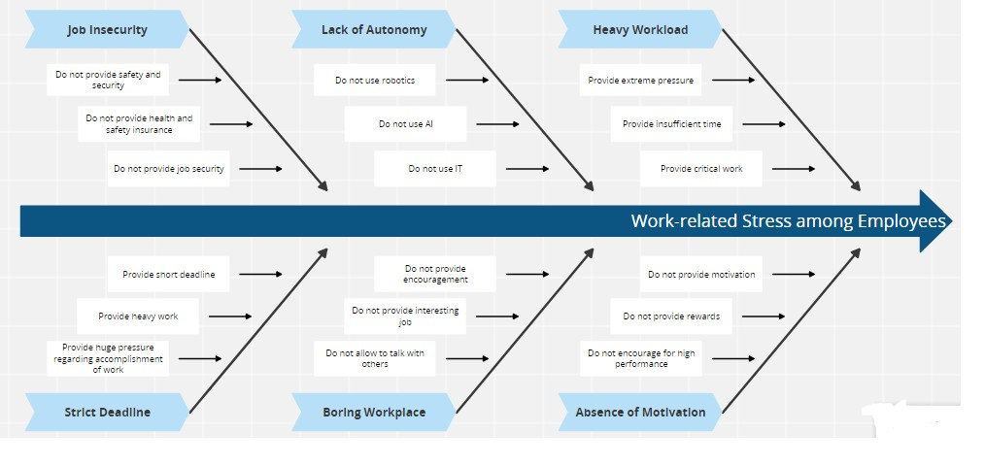
Figure 1: Fishbone Diagram

An Evaluation of Alternative Solutions to the Problem with the aim of choosing the Most Appropriate Solution among These Alternatives.
There is a wide range of strategies that may be used to combat the problem of stress in the workplace and locate long-term remedies (Green and Dallery, 2019).
There are a variety of tried-and-true techniques for lowering levels of stress in the workplace, including enhancing lines of communication, instilling a sense of purpose in one's work, and allowing for some flexibility in one's schedule so that one can achieve a healthy work-life balance (Odey, 2021). Moreover, another alternative solution to combat stress among employees of TM Lewin is the provision of benefits for the mental and physical well-being of workers. It is the most important component of resolving the problem of stress in the workplace. It is essential to not only encourage employees to take breaks but also to provide them with paid time off so that they may do so. Employers should use and put into action within the culture of the organisation a small number of specific actions or initiatives when looking to improve or cultivate the communication system of an organisation (Tripathy, 2018). The use of an effective leadership style can be the best alternative to meet the solution against demotivation. Transformational leadership style is recommended that stimulate managers "let others speak," "don't judge others," "accept that they may disagree with the employer's decision," "ask open-ended questions," and "demonstrate an active listening attitude" in order to cultivate an atmosphere at work that is conducive to the production of quality work (Saudi et al., 2021). Moreover, extra incentives, like bonuses, overtime pay, and company-sponsored outings, can go a long way toward ensuring that employees remain engaged in their work and committed to the organisation's overall mission and objectives. According to O'Connor et al.'s research from 2019, employees who are given some latitude in how and when they carry out their responsibilities have a greater chance of being satisfied with their careers and jobs. As a direct consequence of this, they may be eligible to receive beneficial assistance with the employment policies of their company (Green and Dallery, 2019).
In sum, Maslow's hierarchy of needs can provide 5 benefits with a single strategy which will involve the factors that can contribute to employees’ motivation at work. Job insecurities, lack of motivation, workplace boredom, lack of autonomy, and heavy workload can all be mitigated risk via the 5 steps of Maslow's hierarchy of needs, i.e. physiological needs, safety and security, love and belonging, esteem, and self-actualisation (Tripathy, 2018).

Plan To Implement the Decision

Improve Communication Network
Building g trust among employees can be an effective plan for implementing the improved communication network. In this essence, rapport needed to be employed at the workplace, where there would be no restrictions to follow the hierarchy to communicate the issues and stress at work. Four elements, including empathy similarity, empathy and shared experience, can be planned to open a line of communication between employees and employers and managers in the workplace (Biały and Ružbarský, 2018).

Feedback
MBO feedback can help sort the team performance using performance reviews and reporting tools. This tool will measure the companies' and employees' performance to boost their productivity in the most effective manner. The improved performer with highly productive output can be supported with rewards. Rewards can be based on levels, for example, performer of the month, performer of the year, star performer, etc. these levels can be analysed using MBO feedback (Tripathy, 2018).
In light of employees' rights, a feedback box can be placed in the company where employees can give feedback regarding improvement in the company's operations and ethical considerations to avoid stress and burnout. The most effective use of this method will be that the employee's name will remain anonymous and confidential, so people who do not feel open to communicating can use this type of feedback (Green and Dallery, 2019).

Success Indicators to Measure the Effectiveness
- Improved business results
Inclusivity and diversity in a workplace contain a tendency to improve productivity and outcome and manage stress by creating a healthy work culture (Green and Dallery, 2019).
- Increased productivity and quality of work
A business's goals and objectives can be highly satisfied by implementing a compensation and rewards system at work. This stimulates them to feel valued and will be served as highly productive and effective in completing their roles associated with the goals of the organisation (Odey, 2021).
- High morale and Employee retention
High employee turnover can be reduced by emphasising providing value to employees' voices and raised concerns. Lack of recognition, company culture, poor relationship with managers, and lack of flexibility are the core factors of high employee turnover; success indicators of Maslow's hierarchy of needs advocate the effectiveness of increased morale value and employee retention (Coccia, 2018).
- Customer Satisfaction Index
Motivated employees perform their roles in the most effective manner, which directly impacts the services provided to the customer (Green and Dallery, 2019).

Conclusion
It can be concluded that external factors contain the tendency of both stress and eustress depending on the organisation's tendency and strategies and how they use them to motivate and combat stress at work. Information technology evidence-based practices are the same opportunities provided by the economic rise of prices in energy costs. In previous days, advertisement and production were cost-increasing functions; however, Covid has provided a sense in people to change their social lives and diversify them towards advanced technologies. Moreover, these technologies are also used to solve production issues, like the recording of merchandise, and handling of stocks, keeping the company avoided to face the uncertainty and workload that companies like TM Lewin have been facing. Stress management using a fishbone diagram has provided the causes that need to work on. Open communication, feedback, and compensations are some action plans to mitigate the stress risk by employing Maslow's hierarchy of needs at the workplace.

References
Baliyan, R., 2021. A Shift in Paradigm for Apparel Industry Post Covid 19. Turkish Journal of Computer and Mathematics Education (TURCOMAT), 12(13), pp.5203-5211.
Biały, W. and Ružbarský, J., 2018. Breakdown cause and effect analysis. Case study. Management systems in production engineering.
Coccia, M., 2018. The Fishbone diagram to identify, systematise and analyse the sources of general purpose Technologies. Journal of Social and Administrative Sciences, 4(4), pp.291-303.
Green, N. and Dallery, J., 2019. Evaluating the effectiveness of education, feedback, & task clarification to increase workplace physical activity. Journal of Organizational Behavior Management, 39(3-4), pp.237-246.
Hui, F.K.P. and Aye, L., 2018. Occupational stress and workplace design. Buildings, 8(10), p.133.
Odey, L.D., 2021. An Evaluation of Challenges Affecting New Technology Startups in the United Kingdom Today: A Pest Analysis.
Saudi, M.M., Ahmad, A., Liki, M.N.M.M. and Husainiamer, M.A., 2021, December. Risk Management Using PESTLE: External Factors Trigger COVID-19 Transmission. In 2021 International Conference on Intelligent Cybernetics Technology & Applications (ICICyTA) (pp. 34-39). IEEE.
Tripathy, M., 2018. Role of creative thinking as an imperative tool in communication at workplace. Journal of Organizational Culture, Communications and Conflict, 22(2), pp.1-7.

