Name: Theresa Reynolds

Student number: 1912751

Module Title and Code: Changemakers: Creativity and Value Creation

Assignment Title: E-Portfolio Evidence of Learning

Lecture name: Dr Azora Hurd

Task 1: Create a mind map that demonstrates how the ideas and concepts covered in Unit One of the modules are interconnected and how they contributed to the development of your project idea.
According to Buzan (2006) mind mapping is a tool that someone would use so that they can think and plan in a smarter and faster way. He states that it is a revolutionary way that someone would tap into their brain for infinite resources, which allows them to understand their feelings and make appropriate decisions.
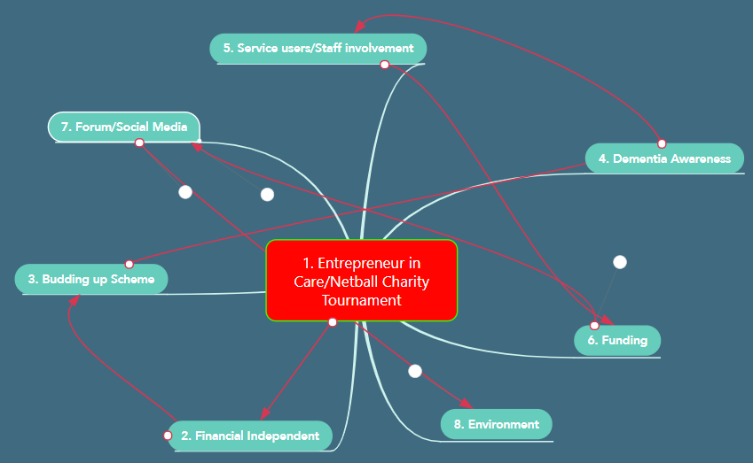

My idea is fuel by my passion of wanting to be my own boss and looking after people who needs help in the care industry. Sadler (2013) states that in the view of Descartes, our passion can affect our brain and mind which can be arise from things that can affect us from experience we have.
The concept of innovation has contributed to my project idea because being in the Fourth Industrial Revolution gives us access to technologies that is blurring the boundaries between people, the internet and the physical world ( Montresor, 2016) .

- Entrepreneur in Care/ Charity Netball Tournament

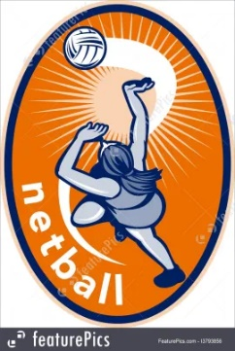

(iPicture, 2021)
(Dreamstime, 2021)

Opening my care company which I could use to start a charity netball tournament on a yearly basis during the summer period.


- Financial Independent

(Guberti, 2019)

Opening up my own business will in time allow me to become financial independent. This will help me to venture in other areas that I am passionate about.

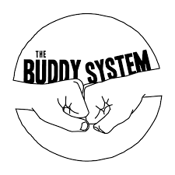
- Budding up Scheme

(Stradling, 2015)

This sees a person with dementia and one without working together to raise awareness of the illness.

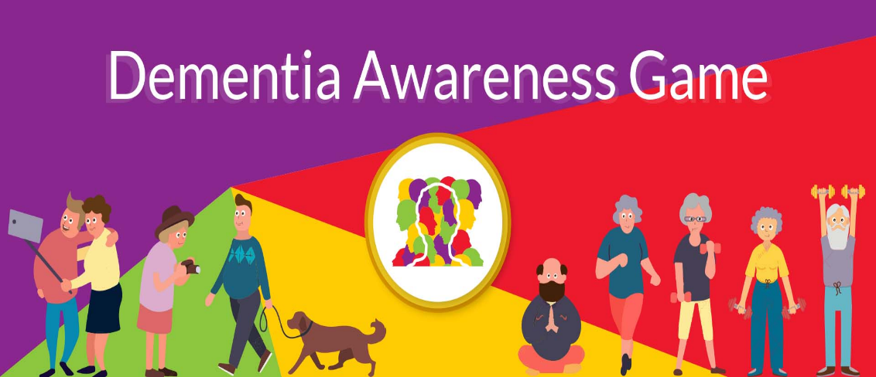
- Dementia Awareness

(Focus Game, 2019)

Raising awareness of dementia as many people do not know what it is. I want to achieve this through my company and the charity netball tournament.

- Service users/ Staff involvement
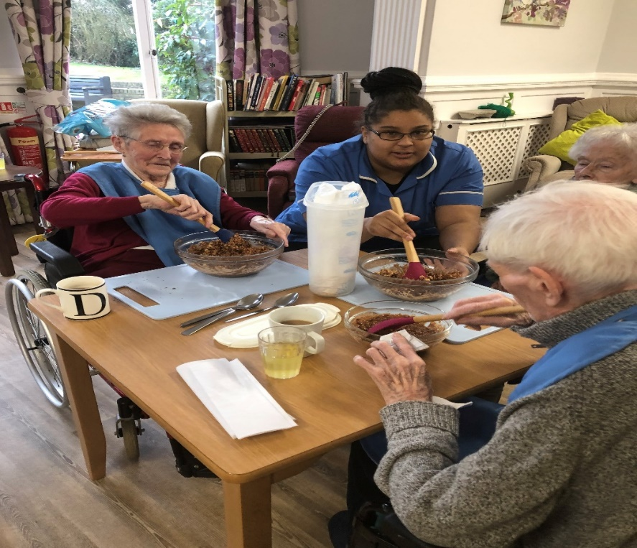

(Westgate Healthcare, 2021)
Service users and their family member will have the option of getting involved such as baking of cakes, making of cards and anything that can be of sale.

- Funding


(Grate, 2019)

I will want to set up some form of financial support so that the money that is raised from the tournament or from any donations through social media or sales will be set aside so that people can have access to fund for the detection of dementia or even to have someone to talk with about it.


- Forum/Social media

(William, 2015)
I want to set up a forum on the company website where people can have discussions and ask questions about dementia. The social media platform will also be a way we advertise our events and to get people coming out to our netball tournament.

- Environment

(Matthews, 2019)

Ensuring that our work and events are environmentally friendly and ensure that we encourage the same to all individuals.

Task 2: Using a medium of your choice, create a summary that outlines how you came up with your idea and how it adds value, based on the concepts introduced in Unit Two of the module.
My Blog
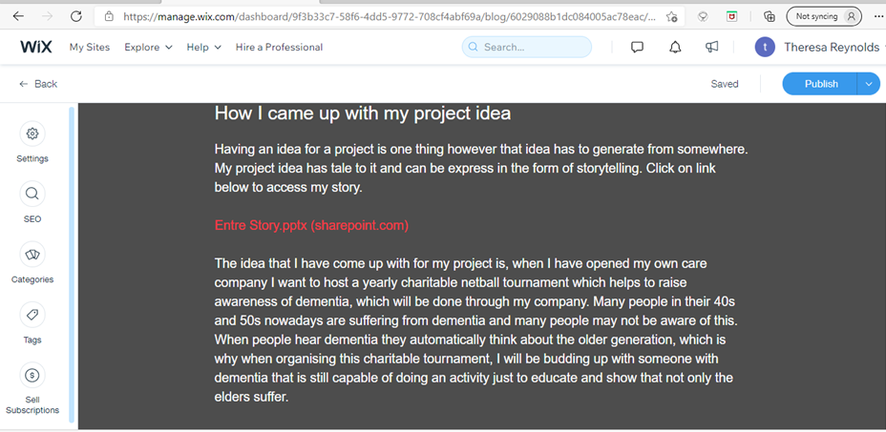

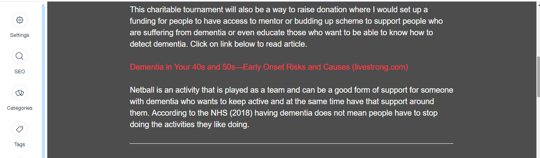

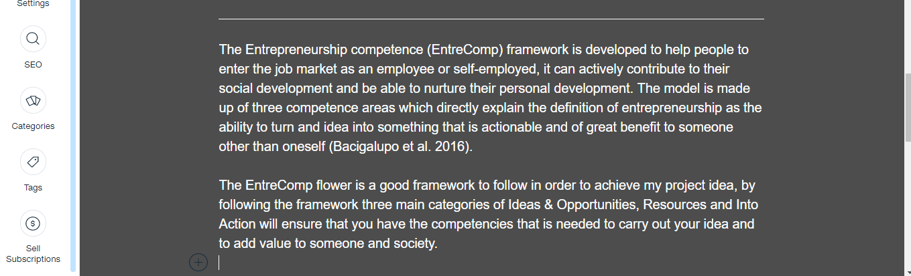

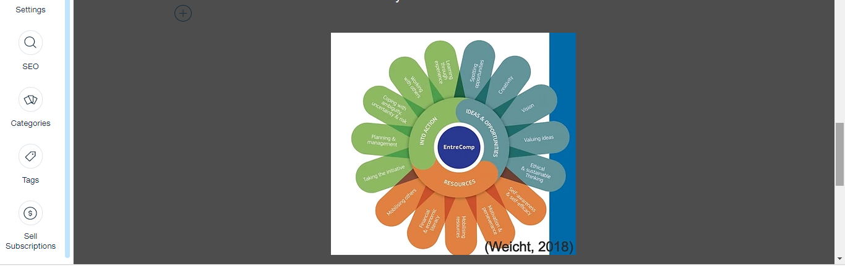

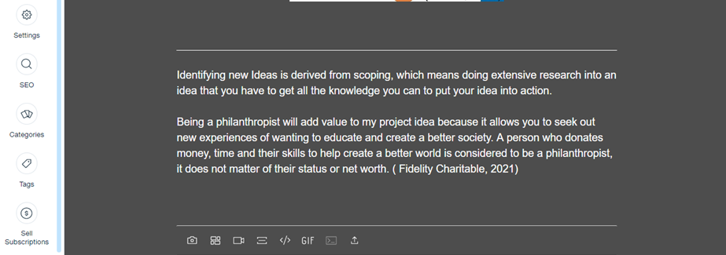

The link for my blog:
https://manage.wix.com/dashboard/9f3b33c7-58f6-4dd5-9772-708cf4abf69a/blog/6029088b1dc084005ac78eac/edit
The link for the website on my blog:
https://www.livestrong.com/article/8143512-dementia-in-your-40s-and-50searly-onset-risks-and-causes/ (Accessed: 16 February 2021).
My Entre Story Link that is on my blog: https://uowtsdmy.sharepoint.com/:p:/r/personal/1912751_student_uwtsd_ac_uk/_layouts/15/Doc.aspx?sourcedoc=%7B442FF43B-0C3A-48F7-A65C-902E9B315678%7D&file=Entre%20Story.pptx&wdOrigin=OFFICECOM-WEB.START.REC&ct=1613477986280&action=edit&mobileredirect=true&cid=d13f27a7-90e0-471f-99c2-37a42c81bc16
References
- Bacigalupo, M., Kampylis, P., Punie, Y., Van den Brande, G. (2016) EntreComp: The Entrepreneurship Competence Framework. Luxembourg: Publication office of the European Union.

- Buzan, T. (2006) Mind mapping. London: Pearson Education.

- Dreamstime (2021) [image]. Available at: Medical Home, House, Real Estate Health Care Building, Architecture, Home People Icons Symbol Logo Design On White Background Stock Vector - Illustration of vector, company: 127920595 (dreamstime.com) (Accessed: 2 February 2021).

- Fidelity Charitable (2021) What is a Philanthropist? Available at: https://www.fidelitycharitable.org/guidance/philanthropy/what-is-a-philanthropist.html (Accessed: 16 February 2021).

- Focus Games (2019) Dementia Awareness Game [image]. Available at: https://www.dementiagame.com/ (Accessed: 8 February 2021).

- Grate, R. (2019) 100 Fundraising Ideas: How to Effectively Raise More Money [image]. Available at: https://www.eventbrite.co.uk/blog/fundraising-ideas-ds00/ (Accessed: 8 February 2021).

- Guberti, M. (2019) 3 Habits of Financially Independent People [image]. Available at: https://medium.com/swlh/3-habits-of-financially-independent-people-19e9dd4d29dc (Accessed: 8 February 2021).

- iPictures (2021) [image]. Available at: Netball Ball Netball Silhouette: Volleyball Clip Netball Ball, Netball player catching ball (russelloliver.co.uk) (Accessed: 2 February 2021).

- Matthews, P. (2019) Eco-Friendly Business Practices for the Environment and Your Wallet [image]. Available at: https://innotechtoday.com/eco-friendly-business-practices/ (Accessed: 8 February 2021).

- Montresor, F. (2016) The 7 technologies changing your world. Available at: The 7 technologies changing your world | World Economic Forum (weforum.org) (Accessed: 16 February 2021).

- National Health Service (2018) Activities for dementia. Available at: https://www.nhs.uk/conditions/dementia/activities/ (Accessed: 16 February 2021).

- Sadler, G. (2013) Descartes Handout: Six Basic Passion in The Passion of The Soul. Available at: https://www.academia.edu/15733937/Descartes_Handout_Six_Basic_Passions_in_The_Passions_of_The_Soul (Accessed: 8 February 2021).

- Stradling, C. (2015) Buddy Systems work [image]. Available at: https://athenatrainingandconsulting.com/7018/ (Accessed: 16 February 2021)

- Weicht, R. (2018) Education systems can stifle creative thought [image]. Available at: Education systems can stifle creative thought. Here’s how to do things differently | World Economic Forum (weforum.org) (Accessed: 13 February 2021).

- Westgate Healthcare (2021) The Benefits of Cooking and Baking in Care Homes [image]. Available at: https://www.westgatehealthcare.co.uk/news-article/the-benefits-of-cooking-and-baking-in-care-homes/ (Accessed: 8 February 2021).

- William, S. (2015) Forum on Social media marketing offered in Upper Hutt [image]. Available at: https://bizedge.co.nz/story/forum-social-media-marketing-offered-upper-hutt (Accessed: 8 February 2021).

