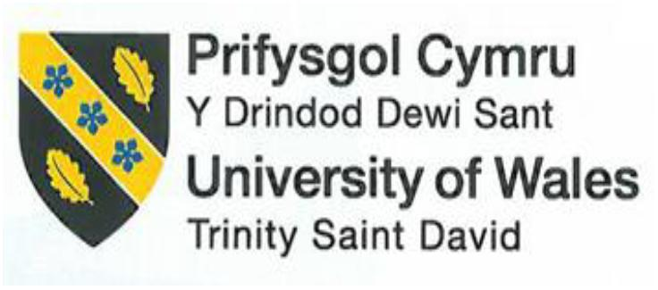

BUSINESS REPORT
Comparison of Corinthia Hotels and Ibis Hotels

Student Name: VICTORIA CHILIANU
Student ID Number: 2208500
The Module Title: Financial Management for the Hotel Industry BMIH5007
Lecturer’s Name: TRISTAN HAWKINS
Word count: 2146

Executive Summary
This research analyses the financials of two hospitality companies Corinthia Hotel Group and Ibis Hotels. The contrast between them is that Corinthia Hotel provides luxury services while Ibis is known for operating as a budget-friendly business. This report aims to cover the revenue models, market positioning, and growth possibilities while evaluating the CSR commitment.
Luxury and exclusivity drive Corinthia Hotel Group’s earnings from premium lodgings, spas, and fine dining (Corinthia Hotels, 2023a). This maximises the strategic worldwide growth leading to a strong luxury market position which boosts revenue.
By contrast, Ibis explains ways in which budget-friendly accommodation reservations are practical in terms of food and beverage offerings (Accor, 2022a). The income of the Ibis hotels is affected by the market coverage and brand loyalty programmes which may influence the economy.
Corinthia brand represents elegance, exclusivity, and excellent service. Ibis Hotels dominates the inexpensive to mid-range category, serving budget-conscious visitors and professionals. For efficiency, practicality, and service consistency. Corinthia Hotel Group expands in luxury areas via partnerships and high standards (Corinthia Group, 2021a). Has economic sensitivity and high operational expenses. Ibis Hotels diversifies service models, and franchises strategically, and integrates technology to grow (Accor, 2022b). Challenges include economic downturns and network service standardisation. To capitalise on luxury travel and experiences, Corinthia Hotel Group should seek burgeoning premium markets. To satisfy budget-conscious, tech-savvy travellers, Ibis Hotels should promote technology and sustainability.
Table of Contents

Executive Summary 1
Introduction 3
Total Revenue Analysis 4
Market Position Assessment 7
Growth Potential Evaluation 10
CSR Financial Commitment Analysis 12
Conclusion 16
Recommendations 17
References 18

Introduction
This report aims to increase understanding of the perspectives of financial aspects by considering ways in which their financial management and sustainability aspects are performed through using in-depth research.
Research demonstrated that hotels are among the most competitive businesses as per Martín-Rios and Ciobanu (2019, p. 218). Hence, businesses are globally recognised regarding the competitive landscape within the operating industry, the financial management strategies and practises play a crucial role in sustainability and growth (Hayes et al., 2022).
Analysis of these characteristics increases understanding of the current status of hotels and the steps that must be taken for future increased performance. By analysing such characteristics, the current hotel status and the steps that should be taken to develop performance will be considered. A comparison between Corinthia and Ibis Hotels will be developed based on revenue sources, previous trends, and ways that influence the revenue streams.

Total Revenue Analysis
The concept of revenue management (RM) involves the company's earnings, profits, and all sources of income (Helmold, 2020). Comparative financial analysis of Corinthia Hotels with 25 hotels in 16 countries (Corinthia Group, 2021b), and Ibis brand, a hotel chain owned by Accor Group with 1269 hotels in over 70 countries (Accor, 2022c). The scope of the total revenue analysis is to evaluate ways in which the price elasticity is measured through a change in total revenues coming from a change in the price of the delivered product.
Corinthia Hotels Revenue
The Group generated revenue of €282.0 million in 2023, an increase of +18% from the prior year (Figure 1). Annual reports for 2022 indicate a Corinthia Group income of €201.8 million from Hotel Operations (Figure 2). An increase of +95% compared to 2021. Demonstrating that the targeted luxury market is productive for the chosen business.
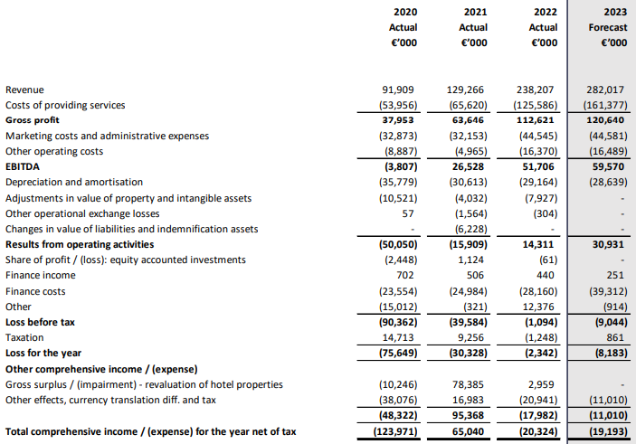
Figure 1. Comprehensive Income, Corinthia, 2023 (International Hotel Investments, 2023)
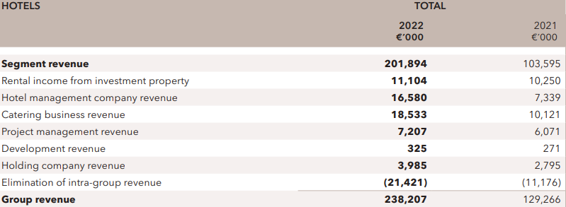
Figure 2. Corinthia Group Revenue, 2021-2022 (Corinthia Group, 2022)
Corinthia Group's main sources of income are rents from investment properties, hotel management, and catering businesses (Figure 2). State-of-the-art accommodations feature spas, fine dining, and corporate meeting centres (Corinthia Hotels, 2023b).
Ibis Hotels (Accor Group) Revenue
The Accor Group reported 2023 Hotel Operations revenue of €2,402 million, up 35% versus 2022 (Figure 3). Information about the total income of Ibis Hotel is not shown in any source, but the annual financial report for the Premium, Midscale, and Economy division of Accor, which belongs to the economy and budget hotel segment, shows a total revenue of €1,418 million in 2023 (Figure 3).
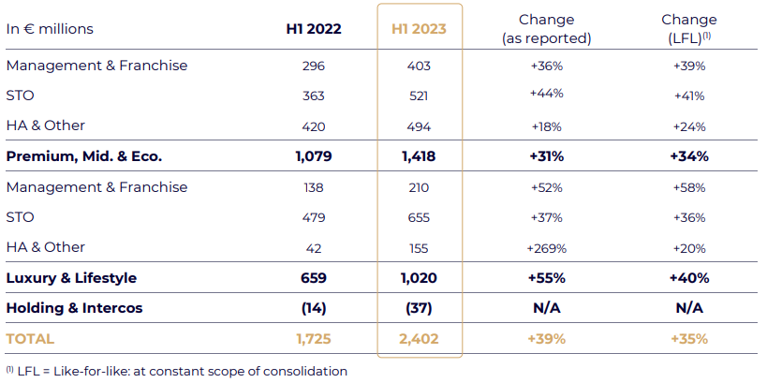
Figure 3. Reported Revenue, Accor, 2023 (Accor, 2023)
The group's highest revenues come from the Premium, Midscale, and Economy divisions, which also include the Ibis hotels (Figure 3). This brand is the leader in the number of rooms available (Figure 4), which is why it is one of the essential brands that brings income to the Accor Group.
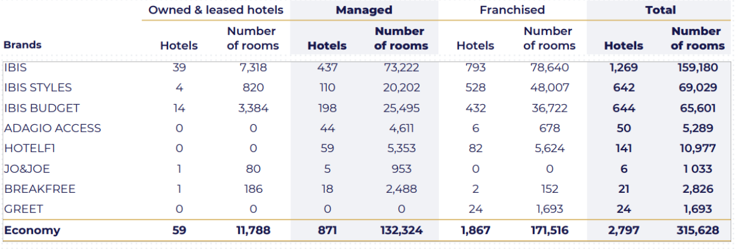
Figure 4. Economy Hotel Brands at 31 December 2022, Accor (Accor, 2022d)

Comparative Analysis
Corinthia Group prioritises financial management to establish Corinthia Hotels as a luxury brand. Although the specific financial details for Ibis Hotels cannot be found in any source, the annual financial reports of the parent company Accor show the impressive revenue of this brand. Corinthia Group's €282.0 million revenue reflects a focus on various sectors, while Ibis Hotels, as part of a larger group, contributes to Accor's substantial consolidated revenue.

Market Position Assessment
Hotel groups' competitiveness, client loyalty, and sustainability depend on their market position (Kasim et al., 2018). This section compares Corinthia Group with Ibis Hotels' market share, customer demographics, and brand perception. To identify the strategic market positioning of both hotel groups will be used Bowman's strategy clock. This strategy is based on the analysis of the ratio between the price and the value perceived by the customers (Echchakoui, 2018).
Corinthia Hotels
The brand's luxury market share is high, especially at flagship locations. The group operates a limited number of hotels, maintaining an exclusive presence (Figure 6).
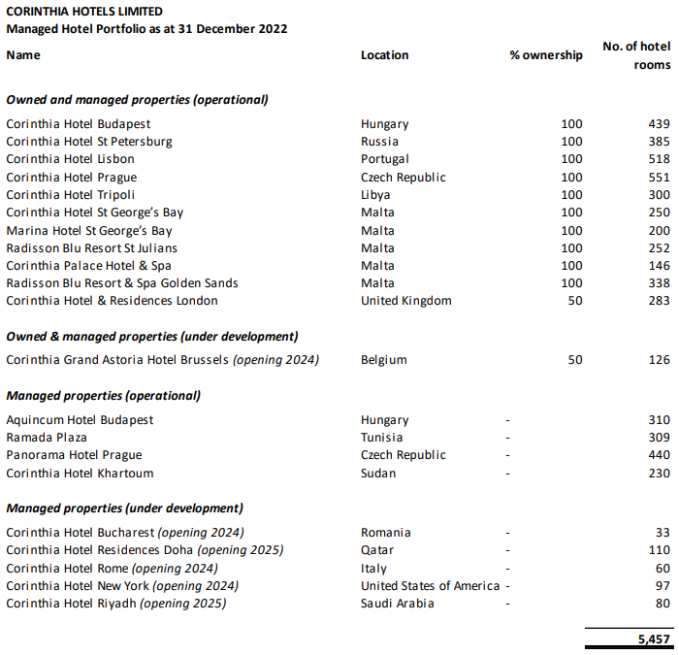
Figure 6. Hotel Portfolio, Corinthia, 2022 (International Hotel Investments, 2023)
Corinthia is noted for its superb service, exquisite elegance, and unique amenities. The brand is known for its quality, attention to detail, and elite guest experience (Gabrielle Shaw, 2020).
Ibis Hotels
Ibis's no-frills, value-for-money strategy attracts youthful visitors, backpackers, budget-conscious travellers, and business professionals (Cheng, 2019).
Ibis Hotels has a wider global footprint, which is why it is known by 66% of people worldwide. (Figure 7). This includes a high brand awareness, which increases the business performance within the operating industry. Moreover, by ensuring that the brand perception remains at a high level it will increase the business awareness and customers will perceive Ibis hotels as being more convenient to use. In addition to this, by aiming for a high score brand reputation, the number of bookings will generate a higher amount of profit as well as increased market share within the operating industry.

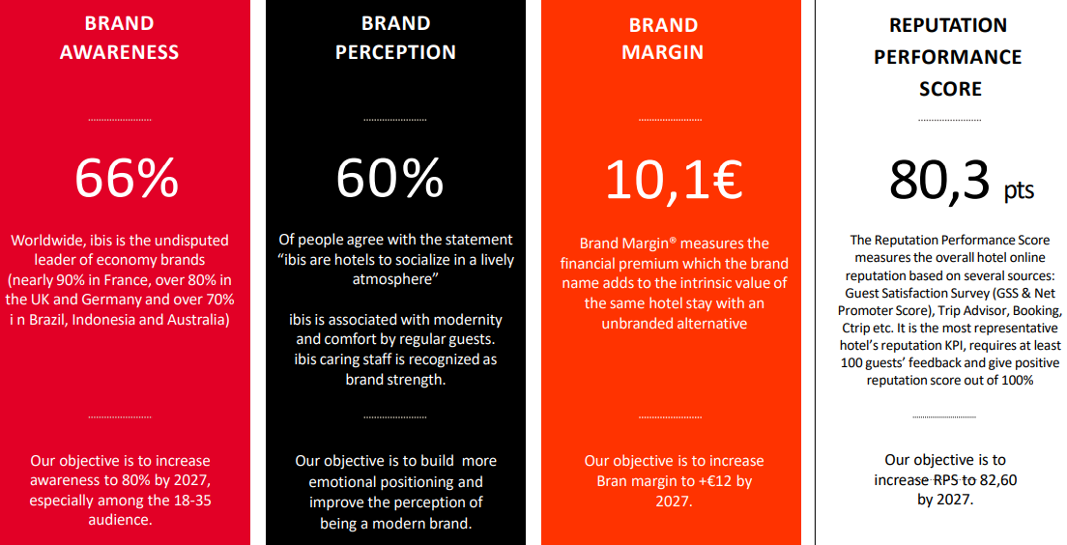
Figure 7. Ibis performance worldwide (Accor, 2023b)

Comparative Analysis
Corinthia targets niche markets with exclusivity, luxury, and personalised services. In contrast, Ibis is practical, convenient, and affordable, appealing to a wider audience.
Offering services for a certain market segment at a premium price, the Corinthia Group positions in the Focused Differentiation segment (Figure 8). The perceived value of the brand ultimately becomes synonymous with quality. Building a reputation by offering fair prices for reasonable services, Ibis Hotels is positioned in the Hybrid segment (Figure 9). They offer services with a higher perceived value than competitors, creating customer loyalty.
However, Corinthia does not use a low pricing scheme, as it strongly targets a niche market. In addition, it provides a focused differentiation as it aims to generate luxurious services for a high price, compared to Ibis which aims to provide high services at low prices.

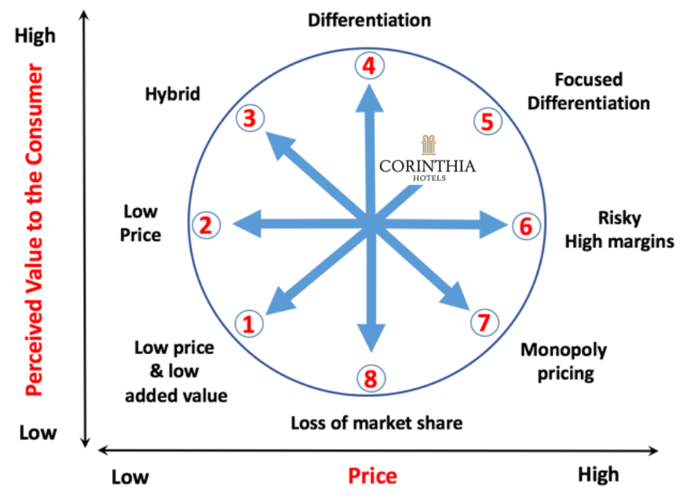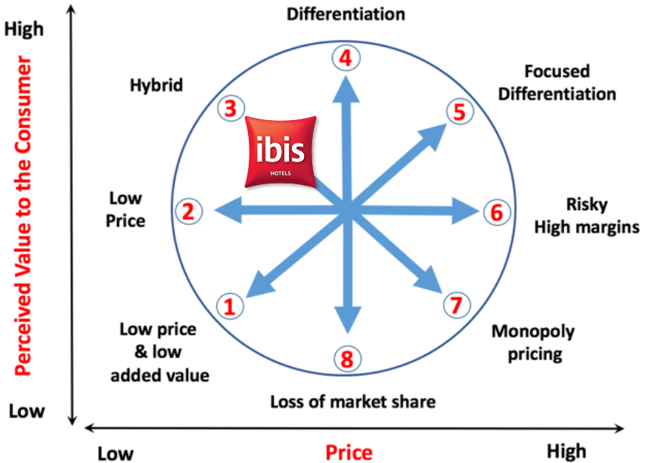
Figure 8. Bowman’s Strategy Clock: Corinthia Figure 9. Bowman’s Strategy Clock: Ibis
(Source: Developed by Author)

Growth Potential Evaluation
A hotel group's development potential relies on its expansion strategy, market possibilities, and capacity to overcome obstacles (Nikolskaya et al., 2018). This section analyses Corinthia Hotel Group and Ibis Hotels' development potential, strategic methods, market opportunities, and possible hurdles.
Corinthia Hotels | Ibis Hotels
Expansion strategies and market opportunities:
In the first half of 2024, Corinthia Group will open the doors of new hotels, and at the beginning of this year, will start the construction of the Oasis project in Malta (Corinthia Group, 2022).  Partnerships with famous restaurant brands such as Kai, Carlo Cracco, or Tom Kerridge maintain the Corinthia Group's restaurant ecosystem at a luxury level, making them formidable competitors in culinary talent (Corinthia Group, 2022). | Covering the global market with 2555 properties and diversifying the Ibis Styles and Ibis Budget concepts, Ibis Brand tends to expand its customer base (Accor, 2022d).  Accelerating its development, from 2023-2026, Accor Group, the parent company of Ibis Hotels, proposed to expand on European territory with another 1200 rooms in 8 countries (Hospitality Net, 2023).  For half of 2024, the Ibis brand aims to open the first Ibis Styles hotel in Brazil, located on the seashore (Accor, 2024).
Barriers to growth:
Economic, social, and political unstable markets exposed to Corinthia Group decrease the value of the assessed property (Figure 10), as it is rapidly expanding the strategy in regards to competitional risks, potential or existing competitors, leading to higher recognition and increased profitability. Hence, Political aspects should be constantly analysed, allowing an evaluation of potential barriers that could reduce business productivity. | Ibis Hotels' rates are competitive and their accommodations and services are comparable to those of hotel chains like Holiday Inn Express or Travelodge (Cheng, 2019). Budget hotels have a variety of affordable options and similar costs.  Airbnb's online platform provides individuals with an opportunity to rent living space and other short-term accommodations at a lower price than budget hotels (Reinhold and Dolnicar, 2018).
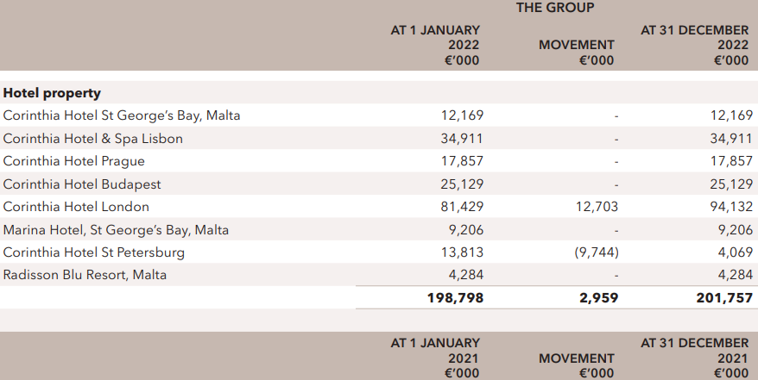
Figure 10. Adjustments to carrying amount of Corinthia Hotel properties, 2022
(Corinthia Group, 2022)

Comparative Analysis
To meet customer expectations, Corinthia continuously invests in maintaining the opulence and state-of-the-art facilities of its hotels. Ibis, on the other hand, is growing in the cheap and mid-range travel categories, focusing on urban development. However, it must maintain service consistency and stand out in a competitive industry.

CSR Financial Commitment Analysis
CSR demonstrates a company's dedication to acting responsibly, boosting the economy, and improving employee’s lives, families, the community, and society (Fond and Lynes, 2018). Corinthia Hotels and Ibis Hotels' financial commitment to CSR activities, including sustainability, community participation, and ethical business practises, is assessed in this section.
Corinthia Group
Corinthia Group's sustainability practises include the concept of green roofs and eco-gardens, systems for cooling and heating, reusing rain and grey water, energy-efficient and low-impact lighting, and waste management systems (Corinthia Hotels, 2023c).

Although guests grew by 71% in 2022, the overall waste production remained at a moderate level of 15% (Figure 11). This should have decreased by ensuring contracts with subcontractors are established efficiently to collect hazardous waste efficiently.
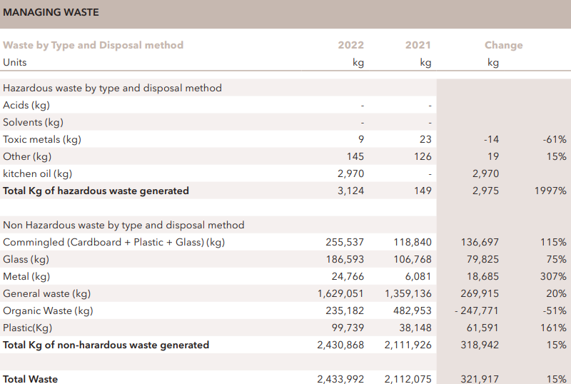
Figure 11. Managing waste, Corinthia, 2021-2022 (Corinthia Group, 2022)
The energy consumed per occupied room decreased by 32% within a year (Figure 12). More energy-efficient equipment would help to significantly lower energy consumption.
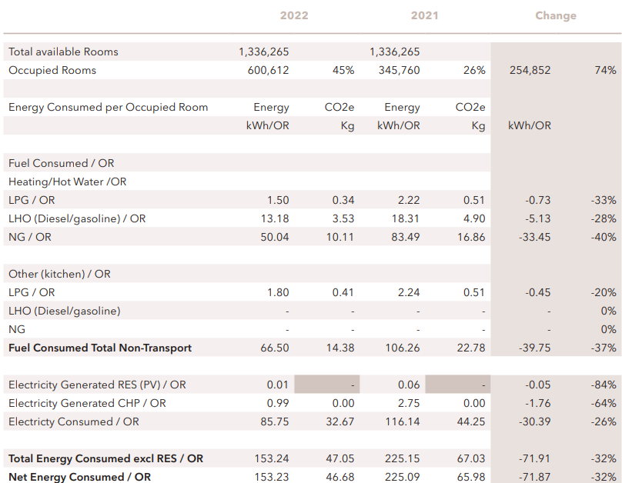
Figure 12. Direct energy per occupied room, Corinthia (Corinthia Group, 2022)

Corinthia Group is directly involved in local and global projects focused on education and healthcare, such as QP, Corinthia Caterers Foundation, and SOAR Hub Service (Insider Plus, 2023).
Ethical practise in organisational behaviour is applied through: the Group Data Protection Reporting Policy, Health and Safety, Security Management, Food Safety, and Ethical Conduct (Corinthia Group, 2022).

During the 2021-2022 period, the organisation experienced a significant increase in the average training hours its employees received (Figure 13). Various in-person and online learning programmes are offered to employees to improve their operational skills.
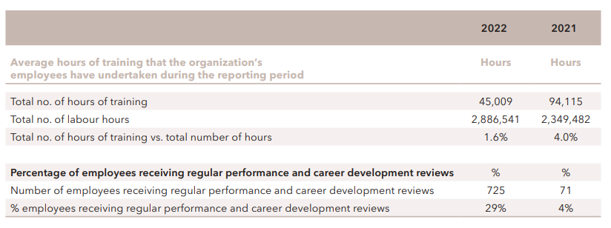
Figure 13. Average hours of training, Corinthia, 2021-2022 (Corinthia Group, 2022)

Ibis Hotels (Accor Group)
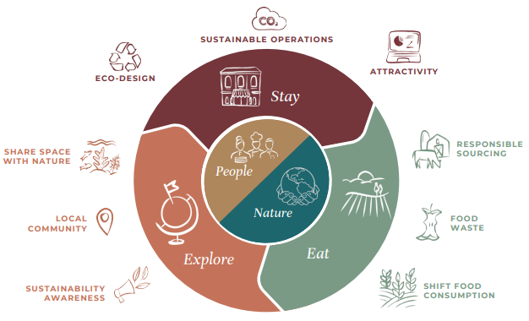
Figure 14. Accor new sustainability strategic framework, 2022 (Accor, 2022d)
Ibis supports sustainable development via the 'Planet 21' initiative. Energy, water, and carbon footprint reduction are funded to decrease environmental effects (Accor, 2020a).
Currently, 84% of Accor hotels have zero single-use plastic in the guest experience (Accor, 2022d).
They saved over 833,000 meals with the TOO GOOD TO GO application (Accor, 2022c).
Ibis' local and worldwide community involvement projects concentrate on health, education, and social inclusion such us: the Creation of the ALL Heartist Fund in 2020, becoming part of the Sustainable Hospitality Alliance (SHA) in 2021 or becoming a signatory of OneInThreeWomen in 2022 (Accor, 2023c).
Accor describes several important business ethical practises within the company: social dialogue, defeating all forms of harassment and bullying, a balance between work and personal lives, health, safety, and working conditions, and transparency, communication, and fairness (Accor, 2020b).

Comparative Analysis
Cultural preservation, strong ethical standards, and targeted, high-impact local community participation are key to Corinthia’s premium brand image and CSR strategy. Ibis, under the Accor Group, offers a more uniform and internationally integrated CSR strategy, with a large financial commitment to sustainability (Planet 21), significant community participation, and a strong emphasis on ethical business practises and workplace diversity. The large, organised financial commitment aims to achieve global environmental objectives.
Even though both brands have great CSR goals for the future, none of them have included sustainability in their company values.

Conclusion
Both businesses have development potential but with different strategies and market emphases. Corinthia's premium growth depends on its exclusivity and ability to adapt to wealthy tastes. Ibis's development relies on affordable travel, urbanisation, and technology. Corinthia's CSR efforts are personalised, culturally integrated, and high-impact, reflecting its premium status. However, Ibis prioritises scalability, uniformity, global sustainability, and social responsibility. Both methods, although different, demonstrate the companies' corporate responsibility and readiness to engage in sustainable, ethical, and socially responsible business operations.

Recommendations

Corinthia Hotels: Entering Emerging Luxury Markets.
Given Corinthia's strong luxury brand presence and demonstrated ability to offer high-end, customised services, the hotel group should concentrate on growing into new premium markets. It is recommended that Corinthia enters Asia and the Middle East as there is increased interest in such travel experiences.
Justification:
Emerging markets will drive luxury travel growth. Corinthia may benefit from rising demand and diversify its market presence by entering these areas. This premium and exclusivity brand fits these rising economies' clients' values of prestige and customised service. Corinthia's high-end hospitality offerings in new, wealthy regions may improve revenue.

Ibis Hotels: Prioritise Technological Integration and Sustainability.
By prioritising technology integration and sustainability within Ibis’ operations and services the business will target sustainable tourists and tech-savvy which will increase the word of mouth regarding the hotel, allowing a higher brand awareness.
Justification:
Based on customer expectations, younger tourists will choose businesses sustainable that provide tech-driven aspects. By differentiating brands, Ibis can outshine other competitive hotels within the budget industry by focusing on digital integration. In addition to this, operating efficiency is based upon the technology that saves costs and boosts service and business performance, allowing the business to develop performance.

References
Accor (2020a) Acting for good. Planet 21. Available at: https://www.bcdtravel.com/wp-content/uploads/sites/61/Accor_Planet-21-Presentation_2020_EN.pdf (Accessed: 23 January 2024).
Accor (2020b) Ethics and corporate social responsibility charter. Available at: https://group.accor.com/-/media/Corporate/Talent/PDF-for-pages/Charte-ethique-et-RSE/ACCOR_Ethics_and_Corporate_Social_Responsibility_Charter_20_ENG.pdf (Accessed: 23 January 2024).
Accor (2022a) Brand Portfolio. Available at: https://group.accor.com/-/media/Corporate/Hotel-development/PDF-for-pages/HP-hotel-development/Accor_Brand_Portfolio_interactive_brochure_August_22.pdf (Accessed: 24 January 2024).
Accor (2022b) Powered by emotions. Available at: https://group.accor.com/-/media/Corporate/Hotel-development/PDF-for-pages/HP-hotel-development/2022-S2/EN_AccorGlobalDevelopment_SummaryPitch_Oct2022.pdf (Accessed: 24 January 2024).
Accor (2022c) 2022 Integrated report. Available at: https://group.accor.com/-/media/Corporate/Investors/Documents-de-reference/ACCOR_RI_2022_UK_vlast.pdf (Accessed: 18 January 2024).
Accor (2022d) 2022 Universal registration Document. Annual financial report. Integrated report. Available at: https://group.accor.com/-/media/Corporate/Investors/Documents-de-reference/ACCOR_DEU_2022_US_PDF_UA.pdf (Accessed: 19 January 2024).
Accor (2023a) 2023 Interim financial report as of June 30, 2023. Available at: https://group.accor.com/-/media/Corporate/Investors/Documents-financiers/2023/07-27-H1/Interim_Financial_Report_2023_Accor_vDef.pdf (Accessed: 19 January 2024).
Accor (2023b) Why invest in Ibis: Accor global development. Available at: https://group.accor.com/-/media/Corporate/our-brands/PDF-for-pages/ibis/5-06-2023-why-invest-in-ibis.pdf (Accessed: 22 January 2024).
Accor (2023c) Key milestones. Our long standing commitment to drive change. Available at: https://group.accor.com/en/commitment/approach/milestones (Accessed: 23 January 2024).
Accor (2024) 2024 Unveiled: Accor Welcomes Spectacular New Properties. Available at: https://group.accor.com/en/Actualites/2024/01/new-hotel-openings-2024 (Accessed: 22 January 2024).
Cheng, J. (2019) ‘Research and suggestions on declining market shares of Ibis Budget Hotels’, Open Journal of Social Sciences, 8(1), pp.253-261. Available at: https://doi.org/10.4236/jss.2020.81018 (Accessed: 20 January 2024).
Corinthia Group (2021a) Annual report and financial statements. Available at: https://www.corinthiagroup.com/wp-content/uploads/2022/05/Corinthia-Annual-Report-2021.pdf (Accessed: 24 January 2024).
Corinthia Group (2021b) Owners, developers & operators of Corinthia Hotels and real estate. Available at: https://www.corinthiagroup.com/ (Accessed: 18 January 2024).
Corinthia Group (2022) 2022 Annual report and financial statements. Available at: 37547-CORINTHIA-ANNUAL-REPORT-2022_WEB-min.pdf (corinthiagroup.com) (Accessed: 19 January 2024).
Corinthia Hotels (2023a) Uplifting lives. Available at: https://www.corinthia.com/globalassets/corinthia-global/documents/development/corinthia-development-presentation-may-2023-compressed.pdf (Accessed: 24 January 2024).
Corinthia Hotels (2023b) Elegant surroundings and exquisite moments. Available at: https://www.corinthia.com/en-gb/ (Accessed: 19 January 2024).
Corinthia Hotels (2023c) Sustainability. Available at: https://www.corinthia.com/en-gb/oasis/sustainability/ (Accessed: 23 January 2024).
Echchakoui, S. (2018) ‘An analytical model that links customer-perceived value and competitive strategies’, Journal of Marketing Analytics, 6, pp. 138-149. Available at: https://doi.org/10.1057/s41270-018-0043-9 (Accessed: 20 January 2024).
Font, X. and Lynes, J. (2018) ‘Corporate social responsibility in tourism and hospitality’, Journal of Sustainable Tourism, 26(7), pp. 1027-1042. Available at: https://doi.org/10.1080/09669582.2018.1488856 (Accessed: 23 January 2024).
Gabrielle Shaw (2020) Corinthia. Available at: https://gabrielleshaw.com/casestudies/corinthia-hotels/ (Accessed: 20 January 2024).
Hayes, D.K., Hayes, J.D. and Hayes, P.A. (2022) Revenue management for the hospitality industry. 2nd ed. Hoboken, New Jersey: John Wiley & Sons.
Helmold, M. (2020) Total revenue management. Switzerland: Springer Nature.
Hospitality Net (2023) 'ibis Styles drives growth across Europe', 15 December [Press release]. Available at: https://www.hospitalitynet.org/news/4119600.html (Accessed: 22 January 2024).
Insider Plus (2023) Corinthia’s Golden Hearts. Available at: https://insider.ihiplc.com/corinthias-golden-hearts/ (Accessed: 23 January 2024).
International Hotel Investments (2023) Financial analysis summary. Available at: https://www.corinthiagroup.com/wp-content/uploads/2023/06/IHI_Financial-Analysis-Summary-2023.pdf (Accessed: 18 January 2024).
Kasim, A., Ekinci, Y., Altinay, L. and Hussain, K. (2018) ‘Impact of market orientation, organizational learning​ and market conditions on small and medium-size hospitality enterprises’, Journal of Hospitality Marketing & Management, 27(7), pp. 855-875. Available at: https://doi.org/10.1080/19368623.2018.1438955 (Accessed: 20 January 2024).
Martín-Rios, C. and Ciobanu, T. (2019) ‘Hospitality innovation strategies: An analysis of success factors and challenges’, Tourism Management, 70, pp. 218-229. Available at: https://doi.org/10.1016/j.tourman.2018.08.018 (Accessed: 17 January 2024).
Nikolskaya, E. Y., Kovaleva, N. I., Uspenskaya, M. E., Makshakova, N. I., Lysoivanenko, E. N., & Lebedev, K. A. (2018) ‘Innovative quality improvements in hotel services’, European Research Studies Journal, 21(2), pp. 489-498. Available at: https://www.um.edu.mt/library/oar//handle/123456789/33728 (Accessed: 22 January 2024).
Reinhold, S. and Dolnicar, S. (2018) Chapter 4 - How Airbnb Creates Value, in S. Dolnicar, Peer-to-Peer Accommodation Networks: Pushing the boundaries, Oxford: Goodfellow Publishers, pp. 39–53. Available at: https://library.oapen.org/bitstream/handle/20.500.12657/30986/1/640674.pdf#page=50 (Accessed: 22 January 2024).

