L4 UCM Assignment 1
Module Name: Learning in the Digital Era
Assignment Title: Assignment 1
Student Name: Liam Aaron Jarvis
Student Number: 2000388
Course Title: Computing (Networks and Cybersecurity)

Table of Contents
*Note: To be able to access the work using the OneDrive links on the E-Portfolio, rather than downloading the files from the attachments on the E-Portfolio, I have had to put a password on the OneDrive links so I was able to check myself if the links worked. (I have also mentioned this on the E-Portfolio itself) To view these documents on OneDrive, use the following password: “Password” (Everything in between the quotes)
E-Portfolio Webpage link:
https://liamjarvis8269.wixsite.com/e-portfolio
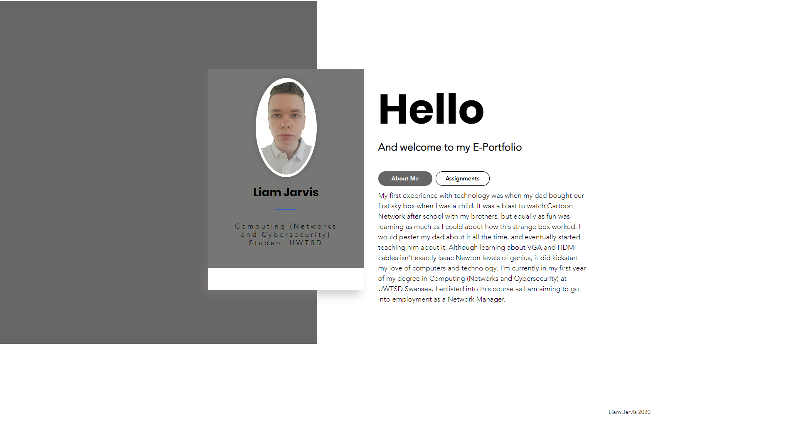

Task 1 - Written Summary Link:
https://liamjarvis8269.wixsite.com/e-portfolio/assignments
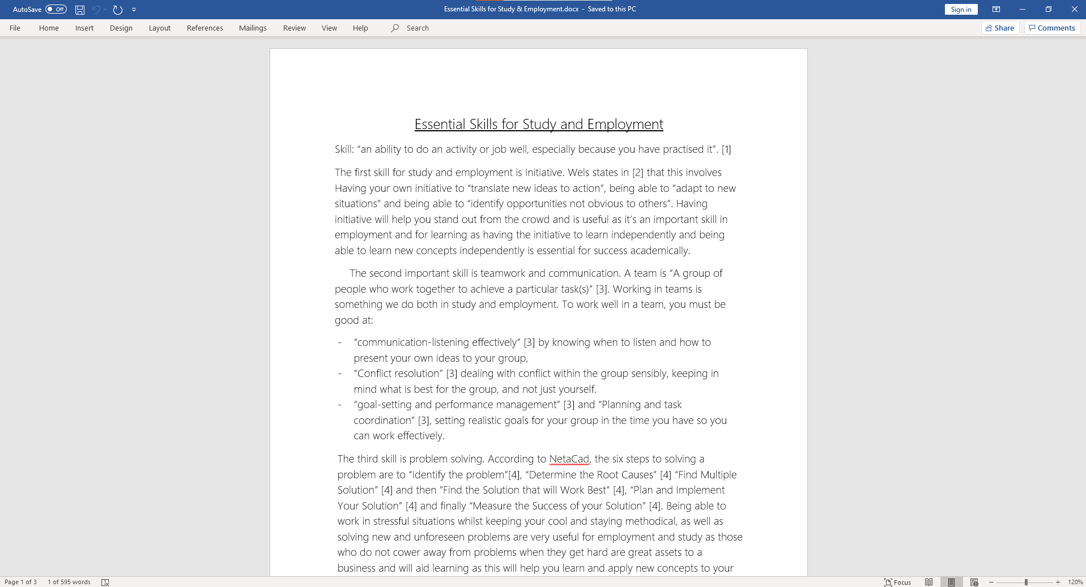

Task 2 – Mind Map Link:
https://liamjarvis8269.wixsite.com/e-portfolio/assignments
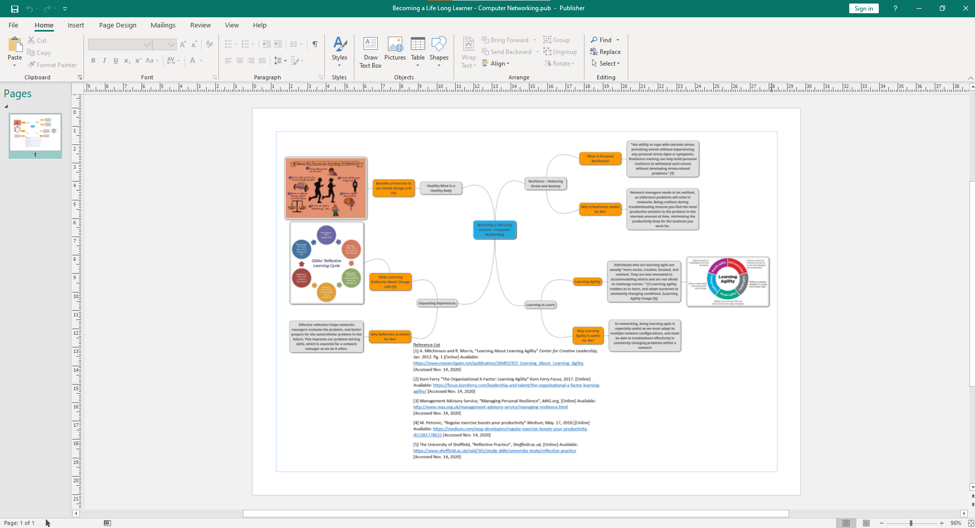

Task 3 – Video Presentation Link:
https://liamjarvis8269.wixsite.com/e-portfolio/assignments
Direct Link to Video:
https://www.youtube.com/watch?v=QOHRgIm69wc&feature=youtu.be
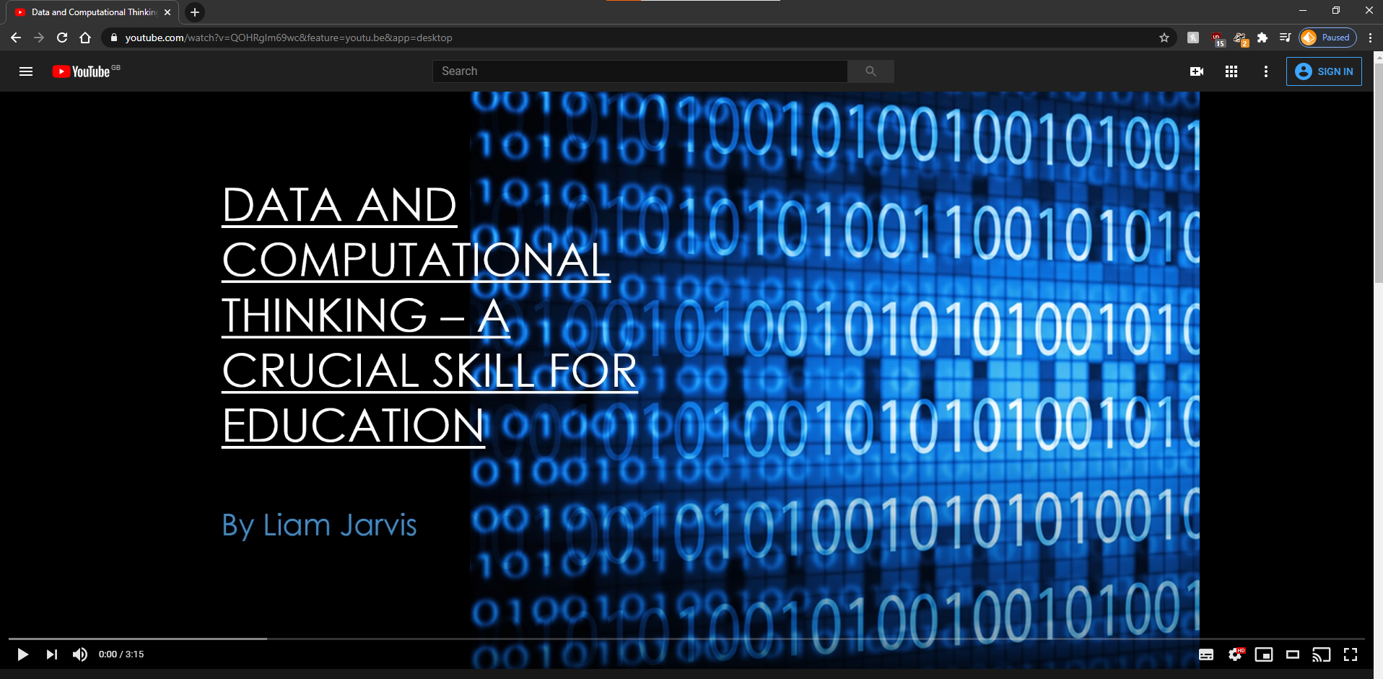

Task 4 – Academic Poster Link:
https://liamjarvis8269.wixsite.com/e-portfolio/assignments


