
The Impact of Child Abuse

A Guide for Parents and Children

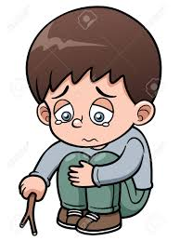
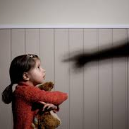


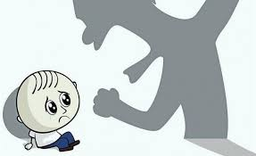
What is child abuse?

⇒ Child abuse occurs when harm is inflicted on a child or young person and when a parent or guardian has failed to protect them. (NICE, 2017)

There are four different types of child abuse and they are:
- Physical Abuse
- Emotional Abuse
- Sexual Abuse
- Neglect (National Research Council, 1993)
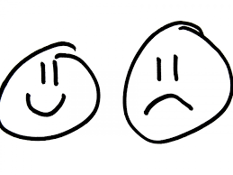
- The World Health Organization defines child abuse as the result of all forms of maltreatment as explained above, which results in the potential harm of a child or young person’s health, development or survival, in relation to trust or power of an individual. (Watson, 2013)
Symptoms of abuse: Physical
Do you recognise any of these?

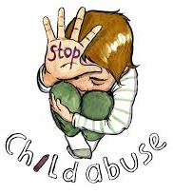
Physical abuse occurs when a child is hurt deliberately by causing injuries such as burns or cuts. (NSPCC, 2017)

NSPCC, 2017
Symptoms of abuse: Emotional
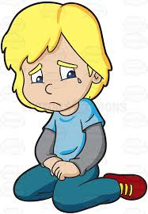
NSPCC, 2017
Can you relate
to these symptoms?
Emotional abuse is the frequent emotional maltreatment of a child and can involve humiliating or scaring a child. (NSPCC, 2017)
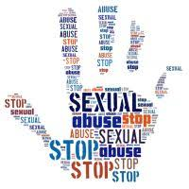
Symptoms of abuse: Sexual
Sexual abuse occurs when a child is made to take part in activities of a sexual nature. They may not know it is happening. (NSPCC, 2017)
NSPCC, 2017
Are some of these symptoms familiar?
Neglect occurs when the basic needs of the child are not met, and it is also the most common type of child abuse.
Children may not receive love and attention of their parents and can be left unkempt and hungry.
(NSPCC, 2017)
What are the signs and symptoms of neglect?
Neglect



NSPCC, 2017

As cited by NICE, during a 1-year period, there were found to be over 590,000 children referred to social care services.
(NICE,2017)
Statistics and findings of Child Abuse
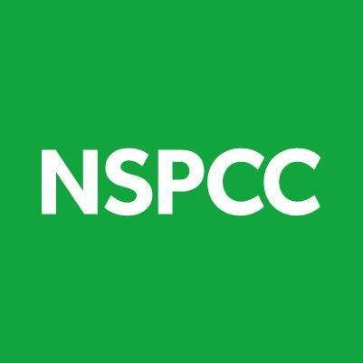
According to NICE, a prevalence study found that 5.9% of children and 18.6% of young people had experienced abuse during their childhoods.
(NICE,2017)

As cited by Watson et al, 2013, for every 100,000 individuals under the age of 18, 300 of them were subject to abuse. (Watson, 2013).


According to the child protection register 2016, there were over 58,000 children who were identified which needed to be protected from abuse in the UK in 2016. (NSPCC, 2017)

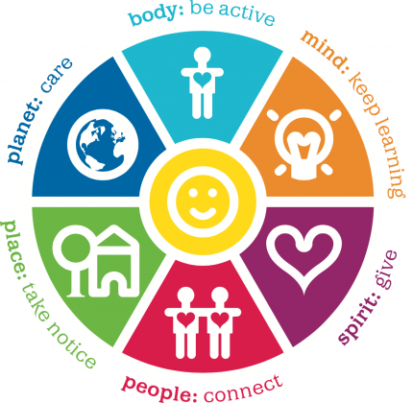
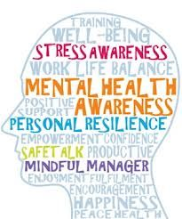
- A child or young person’s abusive experience can be associated with the development of mental health disorders such as depression, anxiety, self-harming or even being bullied. (NSPCC, 2010)
- Other disorders can include panic disorder, ADHD and dissociative disorders.
- As cited by the NSPCC 2010, evidence shows that a child or adolescents experience of abuse can pose long term effects on many aspects of their mental health.
- Also, as cited by the NSPCC 2010, the impact of abuse can increase the risk of social and emotional problems, as well as the chance of developing mental health disorders.
Mental Health and Well-being
So, What’s the Impact?

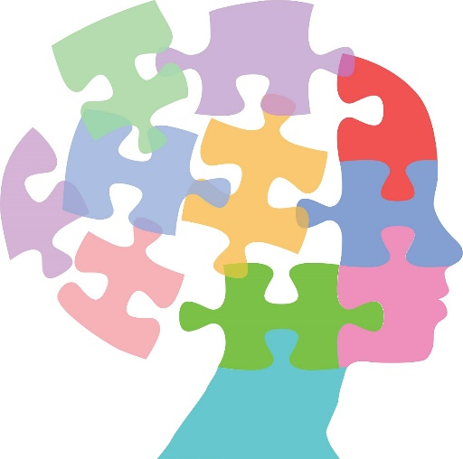
- According to the Child Welfare Information Gateway, 2013, a previous study found that 54% of individuals who had experienced childhood abuse had depression and 58% of individuals had attempted suicide.
- Child maltreatment can have a negative impact on a child or young person’s development of emotional regulation as well as being able to control their emotions into adolescence. (CWIG, 2013)


Children or young people who have experienced abuse are more likely to develop antisocial traits and are more susceptible to violent behaviour and personality disorders. (NSPCC, 2010)
A study conducted by Kelley in 1997 showed that children and young people who have been abused or neglected are 25% more likely to experience problems such as teenage pregnancy in girls, severe drug use and different mental health problems. (NSPCC, 2010)
Mental Health and Well-being cont.

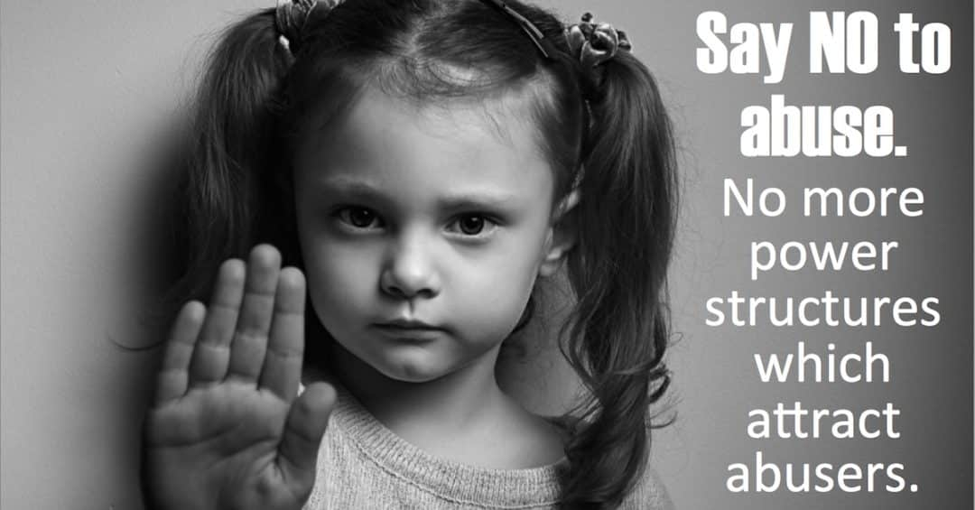

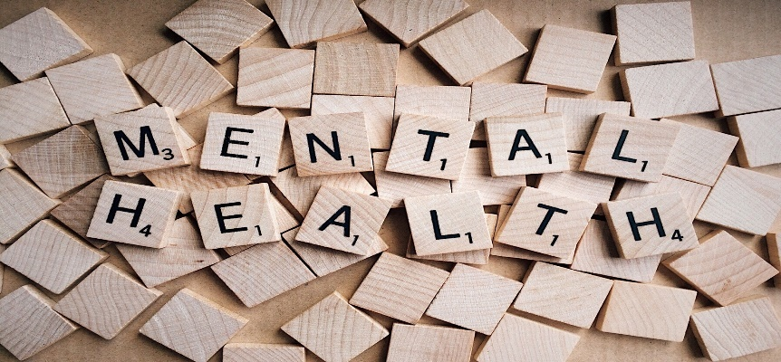

- Sexual abuse has shown a link to the development of mental health problems which have resulted in self-harming, inappropriate sexual behaviour and sadness. (NSPCC, 2010)
- As cited by Dube et al 2005, studies which have looked at the effects of child maltreatment have increased the risk of an individual misusing substances in adolescence and much other mental health and social problems.

Mental Health and Well-being cont.
- As cited by NSPCC 2010, a study conducted by Read 1998 found that 50 – 60% of psychiatric patients reported childhood experience of maltreatment.
- Others such as Fergusson 1996 and Mullen 1993 have found that child abuse and maltreatment may have a significant role in the development or early onset of severe mental health conditions in adulthood. (NSPCC, 2010)
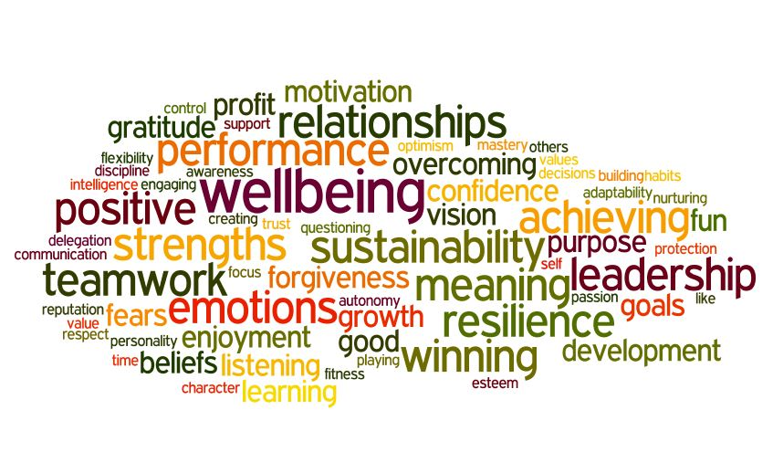

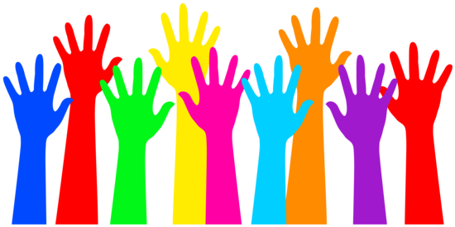
- According to NSPCC 2010, Heim and Nemeroff (2001) have suggested that childhood maltreatment can cause problems in an individual’s emotional wellbeing which can increase the risk of developing mental health disorders.
- Neglect can also cause a child or young person to have low self-esteem and can make them feel unloved, which can then result in low self-confidence and negative wellbeing (NSPCC, 2010)

So, What’s the Impact?
School Life

- As cited by Coohey et al 2011, research has found that children who had experienced abuse or neglected had poorer academic performance than those who had not.
- Also, the academic performance of a child or young person can vary, depending on how long the maltreatment has been present for. (Coohey et al 2011).
- Children or young people who have experienced maltreatment are at greater risk of having poor behaviour at school and being bullied at school.
- Many children and young people who have experienced maltreatment will have low self -confidence and will, therefore, underperform at school because of the abuse.
- Abused children and young people will also leave school before the school leaving age. (YJB, 2008)

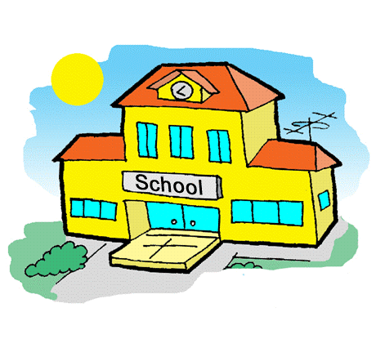
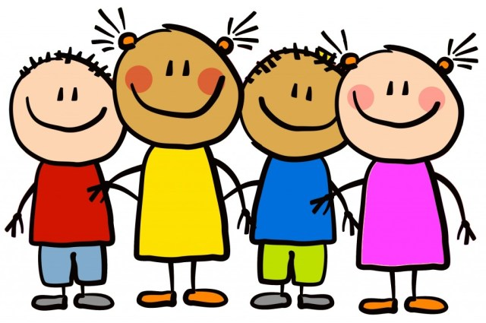


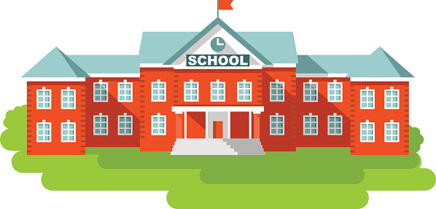
School Life cont.

- As cited by Youth Justice Board, 2008, 92 studies produced to look at the relationship between child maltreatment and school achievement and other factors between 1967 and 2000 were reviewed by Veltman and Brown (2001).
- They found that:
- In 31 out of 34 studies, abuse was linked to negative school performance.
- In 49 out of 65 studies, children who had experienced maltreatment had cognitive delays.
- In 36 out of 42 studies, children showed delays in language development.
- According to Youth Justice Board, 2008, reviewed research has shown that children and young people who have been maltreated are at greater risk of lower academic performance at school and therefore underachieving.
- According to Cawson 2002 as cited by Youth Justice Board, 2008, studies have shown that children and young people who have been abused or neglected are at increased risk of having special educational needs, being excluded from school and are more likely to be absent from school on a regular basis. (YJB, 2008).
- As cited by Boden et al 2007, studies which have looked at the relationship between abuse and academic performance have shown frequent low levels of tests and school outcomes in children and young people that have experienced maltreatment.

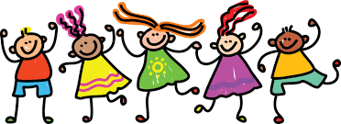

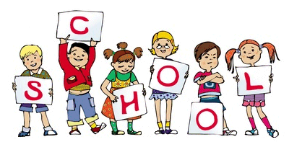
School Life cont.
- A study carried out by the African Research Review looked at the link between child abuse and academic performance.
- From their findings, they found that there was a significant difference in academic performance in the children who had been abused, to those who had not been maltreated.
- As cited by Boden et al 2007, studies have looked at the effects of other types of abuse and have shown a negative impact on academic performance.

From these studies, it has been shown that child maltreatment and neglect can have a negative impact on an individuals school life.
A study conducted by Buckle, Lancaster and Powell Higgins (2005) found that other factors as well as maltreatment can contribute to poor school life.
- In recent years, a study conducted by Coohey et al 2011 was carried out to examine the risk that maltreatment has on a child’s school tests.
- They found that severe abuse, lack of skills in daily activities and low intelligence had a negative effect on their mathematic test results as well as their language and reading tests. (Coohey et al 2011).

Childline
0800 1111
childline.org.uk
24-hour free helpline
Papyrus
HOPElineUK- 0800 068 4141
papyrus-uk.org

Kidscape
020 7823 5430
kidscape.org.uk
Available Mon-Tues, 10am-5pm

NSPCC
Helpline for parents - 0808 800 5000
Helpline for children- 0800 1111
nspcc.org.uk
Available 24-hour, every day
Family Matters
Helpline- 01474 536 661
familymattersuk.org
For children who have survived sexual abuse
Helplines!

References
- All images were accessed from Google Images.
- Coohey, C., Renner, L. M., Hua, L., Zhang, Y. J., & Whitney, S. D. (2011). Academic achievement despite child maltreatment: A longitudinal study. Child Abuse & Neglect, 35(9), 688-699.
- Child Welfare Information Gateway. (2013). Long-term consequences of child abuse and neglect. Washington, DC: U.S. Department of Health and Human Services, Children’s Bureau.
- Boden, J. M., Horwood, L. J., & Fergusson, D. M. (2007). Exposure to childhood sexual and physical abuse and subsequent educational achievement outcomes. Child abuse & neglect, 31(10), 1101-1114.
- Buckle, S. K., Lancaster, S., Powell, M. B., & Higgins, D. J. (2005). The relationship between child sexual abuse and academic achievement in a sample of adolescent psychiatric inpatients. Child abuse & neglect, 29(9), 1031-1047.
- Day, C., Hibbert, P., & Cadman, S. (2008). A literature review into children abused and/or neglected prior custody. London: Youth Justice Board.
- Dube, S. R., Anda, R. F., Whitfield, C. L., Brown, D. W., Felitti, V. J., Dong, M., & Giles, W. H. (2005). Long-term consequences of childhood sexual abuse by gender of victim. American journal of preventive medicine, 28(5), 430-438.
- Lazenbatt, A. (2010). The impact of abuse and neglect on the health and mental health of children and young people. London: National Society for the Prevention of Cruelty to Children. Retrieved from: http://www. nspcc. org. uk/Inform/research/briefings/impact_of_abuse_on_health_pdf_wdf73369. pdf.
- National Institute for Health and Care Excellence. (2017). Child abuse and neglect. Retrieved from: https://www.nice.org.uk/guidance/ng76
- National Research Council. (1993). Understanding Child Abuse and Neglect. Washington, DC: The National Academies Press. doi: 10.17226/2117. Pg 4-5.
- NSPCC. (2017). Child abuse and neglect. Retrieved from: https://www.nspcc.org.uk/preventing-abuse/child-abuse-and-neglect/
- Stirling, J., & Amaya-Jackson, L. (2008). Understanding the behavioral and emotional consequences of child abuse. Pediatrics, 122(3), 667-673.
- Umoren, G., Ukpepi, B., & Ndifon, R. (2010). The Influence of Child Abuse on the Academic Performance of Primary School Pupils in Primary Science in Cross River State, Nigeria. African Research Review, 4(1)
- Watson, W. J., Al Odhayani, A., & Watson, L. (2013). Behavioural consequences of child abuse. Canadian family physician, 59(8), 831-836.

