How a school develops one aspect of its SDP: a report that critically reflects on the actions, impact and evidenced base.

 | Targed/target | Yr hyn yr wyf wedi'i wneud yn yr aseiniad hwn  What I have done in this assignment...
Targed/Target 1 | You are a good researcher, but you need to work on your referencing. There were some critical errors noted in annotations. | I have tried my best to correct my referencing by looking through the Harvard referencing guide and correctly referencing within this assignment.
Targed/Target 2 | You must aim to adhere to the word limit. I know you were in a group of 3 but a lot of what you expressed cuold have been condensed or combined. | I have stuck within the word count; I have used some of the extra 10% allocated but felt I needed it to write an in-depth report.
Targed/Target 3 | Not given | N/A

A school development plan (SDP) sets out action points and improvement priorities to develop learning (Welsh Government, 2014). It also allows schools to set their own agenda (Wallace, 2009). Supported by evidence, within this assignment, I will provide a report on an action point taken from my placement schools development plan. I will assess how the target is being approached and implemented within the school and measure the impact it has on its intended outcome. My first placement was in a three-form entry pioneer primary school situated in Cardiff. 704 of the school’s pupils reside in homes where the main language is English with very few speaking Welsh. The Welsh Government (2017) have placed an increasing emphasis on the education reform mission, to deliver an education system of national pride along with the development of the Welsh Language. I have, therefore, chosen to focus my report on priority point five of the school’s development plan; ‘to improve pupils incidental welsh across the school’. The ever-growing importance of developing the Welsh language and the many links to wider national policies surrounding this influenced my decision to focus my attention on this point within the SDP. The Future Generations Act, (2015) embeds the importance of creating a thriving welsh language and respecting the status as a bilingual nation. Welsh Government, (2017) also highlights the importance of allowing learners to develop their Welsh language skills with confidence through the education reform. As well as the latter points, the latest Estyn, (2015) report for the school stated a need to improve the schools ‘Welshness’. All these points discussed have resulted in the school self-evaluating and drawing focus on developing their incidental Welsh language skills as a priority point on their SDP.

Literature review
Thomas et al, (2018) explains how cross regional planning came into practice in September 2015 with the four regional consortia. School development planning covers a cycle that begins with a clear vision of what a school is hoping to achieve (Welsh Government, 2014). Allowing schools to address a vast array of questions regarding where the school is, what changes needed to be made, how these changes are managed and how to measure the impact of such changes (Hopkins and Reynolds, 1991). The first approach taken involves, self-evaluation, where extensive research, and data analysis path the way for the required improvements and actions required on an SDP (Welsh Government, 2014). According to the Welsh Government, (2014) the effective use of qualitative and quantitative data results in robust self- evaluation. Data is vitally important as, according to Schildkamp, (2019), without it, addressing issues and problems can be ineffective. She further suggests that time and money can be spent on the wrong issues therefore leaving the main issues unresolved. This improvement point derived from the school’s (Estyn, 2015) report, which acknowledged the need for the school to improve standards in Welsh in all classes. The school has reflected well on this suggestion and adding to that with it being a pioneer school has acknowledge the importance of the Welsh Government, (2017) setting out the ambitious challenge of seeing the number of people using the Welsh language reach a million by 2050. According to Estyn, (2014) self-evaluation is an integral part of development at all levels which aid schools focus on the main priorities for development.
Further research outlining the importance of developing and implementing incidental Welsh into schools comes from The Future Generations Act, (2015) where the focus falls on improving the social, economic, and cultural well-being of Wales. Within this act lay seven well-being goals, with the sixth laying claim to making Wales a place of vibrant culture and thieving Welsh language. Williams, (2015) spoke proudly of how this action plan will help and ensure learners develop the language with confidence and sets out the vision and direction for education within Wales. However, this does not come without criticism. Gwenllian, (2019) highlighted her worry over how matters will proceed and how according to experts much will depend on individual teachers and how they implement the new reform and curriculum. This connects with the second stage of a SDP, where strategic planning needs to be considered. The primary responsibility of a SDP belongs to the governing body. However, it is the responsibility of the headteacher and all staff to implement the suggested actions in order to develop improvement across the school (Welsh Government, 2014). The SDP for my school is planned, where each member of staff provides a strategic lead for what they are responsible for and non-contact time is allocated for this to be dealt with efficiently. Welsh Government, (2014) suggests distributing the right people to the right job leads to the achievement of goals. However, for the most effective outcomes, Welsh Government, (2014) further proposes school development planning should also allow involvement from all school partners where possible.
The final two stages involve implementing the action of their goals and reviewing. There is considerable information and advice available surrounding the implementation of the Welsh language. It is an ambitious goal presented to schools in Wales, however the Welsh Government, (2016) have set several approaches to help achieve this. The education system must provide high quality Welsh-language skills to all practitioners (Welsh Government, 2016); most notably the introduction of a Welsh-language Sabbatical Scheme, which aims to give the opportunity for teachers to improve their Welsh language skills whilst building confidence alongside (Welsh Government, 2016). This, I believe encourages and places more confidence in opinions such as that from Gwenllian, (2019) who believes we should not let the opportunity to develop and modernise teaching slip through our fingers. In addition, Welsh language development is incorporated into the seven areas of learning in the Foundation Phase Framework (Estyn, 2013). A report by Blatchford et al (2005) highlights the vital importance the foundation phase has on raising standards and improving educational reform through an increased emphasis on active learning and play. Welsh Government (2017) suggests an improved capacity to use incidental Welsh within the foundation phase. Welsh Government, (2017) proposes achieving this by enabling children under five to have enough contact with the Welsh language, then continuing this throughout all key stages. It must be acknowledged that this will only be achievable through support from schools and contexts outside of the classroom (Wales Government, 2018). Expanding on the latter point, parents and carers need to be given the support to understand the importance of this goal and its relevance to life in the workplace (Welsh Government, 2018). Developing the Welsh language is not presented without the understanding that with it comes a challenge and the need for ambitious action from all within the education sector (Welsh Government, 2017).

Following a meeting with the assistant head of school, it was clear to see how throughout the planning process, strategic planning is discussed amongst the senior leadership team. Each member of staff has a responsibility to provide a strategic lead for the phase they are responsible for. Their role is to keep up to date on local and national levels. This is then driven forward by the leadership team and the consortia who also provide strategic support in order to raise standards of both teacher and learning from initial planning through to delivery. As previously mentioned, I have chosen to focus on aspect five of the report to ‘Improve pupils’ incidental Welsh across the school’. The SDP details how this will be achieved through 17 action points (evidenced in appendices 1). Each provides a clear outline of the expected change, who is directly involved in each point, the budget and resource available, timescale and evidence.
After extensive self-evaluation, the SDP has been carefully streamlined with the inclusion of a success criterion (evidenced in appendices 2). This has been carefully implemented and considered on how they intend to make changes in order to achieve excellent levels of learning of Welsh from the pupils. Within the Estyn, (2015) report states that, while a few pupils could complete oral and written commands in Welsh, improvement was needed to develop this across the whole school. Therefore, the first point on the success criteria involves ‘standards’ where their aim is to improve communication skills in and around the school. The plan puts great emphasis on Welsh being spoken and understood amongst the pupils and staff. Evidenced in the SDP, this is hoped to be achieved through the development of daily 10 minutes oral sessions of Welsh along with mini Welsh tasks in each class and in the playground. I had the opportunity to, both, witness and deliver these sessions where I observed engagement from the pupils and notable improvement. According to Welsh Government, (2008), both hearing and understanding are vitally important aspects of acquiring a new language and the school has placed great emphasis on this. The Welsh Government, (2008) further explain the importance of developing the Welsh language through basic sentence patterns, activities, and the chance to explore Welsh books, stories, and poems. The school have therefore proposed, within the SDP, the introduction of weekly assemblies where Welsh songs and prayers are performed, along with the celebration of the ‘ymadrodd yr wythnos’. They also hope to develop incidental Welsh during key points of the day and within the corridors and playground. Often, when I walked the corridors of the school I would be greeted in Welsh by pupils. Some would go further with their oral skills by creating a conversation asking how I was which demonstrates how the action point is being achieved well.
Next on the success criteria is the aim of ‘provision’, which is to focus on developing staff confidence and subject knowledge of the Welsh language. The school has acknowledged that in order to develop incidental Welsh amongst the pupils and the school, staff need to be sufficiently trained and seen to be using incidental Welsh themselves. In order to develop this, the school have arranged for the Welsh in Education officer to provide training to staff. Welsh Government, (2016) highlight how important it is to provide practitioners with high- quality Welsh language skills. The school acknowledges it is important that teachers collaboratively work together to ensure consistency across learning. Within the SDP, focus is placed on teachers identifying and planning Welsh oracy skills accordingly with support provided during inset days. They propose the implementation of support on the use of recording speech on up to date software, which offers professional development to staff and in turn produces evidence of oracy skills for each class.
The third point on the success criteria is ‘leadership’, the aim being to promote and celebrate the Welsh language as a whole school ethos. It is therefore appropriate that most of the action points within the SDP require participation from all staff. The school believes all staff need to be considered in making the appropriate changes if any improvement is going to be made. The assumption around this lay in that collaborative working would bring stronger continuity and consistency across schools (Thomas et al, 2018).The SDP details how all staff are to be involved in promoting Welsh around the school using displays with the expectation that teachers become more reflective in their practice. I believe this to be a very valid point. However, the importance of making this authentic needs to be considered here. Teachers need to be aware of what they are promoting and understand why? As such, as previously mentioned, self-evaluation is an integral and ongoing process at this school, through day-to-day discussions. The school has acknowledged the importance of developing a positive outlook towards the Welsh language. The development and implementation of the ‘Criw Cymraeg’ is discussed heavily within the SDP and through my own observation, believe it to be implemented authentically and accordingly across the school. They aim to make pupils aware of what the Criw Cymraeg do and proudly present and celebrate the work of the school through displays and assemblies. As with other aspects I have discussed this is the responsibility of all staff to promote within their classrooms. However, the lead practitioner of Welsh within in the school takes main responsibility of overseeing how work is evidenced and presented. Another point within the SDP, which I believe to be a vital aspect in increasing incidental Welsh, is the introduction of the ’Caffi Cymraeg’. Here, parents and carers are invited to learn how Welsh is taught in the school and given the opportunity to develop their own Welsh language skills to aid pupils at home.
There are clearly many adventurous points and expectations discussed within the SDP. However, it is vital to understand how the school measures the impact of each point. The SDP suggests that much of their measuring impact is achieved through monitoring and learning walks. While this is necessary to assess if incidental Welsh is improving within the school it would be beneficial to see timely meetings and action points for situations drawn up if levels are not improving as expected. One effective measure the school has outlined in the SDP, is a reward system, which gives the leadership team quantitative data to work from, whilst still encouraging the pupils to speak Welsh with the introduction of Dojo points and ‘Tocyn Iaith’, both children and staff members are awarded ‘Tocyn Iaith’ tokens when Welsh is spoken. This creates healthy competition to see who can achieve the most. This is something again I witnessed and found to be very effective for pupils and staff in raising awareness and developing Welsh language skills.

‘Improving incidental Welsh’ was an aspect of the SDP that interested me greatly. As previously mentioned within this assignment, Welsh has an ever-growing importance within the curriculum. Therefore, as a pioneer school their goal is to deliver the new curriculum to the best of their ability. Welsh Government (2017) proposal of attaining 1 million Welsh speakers by 2050 has been acknowledged and worked towards within this school. Through research on how the school develops the SDP one could conclude that they have spent considerable time analysing research and data to create an effective SDP that will lead to increased learning throughout the school. They have taken a collaborative approach, involving all members of staff, which has created a communal approach which I believe is necessary for any anticipated positive changes and results to occur. In addition to this, strategic planning is also discussed throughout senior leadership, each member of staff who has a responsibility must provide a strategic lead and direction for the phase or the stage they are responsible for. The lead responsible for the point I have addressed within this assignment is a fluent Welsh speaker who demonstrates her passion for the Welsh language daily. She oversees the implementation of Welsh in and around the school and is an advocate for increasing the confidence of teachers through the means of weekly meetings and rewards. It was inspiring to see pupils’ positive attitudes to developing their Welsh skills. There was a definite whole school ethos of developing an action point in order to achieve greater learning. I understand their development planning to be very advanced in terms of qualitative data they have used. If I were to propose one suggestion, it would be to use more quantitative data in order to measure the impact of their suggested aims. I feel this would allow them to track learners’ progress more efficiently.

Within this assignment I have demonstrated an understanding of how and why school development plans are important for the growth of a school. Through self-evaluation and the use of qualitive and quantitative data, a school can develop action points which will lead to efficient teaching pedagogies resulting in better outcomes for all learners. I focused on one aspect from my placements SDP, which is to focus on ‘improving pupils’ incidental Welsh’. I address how the school collaborated to provide effective steps which aim to develop a deeper understanding of the Welsh language amongst learners. I have shown a deep understanding to the importance of staff collaboration within planning and the implementation of action points. I am aware that no school plans the same and will have different intended improvement journeys, however, through self- evaluation, staff collaboration, and the understanding that learner outcomes are the measure of effectiveness, school development planning will ultimately lead to school improvement (Welsh Government, 2014).

References
Estyn (2013), Welsh Language Development in the Foundation Phase. Available at: https://www.estyn.gov.wales/thematic-reports/welsh-language-development-foundation-phase-january-2013 (Accessed on 25th March 2020)
Estyn (2014), Available at: https://www.estyn.gov.wales/effective-practice/including-all-staff-self-evaluation-process
Estyn (2015), school x Estyn report
Future Generations Commissioner for Wales (2015): The Well-being of Future Generations (Wales) act 2015 [Online] Available at: https://futuregenerations.wales/about-us/future-generations-act (accessed on 24th March 2020)
Gwenllian. S. (2019), ‘Why I’m becoming increasingly worried about the new Welsh curriculum’ Nation Cymru. Available at: https://nation.cymru/opinion/new-welsh-curriculum/ ( Accessed 26th March 2020)
Hargreaves, D.H. and Hopkins, D., 2004. Empowered School. A&C Black. [online] Available at https://books.google.co.uk/books?hl=en&lr=&id=XXXK8WfhbUEC&oi=fnd&pg=PP7&dq=the+empowered+school+david+hopkins+&ots=Nprh28MtLk&sig=Mv8rXr8IB0rc6jwTqYeegUt_n9w#v=onepage&q=the%20empowered%20school%20david%20hopkins&f=false
National Assembly for Wales (2017) Achieving the Ambition. Inquiry into the Welsh Government’s new Welsh Language strategy. Available at https://www.assembly.wales/laid%20documents/cr-ld11046/cr-ld11046-e.pdf
S Wallace (2009) A dictionary of Education. Oxford university press. (Accessed 3rd April 2020)
Schildkamp. K (2019). Data-based decision-making for school improvement: Research insights and gaps. Educational Research. Available at: https://www.tandfonline.com/doi/pdf/10.1080/00131881.2019.1625716 (Accessed 27th March 2020)
Thomas, A et al (2018) The Road to Cross Regional Working. Available at: https://www.gwegogledd.cymru/consortia-gwella-ysgolion-rhanbarthol/?lang=en
Welsh Government (2014), School Development Plans, Available at: https://gov.wales/sites/default/files/publications/2018-03/school-development-plans.pdf (Accessed on 26th March 2020)
Welsh Government (2017), Cymraeg 2050: A million Welsh speakers [Online] Available at https://gov.wales/sites/default/files/publications/2019-03/cymraeg-2050-a-million-welsh-speakers-annual-report-2017-18.pdf (Accessed on 24th March 2020)
Welsh Government (2017), Education in Wales: Our national mission. Action Plan 2017-2021 [Online]Available at: https://gov.wales/sites/default/files/publications/2018-03/education-in-wales-our-national-mission.pdf ( Accessed on 24th March 2020)

Appendices

Appendices 1 – School Development Plan – Action points
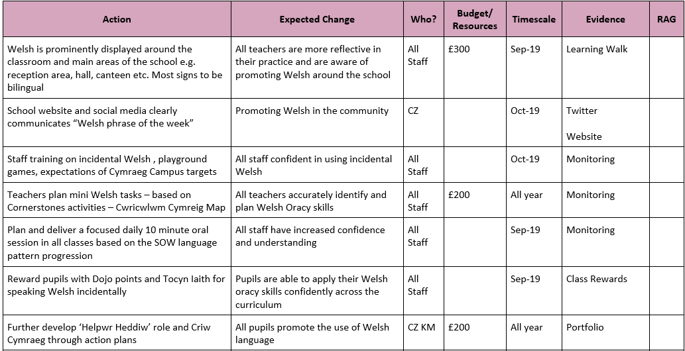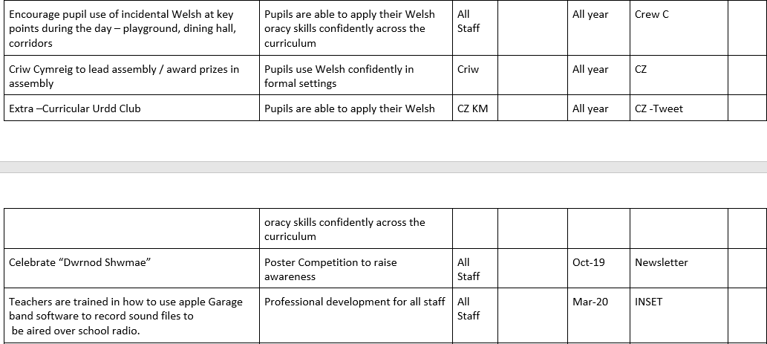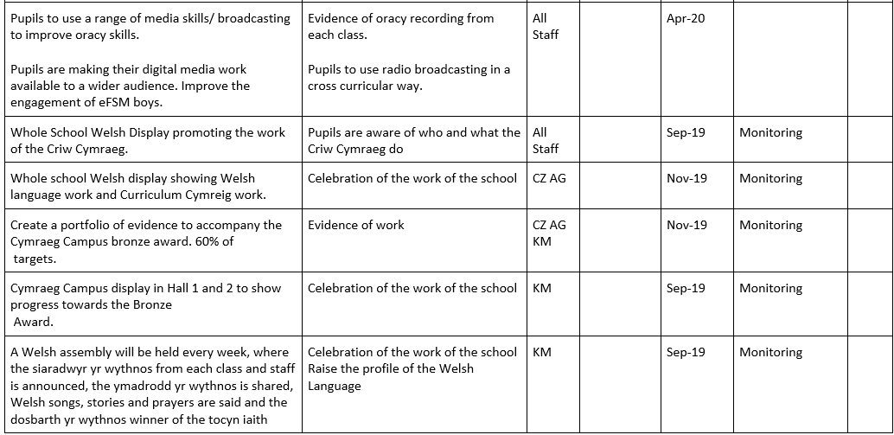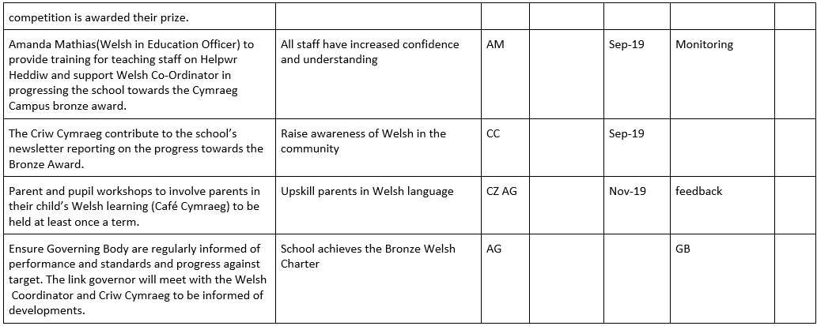

Appendices 2 – Success Criteria


