Integrating Cybersecurity Standards for Secure Cloud Governance
Table of Contents
1. Introduction 5
1.1 Background and Context 5
1.2 Problem Statement 5
1.3 Assignment Objectives 5
1.4 Scope and Assumptions 5
2. Literature Review and Framework Analysis 6
2.1 Information Technology Infrastructure Library (ITIL) 6
2.2 ISO/IEC 27000 Series 6
2.3 NIST Cybersecurity Framework 7
2.4 COBIT (Control Objectives for Information and Related Technologies) 8
2.5 Comparative Analysis 8
3. Recommended NatureGreen Security Strategy 9
3.1 Governance and Strategic Planning 9
3.2 Compliance, Laws and Ethics 10
3.3 Security Policies and Standards 10
3.4 Risk Management 11
3.5 Security Management Practices and Models 11
3.6 Protection Mechanisms 12
3.7 Contingency Planning 12
3.8 Service Level Agreements (SLAs) 12
3.9 Implementation Roadmap 13
4. Critical Analysis: The Significance of Revised Rules and Standards 13
4.1 Evolving Threat Landscape 13
4.2 Technological Development 13
4.3 Regulatory Evolution 14
4.4 Competitive Advantages and Business 15
4.5 Operational Excellence 15
4.6 Challenges and Considerations 16
5. Conclusion 16
6. References 18

List of Figures
Figure 1: ITIL Service Lifecycle 6
Figure 2: ISO 27001 PDCA Cycle 7
Figure 3: NIST Framework Functions 8
Figure 4: Organizational Security Hierarchy 9
Figure 5: Reasons for Continuous Updates 14

List of Tables
Table 1: Regional Compliance Requirements 10
Table 2: Hierarchy of Policy and Priority 10
Table 3: Registers of Risk Samples 11
Table 4: Contingencies and Contingency Reactions 12
Table 5: Examples of Critical SLA measures 13
Table 6: Advantages of new regulations over Disadvantages of old standards 15
Table 7: Summary of Key Strategic Directions 16

1. Introduction

1.1 Background and Context
Nature Green (NG) is an international company that offers healthy-living products and is broadly distributed across the country, having a huge coverage due to the huge presence in the online and social media that contributes to the visibility of the brand and customer interaction. NG, providing IT services to the staff and other customers using cloud platforms brought most of its services to wireless, which is estimated to be 95 percent in the corporate network. This strong dependence on that always-available infrastructure that is internet-based renders NG as a digitally intensive organization that is highly exposed to the current cyber threats (Mirza Akhi Khatun et al., 2023).

1.2 Problem Statement
Both employees and international customers are putting NG under pressure to allow the use of personal devices to access employees corporate network and resources in a BYOD model. At the same time, the company is highly sensitive on securing employee and client information and also the company has billions of dollars intellectual property portfolio in an environment where information security ranks highly but where formal security policies and controls are in shambles (Kamariotou and Kitsios, 2023).

1.3 Assignment Objectives
The task should also examine modern day security frameworks and models in order to provide NG with government security, governance and compliance posture. The learning gained in this research will be applied in developing a specific security strategy that will be in line with the wireless and cloud-centric world of NG, and the global operations. The paper will also critically examine the essence of upholding new or amended regulations and standards to make sure that protection and regulatory observance is maintained.

1.4 Scope and Assumptions
The discussion is clearly limited to the scenario of Nature Green provided in the assessment brief and is considered in terms of organisational properties, only technologies and problems clearly stated. The undocumented architectures, vendors or internal processes are not further assumed; generic application of general security principles is made without making any assertion based on the implementation information are not given within the scenario.

2. Literature Review and Framework Analysis

2.1 Information Technology Infrastructure Library (ITIL)
ITIL is an IT service management best-practice framework based on a service lifecycle generally comprising strategy, design, transition, operation and continuous service improvement, and which is facilitated by incident, change and problem management processes in order to deliver consistent service. Focusing on the value creation process, ITIL ensures the standardisation of the service workflow and aligning of the IT services with business demand under the defined roles and measurable levels of service (Schorr, 2021). In the case of NG, a 95 percent wireless, cloud-based environment and worldwide online image, ITIL has the opportunity to form the design and functionality of security, service availability and support of services to the customer, particularly using well-defined SLAs and operational KPIs. But, ITIL can be process intensive and necessitates substantial documentation, cultural change and tooling, which can potentially impede the agility unless done pragmatically (Iden and Eikebrokk, 2013).
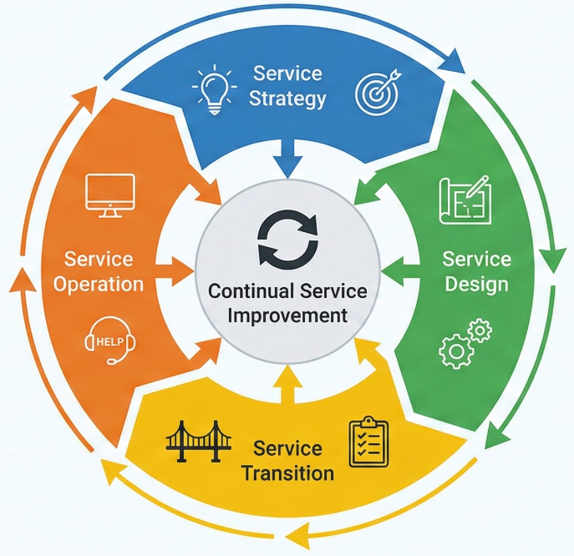
Figure 1: ITIL Service Lifecycle

2.2 ISO/IEC 27000 Series
The ISO/IEC 27000 family consists of standards of defining and executing, sustaining and continuously developing an Information Security Management System (ISMS) to safeguard information confidentiality, integrity and availability. The ISO /IEC 27001 presents formal requirements of the ISMS in terms of a risk-management cycle that allows organisations to institute a control systematically and gain independent certification. This is supplemented by ISO/IEC 27002, which offers a comprehensive code of practice and control catalogue that includes issues of access control, cryptography, operations security and supplier relationships (Reuben-Owoh and Haig, 2025). In the case of NG, worldwide operation processing employees and customer data and other valuable intellectual property, the ISO 27001 certification would assist in proving the due diligence in the eyes of regulators, its partners and consumers, and the ISO 27002 provides practical advice on making and customizing controls to its cloud and wireless infrastructure.
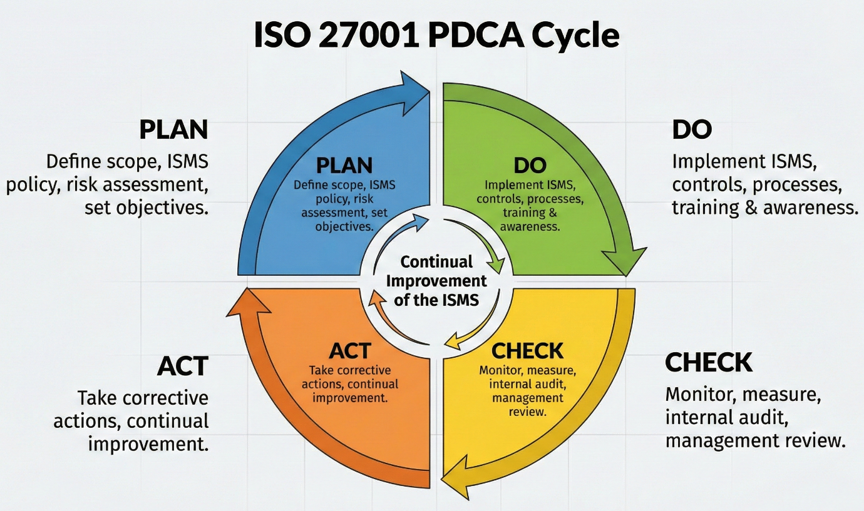
Figure 2: ISO 27001 PDCA Cycle

2.3 NIST Cybersecurity Framework
The NIST Cybersecurity Framework is characterized as a top-level core of five functions, which include; Identify, Protect, Detect, Respond and Recover that combine to offer an orderly perspective of cybersecurity risk management. The functions can be overlaid on the assets of NG, wireless networks, cloud services and business processes to explain the strengths and weaknesses of security capabilities e.g. by highlighting constant monitoring and prompt counteracting attacks of internet-exposed services. The implementation tiers and profiles of the framework scale towards gradual maturity development without defining a particular technology, which proves beneficial in an organisation that develops its security stance over the years (Rose et al., 2020).
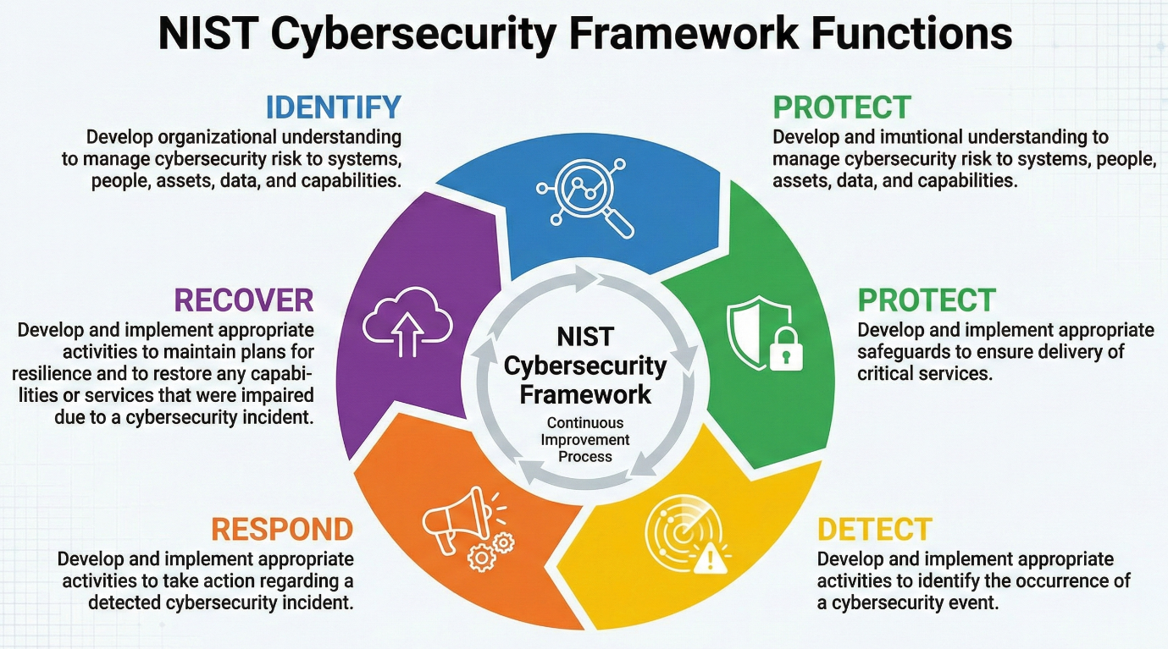
Figure 3: NIST Framework Functions

2.4 COBIT (Control Objectives for Information and Related Technologies)
COBIT is a management and governance framework which deals with information and technology assurance of enterprise objectives by a number of governance principles, goals and processes. It separates governance purposes (evaluate, direct and monitor) and management purposes (plan, build, run and monitor) and offers a model of control to achieve a control-oriented model and measures to align IT including security to business value and risk appetite. In the case of NG, the application of COBIT can be used to avert that the security, compliance and BYOD decisions are taken with a well-defined governance framework balancing the risk, performance and strategic development (De Haes et al., 2019).

2.5 Comparative Analysis
All the frameworks deal with complementary levels: ITIL involves service management processes, ISO/IEC 27000 formalised security controls and certification, NIST CSF risk-based cybersecurity capabilities, and COBIT enterprise-wide governance and alignment. As part of the full assignment, a comparative table can be structured to compare these solutions on such criteria like the cost of adoption, scalability to NG global cloud context, the complexity of compliance support and complex implementation, supporting a rational selection of an integrated, hybrid strategy adopted by NG.

3. Recommended Nature Green Security Strategy
In this section, a multi-layered, risk based, security policy has been proposed that will integrate governance and compliance, policies and technical controls along with resilience in line with 95 percent wireless and globally exposed operations of NG, which is cloud based.

3.1 Governance and Strategic Planning
A Security Governance Committee (SGC) will be created with IT, legal, HR, operations and product units members and is under a report of the senior management to make security decision based on enterprise risk and business concern. The SGC manages security strategy, policies, is the prioritise and risk monitor of investments and duties day-to-day duties are handled by a CISO and technical leadership. The governance, risk, incident response, change management and compliance accountability at the international footprint of NG should be spelled out in a roles-and-responsibilities matrix (e.g. RACI) (Burton et al., 2023).
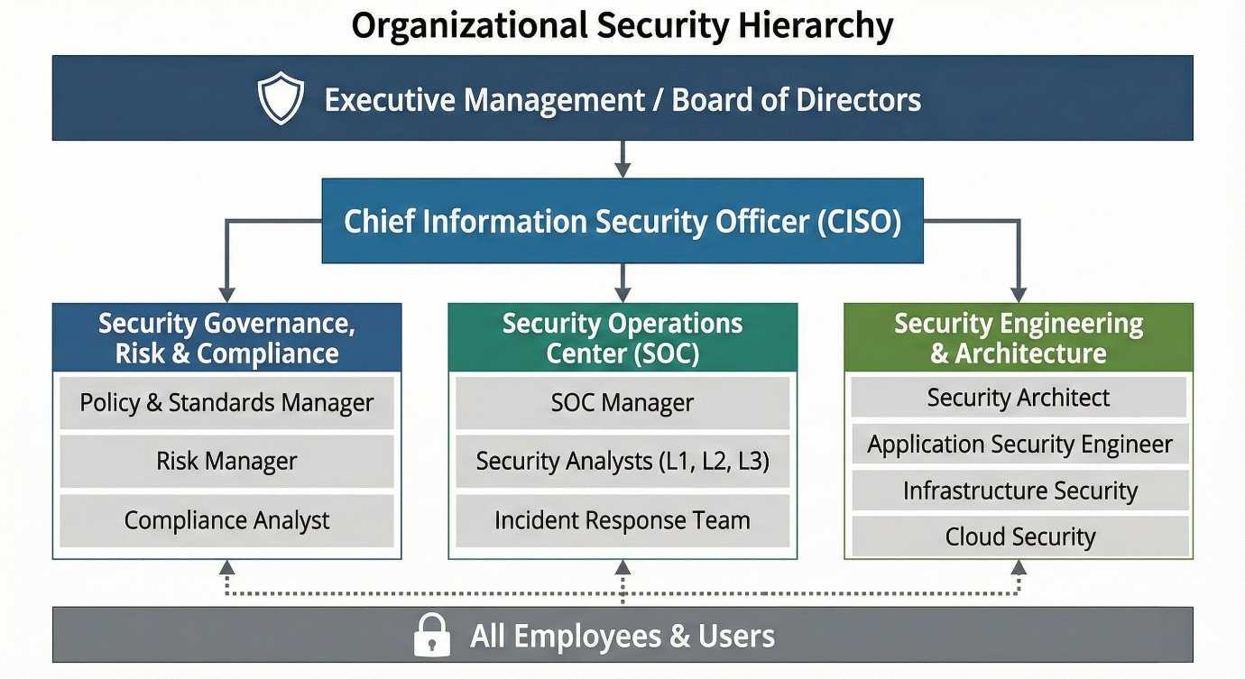
Figure 4: Organizational Security Hierarchy
To create a strategic alignment of security goals (e.g. protect IP, ensure uptime, protect personal data), the security goals should be mapped to business goals (i.e.: brand reputation, regulatory compliance and global growth). An official security plan ought to consist of a four-year roadmap, prioritised initiatives and a resource model (budget, skills, tooling) founded on risk analysis, business impact and effect analysis.

3.2 Compliance, Laws and Ethics
The regulatory framework adopted by NG needs to respond to data-protection law (and GDPR in the case of EU personal data being processed), consumer protection, e-commerce and cybersecurity laws that pertain to every jurisdiction where NG exercises its legal and activities privations or sells. CHD GDPR requirements are a legal processing, no more than what is necessary, minimisation of data, as well as security through processing and accountability, upheld by privacy-by-design and privacy-by-default controls. They ought to defining data-localisation or residency policies by region (e.g. where to keep at least some data of a personal or even financial character in-country), and should be reflected in cloud architecture and cam backup architecture (Sandeep Kumar Reddy Basireddy, 2025).
Table 1: Regional Compliance Requirements
Region / context | Key regulatory focus
EU data subjects (if processed) | GDPR: lawful basis, DPIA, DPO where required
Other jurisdictions (consumer sales) | Consumer, e-commerce, cybersecurity statutes vary
Cross-border cloud transfers | Contracts, SCCs, adequate safeguards for transfers

Morally, NG ought to embrace ideals of fairness, transparency, purpose limit and minimisation, which means to incorporate privacy-by-design into system and process engineering process and activities instead of focusing on compliance as a secondary consideration.

3.3 Security Policies and Standards
The acceptable use policy, BYOD policy, Access control policy, Data Classification and Handling Standard and an Incident Response Policy should be incorporated as core policies and approved by the SGC and aligned per the ISO-style control domains. The policies need to be express about the wireless access, cloud services, protection of high-value intellectual property, and management of staff and client data across borders (Petrov et al., 2022).
Table 2: Hierarchy of Policy and Priority
Policy / standard | Effective purpose and priority.
Information Security Policy | Top level direction; compulsory to all the staff.
Data classification & handling | Guarantee security of IP and personal data with sensitivity.
BYOD and access control | Keep personal facility, secure authentication.
Incident response policy | Detection and reporting and handling of govern.

The implementation should be in phases and prioritised policies should be implemented along with prioritised awareness campaigns, e-learning modules and obligatory sign-off with technical enforcement in terms of IAM, MDM and network controls wherever possible.

3.4 Risk Management
Formal, iterative risk-management process should be applied at NG, and they should start with identification of information assets (e.g. cloud applications, wireless infrastructure, IP repositories, customer databases) and owners, business criticality. Threat and vulnerability analysis is subsequently deployed to determine the impact of attacks like credential theft, loose Wi-Fi, mis-configured cloud services or insider misuse on the confidentiality, integrity and availability. Likelihood and impact ratings create a risk register that is to be reviewed periodically by the SGC with acceptable treatment options (Ganesen et al., 2022).
Table 3: Registers of Risk Samples
Risk | Treatment summary
BYOD data leakage | MDM, containerisation, MFA, training
Insecure wireless access | WPA3, segmentation, NAC enforcement
Incorrect cloud storage configuration | Hardened baselines, CASB, periodic audits

3.5 Security Management Practices and Models
A IAM programme must subject to strong authentication (MFA), role-based access control as well as privileged-access controls to restrict access to sensitive data and IP on least-privilege basis by access channels in the cloud and wireless environments. The identity is centrally stored (e.g. SSO with conditional access) which makes it easier to manage the user lifecycle and also enhance investigation logging (Alsirhani, Ezz and Mohamed Mostafa, 2022).
Network security must transition to Zero Trust where all connections, both intra- and inter-company are treated as unconfirmed and verification must be regularly applied, micro-segmentation, and user/device policy-based access control. This is especially in the highly wireless nature of the environment and remote highly device-diverse users of NG (Mavroudis, 2024).
The application of cloud security must use CASB to enable visibility, implement policies, anomaly detection and enforcement, enforced encryption during transit and at rest, key management and controls on clear shared responsibilities with the provider. BYOD endpoint protection should be done through MDM, application containerisation, minimum-security baselines, and using remote-wipe to lost or compromised devices.

3.6 Protection Mechanisms
Protective measures must encompass intensive encryption (current TLS of data over the wire, sound data storage algorithms), DLP controls of unauthorized data loss and controlled back-up policies with segregation and frequent restore testing. DFR can be used to enhance IP protection by using DRM, watermarking of sensitive design artefacts and secure collaboration systems with granular access and audit trails.

3.7 Contingency Planning
A Business Continuity Plan must consider the key processes (e.g. online ordering, customer support, core cloud applications) and set RTO/RPO goals and outline manual work-around wherever applicable. Cloud-based backup regions, automatic fail over, recovery run-books and periodicals should be specified in the Disaster Recovery Plan. Incident Response Plan should identify types of incidents, the escalation route, responsibilities, communication guidelines, and the practices and guidelines of post-incident review (Blum, 2020).
Table 4: Contingencies and Contingency Reactions
Scenario | Primary response
Cloud service outage | Invoke DR location, reroute traffic
Ransomware on endpoints | Isolate, recover clean and restore backups
Customer records data breach | Contain, notify, forensics, improvements

3.8 Service Level Agreements (SLAs)
Response and resolution goals of incidents, change turnaround and availability goals of critical services should be established in internal SLAs, based on business impact and BCP/DRP needs. The SLAs of cloud providers should be assessed in terms of uptimes guarantees, data-durability goals, security obligations, accessibility of support response times and non-compliance remedies, so as to make them accommodate the regulatory and resiliency responsibilities of NG.
Table 5: Examples of Critical SLA measures
Metric | Typical target focus
Service availability | ≥ 99.9% for key customer services
Incident response time | Primary screening in specified minutes
Recovery time objective (RTO) | Turn around important services in hours

3.9 Implementation Roadmap
This should be implemented under a three year progressive roadmap with year 1 being the set-up of governance, core policies, IAM and quick-win technical controls; year 2 being that of Zero Trust, CASB, DLP and maturing risk management, and year 3 being that of optimisation, advanced analytics and sustain improvement. The Gantt-style plan can be used to globally sequence the activities and depicts the dependency between governance activities and technical activities, the training and the audit activities to facilitate tracking and assurance.

4. Critical Analysis: The Significance of Revised Rules and Standards

4.1 Evolving Threat Landscape
Current threats in the cyber-environment encompass ransomware that are highly profitable, zero-day vulnerabilities that are weaponised fast and malicious artificial intelligence that is able to configure to conventional security measures. Complex ecosystems of cloud services, use by third parties or remote users suffer increased attacks, and in that case, systemic disruption and theft of data are increasingly likely when controls are old-fashioned. IoT devices, BYOD devices, and insecure endpoints increase the attack surface because of both weak and limited patching, weak configurations, and insecure endpoints, social-engineering campaigns with behavioural and generative AI create fully compelling, mass-scaled phishing and fraud (Hayagreevan and Khamaru, 2024).

4.2 Technological Development
Cloud computing has relocated data and workloads to shared, and highly inter-networked structures and demands new sharing responsibility, data residence and unremitting assurance models. Attack and defence are now based on AI and machine learning, which are functional to detect anomalies in a sophisticated way, and are also used to exploit, attack adversarial, and carry out misuse on a large scale of personal data. Future protocol paradigms and standards like quantum computing will rationalize the disapproval of numerous existing cryptographic designs, and necessitate post-quantum standards and future-oriented regulatory advice.

4.3 Regulatory Evolution
There is a need to keep on updating regulation to be explicit on new technologies in decision-making and establishing algorithms like AI, data storage using blockchain, and others which previous regulations did not give full consideration. Revisions also seal the loopholes in the legal regulation of the international data flow, vague data brokerage and automated processing, and enhance the compatibility of the regional frameworks and make the rights of data subjects clear. The current laws also tend to incorporate the ideas of data protection by design and default, where organisations have to consider privacy and security in their architectures, processes and development lifecycle, as opposed to attaching it on afterwards (Jasmontaite et al., 2018).
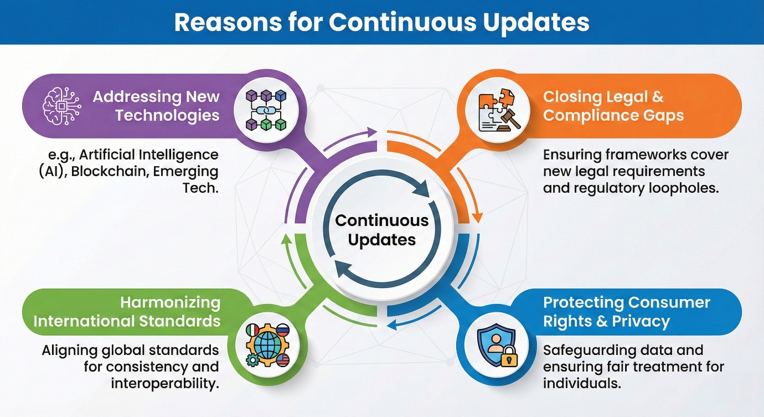
Figure 5: Reasons for Continuous Updates
Case Examples
Guidance and enforcement decisions and tools that emphasise the importance of data-protection-by-design and provable accountability remains one way that GDPR is being interpreted and operationalised. In California, CPRA builds on and improves CCPA through better definitions of its concepts, like the concept of sale of data, which enhances rights of consumers in California and establishes a special agency to enforce the law, which constitutes an example of an iterative privacy law development. In a sign of how standards bodies are adapting to new reality risks and technologies, ISO/IEC 27001 has been updated between the 2013 and 2022 version with new control structures and new risks and threats in focus (Reuben-Owoh and Haig, 2025).

4.4 Competitive Advantages and Business
Staying abreast of new rules and requirements assists organisations in proving that they take the data of the customers and electronic services responsibly, which is at the core of keeping the trust and reputation in data-driven markets. Compliance coupled with proactive compliance lowers the chances of fine, litigation and involuntary remediation and may also simplify the audits and due-diligence process when forming partnerships/acquisitions. Reciprocation or observable compliance with established standards can competitive organisations and allow them to enter jurisdictions or industries where excellent assurance is a minimum requirement.

4.5 Operational Excellence
Revamped frameworks foster iterative cycles of risk management, effectiveness of incident management and control, and drag organisations out of periodic compliance drills. They also aid in adaptive security posture, where the controls are frequently re-assessed with regards to new threats, technologies, business models instead of being constant. Conformity to the current best practices facilitates a more predictable governance in complex, multi-cloud and cross-border setting, facilitating the alignment between technical, legal and business participants.
Table 6: Advantages of new regulations over Disadvantages of old standards
Aspect | New Regulations / Standards Advantage | Obsolete Regulations / Standards Risk
Threat coverage | Controls compared to existing attack methods | Challenges that may have been taken by modern ransomware and AI attacks
Technology alignment | Ultimate guidelines on cloud and AI | Indistinct liability regarding new technologies
Legality and legal certainty. | More effective instruction, compliance templates and tools | Uncertainty, uneven meanings and conflicts
Consumer trust and rights | Greater rights, openness and removal | Feeling of used up and loss of trust
Efficiency and reliability in the operations | Automatised audits and controls | Increased audit load and haphazard Band Aid

4.6 Challenges and Considerations
Changing laws and standards may be very expensive in terms of legal research, technological transformation, and the training and continued governance of the organisation especially in international bodies. Expert abilities and dedicated capability are required to understand requirements, modify architectures and keep records of scale-based compliance. Companies also have to deal with change with caution where powerful controls and consent systems should not unnecessarily negatively impact on usability or innovation at the expense of protection and useful service provision.

5. Conclusion
An integrated solution, incorporating governance-based models (COBIT), service-based management practices (ITIL), risk-focused security models (ISO/IEC 27001) and capability models (NIST CSF), would be more appropriate in a complex cloud-enabled organisation as each model covers complementing levels of control and assurance. Some of the critical controls that arise out of the analysis are formalised governance, strong IAM, Zero Trust networking, cloud security (CASB and configuration management), data protection, incident response and tested continuity arrangements.
Table 7: Summary of Key Strategic Directions
Area | Strategic focus
Governance & compliance | Cobit, ISO 27001 coupled usage and GDPR control
Technical controls | Implementation of IAM, Zero Trust, DLP, and CASB and BCP/DRP
Continuous improvement | Follow-ups, measurements, audits and frameworks revisions

When defining the agendas in the short term, it is more important to establish security governance, core policies, foundational controls and visibility and in the long perspective, mature analytics, automation and cross-framework integration.
Adaptive security is a necessity: constant monitoring and periodic evaluation of risks and how the controls can be effective and compliance plausible should constantly sustain consistent review of the conditions and alignment to the changing regulations and standards.
The end results of an organisation working in this direction would also be the enhanced security of information assets, enhanced resiliency and trust, and a quicker response to future technologies and regulatory change.

6. References
Alsirhani, A., Ezz, M. and Mohamed Mostafa, A. (2022) “Advanced Authentication Mechanisms for Identity and Access Management in Cloud Computing,” Computer Systems Science and Engineering, 43(3), pp. 967–984. Available at: https://doi.org/10.32604/csse.2022.024854.
Blum, D. (2020) “Institute Resilience Through Detection, Response, and Recovery,” Rational Cybersecurity for Business, pp. 259–295. Available at: https://doi.org/10.1007/978-1-4842-5952-8_9.
Burton, S.L. et al. (2023) “Exploring the Nexus of Cybersecurity Leadership, Human Factors, Emotional Intelligence, Innovative Work Behavior, and Critical Leadership Traits,” Scientific Bulletin, 28(2), pp. 162–175. Available at: https://doi.org/10.2478/bsaft-2023-0016.
De Haes, S. et al. (2019) “COBIT as a Framework for Enterprise Governance of IT,” Management for Professionals, pp. 125–162. Available at: https://doi.org/10.1007/978-3-030-25918-1_5.
Ganesen, R. et al. (2022) “Cybersecurity Risk Assessment: Modeling Factors Associated with Higher Education Institutions,” International Journal of Advanced Computer Science and Applications, 13(8). Available at: https://doi.org/10.14569/ijacsa.2022.0130843.
Hayagreevan, H. and Khamaru, S. (2024) “Security of and by Generative AI platforms,” arXiv (Cornell University) [Preprint]. Available at: https://doi.org/10.48550/arxiv.2410.13899.
Iden, J. and Eikebrokk, T.R. (2013) “Implementing IT Service Management: A systematic literature review,” International Journal of Information Management, 33(3), pp. 512–523. Available at: https://doi.org/10.1016/j.ijinfomgt.2013.01.004.
Jasmontaite, L. et al. (2018) “Data Protection by Design and by Default:,” European Data Protection Law Review, 4(2), pp. 168–189. Available at: https://doi.org/10.21552/edpl/2018/2/7.
Kamariotou, M. and Kitsios, F. (2023) “Information Systems Strategy and Security Policy: A Conceptual Framework,” Electronics, 12(2), p. 382. Available at: https://doi.org/10.3390/electronics12020382.
Mavroudis, V. (2024) “Zero-Trust Network Access (ZTNA),” arXiv (Cornell University) [Preprint]. Available at: https://doi.org/10.48550/arxiv.2410.20611.
Mirza Akhi Khatun et al. (2023) “Machine Learning for Healthcare-IoT Security: A Review and Risk Mitigation,” IEEE Access, 11, pp. 145869–145896. Available at: https://doi.org/10.1109/access.2023.3346320.
Petrov, P. et al. (2022) “Digitalization of Educational Services with Regard to Policy for Information Security,” TEM Journal, pp. 1093–1102. Available at: https://doi.org/10.18421/tem113-14.
Reuben-Owoh, B. and Haig, E. (2025) “A Systematic Review of Voluntary Cybersecurity Standards and Frameworks,” International Journal of Information Security, 24(5). Available at: https://doi.org/10.1007/s10207-025-01121-0.
Rose, S. et al. (2020) “Zero trust architecture,” NIST Special Publication 800-207, 1(800–207). Available at: https://doi.org/10.6028/nist.sp.800-207.
Sandeep Kumar Reddy Basireddy (2025) “Securing the Digital Public Sector: Cloud Transformation of Government Infrastructure,” International Journal of Computational and Experimental Science and Engineering, 11(4). Available at: https://doi.org/10.22399/ijcesen.4154.
Schorr, F. (2021) Application of IT Service Knowledge Management Systems in IT Departments, Welcome to DTU Research Database. Technical University of Denmark. Available at: https://orbit.dtu.dk/en/publications/application-of-it-service-knowledge-management-systems-in-it-depa/.

