Mehek Sayeed 1709656
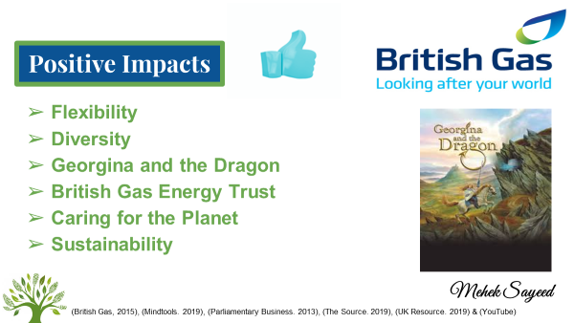

The positive impacts of British Gas
British Gas owner Centrica has become more productive with the cultural change, which was once a
public sector that became a private sector. The public sector was made by the government which
was very bureaucratic, however, as the private sector, they are now flexible with more options
within British Gas. Due to those changes, it has had a negative impact, as there have been many
competitors with all different types of tariff and opening more options for customers to choose
from. However, according to the Parliamentary business (2013), as the private sector, it is evident
that positive impacts have occurred in the organisation.

Previously as a public sector, British Gas was the only supplier in the United Kingdom who had
supplied gas to all homes. The company has been supplying gas for more than 200 years, initially,
they only recruited male employees. After the change within sectors, the company have diversified a
cultural change which had an impact on the organisation, they started to recruit female employees
from all aspects, from the sales department to engineers. This internal change has positively had a
great impact on the organisation to become more efficient (British Gas, 2015). As now the
organisation is recruiting more female employees as well as males and there are no discriminations
within genders.
The organisation has also launched a poster campaign which represents a woman in power, it is

called ‘Georgina and the Dragon’. Uk Resource (2019), indicates that the campaign is to challenge

myths surrounding women in engineering. It is important for British Gas to introduce diversity within

the culture and have a strong workforce to reflect on customers. The company has a strong case of

recruiting more female engineers, for example, engineers are visiting the homes of potentially

vulnerable groups such as elderly, single-parent families and homes from the community. According

to British Gas (2015), females have more interests in science and technology, this is a better

opportunity to show a woman in power. As the UK is facing shortages of engineers and the

workplace attitude is steadily growing more progressive, businesses have a more family-friendly

policies than they did before.

Introducing the British Gas Energy Trust has also had a positive impact on their organisation. As

being the main supplier for such a period of time, British Gas knows their customer needs and how

to keep them happy in their homes. With the help of citizens advice bureau, British Gas Energy Trust

offered grants to those who were in need and for those who could not afford to get their boiler

repaired. Overall, 7,000 people have received advice on how to reduce their debt, this way customer

worries were taken away and they were happier (The Source, 2019). Privatisation for British Gas has

made it easier and being flexible has had a positive impact, whereas as a public sector, the

organisation was very rigid and bind to rules and regulations and did not have many opportunities as

they have now. Which refers back to the Deal and Kennedy cultural framework, that indicates values

and beliefs should be followed by rules and regulations to keep the organisation running successfully

(Mind Tools, 2019).

Changing to a private sector has also helped British Gas reshaping for efficiency, to make
improvement of their resources and concentrate on the talents of British Gas’s employees in one
direction. The company increased in strength and size, positively responding to competitors and
establishing dual fuel supply in the energy sector. Now caring for the planet is one of their major
focuses and the company directs industry changes on how energy is generated and used. For
example, smart metres are helping customers understand and reduce their consumption.
Investment in new technologies has helped to develop sustainability within the business. Therefore,
British Gas has many achievements to celebrate, in the last two centuries it has been caring for
Britain and today is leading to a smarter energy future (YouTube).

Now passing over to Mukta who will discuss the Negative impacts in the organisation after the cultural change…….

References
British Gas. (2015) ‘Why aren’t there more women in Engineering’ [Online] https://www.britishgas.co.uk, Accessed Date: 18th June 2019
Mindtools. (2019) ‘Deal and Kennedy’s Cultural Model’ [Online] https://www.mindtools.com, Accessed Date: 21st June 2019
Parliamentary Business. (2013) ‘Energy and Climate Change Committee Written Evidence Submitted by British Gas’ [Online] https://publications.parliament.uk, Accessed Date: 18th June 2019
The Source. (2019) ‘How The British Gas Energy Trust makes a difference to people like Len’ [Online] https://www.britishgas.co.uk, Accessed Date: 18th June 2019
UK Resource. (2019) ‘Set Workplace Cultures: Making a Positive Impact’ [Online] http://www.mrc-cbu.cam.ac.uk, Accessed Date: 18th June 2019
YouTube. (2019) https://www.youtube.com/watch?v=nK8vEKAwD-c, Accessed Date: 21st June 2019

Bibliography
BBC. (2019) ‘What has happened to Energy since Privatisation’ [Online] https://www.bbc.co.uk, Accessed Date: 19th June 2019
British Gas. (2015) ‘Why aren’t there more women in Engineering’ [Online] https://www.britishgas.co.uk, Accessed Date: 18th June 2019
British Gas. (2019) ‘Warm Home Discount’ [Online] https://www.britishgas.co.uk, Accessed Date: 18th June 2019
Go Compare. (2019) ‘History of the British Gas Industry’ [Online] https://www.gocompare.com, Accessed Date: 19th June 2019
Knapman, H. (2018) ‘Millions of British Gas customers to be hit with 5.5% price hike’ [Online] https://www.moneywise.co.uk, Accessed Date: 18th June 2019
Mindtools. (2019) ‘Deal and Kennedy’s Cultural Model’ [Online] https://www.mindtools.com, Accessed Date: 21st June 2019
Parliamentary Business. (2013) ‘Energy and Climate Change Committee Written Evidence Submitted by British Gas’ [Online] https://publications.parliament.uk, Accessed Date: 18th June 2019
The Source. (2019) ‘How The British Gas Energy Trust makes a difference to people like Len’ [Online] https://www.britishgas.co.uk, Accessed Date: 18th June 2019
UK Resource. (2019) ‘Set Workplace Cultures: Making a Positive Impact’ [Online] http://www.mrc-cbu.cam.ac.uk, Accessed Date: 18th June 2019
YouTube. (2019) https://www.youtube.com/watch?v=nK8vEKAwD-c, Accessed Date: 21st June 2019

