12/17/2025

Analyzing and Solving Problems

Lecturer’s Name: Rajeev Nath
Student Name: DAVID BORST DOMINGUEZ
Student Number: 2422936
Module Code: ACCA4019

Table of Contents:
Introduction: 2
1. Deconstructing the problem: 2
1. Proposing a solution: 3
Flowchart & pseudocode optimized delivery process: 3
2. Reflect and justify: 6
4. ENGAGE WITH LITERATURE: 9
Conclusion: 9
References: 10

Introduction:
I analysed a real-world problem for (Grocer Quick) and developed a structured solution using abstract thinking and problem-solving techniques in this assignment assessing my ability to evaluate problems, identify requirements, constraints, and design a logical generic solution that is simplified to achieve an “END” result in flowchart and pseudocode.

Deconstructing the problem:
I used a break down technique scenario layout to introduce the components, as this structure makes the problem manageable, prioritizes effectively, and describes the relevant variables involved.

- These are efficient allocation of orders to delivery routes:
Management:
Grocer Quick management (business goals: cost reduction, customer satisfaction)
Delivery drivers (execution of routes)
Customers (expect timely deliveries)
Operations team (route planning, monitoring)
Goals:
Efficient allocation of orders to delivery routes
Minimise fuel consumption (reduce costs + environmental impact)
Ensure timely delivery (≤ 30 minutes late)
Processes:
Order intake and batching
Route planning and optimisation
Real-time monitoring of deliveries
Feedback loop for continuous improvement
Constraints:
Budget for technology and fuel
Delivery time window (≤ 30 minutes late)
Vehicle capacity limits
Traffic and road conditions (external factors).

MosSCoW techniques are designed that prioritises basic programming and solving solutions in (Real-Time) conditions and operations.

Table 1: MoSCoW technique [1]

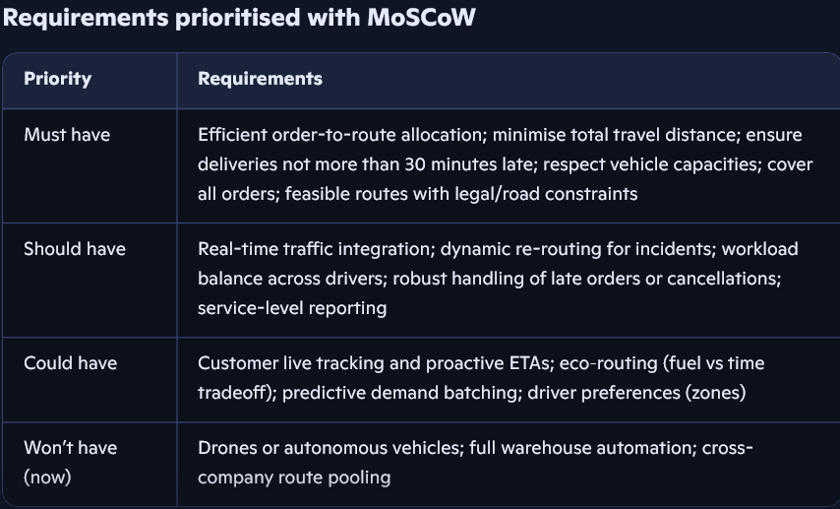 [1]

Proposing a solution:

Flowchart & pseudocode optimized delivery process:
This is how I applied Flowchart and Pseudocode to approach the problem and how it meets goals, efficiently and allocates orders assigned based on proximity, time, capacity, fuel efficiency, distance minimisation, reducing fuel consumption, and timely deliveries with time windows enforced, and lateness capped at 30 minutes that dynamic re-routing ensures compliance. [1]
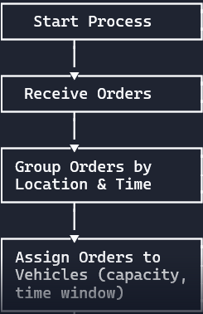
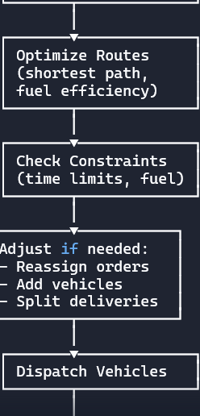
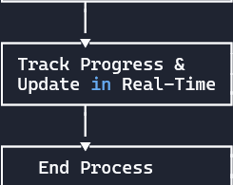 [1]

Pseudocode:
I’m aiming to cut wasted miles and deliver on time without losing the bigger picture of how operations behave under uncertainty. I’ll ground the approach in vehicle routing literature, systems thinking, and practical prioritisation (MoSCoW) so my design choices and reflections are defensible and clear. [2]

(Brief description, of Pseudocode, and Flowchart calculations) =
Optimising delivery routes is fundamental about minimising total distance, and time while meeting constraints like vehicle capacity, and delivery time windows. Below are simple calculations about Grocer Quick and can be used to quantify and simplify this breakdown model.

Key inputs and assumptions=
Average speed: (e.g., 30 km/h urban)
Fuel economy: (e.g., 10 km/L)
Fuel cost: (e.g., £1.60/L)
Stop service time: (e.g., 6 minutes per drop)
Distance matrix: pairwise distances between depot and customers
Vehicle capacity: demand per order
Ensuring timely delivery = lateness capped at 30 minutes.

INPUT: orders list, vehicles list, delivery_time_windows
// Step 1: Group orders
grouped orders = group_by_location_and_time (orders list)
// Step 2: Assign orders to vehicles
FOR each group IN grouped orders: vehicle = select vehicle (vehicles list, group. Capacity, group. time window), assign orders (vehicle, group)
// Step 3: Optimize routes
FOR each vehicle IN vehicles list: vehicle. Route = shortest path (vehicle.
Orders, fuel efficiency=True)
// Step 4: Check constraints FOR each vehicle IN vehicles list:
IF route time (vehicle. Route) > vehicle.max_time OR
fuel usage (vehicle. Route) > vehicle. fuel capacity THEN
adjust assignments(vehicle)
// Step 5: Dispatch vehicles Dispatch (vehicles list)
// Step 6: Track progress
WHILE deliveries_in_progress: update status (vehicle)--IF delay detected THEN
reoptimize (vehicle)
END Delivery Optimization. [2]

Reflect and justify:
The approach is appropriate because it grounds the problem in a well-studied optimisation framework, decomposes complexity into manageable stages, and directly targets the three goals with enforceable constraints. While limitations exist in optimality, data dependence, and real-world variability, the proposed mitigations hybrid heuristics, robust planning, adaptive trade-offs, and continuous learning provide a pragmatic path to sustained efficiency and punctuality. [3]

- (I minimised fuel consumption by reducing total travel distance)

(Reflections and techniques used to clarify the task):

Abstract thinking:
Subdividing (problem decomposition): Focused on core objectives (distance, time, capacity) and reframed the business problem as a Vehicle Routing Problem with Time Windows (VRPTW), separating what must be optimised from how it’s implemented. Enabled a solution that is technology-agnostic and extensible, rather than tied to any single tool or dataset.
Order batching, route optimisation, real-time adjustment, monitoring was treated as distinct subproblems, each with clear inputs/outputs and reduced complexity, making testing and iteration feasible, and clarified decision points.

Prioritisation (MoSCoW):
Musts anchored feasibility and compliance (capacity, ≤30-minute lateness, coverage). Should/Could guide iterative enhancements (traffic integration, eco-routing), protecting delivery against scope creep.

- Timely delivery of all orders, ensuring no delivery is more than 30 minutes late.

Constraint modelling:
Explicit constraints (capacity, lateness, depot rules) ensured solutions are operationally viable, not just mathematically optimal. Supported automated validation and re-optimisation loops.
Heuristic/algorithmic reasoning:
Adopted VRPTW heuristics/metaheuristics for tractability, with a clear objective to minimise distance while meeting time windows. Balanced optimality and runtime for daily operations.
Alignment with objectives:
Distance minimisation directly targets fuel use; time-window enforcement guarantees punctuality; allocation logic ensures all orders are scheduled on feasible routes.
Operational practicality:
Decomposition mirrors real operations (planning → dispatch → monitoring). Teams can own stages and improve locally without destabilising the whole system.
Scalability and responsiveness:
Heuristics handle large order volumes efficiently; dynamic re-routing addresses traffic incidents and late changes, maintaining service reliability.
Transparency and control:
Clear constraints and decision points make the system auditable and tuneable (e.g., trade-offs between fuel and lateness via weights or penalty costs).

ENGAGE WITH LITERATURE:
AI will introduce and embed all the scenarios necessary to construct and deconstruct real time solutions and (End Goals) that is clear to the objective problem. [4]
I initialised routes using the Clarke–Wright savings heuristic [1], I applied local search operators, [2] needed to reduce total distance while respecting time-window constraints [3]. Then lateness cap of 30 minutes reflects Solomon’s VRPTW formulation that balances feasibility and customer satisfaction. Management perspectives were analysed using Soft Systems Methodology to ensure operational constraints were embedded in the optimisation design.
Then the requirements were prioritised using (MoSCoW techniques) with capacities and time-window adherence classified as (Musts), (Should’ve), (Could’ve), and (Won’t).

Conclusion:

Analysis:
Grocer Quick’s challenge is modelled as a VRPTW [1]2][3], ensuring capacity and time-window constraints are respected while minimising distance as a proxy for fuel consumption.
Reflection:
From a systems perspective, route optimisation interacts with reinforcing loops of demand and reliability. Using MoSCoW prioritisation is ensured when hard constraints such as lateness and capacity were treated as Musts, while enhancements like traffic-aware routing were deferred.
Design Choices:
Initial routes are constructed using the Clarke–Wright savings heuristic, then improved with local search and ALNS. This balances computational efficiency with solution quality. This is based on my evidence in my conclusions and clear calculations displayed accordingly throughout my report.

References:

- Zhang, J. Li, and S. Yang [2020]. Efficient Order Dispatching and Route Planning for On-demand Delivery,” in IEEE Transactions on Intelligent Transportation Systems, 2025. [Online]. Available: https://ieeexplore.ieee.org/document/10507705 (Accessed 4 December 2025)
- Page MJ, McKenzie JE, Bossuyt PM, Boutron I, Hoffmann TC, Mulrow CD, et al. (2021) The PRISMA 2020 statement: An updated guideline for reporting systematic reviews. PLoS Med 18(3): e1003583. https://doi.org/10.1371/journal.pmed.1003583 [4]

- [3]

- Clarke, G., & Wright, J.W. (1964). Scheduling of vehicles from a central depot to a number of delivery points. Operations Research, 12(4), 568– 581 [4]
(Accessed 4 December 2025)

