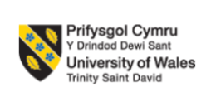

Module Title: Organisational Culture
Module Code: LCLM 5005
Assignment Type: Report
Student Name: Khaled Al Saman
Student ID: 2329747
Lecturer: Eric Osei

Table of Contents
Introduction 3
Company Background 4
Influence of organisational culture on Primark 5
Application of Hofstede’s Cultural Dimensions on Primark’s culture and prevailing culture determination 7
Analysis of how Primark utilises its company culture to tackle and adapt to external environmental influences 10
Effect of organisational culture on Primark 13
Evaluating the impact of organisational culture on the performance of Primark and recommending an improvement strategy with evidence using Hofstede’s Cultural Dimensions 15
Conclusion 17
References 18

Introduction
Organisational culture is a set of unwritten rules or values that direct the operations of an organisation, employees' behaviour, attitudes and working procedures. It often influences companies' success and failures. This helps in shaping employees' behaviour, performance, values and influence on the organisation. A perfect organisational culture helps increase growth, improve the implementation process of any policy or values and also maintain shareholders' values (Williams, 2022). This report will demonstrate the effect of pervasive influence as mentioned by Mullins and Christy on the modern organisation, such as Primark’s culture. The influence of organisational culture in shaping the decision-making process and structure of an organisation will be highlighted. By applying different theories, frameworks and models identification of organisational culture on the operations of Primark will be analysed and determination of prevailing culture will be done. For adopting to the external environment how Primark changes their organisation culture will also be a topic of discussion in this report. By providing justification, this report will demonstrate if organisational culture helps the operations of Primark or just acts as a barrier. And finally, the effects of organisational culture on the performance of the organisation will be evaluated through relevant theories and real-life examples.

Company Background
Primark is an international first fashion British company that provides affordable clothing, homeware and beauty products. It was established in 1969 by Arthur Ryan in Dublin, Ireland. During the establishment of the organisation, it was named Penneys, and during the time of its international expansion, it was rebranded as Primark to avoid trademark-related issues. Now, this company is operating as an international fashion brand in 20 countries and providing jobs for more than 80,000 people globally. They have their business spread across Europe, the US and even the Middle East, and have almost 500 stores all over those places (corporate.primark., 2026). Primark earned around £9.5 billion in revenue in 2025, which was remarkable (Weston, 2025).
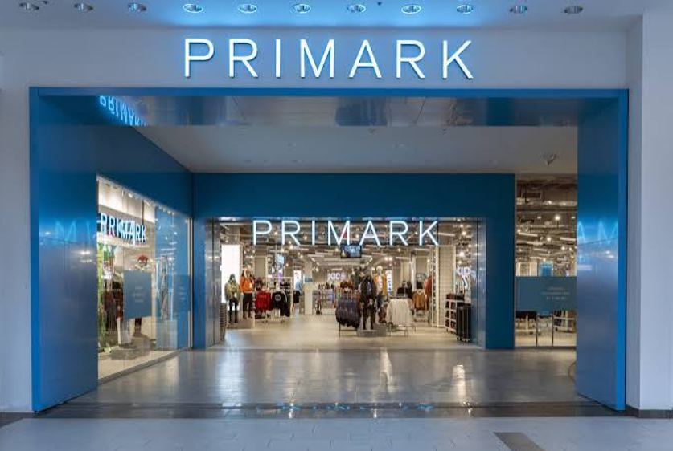
Source: (corporate.primark., 2026)
Figure: Primark store

Influence of organisational culture on Primark
Corporate working culture
Primark follows a corporate working structure which includes three behavioural components as caring, dynamic and together. They take a people-first approach, which includes better mental condition of their employees, wellbeing, creativity, safety in working place and others. Through their Primark Cares strategy, they ensure that workers' wellbeing and equality are prioritised. In their dynamic approach, they focus on adapting to customers' needs, rapid growth of the organisation and also on expanding their digital market. And under the together approach To ensure a sense of togetherness within their work process, they prioritise open communication between customers and staff, team building, sharing responsibility and other factors (careers.primark, 2026).
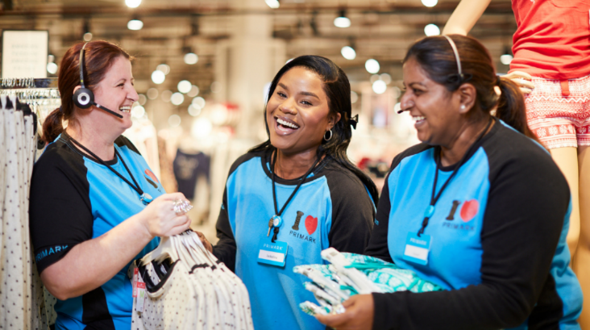
Source: (corporate.primark., 2026)
Figure: Primark customer care executives
Continues improvement
Organisational culture is a set of unwritten rules and policies that focus on the organisation's overall development. The organisational culture of Primark focuses on continuous improvement of the company. They have launched programmes like FWD Th!nk and Your Voice, which give their employees the space to provide feedback (sideways6, 2025). For operating stores in different locations and developing the organisation, Primark needs proper collaboration with its local employees. These initiatives have helped them in connecting and communicating with their store staff.
Centralised Control
Primark as international fast fashion retailer brands follow a centralised approach for handling their day-to-day operation. Their strategic business choices, store layouts, pricing, and merchandising decision-making are completely controlled by the control level of Primark. They strictly follow the same rules, policies, style of product presentation, and even working structure as in every branch of their company. They operate in a low-cost business model, and their centralised decision-making on purchasing helps them control costs and sell their products at low prices (vizologi, 2025).
Management culture
Primark is a fast fashion retail company which faces turnover of products due to changes in trends, continues returns and demands for restocks. Often, employees of the company have complained about heavy work pressure due to overdemands and unrealistic performance expectations from the authorities. Due to the hierarchical working structures, employees often face communication gaps during peak times. The management system of Primark is not considered healthy and is not working appropriately for the employees (builtin, 2026).

Application of Hofstede’s Cultural Dimensions on Primark’s culture and prevailing culture determination
Hofstede’s Cultural Dimensions is a framework which was created in the 1980s by Geert Hofstede, a Dutch management researcher. This theory helps to understand the culture of a country and how business which operates in that particular country adopts those cultures. This framework can also be used to identify different cultures of different countries and how business in those countries is done. According to Hofstede, there are six categories that help in understanding the culture of a country. These are Power Distance Index, Collectivism vs. Individualism, Uncertainty Avoidance Index, Motivation towards achievement and success, Short-Term vs. Long-Term Orientation and Restraint vs. Indulgence (Wale, 2020). By using Hofstede’s Cultural Dimensions, Primark’s organisational culture and prevailing culture will be analysed.
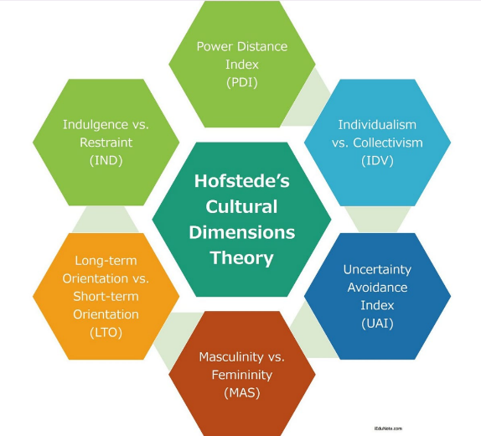
Source: (Wale, 2020)
Figure: Hofstede’s Cultural Dimensions
Power Distance Index
According to Hofstede’s Cultural Dimensions of the UK, where Primark primarily operates, the power distance index is around 35 (theculturefactor, 2026). This indicates that people in the UK do not appreciate the power gap between employees and authorities in an organisation, and also, they do not like the hierarchical structure of an organisation. But Primark follows a centralised process of working. Their main operations are controlled through their headquarters, and they are the ones responsible for decision-making for every branch across the world. This creates a lot of operational problems as well as communication problems within the company (vizologi, 2025).
Collectivism vs. Individualism
People in the United Kingdom prefer individualism more than collective working procedures. But as an international company, Primark operates in multiple countries, which requires proper collaboration and collective work between management and employees. They have teams that work to bridge the gap between head office and the retail team across their 17 markets (careers.primark, 2026).
Uncertainty Avoidance Index
According to Hofstede’s Cultural Dimensions of the UK, their uncertainty avoidance index is very low, which means people in the UK are mostly prepared for unstructured, unpredictable situations. In an industry which faces heavy product turnover, changes in trends, high workload, and other uncertain situations, people working in this industry are supposed to be more tolerant and accepting of situations (Mullins and Christy, 2016).
Motivation towards achievement and success
The motivation towards success is one of the aspects of Hofstede’s cultural dimensions. As per the index, 66% of people are highly motivated towards their work and contribute towards their own and the company’s success. The well-known retail brand also takes a lot of initiatives to motivate its workers, such as giving opportunities for their career growth and others. Hence, it can be understood that the brand can effectively operate in the United Kingdom (corporate.primark, 2026).
Short-Term vs. Long-Term Orientation
The cultural index has shown that the people of the UK are more focused on long-term success. Primark mainly focus on the short-term orientation while securing the long-term success for the brand. The UK fashion sector is quite dynamic, with rapid changes in trends, and Primark introduce new products to maintain similarity with the market. However, the long-term approaches of the brand, such as Primark Cares initiatives and others, can help the workers in the UK to focus on the long-term goal. Hence, the brand can easily operate in the UK market and gain success and profit (corporate.primark, 2026).
Restraint vs. Indulgence
The index shows that 69% of people in the UK prefer indulgence, which allows them to work in their zone without very strict rules and regulations. As per Primark, it offers a flexible working schedule to its staff, focusing on human rights, and gives complete support. This specific company culture will allow the brand to easily operate in the UK and have a satisfied employee base (careers.primark, 2026).
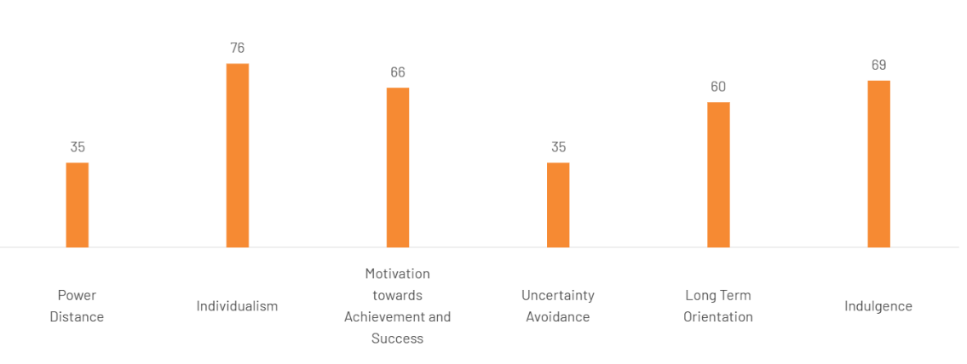
Source: (theculturefactor, 2026)
Figure: Hofstede’s cultural dimensions index of the UK

Analysis of how Primark utilises its company culture to tackle and adapt to external environmental influences
Sustainability law of the UK government
The UK government has imposed a sustainability report that each organisation in the UK needs to maintain sustainability throughout its supply chain to protect the environment. Each organisation needs to clearly inform the government and its stakeholders which raw materials it is using to manufacture its products. The companies are also instructed by the government in this report to use materials in their business which can be reused and do not generate solid waste. The UK organisations need to follow this Green Government Commitment to lower their carbon footprint in their supply chain and logistics (gov.uk, 2025).
Producing durable clothes to reduce waste
Primark has introduced a durability framework into its business team so that its employees can focus on manufacturing durable clothes which will last longer and can be recycled. This brand has taken this idea from NGO WRAP and the Textiles 2030 initiative to implement it in its own business. This business has also contacted environmental charity Hubbub and the University of Leeds (UOL) School of Design to research whether their idea will be able to produce durable clothes or not. The business development team at Primark washed its clothes for a longer time, which were manufactured by following the new initiative. This organisation also conducted a quality-checking test after washing those clothes made of sustainable materials. Thus, Primark ensured that customers can use their dresses for a longer period of time, which will generate less solid waste (corporate.primark, 2024).
Consumer Demand for quality and responsible sourcing of raw materials
People in the UK have suddenly changed their habits to choose eco-friendly organisations that manufacture products with reusable raw materials responsibly. Consumers are choosing foods, apparel, and other daily basic items that are produced by a green method. People are also preferring packages made of sustainable items when they buy a product from any company (rysons, 2025).
Using reusable raw materials to make clothes
This fast fashion brand has decided to use organic cotton to manufacture its clothes to reduce the impact on the environment due to its core business operations. This brand has started a project named Primark Cotton Project to yarn organic cotton so that it can use less water and fewer chemicals in its clothes. This brand will contract with more farmers to train them about yielding organic cotton using less water and fewer pesticides. This opportunity will also increase the income of the farmers who will be associated with Primark through this project (corporate.primark, 2026).
Carbon footprint reduction
Greenhouse gases are emitted by organisations in the UK throughout the supply chain of an organisation, which is tracked by the UK government. The organisations take steps to reduce carbon emissions so that they can tag their organisation as net zero in future. This step by the organisation will lead them to contribute to protecting nature by reducing their carbon footprint. UK government charges a carbon emissions tax on companies that exceed the amount of carbon emissions in the environment throughout their whole supply chain. Hence, the organisations are focusing on reducing their carbon emissions to lower their operational costs and make the environment sustainable for future generations.
Lower energy usage
This fashion brand took necessary steps to achieve the ISO 50001 certificate for all of its stores to signify that all of these stores are able to manage energy consumption. The staff in the stores of this fashion retailing brand were trained to reduce energy consumption so that this company can reduce its total carbon emissions in the environment. The company authority decided to transport all of the products from factories to the stores by ships so that less amount of energy can be used in the supply chain of the business (corporate.primark, 2026).

Effect of organisational culture on Primark
Negative impacts
Impacts of hierarchical structure
As previously mentioned, Primark follows a hierarchical or centralised control working method in the company. Their main operations, like business choices, pricing, and others, are operated from their headquarters in Dublin. This structure of working creates a lot of barriers for their day-to-day operations. This working style affects the communication between higher authorities and ground-level staff, which can lead to a lot of misunderstanding in decision-making. Though this company offers its staff promotions and competitive wages, a lack of communication and freedom decreases employees’ motivation and leads to high staff turnovers (vizologi, 2025).
High pressure of work on the employees
The management and higher authorities of Primark often create a lot of pressure on the employees to improve the company's condition. But it leads to burnout, stress and other negative impacts on the staff. In peak seasons like New Year, Christmas, and other occasions, employees are pressured to work overtime due to the demands, but this disturbs their work-life balance and also causes burnout. And because of the top-down working method, employees don’t get enough freedom to make decisions according to the situation they are facing. This can create operational disputes and also demotivate employees often. Primark also faces problems due to a lack of communication between its staff and authorities, which puts high pressure on the brand value of the organisation. Because of this communication issue, on 1 March 2024, a fake news story had spread through TikTok which claimed that all stores of Primark in the UK were closing down because of bankruptcy (Shaw, 2024).
Positive impacts
Impacts of Corporate working culture
The three behavioural culture values of caring, dynamic and together at Primark help the organisation in building a strong customer base, increasing sales and also creating a positive working environment for the employees. They have an active recognition system for their employees, which helps in keeping them motivated and driven towards work. They also take internal feedback to improve their policies, rules and collaboration, which provides their staff with the ability to change. In the hierarchical structure of work, these behavioural values of the company provide the employees with basic human rights, gender equality, and a positive working environment. On the one hand, where a lack of freedom leads to high employee turnover, these core behavioural values are one of the main reasons for attracting new employees in the organisation (builtin, 2026).
Improvement in communication
After including FWD Think, the company has seen a cultural shift in their organisational working procedures as a result. Through this initiative, employees of the company from different parts of the world have shared more than 3500 unique ideas. These new ideas have helped in generating a 130% rise in sales within the first year of launching. Like one employee from customer service of Italy suggested the company to introduce baby table for the parents who comes in the retail shops of Primark for shopping. This single idea has contributed significantly to the company’s sales within six weeks of launching (sideways6, 2025).

Evaluating the impact of organisational culture on the performance of Primark and recommending an improvement strategy with evidence using Hofstede’s Cultural Dimensions
Less effective employees due to miscommunication
The authority figures at Primark do not communicate in a proper way so that their messages are reached by all of their employees. It is evident that the employees get confused because they do not get clear instructions and guidance from their leaders. For this reason, they fail to work efficiently when the goal of the company is not clear to them. The company receives poor-quality performance from its employees as they are not communicated clearly to execute their daily tasks.
Recommended strategy
According to Hofstede’s cultural dimensions, it can be said that the leaders of Primark need to understand that their employees are not equally talented. The authority figures need to understand that employees may lack knowledge about the current market, technologies, and financial actors. Hence, the employees of the organisation may not understand the purpose and functions of each initiative of the organisation. The organisation can use an AI tool named Notion to collaborate with all of its employees to demonstrate the value and purpose of their initiatives. Uber Technologies is successfully using Notion to collaborate with its employees to engage in a discussion whenever needed (technologychecker.io, 2026).
Poor company culture due to underpayment to employees
Media across the globe often highlights the underpayment and overwork conditions of Primark employees. This lowers the reputation of this fast fashion brand due to the news covered by the media. The employees of this organisation do not stay loyal, as frequent resignations are seen within this organisation due to poor working conditions. The employees of this company do not try to improve their performance, as the authority figures never take feedback from them about the working conditions.
Recommended strategy
Following Hofstede’s cultural dimensions, the leaders of Primark need to remember that people come from diverse financial backgrounds. Hence, each employee may have different responsibilities and different requirements to lead their lives while maintaining a basic lifestyle. The company needs to redesign its codes of conduct so that the employees receive fair wages to maintain their lifestyle while living in the UK. McDonald’s increased the payment of its employees and focused on improving the working conditions for them after being highlighted by the media.

Conclusion
The culture of an organisation shapes its daily activity, goals, values, employees' well-being, and other organisational components. This report has discussed the current organisational culture of Primark, including corporate working culture, centralised control, management culture and its nature of continuous improvement. The effects of this organisational culture on the operations and decision-making of Primark were also mentioned in this report. By using Hofstede’s Cultural Dimensions framework, the working culture of the UK and the working culture within Primark were compared. It has also demonstrated the ways in which the organisation adopts the external environment by leveraging its culture. Maintain sustainable laws of UK, produces durable cloths for reducing waste, and also their ethical sourcing procedures are Primark’s way of adopting new operational culture depending on the external environmental needs. And lastly, by analysing the negative impacts of organisational culture, effective and real-life example-based recommendations were provided for Primark. The company needs to focus on improving its communication system and also needs to improve its payment system, as its competitors.

References
builtin, (2026). Primark Leadership & Management. [Online] Available at: https://builtin.com/company/primark/faq/leadership-management [Accessed 20 October 2026].
careers.primark, (2026). OUR benefits. [Online] Available at: https://careers.primark.com/en/our-benefits [Accessed 13 October 2026].
careers.primark, (2026). People and culture at primark. [Online] Available at: https://careers.primark.com/en/people-and-culture [Accessed 20 October 2026].
careers.primark, (2026). Who We are. [Online] Available at: https://careers.primark.com/en/about-us [Accessed 15 October 2026].
corporate.primark, (2024). Primark sets the bar for longer-lasting clothing with launch of Durability Framework. [Online] Available at: https://corporate.primark.com/en-gb/a/news/sustainability-and-ethics-news/primark-sets-the-bar-for-longer-lasting-clothing-with-launch-of-durability-framework [Accessed 19 October 2026].
corporate.primark, (2026). Halving our Carbon Footprint. [Online] Available at: https://corporate.primark.com/en-gb/a/sustainability-and-ethics/planet/halving-our-carbon-footprint [Accessed 29 September 2026].
corporate.primark, (2026). Learn more about the cotton in our clothes. [Online] Available at: https://corporate.primark.com/en-gb/a/primark-cares/product/organic-recycled-sustainable-cotton-all-affordable [Accessed 19 October 2026].
corporate.primark, (2026). People. [Online] Available at: https://corporate.primark.com/en-us/a/primark-cares/people [Accessed 11 October 2026].
corporate.primark., (2026). Who We Are. [Online] Available at: https://corporate.primark.com/en-us/a/about-us/who-we-are [Accessed 08 October 2026].
gov.uk, (2025). Sustainability Reporting Guidance 2025-26. [Online] Available at: https://www.gov.uk/government/publications/sustainability-reporting-guidance-2025-26/sustainability-reporting-guidance-2025-26 [Accessed 09 October 2026].
Mullins, L. and Christy, G. (2016). Management and Organisational Behaviour (11th ed.). Pearson Education Limited.
rysons, (2025). Sustainable Sourcing: Meeting UK Retailer Demand in 2026. [Online] Available at: https://www.rysons.com/blog/sustainable-sourcing-meeting-uk-retailer-demand-in-2026 [Accessed 29 September 2026].
Shaw, N., (2024). Truth behind claim Primark to close all shops on March 1. [Online] Available at: https://www.walesonline.co.uk/news/uk-news/truth-behind-claim-primark-close-28692284 [Accessed 29 September 2026].
sideways6, (2025). Primark’s FWD Th!nk: 3,500+ Ideas, 10+ markets, and one culture of continuous improvement. [Online] Available at: https://www.sideways6.com/customers/primark#Impact [Accessed 28 September 2026].
technologychecker.io, (2026). Companies Using Notion. [Online] Available at: https://technologychecker.io/technology/notion [Accessed 04 October 2026].
theculturefactor, (2026). Country Comparison tool. [Online] Available at: https://www.theculturefactor.com/country-comparison-tool?countries=united+kingdom [Accessed 19 October 2026].
vizologi, (2025). What type of business structure is Primark? A quick look. [Online] Available at: https://vizologi.com/what-type-of-business-structure-is-primark-quick-look/ [Accessed 18 October 2026].
Wale, H., (2020). Hofstede’s Cultural Dimensions Theory. [Online] Available at: https://corporatefinanceinstitute.com/resources/management/hofstedes-cultural-dimensions-theory/ [Accessed 17 October 2026].
Weston, S., (2025). Primark sales edge up as owner ABF mulls split from food business. [Online] Available at: https://www.drapersonline.com/news/primark-sales-edge-up-as-owner-abf-mulls-split-from-food-business [Accessed 10 October 2026].
Williams, P., (2022). Organisational culture: definitions, distinctions and functions. In Handbook of research methods for organisational culture (pp. 5-22). Edward Elgar Publishing.

