

Analysis of the Vegan Society community engagement project

Module Name: Community Engagement
Module Code: LCBB4002
Student Name: Alina Mutoi
Student Number: 2028702

Lecturer: Dr. Molly Jack
Submitted date: 19th of August 2021

Table of content

- Introduction………………………………………………………………3
2. “Vegan Society” – a community engagement project for a new lifestyle approach………................................................................................................4
2.1 Who are they…………………………………..……………………......4
2.2 Social media as an important tool of the community engagement strategy………………………..........................................................................5
  - Decision making – how are people engaged in protecting animals?.5
  - Be a volunteer with Vegan Society………………………………….6
3. Conclusion……………………………………………………...................6
- Reference list……………………………………………...........................8

- Introduction
The meat industry is one of the largest segment of the world agriculture. Global consumption of animal origin meat rises every year. According to data of The United Nations Food and Agriculture Organization, there were about 150 billion kilograms of poultry and sheep meat consumed around the world in 1990, whilst in 2020 this figure increased by around 200 billion. Even more, it is expected that the global meat consumption will rise more than 1% every year. (Blaustein-Rejto, D. and Smith, A., 2021)
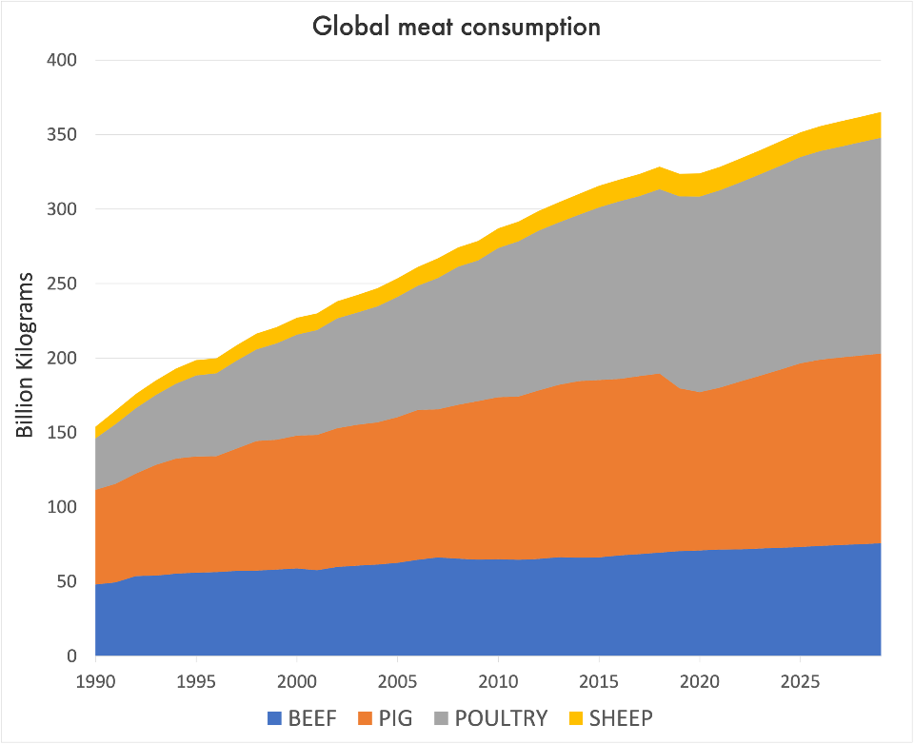

The cruelty that the killed for meat animals are exposed is shocking. Before slaughtering, they live in bad conditions, being locked indoors, in farm factories, suffering from severe health problems, including deformed legs cause by excess weight gain, infectious diseases or even respiratory problems. The chicken are slaughtered by being hanged upside down with throats to be cut or are plunged in scalding water, while the cows are shot in the head with an electric bolt gun in order to be stunned, many times skinned and dismembered whilst still being conscious. (People for the Ethical Treatment of Animals, 2021)
The meat production has a harmful impact on the environment, as well. According to Ecological Economics Journal, it involves 15-24% of current greenhouse gas emissions. (Fiala, 2008)
The industry of milk production also involves exploitation of cows and their veals. A Peta Organisation research mentions that “male calves are often taken away from their mothers when they are just 1 day old to be raised for veal. Their diet is purposely low in iron, so that their flesh stays pale as a result of anemia. In addition to suffering from diarrhea, pneumonia and lameness, calves raised for veal are desperate for their mothers.” (People for the Ethical Treatment of Animals, 2021)
Besides that, some studies find that meat can be unhealthy, associating it to an increased risk of several types of cancer, as digestive tract, kidney, prostate and breast cancer. “Cow’s milk is one of the primary causes of food allergies among children”, says the mentioned Peta Organisation research. “Most of people begin to be lactose intolerant as young as 2 years old. About 80% of native Americans suffer from bloating, headaches and digestive problems after drinking cow’s milk. (People for the Ethical Treatment of Animals, 2021)

- “The Vegan Society” – a community engagement project for a new lifestyle approach
Apart from stopping cruelty to animals, there are a lot of benefits of meat and dairy replacement. Certain researches have found that going vegan may help to prevent a series of diseases, like hypertension, diabetes, cardiovascular conditions, cancer etc. Also, it leads to a weight control, by increasing the intake of fiber and reducing calories, may improve the skin and even hair growing.
Many organisations and communities have started to promote the vegetarian or/and vegan life style in the last years. The Vegan Society is one of the projects that try to make people to enjoy the variety of a plant-based diet, convincing them that the cutting meat off the menu involves no losses to body’s nutrients intake.
2.1 Who are they?
The project was founded in Birmingham, UK, in 1944, on idea of “living which seeks to exclude – as far as it is possible – all forms of exploitation and cruelty to animals for food, clothing or any other purposes”. (The Vegan Society, 2021)
The Vegan Society involves people who want to take part in encouraging all people around the UK, regardless the age, to try to adopt a new life style, namely a plant-based diet. The work team is formed by a large numbers of specialists: chief executive, financial and CEO managers, communication and events assistants, marketing officers etc. To get closer to the public, the project collaborates with some well-known national and international artists and ambassadors like singers Macka B and Benjamin Zephaniah, theatre actress Roxy Shahidi, Freya Dinishah – the president of the American Vegan Society etc. This is a good approach to promote an idea, as most of people are influenced directly or indirectly by brand people – what and how these do or say. Also, Vegan Society has a lot of trustworthy partners, sharing the same principle of promoting a healthier life style: British Dietetic Association, Ecotricity, Hospital Caterers Asocciation, V for Life etc.
The community engagement project has 2 clear expressed key goals: 1. To encourage people to give veganism a try and 2. To make the vegan lifestyle easy to follow. It proposes to achieve its mission by providing information to people about the reasons of becoming vegan, supporting and advising individuals and health professionals, manufacturers, caterers and influencing policy makers.
In collaboration with Veggies Catering Campaign, The Vegan Society holds some vegan catering events in Nottingham, few times a year. There are stalls with buffets at these events where people can come and try meatless and non-dairy food. Members of the project go to schools and to other crowded places to give information about the vegan diet and benefits of it. As more people are often confused about what meals can be cooked without meat and dairy, they also provide recipe books.
2.2 Social media as an important tool of the community engagement strategy
A powerful community engagement tool is social media, as it helps organisations and projects focused on society developing to communicate their principles, ideas. It is a transparent way of sharing community issues, encouraging people worldwide to be involved in solving it. Vegan Society group has a clearly structured web page, with detailed content about the project: information about the work team, partners, about the mission and the activity of the company. The project shares vegan-related news and statistics with the society, keeping people informed about everything related to the lifestyle they promote. The web page also shows contact details, such address, telephone number and e-mail address. It means that the project respects the transparency principle, the community being able to easily contact the members of staff with any enquiries.
Vegan Society is on Twitter, Instagram, Pinterest, Facebook and Youtube platforms. They are active on social media, that is proved by the posts they share and by the numbers of followers. Many people of different ages and countries comment on vegan posts and photos, which means the project keeps people interested on subject, respects inclusion standard and involves the community in process of decision making. There are a lot of different vegan recipes shared on their social media and web pages, as followers can find something suitable for them. Moreover, there is a Shop section on their web page that sells a wide range of vegan products, books, gifts and accessories at affordable prices. Every item is presented clearly and it is easily accessed, with no hassle. It does the principle of “Make the vegan lifestyle easy to follow” working, mentioned in their community plan. (The Vegan Society, 2021)
2.3 Decision making – how are people engaged in protecting animals?
Participation and decision making standard are reflected also in the chance offered by Vegan Society to individuals to come with new ideas of vegan projects. As they mention on their web page, the best projects are going to be funded by the organisation. Community members are encouraged to donate, if they want and are able to, in order to support stopping the exploitation of animals around the world. The project ensures people that every help is a bit to fight cruelty to our little friends. Also, people are offered to take part in activity like walking for long distances in the heart of the nature, running events (marathons). These activities are held in order to raise funds, but, at the same time, they help people to maintain a healthy life style and to keep fit.
The Vegan Society project offers jobs, having a good impact on the employment rate of the community. So, apart from participating in society developing by sharing their ideas, people with required by the project skills can also get a job. Vegan Society provides memberships at decent prices that includes various offers.
2.4 Be a volunteer with Vegan Society
The project also offers the possibility of becoming a volunteer, which is a key tool of the community engagement strategy. Volunteering connects people with common interests and activities, it helps them to meet and collaborate in developing solutions and problem solving. In a report published on their web site, Western Connecticut State University presents some benefits of volunteering for mental and physical health:
- Increasing of self-confidence. “You are doing good for others and the community, which provides a natural sense of accomplishment. It can also give you a sense of pride and identity”;
- Volunteering combats depression by “keeping people in regular contact and helping developing a solid support system. It turns in protecting you against stress when you are going through challenging times”;
- Advance in career. “Volunteering helps in getting experience in a new field, it gives the opportunity to practice important skills used in the workplace, such as teamwork, problem solving, communication, project planning etc.”. (Western Connecticut State University, 2021)
The Vegan Society mentions that the project has become “more creative, more responsive and more ambitious in what they do” due to help of volunteers. They offer 3 types of volunteering opportunities: office experience, specialist volunteer and volunteering for the Community Network, which involves a remotely work of members from all across the UK in order to locally promote project’s campaigns.

- Conclusion
A community engagement is a process of adding people together, people who want to successfully achieve a common goal in order to make a better world. To get everything done, the project should have a plan, a strategy and a specific approach. There are certain principles and standards that community project has to adopt. The success of any social activity requires to be clear with the purpose to be achieved, learning about the people who are going to be engaged, establishing relationships and partnering with them. It also needs to be focused on respecting the diversity of the community, to collaborate with every single member and to prove that you are trustworthy and reliable.
Analysing The Vegan Society activity through the community engagement principles and standards, we could notice that it is based on information, equity, transparency, research, advocacy, collaboration and participation. The project gives the possibility to all people, regardless of age, race, job, gender to be involved in protecting animals by stopping cruelty, to support a vegan lifestyle through a healthy diet and challenge to try something new, better. The Vegan Society is properly engaged on social media to call more people for achieving proposed goals, by using a lot of online platforms to become seen and known.

Reference list
- Blaustein-Rejto, D. and Smith, A., (2021) “We’re on track to set a new record for global meat consumption”, MIT Technology Review. Available at https://www.technologyreview.com/2021/04/26/1023636/sustainable-meat-livestock-production-climate-change/ (Accessed: 10 August 2021);
- Fiala, N. (2008) “Meeting the demand: An estimation of potential future greenhouse gas emissions from meat production”, Ecological Economics, Vol.67, Issue 3, pp. 412-419. DOI. org/10.1016/j.ecolecon.2007.12.021;
- People for the Ethical Treatment of Animals (PETA) (2021), “Animals killed for meat”. Available at: https://www.peta.org.uk/issues/animals-not-eat/meat-2/ (Accessed: 7 August 2021);
- The Vegan Society (2021). Available at: https://www.vegansociety.com/the-vegan-trademark?gclid=EAIaIQobChMIxa3tpO688gIVVO3tCh2nZgCBEAAYASAAEgLbpvD_BwE (Accessed: 7-18 August 2021);
- Western Connecticut State University (2021) “Community Engagement. Benefits of community service”. Available at: https://www.wcsu.edu/community-engagement/benefits-of-volunteering/ (Accessed: 18 August 2021).

