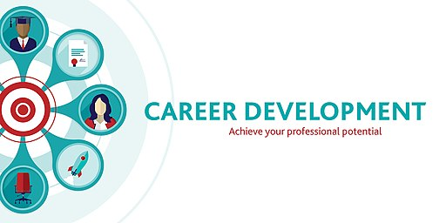

Name: Labli begum
Student number: 2121373
Module: Professional and Career development
Module code: BMSW4005
Lecturer: king/ Olubukola Adegbite
Assignment Title: reflective portfolio

summary
Employability skills, or transferable skills, are the core skills and traits required to succeed in any job”. Okewole et al. (2020) Career development skills are widely advocated as part of research capacity building and strengthening efforts. There are many job opportunities and that merge to a successful career. Skills and experience go hand in hand that is acknowledged by employers and recruitment agencies. Looking into the trend of future employment and changes will impact job opportunities and society. The following explores creating an idea job preference, to a cv and covering letter leading to mock interview. A PDP used to understand plan implemented and swot used for understanding the positive and negatives. Understanding self-awareness and use learning theories. reflecting on the journey using Gibbs cycle I have understood my key strengths and weaknesses and how to better myself and understand myself well enough to how to make decision learn from mistakes to help develop my career.

Contents
PDP for careers and employability 4
swot 5
Self-awareness- 6
Learning theories/styles 7
Johari window 7
Personality test 8
Kolb 9
Honey and Mumford 9
Neil Fleming 10
reflective model Assess the concepts. 11
Gibbs cycle 11
Reference 14

PDP for careers and employability
Personal development plan is a strategy for developing skills for work life. (Morgan (2017). The sole purpose is to become aware of skills I have. identify and develop skills I need. work out what I want to achieve and how to achieve it.

To establish my career path in retail management I need to identify my development need. Which is some experience in retail, being team leader and delegate and direct team members. The opportunities are greater as it will give me to excel in leadership role and managing store independently. Also, the opportunity to work for bigger stores. In order to meet my goal, I need to formulate an action plan which is to a job search on websites or look into a particular store advertising that may strike my interest, such Primark clothing retail, river island clothing or H&M clothing retail. To undertake development, I will need create a desirable CV that is catered for the job I have interest in or fill an online job application providing all information of experience, aspiration and education and may be a covering letter to show my interest even more and how the company will benefit from me and how I will benefit from the company. To undertake development the next stage would be interview stage where I can be more expressive about my experience/skills in the retail fielded. The interview stage will help employers to know a bit more me and why I want this job and how my experience has helped others in situation and how confident you. In order to be successful for an interview I would need prepare to for my interview. To record outcomes I need to make keep on top of my job hunt. make a list of when I applied, to interview stage if application successful or not and whether to add or change job interest preference.

swot
CIPD (2021) “A SWOT analysis is a planning tool which seeks to identify the Strengths, Weaknesses, Opportunities and Threats involved in a project or organisation. It's a framework for matching an organisation's goals, programmes, and capacities to the environment in which it operates.” Using swot, I can identify what I am good at. Where I need to improve, what are career opportunities and what are threats that may be an obstacle that affect the progress of my development plan.

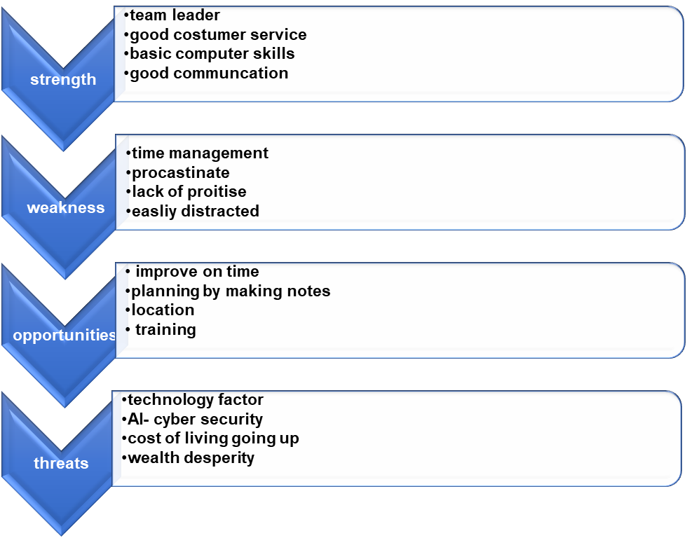

Self-awareness-
Carver, C. S. (2012) “When you think about yourself, what comes to mind? When your attention drifts to yourself while you're working on something, does it change anything about what you're doing, or how you do it?” this is necessary in career development as it allows It allows me to align my career pursuits with who you I am, where I want to go, and how I like to deliver my worth in whatever position I’m in.
The importance self-awareness
Self-reflection: ways to assess yourself
Recognise strength and weakness: to determine key strengths and identify weakness that could be looked at for areas of improvement.
Helps to manage your emotion: emotion effects behaviour and self-esteem and so it is important to control and manage to allow to express yourself comfortably.
Consider other people: acknowledge others and be more understanding.
Take criticism: to be forthcoming of constructive criticism that helps you improve yourself in areas that you may have weaknesses.

Learning theories/styles
There are many learning theories that help understand an individual and their qualities and as well as weakness The learning styles are Johari windows, Kolb cycles, Neil Fleming, honey and Mumford and personality test help identify an individual’s personality, capabilities and how this is used to prepare for work life. Here are some theories that will help understand the need of and importance of self-awareness using Tools for improving self-awareness: swot analysis, personality test all to understand individuals competence and flaws and how has this impacts me in my workplace

Johari window
Johari window model created 1955 by psychologists Joseph Luft and Harry Ingham to understand individuals with visual reference.
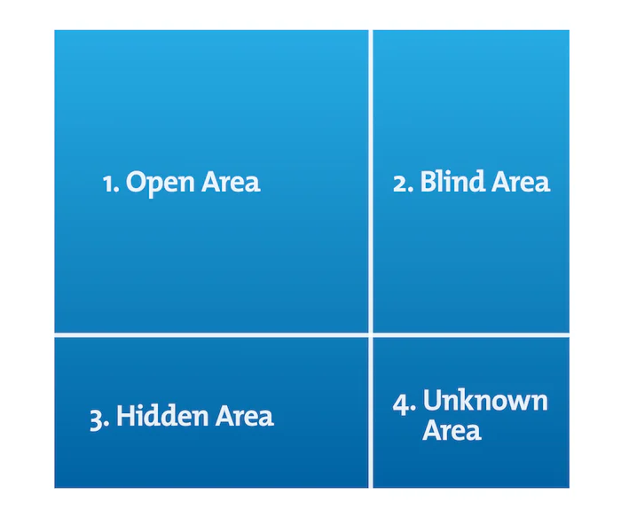
Website Mindtool (2022) Johari window (figure1.)

Open area: information about a person they themselves know and so do others.
Blind area: this is a person’s behaviour towards others that only others notice be the person themselves is not wary of their won information about themselves.
Hidden area: information that the individual doesn’t want others to know. Being more private about their life and what may not be something for discussion amongst others.
Unknown area: information that the person doesn’t know about themselves, or others know. Could be something hidden or matter they are not aware of

Personality test
According to the table by Myers and Briggs a table such as the one following is useful for showing the different types represented in a team, an office, an organization, a profession, or any group that needs to work together or for which you would like to collect personality data.

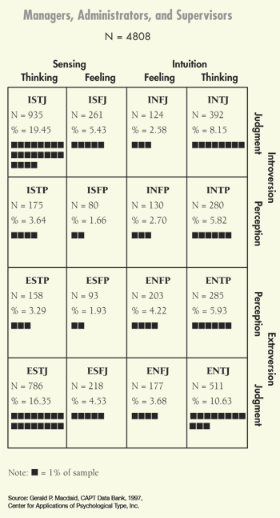
website MBTI (2023) MBTI types of tables (figure 2).

There are 16 types of personality. These are best used to understand how personality can be an advantage to work life as certain qualities are also skills used in work placement. Some activities test has helped me to understand myself as being someone patient, calm, motivating others and being good team player and team leader. Able to socialise with others and able to strike conversation. Being organised. Allowing others to share ideas and be forthcoming in taking ideas. Although the test helped understand me and what my personality could benefit in work environment but in the activities there also scenarios of situation where my weakness was identified. Dealing with confrontation is hard. Being too sentimental could mean taking too long to decide as emotion getting the best of me. Overall, my personality had more positive attributes.
Mike (2021) “Assessing your skills can help you improve the ones you have identified as in need of development”.
Learning styles refer to a range of competing and contested theories that aim to account for differences in individuals' learning.

Kolb
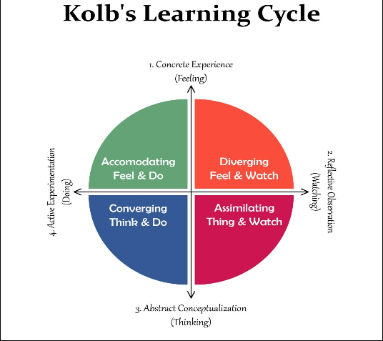
Saul (2023) Kolb learning (figure 3)
Also mentioned Kolb’s experiential learning theory works on two levels: a four-stage cycle of learning and four separate learning styles. Much of Kolb’s theory is concerned with the learner’s internal cognitive processes. David Kolb published his learning styles model in 1984.

Honey and Mumford
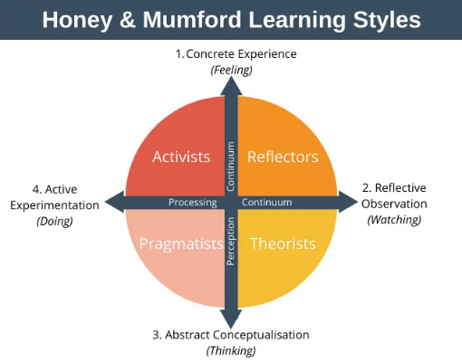
Denis (2020) (figure 4.) website expert programme management
Peter Honey and Alan Mumford in 1986. Honey and Mumford’s learning styles model identifies four different styles that people use to learn something new:
- Activists are people who learn best by doing.
- Theorists are people who learn best by understanding the theory behind why something is the way it is.
- Pragmatists learn best when they can see how what they are learning can be put into practice in the real world.
- Reflectors are people who learn best when they can observe others and think about what they have just observed.

Neil Fleming

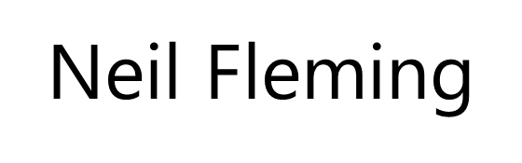
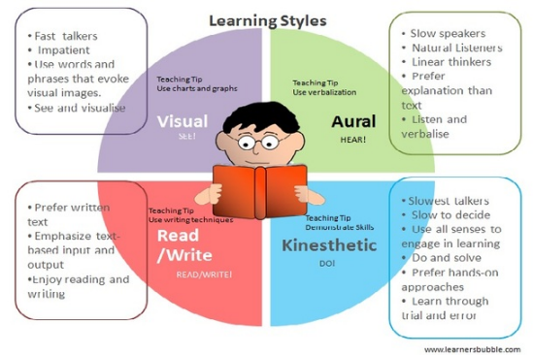
Website powered by Weebly (2014) Neil Fleming (figure 5.)
One of the most common and widely used groupings of the various types of learning styles is Fleming's VARK model. It was initially developed in 1987 by Neil Fleming. The acronym VARK stands for Visual, Aural, Read/write, and Kinaesthetic learning.
I think honey and Mumford is more realistic for me to analyse my learning style. Its more practical. Activist- I enjoy challenging targets and learn through experience and working with others. I have in group work as well as workplace. I can be reflector- looking back at my progress with good and bad making plans to suit my journey. I was able to do that with my first semester my time management was not great and looking back I have now improved trying balance and keep on top of everything whether its work, homelife and uni. Being pragmatist- able relate subject matter and real-life matter. Theorist- I find leaning models, theories most helpful as can most logically understand things and put things in different prospective.
Honey and Mumford in a workplace this would work as its target based, working with others, using models and theories and understand situation, be more practical and always reflecting making room for improvement. The impact can vary implication with understanding individual self-awareness, whether certain theories, model would work to an extent.
I feel motivated by others who inspire. My career aspirations are to work for a big company leading a hardworking team. My strengths are I’m good communication, team player, and maintain professional in my mannerism. My weaknesses are I can easily get distracted and procrastinate. personality type is I’m friendly, approachable, respectable. And have a positive energy even under pressure remain calm and collective. After analysing my self-awareness using tool such as learning theories, I seek for employment opportunities, but impact may vary as future of work will become more demanding and so theories can be used and reviewed to see it meets the future standard of mentality. Creating job advertisement for desire job role, creating cv and covering letter will prepare me for interview mock test and how I need to make myself relevant for my career path.

reflective model Assess the concepts.

Gibbs cycle

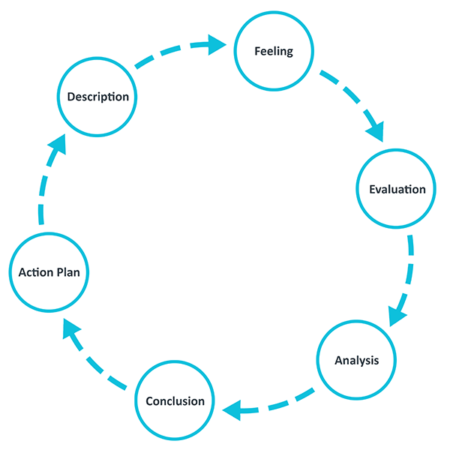
Website reflection toolkit Gibbs cycle (2023) (figure 5.)

Ezezika and Johnston (2022) “Considering Gibbs’ Reflective Cycle framework, in this article, we detail the design, implementation, and evaluation of a reflective writing”.
A cyclical model of reflection leading you through six stages exploring an experience: description, feelings, evaluation, analysis, conclusion, and action plan that I will to look back at my journey.

Description: Learned about PDP, swot analysis, self-awareness using self-awareness tool for learning theories such as Kolb, Honey and Mumford, a personality test and Johari window and understanding which theory works the best for work life. Learning about the future of work and using the knowledge to write 500 words based on the case study. Doing our own job advertisement, covering letter and cv. Preparing for interview and attending interview.
Feeling: learning about PDP I felt it was a good structural plan that works personal life as well as work life. First, I couldn’t understand how to do the PDP as we did it on a big A3 paper and started writing my plan to do my room panelling. So, this table concept helped me plan my personal goals, but I was not happy as I only had 2 personal development plan and wish I had more. To understand my I felt the swot analysis helps understand my strengths, weakness, opportunities, and threats. I was happy to express my strength as was proud of them. I felt a little uncomfortable expressing my weakness, but it was ok as talking about it, helped me to work on my weakness such I procrastinate and getting easily distracted. As for opportunities it always excites and threats does make me feel a little nervous of what may be uncertain. To help understand my self-awareness we did a quiz to understand myself better and my peer in class. I was puzzled first because I wasn’t able to submit the test for my peer in the class. Also, I felt it wasn’t easy being honest about my peer as she was also my friend. Also to know our own self-awareness we learnt about different theories. Learning theories was too many too to consider, we had done some test to find out which theory felt most suitable and most people had said the honey and Mumford as its more simple of four parts. I felt Honey and Mumford best suits my learning style as I can be and theorist, reflector, pragmatic, and activist. As for the case study assessment to do 500 words. I was happy with what I wrote but felt annoyed after the test as I remembered some keys facts that would help me get a better mark. Doing CV, I felt happy because I already had cv from previously but just needed to make some changes. As for job advisement I wasn’t sure, a bit lost but eventually I figured out by looking at the job advertisement website. covering letter felt was easy as it had to relate to job advertisement and emphasis on my cv skills and experience. When preparing for mock interview I was ok but on the day of mock interview I was little nervous and did repeat on few occasion but overall was good.
Evaluation: The good experience in doing PDP was I planned to do my bed room panelling and trying to attempt meet my action plan but the bad news is I’ve procrastinated and with Uni work and job I’m just not meeting my target timescale. With my PDP plan I’ve looked other goals in getting a job in retail managing, motivational speaker, and event manager but not able to complete action plan, undertake development and record and review my development plan. With the swot analysis we did in class looking at strength. As like the rest I was eager to outline my good qualities but took time knowing where my weakness lies. Many of my peers were honest about their strengths and weaknesses but we were all lost in threats and took time figuring out what factors affect our development plan. As for opportunities the list for desired job role was many and ways to progress. Self-awareness we did a quiz for self and our peer. There was confusion in submitting the test and at the end we figured it out. We learnt about all the different and felt the most suitable learning theory was the Honey Mumford as the rest of learning styles such as Kolb cycle , Johari Window, Neil Fleming, and personality test were too complicated to follow. When asked majority agreed with Honey and Mumford and some said Kolb cycle. We did a case study 500 word based on future of work. It went well but later I felt there was something I should have added that would have benefited getting for marks. doing a cv we had extra help from campus members offering help online to better our cv. It was good option using the cv 360 as it scored my cv to see how I can make room for improvements but I changed my cv and kept simple and readable. As for crating job advertisement I struggle. Search online job advertisement and then I was able to create my own. With mock interview I could have prepared better but on the day it went well.
Analysis: with PDP although there wasn’t fully completed of what I wanted to do I could have looked someone else’s example I got a better idea. The swot was easier than PDP as it was simple and straight forward and I’ve swot before more than PDP, and this works for me better. With learning theory to understand self-awareness there was too styles and I couldn’t make sense of all of them except for honey and Mumford. With case study the reason I felt I could have added more in my writing about the future of work is I should revised the case study more. I had my key strengths to emphasis on my mock interview but did repeat a little because I was nervous.
Conclusion: I learned in certain areas as doing PDP, learning about many theories and doing a case study I struggled and was able to recognise my mistakes but where strength are I can proudly say I have accomplished in understanding such as creating job ad and having a positive feedback from mock interview.
Action: I feel a positive outcome from all this as I know where I need to better myslf career development and how my strength are the key factors to desired career path use those strengths target my aim and reach for my goals and ambitions. I know I could have better in creating a better PDP for more job roles but I managed to do the most desired job role as already have more experience in it. Also trying to familiarise all the learning theories I should asked my lecturer for more insight so I am absolutely sure one I chose to help me know self-awareness was the correct one.

Reference

Carver, C. S. (2012). Self-awareness. In M. R. Leary & J. P. Tangney (Eds.), Handbook of self and identity (pp. 50–68). The Guilford Press.
CIPD (2021) ‘Learn about the SWOT framework, the process of a SWOT analysis, and its advantages and disadvantages, Available online: https://www.cipd.co.uk/knowledge/strategy/organisational-development/swot-analysis-factsheet#gref accessed online 19/03/23
Denis G. (2020) Honey and Mumford (figure 4.) Minute Tools Content Team, Honey, and Mumford Learning Styles, available online: https://expertprogrammanagement.com/2020/10/honey-and-mumford/ accessed online 25/03/23.
Ezezika O, Johnston N. Development, and Implementation of a Reflective Writing Assignment for Undergraduate Students in a Large Public Health Biology Course. Pedagogy in Health Promotion. 2022;0(0). doi:10.1177/23733799211069993
Gibbs reflective cycle (2023) fig.5.’ One of the most famous cyclical models of reflection leading you through six stages exploring an experience: description, feelings, evaluation, analysis, conclusion, and action plan’ Reflective Toolkit. Available online https://www.ed.ac.uk/reflection/reflectors-toolkit/reflecting-on-experience/gibbs-reflective-cycle accessed online 19/03/23
Indeed (2023) ‘The top 10 employability skills that will help you get any job’, Available online: https://uk.indeed.com/career-advice/finding-a-job/employability-skills accessed online 18/03/23
MBTI (2023) figure 2. ‘types table’ Myers and Briggs foundation, available online: https://www.myersbriggs.org/my-mbti-personality-type/mbti-basics/type-tables.htm accessed online 25/03/23
Mike D. (2021). ‘Skills 101: How to Assess Your Skillset in 6 Simple Steps’, Career addict, Available online: https://www.careeraddict.com/assessing-skills-career accessed online: 18/03/23
Mindtools (2022) figure 1. ‘The Johari Window Building Self-Awareness and Trust’ Emerald works company available online: https://www.mindtools.com/au7v71d/the-johari-window,assessed online: 25/03/23.
Okewole, H., Merritt, C., Mangezi, W., Mutiso, V., Jack, H.E., Eley, T.C. and Abas, M., 2020. Building career development skills for researchers: a qualitative study across four African countries. Annals of global health, 86(1).
Saul Mcleod, Ph.D. (2023) Kolb (figure3.) ‘Kolb’s Learning Styles and Experiential Learning Cycle’, Simply psychology, available online: https://simplypsychology.org/learning-kolb.html accessed online 25/03/23.
Weebly (2014) Neil Fleming (figure 5.) ‘Learning for styles for GMIT students’ available online: https://learningstyles2014.weebly.com/learning-styles.html accessed online: 25/03/23.

