Placement Portfolio.
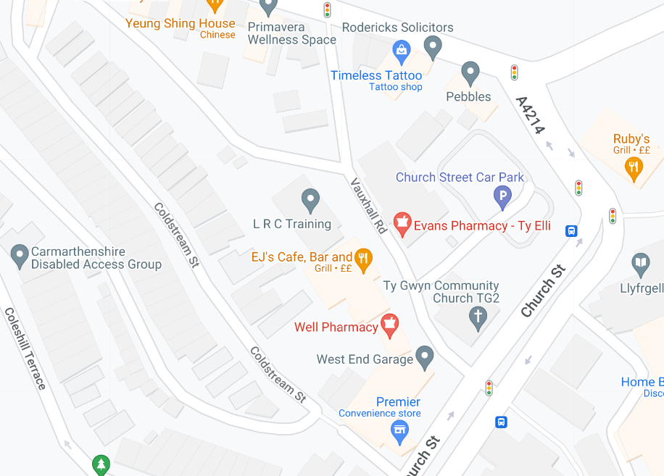
Contents page.
Placement arrangement forms. Pages 3-6
Introduction Page 7
Observation and evaluation page 8
Community Profile pages 9-12
Summary of learning Pages 13-14
PDP Pages 15-18
NOS evidence matrix Pages 19-26
Supervisor final report Pages 27- 29
Learning mentor final report. Pages 30-37
References. Pages 38-39
Placement Arrangement
Forms.
FIELDWORK PLACEMENT CONTRACT
Where possible please complete this information electronically, the text boxes will expand to contain the necessary information.
STUDENT INFORMATION
Student Name | Cassie Thomas
Student Address | 37 Maespiode Llandybie Ammanford SA18 3YS
Student University e mail | 1902530@student.uwtsd.ac.uk
Student DBS Status and date
Additional requirements
Name of fieldwork supervisor | Fran Chester
Fieldwork supervisor Tel.
Fieldwork supervisor e mail | f.chester@uwtsd.ac.uk

HOST ORGANISATION INFORMATION

Name of Organisation |  |  | LRC Llanelli
Tel. |  |  | 01554774121
Email |  |  | Jana.neumann@llanelli-rural.gov.uk
Aims/ Purpose of the Organisation |  |  | For young people to gain skills and qualities needed for the work of work, education, or apprenticeship.
Duration of placement |  |  | Level 4 Placement: 200 hours (100 or more face to face Youth Work).
Please outline the activities expected of the student  (Use more space if necessary) |  |  | Lerner to support young people with their work, in group settings and one-to-one settings.
Facilities/equipment available to student |  |  | Printer/photocopier. laptop
Please confirm that your organisation has in place the following procedures/policies and where the student can have access to them:
a. Equal Opportunities Policy and procedures |  |  | Main office
b. Safeguarding policy and procedures including a designated child protection officer |  |  | Main office
c. Disability Policy (please state how you will meet any special requirements noted by the student) |  |  | Main office
d. Health and Safety Policy and procedures |  |  | Main office
e. Risk assessments including significant risks identified? An example to be provided to the University. |  |  | Main office
f. Appropriate measures, informed by up to date legal requirements and public health guidance to  minimise health risks associated with COVID-19 |  |  | Main office
During induction the student will be made aware of the organisation's rules of conduct (including boundary management), practices and policies, including Safeguarding and Health and Safety (e.g. accident reporting), First Aid contact details and materials and fire procedures.

During induction the student will be made aware of the welfare facilities available during placement.
The student will be covered by your employer's liability insurance whilst on your premises and undertaking any assigned tasks.

Yes No
During the placement, the student will be responsible to:

Name of Learning Mentor |  | Jessica Samuels
Position |  | Youth worker. Lecturer.
Telephone No.
Email |  | Jessica.Samuel@llanelli-rural.gov.uk
UNIVERSITY INFORMATION

Name of visiting tutor | Fran Chester
Telephone Number | 01267676929 X6929
Email address | F.chester@uwtsd.ac.uk

Student, Learning Mentor, and Visiting Tutor to sign below:

I hereby agree to the terms and conditions outlined above

Signed (student)…Cassie Thomas …… Date: ……18/9/2023……………

Signed (Learning Mentor)…… J.Samuel …………… Date ……18/09/2023………………

Signed (visiting tutor)………………………………………………………. Date: …………………

The placement took place in the Llanelli Rural Council (LRC) in Llanelli. Llanelli is located 16.2 miles south-east of Carmarthen. The LRC is a training facility for young people aged 16-20 who are not in work or education. Through this portfolio, I will talk about the community where the placement is located and what is in the community for young people. This placement is located in Llanelli so it will be focused on the Llanelli area. There is also going to be a summary of my learning and development, it is going to highlight what I learned whilst on placement, how I supported and helped the young people and how I organized sessions whilst on placement. Finally, there will be learning reports from my mentor and line manager.
Introduction.

Observation and evaluation

The Llanelli Rural Council (LRC) in Llanelli is a training provider for young people aged 16-20, who are not in work or education. The LRC is designed for people who are not ready for college or the world of work, the LRC aims to get young people ready for work. It helps young people gain the skills they need to succeed in a job or college or university. The young people attend the centre three days a week, where they learn in various ways. Whilst in the LRC the young people have work that needs to be completed on various topics such as healthy living, hygiene and CV writing this links in with the educative pillar in the five pillars of youthwork (Youth Work in Wales Review Group, 2018). The young people do not have a uniform to wear whilst they attend the LRC this allows the young people to be expressive (Youth Work in Wales Review Group, 2018) and to express their likes through the way that they dress. Even though there is no uniform there are clothing rules for example they are not allowed to wear revealing clothes. Whilst at the LRC the young people are allowed to be themselves they do not have to hide who they are for example they can be open about gender and sexual identity; they can express their feelings regarding topics in the news, this can be linked to both educative and expressive because not only are they expressing how they feel they could also be learning new things regarding the topic from the other young people in the class (Youth Work in Wales Review Group, 2018). The LRC is less structured than school there are not any bells, and there no set lesson times, the learners can arrive between 9;30 and 11 at the latest. When they have arrived, they will be set work from the lecturer they are either instructed to finish the booklet by the end of the day or they are told which pages need completing. They have a lunch break around 12:15 and they are allowed to leave the premises as long as they are back by 1pm. After lunch sometimes they continue with work booklets, or they will be set a different task such as a research task. The learners are allowed to leave any time after 2pm as long as they have completed what needs to be done for that day, such as the set work and timesheets.
.

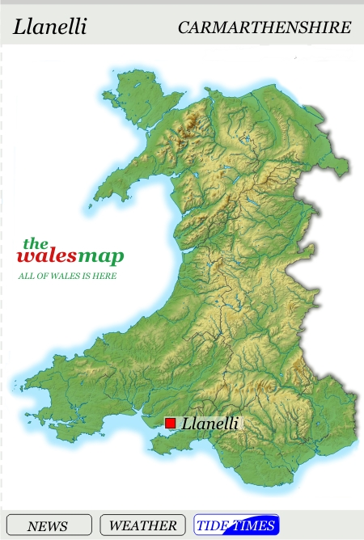

Community profile
Below is the official Scarlets logo.
image: (Scarlets, 2024).
Llanelli is home to the Scarlets rugby team, they were established in 2003 (Parc Y Scarlets, 2023). At the end of November 2008, the Scarlets relocated from Stradey Park to the brand-new Parc Y Scarlets (Parc Y Scarlets, 2023). Llanelli is also known for a variety of other sports such as bowls, football and golf.
The aim of the community profile is to educate people on the area of Llanelli.
The photo to the right shows the location of Llanelli on a map of Wales.
Llanelli is a coastal town that has a large number of individuals who speak Welsh. The town’s history has links with industries including coal mining, tin plate and steel (Reimagine the Llanelli story, 2022). Eventually, the art of coal mining stopped, and the docks were closed in 1951, shortly after there was a new cold-reduction mill built in Trostre (Britannica, 2024).
Llanelli is a large town that is located in the county of Carmarthenshire. Llanelli is located 16.2 miles south-east of Carmarthen and 11.8 miles West of Swansea (Google maps, 2024). The coordinates for Llanelli on Google Maps are ’51.682700, -4.160362’ (Google Maps, 2024. City population (2023) shows that according to the 2021 census Llanelli had a population of 42,175.
Image: (The Wales Map, 2021).
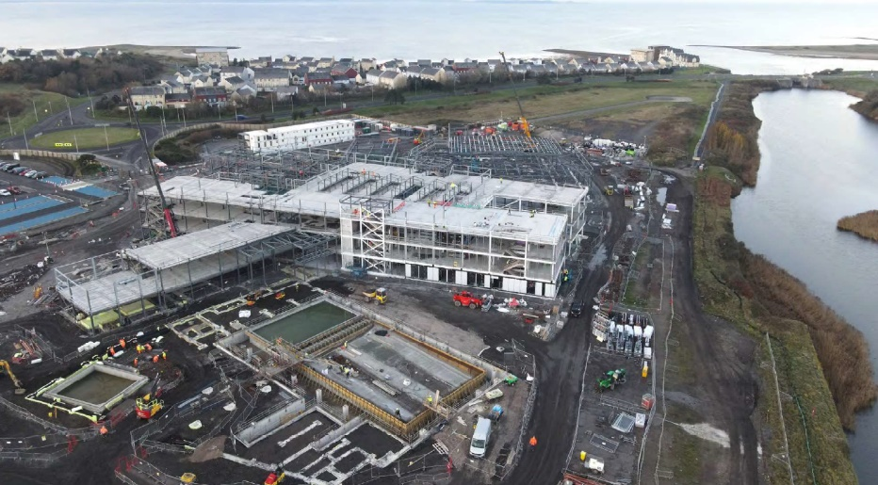

Since the first store opened on Market Street in December 1958, the town has kept growing (Streek, 2019).
One intriguing fact is that, following a local public movement, the anglicised spelling "Llanelly" was replaced with Llanelli in 1966 (Donald Insall Associate, Unknown). It still appears in the name of Llanelly House, a historic structure in the area.
Carmarthenshire County Council is currently in partnership with Hywel Dda University Health Board to build a £200m development along the Llanelli coastline called Pentre Awel set on 83 acres of land at Delta Lakes (Trade and Invest, 2021). Pentre Awel will promote and encourage individuals to enjoy active and healthy lifestyles by offering top-notch medical research and healthcare services (Carmarthenshire County Council, 2024). In addition to enhancing health and well-being, the project is anticipated to provide approximately 1,800 employment opportunities, training, and apprenticeship programs, and £467 million in economic growth in the region over the following 15 years (Carmarthenshire County Council, 2024).
This image shows the latest update of the Pentre Awel site from December 2023
Image (Carmarthenshire County Council, 2024).
This picture shows the Delta Lakes site where Pentre Awel is being built in 2021 before work commenced.
Image (Carmarthenshire County Council, 2024).
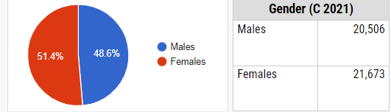
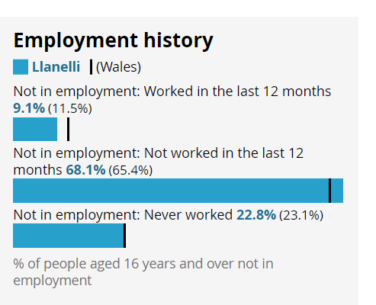
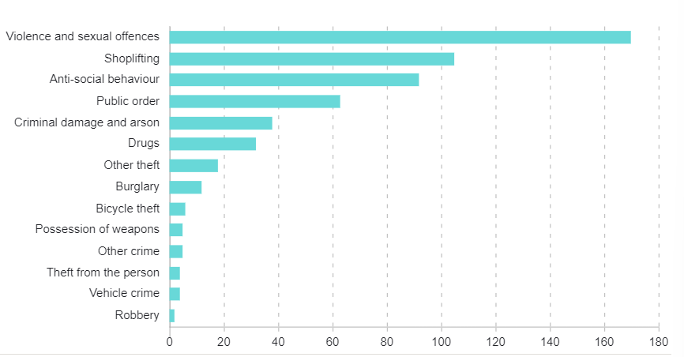
This bar graph shows the employment history for the Llanelli area in 2021 City population (2023). From this graph, you can see that there is a large number of people that are not in employment and haven’t worked in the last 12 months. This Is a high percentage of people for a small area.
Some parts of the Llanelli area appear in the top 10% of areas in Wales that are the most deprived in the following categories education, health, income, and employment (The Carmarthenshire We Want, 2024).
City population (2023) shows that according to the 2021 census Llanelli had a population of 42,175. This pie chart shows the number of males and females that live in the Llanelli area. From the chart it is clear that there are more females than males living in Llanelli. Image (city population, 2023).
The graph below shows the crimes that were reported in the Llanelli area in 2023. From this graph we can see that the most reported types of crime are violence and sexual offences with 170 reports just last year. The least reported crime in the Llanelli area is robbery with only 2 reports in the whole of last year.
Image (Police UK, 2023)
What is in Llanelli for young people?
There are a few local attractions in Llanelli such as the wetlands which is an attraction that ‘protects the wetlands and the wildlife’ (WWT, 2024). Llanelli Wetland Centre, a breathtaking 450-acre patchwork of lakes, reedbeds, forests, pools, and lagoons, is an important home for some of the most amazing birds in the world, many of which are rare or endangered (Visit Wales, 2024).
There is the ‘Millennium Coastal Path’ which is 13 miles long going from Loughor to Pembrey, the coastal path provides views of the Gower Peninsula and the chance to cycle without any traffic (Discover Carmarthenshire, 2024).
The hub of Llanelli, Llanelly House is one of the most remarkable examples of early Georgian architecture in Wales. It currently houses a unique event space, a gorgeous bistro, guided tours, and a wedding venue (Visit Wales, 2024).
Public access to the park Howard Museum, and art gallery began in 1912. In addition to telling the history of Llanelli, Parc Howard is the location of a sizable collection of Llanelly Pottery (Art UK, 2024).
The Theatre Elli, which was a component of the Llanelli Entertainment Centre, was replaced by the Ffwrnes Theatre when it opened in late 2012. A theatre with several screens debuted in October 2012 (Theatre Sir Gar, 2024)
All year long, Llanelli has a large variety of carnivals, festivals, and other events. Among them are: (Visit Wales 2024).
- The World Bowls Tour competition, the Welsh International Open (February)
- The county council is hosting the Into the Future Festival, an educational program involving technology and the environment Pop and live music event Llanelli Big Day Out (August)
- The official CAMRA event is the Llanelli Beer Festival November: Llanelli Christmas Carnival (August)
- An annual walking event, the Llanelli Ramblers Festival of Walks takes place Bank Holiday weekend in May.
- Llanelli pride is held on the first Saturday of August.

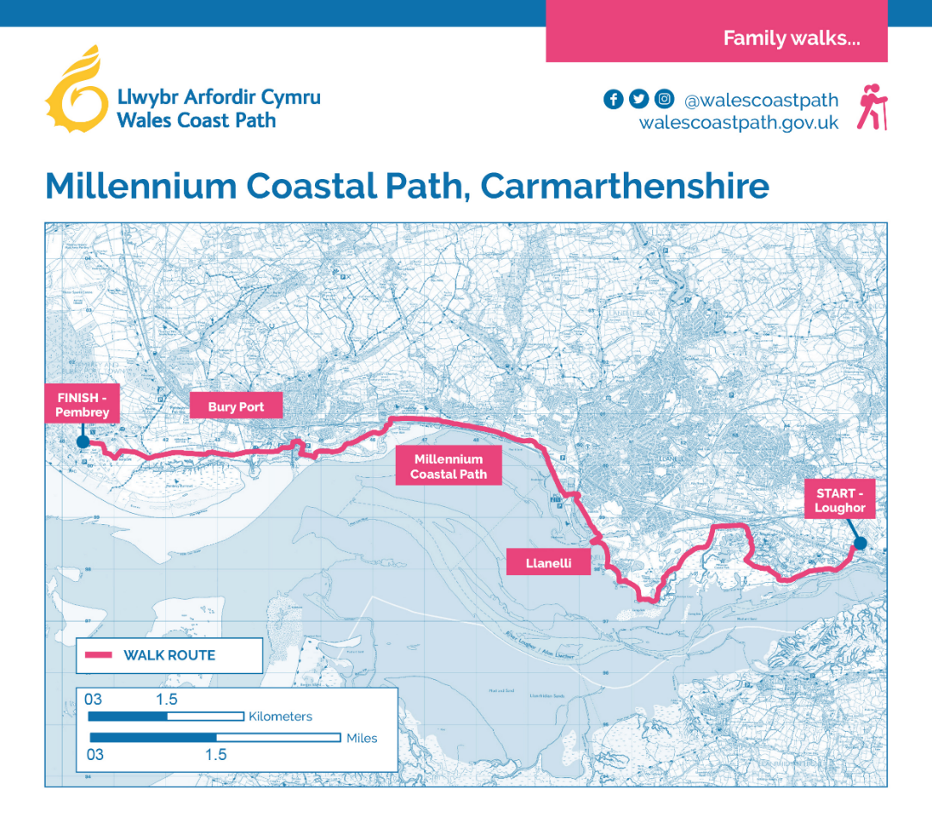
This is a map showing the route of the Millennium Coastal Path that starts in Loughor and ends in Pembrey.

Image. (Wales Coast Path, 2024).
Summary of own learning.
From my placement at LRC Llanelli I learned that it supports all of the five pillars of youth work, these pillars of youth work are educative, expressive, participative, inclusive, and empowering (Youth Work in Wales: Principles and purposes, 2018).
Whilst I was on placement I witnessed the LRC enabling the young people to gain new skills, such as interview skills, CV writing skills, budgeting skills and skills that would help them in the world of work. Not only did these skills helps the young people to get jobs or apprenticeships it also enables the young people to have more confidence and to realise they can do what they always thought they wouldn’t be able to do. this links with the educative pillar of youth work.
I witnessed the young people being encouraged to try new things such as new foods, new hobbies, and new learning styles. The young people mainly work from paperwork booklets, however for some this was more difficult and time consuming so it was changed, and instead the young people could do the work booklets on a laptop if they wanted. I witnessed not only the staff but also other service users encouraging one another to do things that they found scary such as going to the shop alone or drawing when they didn’t feel confident with doing so. These link with the expressive pillar of youth work.
I witnessed the young people being encouraged to do the work and do research on things that they asked for more information on, such as what a word means or how to spell a word. The young people often had conversations which sometimes led to a debate about things happening in the world today such as makeup use and the war. This links to the participative pillar of youth work.
I witnessed a small debate regarding gender and sexuality this helped some of the young people to gain a better understanding of the use of pronouns, and the different types of gender identity and sexualities there are. Most of the young people respected their peers that had a different sexuality to themselves. There was also a session held were the young people made posters about different countries and what their traditions are on Christmas, this allowed the young people to learn about a country they were interested in. this links to the inclusive pillar of youth work.
I witnessed the young people learning about what rights they have, safe relationships and water safety. In the water safety session, they were taught what to do if they were in trouble in the water but also how they can help someone else who is in trouble in the water. This links with the empowering pillar of youth work.
From my placement at LRC Llanelli, I have learned to be engaging with young people. I learned to make sure that when doing group activities all learners had a chance to give their views. I learned that not all learners are confident enough to speak when in a group, so I gave them different ways of participating such as writing down their views and I read them to the group. I learned better communication skills; I learned how some young people use sarcasm to communicate and some people don’t understand the use of sarcasm. I learned that not all young people are mean because it’s who they are most of the time they are going through stuff and don’t know how to express or talk about it, and a lot of the time it comes out as anger or sarcasm. I learned that showing empathy is more important than people think, when a young person is talking about what going on don’t be sympathetic and say I’m sorry, you need to try to understand how they are feeling, why they are feeling that way, put yourself in their shows what would you want someone to say to you if you were in that position. I learned not to be judgemental on my first day I thought there was a group of girls that I would struggle to work with because they were disruptive and loud however, this is the group that I gelled with, this group listened more to me they asked me for help they took my advice and help. I learned to be calm and patient some young people need things required extra help on a one-to-one basis.

explained to them more than once so they can understand the task, other young people need words spelled for them.
Whilst on placement I successfully planned and ran 4 sessions of personalised Christmas bauble making, I made templates for the learners to design their baubles on paper first. I made sure that bags were away and not left on floors, I made sure that laptop cables were away and not stretched around the classroom.

PROFESSIONAL DEVELOPMENT PLAN
For completion by the student after consultation with the Learning Mentor and Fieldwork Supervisor at the outset of the Placement
Student | Cassie Thomas
Learning Mentor | Jessica Samuel
Placement | LRC Llanelli
Date | 19th January 2024

Students will be expected to consider their placement experience to demonstrate competence in the key aspects of youth work outlined in the table below based on the National Occupational Standards for Youth Work (CLD Standards Counci l Scotland, 2019) and the Youth Work in Wales: Principles and Purposes Document (YWWRG, 2018).
Learning Mentor’s/mentor’s opening comments about the placement – exactly what type of work will the placement involve?
I will be supporting learners in the classroom through a wide range of activities such as job searches, external events, outdoor activities and developing employability skills.
The learners have different needs which means they would learn through different learning styles. This needs to be taken into account when working with young people. Some learners may have additional learning needs such as autism and ADHD.

Student initial comments about the Placement.
The placement providers went through all the policies and procedures. The LRC is a training facility with classrooms with a few students in each. The students attend for three days out of the week. There aren’t many rules the learners just need to turn up and do the work that they have been set. The placement gives the learners opportunities they may have never been able to access. LRC gives young people the opportunity to learn skills to get them through everyday life. And skills to help them get a job or to go on to further education.

PROFESSIONAL DEVELOPMENT PLAN
Please note that at Level 4 we expect students to be assisting a professional youth worker, assisting development, delivery, supporting youth work activities. Please complete the form electronically to enable the boxes to expand, ensuring you provide adequate detail.

 | 1. Work in accordance with the 5 pillars of Principles and Purposes of Youth Work in Wales (YWWRG, 2018) (Educative, Expressive, Participative, Inclusive, Empowering). | 2. Facilitate the personal, social and educational development of young people | 3. Promote inclusion, equality and young people’s interests and wellbeing | 4. Work with young people and others
What do you need to learn? | I need to learn the five pillars of youth work. And the rules of the placement. | I need to learn what young people are into and learn how to encourage them to reach their full potential | I need to learn the young people's interests and use them to my advantage to explain equality and well-being. | I need to learn how to communicate with young people and how to work in a team
Activities you will learn from (how will you learn, what will you learn from) | I will learn by reading over the five pillars of youth workbooks and using them in my practice.  I will also learn from working with young people, I will learn the different ways in which young people learn and communicate, and I will learn about the young person. | Ask the young people what interests them and what kind of work they enjoy doing for example, booklets, research, PowerPoint etc. | Assisting the young people with research and answering appropriate questions from them | Assisting with group work and tasks.

Student | C.Thomas.
Supervisor | J.Neumann
Date | 19th January 2024.

Youth and Community Work Programme

National Occupational Standards for Youth Work (LSIS, 2019) Checklist

Name: Cassie Thomas

Date: 19th January 2024

Placement: LRC Llanelli

Description of the group: young people not in education or work, but are gaining new skills and training through the LRC

Line manager: Jessica

Supervisor: Jana neumann

Visiting tutor: Fran chester

This document is a checklist to be used by students when compiling evidence for assessment. The line manager is required to sign the final page to confirm that each standard has been met. It is the responsibility of the student to ensure that each standard has been met and that the evidence for that is included within the portfolio. This evidence will be checked during observations and at the final assessment.

This checklist must be completed and included in the portfolio.

Key Area A: Work with young people and others |  | Tick, if the evidence is available, whether the standard was achieved | Page No. or location in portfolio
YW01 | Initiate, build and maintain purposeful relationships with young people | * | Summary of own learning
YW02 | Assist young people to express and to realise their goals | * | Summary of own learning
YW03 | Engage with communities to promote the interests and contributions of young people
YW04 | Develop productive working relationships with colleagues and stakeholders to support youth  work | * | Summary of own learning
No. 32 | Lead and motivate volunteers (SFT MV D2)

Key Area B: Facilitate the personal, social and educational development of young people |  | Tick, if the evidence is available, whether the standard was achieved | Page No. or location in portfolio
YW05 | Enable young people to use their learning to enhance their future development | * | Summary of own learning
YW06 | Enable young people to work in groups | * | Summary of own learning
YW07 | Encourage young people to broaden their horizons to be effective citizens | * | Summary of own learning
YW08 | Support young people to identify and achieve aims | * | Summary of own learning
YW09 | Support young people in their understanding of risk and challenge | * | Summary of own learning
YW10 | Facilitate young people’s empowerment through their active involvement in youth work | * | Summary of own learning
YW11 | Plan, prepare and facilitate activities with young people | * | Summary of own learning
YW12 | Work with young people to manage resources for youth work activities | * | Summary of own learning
YW13 | Support young people in evaluating the impact of youth work activities | * | Summary of own learning
YW14 | Facilitate young people’s exploration of their values and beliefs | * | Summary of own learning
YW15 | Advocate on behalf of young people and enable them to represent themselves to others
YW16 | Enable young people to access information to make decisions | * | Summary of own learning

Key Area C: Promote inclusion, equity and young people’s interests and wellbeing |  | Tick, if the evidence is available, whether the standard was achieved | Page No. or location in portfolio
YW17 | Work with young people in promoting their rights
YW18 | Explore with young people their wellbeing | * | Summary of own learning
YW19 | Work with young people to safeguard their own welfare | * | Summary of own learning
YW20 | Embed organisational policy for the protection and safeguarding of young people
No. 33 | Promote equality of opportunity and diversity and inclusion in your area of  responsibility (Management and leadership NOS B11) | * | Summary of own learning
YW21 | Develop a culture and systems that promote inclusion and value diversity | * | Summary of own learning
YW22 | Ensure that youth work activities comply with legal, regulatory and ethical requirements | * | Summary of own learning

FUNCTIONAL AREA D: Develop Youth Work Strategy and Practice |  | Tick, if the evidence is available, whether the standard was achieved | Page No. or location in portfolio
YW23 | Investigate the needs of young people and the community in relation to youth work | * | Summary of own learning
YW24 | Evaluate and prioritise organisational requirements for youth work activities | * | Summary of own learning
YW25 | Influence and develop youth work strategies | * | Summary of own learning
YW26 | Identify and secure funding and resources for youth work
YW27 | Facilitate and engage young people in the strategic development and delivery of youth work | * | Summary of own learning
YW28 | Work in partnership with agencies to improve opportunities for young people
No. 34 | Develop structures, systems and procedures to support volunteering  (Managing Volunteers NOS A3)
YW29 | Monitor and evaluate the quality of youth work activities | * | Summary of own learning

FUNCTIONAL AREA E: Develop, lead and manage self and others |  | Tick, if the evidence is available, whether the standard was achieved | Page No. or location in portfolio
YW30 | Work as an effective and reflective youth work practitioner | * | Summary of own learning
YW31 | Provide youth work support to other workers | * | Summary of own learning
No. 32 | Involve, motivate and support volunteers (Managing Volunteers UKWH B2) | * | Summary of own learning
No. 33 | Promote equality of opportunity and diversity in your area of responsibility (Management and leadership NOS B11) | * | Summary of own learning
No. 34 | Develop structures, systems and procedures to support volunteering (Managing Volunteers A3) | * | Summary of own learning
No. 35 | Manage your own resources and professional development (Management and leadership A2) | * | Summary of own learning
No. 36 | Provide leadership for your team (Management and leadership B5)
No. 37 | Allocate and check work in your team (Management and leadership D5) | * | Summary of own learning
No. 38 | Recruit, select and keep colleagues (Management and leadership D3)
No. 39 | Provide learning opportunities for colleagues (Management and leadership D7)
No. 40 | Make sure your own actions reduce risks to health and safety (Health and Safety HSS1) | * | Summary of own learning
No. 41 | Ensure health and safety requirements are met in your area of responsibility (Management and  leadership E6)

SIGNED STUDENT C.Thomas DATE 19/01/2024
SIGNED LINE MANAGER J.Neumann DATE 19/01/2024

Fieldwork Supervisors Final Report - Key areas of competence
When considering the level of competence of a student in supervision please refer to the marking criteria outlined below:
Grade | Description | Equivalent % marks towards HE qualification
A | An exceptional trainee Youth worker who is a reflective practitioner; shows initiative and an ability to work independently for a sustained period; demonstrates thoroughness and commitment to all aspects of professional practice. | 70%+
B | An effective trainee youth worker who displays a degree of independence and commitment to further professional development. | 60-69%
C | A satisfactory trainee youth worker who has met the requirements appropriate for a professionally qualified Youth Worker and with further experience should develop into an effective youth worker. | 50-59%
D | A rather weak trainee youth worker with a basic level of knowledge or skill. May be very poorly organised with very limited understanding of important concepts. | 40-49%
E Fail | A weak trainee youth worker who has been unable or unwilling to meet the required standard, may demonstrate inappropriate values or lack understanding or attention to detail. | Below 40%

FIELDWORK SUPERVISOR’S FINAL REPORT
This section of the report should be completed by the fieldwork supervisor. To complete the report we would like you to use the headings below giving specific examples to support your observations.
How did the student use supervision and respond to feedback?
Cassie was able to take on board feedback from their learning mentor. Cassie was able to respond to feedback and take this on board. I would encourage Cassie to continue to learn from those are them and ask questions should they not understand.

To what extent did the student seek challenging situations, and how were these worked with?
Cassie has dealt well with certain challenging situations within the centre which had a impact on them personally. The topic around gender and gender identification was raised within a classroom discussion. The issue was dealt with and I personally feel that despite the situation being difficult and challenging, it will help form their youth work practice.

To what extent did the student show enthusiasm and commitment?
Cassie on the whole was committed to their placement at LRC. Cassie was in touch with staff if they were unable to make their placement which is positive. It is important for Cassie to continue this on their next placement as they progress with the Youth work practice.

How well was the student able to relate theory to practice and reflect on her/his own practice and that of others?
Yes.

How did the student articulate her/his own beliefs and values and relate them to the work?
Cassie has been able to articulate their own beliefs and values within the placement.

How pro-active was the student in demonstrating anti oppressive beliefs, language, and behaviour?
I feel that Cassie was able to demonstrate this in a good way. Cassie dealt with some challenging behaviour from another learner in regards to their gender identification and use of pronouns. It will be important for Cassie to approach these situations in a positive and calm manner. This will no doubt help to mould Cassie’s youth work practice going forward.
In your professional opinion has the student achieved the necessary standards to progress to Level 5?
Yes, I believe that Cassie will be able to progress positively to the Level 5.
Student’s Provisional Grade % (Please refer to the grading criteria above)
C – 50-59%

Signed Supervisor | J.Neumann
Signed Student | C.Thomas
Date | 18.01.2024


Learning Mentor Information
BA & MA Youth Work and Social Education Programmes

Fieldwork is undertaken as an integral part of the programme, where the achievement of the learning outcomes for the placement is dependent on the arrangements made with the Placement Provider; where the student is enrolled at the University during this period; and where there is a transfer of direct supervision of the student to the Placement Provider (Academic Quality Handbook).
It is the intention of the programme team to create thoughtful and reflective youth workers. Fieldwork will provide a huge range of learning experiences for you. It is the responsibility of the student to utilise these opportunities as learning experiences and to be an active participant in their professional development.
Your responsibilities as a Learning Mentor will be as follows;
- The Learning Mentor plays an important role in the students’ learning on placement – as in, the students’ learning doesn’t merely take place in the lecture room.
- Health and Safety, including signing off the risk assessment;
- Safeguarding and Insurance;
- Managerial supervision (crucial and included in the final assessment);
- Clearly outlining the role and responsibilities of the host placement and in supporting the students’ learning through a process of shadowing and observation.
- Inducting the student into the host organisation, ensuring a workplace induction is completed during the first week;
- Drawing up a work agreement with the visiting tutor and the student on the basis of their learning needs and the requirements of the programme;
- Signing off the students’ collected hours at the end of each session – outlining the hours collected as evidence for the completion of the module requirements;
- Produce a final report with clear recommendation of the grade. Learning Mentors will be made aware of the submission date for the final report during the initial three way meeting. Reports must be submitted in time for the students to meet the submission date.

The University, in conjunction with local employers has a responsibility to ensure that the student exhibits principles, values and behaviours during the course of their studies that demonstrate that they are ‘fit to practice’ and is adequately prepared to function at a professional standard upon successful completion of the Programme of Study. Due to this, student’s are expected to approach placement with commitment and enthusiasm to further their professional development. Should the student not meet these expectations, the following process should be followed.
It is vital that all those involved in the support, conduct and evaluation of the placement are committed to ensuring that only those students demonstrating the ability to practice as professional youth and community workers successfully complete placement modules. Issues of competence which may jeopardise a student’s ability to complete fieldwork practice successfully should be identified as soon as possible following the steps outlined below. If there is a risk that an Examination Board may fail a student on fieldwork practice, the following steps should be followed prior to the Examination Board:
- Fieldwork Supervisor and/or the Learning Mentor to contact the Visiting Tutor/Fieldwork Coordinator immediately if a student is demonstrating unsatisfactory standards.

- A University representative is to visit the student, to consult with the student and relevant personnel, and agree on a plan of action to improve the situation. The visit should be recorded and a copy of the report should be provided for the student, the organisation, Fieldwork Supervisor and Fieldwork Co-Ordinator.

- If the situation does not improve, and if the organisation and the Visiting Tutor recommends that the student is failing to reach the required standards, then arrangements should be made for the student to see the Programme Director to give the student appropriate support, and to discuss the student’s progress.

- In certain circumstances raising concerns around a student’s conduct or behaviour, the School of Social Justice and Inclusion’s Fitness to Practice, Code of Conduct or Satisfactory Progress Policies may be referred to.

- If it is necessary to move a student to an alternative placement before the end of a practice period, a written report should be obtained from the Fieldwork Supervisor, Learning Mentor and Visiting Tutor outlining the reasons for such action, before the student is asked to leave. These reports should be passed to the Examination Board.

- Reports are to be presented to the Board with appropriate recommendations.

- Reports noted in 4 and 5 above should be available to the External Examiner, who may wish to visit the placement and asses the standards.

The University would like to thank Learning Mentors and Placement Providers for their time and commitment to supporting UWTSD students through their studies.
LEARNING MENTORS FINAL REPORT
The University would like to remind the Learning Mentor of the importance of their role in the assessment of the student. This role is fundamental in ensuring standards of practice of those working with young people in communities, and cannot be taken lightly.
To ensure the desired results are achieved, all those involved in the placement are required to understand and remain committed to the process of supervised practice. Issues of competence which might jeopardise a student’s ability to complete workplace/work based practice successfully should be identified and communicated to the visiting tutor or fieldwork coordinator as soon as possible.
After the student’s induction to the placement, the student will have drawn up a professional development plan balancing the needs of the student and the requirements of the programme. As Learning Mentor you will have carried out managerial supervision and an interim review of the placement. This document is the final report, and will include your final assessment of the standards achieved by the student on placement and an assessment of an observed piece of youth work practice.
Key areas of competence
When considering the level of competence of a student please refer to the marking criteria outlined below:
Grade | Description | Equivalent % marks towards HE qualification
A | An exceptional trainee Youth worker who is a reflective practitioner; shows initiative and an ability to work independently for a sustained period; demonstrates thoroughness and commitment to all aspects of professional practice. | 70%+
B | An effective trainee youth worker who displays a degree of independence and commitment to further professional development. | 60-69%
C | A satisfactory trainee youth worker who has met the requirements appropriate for a professionally qualified Youth Worker and with further experience should develop into an effective youth worker. | 50-59%
D | A rather weak trainee youth worker with a basic level of knowledge or skill. May be very poorly organised with very limited understanding of important concepts. | 40-49%
E/Fail | A weak trainee youth worker who has been unable or unwilling to meet the required standard, may demonstrate inappropriate values or lack understanding or attention to detail. | Below 40%

LEARNING MENTOR’S FINAL REPORT (continued)
Work in accordance with the pillars of Youth Work in Wales: Principles and Purposes
A-Exceptional  70%+ | B-Effective  60-69% | C-Satisfactory  50-59% | D-Rather weak  40-49% | E-Weak  0-39%
Cassie has shown they can use different techniques to develop good strategies that promote the pillars of youth work as well as Principles and purposes. They have shown they can work effectively with young people and be inclusive with all genders and difficulties within young people aged 16 – 19 years old.
Cassie has shown great opportunities for learners with arts, crafts and other icebreakers within sessions and promoting them to have their voice and to be heard within the boundaries this has shown trust, and good ethical practice.

Facilitate the personal, social and educational development of young people
A-Exceptional  70%+ | B-Effective  60-69% | C-Satisfactory  50-59% | D-Rather weak  40-49% | E-Weak  0-39%
Cassie has been great in ensuring the learners have been expressive within their views with social and educational events. Cassie has been involved in various sessions with young people and other agencies that benefit the social and educational development of young people such as Ieuchlu Da sexual health talks, RNLI lifeboat with water safety and various more. Cassie has been inclusive encouraging young people to promote their own personal and social development through open talks this has benefited Cassie and the young people to be more confident to speak up in difficult situations.

Promote inclusion, equality and young people’s interests and wellbeing
A-Exceptional  70%+ | B-Effective  60-69% | C-Satisfactory  50-59% | D-Rather weak  40-49% | E-Weak  0-39%
Cassie has been very proactive with involving young people in all aspects of sessions and discussions this has helped Cassie with their confidence building and I feel this is a great way forward for Cassie in developing into a successful youth worker. Young peoples interests are at the forefront within youth work and Cassie has promoted that within Cricut sessions and discussions around various topics which went successfully.
Work with young people and others
A-Exceptional  70%+ | B-Effective  60-69% | C-Satisfactory  50-59% | D-Rather weak  40-49% | E-Weak  0-39%
Cassie has been effective with working with the learners by helping them on a one to one basis especially learners with additional learning difficulties. Cassie has been a great help in helping with the social development and vocational side of learning. Learners have been given a chance to bound with Cassie and develop good relationships this has not gone unseen with others. Their confidence in helping young people with booklets and Prentis Iaith has been remarkable and Cassie has shown to use different methods of learning and communication.

LEARNING MENTOR’S FINAL REPORT (continued)
How has the student developed during the placement?
Cassie has developed with their confidence since the start when they were a little resistant and didn’t show much enthusiasm since then Cassie has shown good sportsmanship and has got stuck in to all aspects without questions and I feel that Cassie will go from strength to strength given the right opportunities to work with young people.

What are your suggestions for further development? What would be your recommendations for the Student’s development during the Level 5 placement?
Be more confident within themselves and do not back down from feelings and thoughts that they feel strongly about unless it can affect a young person or learner. Confidence building and promote different ways to learning with young people. Cassie to build relationships with other staff members and be more involved with the team members would be a good opportunity for Cassie to explore new avenues and network with others in youth work and to be more clear with communicating.

What is your feedback on observing the student’s planned piece of practice?
Cassie provided a session in December that all young people enjoyed, there was aspects which young people found difficulty but they were ensured that it “can be done” and through perseverance, the young people thrived and thoroughly enjoyed. It was very informal and all young people gained new skills and experience in something they would not necessarily do again.

Has the student passed the placement? Please take into account your view of the student’s performance in each of the Key Aspects of Youth Work (Please circle clearly).
Yes, Pass |  | No, Fail
Provisional Grade: 62 %
Further Comments
Cassie to progress onto Level 5 and keep on doing youth work and be more confident in their decision making. Wishing Cassie all the best in the future thank you for all your support hope to see you soon.

Signed Learning Mentor | J.Samuel
Signed Student | C.Thomas
Date | 17th January 2024

References.
Art UK. (2024). Parc Howard Museum. Available at: https://artuk.org/visit/venues/parc-howard-museum-6857. [Accessed 9th January 2024].
Britannica. (2024). Llanelli. Available from: https://www.britannica.com/place/Llanelli-Wales. [Accessed 4th January 2024].
Carmarthenshire County Council. (2024). Pentre Awel. Available at: https://www.carmarthenshire.gov.wales/home/business/development-and-investment/pentre-awel/. [Accessed 7th January 2024]
City population. (2023). Llanelli. Available from: https://www.citypopulation.de/en/uk/wales/carmarthenshire/W45000448__llanelli/. [Accessed 4th January 2024]
Discover Carmarthenshire. (2024). Millennium Coastal Path. Available at: https://www.discovercarmarthenshire.com/explore/epic-cycling/family-friendly-routes/millennium-coastal-path/. [Accessed 9th January 2024].
Donald Insall Associate. (unknown). Conservation Area Character Appraisal and Management Plan. Llanelli Conservation. unknown, p.9.
Google maps. (2024). Llanelli, 1KM. Available from: https://www.google.com/maps/@51.6791529,-4.1391013,13.42z?entry=ttu. [Accessed 18th January 2024].
Image: The Wales Map. (2024). Llanelli. Available at: https://www.thewalesmap.com/llanelli.htm. [Accessed: 4th January 2024].
Parc Y Scarlets. (2023). The pride of Llanelli 147 years of proud history. Available at: https://parcyscarlets.com/our-legacy-2/#:~:text=The%20Llanelli%20Scarlets%20region%20was,four%2C%20top%20flight%20rugby%20regions. [Accessed 5th January 2024.
Image. Police UK. (2023). Llanelli town centre. Available at: https://www.police.uk/pu/your-area/dyfed-powys-police/llanelli-town-centre/?tab=Statistics. [Accessed 5th January 2024].
Reimagine The Llanelli Story. (2022). Welcome to LLANELLI. Available from: https://www.lovellanelli.co.uk/english/. [Accessed 4th January 2024]
Scarlets. (2024). Scarlets. Available at: https://www.scarlets.wales/. [Accessed 7th January 2024]
Streek, C. (2019). The First Purpose-Built Supermarket in Wales. [Online]. Llanelli Community Heritage. Last Updated: 21st May 2019. Available at: https://www.llanellich.org.uk/files/415-the-first-purpose-built-supermarket-in-wales [Accessed 3rd January 2024].
Theatre Sir Gar. (2024). Access. Available at: https://www.theatrausirgar.co.uk/en/your-visit/ffwrnes/access. [Accessed 9th January 2024]
The Carmarthenshire We Want. (2024 Copyright). Wellbeing Fact sheet. Available at: chrome-extension://efaidnbmnnnibpcajpcglclefindmkaj/https://www.thecarmarthenshirewewant.wales/media/8164/wellbeing-fact-sheets.pdf. [Accessed 6th January 2024).
Trade and invest. (2021). Pentre Awel life science and well-being village. Available at: https://tradeandinvest.wales/regional-strengths/pentre-awel-life-science-and-well-being-village. [Accessed 7th January 2024].
Wales Coast Path. (2024). Millennium Coastal Path, Carmarthenshire. Available at: https://walescoastpath.gov.uk/plan-your-visit/itineraries/family-walks/millennium-coastal-path-carmarthenshire/?lang=en. [Accessed 9th January 2024]
WWT. (2024). Llanelli Wetland Centre. Available at: https://www.wwt.org.uk/wetland-centres/llanelli/. [Accessed 9th January 2024]
Youth work in Wales Review group. (2018). Youth work in Wales: principles and purposes. 4th ed. unknown: Youth work in Wales Review group. pp.7-8.
Visit Wales. (2024). Plas Llanelly House. Available at: https://www.visitwales.com/attraction/historic-house/plas-llanelly-house-1490090. [Accessed 9th January 2024]

