

Simona Elisabeta Brendea
Module title: Changemakers: Building your Personal Brand for Sustainable Employment
Module Code: BMHP5015
Component 1: Online Portfolio of Set Exercises
Student ID: 2322799

Table of Contents
Contents
Task 1 – Personal Brand 3
Task 2 - Network Map and Rationale 4
Task 3- Blog 6
Task 4- NHS Equality, Diversity and Inclusion Quiz 7
Task 5- A Letter to Yourself 10
Task 6- GANTT Chart (200 words equivalent) 11
Task 7- Making Changes- Report 12
Task 8- Self-Reflection 13
Reference List 15

Task 1 – Personal Brand
Write about your own person brand and how you could develop this to enable you to reach your employment goals (200 words- 2 referenced sources)

Personal brand statement

My personal brand is a commitment to the way I work with individuals in the social and health care sectors. Even in stressful situations, I want to be regarded as a practitioner who maintains composure, shows respect and communicates clearly. To put this into reality, I listen first, give clear explanations of treatment options, and maintain accurate documentation so that other professionals can have faith in my transfer. In interdisciplinary collaborations, this is important. A personal brand is more than just your "image"; it's the value that you consistently provide to other people (Peters, 1997).

Developing the brand toward my employment goals

After completing my course, I hope to advance to a team-lead job and subsequently into a senior support or care-coordination role. I will use reflective logs from placements to demonstrate how I adhere to person-centred care, safeguarding responsibilities and ethical decision making to build my brand by connecting my strengths to evidence-based practice. In addition, I'll create a polished web persona that reflects my actual work, including pertinent training credentials and brief learning insights. Values, behaviour and public messaging must all be in harmony for a brand to be considered authentic; otherwise, it will appear fake (Rampersad, 2008). Employers now view me as dependable and capable because to my improvement.

Task 2 - Network Map and Rationale
Create a map of your own network considering career, support, social and community dimensions. Additionally, you should provide a supporting rationale explaining and critically assessing this (200 words- 2 referenced sources).
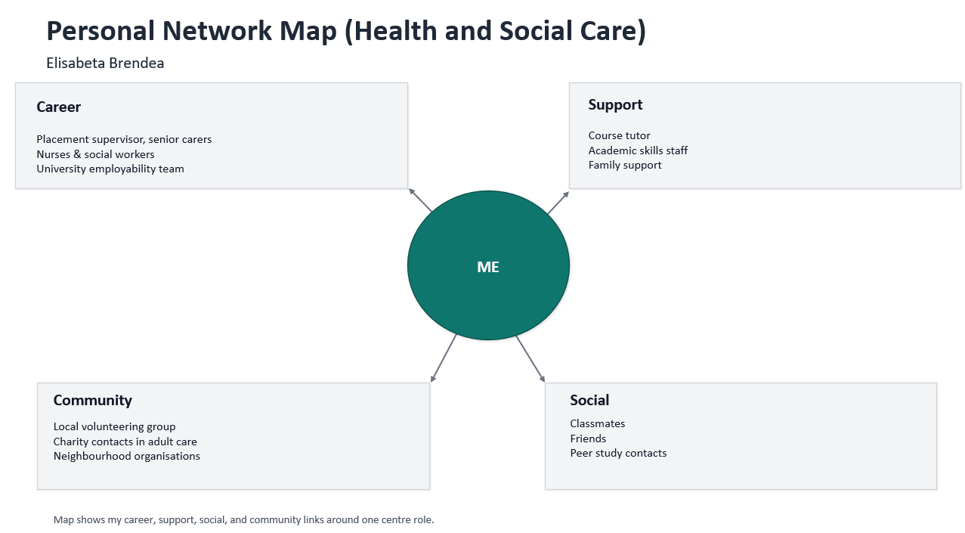

Network map

There are about four interconnected locations in my network. As a Health and Social student, I am at the centre, and I have connections to the community, social media, career and support systems. The university employability team, senior caretakers, nurses, social workers, placement supervisors and professional LinkedIn contacts are all included in the career section. They are the ones who can let me know about openings, provide references, and let me know what to expect from care employment. My course instructor, academic skills personnel and close family members are all included in the support section. They assist with time management and emotional stability during periods of high workload. Classmates and friends who encourage attendance, give notes, and occasionally introduce me to their own professional contacts are included in the social section. Local charities linked to senior social care, church or neighbourhood associations and volunteer groups are all included in the community section. Informal connections might serve as a conduit for job information.

Rationale and critical assessment

The significance of this map lies in the fact that many opportunities arise through "weak ties," or people who know you professionally but not intimately, as they introduce you to new knowledge and broader networks (Granovetter, 1973). I shouldn't rely solely on family and close friends since I need both strong and weak links for advancement and well-being. While maintaining the boundaries and confidentiality required for care work, I will use cross-team relationships and professional groups to expand my network because it could become too limited in a single placement context. According to leadership research, networks should be established with a specific goal in mind. For example, I must maintain operational assistance, personal support, and strategic visibility separately rather than combining them (Ibarra and Hunter, 2007).

Task 3- Blog
Write a blog exploring a current topic or issue of your choice within the health and social care sector in the UK. The purpose of this is to inform a specific target audience of your choosing (300 words)

Why the adult social care workforce is the UK’s emergency

This blog is for family carers and people arranging care for an older relative. When care feels hard to find, it is not only “bad luck”. Staffing gaps sit underneath.

What the numbers say now

According to Skills for Care's 2024–2025 forecast, there were 1.60 million adult social care positions filled in England and around 111,000 unfilled, resulting in a 7.0% vacancy rate (Skills for Care, 2025). This is less than the 10.5% peak during 2021–2022. Employers continue to pursue the same personnel since the vacancy rate is still about three times higher than the norm for the entire economy (Skills for Care, 2025). Service users may experience a break in continuity due to the independent sector's 24.7% turnover rate in 2024–2025 (Skills for Care, 2025).

Why this matters to you

Care plans may be repeated, and new carers may arrive frequently as a result of high turnover. A person with dementia or frailty finds frequent changes upsetting since trust takes time. The fragmented and severely strained system is described by the Care Quality Commission, which also cautions that improved collaboration between health and adult social care is required (CQC, 2025). Families fill the void when hospital discharge slows down due to the inability to begin homecare.
What needs to change

With a projected 50,000 individuals beginning direct care work in the independent sector after arriving in the UK between March 2024 and March 2025, international recruitment has aided in filling positions (Skills for Care, 2025). This is helpful now, but it shouldn't take the place of reasonable compensation and retention. With £32 billion spent on adult social care in 2023–2024, Parliament attributes the escalating price to both delayed reform and rising costs (House of Commons Health and Social Care Committee, 2025). Cost containment also includes investments in dependable teams and oversight.

Task 4- NHS Equality, Diversity and Inclusion Quiz (250 words equivalent)
- What is the primary goal of the NHS Equality, Diversity, and Inclusion Improvement Plan?
(Answer in one or two sentences.)

The primary goal is to improve equality, diversity and inclusion across the NHS workforce and increase staff sense of belonging, so staff experience and outcomes improve.

- How does the NHS EDI Improvement Plan propose to tackle the gender pay gap?
(Answer in one to two sentences.)
It proposes that every NHS organisation develops and delivers an improvement plan to eliminate gender pay gaps, using accurate pay-gap data to identify causes and track progress.

- What is meant by the term ‘intersectionality’ as used in the NHS EDI Improvement Plan?
(Answer in one to two sentences.)
Intersectionality means people can have several identities at the same time, and disadvantages can combine, so inequalities cannot be fixed only looking at one protected characteristic in isolation.

- Why is it important for the NHS to create a psychologically safe work environment?
(Answer in one to two sentences.)

A psychologically safe environment matters because staff need to feel able to speak up, raise concerns, ask questions, and admit mistakes without fear, which protects staff wellbeing and patient safety.

- How does the NHS EDI Improvement Plan suggest improving the experience of internationally recruited staff?
(Answer in one to two sentences.

It suggests a comprehensive induction, onboarding and development program for internationally recruited staff, so they feel supported, included and less exposed to unfair treatment.

- What role does leadership play in advancing EDI objectives according to the NHS Improvement Plan?
(Answer in one to two sentences.)

Leadership is expected to set clear EDI objectives, be held accountable for delivery, and use board-level oversight to make sure improvement actions are not optional.

- Identify one way the NHS EDI Improvement Plan aims to reduce health inequalities within the workforce.
(Answer in one to two sentences.)

One way is to create a workforce health-inequalities improvement plan that targets unequal access to health and wellbeing support for different staff groups.

- Why does the NHS EDI Improvement Plan emphasise the importance of collecting and analysing data on protected characteristics?
(Answer in one to two sentences.)

It emphasizes data on protected characteristics because without it the NHS cannot see who is disadvantaged, measure pay gaps and progression gaps, or judge if interventions are working.

- Explain how flexible working policies can contribute to equality and inclusion in the NHS workforce.
(Answer in one to two sentences.)

Flexible working can support equality because it helps staff with caring responsibilities, disabilities, or health needs to stay in work and progress, instead of being pushed out by rigid schedules.

- What is one strategy mentioned in the NHS EDI Improvement Plan to combat bullying and harassment in the workplace?
(Answer in one to two sentences.)
One strategy is creating conditions that prevent bullying and harassment, including stronger reporting routes and action when behaviors breach expected standards.

Task 5- A Letter to Yourself
Think of a time in the past when you may have been experiencing issues or difficulties, and after considering what you have learned in this module about emotional intelligence and resilience write a letter to your younger self explaining how these attributes were important at that time and perhaps how developing these areas could have been useful (250 words)

A Letter to Myself

Dear Elisabeta,
I remember you in the first months in the UK, when English felt heavy in your mouth and you was scared to speak in class because you might sound “wrong”. You was also tired from working, studying and trying to look confident at the same time. You thought if you show stress, people will judge you as not capable. This was the moment emotional intelligence would help you most, even if you did not name it like this.
Emotional intelligence means you notice what you feel, then you choose what to do with it, instead of letting it control you. When you feel shame after a small mistake, stop and label it. Tell yourself: this is anxiety, not truth. Watch what triggers it, like fast conversations or group work, then prepare simple sentences before you enter the room. This is not weakness, it is self-management. It also helps with empathy. Other people are nervous too, even native speakers, they just hide it differently.
Resilience is the part that makes you return again. It is not being strong every day. It is doing one more attempt after you want to quit. In this module, Changemakers: Building your Personal Brand for Sustainable Employment, you learn that your brand is built from repeated actions. So, keep showing up, asking for feedback, and correcting one thing at a time. Your accent is not your enemy. Your consistency will speak louder than it.

With care,
Elisabeta

Task 6- GANTT Chart (200 words equivalent)
Compile a Gantt chart which illustrates the tasks you must complete to achieve your future employment goals
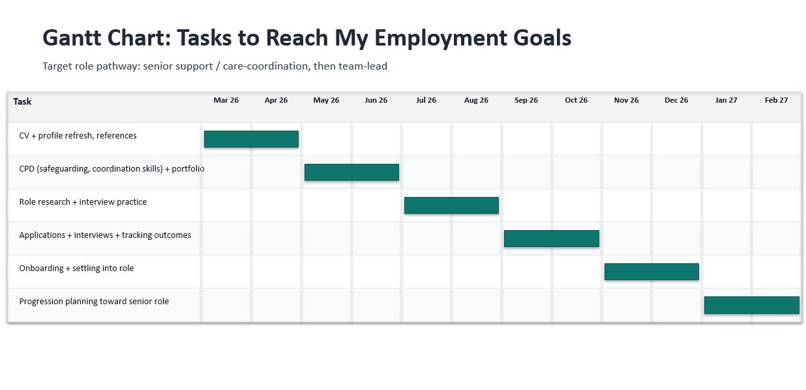

(m

(made with PowerPoint)

Task 7- Making Changes- Report
You are the manager of a care home and want to make changes to your workplace. Identify one specific change that you want to implement and write a brief report on how this is going to be achieved considering the necessary skills needed and addressing possible barriers to success. Relevant change models can be highlighted (250 words- 2 referenced sources).

Introducing structured SBAR handovers to reduce medicines errors

The change to implement

At every shift change, in my capacity as care home manager, I will implement a structured handover process that incorporates a brief medication safety check and uses SBAR (Situation, Background, Assessment, Recommendation). Less skipped doses, less transcription errors, and more transparent escalation when a resident's health changes are the goals. This promotes the safe medication systems that are anticipated in assisted living facilities, where responsibility, transparency and management are crucial (NICE, 2014).

How it will be achieved

Using Kotter's change methodology, I will spearhead the transformation. Prior to forming a small guiding group with the senior carer, nursing lead, and medications champion to develop the new handover template, I will first generate urgency by sharing recent incident themes and audit results (Kotter, 1996). After a brief role-playing training, we will use a standard script and a basic checklist for high-risk medications to pilot SBAR on one unit for two weeks. In order to maintain consistency, we will modify the template following the pilot, implement it throughout the entire house, and include it in induction and supervision.

Skills needed and barriers

Communication, mentoring, dispute resolution, and fundamental quality improvement abilities like conducting audits and utilising feedback are essential. Staff members viewing SBAR as "extra paperwork" during busy shifts is probably a barrier. By keeping the tool brief, scheduling the handover, and presenting preliminary findings from incident reporting and medication audits, I will lessen this. Uneven confidence in speaking up is another obstacle. In order to encourage staff to speak up when a resident is in danger, I will demonstrate how to escalate a situation calmly during handovers and emphasise that concerns are encouraged rather than punished.

Task 8- Self-Reflection
Using one of the highlighted models of reflection, reflect on what you have learned about yourself during this module, as well as the knowledge you have gained, and explain how this has developed your skills and informed your future practice (250 words- you must reference the model you use)

Self-reflection using Gibbs’ Reflective Cycle
Description
During this module, Changemakers: Building your Personal Brand for Sustainable Employment, I completed activities on my personal brand, networking, and planning for employment. I also had moments where I had to present my strengths and values clearly, which was uncomfortable at first.
Feelings
At the start I felt worried that I might sound too confident, or the opposite, too unsure. I also felt pressure because I am a health and social care student and I want to be taken seriously. When I compared myself with other students, I sometimes felt behind.
Evaluation
The useful part was that I became more organised and intentional. I stopped waiting for motivation and started treating employability tasks like real work. The difficult part was self-doubt, especially when thinking about interviews and professional communication.
Analysis
Gibbs’ cycle helped me to slow down and look at what happened, then connect it with my reactions, then decide what I will do next (Gibbs, 1988). I learned that my emotional reactions could push my behaviour, like avoiding speaking up or delaying tasks. When I noticed this, I could plan small actions that are realistic, like practising answers aloud and asking for feedback early, not at the deadline. I also learned that my personal brand is built from consistent behaviour, not from one “perfect” performance.
Conclusion and action plan
I am more aware of my strengths, mainly reliability and respectful communication. In future practice I will use reflection after feedback, keep a portfolio of evidence, and set monthly goals for skills, so my employability progress stays steady (University of Cambridge, 2025).

Reference List

Peters, T. (1997) The Brand Called You. Fast Company. Available at: https://www.fastcompany.com/28905/brand-called-you (Accessed: 25 February 2026).
Rampersad, H.K. (2008) ‘A new blueprint for powerful and authentic personal branding’, Performance Improvement, 47(6), pp. 34–37. Available at: https://onlinelibrary.wiley.com/doi/abs/10.1002/pfi.20007 (Accessed: 25 February 2026).
Granovetter, M.S. (1973) ‘The strength of weak ties’, American Journal of Sociology, 78(6), pp. 1360–1380. Available at: https://www.journals.uchicago.edu/doi/10.1086/225469 (Accessed: 25 February 2026).
Ibarra, H. and Hunter, M. (2007) ‘How leaders create and use networks’, Harvard Business Review. Available at: https://hbr.org/2007/01/how-leaders-create-and-use-networks (Accessed: 25 February 2026).
Care Quality Commission (CQC) (2025) The state of health care and adult social care in England 2024/25. Available at: https://assets.publishing.service.gov.uk/media/68fa3b4fe200d653d8b63735/care-quality-commission-state-of-health-care-and-adult-social-care-England-2024-2025.pdf (Accessed: 25 February 2026).
House of Commons Health and Social Care Committee (2025) Adult Social Care Reform: the cost of inaction. Available at: https://publications.parliament.uk/pa/cm5901/cmselect/cmhealth/368/report.html (Accessed: 25 February 2026).
Skills for Care (2025) The size and structure of the adult social care sector and workforce in England – 2025. Available at: https://www.skillsforcare.org.uk/Adult-Social-Care-Workforce-Data/workforceintelligence/resources/Reports/National/The-size-and-structure-of-the-adult-social-care-sector-and-workforce-in-England-2025.pdf (Accessed: 25 February 2026).
Kotter, J.P. (1996) Leading Change. Harvard Business School Press information page. Available at: https://www.hbs.edu/faculty/Pages/item.aspx?num=137 (Accessed: 25 February 2026).
National Institute for Health and Care Excellence (NICE) (2014) Managing medicines in care homes (SC1). Available at: https://www.nice.org.uk/guidance/sc1 (Accessed: 25 February 2026).
Gibbs, G. (1988) Learning by Doing: A Guide to Teaching and Learning Methods. Oxford: Oxford Polytechnic. Available at: https://thoughtsmostlyaboutlearning.files.wordpress.com/2015/12/learning-by-doing-graham-gibbs.pdf (Accessed: 25 February 2026).
University of Cambridge (2025) Models of reflection – Reflective Practice Toolkit. Available at: https://libguides.cam.ac.uk/reflectivepracticetoolkit/models (Accessed: 25 February 2026).

