Taylor Dawn Hodges (2008862)

HND Computing (Software Engineering)
Learning in the Digital Era (ACCA4025)
Assignment 1: E-Portfolio

Table of Contents
E-Portfolio 2
Task 1 – Written Summary 3
Task 2 – Mind Map 4
Task 3 – Video Presentation 5
Task 4 – Academic Poster 6

E-Portfolio
https://uowtsd-my.sharepoint.com/:o:/g/personal/2008862_student_uwtsd_ac_uk/EjxTwIjVlDxOhHvya-Ag10UBpJClN32tRT5vO0MGEPOKRg
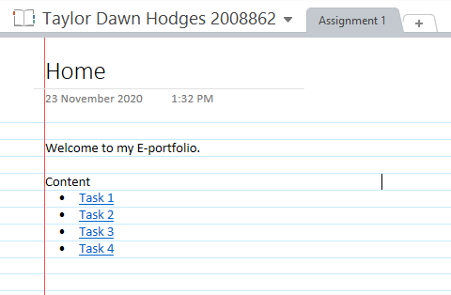
*My E-Portfolio is in OneNote to protect my own privacy and not potentially expose myself to cyber-attacks.

Task 1 – Written Summary
Task 1 (Web view)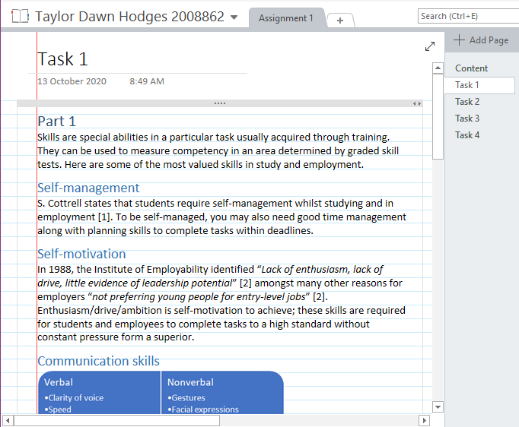

Task 2 – Mind Map
Task 2 (Web view)
https://coggle.it/diagram/X4mu1S4exXT4QD-z/t/software-engineering
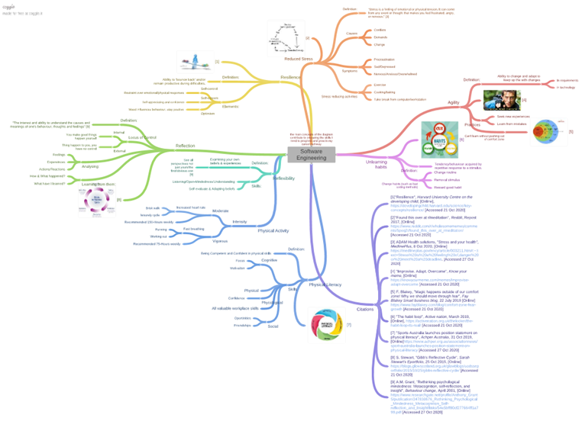

Task 3 – Video Presentation
Task 3 (Web view)
Digital Competency: Citizenship
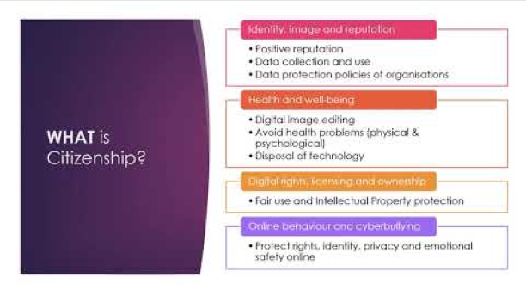

Task 4 – Academic Poster
Task 4 (Web view)
https://uowtsd-my.sharepoint.com/:b:/g/personal/2008862_student_uwtsd_ac_uk/EXQrWpahZzJLmXXRRhxz9PcBLtmEJlN_5q8i9_jfcB78qg?e=feP29Y


