Distributed and Cluster Concepts

By Eben Stewart

P115266

In fulfilment of the requirements for

M6X01093

Distributed and Cluster Computing

Coursework One

Lecturer

Dr. Tim Bashford

27 February 2019

Contents

Introduction 1
Historical Context Behind the Use of Parallelism 1
Beginning of Multiprogramming 1
Pseudoparallelism 1
Processes 2
Scheduling 2
True Parallelisation 2
Threads 2
Relevant Architectural Concepts 3
Models of Implementation of Parallelism 3
Pitfalls of Parallelisation 5
Race Conditions 5
Amdahl’s Law 5
Deadlocks 6
Environmental Multiplicity 6
Implications of Parallelism for Other Hardware 6
Cluster Processing (MPI) 7
Message Passing 7
GPGPU (see: Cuda, OpenCL) 8
Conclusion 8
References 10

Figures
Figure 1 Installation of the IBM 360/91 in the Columbia Computer Center machine room in February or March 1969. Photo: AIS archive. 1
Figure 2 Diagram of a proposed multi-core Processor 4
Figure 3 Diagram of the Maths SCAN at Imperial College London 4
Figure 4 IBM's Summit - 2018's fastest computer in the world 5

Introduction
The thrust of the evolution of computing technology has been, from early days, to compute faster for less money and get more done. Since Moore’s law hit the limit imposed by the laws of physics, the direction of progress has been to increase processing power through ever increasing parallelism of execution. The following essay is an exploration of this development, concepts and technology relevant to it, some of the tools that have been developed and some practical solutions for implementation of extensively parallel systems.

Historical Context Behind the Use of Parallelism

Beginning of Multiprogramming
In pre-1965 computers a single Central Processing Unit (CPU) took one set of instructions and performed one instruction at a time. Encountering an instruction involving I/O it sat idle waiting for the peripheral device to do its work [1, p. 11] Computers then were hugely expensive and uncommon. High demand meant that idle time was a huge waste.

Pseudoparallelism
In 1965, IBM introduced the OS/MFT and the OS/360-MVT, which could multiprogram [2].
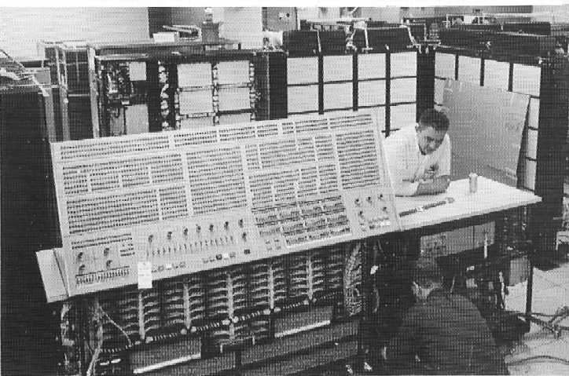
Figure 1 Installation of the IBM 360/91 in the Columbia Computer Center machine room in February or March 1969. Photo: AIS archive. [3] This author visited that room many times at age 7, a year before this installation.
This meant one CPU, executing serially, ran multiple programs serially, but switched between them so quickly that they appeared to be executing concurrently. Now, when one program waited on I/O, the CPU switched to other waiting work with fewer wasted cycles [1, p. 86].
Multiprogramming was made possible by partitioning memory, one partition for each executing program. [4, p. 36]. The architects of this innovation Gene Amdahl, et al. called it ‘tamper-proof storage protection’ [5].

Processes
Processes are programs in execution. They have threads of execution, address space, and data structures to keep track of their ‘context’, the collection of information necessary to their running. Switching processes is called a context switch because this information must be stored for the process currently in execution and retrieved for the process being switched to [1, pp. 85–96].

Scheduling
Amdahl et al. understood that multiprogramming required scheduling by ‘a protected supervisor program’ (now called the scheduler) and the ability of the operating system to interrupt processes’ execution [5].
The scheduler shares out processor time among ready threads of execution, following a scheduling algorithm [6, pp. 394–6] [1, p. 149]. Common goals of scheduling are to keep the CPU (and less critically, other system resources) as busy as possible and to make sure that processes don’t hog the CPU to the detriment of others [7] [8].

True Parallelisation
A multiple processor approach was mentioned by Amdahl in 1967 [9]. IBM’s 1968 System/360 Model 65 optionally included two CPUs with shared storage [10, p. 30] However, the main thrust of computer development until fairly recently was not parallelisation, but increasing clock speed of single core processors through transistor miniaturisation so more could fit on a die [11, p. 5].
Increasing execution speed avoids problems involved in parallelisation, so it was the preferred way to increase performance until about 2006 when Moore’s law, which stated processor speed doubled every 1-2 years, began to breakdown due to physical limits at the incredibly small scales then reached [11, p. 9].

Threads
A process often has more than one thread of execution which run concurrently in its address space. These too are context switched by the CPU so store context in structures [1, pp. 97–102]. Sharing the same address space and implementing code from the same program, threads are designed by their author(s) to work cooperatively at the same or complementary tasks to more quickly and efficiently do the work of their parent process [1, pp. 97–102]. This is called task parallel computation.

Relevant Architectural Concepts
Inside a processor is (at least one) execute core which acts upon data held in memory. In microelectronics, proximity equals speed due to wire capacitance effects which corrupt signals in direct proportion to their frequency and the distance they must travel [12]. Memory fast enough to keep up with the execute core is so expensive that it is used only where it really counts, in small bits called registers located close to the execute electronics.
Main memory, on the other hand is, from the processors point of view, accessed relatively infrequently so it need not be anywhere near as fast, but it should be much more abundant. So, it is both made of cheaper material and distant on the motherboard. Between these extremes in hierarchically descending order of speed and expense but in increasing order of size, are level 1, level 2 and (sometimes) level 3 caches [1, p. 25] [13].
The northbridge chip handles communication between CPU, GPU, memory and other high-speed devices. The southbridge chip connects to the northbridge and handles I/O and less speed critical communication. Together, the bridges and associated hardware make up the chipset. Efficient operation of the northbridge especially, has implications for the performance of the system [14] as does design of communication pathways. High bandwidth and accuracy are needed and avoidance of bottlenecks.

Models of Implementation of Parallelism

Multiprocessor
True parallelisation can be done as the Model 65 did, with separate CPUs accessing shared memory. Such a system is called a shared memory multiprocessor. These share main memory, but have their own caches [1, p. 520].

Multicore
Modern consumer grade (and higher) CPUs contain multiple cores mounted on the same die. This is cheaper, more compact and energy efficient than single core multiprocessors. Cores have their own level 1 and sometimes level 2 cache or they share it and share level 3 cache if present [15].
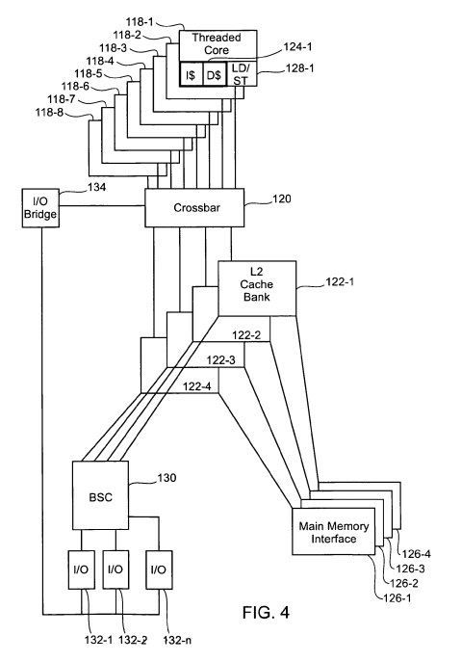
Figure 2 Diagram of a proposed multi-core Processor
(8 cores) showing one L1 cache per core (124-n), but a
set of L2 caches (122-m) each shared between 2 cores,
with dedicated memory interfaces [15]

Distributed Systems
Thirdly, parallelisation can be achieved by sharing computation between multiple computers in a ‘cluster’. Clusters can also be clustered. One of the least expensive ways to implement parallel computation is to network together disparate PCs during their downtime so that they become nodes in a distributed system [16].
Imperial College London’s Maths SCAN was a system which networked teaching PCs in three classrooms. Separate multicore Windows machines by day, they would, after closing, reboot a FreeBSD image from a network boot server. With a specialised file server and networking hardware, they formed a cluster. Here specialised computers performed key functions [16]. 97
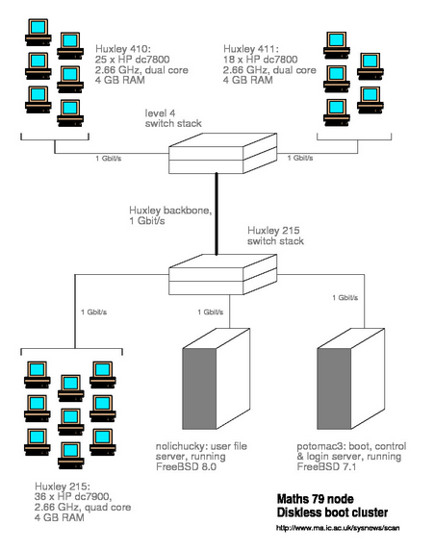
Figure 3 Diagram of the Maths SCAN at Imperial College London [16]

HPCs
Faster clusters can be made with specially designed equipment. Modern High-Performance Computing (HPC) systems, (supercomputers), are clusters. They include the world’s fastest computers [17].
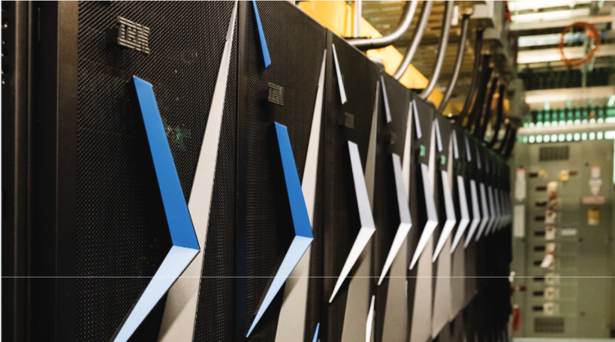
Figure 4 IBM's Summit - 2018's fastest computer in the world [18] [17]

Pitfalls of Parallelisation
At the level of user space programming, writing code for parallel execution is conceptually difficult compared to serial code. Though efficient, there are pitfalls to allowing different threads access to the same data in shared memory.

Race Conditions
Atomic operations appear indivisible to other threads. They’re uninterruptible.
In a single processor system, if two or more separate threads, whether in the same process or not, access the same data non-atomically, then context switching mid-operation can corrupt that data [19]. The section of code where interruption and context switching must be prevented is called the ‘critical section’ [1, pp. 120–121]. One way of correcting this bug is to ‘lock’ access to the critical section by more that one thread at a time so that the critical section, once locked, executes as if it is atomic [20]. This is called mutual exclusion. It is achieved through the use of primitives such as semaphores, mutexes, futexes (user space mutexes) and programming language artifacts such as monitors, etc [1, p. 144].
Forcing threads to wait for each other essentially de-parallelises their execution, which is to be avoided, if possible, and minimised if not. Structuring code so that contention for shared resources is avoided as much as possible is best. As much as possible threads should be free to run without possibility of interference from other threads.

Amdahl’s Law
Gene Amdahl [9] recognised that while parts of a program can be made to run in parallel, if there remain parts that can only run serially, the execution time cannot be made any faster than the time needed to run the non-parallelisable part. Furthermore, adding processors or cores to increase the number of threads that can be executed in parallel only affects the proportion of the program that is parallelisable [9]. If 30% of a program is non-parallelisable, tripling the number of cores will reduce the entire application’s runtime (all else being equal) by only 50%, not 66.6% as one might assume, since .3 + (.6/3) = .5.
Amdahl was pessimistic about the speed up potential of parallel computing. He was both cognizant of the difficulties of parallelisation with the technology of the day and optimistic increasing serial execution speeds [9].
Later researchers in parallelism, seeing impressive speedups became suspicious of the accuracy of his formula. In 1988, Gustafson [21] came up with a more optimistic one. The equivalence of both laws has since been shown [22] [23].

Deadlocks
Deadlocks occur when none of a set of threads can proceed without an event (such as the release of an exclusively held resource) that only one of the other processes can provide. Since none can proceed, none can produce that event which would unlock another thread, so all remain stuck [24]. Resource deadlocks can only occur if:
- Threads claim exclusive control of the resources they require.
- They hold those resources they do have control over while they wait for whatever else they need to run.
- Nothing can force them to relinquish those resources before they’re done with them. The only way they can be released is by the holding process.
- There is a circle of dependency, a chain, such that each of the threads holds a resource that the next one in the chain is requesting [24].
It is worth noting that without mutual exclusion deadlocks can’t occur [1, pp. 435–458]. It is also worth noting that the above conditions can apply in a distributed system where resources are shared.

Environmental Multiplicity
In a distributed environment mutual exclusion won’t work because locking using primitive types depends on low level routines that are not shared between different operating system kernels [19]. Solutions exist that use message passing of the states of mutual exclusion for threads on one system to another over a network. Such solutions must deal with the difficulty of ensuring atomicity of operation in those circumstances [25].

Implications of Parallelism for Other Hardware
To the extent that execution cores share memory resources (main and/or caches), the potential for increased speed of access to them and greater efficiency due to shared access, as opposed to passing copies of data, leads to high performance. On the other hand, the potential for low-level resource contention is higher increasing with the complexity of sharing caches ever closer to the execution core, where the frequency of reads and writes increases.
The interdependence of cores sharing caches along with other hardware supporting memory access means that a thread’s execution time is affected by which threads are running on the other cores. Choice of a good cache-aware scheduling algorithm can make a significant difference in task completion time [26].
Zhuravlev et al. state that cache contention occurs when a thread’s co-running threads (those sharing Last Level Cache (LLC)) take control of the LLC, inserting their own data and evicting that of co-runners. Other issues such as contentions for prefetching hardware and memory bus and controller can also occur when LLCs are shared and have been shown to have significant effect. Their research shows that these conflicts contributed more to performance degradation than cache contention [26].

Cluster Processing (MPI)

Message Passing
Message passing is a communication solution that works by passing copies, avoiding the need for shared resources and therefore for mutual exclusion. This makes it more expensive and slower but eliminates the possibility of problems such as race conditions, though not deadlocks [1, p. 144].
It scales well and is fast, so while it can be less efficient between processes on a single machine, it is the natural solution for communicating between machines in a local cluster or one widely spread geographically.
Message passing systems have their own set of problems. Unlike shared data, messages can get lost when sent over a network [1, p. 144]. and speed of communication can vary. Both issues can be coped with by cooperation between sending and receiving threads but routines to ensure reliability are expensive, involving acknowledgement and rank checking. Portability is also an issue [27].
The Message Passing Interface (MPI) standard is developed by the MPI Forum [28]. As a standard, it mandates implementation to a common interface ensuring portability between complying systems. There are various libraries implementing MPI, many of which are thread safe. The standard specifies a structure and rules designed to make message passing accurate, reliable quick overall etc. but leaves how this is implemented to the library [28].
It specifies that communication occur within an MPI environment which is initialised and terminated in code, types of communication, how threads and messages may be organised for unique identification, structures for keeping track of who the message is for and from etc. It also guarantees things like the order of messages but leaves other problems to the programmer. MPI defines its own types independent of, but translatable by the host computers into their own implementation [27, p. 16].

GPGPU (see: Cuda, OpenCL)
While CPUs are good at task parallel computing, Graphics Processing Units (GPUs) are made of many small compute cores designed to do the same set of routines concurrently on members of large sets of data at high speed. This is known as Single Program Multiple Data (SPMD) [29]. They are designed to be highly specialised for vector maths for graphics rendering [30]. They have much faster computation rates when performing compute heavy operations upon floating point number sets [31]. So their potential for use in HPCs and data centres as accelerators of fast, massively parallel operations is being recognised and exploited [32] [18].
General Purpose Computing on Graphics Processing Unit (GPGPU) is this use of GPUs for more general computing. While initially GPUs were designed to only work with DirectX or OpenGL, libraries were developed to abstract away the graphics interfaces [33].
Nvidia’s proprietary offering is Complete Unified Device Architecture (CUDA), a set of software tools designed to enable programmers to write C-like code to run on their own GPUs only [34]. The universality and speed of C make this a tempting solution, but it only works with Nvidia products.
ATI’s hardware solution, the AMD Stream Processor has a hardware interface that allows direct access to the instruction set. This has the promise of speed and fine control, but it also is proprietary.
OpenCL is a non-proprietary open standard incorporating CUDA and other toolkits. It specifies a framework for programming a wide variety of processor types including but not limited to CPUs and GPUs. It models memory and compute cores, etc. in an abstract enough way that all processor types are supported by the core functionality it defines [35] and can be programmed with the OpenCL C language [36]. OpenCL seems the most promising solution to GPGPU programming for distributed systems of those discussed.

Conclusion
What constitutes a good solution for communication on a distributed system depends upon one’s budget and needs. For speedy processing of computation heavy workloads, extensively parallel systems have become the norm. The fastest systems include state of the art equipment and include hierarchies of parallelised execution cores. Architectures vary, but the general idea is of clusters of multicore processors in multiprocessor computers working in parallel. In a limited way these resemble fractal hierarchies of horizontal communication.
Choices not only of the cores themselves but of the interconnecting hardware and the software solutions for their effective implementation (especially scheduling) are critical as bottlenecks can occur. Incredible amounts of money can be spent on HPCs, but effective work can be done much more cheaply using networked commercial workstations or even borrowed machines on the internet or more local networks.
In either case, optimising computation speed involves making good choices of communication and cooperation methods to use between components at the various levels of a distributed system’s organisation. The lower the level, the more resources are shared. When there is contention for them, threads can’t execute optimally. Avoiding contention is desirable.
At the lowest level, hardware solutions and low-level software such as the choice of scheduling algorithm are most critical. Above that, in situations where memory resources can be shared, programmers can optimise speed and efficiency by allowing access to shared data while guarding independence of execution between threads through good coding practices that avoid contention as much as possible, using mutual exclusion primitives (and monitors) only when necessary. Care must be taken to avoid problems such as race conditions, deadlocks and avoidable serialisation, as described above. Message passing is slower and to be avoided, if possible, at this level.
Between networked machines and clusters of machines, message passing is the best choice. MPI is the de facto standard for good reason. It’s fast (relatively), truly portable, and clear and systematic in the way it must be implemented.
Including specialised hardware in the system can synergistically increase (accelerate) performance, especially using GPGPU techniques. OpenCL is the best solution here. Since most workstations include a GPU, GPGPU should be possible even on borrowed-machine clusters.

References
[1] Andrew S. Tanenbaum and Herbert Bos, Modern Operating Systems, 4th ed. India: Pearson India Education Services Pvt. Ltd., 2017.
[2] ‘IBM100 - System 360’, 07-Mar-2012. [Online]. Available: http://www-03.ibm.com/ibm/history/ibm100/us/en/icons/system360/. [Accessed: 06-Feb-2019].
[3] ‘The IBM 360/91’. [Online]. Available: http://www.columbia.edu/cu/computinghistory/36091.html. [Accessed: 08-Feb-2019].
[4] ‘Computer History: IBM 360/370/3090/390’. [Online]. Available: http://www.beagle-ears.com/lars/engineer/comphist/ibm360.htm. [Accessed: 08-Feb-2019].
[5] G. M. Amdahl, G. A. Blaauw, and F. Brooks, ‘Architecture of the IBM System/360’, IBM J. Res. Dev., vol. 8, no. 2, pp. 87–101, 1964.
[6] W. Stallings, Operating Systems: Internals and Design Principles, 6th ed. Upper Saddle River, NJ, USA: Prentice Hall Press, 2008.
[7] Paul Krzyzanowski, ‘Process Scheduling’, pk.org, 14-Feb-2019. [Online]. Available: https://www.cs.rutgers.edu/~pxk/416/notes/07-scheduling.html. [Accessed: 23-Feb-2019].
[8] C. S. Wong, I. Tan, R. D. Kumari, and F. Wey, ‘Towards Achieving Fairness in the Linux Scheduler’, SIGOPS Oper Syst Rev, vol. 42, no. 5, pp. 34–43, Jul. 2008.
[9] G. M. Amdahl, ‘Validity of the Single Processor Approach to Achieving Large Scale Computing Capabilities’, in Proceedings of the April 18-20, 1967, Spring Joint Computer Conference, New York, NY, USA, 1967, pp. 483–485.
[10] ‘IBM System/360 Model 65’, International Business Machines Corp., File No. S360-01, Sep. 1968.
[11] R. Ramanathan, ‘Intel® Multi-Core Processors Making the Move to Quad-Core and Beyond’, Technol. Mag., Dec. 2006.
[12] ‘Why is Cable Capacitance Important for Electronic Applications? | Quabbin Wire & Cable’. [Online]. Available: https://www.quabbin.com/tech-briefs/why-cable-capacitance-important-electronic-applications. [Accessed: 16-Feb-2019].
[13] ‘performance - Cache or Registers - which is faster?’, Stack Overflow. [Online]. Available: https://stackoverflow.com/questions/14504734/cache-or-registers-which-is-faster. [Accessed: 16-Feb-2019].
[14] S. B. Chen, ‘Method for user setup of memory throttling register in north bridge via BIOS to save power’, US7003658B2, 21-Feb-2006.
[15] L. D. Kohn, K. A. Olukotun, and M. K. Wong, Multi-core multi-thread processor. Google Patents, 2007.
[16] ‘Maths SCAN - SuperComputer At Night’. [Online]. Available: http://sysnews.ma.ic.ac.uk/supercomputer/index9.html. [Accessed: 16-Feb-2019].
[17] ‘Home | TOP500 Supercomputer Sites’. [Online]. Available: https://www.top500.org/. [Accessed: 20-Feb-2019].
[18] J. Hines, ‘Stepping up to Summit’, Comput. Sci. Eng., vol. 20, no. 2, pp. 78–82, Mar. 2018.
[19] Paul Krzyzanowski, ‘Synchronization’, pk.org, 09-Feb-2015. [Online]. Available: https://www.cs.rutgers.edu/~pxk/416/notes/06-sync.html. [Accessed: 23-Feb-2019].
[20] R. H. B. Netzer and B. P. Miller, ‘What Are Race Conditions?: Some Issues and Formalizations’, ACM Lett Program Lang Syst, vol. 1, no. 1, pp. 74–88, Mar. 1992.
[21] J. Gustafson, ‘Reevaluating Amdahl’s Law’, Commun ACM, vol. 31, pp. 532–533, 1988.
[22] Y. Shi, ‘Reevaluating Amdahl’s law and Gustafson’s law’, Comput. Sci. Dep. Temple Univ. MS 38-24, 1996.
[23] S. Krishnaprasad, ‘Uses and Abuses of Amdahl’s Law’, J Comput Sci Coll, vol. 17, no. 2, pp. 288–293, Dec. 2001.
[24] E. G. Coffman, M. Elphick, and A. Shoshani, ‘System deadlocks’, ACM Comput. Surv. CSUR, vol. 3, no. 2, pp. 67–78, 1971.
[25] M. Singhal, ‘A heuristically-aided algorithm for mutual exclusion in distributed systems’, IEEE Trans. Comput., vol. 38, no. 5, pp. 651–662, May 1989.
[26] S. Zhuravlev, S. Blagodurov, and A. Fedorova, ‘Addressing shared resource contention in multicore processors via scheduling’, in ACM Sigplan Notices, 2010, vol. 45, pp. 129–142.
[27] W. Gropp, E. Lusk, and A. Skjellum, Using MPI: Portable Parallel Programming with the Message-Passing Interface. The MIT Press, 2014.
[28] C. The MPI Forum, ‘MPI: A Message Passing Interface’, in Proceedings of the 1993 ACM/IEEE Conference on Supercomputing, New York, NY, USA, 1993, pp. 878–883.
[29] N. Bell and M. Garland, ‘Efficient sparse matrix-vector multiplication on CUDA’, Nvidia Technical Report NVR-2008-004, Nvidia Corporation, 2008.
[30] E. Smith, ‘Parallel solution of linear programs’, 2013.
[31] S. Lee, ‘Exploring security implications of the AMD STREAM PROCESSOR’, PhD Thesis, UC San Diego, 2008.
[32] ‘NVIDIA High Performance Computing Solutions’, NVIDIA. [Online]. Available: https://www.nvidia.com/en-us/high-performance-computing/. [Accessed: 26-Feb-2019].
[33] S. Che, M. Boyer, J. Meng, D. Tarjan, J. W. Sheaffer, and K. Skadron, A Performance Study of General-Purpose Applications on Graphics Processors Using CUDA. .
[34] ‘CUDA Technology’, SCAN, 22-Oct-2008. [Online]. Available: https://www.scan.co.uk/tekspek/gpu-graphics/cuda-technology. [Accessed: 26-Feb-2019].
[35] J. E. Stone, D. Gohara, and G. Shi, ‘OpenCL: A Parallel Programming Standard for Heterogeneous Computing Systems’, Comput. Sci. Eng., vol. 12, no. 3, pp. 66–73, May 2010.
[36] A. Munshi, ‘The OpenCL specification’, in 2009 IEEE Hot Chips 21 Symposium (HCS), 2009, pp. 1–314.

