
Series Hybrid Vehicle (A1)

Name: Irfan Yaqoob
Student ID: P145563
Module: Electric and Hybrid Propulsion Control
Course: BSc Automotive Engineering
Date: 5/12/2017

Abstract

This report concerns the typical duty cycle of an off-road buggy when used for corporate entertainment events. This will include a spreadsheet showing calculations related to performance with respect to acceleration, speed, gradient, rolling resistance and aerodynamics. The findings indicate the off-road buggies are suitable as an exciting pursuit to be included in the recreational and corporate entertainment sector.

Table of Contents
Abstract
List of figures
List of Table
1. Introduction 1
2. Research 2
2.1 Duty cycle Analysis and buggy Specification 2
2.2 Road track developed 3
3. Calculation 3
3.1 Time 4
3.2 Speed 4
3.3 Acceleration 4
3.4 Force 4
3.5 Tractive Effort 4
3.6 Power 4
3.7 Gradient resistance 5
3.8 Rolling Resistance 5
3.9 Rolling Resistance Coefficient values 5
3.10 Coefficient of Drag 6
3.11 Aerodynamic Drag 6
3.14 Radius of wheel 6
3.15 Coefficient of Drag 6
4. Results and Analysis 7
4.1 Rolling resistance against Time 7
4.2 Gradient resistance against Time 7
4.3 Aerodynamic drag against Time 8
4.4 Acceleration resistance against Time 8
4.5 Total resistance against Time 9
4.6 Velocity against Time 9
4.7 Power against Time 10
4.8 Power and Average power against Time 10
4.9 Forces against Time 11
5. References/ Bibliography 12

List of figures
Figure 1 shows specification of the buggy 2
Figure 2 shows the buggy for terrain track 2
Figure 3 shows developed track for buggy 3
Figure 4 shows the dimension of buggy 3
Figure 5 shows the illustrate the Gradient resistance 5
Figure 6 shows the rolling resistance against time graph 7
Figure 7 shows the gradient resistance against time graph 7
Figure 8 shows the aerodynamic drag against time graph 8
Figure 9 shows the acceleration resistance against time graph 8
Figure 10 shows the total resistance against time graph 9
Figure 11 shows the velocity against time graph 9
Figure 12 shows the power against time graph 10
Figure 13 shows the power and average power against time graph 10
Figure 14 shows the forces against time graph 11

List of Table

Table 1 shows the rolling resistance Coefficient values 5

1. Introduction

This report explains the typical duty cycle of off-road buggies when used for corporate entertainment events. The engineering director of the company producing these vehicles has requested this report. The corporate entertainment sector provides events for larger companies for such purposes as workforce bonding, training events etc. This report includes a description of the buggy selected and the selection criteria. These criteria include the buggy speed, acceleration and ability to climb and descend gradients. This will be illustrated by use of an Excel spreadsheet and be concluded with a summary of findings. In addition, the planning for development of road course will be included. As well as an analysis of the duty cycle of the buggy. The duty cycle of the buggy over one lap of the track, which includes straights, bends, ascents and descends will show in the Excel spreadsheet.
As off-road race vehicles, buggies are required to traverse rough terrain while maintaining speed for an extended period of time. As in any racing competition, weight is also an important factor. Weight must be at a minimum so that the inertia of the car is small. Fewer inertia results in less force needing to be applied to the car during dynamic loads, which in turn means less stress on components. Reduction in weight generally produces a higher performance vehicle all-round. To continue, if we look at turning, the ability to sustain lateral acceleration is enabled by the lateral characteristics of the tyres. Thus, these loads are also limited to the traction of the tyres. Once again, in the off-road case, the tyre-soil interaction is much more difficult to understand. The variation in the surface can cause a wide range of tyre performance. (Owen, 2006)

2. Research

2.1 Duty cycle Analysis and buggy Specification
The buggy decided on for use on the terrain track, is the Vigilante corporate buggy. This buggy is of a standard manufacture build but capable of modification with the latest technology by using various components. This buggy can be fitted with 1200cc up to a 2000cc range of diesel engine, whereas these engines are not too expensive to replace if the engine breaks.
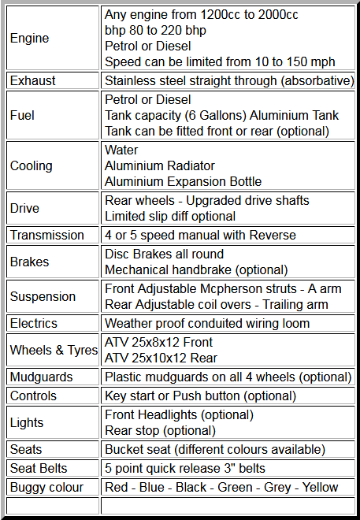

For insurance purpose, the buggy fitted with a 1200cc engine, which produces 80/90 bhp, is limited to 45 mph. To protect the driver, this buggy is made from 42 mm diameter and 4mm thick tube similar to the Nascar type roll cage that has proved its worth on some of our track days. On these occasions, it was put through constant abuse when jumping obstacles on a purpose-built track. The buggy has fully independent suspension with FOX nitrogen damped shocks on the rear.( Vigilante, 2017)

Figure 1 show specification of the buggy

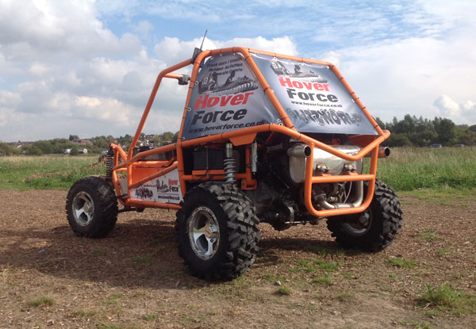

Figure 2 show the buggy for terrain track

2.2 Road track developed
Figure (3) illustrates the off-course track for the buggies. This off-course track was developed with various terrain and uphill climb and downhill descent of 20 metres to investigate the realistic duty cycle for the buggy. Under this assumption, a manoeuvre that involves linear motion or cornering at constant speed defines the limits of the steady-state performance of the vehicle. To simplify calculations, no transient effects due to the accelerations have been taken into account.
Wet Mud
Concrete road
Unpaved road
Dry mud
Field
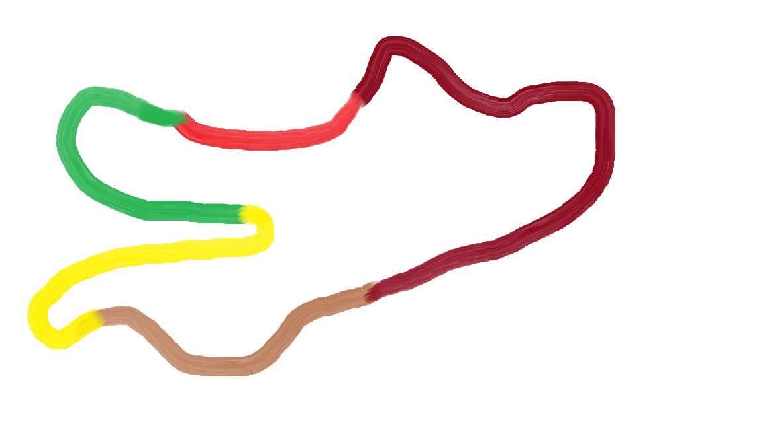

As current circuit design practice, it attempts to monitor the duty cycle of off-road vehicle motion and speed with a combination of gravel traps and barriers to the motion. Poor gravel trap deceleration rates, coupled with a wide variation in vehicle attitude during such excursions, produces an unsatisfactory and unacceptable vehicle response. Walls and Barriers, while more effective at creating high deceleration rates, can also produce an unpredictable response. (Metz, 2000)
Figure 3 Show developed track for buggy
The main disadvantage of the off-course track is that it is not capable of simulating phenomena such as “turn-in” behaviour or other transient reactions, like kerb riding or the polar inertia associated effects. These methods assume that the vehicle can use the tyre maximum capacity in each moment, and they are not able to evaluate vehicle frequency-dependent responses. (Varela, 2017)

3. Calculation
This part of the report will explain how to calculate the duty cycle, to enhance the calculation of duty cycle for the buggy. It is necessary to obtain the buggy dynamic reading on an off-course track to create the spreadsheet in Microsoft Excel. This spreadsheet includes off-course track data for the buggy speed, time, gradient resistance, rolling resistance, aerodynamic resistance, total resistive force, average power and maximum power calculation requirements from the buggy. Buggy dimensions can be seen in figure (4). These dimensions will be used in the calculation to solve the equations for the Coefficient of Drag and Force to be achieved. All these parameters are calculated by using the equations below:
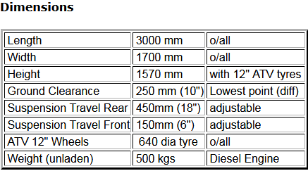

Figure 4 Show the dimension of buggy

3.1 Time
$$Time=\frac{Distance}{Speed}$$

3.2 Speed
Speed is the rate at which distance is covered with respect to time. Speed can be specified by its size alone. Th equation can be rearranged to find the speed of the vehicle. (Bonnick,2008)
$$Time=\frac{Distance}{Speed}$$
$$Speed=\frac{Distance}{Time}$$

3.3 Acceleration
Acceleration occurs whenever the velocity of object changes. When the velocity of an object
decreases it is said to have decelerated. (Bonnick,2008)
Where:
Final velocity= v Initial velocity =u Time =t (120 sec)
$$Acceleration=\frac{(v-u)}{t}$$

3.4 Force
Force is an effect that changes or tends to change, the state of rest or uniform motion of an object (Bonnick,2008). i.e Force is required to move a stationary object or increase the speed of moving object. Total buggy mass 500kg
Two peoples average mass 130Kg = total mass 630 Kg

$$Force =Mass ×Acceleration$$
$$Force = 630 ×Acceleration$$

3.5 Tractive Effort
Tractive effort is the force that is required to propel the vehicle against all resistance to motion. (Bonnick,2008). Gradient resistance starts at 23 sec and Aerodynamic drag start at 1sec.

$$TE=Rolling Resistance+Gradient+Aerodynamic Drag$$

$TE=630+1370+1.152$

3.6 Power
The rate of doing work is described as power as shown by the following formula.
$$Power=Force ×Velocity$$

3.7 Gradient resistance
When a vehicle is climbing a slope (gradient), the extra tractive effort is needed to overcome the effect of gravity. (Bonnick,2008)
$$Gradient resistance=Mass×Gravity ×Sinθ$$
$$Gradient resistance=630×9.81 ×Sinθ$$

Figure (5) show them how to calculate Gradient resistance.
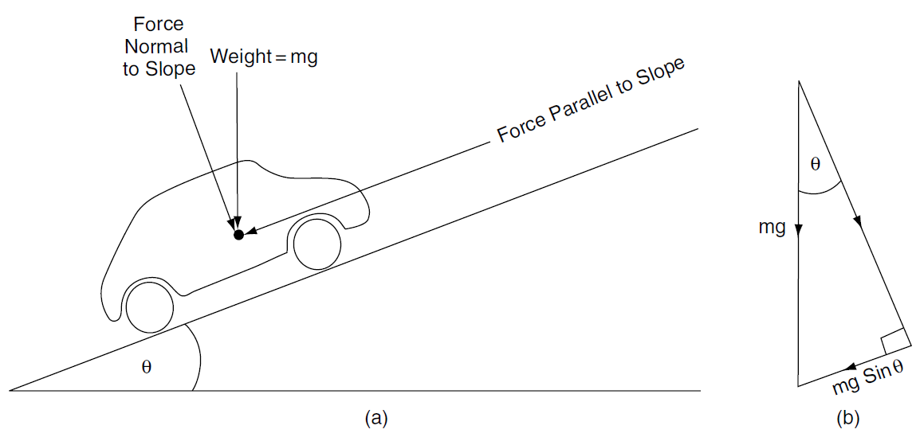

Figure 5 show the illustrate the Gradient resistance

3.8 Rolling Resistance
The rolling resistance of a tyre on a hard surface is primarily caused by hysteresis in the tyre materials. (Ehsani, 2010)
$$Rolling Resistance=Mass ×Grvaity ×RR Coefficient$$
$$Rolling Resistance=630 ×9.81 ×RR Coefficient (Depend on track)$$

3.9 Rolling Resistance Coefficient values
Rolling resistance values are obtained from the tutor handout as it can see in the table (), which will be used in the calculation to solve the buggy duty cycle.
Table 1 shows the rolling resistance Coefficient values
Conditions | Rolling Resistance Coefficient
Car tyres on a concrete or asphalt road | 0.013
Car tyres on a rolled gravel road | 0.02
Tar macadam road | 0.025
Unpaved road | 0.05
Field | 0.1-0.35
Truck tyre on a concrete or asphalt road | 0.006-0.01
Wheel on iron rail | 0.001-0.002

3.10 Coefficient of Drag
Coefficient of drag unit has been converted into metre instead of the millimetre
$$Cd=Height ×Width$$
$$Cd=1.570 ×1.700$$

3.11 Aerodynamic Drag
A vehicle travelling in air encounters a force resistance to its motion. This force is referred to as aerodynamic drag and is dependent on the shape of the vehicle and the speed.
$$Aerodynamic Drag=0.5 ×CD×Air Density ×v^{2}×FrontalArea$$
$$Aerodynamic Drag=0.5 ×0.9×1.2×v^{2}×2.67$$

3.14 Radius of wheel
Buggy tyre rolling circumference was measured at 1.884 metres, which presents the full distance the mark on the tyre travelled in one full revolution of the tyre. The formula to find the radius of the rolling wheel is:-
C=π.D (1.884 =3.14 X D)
Rearrange it to make D subject

Diameter of the tyre on the rolling road = 0.60m

3.15 Coefficient of Drag
To find the coefficient of drag it is necessary to rearrange the force drag equation (Bonnick, 2008).
Whereas, F_{D} = Drag force, $ρ$ = mass density, $u^{2}$= Flow velocity and A= Area
$F_{D}=\frac{1}{2}ρu^{2} C_{D }A$
$$C_{D }=\frac{2F_{D}}{ρu^{2}A}$$

4. Results and Analysis

4.1 Rolling resistance against Time
Rolling resistance was constant on field and on the dry mud until the 40 sec, soon it was on wet mud and the rolling resistance increased between the 41 sec and 72 secs, after which the rolling resistance decreased on the unpaved road until the 96 sec and the concrete road also showed less resistance.

Figure 6 shows the rolling resistance against time graph

4.2 Gradient resistance against Time
Gradient resistance was constant on the field until the 20 sec, after which it was on dry mud and the resistance increased. The resistance then decreased then increased between the 34 sec and 37sec. Soon it was on wet mud and it has decreased before increasing again between the 60 sec and 68 sec. It varies on the unpaved road and the concrete road

Figure 7 shows the gradient resistance against time graph

4.3 Aerodynamic drag against Time
The aerodynamic drag force constantly increases from the field between the 2 sec and 16 sec. Then it moved to dry and wet mud and it started to drop between the 26 sec and the 74 sec. It progressed to the unpaved road when it increased again between the 76 sec and 100 sec. It then dropped on the concrete road.

Figure 8 shows the aerodynamic drag against time graph

4.4 Acceleration resistance against Time
Acceleration resistance was constant between the 2 sec and the 10 sec. Then it started to decrease and increase on dry then wet mud. Acceleration quite drops at 31 sec and increases on the 38 sec when it was on dry mud. It then constantly increased and decreased on each terrain.
Figure 9 shows the acceleration resistance against time graph

4.5 Total resistance against Time
Total resistance decrease between the 36 sec and 46 secs when it's on the dry and the beginning of the wet mud. It then increased and then started to decrease at between the 101 sec and the 121 sec.

Figure 10 shows the total resistance against time graph

4.6 Velocity against Time
Velocity increased between the 12 sec and 20 secs when it was on the field. It has decreased on dry and wet mud between 24 sec and 68 sec and then increased between the 76 sec and 88 sec when it was on an unpaved road. It then started decreasing on the concrete road.

Figure 11 shows the velocity against time graph

4.7 Power against Time
Power decreased between 34 secs and 36 secs when it was on the dry mud. It then increased between 84 secs and 86 secs and decreased between 101 secs and 102 secs when it was on the unpaved road.

Figure 12 shows the power against time graph

4.8 Power and Average power against Time
Power increased and decreased when it was on different terrains, but average power was constant.

Figure 13 shows the power and average power against time graph

4.9 Forces against Time
Forces increased and decreased on the different track surfaces, but the total resistance decreased between 34 secs and 43 secs when it was on the dry and wet mud. It then increased between 63 secs and 67 secs when it was on an unpaved road.

Figure 14 shows the forces against time graph

5. References/ Bibliography
Ehirim, O., "Optimal Diffuser Design for Formula SAE Race Car Using an Innovative Geometry Buildup and CFD Simulation Setup with On-Track Testing Correlation," SAE Technical Paper 2012-01-1169, 2012, https://doi-org.ezproxy.uwtsd.ac.uk/10.4271/2012-01-1169.
Haubenreich, R. and Law, E., "An Investigation into the Effects of Suspension Tuning on the Cornering of a Winston Cup Race Car," SAE Technical Paper 2000-01-3569, 2000, https://doi-org.ezproxy.uwtsd.ac.uk/10.4271/2000-01-3569.
"Vigilante, Corporate USE, Any Engine, Diesel, Full Roll Cage." Blitzworld.co.uk. N.p., 2017. Web. 12 Oct. 2017.
Wordley, S. and Saunders, J., "Aerodynamics for Formula SAE: Initial Design and Performance Prediction," SAE Technical Paper 2006-01-0806, 2006, https://doi-org.ezproxy.uwtsd.ac.uk/10.4271/2006-01-0806.
Baleato Varela, A. and Irlinger, F., "A Feasibility Study on Driver Model Based Lap Time Simulation Using Genetic Algorithms," SAE Int. J. Passeng. Cars - Mech. Syst. 10(2):401-412, 2017, https://doi-org.ezproxy.uwtsd.ac.uk/10.4271/2017-01-9679.
Floyd, R. and Law, E., "Simulation and Analysis of Suspension and Aerodynamic Interactions of Race Cars," SAE Technical Paper 942537, 1994, https://doi-org.ezproxy.uwtsd.ac.uk/10.4271/942537.
Gadola, M., Candelpergher, A., and Adami, R., "The Impact of Non-Linear Aerodynamics on Racecar Behaviour and Lap Time Simulation," SAE Technical Paper 2002-01-3332, 2002, https://doi-org.ezproxy.uwtsd.ac.uk/10.4271/2002-01-3332.
Owens, A., Jarmulowicz, M., and Jones, P., "Structural Considerations of a Baja SAE Frame," SAE Technical Paper 2006-01-3626, 2006, https://doi-org.ezproxy.uwtsd.ac.uk/10.4271/2006-01-3626.
Metz, L. and Metz, L., "A Technique for Slowing Racing Cars After Off-Road Excursions: The Vehicle Arrester," SAE Technical Paper 2000-01-3574, 2000, https://doi-org.ezproxy.uwtsd.ac.uk/10.4271/2000-01-3574.
Bonnick, Allan. Automotive Science And Mathematics. 1st ed. Oxford: Elsevier Ltd, 2008. Print.
Ehsani, Mehrdad. Modern Electric, Hybrid Electric, And Fuel Cell Vehicles. 2nd ed. Boca Raton, FL: CRC Press, 2010. Print.

