DS 1 Template

My Screenshots/Photos
- Please add 4–6 screenshots or photos of your digital life.
- You can use your phone or laptop.
- For each screenshot, write one or two sentences explaining what it shows.

Screenshot/Photo 1
[Insert Photo/Screenshot below]
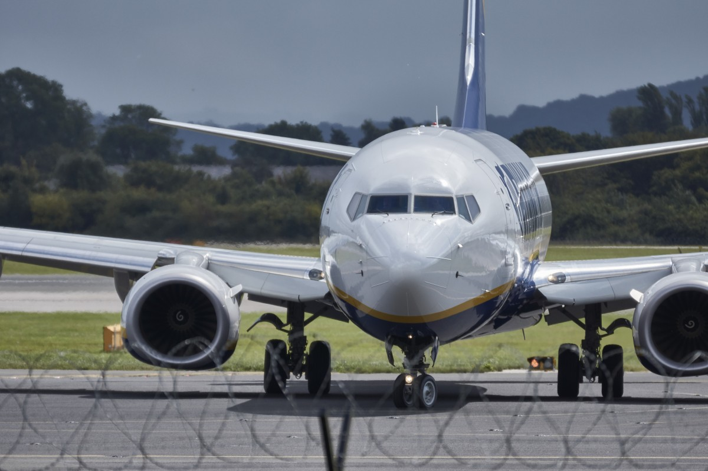
I Use Aeroplane for travelling one country to another country. Even one city to another city and it saves my time. Travelling is very convenient. Use entertainment tools by playing games while travelling and watching movies.

Screenshot/Photo 2
[Insert Photo/Screenshot below]
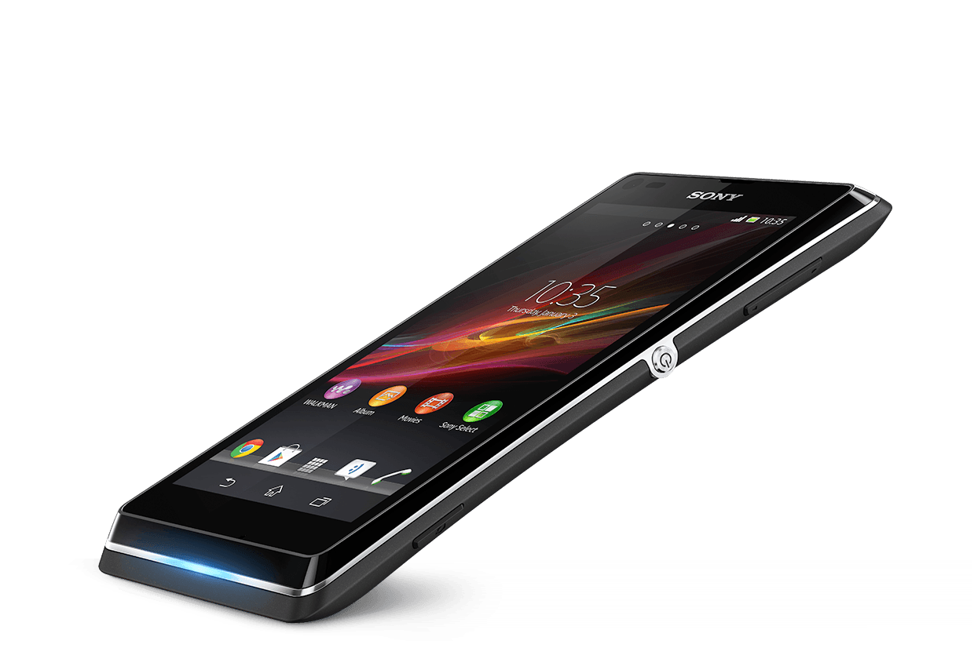
Phone keep me in touch with my family and friends. I use this phone for all my communications. In these days I check all me emails on the phone. I got lot of apps for different purpose for example to check the weather etc.

Screenshot/Photo 3
[Insert Photo/Screenshot below]
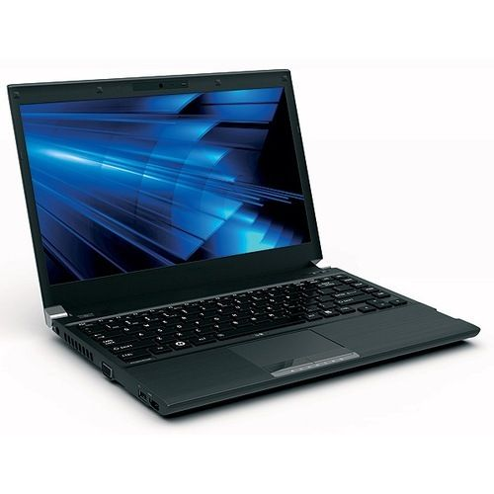
I use this Tool for all my assignments. It is useful for daily tasks by putting all my meetings notes. I use this for my business purpose. I have stock apps and get connected to the brokers.

Screenshot/Photo 4
[Insert Photo/Screenshot below]
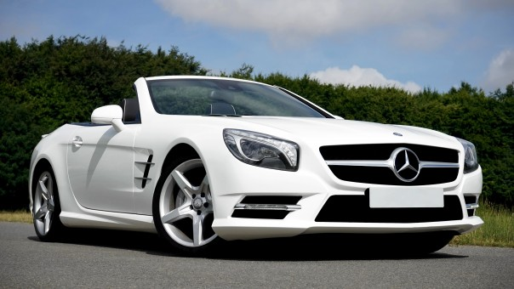
I use my car for commuting one place to another place. My car got lot of functions. For example, Bluetooth, cruise control, cd player. Very fuel efficient because of new technology.

alScreenshot/Photo 5
[Insert Photo/Screenshot below]

[Write what this shows of your digital life]

Screenshot/Photo 6
[Insert Photo/Screenshot below]
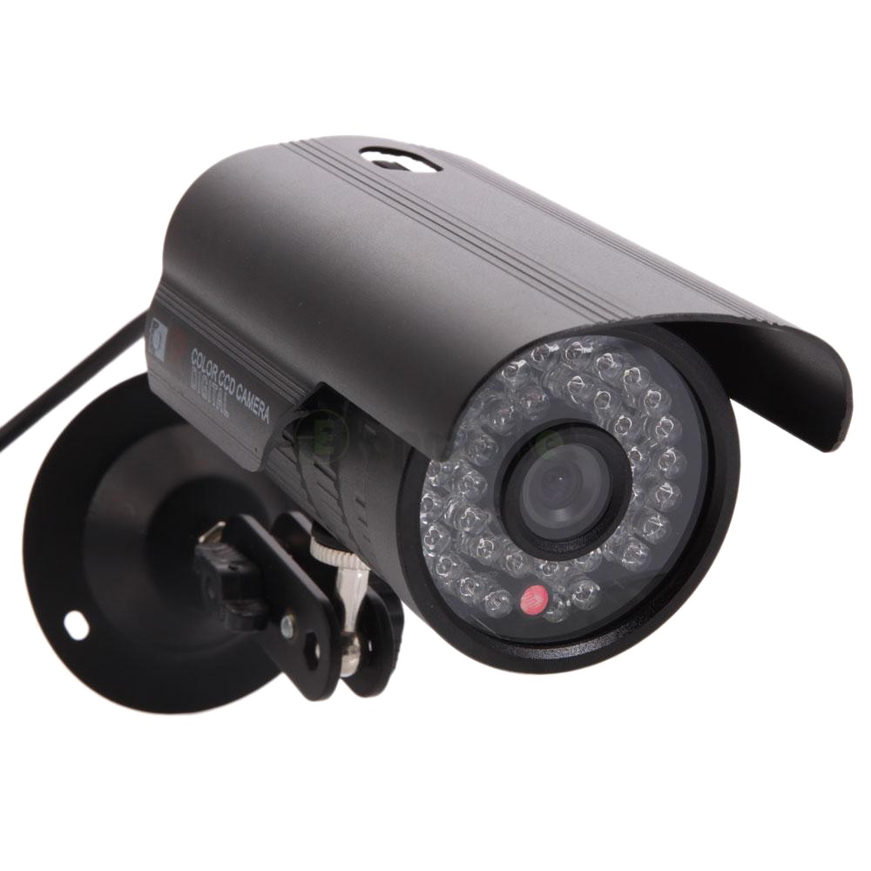
This is very useful tool for my house and business security. I can check while anywhere in the world what exactly is going on in my property.

My Short Reflection
- Write 5–8 simple sentences about your digital life.
- You can use the sentence starters below if helpful.
I use digital tools to make my life easy and comfortable.
I feel confident when I use my phone as I get all the updates over the phone and not worried about my family as I got this tool always with me, so they can contact me in any situation.
I want to improve my digital skills. I am still working on them to make more use of this technology.
I often use these tools to ease my life.
I am studying digital skills to polish my knowledge about these tools.

Sentence starters
- I use digital tools to …
- I feel confident when I …
- I want to improve …
- I often use these tools: …
- I sometimes feel nervous about …
- I hope this module will help me …
- Digital skills are important for me because …
You can write more if you want.

Submission Checklist
Before you submit, please check:
​​​ ☐ I added 4–6 screenshots
☐ I wrote short sentences for each screenshot
☐ I wrote my short reflection
☐ My work is my own
☐ My file opens correctly
​​☐ My file opens correctly

