

Student Name: Ahmed Rain

Student ID: 2535781

Module Name: Marketing Management

Module Code: LCMB7024

Lecturer’s Name: Tushara Balendran

Work Count: 2583

Term 1

Introduction
This report examines BHP Group Limited and its journey towards being a lower carbon group of companies. It covers the natural and political/regulatory marketing environment, the growth strategy from the Ansoff Matrix, a discussion on competitive advantage from the Porter's Generic Strategies. Lastly, it offers a critical reflection on the responsible use of Artificial Intelligence (AI) in the preparation of the report.

1. Task 1: Marketing Environment Analysis

1.1 Company Selection and Context
BHP Group Limited is an Australian multinational mining and metal company established in August 1885. The company was founded and headquartered in Broken Hill and is headquartered in Melbourne, Victoria. The company operates in more than 90 countries, which include Australia, South America, the United States Canada and many more (BHP, 2026a). The key products of BHP include copper ore (for renewable energy), iron ore and metallurgical coal (for steel for new infrastructure) and potash (to support sustainable farming) (BHP, 2026a). With increasing pressure on the metals and mining industry to lower its GHG footprint, BHP has integrated sustainability into their long-term strategy (Kotler et al. 2024). The company aims to achieve a 30% reduction in operational GHG emissions by 2030, emissions intensity reduction in shipping, and invest in steelmaking technologies that produce emissions 30% lower than conventional blast furnace technologies (BHP, 2026b). It also seeks to conserve, restore or practice regeneration on 30% of land and water under its supervision, cementing its position as the leader in the low-carbon mining transition (BHP, 2026b).

1.2 External Marketing Environment Actor 1: The Natural Environment
According to Kotler and Amstrong (2018), the macro environment consists of larger forces (such as the demographic, economic, natural, technological, political and culture) forces that impact the microenvironment and drive a firm to meet the needs of its customers (Refer to Figure 1). The forces are out of the firm’s control and have to be monitored and adapted.
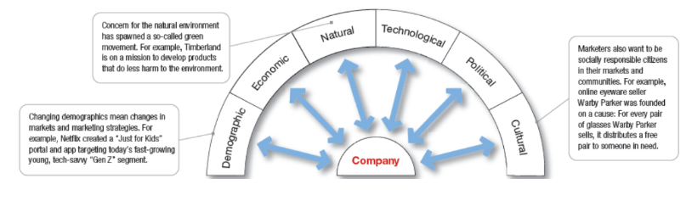
Figure 1: Macro-environmental factors of a company
(Source: Adapted from Kotler and Amstrong, 2018)
The natural environment is identified as one of the most significant factors of the external environment, which is responsible for the transition towards the low-carbon products of BHP. The variables that influence this shift include resource scarcity, climate change, carbon footprint carbon regulations and many more. For example, Enemuo and Ogunmodimu (2025) reported that the mining industry is responsible for contributing to around 4-7% of the emission of greenhouse gases (GHGs) across the world. This is also evident in Australia. For example, as per Figure 2, the Scope 1 emission from coal mining in Australia was 36% in 2023-2024 and 16% from other mining sectors (Australian Government, 2024). Also, the resources industry (mining and oil & gas) accounts for 23% of Australia's total GHGs at 99 Mt CO₂ equivalent in 2022. Fugitive coal mine emissions (25%), diesel combustion (20%) and on-site power generation (11%) were the largest emission sources (NRI Digital, 2026).
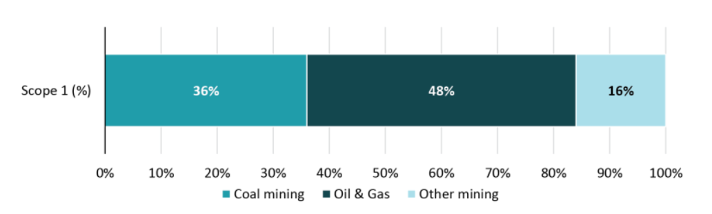
Figure 2: Scope 1 Emission from Resource Sector (mining, oil and gas) in Australia in 2023-24
(Source: Australian Government, 2024)
This can be further supported by Punia and Singh (2025), who argued that mining and mineral processing is responsible for contributing to climate change. This is done by emitting GHG during operations and decreasing the carbon storage due to a loss of vegetation cover. As a result, this also led to resource scarcity. These include the decline of water resources conversion of fertile land into wasteland and many more. Apart from these carbon regulations such as Climate Change Act 2022 (mandated 43% GHG reduction by 2030 and net-zero emission by 2050), Safeguard Mechanism Reforms 2023 (mandated to either reduce carbon emission or buy carbon credits) and others are also put in place to reduce carbon emission (Datamine, 2024). Due to this reason, decarbonisation becomes a strategic priority for mining companies, like BHP. The influence on BHP’s operations is also evident through the achievement of the target regarding at least 30% reduction in carbon emission.
BHP has strategic opportunities and threats in the natural environment. A key opportunity is the growing global demand for critical minerals like copper, nickel and potash, which are vital for renewable energy and electric vehicles and battery technologies (Gielen, 2021). This allows BHP to build on its market position by providing resources needed for the global low-carbon transition and to draw in sustainability investors. However, climate change and tougher environmental laws are also serious threats. Weather disasters, water shortages and loss of biodiversity can affect mining activities and production expenses. Moreover, the implementation of Climate Change Act 2022 and Safeguard Mechanism Reforms 2023 will involve significant investments in low carbon technologies and emissions abatement. The inability to meet these environmental goals may lead to increased compliance costs, regulatory fines and reputational risks, which in turn could have long-term consequences for BHP's competitiveness and profitability.

1.3 External Marketing Environment Actor 2: Political/Regulatory
Political and regulatory climate is a very pertinent external marketing actor for BHP because policies relating to climate change have a direct impact on large mining companies in Australia. The Australian Government introduced the Safeguard Mechanism to reduce emissions from industrial facilities that emit more than 100,000 tonnes of carbon dioxide equivalent (CO₂-e) each year (including mining operations) (DCCEEW, 2026a). In 2023–24, the scheme included 219 facilities, including those in the mining, manufacturing and transport sectors that account for some 31% of Australia's GHGs (DCCEEW, 2026b). Therefore, this policy has a significant influence on BHP's marketing environment and sustainability transition.
The reformed Safeguard Mechanism requires covered facilities to reduce their emissions through annual baseline declines of 4.9% until 2030. This supports Australia's target of reducing emissions by 43% below 2005 levels by 2030 and achieving net zero by 2050 (DCCEEW, 2026a). These stricter regulations create challenges for BHP because the company must continue investing in renewable electricity, cleaner technologies and operational improvements to meet declining emissions limits. Facilities have compliance obligations if emissions are above and beyond the required baseline, for example, by buying carbon credits, which can add to operating costs (DCCEEW, 2026b). Further pressures on future mining projects also exist as new plant must be compliant with international best practice emissions standards (DCCEEW, 2026a).
Nonetheless, there are also key opportunities for BHP in the regulatory landscape. This has led to the company's response of redirecting its portfolio to commodities that are associated with the decarbonisation and electrification process, such as copper, nickel, uranium, potash and high-quality iron ore (BHP, 2024b). The rising demand for these commodities for electric vehicles, renewable energy technologies, power grids, and sustainable agriculture will aid in BHP's alignment with evolving government policies and market demand (BHP, 2024b). BHP also claims that it is supporting government policies that align with Paris Agreement objectives, and collaborating with industry and governments to accelerate their transition to net zero (BHP, 2024a). Additionally, the Australian Government is promoting industrial decarbonisation through various initiatives, including the Safeguard Transformation Stream, which is worth $600 million, and the Industrial Transformation Stream, which has a value of $400 million (DCCEEW, 2026b). These initiatives support BHP's target to reduce operational greenhouse gas emissions by at least 30% by FY2030 and achieve net zero operational emissions by 2050 (BHP, 2024a). Therefore, effective compliance with Australian regulations can strengthen BHP's sustainability reputation, improve investor confidence and enhance its competitive position in the global mining industry.

2. Task 2: Strategic Growth and Competitive Positioning

2.1 Strategic Growth Recommendation Using the Ansoff Matrix
Building on the environmental analysis in Task 1, Product Development is the most appropriate growth strategy from the Ansoff Matrix for BHP. This strategy focuses on developing improved products for existing markets rather than entering completely new markets (Peterdy, 2022). This is why; this quadrant matrix has medium risk (more risk than market penetration but less risk than market development and diversification) (Refer to Figure 3). It is suitable because BHP already has a strong position in global mining, while the growing demand is shifting towards lower-carbon and transition minerals. Therefore, the company should continue improving and expanding its portfolio of lower-carbon products instead of relying on traditional mining products.
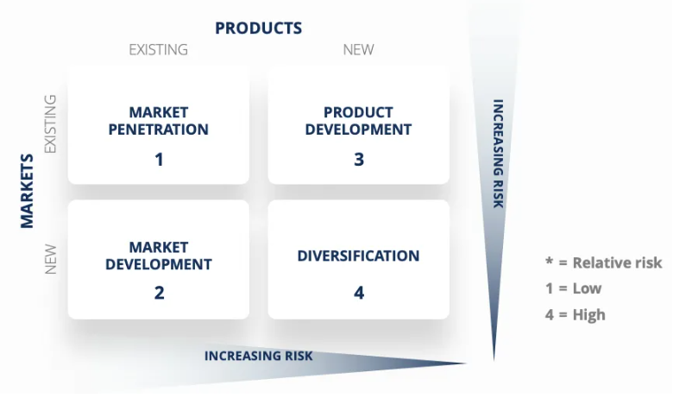
Figure 3: Ansoff Matrix
(Source: Peterdy, 2022)
This strategy is well supported by the identified environmental pressures in Task 1. Australia's ambition of 43% less emissions than 2005 levels by 2030 and net zero by 2050 (DCCEEW, 2026a) and its more stringent climate policies such as the Safeguard Mechanism are a challenge for large mining facilities to reduce emissions. Meanwhile, shifting customer expectations are a result of climate change and carbon regulations, and the growing demand for cleaner supply chains. Such pressures incentivise BHP to create products that will enable decarbonisation more so than to increase production of existing commodities.
This strategy is well supported by the identified environmental pressures in Task 1. Australia's ambition of 43% less emissions than 2005 levels by 2030 and net zero by 2050 (DCCEEW, 2026a) and its more stringent climate policies such as the Safeguard Mechanism are a challenge for large mining facilities to reduce emissions. Meanwhile, shifting customer expectations are a result of climate change and carbon regulations, and the growing demand for cleaner supply chains. Such pressures incentivise BHP to create products that will enable decarbonisation more so than to increase production of existing commodities (BHP, 2025).
The experience of other leading mining companies further justifies this recommendation. For example, Anglo American has partnered with H2 Green Steel to test premium iron ore in hydrogen-based steelmaking (Anglo American, 2023). The partnership aims to develop lower-carbon steel production and reduce emissions across the steel value chain by supplying higher-quality iron ore for direct reduced iron technology. Similarly, Rio Tinto, together with BHP and BlueScope Steel, is developing the NeoSmelt pilot project (new improved products) in Western Australia (existing market) (Reuters, 2024). Direct reduced iron (DRI) technology will use renewable electricity to generate 30,000–40,000 tonnes of low-carbon molten iron per year at the plant. The purpose of this project is to decrease emissions from steel manufacturing, responsible for approximately 8% of the world's carbon emissions at present (Reuters, 2024).
Market Penetration, on the other hand, would primarily focus on the promotion of current products with no special consideration given to rising sustainability requirements. Market Development concentrates on new geographical markets while Diversification has a greater investment risk because it is entering into entirely new industries (Peterdy, 2022). Hence Product Development has the optimum ratio of growth and risk. It will allow BHP to meet environmental and regulatory challenges, further enhance its low carbon strategy and ensure long term competitiveness in the global mining sector.
Advantages and disadvantages of the Ansoff Matrix
Ansoff Matrix is a tool which is used to look into the possibilities of growth opportunities in consideration of the risk level. It offers an easy way to choose the right strategy considering market and product conditions (Peterdy, 2022). It primarily deals with growth possibilities and looks at nothing outside of itself (other external factors like competition, market uncertainty or changes in regulations).

2.2 Competitive Advantage Through a Lower-Carbon Business Model
BHP can pursue long-lasting competitive advantage through a combination of Product Development as recommended in Section 2.1 and adoption of a lower carbon business model. Based on Porter's Generic Strategies (refer to Figure 4), BHP can improve its position by using cost leadership. This can be beneficial in reducing operational costs, along with supplying low carbon products that will align with evolving customer needs and regulatory expectations.
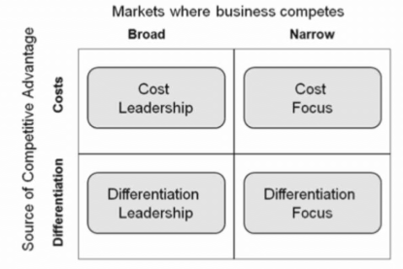
Figure 4: Porter’s Generic Force
(Source: Subrahmanyam, 2019)
On the cost leadership side, decreasing emissions in the operational phase helps in making the process more efficient in the long run. To reduce emissions and remain productive, BHP is making investments in renewable electricity, electrification of mining equipment and operational decarbonisation (BHP, 2024a). The company has also entered into renewable electricity contracts to fund new renewable electricity generation projects, and to lessen reliance on fossil fuels (BHP, 2024a). As opined by Aydogdu et al. (2024), high upfront cost is the major barrier of integrating renewable energy and electrification in mining operations because diesel-powered alternatives are comparatively cheaper. Therefore, it could decrease short-term profits. The substitution of diesel-powered equipment with electric alternatives and increased use of renewable energy, however, can lower GHG emission by 50% and reduce long-term energy cost (Onifade et al. 2024). It will minimise the company's vulnerability to future carbon pricing and compliance costs through compliance with the Australian Safeguard Mechanism. This is relevant as facilities with emissions greater than 100,000 tonnes of CO₂-e per annum are required to reduce emissions under declining baselines (DCCEEW, 2026a). So, operational efficiency can translate to an ongoing cost benefit.

3. Task 3: Critical Reflection on AI Usage

3.1 Tool Disclosure
Artificial intelligence tools were used only for limited purposes during the preparation of this report. ChatGPT was used to support the research process by identifying relevant company reports and industry publications related to BHP and also sustainability and lower-carbon business strategies. But not all of the sources were correct as I checked the suggested sources. Grammar, Spelling, Punctuation and Sentence clarity were also checked using Grammarly. Most importantly, the final written content and structure of the report has not been created by an AI tool as per the assessment requirements

3.2 Critical Evaluation of AI Output
Care was taken to ensure that all information gathered via AI-assisted research was verified prior to the incorporation of the information in the report. Facts, statistics and company information were checked against original sources (including BHP's Annual Report and Climate Transition Action Plan, Australian Government publications and peer-reviewed academic journals). Where differences were identified between AI suggestions and the original sources, only the information supported by authentic and accessible references was used. This verification process helped improve the accuracy and reliability of the report.

3.3 Contribution Analysis
AI was only used to help with identifying literature and to aid with the grammatical quality of the report. The choice and selection of evidence, interpretation of findings, comparison of different sources and evaluation of BHP's marketing environment, strategic growth and competitive advantage were done separately. The discussion, critical analysis and conclusions reflect personal understanding of the module concepts. Besides, the evidence collected from credible academic and industry sources. This method helped maintain the authenticity of the report while leveraging AI in an ethical and responsible way as an aid to the writing process, not as a substitute for autonomous learning and critical thinking.

3.4 Ethical and Professional Reflection
The use of AI has greatly improved the overall research efficiency as it assisted me to search resources and compare and interrogate materials. But I also understood that over relying on AI might have diminished my critical thinking skills and led me to inaccurate or biased information. Hence, I made sure that all the AI-generated material was validated from reliable sources and referenced appropriately. I think that AI should complement rather than substitute my own thinking so that a critical analysis and ethical decision-making is done.

Conclusion
Natural and political/regulatory factors are important influences on BHP's path to a lower carbon business model. These pressures favour the adoption of the Product Development strategy to achieve sustainable growth, and enhance competitive advantage with cost efficiency and low-carbon products. Nevertheless, there is a need for ongoing investment, innovation and respect for the environment for success in the long term. The report also emphasises the importance of responsible use of AI to aid in research and proofreading. It also emphasises the need for independent analysis, critical thinking, and verification in the creation of reliable and ethical academic work.

4. References
Anglo American (2023) Press releases – 2023. https://www.angloamerican.com/media/press-releases/2023/04-04-2023 (Accessed: 06 July 2026)
Australian Government (2024) Resources sector emissions: an overview. Available at: https://www.industry.gov.au/publications/resources-sector-plan/resources-sector-emissions-overview (Accessed: 06 July 2026)
Aydogdu, K., Duzgun, S., Yaylaci, E.D. and Aranoglu, F. (2024) ‘A systems engineering approach to decarbonizing mining: Analyzing electrification and CO2 emission reduction scenarios for copper mining haulage systems’. Sustainability, 16(14), p.6232. Available at: https://doi.org/10.3390/su16146232
BHP (2024a). BHP's Climate Transition Action Plan (CTAP) 2024. https://www.bhp.com/sustainability/climate-change/climate-transition-action-plan (Accessed: 06 July 2026)
BHP (2024b) CLIMATE TRANSITION ACTION PLAN 2024. https://www.bhp.com/sustainability (Accessed: 06 July 2026)
BHP (2025) Annual Report 2025. https://www.bhp.com/-/media/documents/investors/annual-reports/2025/250819_bhpannualreport2025.pdf (Accessed: 06 July 2026)
BHP (2026a) Building what’s next is what BHP does best. Available at: https://www.bhp.com/ (Accessed: 06 July 2026)
BHP (2026b) Sustainability. Available at: https://www.bhp.com/sustainability (Accessed: 06 July 2026)
Datamine (2024) Legislative Whirlwind: Rapid Policy Changes in Australia’s Mining Industry. Available at: https://dataminesoftware.com/legislative-whirlwind-rapid-policy-changes-in-australias-mining-industry/ (Accessed: 06 July 2026)
DCCEEW (2026a) Safeguard Mechanism. Available at: https://www.dcceew.gov.au/climate-change/emissions-reporting/national-greenhouse-energy-reporting-scheme/safeguard-mechanism (Accessed: 06 July 2026)]
DCCEEW (2026b) Safeguard Mechanism overview. Available at: https://www.dcceew.gov.au/climate-change/emissions-reporting/national-greenhouse-energy-reporting-scheme/safeguard-mechanism/overview #ensuring-the-schemes-emissions-reduction-targets-are-met (Accessed: 06 July 2026)
Enemuo, M. and Ogunmodimu, O. (2025) ‘Transitioning the mining sector: A review of renewable energy integration and carbon footprint reduction strategies’. Applied energy, 384, p.125484. Available at: https://doi.org/10.1016/j.apenergy.2025.125484
Gielen, D. (2021) Critical minerals for the energy transition. International Renewable Energy Agency, Abu Dhabi, 42.
Kotler, P. and Amstrong, G. (2018). Principles of Marketing. Edisi 15 Global Edition.
Kotler, P., Armstrong, G., Harris, L.C. and He, H. (2024) Principles of marketing. 19th edn. Harlow: Pearson.
NRI Digital (2026) Emissions reduction in Australia's mining sector. Available at: https://mine.nridigital.com/mine_australia_nov24/australia-mining-emissions#nav-area (Accessed: 06 July 2026)
Onifade, M., Zvarivadza, T., Adebisi, J.A., Said, K.O., Dayo-Olupona, O., Lawal, A.I. and Khandelwal, M. (2024) ‘Advancing toward sustainability: The emergence of green mining technologies and practices’. Green and Smart Mining Engineering, 1(2), pp.157-174. Available at: https://doi.org/10.1016/j.gsme.2024.05.005
Peterdy, K. (2022) Ansoff Matrix. https://corporatefinanceinstitute.com/resources/management/ansoff-matrix/ (Accessed: 06 July 2026)
Punia, A. and Singh, S.K. (2025) ‘Concurrence of mining and climate change: environmental implications and mitigation strategies’. Environmental Geochemistry and Health, 47(7), p.241. Available at: https://doi.org/10.1007/s10653-025-02556-z
Reuters (2024) BHP, Rio Tinto to build low-carbon iron pilot plant in Western Australia. https://www.reuters.com/markets/commodities/bhp-rio-tinto-build-low-carbon-iron-pilot-plant-western-australia-2024-12-17/ (Accessed: 06 July 2026)
Subrahmanyam, S. (2019). Carrefour's competitive strategy-cost leadership and differentiation: A case study. Pacific Business Review International, 11(8). https://www.researchgate.net/profile/Sarah-Azad-Fouad-Arif/publication/333118406_Carrefour's_Competitive_Strategy-_Cost_Leadership_and_Differentiation_A_Case_Study/links/5cdc7435299bf14d959c419a/Carrefours-Competitive-Strategy-Cost-Leadership-and-Differentiation-A-Case-Study.pdf

