

Academic and Employability Skills
Reflective report
Term 2

Student: Irina Merlan
1818268
Sylvia Hoffmann and Matthew Peak
03.01.2020

Table of content:
- Aknowledgments……………………………………………………………………………….page 3
- Introduction………………………………………………………………………………..……..page 3
- Methodology…………………………………………………………………………………..…page 3
- Reflective report(the first and second term)…………………………..……..…..page 3
  - Topic 1 C.V. with Personal statement and Cover Letter(Gibbs)page 3
  - Topic 2 Presentation Skills(Kolb’s)…………………………………………. page 5
  - Topic 3 Time management(Driscoll)………………………………………..page 6
  - Topic 4 Analytical and critical thinking(Schon)………………………..page 7
- Conclusion…………………………………………………………………………….…………...page 9
- Refferences……………………………………………………………………..…………...…...page 10
- Appendices ……………………………………………………………………………..…….…..page 11

Aknowledgments
I would like to express my very incredible appreciation to my professor Matthew Peake for his precious and constructive suggestions during this term when we were planning and developing this research work. I would like to express my appreciation and gratitude to Sylvia Hoffmann because she guide me the whole term. As well, many thanks to Joanna Walsh because she was my lecturer in the first term and she suggest me methods of how to discover and to improve my academic and employability skills such as paraphrasing, summarising, how to write an academic report, harvard referencing style, swot analysis about myself and many more. Her willingness to provide her time at our classes and her patient quidance were very much appreciated.
Introduction
This reflective report has the purpose to demonstrate how the learning on this module helped me to develop my employability skills. According to D. Pool&Sewell( 2007), “Employability is having a set of skills, knowledge, understanding and personal attributes that make a person more likely to choose and secure occupations in which they can be satisfied and successful.’’ As a simple definition, employability is about being capable of getting and keeping a fulfilling job. My employability depends on what I know (my knowledge), what I do with my knowledge ( my skills) and the way that I approach tasks( my attitude).
Methodology
I learned during the first and second term of this module different methods in which I can develop my employability skills. I reflect on this methods using four models of reflection: Gibbs, Kolb, Driscoll and Schon. I have used Gibbs model of reflection to analysise my C.V. Writing Skill, in order to develop my presentation skills I have used Kolb model of reflection. After that I wanted to analyse and to reflect how good I am with writing my cover letter and I have used Driscoll model of reflection and to complete my employability skills with a good personal statement I have used Schon’s model of reflection to reflect on this subject.
C.V. Writing, Personal Statement, Cover Letter, Presentation Skills, Models of Reflective Writing(Gibbs, Analytical and Critical Thinking, Time Management
C.V. Writing with Personal Statement and Cover Letter
A CV represents for me one of the most important documents ever created with and for my career experience. That is why the writing of a CV can be a difficult and stressful task because I need to provide to a potential employer a professional and polished description of myself including my work experience, my education, my interests or my hobbies, my achievements, my skills and references (if it is the case). In order to write a good CV it doesn’t need to be longer that two A4 pages and it doesn’t need to have any grammar mistakes that is why I need my academic skills as well such as writing. In the CV I need to include a Personal Statement and along with the CV I need to create a Cover Letter for the employer and it needs to be attached together with the CV.
Gibbs reflective model
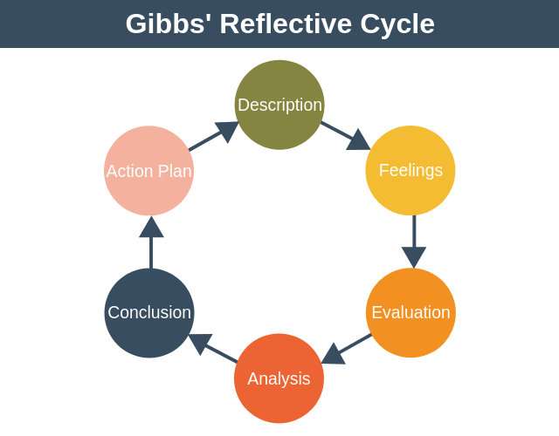
Description
Through my university period I was employed but I wanted to change my job so in order to do this I had to write my CV. I didn’t knew how to write a good CV before but because of all the skills that I gained during this two terms now I am confident in my CV writing skills.
Feelings I see myself shaped as an entirely different but better person on both professional and personal fields because from the begging of university I gained multiple skills which helped me to gain the skill of writing a good CV
Evaluation
I think it was a weak point for me the fact that I didn’t knew about the existence of a Personal Statement and I didn’t always attached a Cover Letter along with my CV, only if the employer requested it. The good about this experience of applying at a new job on this term is the fact that I learned and practice the writing of a CV with a Personal Statement and what is the format of a Cover Letter.
Analysis
After analysing this situation I must admit that I manage to create the most accurate version of my CV which really represents me and after a short waiting to be called at interviews I succeded to get employed on the position that I wanted at one of the best company which I have ever applied to.
Conclusion
Before this term I didn’t even knew what is a Personal Statement and that a good CV has this included but since I have developed my critical and analytical thinking and with the help of the SWOT Analysis which I have made last term about my skills I am feeling ready to apply all this and to write a Personal Statement which represents me in a short, clear and effective way and to write the perfect CV.
Action Plan
My plan is to follow my Personal Development Plan to check how to accomplish my goals especially in my professional life and if I will lose my job I am able to apply quicky for a new one because I gained the skills that I need in order to improve my employability.
Presentation Skills
A presentation is a speech made by an individual before a specified audience on a subject based on real data and information processed for the purpose of that specific occasion and it is delivered with the help of audio-visual aids in order to make a positive impact on the audience,
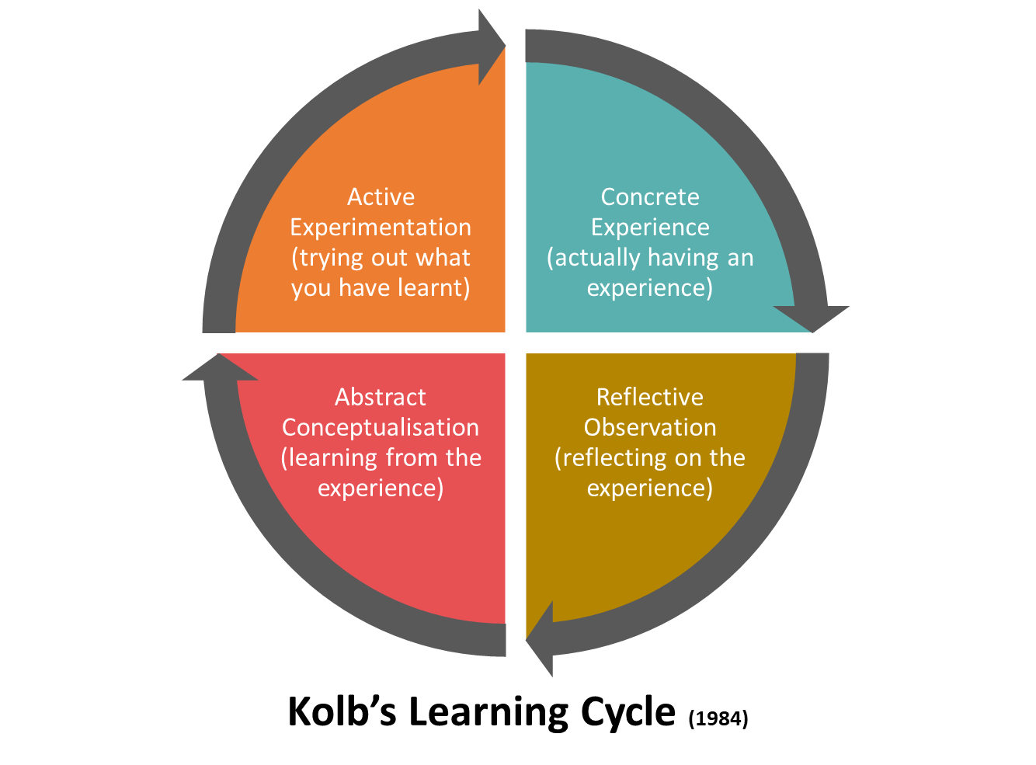

Concrete experience
During my academic experience I had to do a few presentations about different subjects during my classes and I had to present myself during interviews.
Reflective Observation
Presentations weren’t my strongest skill but as a student and as a worker in retail industry as a team-leader I gained interesting experiences which helped me to improve my presentation skills. I realised that if I am interacting with my colleagues and in general with the people that I need to do team-working I become more confident on myself. I had to do a presentation about Transferable Skills and it was a group presentation but because the other persons were mising I needed to handle with the situation myself and to present alone the whole thing.
Abstract Conceptualisation
I learned from my experiences as a student and as a team-leader that if I get myself out of my comfort zone and explore new stuff and try to develop my abilities I become able to present myself anytime and anywhere because I am prepared now. That is on the strenght of this module as well because I had to do the in-class presentation which I have it attached in my appendices.
Active Experimentation
The following week after that presentation which basically change my point of view about presentations I had to do a presentation by myself which I succeded at because I learned how to apply all the thinks that I learned and how to improve my presentation skills based on the feedback that I received.
Time Management
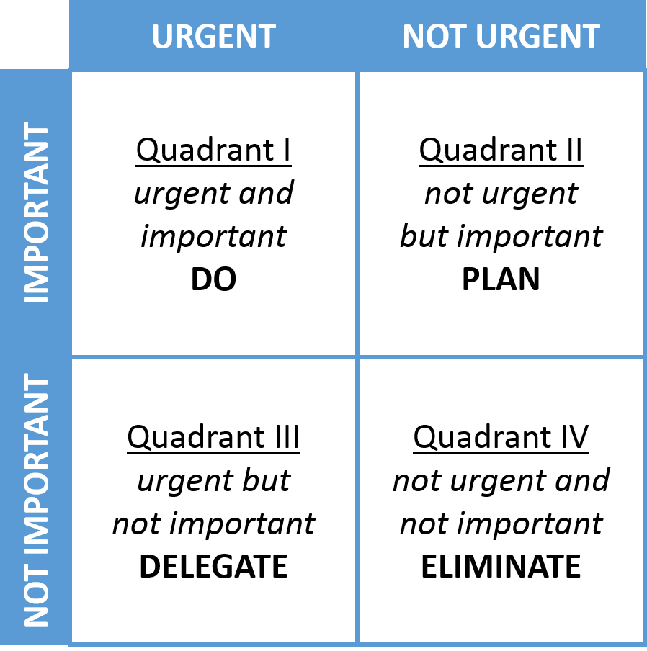
Time management is a crucial skill in everybody’s life. Stephen Covey developed a Matrix named The Eisenhower Method which helped me to improve my time management skill. This method helps me to analyse my activities bades on which one is urgent and which one is important and I can divide my activities in 4 categories: urgent and important, not urgent but important, urgent but not important and not urgent and not important. In thw first category I choose which tasks I need to do now, in the second category I planned when to do the important activities, in the third category I can analyse which activities are urgent and I can delegate another person to help me to complete my activities.
In the last category I discovered which are the tasks that I need to eliminate from my plan because they are not urgent and not important.
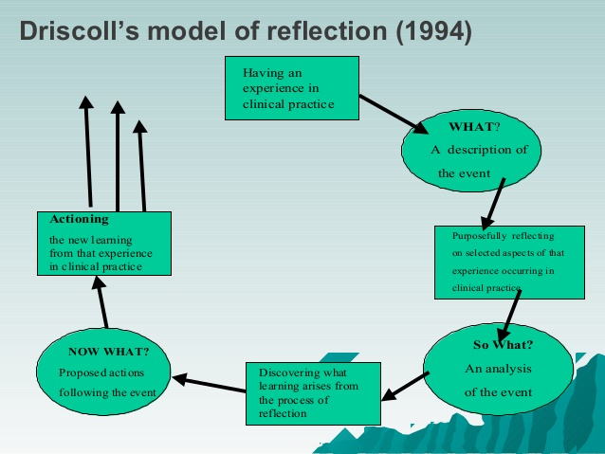
Description of the event: At the begginging of my academic experience I was always late for classes, I had a lot of things to do because I was really busy but I focused myself on irelevent and not important activities which steal my time. Now with the help of Time Management Matrix which I learned about in the first term I am able to plan my daily tasks and to complete them succesfully.
Analysis of the event: I started to create my personal development plan and I didn t finish to complete it because I had to think about different period of time such as goals on a short term, midle term and long term and it was hard for me to plan it for that time.
Proposed actions following the event: Now with the method learned I finished my PDP and I can focuse more on my goals because I know the time requested for each goal and I am able to prioritize things effectively which also includes the planning of the workloads along with that arriving on time at the workplace and manage everything on time as well (Cathro, O’Kane & Gilbertson, 2017).
Analytical and critical thinking
Analytical and critical thinking is the capacity to hyperlink between problems or trouble in an organisational context. Critical wondering capacity allows an man or woman to draw valid end about sure problems. The process starts with the identity of any troubles that needs to be solved. (Hind& Moss,2011).

Schon’s reflective model
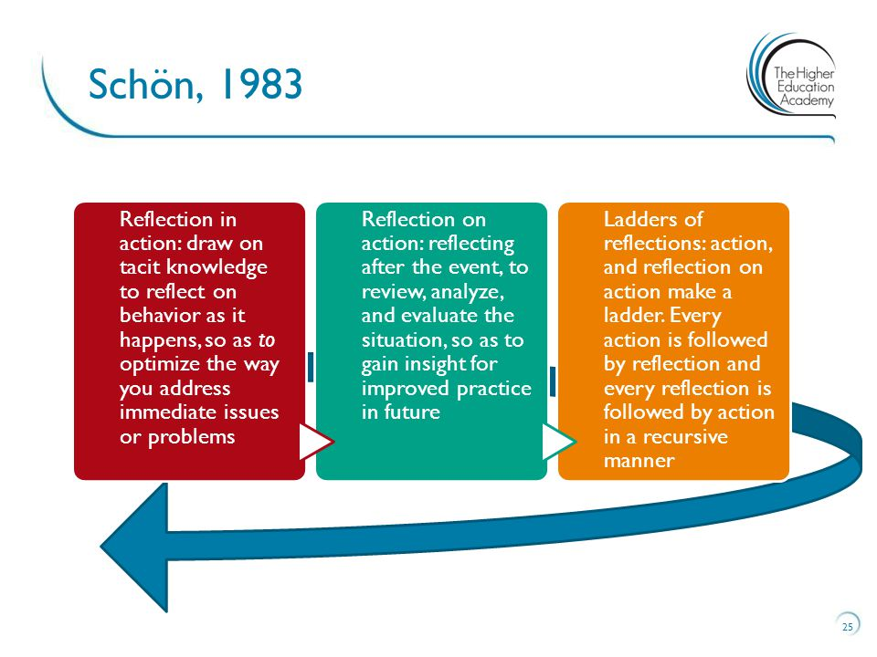
Reflection in action
Working with other people can lead to multiple problems which can not be ignored and I was exposed to those as a team-leader. However, the main problem that I was challenging was the fact that english is not my first language and somehow I felt left aside by my colleagues.
Reflection on action
I have realised that all of us have a different ethnic and racial background and even if for other people they could handle better than myself at work when they are communicating because speaking in english is easier for them than it was for me I tried to change my point of view. I felt criticized and even if nobody told me nothing my analytical and critical thinking helped me to confront my problems.
Ladders of reflection
I tried to manage my issues related to english which is not my first language and I tried on my academic period as a student to express myself more often and to improve my communication skills along with grammar. I thought that if I am missunderstood at work especially as a team-leader it can reduce our productivity for the business and can lead to bad results. I confronted my employees and I understood that even if we are different, we can work together(Green, Hammer & Star, 2009). The results starts to appear slowly but I finally solve my main issue.
Conclusion
Employers want graduates with applicable subject competencies, expertise and understanding, but further to this are looking for well-rounded individuals who have a hard and fast of life capabilities that equip them to evolve well , learn new and specific abilties of the process and take part and make a contribution in a valuable way in their organisation. I am constantly developing useful and marketable capabilities and abilities through managing university work, assignments and projects, element time jobs, involvement in jobs and interests and extracurricular activities.

References
- Green, W., Hammer, S. and Star, C., 2009. Facing up to the challenge: why is it so hard to develop graduate attributes?. Higher Education Research & Development, 28(1), pp.17-29.
- Cathro, V., O’Kane, P. and Gilbertson, D., 2017. Assessing reflection: Understanding skill development through reflective learning journals. Education+ Training, 59(4), pp.427-442.
- Cottrell, S., (2015). Skills for success: Personal development and employability. Macmillan International Higher Education.
- Hind, D. and Moss, S. (2011) Employability skills. Houghton le Spring: Business Education Publ.
- Robinson, J.P., 2000. What are employability skills. The workplace, 1(3), pp.1-3.
- Pitan, O. (2016). Employability development opportunities (EDOs) as measures of students’ enhanced employability. Higher Education, Skills and Work-Based Learning, 6(3), pp.288-304.
- Brewer, L. (2013). Enhancing youth employability: What? Why? and How? Guide to core work skills. ILO.
- Stephan C.,2004 The Seven Habits of Highly Effective People

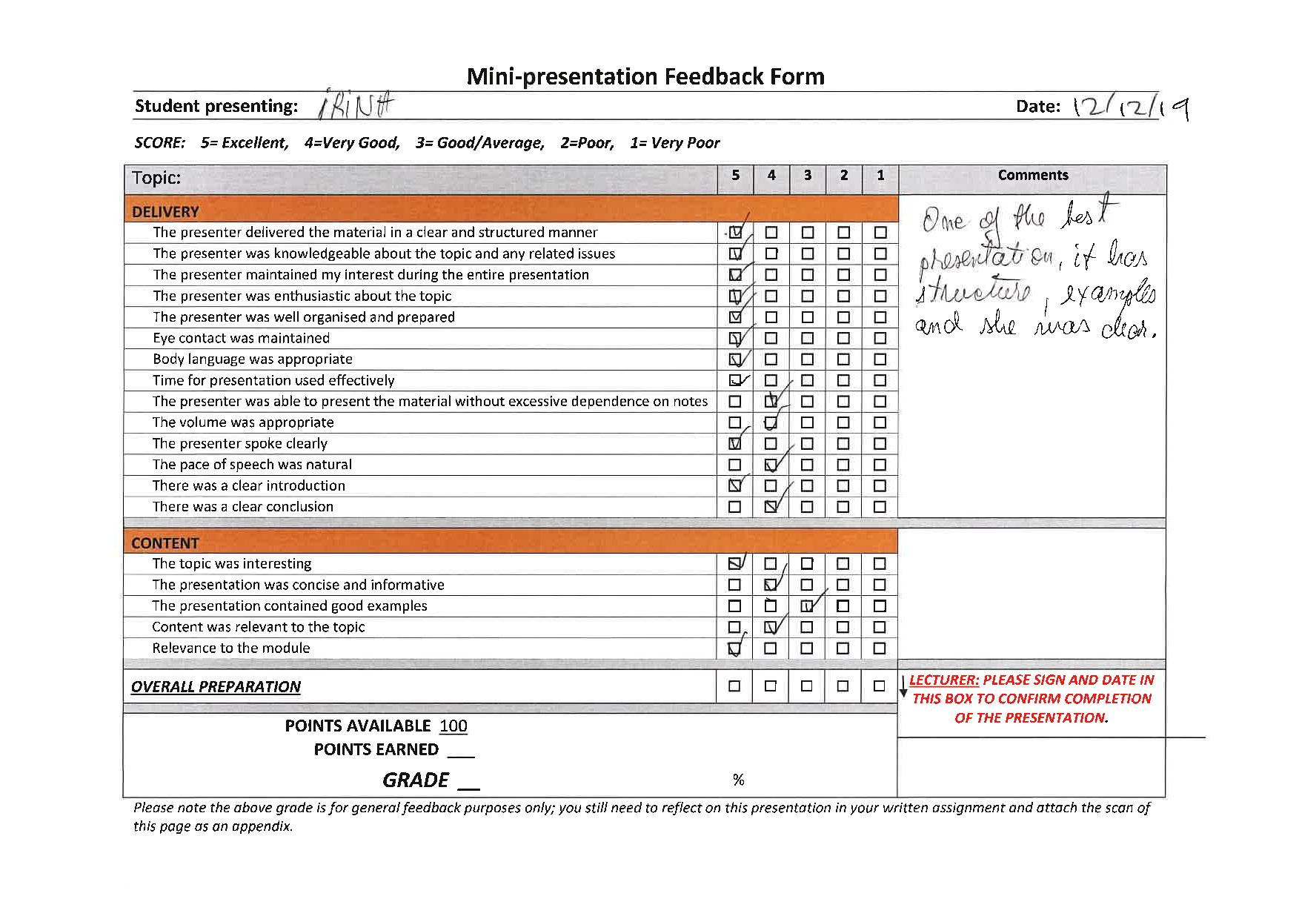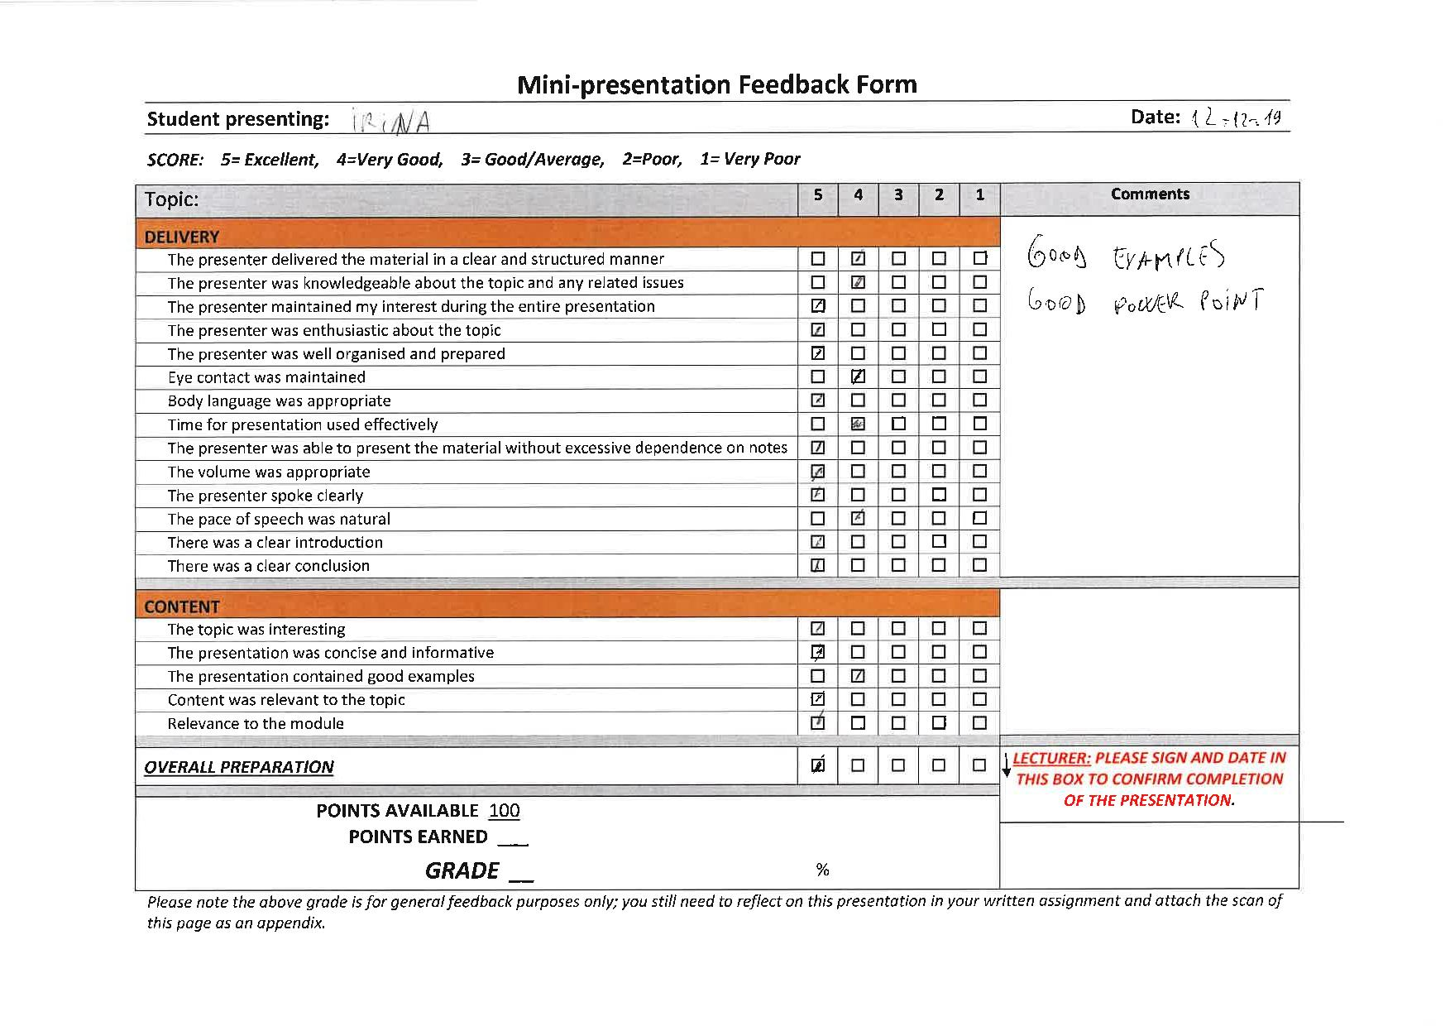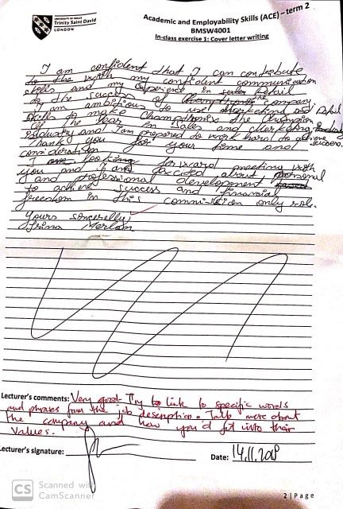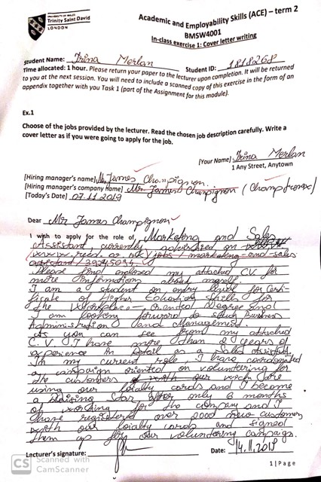
Appendices

