Student name: | Hiral Jitubhai Jasoliya | Student ID number: | 2507162
Programme: | MSc/PgDip/PgCert Cybersecurity and Digital Forensics
Module: | Ethical Hacking
Module code: | ACCA7033 | Assignment Title: | Research into cyber security attacks and Penetration testing for a virtualise simulated company Website

Abstract
Coordinated cyber attacks on Marks and Spencer (M&S) and the Co-operative Group (Co-op) indicate the growing advanced nature of ransomware campaigns in the retail industry. Analysis employs the threat-centric perspective of investigating the attack lifecycle, adversary behaviour, and exploitation methods with the MITRE ATT&CK framework. Some of the major phases, such as initial access through social engineering, credential compromise, lateral movement, and ransomware deployment, are critically assessed. Study major human, technical, and organisational control failures, which make the breach possible, and the gaps in the capabilities of detection and responding to the incident. Controlled red team simulation is used to simulate the real attack conditions in the world and determine vulnerabilities in the system. Results highlight the significance of defence-in-depth approaches, improved monitoring, and zero-trust security models in enhancing the resilience of organisations against emerging cyber threats.
Table of Contents
TASK 1: Strategic Threat Analysis 5
Overview 5
Incident Summary and Timeline 5
Adversary TTP Mapping (MITRE ATT&CK) 6
Root Cause and Security Failures 9
Threat Actor Profile and Motive 10
Detection and Response Analysis 10
Strategic Recommendations 11
Summary 11
TASK 2: Red Team Engagement 14
Overview 14
Rules of Engagement (RoE) 14
Threat Emulation Plan 14
Lab Environment Design 15
Reconnaissance and Scanning 20
Exploitation (Three Exploits) 23
Tools and Techniques Used 28
Detection Gap Analysis 29
Summary 29
Conclusion 30
References 32
Appendices 35

TASK 1: STRATEGIC THREAT ANALYSIS
Executive summary
The strategic threat analysis examines an organised ransomware attack on large retail organisations, demonstrating an organised attack cycle that is related to the MITRE ATT framework. It highlights the human, technical, and organisational vulnerabilities that are critical, such as phishing vulnerability, lax identity management, and a lack of network segmentation. Analysis shows the ways in which the adversaries use such weaknesses to gain persistence, lateral movement, and exfiltration of data. It also evaluates the gaps in detection and response with a focus on the late incident response. The research offers evidence-based research to guide risk reduction practices and enhance organisational cyber resilience against advanced persistent threats.

TASK 1: Strategic Threat Analysis

Overview
Cyber attacks on Marks and Spencer (M&S) and the Co-operative Group (Co-op) are analyzed as a coordinated threat campaign or a very similar one, offering a strategic perspective on how they are executed, the similarities, and the underlying adversary behaviour. It is a threat-based focus in the analysis that incorporates publicly available intelligence, industry news, and academic literature to develop evidence-based insight into the attack lifecycle. The focus is on the reconstruction of the incident timeline, with recognition of key stages between initial access and containment and remediation.
Analysis also compares attacker behaviours as to the MITRE ATT&CK framework to provide a systematic mapping of tactics, techniques, and procedures (TTPs) used throughout the chain of attack. This facilitates systematic analysis of the manner in which opponents exploited technical flaws, organisational flaws, and human aspects to accomplish their goals. Also, the overview takes into account attribution issues and the possible motives of the threat actors.
These synthesised elements allow the section to form a basis to critically assess detection and response capabilities, and inform the formulation of risk-focused, security recommendations to enhance organisational resilience to advanced cyber threats.

Incident Summary and Timeline
Data breaches of Marks and Spencer (M&S) and the Co-operative Group (Co-op) in early 2025 are discussed as a coordinated attack by a shared threat actor with the use of social engineering tools. This attack lifecycle commenced in February, 2025, with the attackers first gaining access into M&S systems by compromising their credentials, stealing the Active Directory database (NTDS.dit), which they used to make unauthorised authentication and continued access (Kemp et al. 2023).
Attack continues into an implementation phase at the time of the Easter period (19-21 April 2025), where operational disturbances are observed in terms of failed contactless payment systems and Click and Collect services (Akeiber, 2025). This is a sign of good lateral motion and compromise at the system level. M&S formally disclosed the incident and enlisted the National Cyber Security Centre (NCSC). On 22 April 2025, the interface for detection and response to the incident.
Attackers installed ransomware named DragonForce, which encrypted VMware ESXi infrastructure, causing most services to be brought down on 24 April 2025. Immediate containment measures are taken, which include suspension of online services to curtail the further effect on 25 April 2025. The campaign continues at the Co-op on 30 April 2025, but quick initial detection and system segregation minimise the damage to operations.
The national level of intervention occurs, and the NCSC supports it on 2 May 2025. The climax of the event comes on 13 May 2025, when it is established that there is a data breach of information of the customers. The recovery efforts are still ongoing, and on 10 June 2025, it has already partially regained its services.
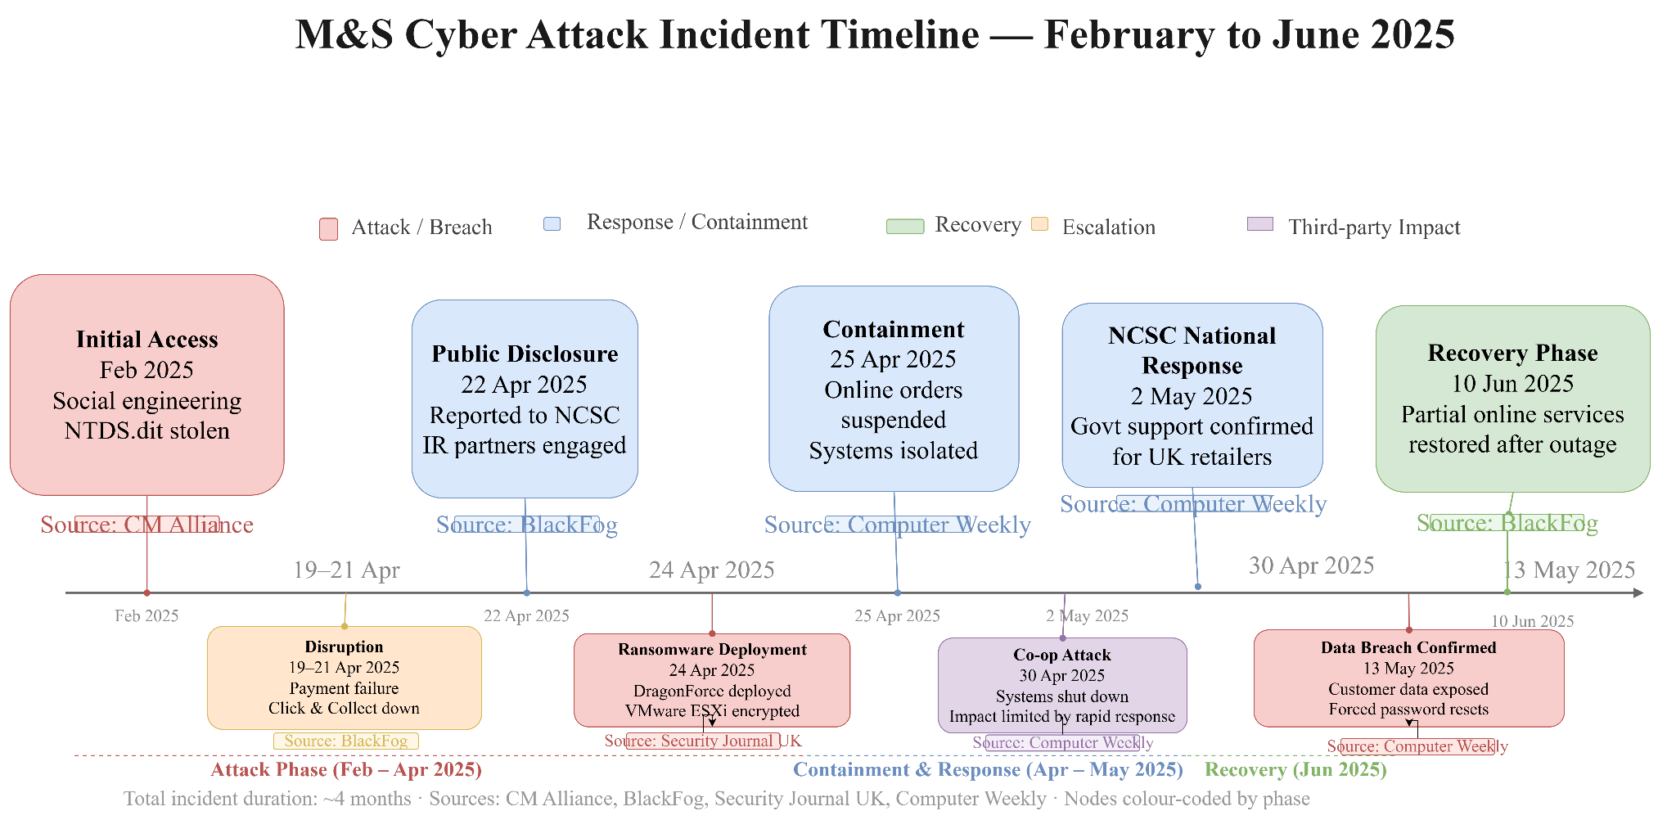
Figure 1: Timeline of the Coordinated Cyber Attack Campaign Targeting M&S and Co-op (2025)
The figure depicts the time sequence of the lifecycle of the cyber attack that begins with the initial access using social engineering and proceeds to the disruption, the installation of ransomware, containment, and the validation of data breach. Major time landmarks and the system are highlighted and it demonstrates how the attack was organised and the systems used by the organisation to respond accordingly.

Adversary TTP Mapping (MITRE ATT&CK)
The evaluated cyber campaign is evidence of a planned and multi-level intrusion in line with the MITRE ATT&CK Enterprise Matrix (Omotunde and Ahmed, 2023). Attacker systematically uses a series of tactics, techniques and procedures (TTPs) to reach the first compromise, increase access and provide ransomware-based impact to organisational systems.

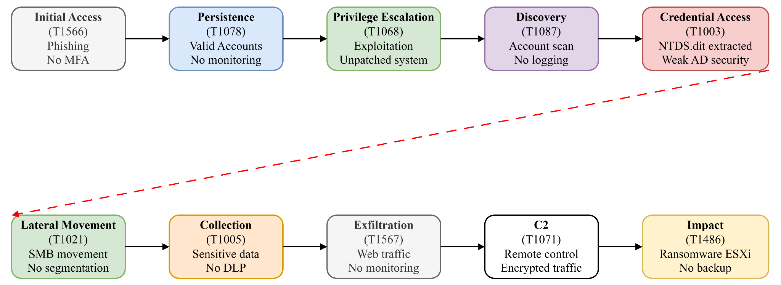
Figure 2: MITRE ATT&CK-Based Adversary Attack Flow of the DragonForce Ransomware Campaign
This diagram is a structured overview of the adversary tactics and techniques with an alignment to the MITRE ATT&CK model of how initial access evolved into privilege escalation, lateral movement, and exfiltration of data to the final impact. It emphasizes that TTPs are executed in a descending manner and are used to attack systems and deliver ransomware.
Initial Access – Phishing (T1566)
The attack is by a social engineering method, as attackers make use of user trust to gain access to credentials. This facilitates the infiltration of systems without any security alerts into the enterprise systems.
- Why it worked: Lack of phishing-resistant MFA and insufficient user awareness
- Control failure: Weak email filtering and no strong authentication mechanisms
- Impact: Enabled unauthorised entry into enterprise systems
Persistence – Valid Accounts (T1078)
Attacker uses valid credentials to maintain access. Valid accounts enable the activity to mix with normal user behaviour, making it less likely to be detected.
- Why it worked: Legitimate credentials bypass security monitoring
- Control failure: No identity behaviour analytics (UBA) or login anomaly detection
- Impact: Long-term undetected access
Privilege Escalation – Exploitation (T1068)
The enemy gains privileges to bring control on the administrative level. This allows sensitive infrastructure elements to be accessed, such as domain controllers and virtualised environments.
- Why it worked: Outdated systems and weak patch management
- Control failure: Lack of vulnerability management and least-privilege enforcement
- Impact: Administrative control over domain systems

Discovery – Account Discovery (T1087)
The reconnaissance is conducted by the attacker by listing the accounts and network resources of the user accounts (Zhang et al. 2025). This helps in identifying high-value targets and also aids in further movement on the lateral axis.
- Why it worked: No monitoring of enumeration activity
- Control failure: Absence of logging and detection for reconnaissance behaviour
- Impact: Identification of critical assets
Credential Access – Credential Dumping (T1003)
Extraction of credential information, including NTDS.dit, allows the attacker to gain access to password hashes and reuse credentials on the network, greatly increasing their control.
- Why it worked: Poor protection of Active Directory database
- Control failure: No credential protection (e.g., LSASS protection, encryption)
- Impact: Full domain compromise
Lateral Movement – Remote Services (T1021)
Opponent traverses across systems of remote access protocols. This facilitates the distribution of the attack among the interconnected systems and business-critical assets.
- Why it worked: Flat network architecture and lack of segmentation
- Control failure: No network isolation or internal firewall rules
- Impact: Rapid spread across enterprise systems
Collection – Data from Local System (T1005)
Organisational and customer-sensitive data are gathered using systems that are compromised. The move helps further extortion actions.
- Why it worked: Lack of data access monitoring
- Control failure: No Data Loss Prevention (DLP) controls
- Impact: Preparation for double extortion
Exfiltration – Exfiltration Over Web Services (T1567)
The data that is collected moves out of the organisation via normal web-based channels, and so the activity may seem legitimate and evade detection systems.
- Why it worked: Traffic appeared as normal HTTPS activity
- Control failure: No outbound traffic inspection or anomaly detection
- Impact: Data breach and regulatory risk
Command and Control – Application Layer Protocol (T1071)
The attacker sets up command and control communications via common protocols, which provides constant communication with compromised systems and operational stealth.
- Why it worked: Encrypted communication masked malicious traffic
- Control failure: Lack of deep packet inspection
- Impact: Persistent attacker control
Impact – Data Encrypted for Impact (T1486)
The last phase is the implementation of the ransomware, which encrypts important systems and interferes with the operations. This imposes ransom and maximises the impact of an organisation.
- Why it worked: Weak backup strategy and lack of segmentation
- Control failure: No ransomware protection or immutable backups
- Impact: Operational shutdown and financial loss
Attack demonstrates a well-organised and disciplined implementation of MITRE ATT&CK strategies, which showcases the efficiency and professionalism of contemporary ransomware attacks.

Root Cause and Security Failures
It is clear that the breach itself is due to a set of human, technical, and organisational control failures, but not a single point of weakness in the incident that is analysed. The first concession is conditional on phishing vulnerability, a lack of security awareness education and user laxity (Dimitrov and Nikolov, 2025). Lack of multi-factor authentication (MFA) also contributes to this human aspect, as attackers now use stolen credentials without any other authentication measures.
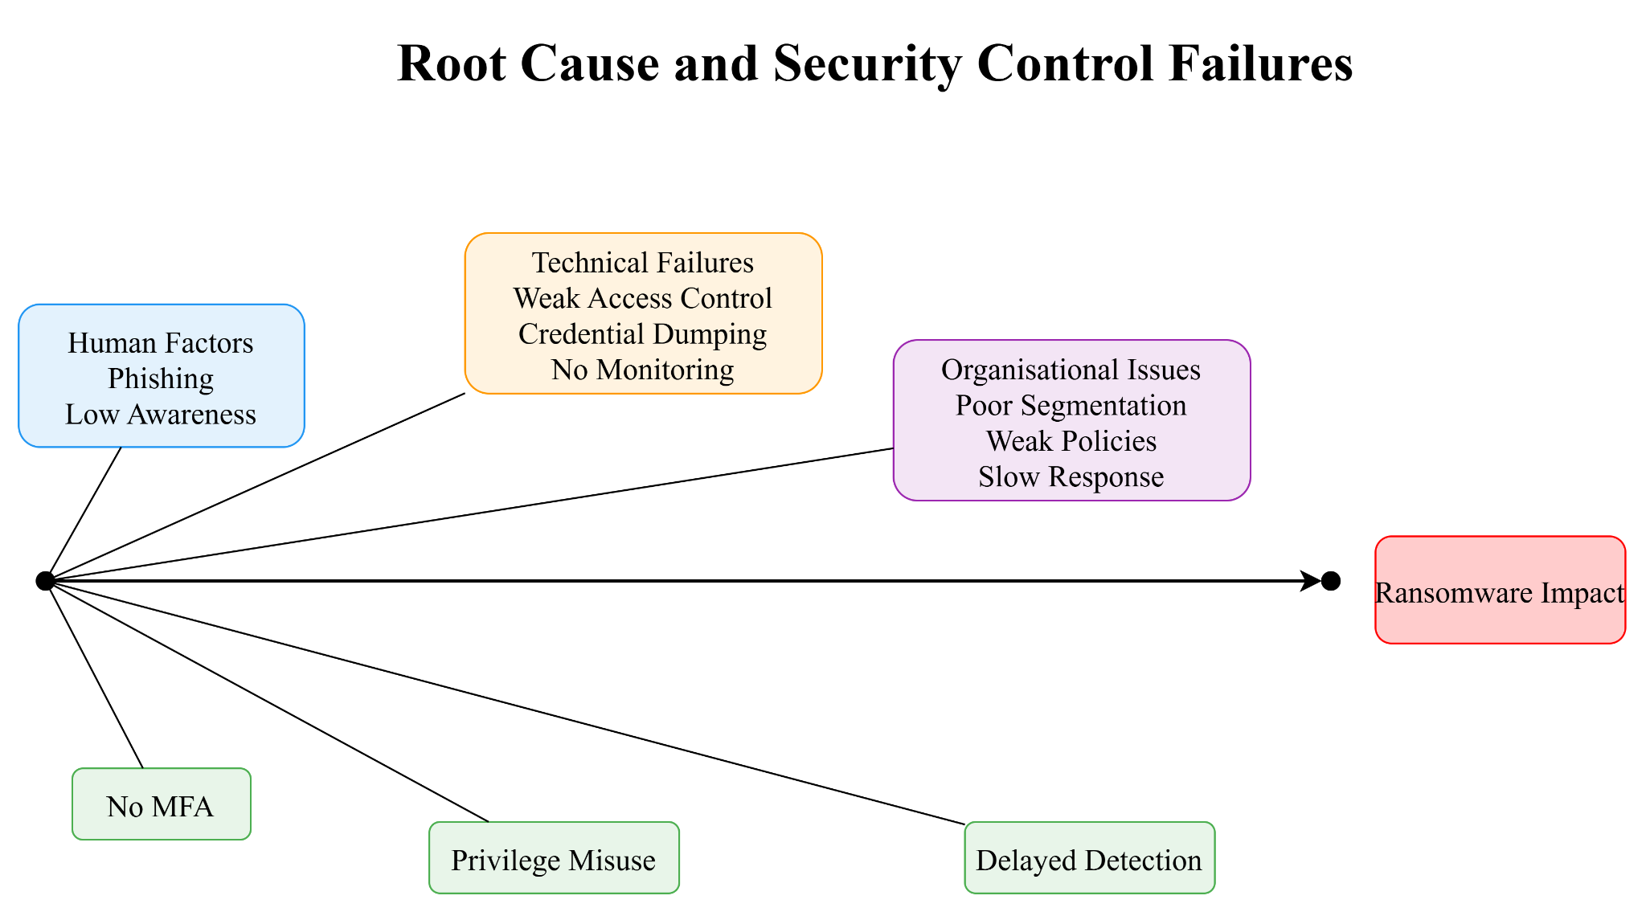
Figure 3: Root Cause and Security Control Failures Leading to Ransomware Impact
The diagram provides the cause and effect analysis of the cyber incident and defines the most important human, technical, and organisational failures which led to the occurrence of the breach. It identifies factors such as vulnerability to phishing, ineffective access controls, and weak network segmentation, showing how several control vulnerabilities compounded with one another to facilitate lateral movement and lead to ransomware impact.
Privilege escalation occurs due to poor access control systems and a lack of identity and access management (IAM) practices. Active Directory credentials, such as the NTDS.The .dit file is extracted, which is indicative of the lax protection of important authentication infrastructure (Aljohani, 2023). The inability to effectively monitor and log makes it slow to detect, allowing attackers to continue to persist, as well as perform lateral movement between systems.
It is also the organisational deficits that play a critical role in the advancement of the attack. Inadequate network segmentation enables the enemy to roam freely in the environment, and ineffective security policy and governance structures cannot exercise effective control mechanisms. Sluggish incident response procedures lead to extended exposure of the system and heightened operational sensitivity.
The incident is a breakdown in defence-in-depth, in which several security controls fail at the same time, culminating in the deployment of ransomware and the mass disruption.

Threat Actor Profile and Motive
A threat group, which is usually linked to Scattered Spider and the DragonForce ransomware group, is credited with the cyber campaign as it is financially motivated. The aggressor proves to be very capable, with sophisticated social engineering tricks, harvesting of credentials and subsequent lateral movement within enterprise environments (McIntosh et al. 2024). Their modus operandi is similar to organised criminal gangs using a double-extortion ransomware construct, exfiltrating data and encrypting the system to extract as much money as possible. Financial extortion is the main motive, but the magnitude and organization of the attacks suggest a resourceful and well-organised threat agent. Although attribution is a biased approach, such that it is classified as an inference, the methods and actions lend much weight to this inference.

Detection and Response Analysis
The capabilities in the field of detection and response have significant gaps in technical and organisational levels. Initial compromise will go unnoticed because of poor monitoring, low visibility of logging and a lack of anomaly detection in identity and access operations. Lack of real-time Security Information and Event Management (SIEM) correlation slows down the detection of credential misuse and lateral movement (Zhu et al. 2026). Although eventually deployed, incident response actions are not in a timely manner, which gives the attacker time to gain privileges and install ransomware (Aksoy, 2023). More advanced security operations are reflected in the Co-op being better detected due to quick identification and system separation. The incident reveals the lack of proactive threat detection, ongoing monitoring and incident response preparedness.

Strategic Recommendations
- Install multi-factor authentication (MFA) with resistance to phishing (FIDO2-based authentication), to reduce the credential compromise (medium cost, medium impact).
- Adopt a zero-trust structure and identity authentication, and least-privilege access control (high effort, high impact).
- Enhance segregation of the networks to limit lateral flow across the critical systems (median effort, high impact) (Xiang et al. 2025).
- Install SIEM and endpoint detection and response (EDR) on the state-of-the-art to track in real-time and detect threats (medium cost).
- Logging more and collecting more telemetry (low cost).
- Increase the security awareness training programmes to ensure that people are less susceptible to phishing (low price, high effects).

Summary
It is evident that the cyber incident is caused by inter-reliant failures in human, technical and organisational factors that are used by a knowledgeable threat actor through this analysis. There is a well-organised lifecycle of the attack, which is consistent with MITRE ATT&CK, with emphasis on the absence of detection and limitations in responses. The targeted security controls and strategic additions are implemented to implement resilience to future ransomware assaults.

TASK 2: RED TEAM ENGAGEMENT

Executive summary
Adversarial behaviour described is simulated through the red team engagement in a controlled enterprise environment as part of assessing system vulnerabilities and resilience to security. A multi-stage attack lifecycle that consists of reconnaissance, exploitation, privilege escalation, and lateral movement performed with realistic tactics that correspond to MITRE ATT&CK. First access is done via the exploitation of a web application, then SMB-based compromise and data dumping. Analysis reveals some significant gaps in patch management, monitoring, and access controls. The results offer strong indications of wide gaps in detection and illustrate how unpatched systems allow compromise of the entire system, to incentivise strategic changes in support of proactive defence and threat reduction.

TASK 2: Red Team Engagement

Overview
A simulated adversarial behaviour within an isolated enterprise network is achieved by creating a controlled penetration testing scenario. The goal is to finding and exploiting vulnerabilities on a variety of systems and then performing privilege escalation and data access operations. A multi-stage attack approach is embraced, which is aligned with actual Red Team tactics and procedures in the real world. This environment consist of a domain controller, a vulnerable web application server, and a domain-joined client workstation allowing an extensive attack surface coverage. This is first gained with the help of web application exploitation, and lateral movement is carried out with the help of network based vulnerabilities.
Access is gained through SMB exploitation, and it shows the effect of the unpatched systems. The attack lifecycle is organised in a way which represents reconnaissance, exploitation, escalation and exfiltration. All the activities are carried out in a regulated laboratory setting so that there is no interference with any outside systems. The situation offers real-life lessons on the vulnerabilities of security in the enterprise and the methods used by the attackers.

Rules of Engagement (RoE)
Any penetration testing undertakings are done within established rules of engagement to make the penetration testing ethical, controlled and non-disruptive. It is also limited to the specified virtual machines in the isolated lab network comprising the domain controller, the web server, and the client workstation. Any outside networks or unauthorised systems are not targeted for the report.
Testing is conducted in the least destructive way where possible, and destructive actions are restricted to controlled exploitation situations needed to show impact (Marcinko, 2024). Administrative credentials and sensitive settings are safely managed and are not used in the lab. The host-only network only allows network traffic to be limited within the host to avoid unwanted propagation. Everything is recorded and reported to maintain traces of activities. Persistence mechanisms and denial-of-service attacks are carefully avoided to ensure that the system remains available. The process is performed under ethical hacking principles to be sure that the confidentiality, integrity and availability issues are considered during the testing lifecycle.

Threat Emulation Plan
A systematic threat modelling strategy is carried out to simulate realistic attacker behaviour in more than one phase of attack. The attack pathways are initiated through the attacker machine where network reconnaissance is carried out to determine the active hosts and opened services. The first point of attack is a vulnerable Linux-based web server because there are exploitable vulnerabilities of web applications. The vulnerability of SQL injection is used to compromise authentication and retrieve database data and provide initial access to the network. This is followed by internal reconnaissance to list out more systems which highlights in the discovery of a Windows client machine that is a part of the domain.
Client system is analysed and vulnerable to the MS17-010 exploit due to the SMB service. EternalBlue exploit is used to achieve SYSTEM-level access, which allows privilege escalation and control of the host. Techniques of credential dumping are then used to steal authentication information (Holm and Sommestad, 2025). The attack trail shows the horizontal movement of a hacked web server to the resources of an internal domain. All phases are align with MITRE ATT&CK techniques, which provides realistic simulation of adversaries. The emulation identifies vulnerabilities in patching, input validation and network segmentation in enterprise settings.

Lab Environment Design
Network diagram
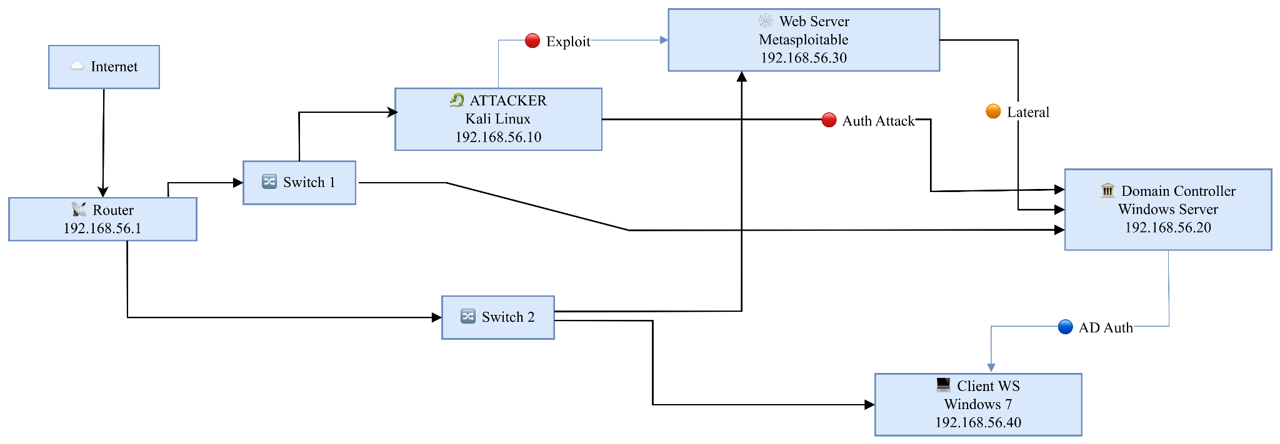
Figure 4: Network Diagram
Network diagram shows a contained laboratory setting where a Kali Linux attacker starts with SQL injection of a Metasploitable webserver and takes advantage of SMB vulnerability of a Windows client. This process is authenticated by domain authentication and DNS services on a centralized Windows Server domain controller on the isolated host-only network.
VM Roles
VM-1: Domain Controller
VM-1 is a centralised domain controller that offers the Active Directory Domain Services and DNS services in the lab environment. It handles authentication, authorisation, and directory services of domain-joined systems, making it possible to perform user management, policy enforcement and secure communication. It is the main identity and the access control authority.
VM-2: vulnerable web server role
VM-2 is a Linux-based web application server which runs deliberately vulnerable applications like DVWA. It has a high exterior attack surface and can be exploited by web vulnerabilities such as SQL injection. It serves as the first entry point to attackers, allowing establishing footholds and further internal network reconnaissance operations.
VM-3: Domain Client Workstation Role
VM-3 is a domain-joined Windows client workstation, which is a representative of an internal enterprise user system. It is involved in domain authentication and communicates with the domain controller in order to get access to resources. It is used as a lateral movement target, which allows escalating privilege, extracting credentials and proving the presence of internal network damage.
VM1: Domain Controller Configuration
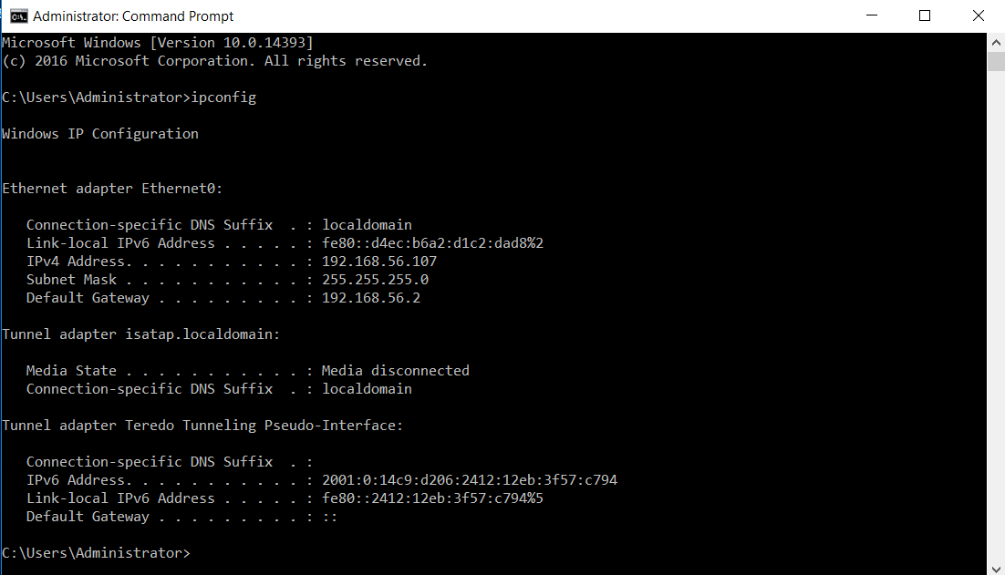
Figure 5: VM1 Static IP Configuration
VM1 has a static IPv4 address of 192.168.56.107, subnet mask of 255.255.255.0 and a gateway set to 192.168.56.2 (Nguyen et al. 2025). This provides a stable domain communication and active Directory service availability in the isolated lab network.
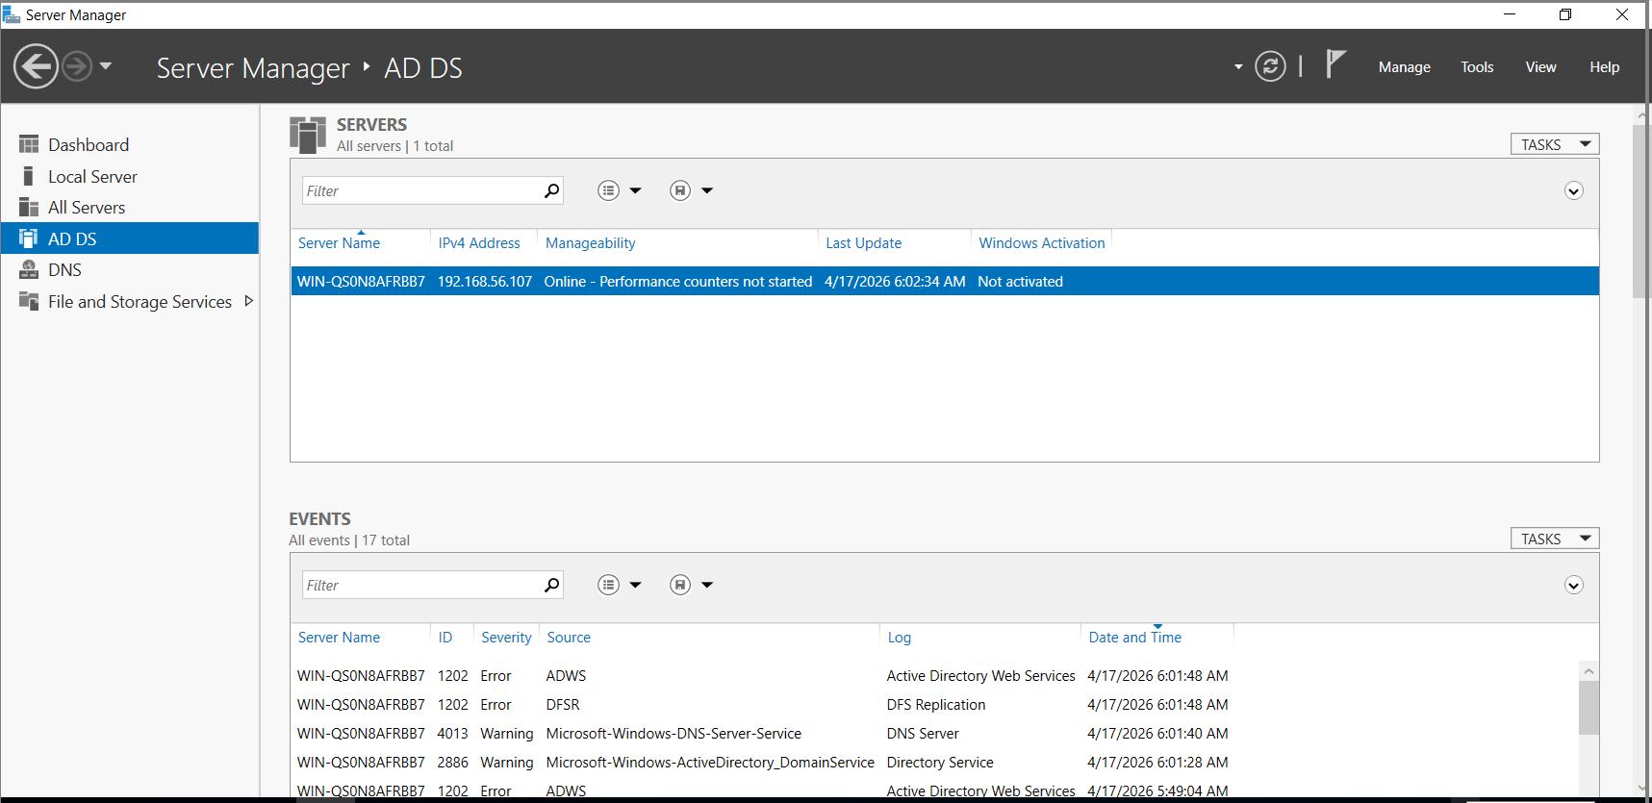
Figure 6: Active Directory Server Overview
Server Manager shows the role of AD DS running on the server including system status, performance indicators and event logs. It validates the machine as a domain controller in the setup lab environment.
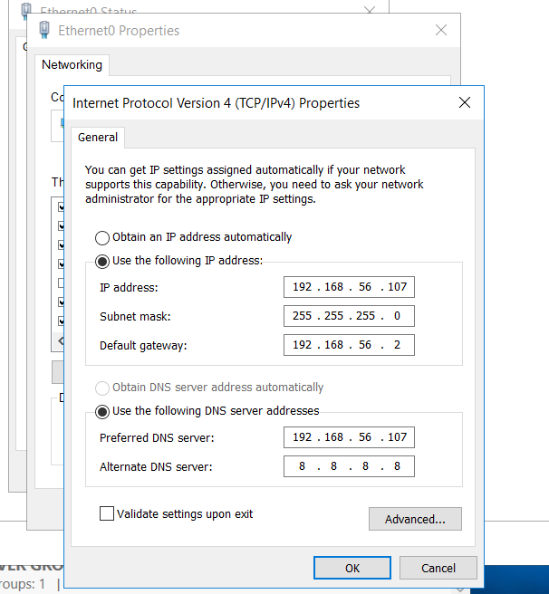
Figure 7: IPv4 Network Configuration Settings
IPv4 characteristics define the existence of a static addressing with DNS address on 192.168.56.107. It is important to have the correct name resolution, discovery of domain controller and smooth communication between domain-joined nodes within the environment of controlled network infrastructure.
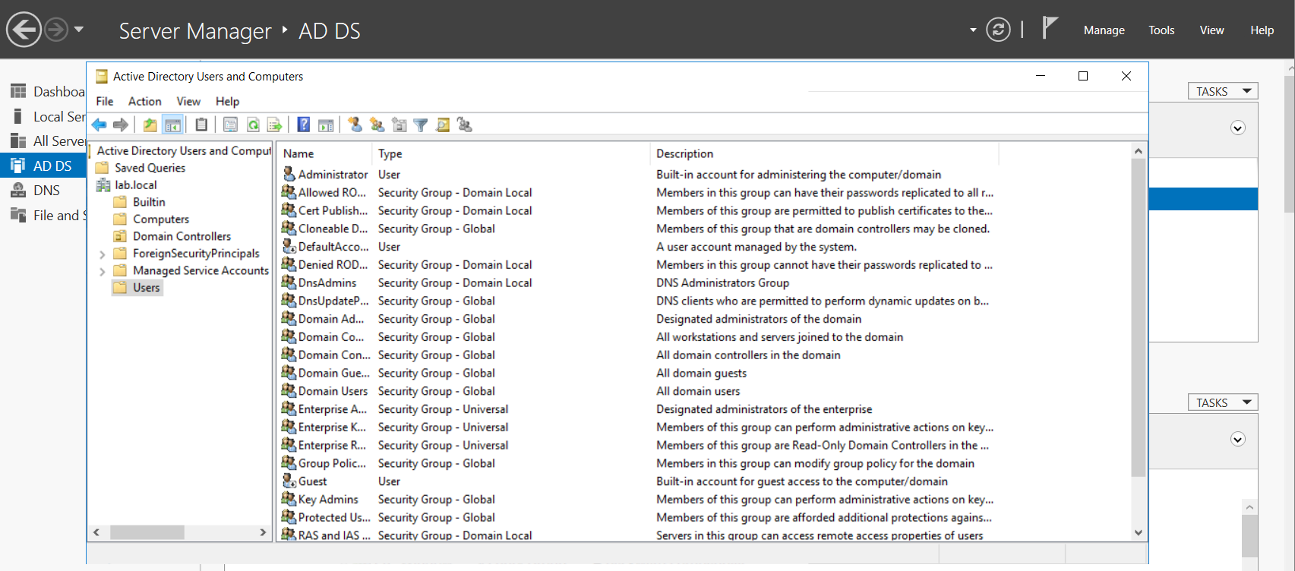
Figure 8: Active Directory Users Management
Active Directory Users and Active Directory Computers console displays domain objects. These objects are users, groups and security roles allowing centralized identity management, permission control, and administrative control over the enterprise network environment in the lab.
VM 2: Linux-Based Web Hosting Server
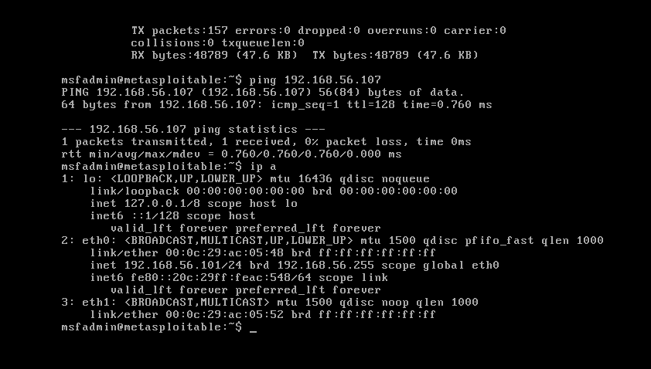
Figure 9: Linux Network Connectivity Verification
Linux-based server confirms connectivity with ping to 192.168.56.107, ping to 192.168.56.107 (Ansar et al. 2025). This process verifies that there is connectivity in the controlled lab network, and that packets are sent and received successfully, without loss, and with proper IP assignment 192.168.56.101.

VM-3: Windows Client Endpoint System
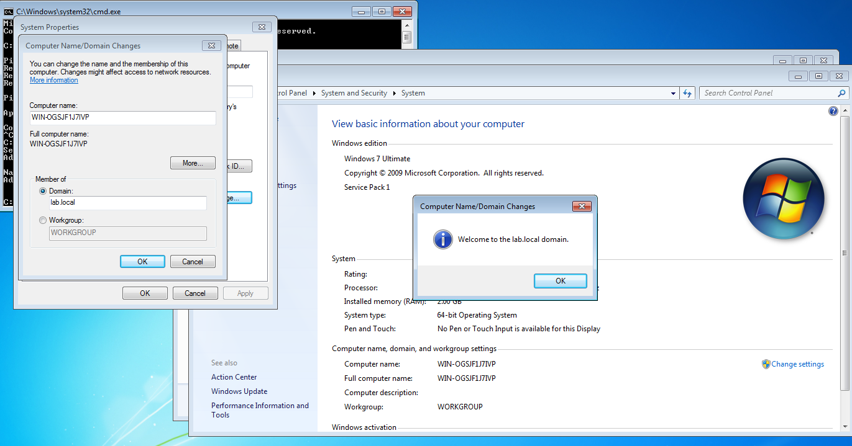
Figure 10: Domain Join Confirmation Window
Windows client system can successfully add itself to the lab.local domain with a confirmation message, updated system properties, and domain membership settings. This is indicative of the successful integration with Active Directory and preparation to undergo centralized authentication procedures.
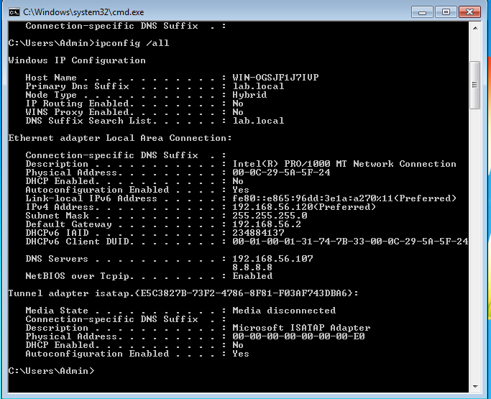
Figure 11: Windows Network Configuration Details
The ipconfig command results in the assigned IP address of 192.168.56.120, the subnet mask, the gateway, and the DNS server of 192.168.56.107 (McDonald et al. 2022). It confirms the right domain alignment, network settings, and communication preparedness in the Active Directory setting.

Reconnaissance and Scanning
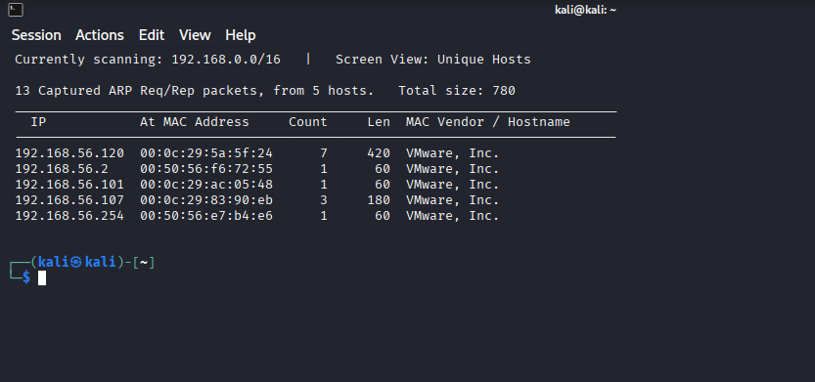
Figure 12: ARP Network Host Discovery
ARP scanning is used to detect active hosts in the 192.168.0.0/16 network, recording MAC addresses and the number of packets. It allows to observe which devices are connected, and provides a starting point of reconnaissance to continue enumeration
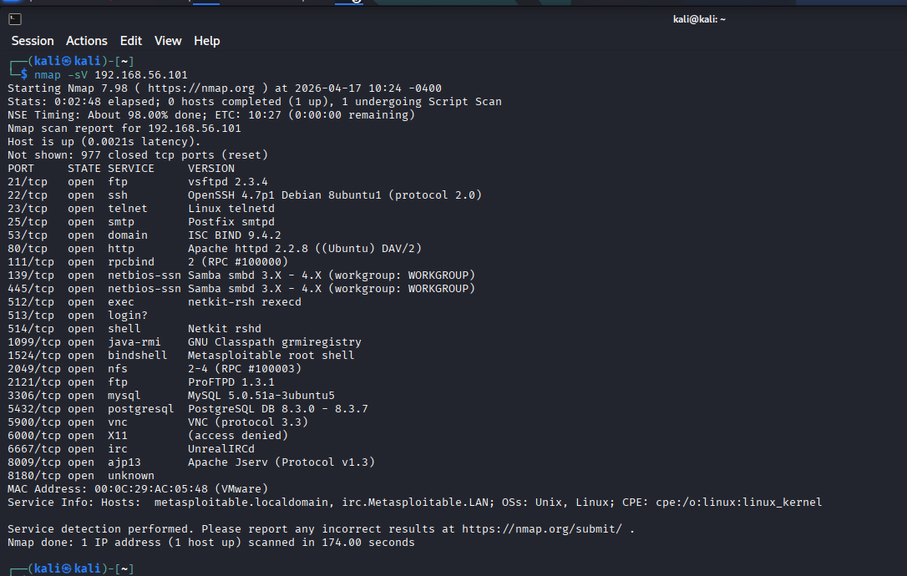
Figure 13: Service Version Enumeration Scan
The version scan of Nmap services detects many open ports such as FTP, SSH, HTTP, SMB, and database services on 192.168.56.101. It exposes outdated software versions and offers a broad range of attack surfaces to exploit.
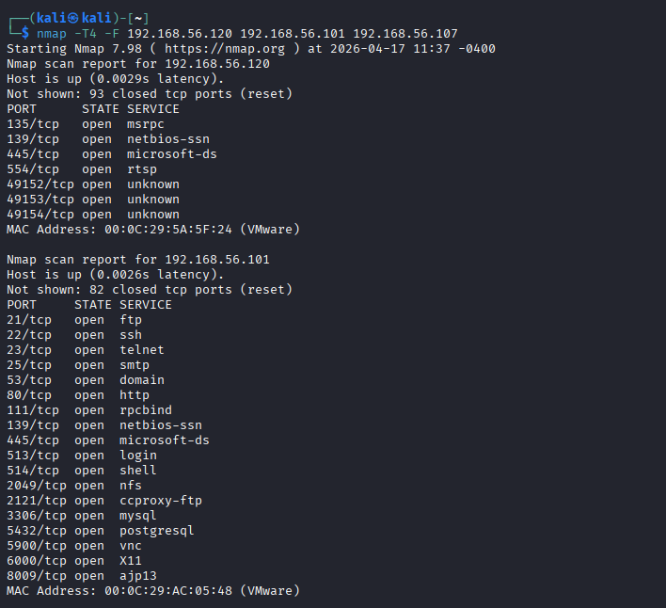
Figure 14: Multi-Host Port Scanning
Nmap scan of multiple hosts with a set of targets provides open services SMB, HTTP, MySQL, and VNC (Alba Torres et al. 2026). It allows revealing systems at risk and prioritizing ways of exploitation inside the internal network environment.
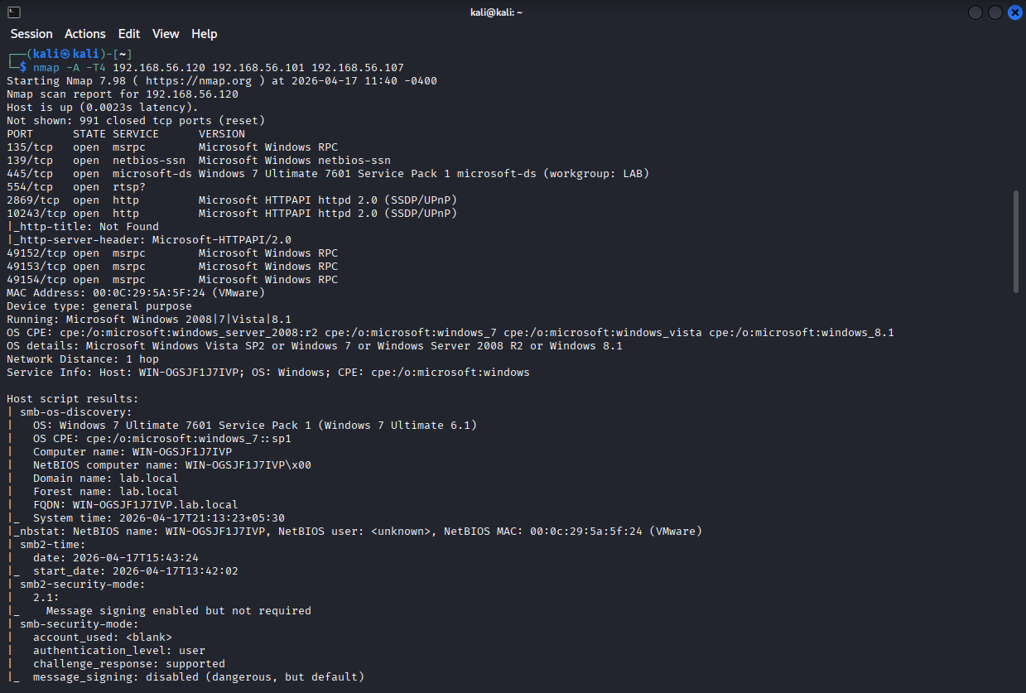
Figure 15: Advanced Service Detection Analysis
Aggressive Nmap scan with OS detection identifies Windows 7 client system, SMB settings and security modes, with weak settings of message signing. This process allows the identification of exploit-able vulnerabilities like MS17-010.
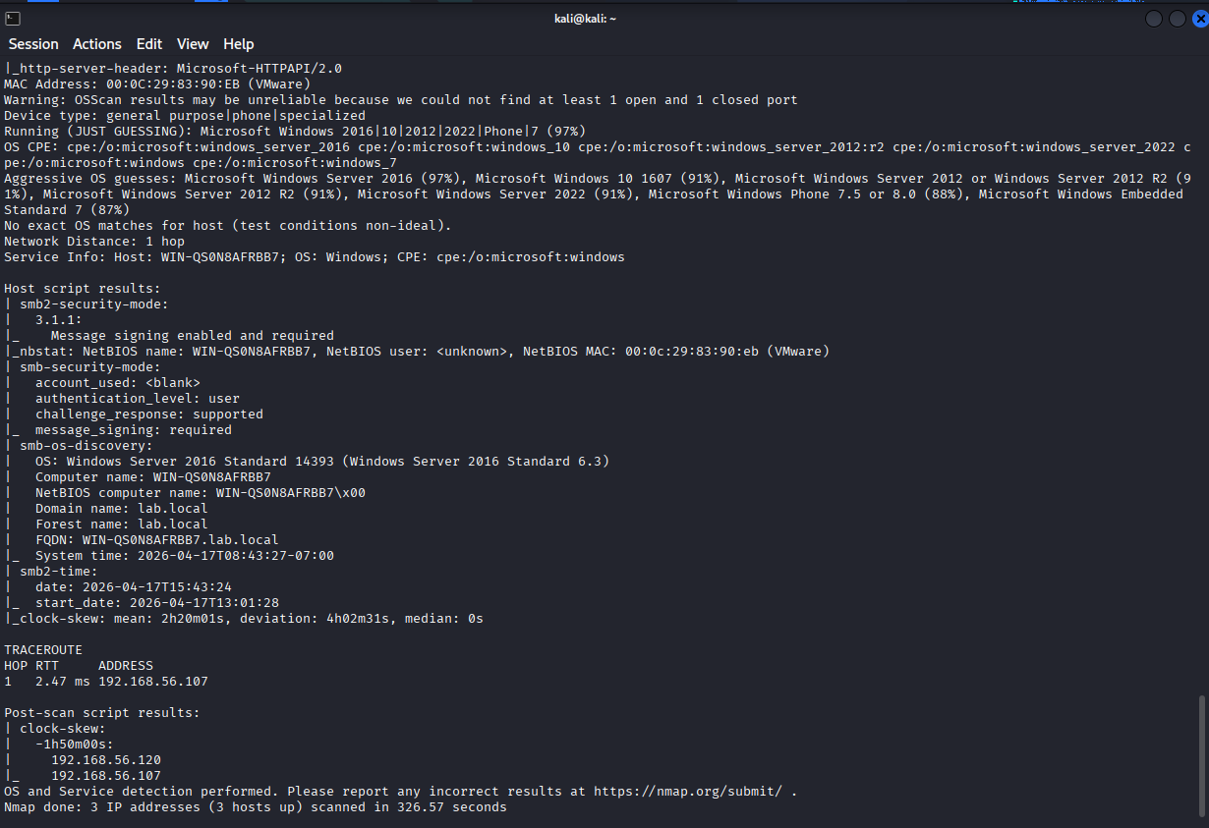
Figure 16: Domain Controller Service Enumeration
Service enumeration detects Windows Server system running Active Directory services, SMB settings and domain data. It validates its use as domain controller and offers vital intelligence on targeted lateral movement in the network.

Exploitation (Three Exploits)
Exploit 1: Web Application Exploitation
Exploitation process starts with reconnaissance and service enumeration with Nmap, whereby an accessible web application can be identified as existing in the Metasploitable server. The input validation weaknesses of the application are analysed, exposing the application to SQL injection. SQLMap is used to automate injection testing, which focuses on parameters which are vulnerable in the HTTP requests. Several methods of injection are performed, and it proves to be possible to control the queries of the database backends. Database structures (schema and tables) are enumerated on successful exploitation. Sensitive data such as user credentials, is stolen, and this indicates unauthorised access to data. This step provides the first presence in the network and allows further internal reconnaissance and the development of the attack.

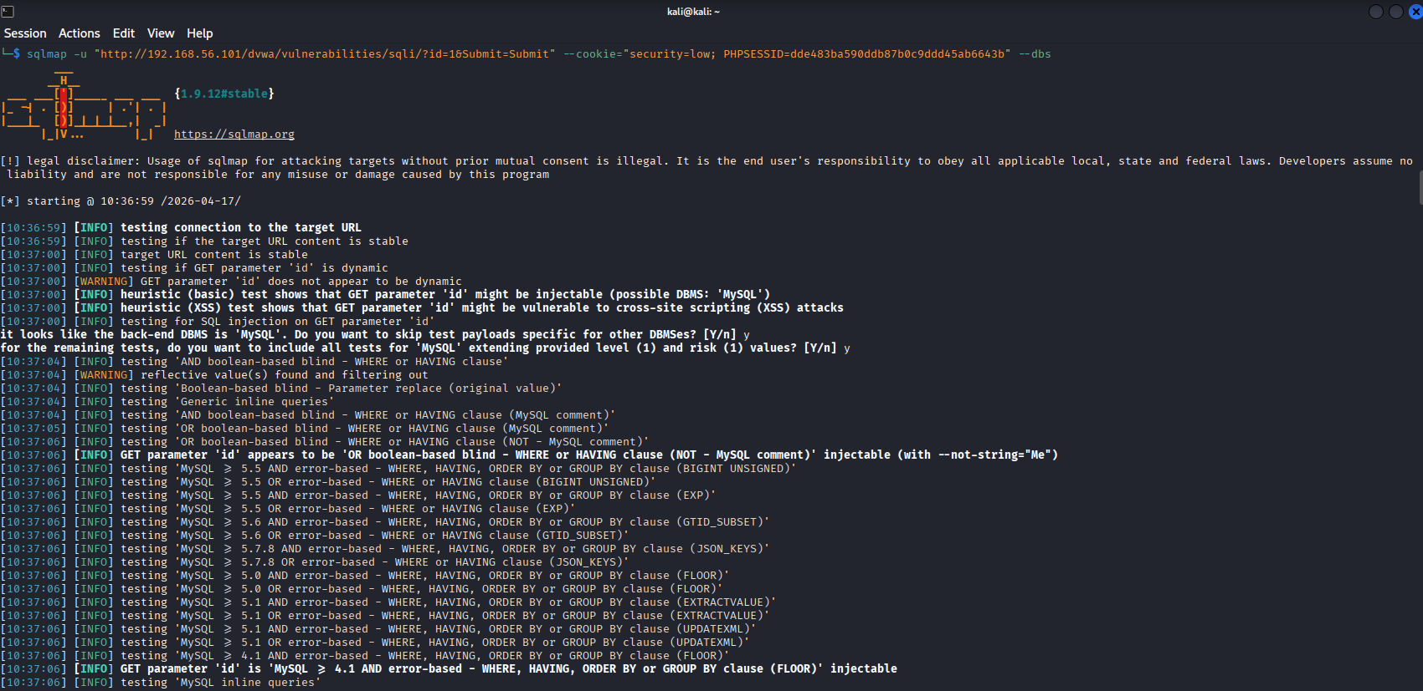
Figure 17: SQL Injection Exploitation Initiation
SQLMap starts injection testing vulnerability of web application where it determines the entry points of parameter injections, makes testing of various techniques. This process also verifies the ability to manipulate database query whereby an unauthorized user can gain access to the information and database systems at the back end.
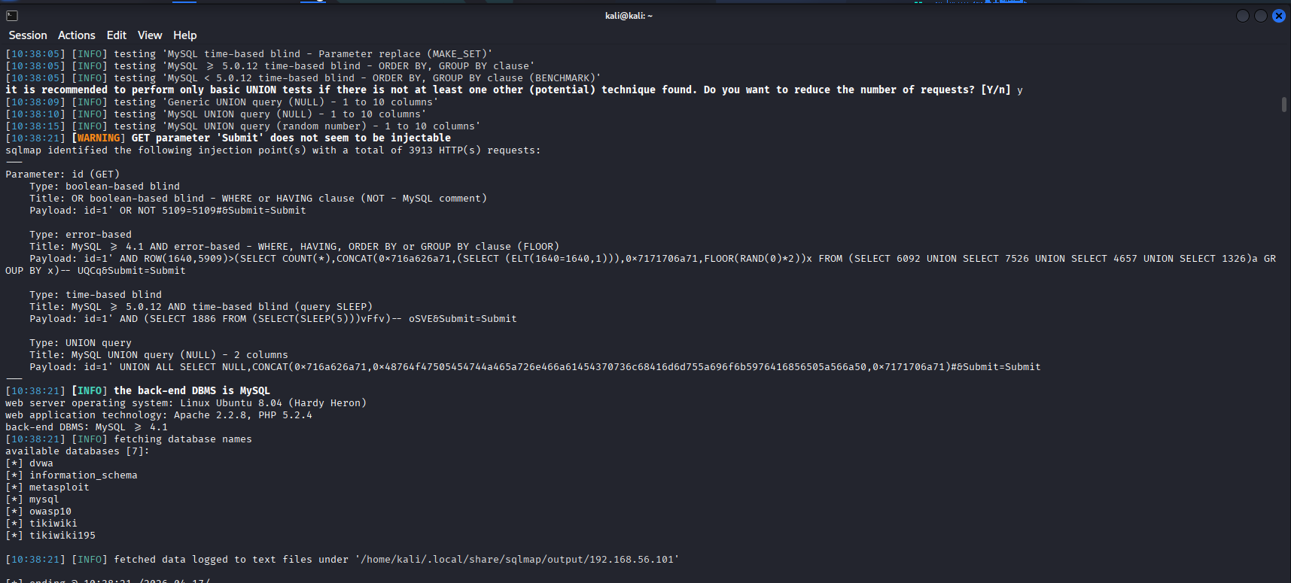
Figure 18: Database Extraction Using SQLMap
SQLMap manages to retrieve information of a database such as schema and tables, which proves the compromise of the back end database. It proves that it can access sensitive data and proves that there is indeed an effective exploitation of SQL injection in a web application setting.

Exploit 2: Eternal Blue Backdoor RCE
Internal network scanning is done to find out other targets after the first access, which reveals a domain-joined Windows 7 system with SMB exposed. The existence of the MS17-010 flaw is verified by vulnerability assessment. The Metasploit framework is used to execute the EternalBlue exploit, which attacks the SMBv1 protocol. When it is executed, remote code execution is accomplished, and a Meterpreter session is created. Privilege escalation is automatically gained, and access is gained to the SYSTEM level. Further enumeration, such as process inspection and network discovery, is then done using the compromised system. This phase shows the ability to move laterally, enabling attackers to bypass external-facing services and move to internal enterprise systems.
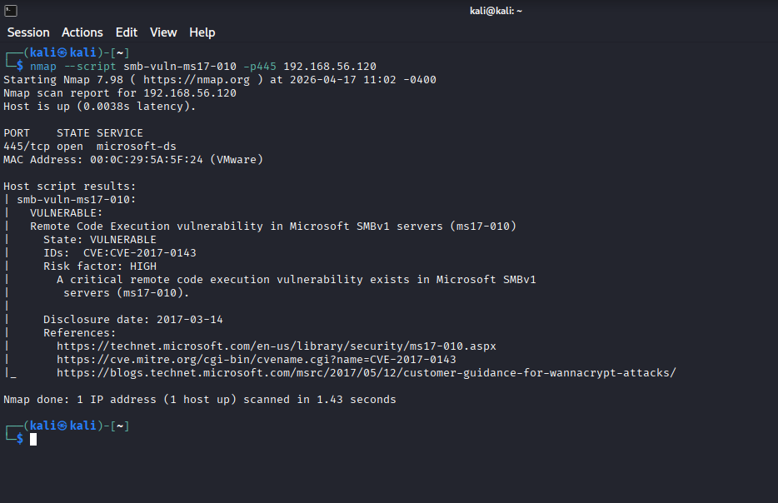
Figure 19: SMB Vulnerability Detection Scan
The presence of MS17-010 on Windows client system is confirmed by Nmap vulnerability script, and a critical SMBv1 remote code execution vulnerability is identified. This indicates that the system is at high risk of exposure and allows the attacker to prepare to the EternalBlue exploitation phase.
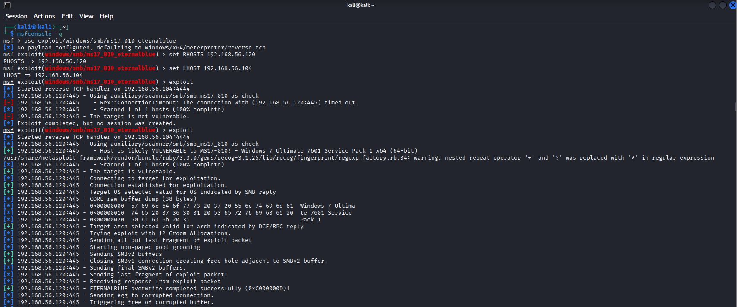
Figure 20: EternalBlue Exploitation Execution
Metasploit framework uses EternalBlue exploit on a vulnerable SMB service, connects and causes buffer overflow then attempts to execute remote code.
Exploit 3: Credential Dumps of Windows
Post-exploitation operations are conducted to steal sensitive credentials of the compromised Windows system with SYSTEM-level access. Credential dumping commands are run in the Meterpreter environment, recovering NTLM password hashes stored in system memory. These hashes are exported and transferred to the attacker's machine, where they are offline cracked. John the Ripper and Hashcat are some of the tools used in dictionary-based attacks to retrieve plaintext passwords. The fact of successful cracking validates weak password policies and substandard credential protection. The obtained credentials allow possible access to other systems, which proves the effects of the credential compromise and indicates threats posed by the lack of adequate authentication security measures.
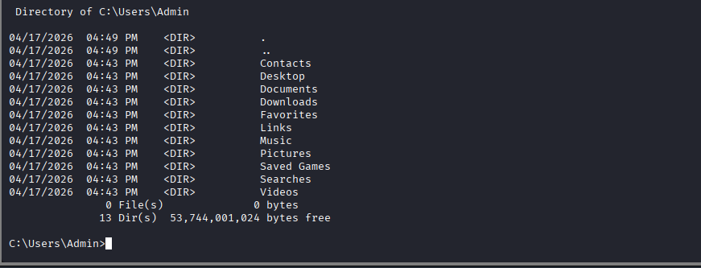
Figure 21: Windows Directory Enumeration Access
Afyer successfully exploitation, listing of C:Users:Admin is opened, which discloses user folders and structure of the system. It allows identifying sensitive locations and further credential extraction and data exfiltration operations in the compromised system environment.
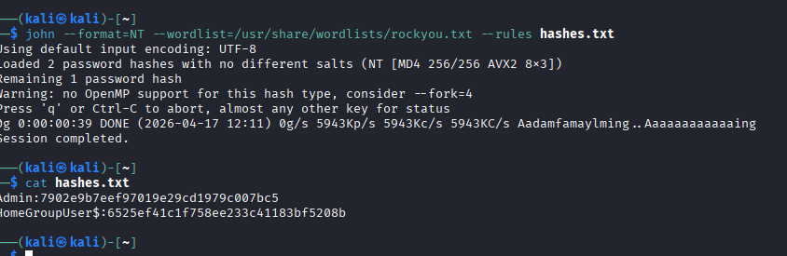
Figure 22:Attempt for cracking the hash
Hashcat starts cracking passwords with NTLM hashes and rockyou wordlist, allocating for GPU resources. In this process dictionary cache construction, and brute-force preparations are used to effectively crack passwords in large quantities and limited execution time.
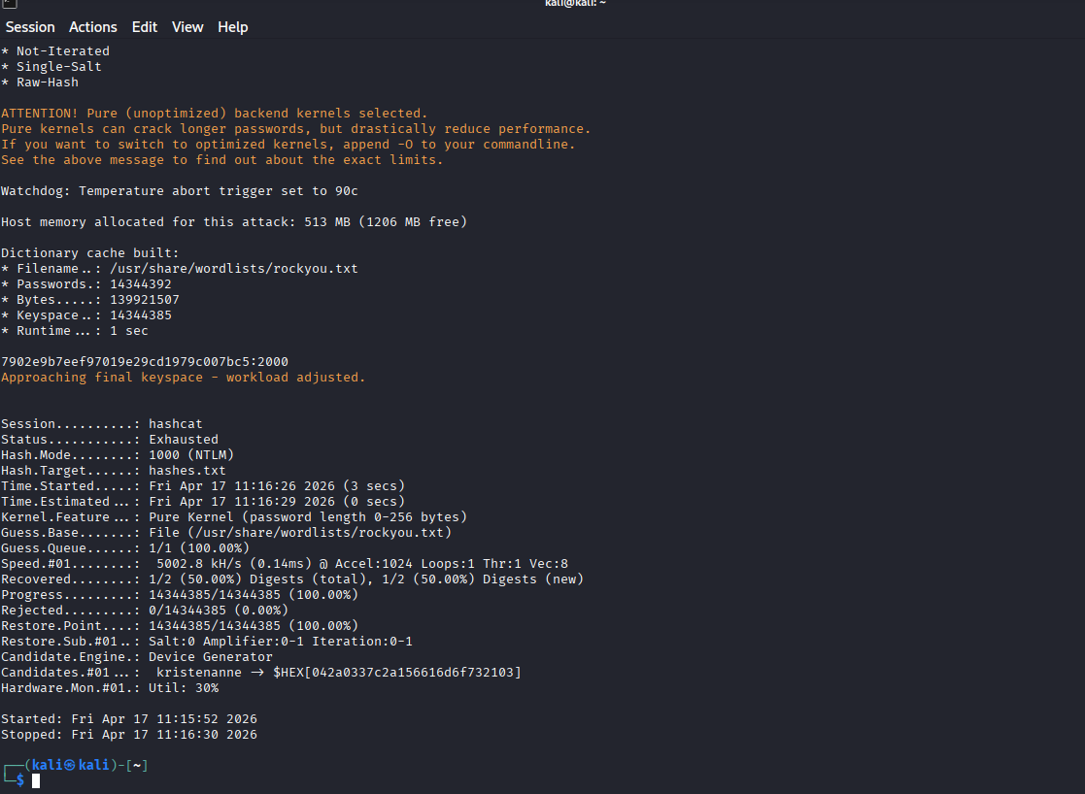
Figure 23: Hashcracking successful
Hashcat manages to retrieve NTLM password hashes, showing cracking credentials, statistics, and performance measurements. This process proves the effective compromise of credentials and the ineffectiveness of poor password policies in the environment of the compromised system.

Tools and Techniques Used
Tool / Technique | Application | Technical Purpose
Nmap Scanning | Network reconnaissance and port scanning | Determines active hosts, open ports, and versions of the services, making it possible to map the attack surface and identify vulnerable services.
ARP Scanning | Local network discovery | Identifies live hosts on the subnet, which offers mapping of MAC addresses and enhances visibility of internal network devices (Putra et al. 2024).
SQL Injection | Web application exploitation | Includes unsanitized database query manipulation, enabling unauthorised access, authentication bypass and sensitive backend data extraction.
SQLMap | Automated exploitation tool | Automatically detects SQL injections, enumerates databases and extracts data, making web exploitation processes more efficient and more accurate.
Metasploit Framework | Exploitation and post-exploitation | Runs the EternalBlue MS17-010 exploit, which allows executing the remote code and gaining access to the privileged system (Aditya et al. 2025)
EternalBlue Exploit | SMB vulnerability exploitation | Targets MS17-010 flaw to achieve remote code execution on Windows systems, enabling privilege escalation and system compromise.
Meterpreter | Post-exploitation interface | Connects to compromised systems to support commands to escalate privileges, enumerate the system, and dump credentials
Hashcat / John the Ripper | Password cracking | Performs offline cracking of extracted hashes using dictionary attacks, revealing weak passwords and validating credential compromise risks.
SMB Protocol Abuse | Lateral movement technique | Exploits weaknesses in SMB services to move across systems, enabling internal network compromise and privilege escalation.
Table 1: Tools and Techniques
All these tools prove the efficacy of integrated offensive security practices and also highlight the proper justification for the choices.

Detection Gap Analysis
Substantial gaps in detection occur during the simulated attack lifecycle which indicates that there is a lack of monitoring and protective measures in the lab environment. Network reconnaissance, such as ARP scanning and Nmap enumeration are all conducted devoid of any alert. It indicates the lack of an intrusion detection or a network traffic analysis system. The SQL injection attack to exploit the web application is carried out successfully without detection. It proves the absence of input verification measures and application-layer security monitoring.
Exploitation of the SMB vulnerability (MS17-010) occurs during lateral movement is not intercepted. It indicates a fact that shows the lack of patch management procedures and poor host-based intrusion detection systems. Setting up Meterpreter sessions and running the post-exploitation commands, such as credential dumping, go unnoticed, which cannot be described as a strong endpoint monitoring and logging. There are no alerts in the abnormal authentication behaviour or priviledged access escalation. Combination of these gaps indicates the lack of centralized logging, real-time threat detection, and security event correlation, and greatly contributes to the threat of undetected compromise.

Summary
A managed security test is also performed to replicate adversary behaviour in a partitioned enterprise-like setting with a particular emphasis on privilege escalation and horizontal movement endeavors. After gaining access via a weak web application, the attack continued to the internal network. Whereby the critical assets of the network are targeted in order to test the robustness of the system settings and security measures. The aim of this step is to find out whether an attacker was able to use escalation of privileges and spread across systems interconnected with each other without being noticed.
The evaluation had established a domain-joined windows 7 client system as a high-value target because it is vulnerable to old vulnerabilities (Bagane et al. 2025). The network reconnaissance indicated that the system was operating the SMB service on port 445 and that the system was not patched with important security patches. Existence of the MS17-010 vulnerability, one of the most popular remote code execution vulnerabilities affecting SMBv1 services, is confirmed by a vulnerability scan. This vulnerability give a direct exploitation capability with the use of the EternalBlue module of the Metasploit platform.
This action is managed to succeed, and a remote Meterpreter session with SYSTEM-level privileges was established. This high access provided unlimited access to compromised machine, further interaction with the system, enumeration of processes and navigation in the file system. Then, the methods of credential dumping are used to retrieve NTLM password hashes in the system memory. These credentials pose a profound security threat, since these can be used to gain access to domain resources, and lateral mobility.
Successful implementation of this attack throws into perspective vital vulnerabilities in patch management, endpoint security, and internal network segmentation. The lack of host based intrusion detection systems and real time monitoring facilitated the exploitation and post exploitation processes to be carried out. Also, ineffective password policies and poor protection of credentials also led to the leakage of sensitive authentication information.
Overall, this step shows how one unpatched vulnerability can be exploited to attain complete control over the system and steal other assets on an enterprise network. The results highlight the significance of deploying patches on time, network segmentation and constant monitoring as crucial measures that can be implemented to identify and prevent sophisticated attack strategies. The test shows how to carry out a privilege escalation and lateral movement with the EternalBlue exploit on an unpatched Windows 7 system. The access is attained at the SYSTEM -level, which allows dumping credentials and compromising internally. This process underscores major vulnerabilities in patch management, monitoring, and network segmentation in the simulated enterprise environment.

Conclusion
The discussion establishes that the cyber campaign is the product of well-organised adversarial action taking advantage of layered security vulnerabilities. Attack lifecycle illustrates advanced methods that match the MITRE ATT&CK, with gaps in the detection and response. Enhancement of security measures, monitoring and organisational behaviour is critical to reduce the risk of future ransomware and become more resilient.

References
Aditya, F., Mahrani, A. and Rahman, R., 2025. Pengujian Penetrasi Jaringan Lokal dengan Metasploit Framework. Jejak digital: Jurnal Ilmiah Multidisiplin, 1(4), pp.2127-2137. https://indojurnal.com/index.php/jejakdigital/article/download/549/466
Akeiber, H.J., 2025. The evolution of social engineering attacks: A cybersecurity engineering perspective. Al-Rafidain Journal of Engineering Sciences, pp.294-316. https://rjes.iq/index.php/rjes/article/view/166
Aksoy, C., 2023. Critical success factors for cybersecurity just technical? Exploring the role of human factors in cybersecurity management. Research Journal of Business and Management, 10(2), pp.51-57. https://dergipark.org.tr/en/pub/rjbm/issue/79447/1343978
Alba Torres, L., Rebollo, M., Palanca, J. and Aragonés Lozano, M., 2026. cyberSPADE: A Hierarchical Multi-Agent Architecture for Coordinated Cyberdefense. Journal of Cybersecurity and Privacy, 6(1), p.28. https://www.mdpi.com/2624-800X/6/1/28
Aljohani, A., 2023. Zero-trust architecture: Implementing and evaluating security measures in modern enterprise networks. Shifra, 2023, pp.60-72. https://peninsula-press.ae/Journals/index.php/SHIFRA/article/view/35
Ansar, S.H., Sadiq, A., Ihsan, U., Ashraf, H. and Somantri, 2025. Fortifying Linux Server and Implementing a Zero Trust Network Access (ZTNA) for Enhanced Security. Engineering Proceedings, 107(1), p.99. https://www.mdpi.com/2673-4591/107/1/99
Bagane, P., Sable, M., Panicker, A., Ansh, A. and Jebessa, O.A., 2025. Passcrack: cracking, hashing, and strength testing for a secure digital future. International Journal on Smart Sensing and Intelligent Systems, 18(1). https://sciendo.com/pdf/10.2478/ijssis-2025-0024
Dimitrov, D. and Nikolov, D., 2025, June. Leveraging YARA and Sigma Rules to Detect Chinese State-Sponsored Hacking Groups of the" Typhoon" Type. In ENVIRONMENT. TECHNOLOGY. RESOURCES. Proceedings of the International Scientific and Practical Conference (Vol. 2, pp. 107-113). https://archive-journals.rtu.lv/etr/article/view/5146
Holm, H. and Sommestad, T., 2025. Realistic and balanced automated threat emulation. Computers & Security, 151, p.104351. https://www.sciencedirect.com/science/article/pii/S0167404825000409
Kemp, S., Buil-Gil, D., Miró-Llinares, F. and Lord, N., 2023. When do businesses report cybercrime? Findings from a UK study. Criminology & Criminal Justice, 23(3), pp.468-489. https://journals.sagepub.com/doi/abs/10.1177/17488958211062359
Marcinko, M., 2024. Rules of Engagement as an Example of a Security Protocol Constituting a “Code of Conduct” in Military Operations. Politeja-Pismo Wydziału Studiów Międzynarodowych i Politycznych Uniwersytetu Jagiellońskiego, 21(93), pp.33-55. https://ruj.uj.edu.pl/bitstreams/6fb63d38-8bc5-439b-a7a2-77032561886a/download
McDonald, G., Papadopoulos, P., Pitropakis, N., Ahmad, J. and Buchanan, W.J., 2022. Ransomware: Analysing the impact on Windows active directory domain services. Sensors, 22(3), p.953. https://www.mdpi.com/1424-8220/22/3/953
McIntosh, T., Susnjak, T., Liu, T., Xu, D., Watters, P., Liu, D., Hao, Y., Ng, A. and Halgamuge, M., 2024. Ransomware reloaded: Re-examining its trend, research and mitigation in the era of data exfiltration. ACM Computing Surveys, 57(1), pp.1-40. https://dl.acm.org/doi/abs/10.1145/3691340
Nguyen, H.T., Nguyen, N.Q., Le, V.H., Tran, S.D. and Hoang, L.D., 2025, November. PROPOSED DATA ROAMING NETWORK SIMULATION ENVIRONMENT FOR 5G NETWORK. In Proceedings of the 2025 10th International Conference on Cloud Computing and Internet of Things (pp. 138-147). https://dl.acm.org/doi/pdf/10.1145/3785520.3785539
Omotunde, H. and Ahmed, M., 2023. A comprehensive review of security measures in database systems: Assessing authentication, access control, and beyond. Mesopotamian Journal of CyberSecurity, 2023, pp.115-133.nhttps://journals.mesopotamian.press/index.php/CyberSecurity/article/view/109
Putra, F.P.E., Ubaidi, U., Tamam, A.B. and Efendi, R.W., 2024. Implementation And Simulation Of Dynamic Arp Inspection In Cisco Packet Tracer For Network Security. Brilliance: Research of Artificial Intelligence, 4(1), pp.340-347. https://itscience-indexing.com/jurnal/index.php/brilliance/article/download/4199/3262
Xiang, W., Qian, L. and Jing, L., 2025. Research on the Effect of Micro-Segmentation Products in Suppressing Lateral Movement Based on the Idea of Attack Surface Measurement. IEEE Access, 13, pp.195379-195384. https://ieeexplore.ieee.org/abstract/document/11242106/
Zhang, H., Zhang, R. and Sun, J., 2025. Developing real-time IoT-based public safety alert and emergency response systems. Scientific Reports, 15(1), p.29056. https://www.nature.com/articles/s41598-025-13465-7
Zhu, T., Zheng, J., Chen, T., Lv, M., Xiong, C., Weng, Z. and Zheng, X., 2026. Lotldetector: living off the land attacks detection system based on feature fusion. Cybersecurity, 9(1), p.4. https://link.springer.com/article/10.1186/s42400-025-00531-w

Appendices
Appendix -A Timeline data
Event | Description | Date | Source
Initial Access | Attackers infiltrated M&S systems via social engineering and obtained Active Directory credentials (NTDS.dit) | February 2025
  CM Alliance: https://www.cm-alliance.com/cybersecurity-blog/the-marks-and-spencer-cyber-attack-everything-you-need-to-know?utm_source
Escalation / Disruption | Payment systems and Click & Collect services disrupted during Easter weekend | 19–21 April 2025 | BlackFog: https://www.blackfog.com/marks-and-spencer-ransomware-attack/
Public Disclosure | M&S formally reports cyber incident to NCSC and engages incident response partners | 22 April 2025 | BlackFog:  https://www.blackfog.com/marks-and-spencer-ransomware-attack/?utm_source
Ransomware Deployment | DragonForce ransomware deployed, encrypting VMware ESXi infrastructure | 24 April 2025 | Security Journal UK: https://securityjournaluk.com/dragonforce-ransomware-ms-attack/
Containment | M&S suspends online orders and isolates systems to limit spread | 25 April 2025 | Computer Weekly: https://www.computerweekly.com/news/366623685/Chaos-spreads-at-Co-op-MS-following-DragonForce-attacks
Co-op Attack | Co-op detects attack rapidly and shuts down systems, limiting impact | 30 April 2025 | Computer Weekly: https://www.computerweekly.com/news/366623685/Chaos-spreads-at-Co-op-MS-following-DragonForce-attacks?utm_source
National Response | NCSC confirms support for affected UK retailers | 2 May 2025 | Computer Weekly: https://www.computerweekly.com/news/366623685/Chaos-spreads-at-Co-op-MS-following-DragonForce-attacks?utm_source
Data Breach Confirmed | M&S confirms customer data exposure and forces password resets | 13 May 2025 | Computer Weekly: https://www.computerweekly.com/news/366623685/Chaos-spreads-at-Co-op-MS-following-DragonForce-attacks?utm_source
Recovery Phase | M&S resumes partial online services after extended outage | 10 June 2025 | BlackFog:  https://www.blackfog.com/marks-and-spencer-ransomware-attack/?utm_source

Appendix -B -MITRE ATT&CK mapping table
Tactic | Technique | MITRE ID | Justification
Initial Access | Phishing | T1566 | Attackers used social engineering to gain initial access to M&S systems
Credential Access | OS Credential Dumping | T1003 | Extraction of NTDS.dit indicates credential dumping from Active Directory
Persistence | Valid Accounts | T1078 | Stolen credentials enabled continued access without detection
Privilege Escalation | Exploitation for Privilege Escalation | T1068 | Attackers elevated privileges after initial compromise
Discovery | Account Discovery | T1087 | Attackers enumerated domain accounts after accessing AD
Lateral Movement | Remote Services | T1021 | Movement across systems during disruption phase
Command & Control | Application Layer Protocol | T1071 | Attackers likely used standard protocols for communication
Collection | Data from Local System | T1005 | Customer and internal data accessed before ransomware deployment
Exfiltration | Exfiltration Over Web Services | T1567 | Data exfiltration prior to encryption (double extortion model)
Impact | Data Encrypted for Impact | T1486 | DragonForce ransomware encrypted systems (ESXi infrastructure)

Appendix C: Attack Chain Diagram
Category | Root Cause | Failed Security Control | Evidence from Scenario | Impact
Human | Phishing susceptibility | Lack of security awareness training | Social engineering used for initial access | Credential compromise
Human | Weak authentication practices | No Multi-Factor Authentication (MFA) | Accounts accessed using stolen credentials | Unauthorised access
Technical | Credential dumping (NTDS.dit) | Weak Active Directory protection | Attackers extracted domain credentials | Privilege escalation
Technical | Weak access control | Excessive permissions / poor IAM | Attackers gained admin-level access | Full system control
Technical | Lack of monitoring | Ineffective SIEM / logging | Attack detected late | Delayed response
Organisational | Poor network segmentation | No network isolation controls | Attack spread across systems | Lateral movement
Organisational | Weak security policies | Inadequate governance | No strict enforcement of controls | Increased exposure
Organisational | Slow incident response | No rapid containment strategy | Systems remained active during attack | Ex

Appendix D: Open‑source intelligence (OSINT) notes
Open-source intelligence techniques are utilized to gather publicly available information relevant to the technologies, vulnerabilities, and attack methodologies applied within the lab environment. OSINT sources include vulnerability databases, security advisories, and technical documentation, which are analysed to support reconnaissance and exploitation planning.
Information regarding the MS17-010 vulnerability is obtained from publicly accessible repositories such as the National Vulnerability Database (NVD) and vendor security bulletins, providing detailed insights into exploitation mechanisms and affected systems. Similarly, documentation for SQL injection techniques is referenced from OWASP resources, outlining common web application vulnerabilities and mitigation strategies.
Tool-specific knowledge, including Nmap scanning techniques, Metasploit modules, and SQLMap usage, is derived from official documentation and community-maintained knowledge bases. Password cracking methodologies are supported through publicly available wordlists such as the RockYou dataset, commonly used in security testing environments.
No active OSINT reconnaissance targeting real-world organisations is conducted. All intelligence gathering is limited to general-purpose, publicly available technical information to support controlled and ethical penetration testing within the lab environment.

Appendix E: Rules of Engagement plan (RoE)
Category | Rule Definition | Technical Rationale
Scope Control | Only VM-1, VM-2 and VM-3 are tested in the host-only network. | Make sure that all actions are within the limits of the authorised lab facilities, to avoid unintended access to other systems.
Network Isolation | Host-only configuration is used with all communication limited to the 192.168.56.0/24 subnet. | Restricts leak traffic and not run the risk of impacting external infrastructure or production environments.
Authorized Techniques | Reconnaissance, SQL injection, SMB exploitation, and credential dumping are only allowed. | Runs testing on a predetermined objective but under controlled conditions of attack simulation.
Prohibited Actions | Denial of service, persistence and execution of destructive payloads are not allowed. | Keeps the system available and does not cause irreparable lab infrastructure damage.
Credential Security | Credentials extracted are only demonstrated in the lab and not stored outside. | Avoids the misuse of sensitive data and compliance to ethical practices of handling data.
Exploitation Boundaries | Exploitation is limited to proof-of-concept validation and halted after successful demonstration. | Reduces system instability and limits excessive impact on target systems.
Activity Logging | Proof-of-concept validation is limited to exploitation and terminated once it has been demonstrated to be successful. | Lessens instability in systems and minimises undue interference with target systems.
Data Management | During testing, all commands and actions are logged with timestamps. | Provides the ability to trace, replicate and organise reporting of attack activities.

Threat Emulation Plan
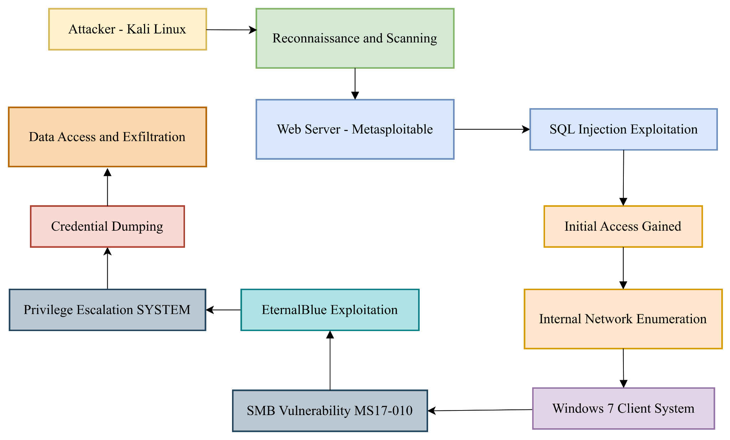
Screenshots/logs


