

BA(Hons) Business Management

Student Name: Karol Kutak
Student Number: 2030580
Module: International Financial Management Component 1 (LCBB6002)
Lecturer Name: Zainab Atta

Table of Contents
1. Introduction 3
2. Importance of corporate governance and practices 3
3. Corporate governance variables identified 4
4. Analyzing relation between corporate governance and Financial performance 4
5. Conclusion 14
References 16

1. Introduction
This report will discuss the importance of corporate governance and practices in the organisations. AstraZeneca will be selected for conducting analysis on the corporate governance and financial activities of this organisation. This company is operating under the UK pharmaceutical industry and its financial information is available over the annual report for the last 5 years. Ratios will be calculated for determining the financial performance and corporate governance variables will be identified to determine the relation between variables. Whether corporate governance has a direct impact over the organisation's financial performance or not can be contemplated as the main objective of conducting this report.

2. Importance of corporate governance and practices
Corporate governance always works for maintaining the ethical standard and other principles in the organisational process. According to the available information, companies without corporate governance cannot ensure compliance with regulation (Arnold, 2007). In order to determine the importance of some factors are need to be taken into consideration such as:
- Enhancing the trust on brand
- Developing the employee retention policies
- Increasing employee motivational strategy
- Promoting organisational transparency (Fahad and Rahman, 2020)
- Securities account ability for organisation activities
- Decision making processes will be increased
According to the available information, it is identified that the corporate governance of an organisation is always contributing towards the development of the organisation market. It helps in achieving competitive advantages for the company through developing communication and the stakeholder management of the company (Almashhadani and Almashhadani, 2023).
As per the website and annual report of AstraZeneca PLC, it is identified that the management has implemented AZ group strategy as a main part of their corporate governance (astrazeneca.com, 2024). It helps in determining the value of stakeholders and the requirements of society for their business development (Atrill, 2006). Ranging from manufacturing processes to organisation contribution to human health, the entire strategy has been covered by this group of strategies. Some metrics have been used by the organisation in terms of determining the actual requirement of transparency in the current business environment.

3. Corporate governance variables identified
Corporate governance metrics always need to be considered by every organisation and AstraZeneca is operating under the competitive market, so corporate governance is a mandatory factor for its management. Metrics are:
- Executive compensation transparency in terms of remuneration policies.
- Its corporate governance represents equality and diversity in the organisation (Tiep Le and Nguyen, 2022).
- Compliances and ethical practices representing anti-corruption policies and proactive measures in determining potential interest (McLaney, 2005).
- Audit and risk management reports represent financial transparency.
- Social responsibilities and sustainability reports will also represent the environment and target of the organisation (Bekaert and Hodrick, 2012).
- Communication strategies and its development represents the changes in organisational structure.
AstraZeneca has considered these factors as their corporate governance metric, in terms of analysing their positive impact of the governance (Kyere and Ausloos, 2021).

4. Analyzing relation between corporate governance and Financial performance
Financial analysis
Five types of financial ratios are calculated for the purpose of determining the financial performance of the company.

Profitability ratio
Years | Net profit margin | Amount | Ratio
2020 | Net profit | £ 3,196.00 | 0.12007
2020 | Revenue | £ 26,617.00 | 0.12007
2021 | Net profit | £ 1,120.00 | 0.02993
2021 | Revenue | £ 37,417.00 | 0.02993
2022 | Net profit | £ 3,288.00 | 0.07414
2022 | Revenue | £ 44,351.00 | 0.07414
2023 | Net profit | £ 5,955.00 | 0.12999
2023 | Revenue | £ 45,811.00 | 0.12999
2024 | Net profit | £ 6,234.00 | 0.12925
2024 | Revenue | £ 48,233.00 | 0.12925
 | Revenue | £ 48,233.00
Table 1: Profitability ratio
According to the profitability ratio, it is determined that the net profit of Astrazeneca was calculated as 12% in 2020 and it became 12.9% in 2024. Different types of fluctuations have been identified over these 5 year periods however the ultimate changes represent growth in the organisation profitability (Campião, 2023).

Liquidity ratio
Years | Current ratio | Amount | Ratio
2020 | Current asset | £ 19,544.00 | 0.96243
2020 | Current liabilities | £ 20,307.00 | 0.96243
2021 | Current asset | £ 26,244.00 | 1.16155
2021 | Current liabilities | £ 22,594.00 | 1.16155
2022 | Current asset | £ 22,593.00 | 0.85928
2022 | Current liabilities | £ 26,293.00 | 0.85928
2023 | Current asset | £ 25,054.00 | 0.82031
2023 | Current liabilities | £ 30,542.00 | 0.82031
2024 | Current asset | £ 27,233.00 | 0.85757
2024 | Current liabilities | £ 31,756.00 | 0.85757
 | Current liabilities | £ 31,756.00
Table 2: Liquidity ratio
Liquidity ratio can be presented in terms of negative growth for this organisation as the current ratio was 0.96 in 2020 and it becomes 0.86 in 2024. Both figures represent the efficiency of the organisation in covering their current liabilities by using assets. During the last 5 year period in 2021, the organisation can achieve a better current ratio of 1.17. It means that the management is capable of maintaining the working capital (Revalska, 2021).

Gearing ratio
Years | Debt to equity | Amount | Ratio
2020 | Total debt | £ 20,380.00 | 1.30457
2020 | Total equity | £ 15,622.00 | 1.30457
2021 | Total debt | £ 30,781.00 | 0.77675
2021 | Total equity | £ 39,628.00 | 0.77675
2022 | Total debt | £ 29,232.00 | 0.78926
2022 | Total equity | £ 37,037.00 | 0.78926
2023 | Total debt | £ 28,622.00 | 0.73122
2023 | Total equity | £ 39,143.00 | 0.73122
2024 | Total debt | £ 29,096.00 | 0.72515
2024 | Total equity | £ 40,124.00 | 0.72515
 | Total asset | £ 110,324.00
Table 3: Gearing ratio
According to the gearing ratio, it is identified that the debt to equity ratio of this organisation was 1.3 in 2020 with this under the limit of liability in comparison to the capital (Majidi and Khorshidi, 2024). In 2024, a better financial condition has been represented as the amount of debt has increased but the growth rate of equity is higher than the liability. In this year, the debt ratio has decreased to 0.72.

Efficiency ratio
Years | Interest coverage ratio | Amount | Ratio
2020 | Earnings before interest and tax | £ 3,916.00 | 3.07862
2020 | Interest expenses | £ 1,272.00 | 3.07862
2021 | Earnings before interest and tax | -£ 1,390.00 | -1.0893
2021 | Interest expenses | £ 1,276.00 | -1.0893
2022 | Earnings before interest and tax | £ 4,512.00 | 3.39248
2022 | Interest expenses | £ 1,330.00 | 3.39248
2023 | Earnings before interest and tax | £ 8,722.00 | 5.48899
2023 | Interest expenses | £ 1,589.00 | 5.48899
2024 | Earnings before interest and tax | £ 9,156.00 | 5.28637
2024 | Interest expenses | £ 1,732.00 | 5.28637
 | Inventory | £ 6,544.00
Table 4: Interest coverage ratio
Efficiency ratio has been represented that in 2020 the interest coverage ratio was 3 which is representing the efficiency of management in covering their expenses by using profit. In 2024, interest coverage efficiency has been increased to 5.3 which is reflecting the growth in profitability.

Investment ratio
Years | Return on equity | Amount | Ratio
2020 | Net profit | £ 3,196.00 | 0.20458
2020 | Total equity | £ 15,622.00 | 0.20458
2021 | Net profit | £ 1,120.00 | 0.02826
2021 | Total equity | £ 39,628.00 | 0.02826
2022 | Net profit | £ 3,288.00 | 0.08878
2022 | Total equity | £ 37,037.00 | 0.08878
2023 | Net profit | £ 5,955.00 | 0.15213
2023 | Total equity | £ 39,143.00 | 0.15213
2024 | Net profit | £ 6,234.00 | 0.15537
2024 | Total equity | £ 40,124.00 | 0.15537
 | Total asset | £ 110,324.00
Table 5: Investment ratio
According to the investment ratio, return on equity was 0.2 in 2020 which represents 20% of equity is net profit. In 2024, it is decreased to 15% which is not considered as the poor financial performance of the company as its equity has been increased.
Analyzing the relation between variables
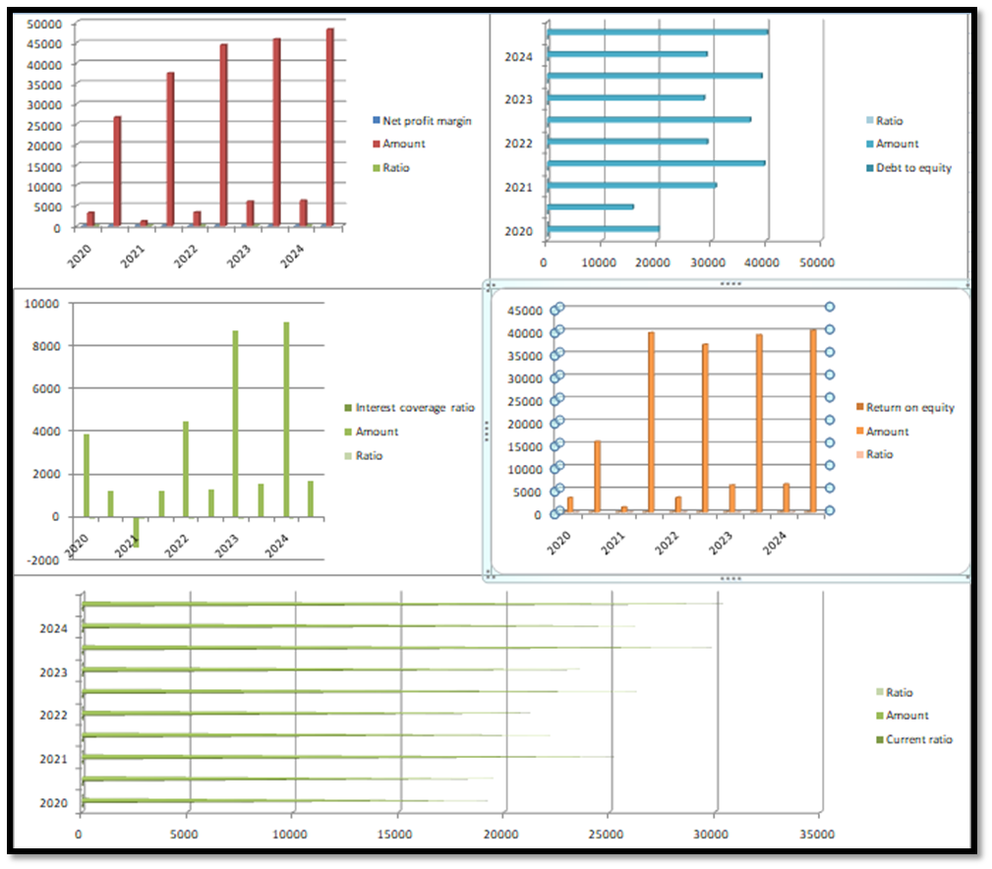
Figure 1: Financial performance of AstraZeneca Plc
In terms of the board structure the developments have been identified in the organisation by using its corporate governance. Gender equality of this organisation has been increased as 50.1% of senior roles of the company will be held by women in 2023. Due to this reason, the amount of equity has been increased in this organisation as the implementation of equality, diversity and inclusion enhances the interest of investors.
Executive compensation of this organisation has been increased in terms of earning per share to GBP 7.26 in 2023. It represents a better collaboration between the corporate governance and financial performance of the company as the decision taken over by management is contemplated as the result of corporate governance and it represents the profit ability. According to the available information, it could be stated that the organisation has managed their corporate governance in such a way so that the financial profitability can be shared with the stakeholders (Campião, 2023).
Ethical practices and sustainability also represents the efficiency of corporate governance in an organisation. Financial condition of the organisation also has been affected with the changes in corporate governance as the investment ratio of the organisation has been increased. It means that return on equity can be identified by comparing the profitability and the equity. Growth in profitability is lower in comparison to the equity which means that the dividend might be reduced in organisation (Majidi and Khorshidi, 2024). However, the investors are willing to invest in the same organisation as its financial statements and other reports are always contributing towards the transparent picture. Considering the environment and policies and other ethical practices, investors have started making more investments in the organisation in terms of achieving market status by making an ambition of zero-carbon by 2026. It represents the capability of the company in terms of equity, more revenue has been generated which was GBP 26617 million in 2020 and it is increased to GBP 48233 million by 2024. Market position of the company has been increased which has automatically resulted in organisational growth.
According to the overall information, it is determined that the organisation will need to consider their corporate governance in such a way so that the profit ability and overall financial efficiency will be increased (Majidi and Khorshidi, 2024). However, the management of AstraZeneca PLC is suggested to develop their working capital as the current assets were incapable of resolving the current liabilities.

5. Conclusion
As per the overall analysis, it is identified that AstraZeneca PLC has developed their financial condition in terms of profitability and efficiency ratio. On the other hand, the investment and gearing ratios are also representing a better financial efficiency of the company. Liquidity ratio of this organisation is always representing a poor financial management of the company as it is not able to cover the current liabilities by using current assets. Corporate governance of this organisation is contributing towards their financial development as investors have made decisions in investing in the company. Hence, it is identified that the organisation has developed their financial condition along with implementation of corporate governance strategy which represent the variables have positive relation.

References
Almashhadani, M. and Almashhadani, A.A., (2023). Corporate Governance Science, Culture and Financial Performance. International Journal of Business and Management Invention, 11(2), pp.55-60.
Arnold, G., (2007). Essentials of corporate financial management. Pearson Education.
astrazeneca.com (2024), H1 and Q2 (2024) results https://www.astrazeneca.com/content/dam/az/PDF/(2024)/h1/H1-and-Q2-(2024)-results-announcement.pdf
Atrill, P., (2006). Financial management for decision makers. pearson Education.
Bekaert, G. and Hodrick, R.J., (2012). International financial management. Pearson Education Ltd.
Campião, A.C.S., (2023). Equity research: AstraZeneca PLC (Master's thesis, Universidade do Minho (Portugal)).
Campião, A.C.S., (2023). Equity research: AstraZeneca PLC (Master's thesis, Universidade do Minho (Portugal)).
Fahad, P. and Rahman, P.M., (2020). Impact of corporate governance on CSR disclosure. International Journal of Disclosure and Governance, 17(2), pp.155-167.
Kyere, M. and Ausloos, M., (2021). Corporate governance and firms financial performance in the United Kingdom. International Journal of Finance & Economics, 26(2), pp.1871-1885.
Majidi, A. and Khorshidi, Z., (2024). A Comprehensive Financial Analysis of AstraZeneca in the Face of Global Crises.
McLaney, E., (2005). Business finance: theory and practice. Pearson education.
Revalska, P.S., (2021). AstraZeneca Going Beyond (Master's thesis, Universidade NOVA de Lisboa (Portugal)).
Tiep Le, T. and Nguyen, V.K., (2022). The impact of corporate governance on firms’ value in an emerging country: The mediating role of corporate social responsibility and organisational identification. Cogent Business & Management, 9(1), p.2018907.

