Narrative Scene Reel in Animation – Planning and Research

I am Arif Khamis, and my student number is 2305406.
This file includes my research, writing and the links to the work I’ve done over this semester for the ACA module.

Plan
I plan to go with a narrative/scene-based approach, using some of my own pre-existing characters, diving into their personalities to craft a reel of interactions with dialogue where applicable. My reel will show stages from storyboards to blocking/layout, to final animation, to final rendering.

Characters
The characters I’ll be using in this are some personal characters of mine named Bluebuzz and Nihil, a duo of contrasting personalities, both mentally and visually, that have potential for interesting interactions onscreen. These are pre-existing rigs I’ve made and have been refining over the past few years.


Bluebuzz

Bluebuzz is a curious, trusting, gullible and slightly naïve character who, for this project, finds himself in a strange new world after going to sleep. He can be awkward, but when it comes down to it, will stop at nothing to make a friend. He is emotionally inclined and can sometimes be a little self-absorbed or impulsively act on emotions when threatened or motivated. Bluebuzz’s way of thinking can be very innovative, if sometimes a bit impractical.

Nihil

Nihil is mysterious, sarcastic, clever and deadpan. She doesn’t open up as easily, to the degree of withholding even her name sometimes. She arrives to conclusions very quickly and often sees long-winded conversation as unnecessary, preferring people to ‘take a hint’ or being blunt when told to spell out her thoughts. She heavily prefers logic and reason over emotion, but deep down, feels just as strongly as Bluebuzz.

Concepts
Bluebuzz and Nihil’s designs were inspired by two of the four card suits - spades and diamonds respectively. Here is their initial concept art. The characters also represent numbers – Nihil represents the number 0, and Bluebuzz represents the number 1.



LAVs?
Although my characters are not humanoid, I believe LAVs (live action videos) can be a good way to help convey expressions. I plan to include these with my work. I have some friends outside of university willing to provide voices for these characters too, wherever applicable.
Texture Idea
Nihil does not have any hands, but I plan for her to have a magic ability to summon hands made from particles in a similar fashion to the fuzzy particle cloud texture the Inside Out characters use^{[1]}.

１ - Joy (Inside Out) staring at a memory
Using this set of hand shapes and potentially video reference of my own hands, I’ll animate a flat-textured hand first, before creating the particle effect around it. I also found a photography article that talks about posing hands^{[2]}.


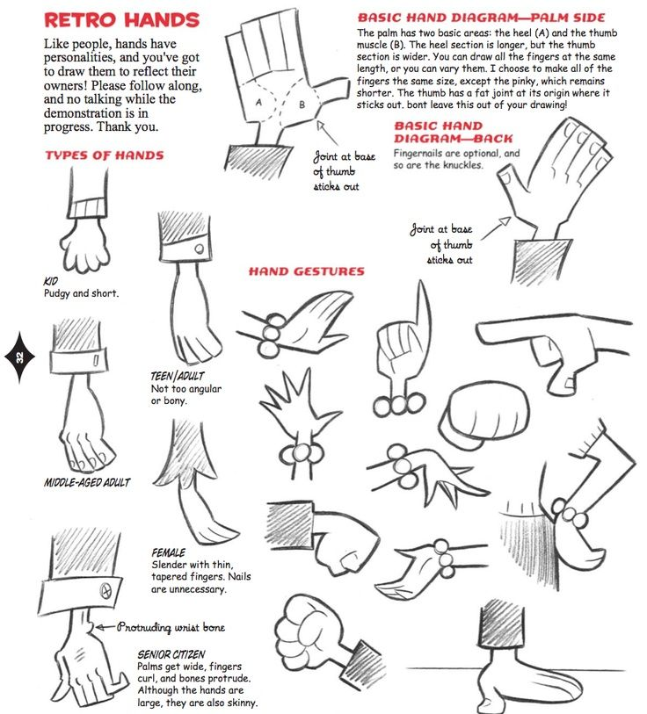

Script
Here is a part of the script involving Bluebuzz and Nihil’s interactions.
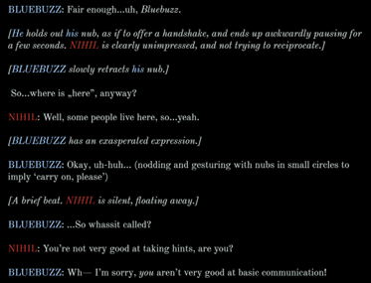
Shot Progression / Final Animation.
I’m not the strongest when it comes to drawing especially to convey backgrounds and perspective, so I tend to create ‘layouts’/pre-vis type animations using the existing models. Thus, my animation workflow is a mix between blocking and jumping straight in.
For the first part of my animation, Bluebuzz is meeting Nihil for the first time, and Nihil is dismissive, which makes Bluebuzz eventually lose patience.
The second part of my animation is musical, as I found the opportunity to use an old instrumental, I made outside of university that I had once shelved. I have a circle of people who can help record lines for my characters, so I sent them script parts for the shorts.
Here is the link to my shot progressions. They include the final animations as part of them for comparison.
https://www.youtube.com/watch?v=mzhJYsvB8dM
Here is the link to my final animations on their own.
https://www.youtube.com/watch?v=-b8P_6exy7s

LINKS
[1]
“Inside Out Rendering,” fxguide, Jun. 18, 2015. https://www.fxguide.com/fxfeatured/inside-out-rendering

[2]
metatags generator, “How-To Guide: Hand Posing Secrets of the Pros,” Ezbackgrounds.com, 2025. https://ezbackgrounds.com/blog/hands-posing-guide-photography.php
‌

‌

