University of Wales
Trinity Saint David

Community Engagement
ASSESSMENT 2

Reflective Evaluation

Student Lecture

Manal Talharchet Tanja Nathan
1917140

May 2020

Table of Contents
Introduction 3
Analytical Framework…………………………………………………………………………4
Description 6
Feelings 6
Evaluation 6
Analysis 7
Conclusion 8
Action Plan 8
Summary and Conclusion………………………………………………………………..8
Reference List………………………………………………………………………........9

Introduction
Reflective assessment requires professionals in a continuous process of self-observation and self-evaluation to consider their own behaviour and the responses they elicit within themselves and in learners (Brookfield, 1995; Thiel, 1999). Reflective assessment is considered an emerging term that views learning as "an active process of evaluating a practise experience to identify, interpret, assess and thus inform learning about practise" (Reid, B 1993 cited in Garfat, T. 2005).
As part of my study and thesis, I conducted a reflective reflection process that captured key points of personal growth, learning , and development from my studies. While my thesis results reflect the more analytical dimension of my learning experience, this article reflects the less measurable aspects of my research and concentrates on the way I handled the job. The aim is to provide me with the awareness of my experiences, through the use of a reflection approach and to gain a deeper understanding of how I approached my work.
Reflection is also an important skill in the business world of our time. Therefore, from the very beginning of their educational programme the students are required to always participate in reflective learning (Wilding, 2013). This essay seeks to provide a perspective on my practise-related experience, focused largely on the reflective process of the Gibb. This is due to the fact that the Gibbs Reflective Process is the best known method often used to plan a reflection on one's experience in order to consistently analyse and be able to learn from it. So the reflective process of the Gibbs can be said to be a learning tool that can often be used in the production of information. Gibbs reflective process is a theoretical construct that often consists of six phases during a debriefing system (Eikeland, O'Regan, & Nestel, 2015). The six stages of the reflective process involving the Gibbs are explanation, thoughts, assessment, interpretation, conclusion and, lastly, action plan.
There was a time when I worked in a hospital and it was after just a month of fieldwork. During this month of spot work, I came across a 93-year-old patient who had attended from Greece and had no knowledge of English as well. I was given the duty that day of ensuring the patient was clean and presentable. I knew the lady very well and she was incredibly clean and demanding too. It took me about an hour and a half to complete my task to the necessary degree. The consumer encountered a significant catastrophic demonstration when conducting my task, because the patient was not communicating with the same language. And to solve the problem, I most of the time had to use body language to communicate with the patient. My registered nurse was searching for me during my time of work anywhere she did not find me. Once the patient had finished all of her regular tasks, my registered nurse was there to ask me where I had been all that time. I tried to explain them as much as I could but here it was, I couldn't believe myself. I only treated and nurtured the patients for the rest of my shift, having thus observed that they were learning and playing other roles as nurses.
Analytical Framework
In view of the input and advice I got from my academic institution, I acknowledged the value of doing reflective practise in conjunction (Hoult, 2006). Through this (and through my subsequent preparatory lectures on learning styles) I noticed that I was a 'reflector,' i.e. someone who is more relaxed in thinking about new circumstances when given time (Honey & Mumford, 2000). Though I have showed some 'activist' tendencies (I am always keen to tackle new challenges), I realise that before developing and exhibiting a wider understanding, I prefer to observe and collect / collect knowledge first.
In response, during my investigative period, I agreed to keep a newspaper to record and analyse my acts as well as the feelings and behaviours which I felt at the time. This method was consistent with my learning style and applied to each entry the framework proposed by Scragg and Knott (2013).
I was concerned by reflecting on what problems when I wrote (e.g., not being able to get me motivated to begin secondary research).
• Review – I understand what's going on and what assumptions I've reached (for example , finding secondary research challenging and tedious), what my thoughts and experience have been exposed (for example, I find it difficult to implement new working practises without any help) and how others have interpreted it.

• Action -after reading the journal article, I could then decide what steps I could take (immediately and in the long term). For example, after reviewing my secondary research entries, I was seeking support from my tutor. This gave me both inspiration and encouragement. (Scragg & Knott, 2013)

Based on my reflective learning through this diary, the first step was to follow the cyclical model of Kolb, as the entries provided the requisite critical material for my learning, adaptation and development. (Kolb, 1984). The journal illustrated the experience and my subsequent observations (Do and Observe), encouraged the learning required to help me change my strategies in the future ('Think') and provided me with a personal education and growth strategy to guarantee that I acquired the skills and knowledge required ('Plan') (Kolb, 1984).
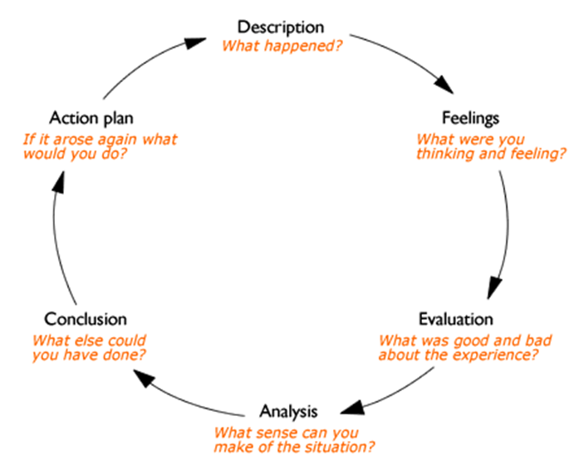
On this basis, I use a useful method known as the Gibbs Learning Cycle (Gibbs , 1988) to provide a perspective on my experience during the class, as shown in Figure 1.

Figure 1: The reflective cycle
Source: Gibbs G (1988)

Description
According to Gibbs (1988) and as seen in Figure 1, description is the first phase of the cycle in which I describe my learning experience throughout the module without drawing any conclusions. For example, I learned that every element of global communication is partly driven by cultural differences. I learned that culture is so influential in communication such that even the selection of medium I use to communicate is likely to have cultural implications. For example, I learned that developed countries depend heavily on electronic technology and prefer written communication to face-to-face communication. More specifically, I learned communication leads to what Park (1938) called “diffusion of cultural traits and so it widens the cultural area within which socia relations may exist” (187). The second important thing I learned about is time management or using my available time more effectively. Throughout the module, I learned that one crucial element of effective time management is the discipline in evaluating how I use my time.

Feelings
I understood that I had to work hard and manage time not to fail in project management capability.
However, with the COVID-19 problem we had to take lessons online. On the one hand it is positive because you do not waste as much time as in class, on the other hand it is negative because you struggle to follow given the distractions at home.

Evaluation
Throughout the course, I have developed skills relative to organization strengths and weaknesses using strategic models applied in company operations. The strategy process model has helped me apply strategic plans in the organization portfolio to articulate the needs of its customers. My positive organizational approach has helped develop a holistic approach needed in marketing. Therefore, I have gained skills to understand an organization internal environment needed to control the external environment. As a result, I can spearhead organizational changes by articulating organizational strengths and weaknesses to give desirable results. Consequently, the course has enhanced my cognitive skills required to address threats in the external environment. I can, therefore, utilize opportunities to ensure long viability of the company by exploiting opportunities present in the market. Also, the course has improved my teamwork skills and ability to interact with stakeholders to provide relevant information needed for change. Additionally, I was able to take other people's opinions into account to design the best operational strategies required to spearhead competitive advantages. As a result, the course helped me developed an insight into Primark company and the general clothing industry in the UK.

Analysis
As Vora (2014) describes it, I think throughout the entire project I was a clear and reasoned thinker and communicator.
I have given my full attention and dedication to the key goal of working properly which has allowed me to be able to deliver a report on time.
I think I will succeed in this project because I took responsibilities according to my own strength. As a result, work pressure was enjoyable.

Conclusion

Overall the module experience was positive in many aspects and I do not at the moment feel I would be better informed than I am now if it was taught differently.

Action Plan
Having identified my strengths and weaknesses in my own work, I aim to improve my future abilities and character. I think I was lucky and I hope to use this experience as a guide / framework for any potential activities.

Summary and Conclusion
The reflective cycle of Gibbs is a critical psychological tool that always helps people to find optimistic paths even when faced with difficult situations. The reflective process helped me make sense of the situation I was faced with and I was also able to grasp what I did wrong first. So it can be summarised in short that, in a demoralising situation as such, this loop is beneficial when it comes to comprehension.
The example set out in this paper highlights some of the key learning points I captured during my study period. Including:
• The need to understand and not be constrained by my learning styles and preferences.

• The value of creating a support group or network in which I work easily, so I can question and objectively evaluate my ideas, behaviours and behaviours.

• The need for learning to be seen as an iterative process and the importance of reflective processes in refining my performance and developing a targeted training and development plan;

(2014 by Armstrong & Taylor)
Reference List
Armstrong, M., Taylor, S. (2014). Armstrong's Handbook of Human Resource Management Practice, 13th Edition, London: Kogan Page Ltd.
Gibbs, G. (1988). Learning by Doing: A guide to teaching and learning methods. Oxford: Oxford Polytechnic.
Honey, P., Mumford, A. (2000). The Learning Styles Helper's Guide. Maidenhead: Peter Honey Publications.
Hoult, E. (2006). Learning Support: a guide for mature students. London: Sage Publications Ltd.
Knott, C., Scragg, T. (2013). Reflective Practice in Social Work, 3rd Edition. London: Sage.
Kolb, D.A. (1984). Experiential Learning: experience as the source of learning and development. New Jersey: Prentice Hall.
Park, R.E., 1938. Reflections on communication and culture. American Journal of sociology, 44(2), pp.187-205.
Vora, T. (2014) Critical thinking: The soul of effective communication [online] available from <http://criticalthinkingindia.in/2014/03/critical-thinking-the-soul-of-effectivecommunication/> [19 May 2020]
Williams, K., Woolliams, M., Spiro, J. (2012). Reflective Writing. London: Palgrave MacMillan.

