Component 2 - Research Report
Student Name: Lisa Ellam
Student Number: 2014962
Lecturer Name: Robert Nartowski
LCHS4002_BIRM
Digital Skills and Research Methods.

Contents

- Introduction …………………………………………………………………………….
- Research design……………………………………………………………………….
  - Research question……………………………………………………………
  - Method…………………………………………………………………………
  - Ethical considerations………………………………………………………..
- Results………………………………………………………………………………….
- Discussion………………………………………………………………………………
- Conclusion……………………………………………………………………………...
- Reference list…………………………………………………………………………...
- Appendix A- A blank copy questionnaire…………………………………………....

Introduction

This report summarises the importance of digital skills and technology for students. University Wales Trinity Saint David students participating in the Digital and Research Skills module were assigned a question selected by the lecturer, “Which digital tool is most used by students at UWTSD to collaborate together.” and were tasked to create a survey based on the chosen question, recruit participants in the survey, create a statistics chart using the results from the survey, create a presentation and discuss the results in class. UWTSD students were then assigned to write a report based on the independent research of the assigned question and the importance of digital skills and technology for students.
According to (Christensen, R., 2002. Effects of technology integration education on the attitudes of teachers and students. Journal of Research on technology in Education, 34(4), pp.411-433.) Technology provides students access to an abundance of online resources and simplifies learning and communication between students and teachers. According to the report, digital tools and technology such as Microsoft teams, Zoom, student email and Google Meets allow students and teachers to communicate, collaborate, receive feedback or request support when off campus. The report suggests that demonstrating technology education has been shown to have a rapid and positive effect on the attitudes of students and teachers.

Research design
According to (Yin, R.K., 2009. Case study research: Design and methods (Vol. 5). sage.) The definition of research design is a structural framework and overall collection of various research methods and techniques that a researcher uses to collect, measure and analyse data—for example, experimental, survey or review. According to (Groenewald, T., 2004. A phenomenological research design illustrated. International journal of qualitative methods, 3(1), pp.42-55.), the definition of research design is the process of planning and developing a study to answer specific questions.
Research question
Students participating in the Digital and Research Skills module at the University Trinity Saint David were assigned into groups and tasked with choosing a question from a small selection of questions the lecturer chose regarding technology and the use of digital tools used amongst and throughout the University and the importance. UWTSD students were also tasked to research and collect data on the chosen question. The selected research question that will be used throughout this report is, “Which digital tool is most used by students at UWTSD to collaborate together.”
Method
Based on the chosen question, UWTSD students were tasked to create a survey using Microsoft Excel with a multi-question list of relevant open and closed-answered questions about technology and digital tools. Once the survey was independently produced, it was shared with other UWTSD students through student email with the request to participate in the questionnaire. All of the students that participated in the survey were recruited and utilised as data and statistics to decipher “which digital tool is most used by students at UWTSD to collaborate together”. The survey consisted of seventeen questions and received thirteen responses.
The questions in the questionnaire begin with, do you give consent? What is your gender? What is your age group? What digital tool do you use the most? Which digital tool do you use to communicate with other students? How often do you use the UWTSD App? How would you rate your IT skills? How confident are you with using digital tools? Do you require training on how to use the UWTSD App? Do you feel your IT and digital tools skills can majorly impact your learning? How would you rate the UWTSD App? (1 star being the lowest)? How likely are you to recommend UWTSD to friends and family? What do you mainly use technology for? How confident are you in using digital tools and technology to collaborate with each other? Do you access UWTSD pre-recorded and live sessions? Which device do you mainly use? I agree that older students and students returning back into education after a long period of time should be given support and training on using technology and accessing digital tools?
Each question on the survey has a selective choice answer, for example, a choice between yes and no. Once all the responses were submitted, UWTSD students were tasked to collect and analyse the recorded data. All of the participants were recruited through student email.
Ethical considerations
During the research, ethical considerations were demonstrated; for example, informed consent. All participants were asked for consent before beginning the survey. According to (Gajjar, D., 2013. Ethical consideration in research. Education, 2(7), pp.8-15.), it is fundamental to ensure anonymity, protect the rights, dignity and welfare of research participants and avoid any errors. According to the report, ethical considerations for researchers are not to fabricate, falsify or misrepresent data collected from research.
Results
The overall results of this survey suggested that although twelve of the thirteen participants were somewhat confident or extremely confident in using technology to collaborate with each other. All thirteen participants strongly and somewhat agreed that older students and students returning to education after a long period should be given support and training on using technology and accessing digital tools.
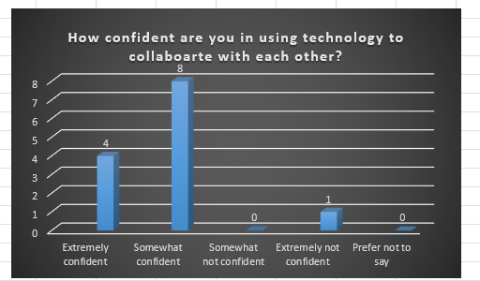

(Microsoft Excel Chart. Question 8. Appendix.)

This chart was created on Microsoft Excel using the results from the thirteen participants in the survey. During question 8, participants were asked, “How confident are you in using technology to collaborate with each other?” four participants selected extremely confident, eight chose somewhat confident, and one answered extremely not confident. This chart illustrates the statistics of the answers to question 8 of the survey.

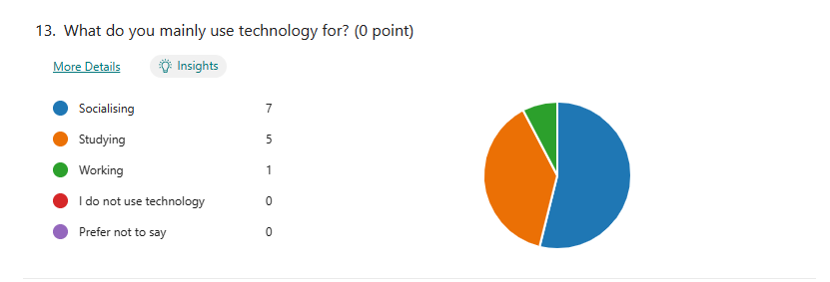
(Microsoft Forms, Digital tools and technology. Question 13. Appendix.)

During question 13 in the survey, each participant was asked, “What do you mainly use technology for?” this diagram provides a pie chart demonstrating the answers selected by participants. Seven of the thirteen UWTSD participants answered socialising, five selected studying, and one answered working. This chart displays the statistics of the answers to question 13 of the survey.
According to (Van Laar, E., Van Deursen, A.J., Van Dijk, J.A. and De Haan, J., 2017. The relation between 21st-century skills and digital skills: A systematic literature review. Computers in human behavior, 72, pp.577-588.) Digital tools and platforms such as social media are becoming more evident in individuals’ education, work and personal lives. According to the report, digital learning can help students build digital skills and increase an individual’s access to education and knowledge.

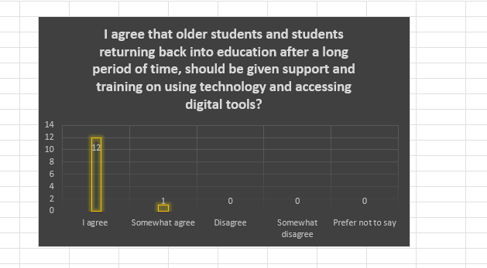

(Microsoft Excel Chart. Question. 17 Appendix.)

This chart was designed on Microsoft Excel using the results from the thirteen participants in the survey. During question 17, participants were asked to agree or disagree with the following statement. “I agree that older students and students returning back into education after a long period of time should be given support and training on using technology and accessing digital tools”. Twelve of the thirteen participants selected agreed. The final participant chose somewhat agree. This chart provides the statistics of the answers to question 17 of the survey.
According to (Schirmer, W., Geerts, N., Vercruyssen, A., Glorieux, I. and Digital Ageing Consortium, 2022. Digital skills training for older people: The importance of the ‘lifeworld’. Archives of gerontology and geriatrics, 101, p.104695.) Training on using technology and accessing digital tools can benefit older students. However, the report also indicates that ICT training for the older generation usually has limited effect concerning digital tools and technology training.
Discussion
During question 8, participants were asked, “How confident are you in using technology to collaborate with each other?” four of the thirteen participants selected extremely confident as their answer, the other eight chose somewhat confident, and the final participant answered with extremely not confident. These results demonstrate that twelve out of the thirteen participants are confident when using technology to communicate, share and collaborate and one participant lacked the confidence to use technology to collaborate. The results suggest that most UWTSD participants are confident in using technology to collaborate with other students. According to (Kiss, M., 2017. Digital skills in the EU labour market. European Parliamentary Research Service.) Digital skills are essential for students and teachers because it provides students with the ability to research, communicate, collaborate, share and create. For example, writing assignments or designing presentations. According to the report, digital skills are essential because it provides students to work with others collaboratively and builds team-related and interpersonal skills. The report suggests that digital technology and skills have growing importance to every individual and are used in every field of public, education, private and work life.

During question 13 in the survey, each participant was asked, “What do you mainly use technology for?” Seven of the thirteen UWTSD participants currently in their first term at university selected socialising as an answer. According to (Margaryan, A., Littlejohn, A. and Vojt, G., 2011. Are digital natives a myth or reality? University students’ use of digital technologies. Computers & education, 56(2), pp.429-440.) Students’ use of collaborative social networking sites was low. However, although students may lack awareness or knowledge of collaboration on social networking sites, the report suggests that technology can significantly advance communication and allow individuals to connect with students, lecturers, family, friends, or work colleagues through digital platforms such as Microsoft teams, zoom video calling, Google Meets or social networking, for example, WhatsApp, Facebook or Instagram.
Five of the thirteen UWTSD participants selected that they mainly use technology for studying. According to (Cassidy, E.D., Britsch, J., Griffin, G., Manolovitz, T., Shen, L. and Turney, L., 2011. Higher education and emerging technologies: Student usage, preferences, and lessons for library services. Reference & User Services Quarterly, pp.380-391.) technology has grown and positively impacted education by increasing interactivity, promoting time management, and providing students access to limitless resources. It also allows for combined learning and boosts collaboration and confidence between students. The final participants selected working as their answer. (Jacobs, J.V., Hettinger, L.J., Huang, Y.H., Jeffries, S., Lesch, M.F., Simmons, L.A., Verma, S.K. and Willetts, J.L., 2019. Employee acceptance of wearable technology in the workplace. Applied ergonomics, 78, pp.148-156.) digital tools and technology are used in many workplaces, and the knowledge of digital tools and skills can be essential in some workplaces. For example, a healthcare assistant must legally document every interaction with a service user using technology, such as a secured software computer or work phone. The report also suggests that technology is frequently used in academic settings and workplaces. The results to question 13 indicate that the UWTSD participants are familiar with using technology.

During question 17, participants were asked to agree or disagree with the following statement. “I agree that older students and students returning back into education after a long period of time should be given support and training on using technology and accessing digital tools”. Twelve of the thirteen participants chose agreed, and the final participant selected somewhat agree. The results suggest that all UWTSD Digital and Research Skills participants agreed that older students and students returning to education after a long period should be given training and support on using technology and digital tools. The overall results suggest that all thirteen individuals who participated in the survey would have benefited from training or support on using technology and digital skills during their first term enrolled at the university.
The results from this research confirmed the hypothesis that digital tools are highly used and needed throughout education. Technology and digital tools have drastically advanced the learning and teaching for adolescents and mature students. Knowledge or training in digital skills can positively impact a student.
The results in this report are appropriate with the literature because all of the resources and sources used in the introduction and throughout the report’s duration are credible and relevant to the topic of discussion.
Conclusion
In conclusion to this report, technology is used in daily life; it is used for personal, educational, social and work. Combining the results from developing an independent survey and research present within this report, it is evident that technology and digital tools have advanced within society. Training students and providing support on digital skills will benefit students by enhancing their knowledge of using technology devices such as a computer, laptop or tablet to access all of the required digital tools. For example, if teachers demonstrate to students how to use Microsoft word and PowerPoint, access credible resources and effectively collaborate with other students through digital platforms such as Microsoft teams, Skype, Zoom, WhatsApp, student email and Google Meets. Due to technology and digital tools being in high demand in businesses, healthcare and education settings, training students on using technology and digital tools will benefit the student in employment. “Which digital tool is most used by students at UWTSD to collaborate together.” According to the results from UWTSD participants in the survey and research, UWTSD students mostly use laptops and smartphones to collaborate through student email.

Reference list

Cassidy, E.D., Britsch, J., Griffin, G., Manolovitz, T., Shen, L. and Turney, L., (2011.) Higher education and emerging technologies: Student usage, preferences, and lessons for library services. Reference & User Services Quarterly, pp.380-391
Christensen, R., (2002.) Effects of technology integration education on the attitudes of teachers and students. Journal of Research on technology in Education, 34(4), pp.411-433.)
Gajjar, D., (2013.) Ethical consideration in research. Education, 2(7), pp.8-15.
Groenewald, T., (2004.) A phenomenological research design illustrated. International journal of qualitative methods, 3(1), pp.42-55.
Jacobs, J.V., Hettinger, L.J., Huang, Y.H., Jeffries, S., Lesch, M.F., Simmons, L.A., Verma, S.K. and Willetts, J.L., (2019.) Employee acceptance of wearable technology in the workplace. Applied ergonomics, 78, pp.148-156.
Kiss, M., (2017.) Digital skills in the EU labour market. European Parliamentary Research Service.
Schirmer, W., Geerts, N., Vercruyssen, A., Glorieux, I. and Digital Ageing Consortium, (2022.) Digital skills training for older people: The importance of the ‘lifeworld’. Archives of gerontology and geriatrics, 101, p.104695
Van Laar, E., Van Deursen, A.J., Van Dijk, J.A. and De Haan, J., (2017). The relation between 21st-century skills and digital skills: A systematic literature review. Computers in human behavior, 72, pp.577-588.
Yin, R.K., (2009.) Case study research: Design and methods (Vol. 5). sage.

Appendix A- A blank copy of questionnaire

Digital Tools And Technology.

- Do you give consent? Yes or no.
- What is your gender? Male, female, non-binary, prefer not to say.
- What is your age group? 16-25, 25-45, 45-65, 65+.
- What digital tool do you use the most? Microsoft teams, UWTSD library, Google Meets, Moodle, Google.com.
- Which digital tool do you use to communicate with other students? Student email, Microsoft teams, Google Meets, WhatsApp, on-campus or social media.
- How often do you use the UWTSD App? Daily, weekly, monthly, yearly, never.
- How would you rate your IT skills? Beginner, intermediate, advanced, expert.
- How confident are you with using digital tools? Extremely confident, somewhat confident, neutral, somewhat not confident, not confident.
- Do you require training on how to use the UWTSD App? Yes, no, maybe.
- Do you feel your IT and digital tools skills can majorly impact your learning? Yes, no, maybe.
- How would you rate the UWTSD App? (1 star being the lowest)?
- How likely are you to recommend UWTSD to friends and family? Very likely, somewhat likely, somewhat unlikely, very unlikely.
- What do you mainly use technology for? Socialising, studying, working, I do not use technology, prefer not to say.
- How confident are you in using digital tools and technology to collaborate with each other? Extremely confident, somewhat confident, somewhat not confident, prefer not to say.
- Do you access UWTSD pre-recorded and live sessions? Yes, no, prefer not to say.
- Which device do you mainly use? Tablet, desktop, laptop, mobile, none of the above.
- I agree that older students and students returning back into education after a long period of time should be given support and training on using technology and accessing digital tools? I agree, somewhat agree, disagree, somewhat disagree, prefer not to say.

