

LCHS4010 Psychology in Health and Social Care

Understanding Isaac’s Development Through Bowlby’s Attachment Theory: An Early Years Support Plan

Student Name:
Student ID:

Contents
Introduction and Overview of Isaac’s Situation 3
Selected Lifespan Development Theory: Bowlby’s Attachment Theory 4
Explanation of Bowlby’s Attachment Theory 5
Applying Bowlby’s Attachment Theory to Isaac’s Experiences 6
Nature and Nurture Influences on Isaac’s Development 7
Theory-Informed Support Plan for Isaac 8
Critical Evaluation of Bowlby’s Attachment Theory 9
Conclusion 10
References 11

Introduction and Overview of Isaac’s Situation
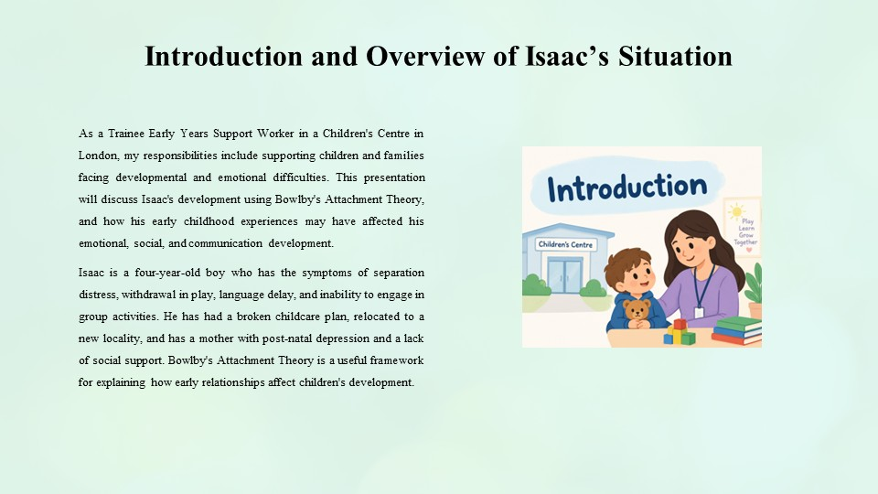
As a Trainee Early Years Support Worker in a Children's Centre in London, my responsibilities include supporting children and families facing developmental and emotional difficulties. This presentation will discuss Isaac's development using Bowlby's Attachment Theory, and how his early childhood experiences may have affected his emotional, social, and communication development.
Isaac is a four-year-old boy who has the symptoms of separation distress, withdrawal in play, language delay, and inability to engage in group activities. He has had a broken childcare plan, relocated to a new locality, and has a mother with post-natal depression and a lack of social support. Bowlby's Attachment Theory is a useful framework for explaining how early relationships affect children's development.

Selected Lifespan Development Theory: Bowlby’s Attachment Theory
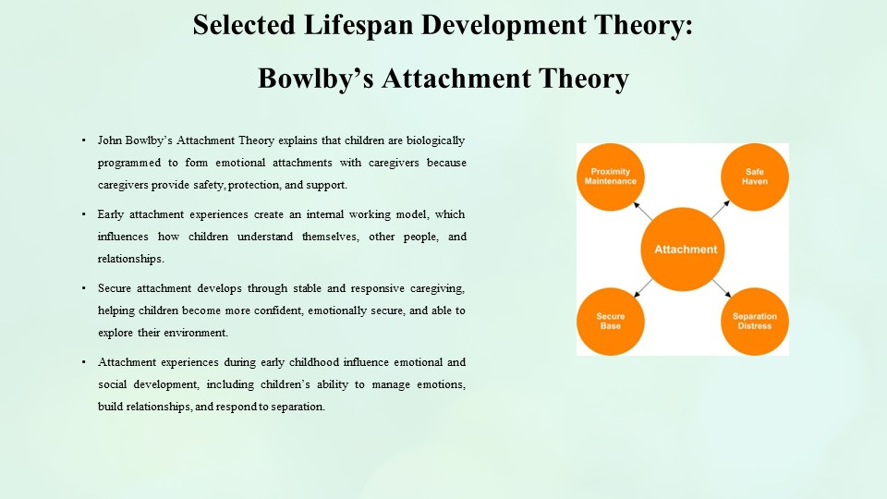
The theory adopted is the Attachment Theory of John Bowlby. According to the theory, children are biologically programmed to form emotional attachments to caregivers since caregivers offer them safety, protection, and support.
According to Bowlby, childhood attachment experiences form an internal working model, which shapes the way children perceive themselves, others, and relationships. Secure attachments are formed when children are given a stable and responsive care by the caregivers, that makes them confident and emotionally stable.
The theory applies to Isaac as his behaviours, such as problems in separation, reliance on his mother and his lack of confidence in social contexts, can be related to his childhood attachment experiences.

Explanation of Bowlby’s Attachment Theory
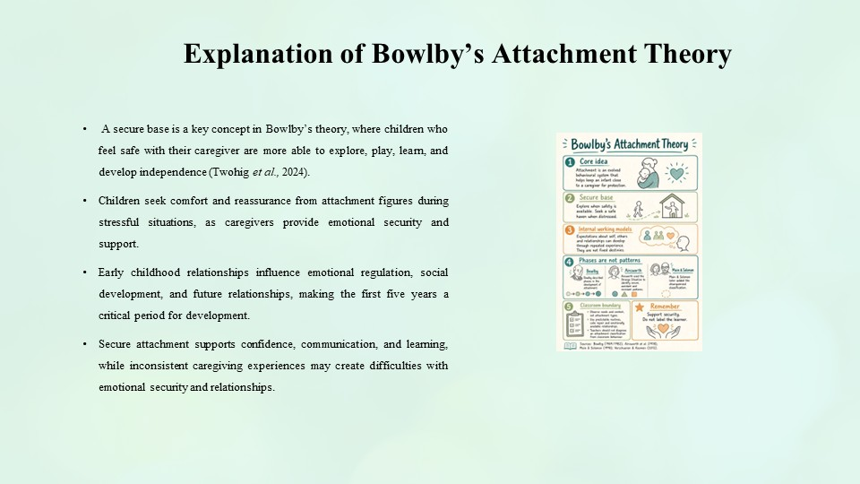
One of the main ideas in the theory of Bowlby is the secure base. Children will be in a better position to explore, play, learn and develop independence when they feel safe with their caregiver (Twohig et al., 2024). They turn to their attachment figure for comfort and assurance when they are stressed.
Bowlby underlined that emotional regulation, social development, and future relationships depend on relationships during early childhood. The initial five years of life is critical since during this period children grow very fast as they interact with their caregivers and the surrounding.
Confidence, communication, and involvement in learning can be facilitated by secure attachment. Nevertheless, uneven experiences of caregiving can bring about challenges in emotional security and relationships.

Applying Bowlby’s Attachment Theory to Isaac’s Experiences
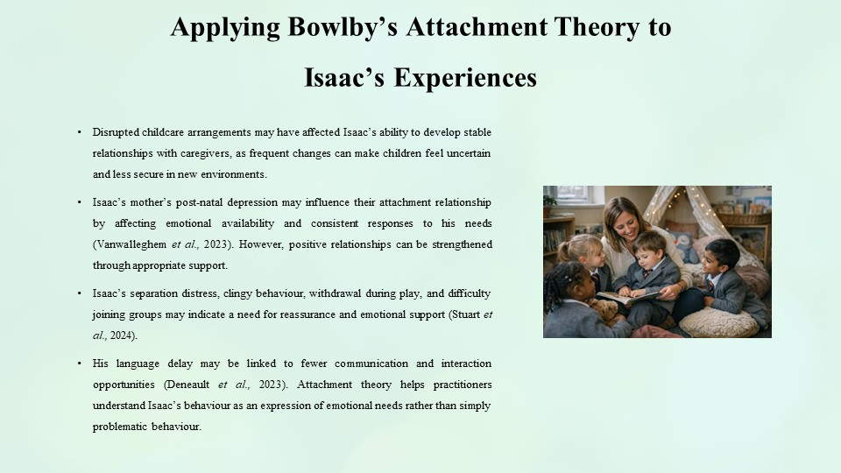
The upheaval of his childcare could have influenced Isaac's ability to have stable relationships with his caregivers. The constant changes may confuse and complicate the process of children feeling safe in new settings.
Their relationship can also be influenced by his mother's experience of postnatal depression by his mother. Depression has the potential to affect emotional availability and consistency of response of a parent to the needs of a child (Vanwalleghem et al., 2023). But, positive relations are reinforced with proper support.
The fact that Isaac is distressed when separated and displays clingy behaviour could indicate that he requires more reassurance and emotional support. His isolation in free play and inability to join the groups might indicate a lack of confidence in social situations (Stuart et al., 2024). His language delay can also be associated with the lack of communication and interaction opportunities (Deneault et al., 2023).
Attachment theory can assist practitioners to interpret the behaviour of Isaac as a way of expressing his needs emotionally and not merely problematic behaviour.

Nature and Nurture Influences on Isaac’s Development
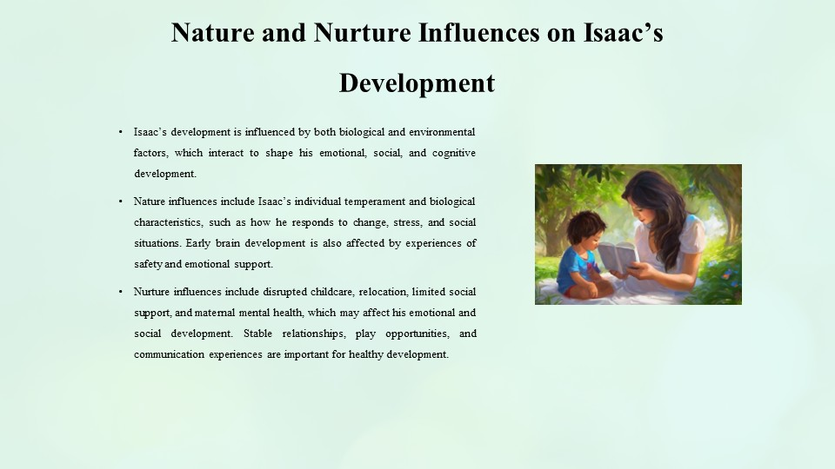
The development of Isaac is affected both by biological and environmental factors.
Nature wise, children possess unique temperaments that determine the reaction to change, stress and social situations. There are children who might be inherently sensitive or shy. Early brain development is also affected by experiences of safety and emotional support.
Nurture-wise, the situation of Isaac being subjected to interrupted child care, change in location, lack of social support, and the mental health of his mother can affect his emotional and social development. Stable relationships, play opportunities, and communication experiences are important for healthy development.
Hence, the development of Isaac is to be perceived in terms of his biological peculiarities and environmental influences.

Theory-Informed Support Plan for Isaac
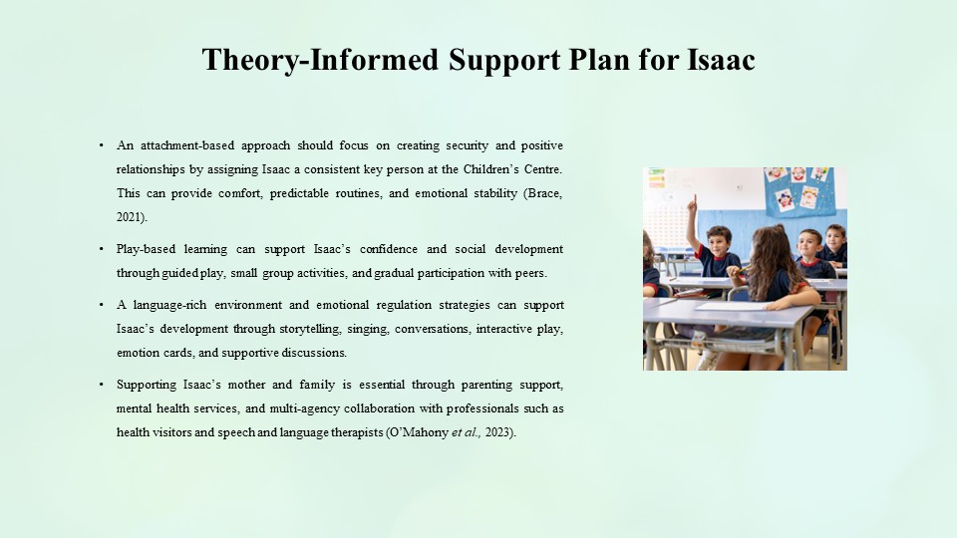
The support plan in accordance with the theory of Bowlby is supposed to be aimed at establishing security and good relations.
An attachment-based approach may include the appointment of a regular key person to Isaac at the Children Centre. This association can provide comfort, familiar schedules, and emotional stability (Brace, 2021).
Play-based learning has the potential to build the confidence of Isaac by offering him the possibility to engage in guided play, small group tasks, and gradual participation with peers.
Story telling, singing, conversations and interactive play should be employed to provide a language rich environment that aids in the development of communication.
The emotional regulation strategies can aid Isaac to recognize and communicate feelings through activities like emotion cards, stories and supportive conversations.
It is also important to support Isaac's mother. The support network of the family can be enhanced by parenting support, provision of mental health services, and multi-agency partnership with other professionals like health visitors and speech and language therapists (O'Mahony et al., 2023).

Critical Evaluation of Bowlby’s Attachment Theory
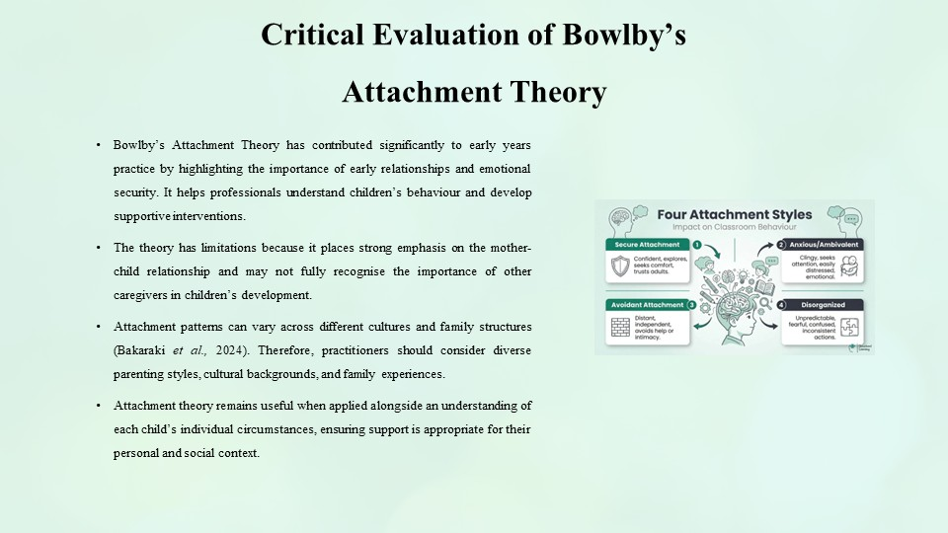
Bowlby’s Attachment Theory has made an important contribution to early years practice by highlighting the importance of early relationships and emotional security. It assists the professionals to comprehend the behaviour of children and come up with supportive interventions.
But there are limitations to the theory. It has been criticised that Bowlby emphasised the mother-child relationship a lot and did not acknowledge the value of other caregivers. Patterns of attachment can also be different in cultures and family arrangements (Bakaraki et al., 2024).
Practitioners ought to take into account various parenting styles, culture and family experiences in diverse communities like London. Attachment theory is useful when it is used in conjunction with an insight into the personal situation of each child.

Conclusion
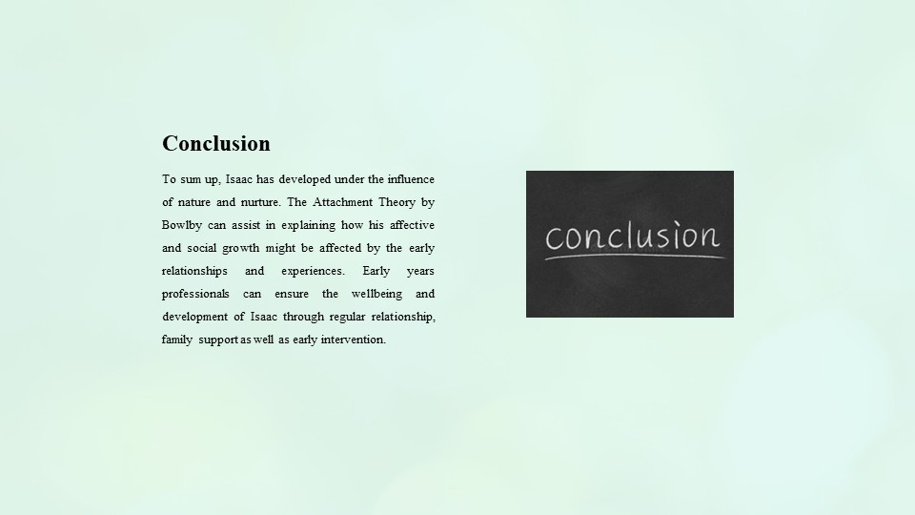
To sum up, Isaac has developed under the influence of nature and nurture. The Attachment Theory by Bowlby can assist in explaining how his affective and social growth might be affected by the early relationships and experiences. Early years professionals can ensure the wellbeing and development of Isaac through regular relationship, family support as well as early intervention.

References
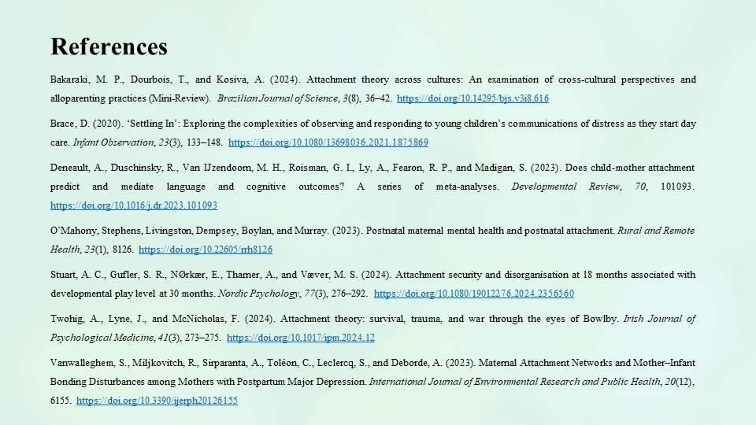
Bakaraki, M. P., Dourbois, T., and Kosiva, A. (2024). Attachment theory across cultures: An examination of cross-cultural perspectives and alloparenting practices (Mini-Review). Brazilian Journal of Science, 3(8), 36–42. https://doi.org/10.14295/bjs.v3i8.616
Brace, D. (2020). ‘Settling In’: Exploring the complexities of observing and responding to young children’s communications of distress as they start day care. Infant Observation, 23(3), 133–148. https://doi.org/10.1080/13698036.2021.1875869
Deneault, A., Duschinsky, R., Van IJzendoorn, M. H., Roisman, G. I., Ly, A., Fearon, R. P., and Madigan, S. (2023). Does child-mother attachment predict and mediate language and cognitive outcomes? A series of meta-analyses. Developmental Review, 70, 101093. https://doi.org/10.1016/j.dr.2023.101093
O’Mahony, Stephens, Livingston, Dempsey, Boylan, and Murray. (2023). Postnatal maternal mental health and postnatal attachment. Rural and Remote Health, 23(1), 8126. https://doi.org/10.22605/rrh8126
Stuart, A. C., Gufler, S. R., NØrkær, E., Tharner, A., and Væver, M. S. (2024). Attachment security and disorganisation at 18 months associated with developmental play level at 30 months. Nordic Psychology, 77(3), 276–292. https://doi.org/10.1080/19012276.2024.2356560
Twohig, A., Lyne, J., and McNicholas, F. (2024). Attachment theory: survival, trauma, and war through the eyes of Bowlby. Irish Journal of Psychological Medicine, 41(3), 273–275. https://doi.org/10.1017/ipm.2024.12
Vanwalleghem, S., Miljkovitch, R., Sirparanta, A., Toléon, C., Leclercq, S., and Deborde, A. (2023). Maternal Attachment Networks and Mother–Infant Bonding Disturbances among Mothers with Postpartum Major Depression. International Journal of Environmental Research and Public Health, 20(12), 6155. https://doi.org/10.3390/ijerph20126155

