

Program: MSc Public Health and Social Care in Practice

Module Name and Code: LCHS7002 Health Care System Organisation and Leadership

Student Name: Krinalben Hapani
Student ID: 2531601

Assessment: Critical Analysis Study Report
(Chosen Case Study: Case Study 3)

Word Count: 5010 words

Title: Improving Patient Safety and Clinical Escalation: A Systems-Based Analysis of Medication Errors and Deteriorating Care in an Older Patient

Table of Contents
1. Introduction 4
2. Main Body 5
2.1 Identifying the Problem and Setting the System Context- Applying Systems 5
Thinking and the Rich Picture 7
2.2 Centralisation or Decentralisation within the Case Study 8
2.3 Leadership Theories and Application to the Case Study 11
2.4 Improvement, and Lessons Learned 15
3. Recommendations 17
4. Conclusion 18
Reference List 20

1. Introduction
This report has been designed for the critical examination of the selected case study 3. The selected case study explores the care of Len, an 89-year-old man with Charcot-Marie-Tooth disease (CMT), that worsened after a fall. This resulted in persistent chest pain, suspected rib fracture and respiratory complications and the subsequent prescribing and administration of oral morphine. There were many healthcare professionals involved in the case but the opportunity to identify the increasing medical deterioration, coordination care, communicate medication risks along with safe prescribing were missed. This ultimately resulted in the death of the patient after suffering from respiratory failure and pneumonia, issues associated with CMT.
In health and social care leadership is referred to as the process of motivating, influencing and enabling people and multidisciplinary teams of healthcare professionals to work together for a common goal (Harris et al., 2022). This further focuses on delivering effective person-centred care that is safe as well. Instead of depending only, positional authority, effective leadership within the healthcare system promotes shared decision making, continuous learning and a culture that focuses on patient safety and improvement of the overall healthcare services (Hejazi et al., 2026).
Healthcare organisations adopt different leadership structures to support delivery of the services (Thapa et al., 2026). Centralised leadership focuses on decision-making authority within the senior management with promotion of standardisation, accountability, consistency, specifically for governance, clinical regulation and policy implementation (Nordholm et al., 2023). On the other hand, decentralised leadership helps in distributing the process of decision making to frontline-teams and local services enabling faster responses, greater professional autonomy and care customised for the need of each patient (Slåtsveen et al., 2023). Both of the methods have different benefits and effective healthcare companies consider a combination of the elements of each method to balance organisational control within clinical flexibility.
Different leadership theories provide frameworks for addressing challenges within the system of healthcare. Transformational leadership inspires and empowers employees through shared vision, continuous improvement and thereby making it valuable during culture change and service redesigning. On the other hand, transactional leadership focuses on monitoring of the performances and adherence to policies and situational leadership identifies that no single leadership approach universally effective and recommends adaptation of leadership approaches on the basis of the competence of the staff, context of the organisation and how challenging the situation is (Islam and Noor, 2025). Choosing the best leadership style becomes very crucial when an organisation or an institution is undergoing some changes or there is a medical crisis. Good leadership will help to make decisions faster, foster collaboration, encourage communication, ensure psychological safety and provide patient-centred care (Taylor and Staniszewska, 2023).
Therefore, the objective of this report is to critically examine the issues associated with leadership and management which have arisen from the care provided by Len and also highlight the strengths and weaknesses of the leadership style used in this case. Lastly, evidence-based recommendations will be made with the aim of improving leadership in the integrated care environment.

2. Main Body

2.1 Identifying the Problem and Setting the System Context- Applying Systems
Central Problem
The focal issue of the case of Len was a lack of successful medication communication, labelling, dose measurement, and an accidental morphine overdose. Charcot-Marie-Tooth (CMT) disease, Len, an 89-year-old man, fell and experienced chest pain and breathlessness. His GP recommended morphine in the form of oral solution 1.25- 2.5 ml (2.5-5 mg) at four hour intervals as needed. But Len and his wife had the misconception that the label on the bottle 10 mg/5 ml was the dosage they needed. Len thus consumed 5 ml thrice, being over administered. He was subsequently put in a coma and admitted in a hospital with the suspected morphine toxicity, pneumonia and progressive CMT. He slightly got better, and then went worse and passed away. HSSIB found that the toxicity of opioids could have been the cause of deterioration.
Global Evidence
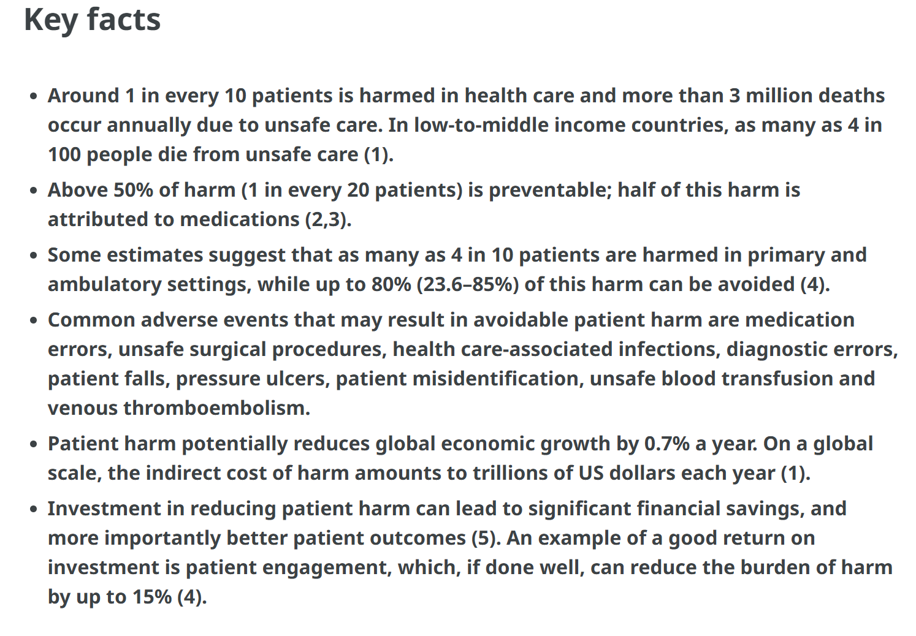
Figure 1: Key facts on patient safety
(Source: WHO, 2023)
The situation of Len is an international patient-safety issue. According to the World Health Organization (WHO), every one out of ten patients suffer harm in the course of healthcare and every year, over three million deaths happen to be related to unsafe healthcare (World Health Organization, 2023). Patient harm can be avoided in more than half the cases and in this case, that harm that can be prevented is with the medicines which is about 50 percent (World Health Organization, 2023). WHO approximates that medication errors consume about US $ 42 billion each year around the globe (WHO, 2022).
National Evidence: England and NHS.
In the case of UK evidence, the extent of medication harm is also evident. In a study reported in BMJ Quality and safety, the authors approximated some 237 million in England alone with an estimated 66 million that could have been of clinical significance (BMJ, 2020). Avoidable adverse drug events that were definitely avoidable were estimated to incur costs of around £98.5 million each year to the NHS, included around 181,626 bed-days in hospitals and were attributed to around 1708 deaths (Hodkinson et al., 2020). His prescription was thought to be an appropriate one but there was a breakdown in communication between dispensing and administration at home.
IHI and Under-Reporting
The Institute of Healthcare Improvement (IHI) presents evidence that the number of medication harm can be underestimated. According to IHI, only some 10-20 percent of errors, according to conventional reporting, can be detected (Learning, 2021). Its Global Trigger Tool involves retrospective review of patient records in order to detect adverse events and quantify harm. Healthcare organisations are therefore advised to take active measures in order to detect medication risks, as opposed to the voluntary method of actively reporting.
Weaknesses and Governance of the System
It is seen in the case of Len, which shows systemic vulnerabilities of communication, human factors and accountability. The dispensing label on the outer packaging contained the correct dose, but Len and his wife failed to recognise it. They read clearly on the bottle one-fifth-milliliters (10 mg/5 ml), which they interpreted to mean the necessary dose (Canada, 2018). The dosage of 1.25 ml which was the lowest dose prescribed could not be measured on the supplied 5 ml syringe. HSSIB indicated the necessity of better dose information and measuring equipment that was appropriate across the entire prescribed range.
The pharmacist and GP had to discuss the prescription in the area of the prescription and ensure the understanding (pharmmaceutical, 2026). Organisationally, medication procedures had to take into consideration age, dexterity and ability of Len to understand instructions. Regulation of the labelling, packaging and measuring- device standards of the medicine is affected nationally by manufacturers, regulators and professional bodies.

Thinking and the Rich Picture
It can be seen in the Rich Picture that the medication incident that occurred to Len can be traced to the interaction of failure among people, processes and organisational structures and not a lone person's action. At the centre was Len and his wife with the help of the GP, the community pharmacist and the hospital team. These medicine pathways included: prescribing, dispensing, communication, measurement and home administration. There was an incidence of a critical communication break since the concentration was prescribed to 1.25-2.5 ml whereas the bottle clearly displayed the concentration of 10mg/5ml and so Len and his wife assumed the required dose to be 10mgs/5ml. The risk of measurement was further increased by the 5 ml syringe. Len was frail due to advanced age, CMT, low level of dexterity and kidney function, but his wife had hearing and memory impairments, which posed additional communication problems. The feedback loop created as a result was unclear information relayed inappropriately to patients taken in too much form dose, possibly resulting in opioid toxicity, respiratory worsening, and subsequent hospitalization. On the whole, the Rich Picture provides systemic indicators of weaknesses in communication, human factors, medication design, accountability and governance.
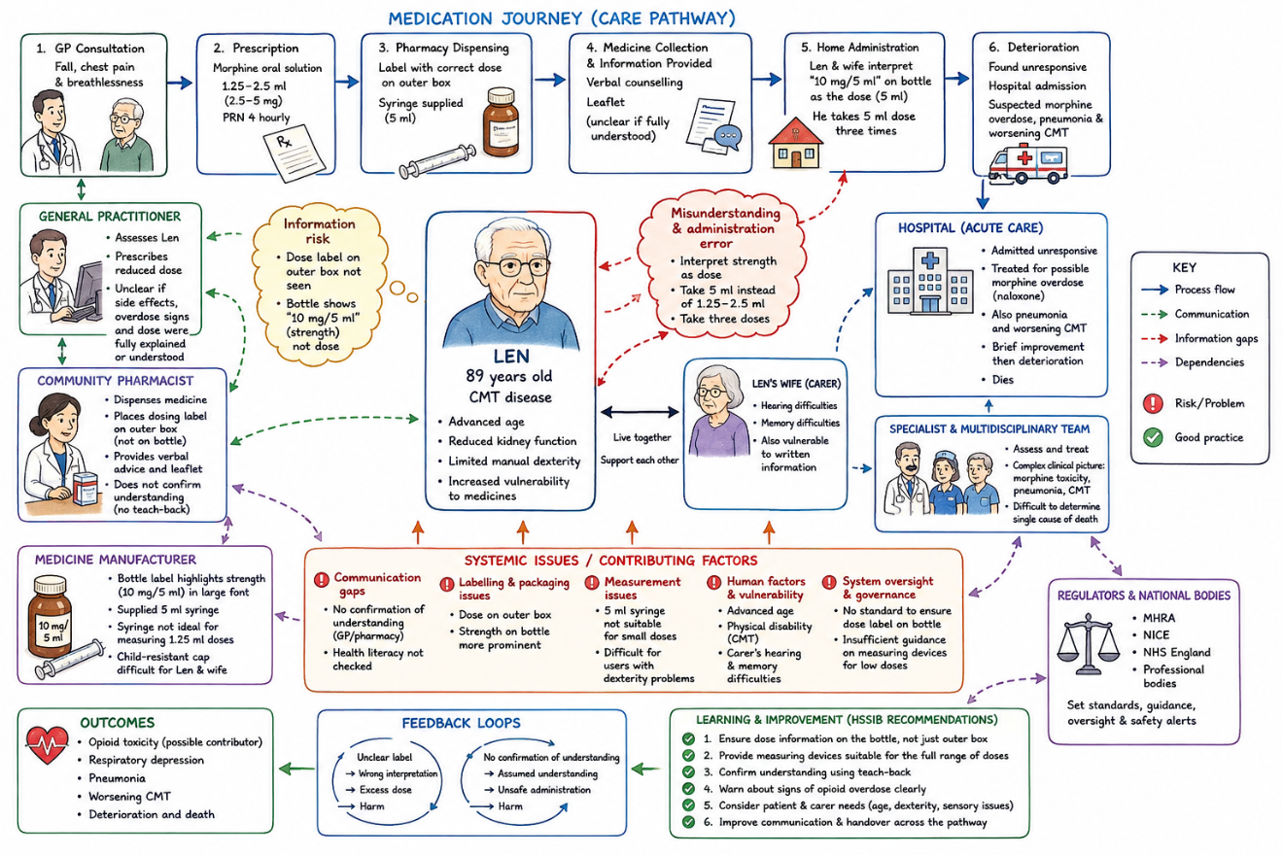
Figure 2: Rich picture
(Source: Self-created)

Firstly, the major issue that has been highlighted in the Case study 3 is that the complexity of the health system has failed to identify, communicate and act appropriately in response to the clinical deterioration of the elderly patient who suffered from breathlessness due to falling, which led to an injury and ultimately resulted in the death of the patient. While Len suffered from chest pain and breathlessness following the rib fracture, he underwent the fragmented healthcare process including GP, ED, Pharmacy, Ambulance and Respiratory care. At different stages of the journey, the clinicians could have picked up the signs of deterioration, improved pain control, risk of respiratory complications with CMT and communication among the clinicians.

2.2 Centralisation or Decentralisation within the Case Study
NHS Structure Character
Alternatively, as it can be seen through the case of Len, there is a sort of hybrid healthcare model where NHS national governance is comparatively centralised, the national decisions prescribing, dispensing or those concerned with patient-level are decentralised among GPs, community pharmacies and hospitals. The centralisation involves concentration of decision-making and facilitating regulation and expenditure control and decentralisation involves distribution of power and could enable healthcare to be more responsive to individual patient needs (Scarffe et al., 2022).
Centralised Decision-Making
The national medicines guidance, prescribing standards, professional regulation and NHS governance was centralised authority in practice (NHS England, 2023). The GP of Len was guided by national principles at the time when Len received paracetamol and ibuprofen and some time after that was prescribed with the use of morphine in a lower dose that would be relevant to an older individual with kidney dysfunction. Morphine and reduced dose agreed upon by HSSIB were in line with the national recommendations (Baker, 2023). This demonstrates one of the major strengths discovered during centralisation facilitates regulation and maintenance of regulations and establishes uniformity in healthcare services.
The centralisation is more beneficial in medication safety since common expectations can be developed in case of standardised rules. According to WHO, medication-related harm occurs in up to one-in-thirty patients around the world and over a quarter is severe or life threatening (WHO, 2022b).Nonetheless, centralisation did not stop the incident involving Len due to the fact that regulations failed to ensure its proper use in the point of care. The 1.25- 2.5 ml dose was printed on a dispensing label placed on the outside box, and not viewed by Len and his wife. They rather took the meaning of the statement on the label by the manufacturer, which stated 10 mg/5 ml, to imply the dose. HSSIB also established that the provided 5 ml syringe was not the best performance when it comes to precision in determining the lowest dose prescription (Health Services Safety Investigations Body, 2021). Therefore, there were general regulations, which however, were practiced based on local communication and patient knowledge.
The benefits of Decentralised Decision-Making
It also uses decentralisation as the power was spread between the GP, community pharmacist, patient and family. Len had tried paracetamol and ibuprofen, on which the GP appraised his evolving status, and determined that more powerful analgesia was necessary (Parri et al., 2023). This medicine was then dispensed in the community pharmacy, administered at home by Len and his wife. This is representative of the argument that decentralisation is a possible way to improve the governance, service delivery and responsiveness due to the ability of local professionals to react to local needs (Halil, 2024). Personalised care can be supported by decentralisation as well. Len did not receive an adult dose on a case by case basis. The lower dose of morphine was prescribed given his advanced age and because of his dysfunctioning kidneys (Owsiany et al., 2019).
Disadvantages of Decentralisation
However, decentralisation resulted in gaps in communication and accountability. The role of safety in medication was shared among the GP, pharma and household. The GP gave the right amount of dose, the pharmacy communication system had failed to make sure that the information that Len and his wife as individuals had comprehended (Alqenae et al., 2023). The dispensing label was printed on the outer package as the information about the large strength was clearer in the bottle (Tariq et al., 2024). Therefore, the technical information about the products was perceived as individual prescribing orders.This indicates the mentioned drawbacks of decentralisation identified poor delegation, issues in coordination between central and local governments, and lack of technical abilities (Shardeum Content Team, 2022). WHO also recognizes the weak medication systems and human factors as causes of medication errors.
National Patient-Safety Evidence
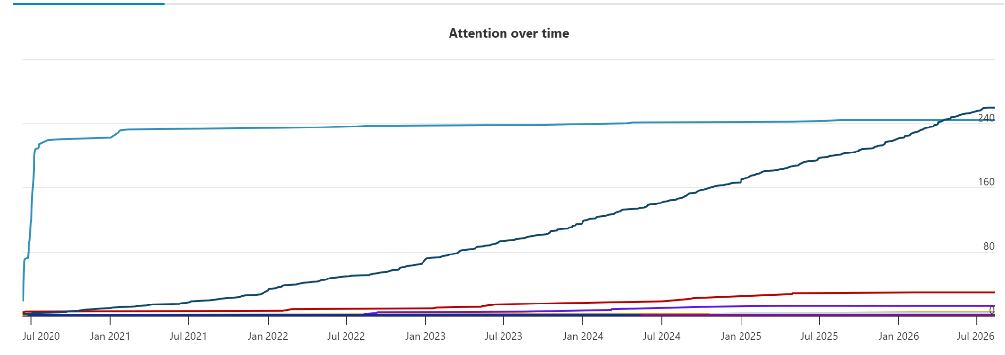
Figure 3: Errors in medication in UK
(Source: BMJ, 2020b)
A study in England made an estimated calculation of 237 million medication errors and around 66 million of these were estimated to be potentially clinically significant errors (BMJ, 2020b). This further justifies the necessity of central standards, yet demonstrates that even national policy cannot ensure safe implementation in situations where communication and responsibilities are effectively spread in care settings.
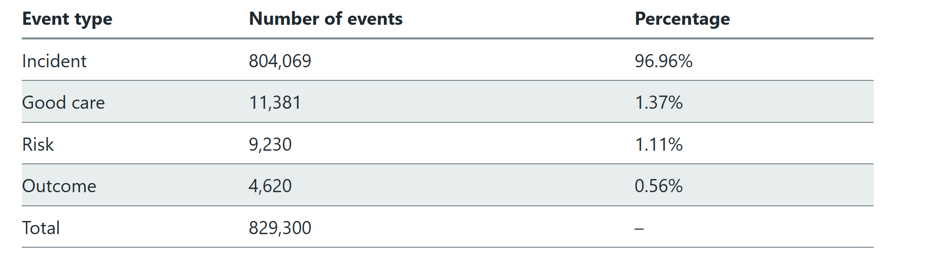
Table 1: Number of the event types in LFPSE
(Source: Statistics, 2025)
In January-March 2026 NHS England registered 829, 300 patient-safety incidents of which 804, 069 events occurred (Statistics, 2025).
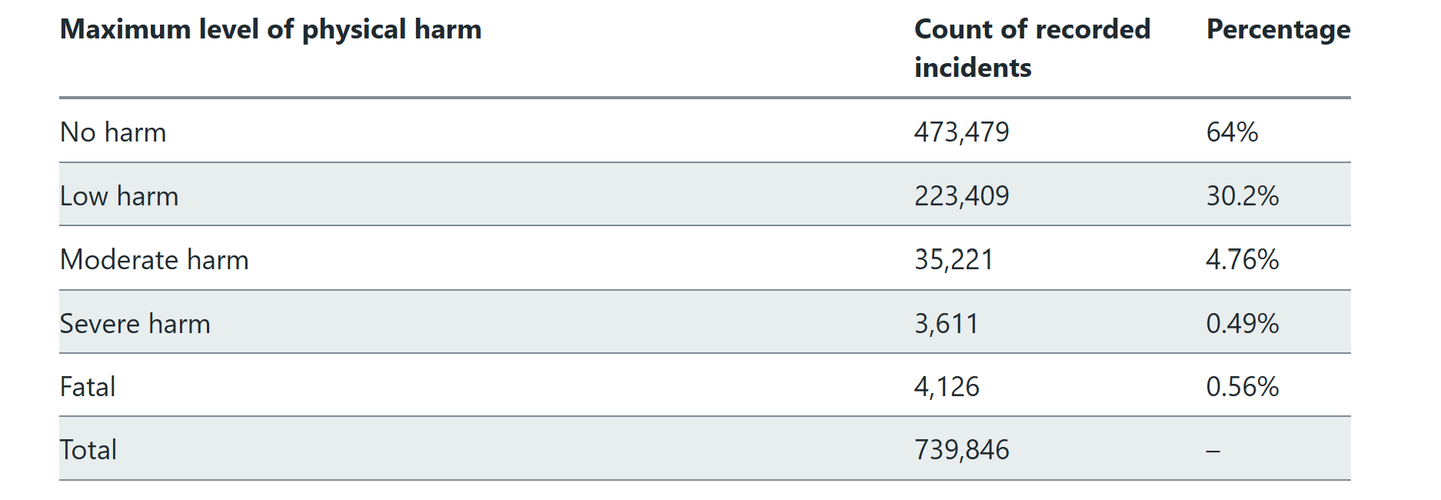
Table 2: Number of patient safety incidents by maximum physical harm
(Source: Statistics, 2025)
Out of 739,846 incidents that had reported harm, 4,126 were fatal, 35,221 moderate and 3,611 severe harm (Statistics, 2025). Some of the most common recorded involved agents included medications, devices and IT systems. These data show all patient-safety incidents, not just medication errors, but indicate the magnitude of safety activity that needs to be governed and coordinated.
Critical Comparison
Altogether, the case of Len can be interpreted as a sort of a hybrid system where there is centralised governance with medication standards, and decentralised professionals who provided care and made patient-specific decisions. Centralisation would offer uniformity and regulatory assistance, yet standardised information was not always understandable guidelines to an aged client (Ramsay et al., 2025). The decentralisation was able to facilitate personalised prescribing and offer local responsiveness, yet communication and accountability gaps were caused by fragmented responsibility.
A balanced model is the best structure to use. Clear medication-labelling and medication-safety standards should be centrally developed by national authorities, but front-line professionals should have the wherewithal to adjust the communication to individual patient inabilities (Sharma, Prakash and Medhi, 2024). In the case of Len, more explicit dose labeling, ensuring comprehension and an appropriately-named measuring device to match the 1.25 ml prescription might have provided further safeguards.

2.3 Leadership Theories and Application to the Case Study
Medication-safety compromises that were noted in the case of Len were all primarily related to leadership. The study locates the healthcare leadership to be all about governance, health systems, systems thinking, whereby health systems are organised and operated by leadership. In the case of Len, it is evident that there were gaps in the communication, packaging, measuring and coordination that compromised the prescribing. Leadership then is to be evaluated in terms of consequential development of reliable systems by the leaders and not solely on a case-by-case basis (Gutterman, 2023).
Transformational Leadership
Transformational leadership is aimed to develop a common vision, inspire employees, foster innovation and build as a sense of commitment to change. The approach is applicable since medication safety demands that leaders in primary care, pharmacy and manufacturers be interdependent, as opposed to working in silos (Notarnicola et al., 2024). HSSIB found that Len was given less morphine per his age and kidney dysfunction, but the right dose was not not mastered at home. This failure was not so much regarding the prescription of knowledge but about how to translate safe practice into a reliable system.
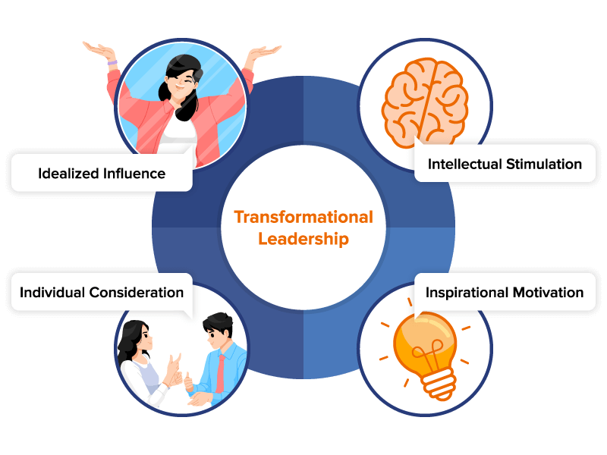
Figure 4: Transformational leadership in healthcare
(Source: as inspired from Ystaas et al., 2023)
A transformational leader would have advanced a medication-safety mission, stimulated personnel to challenge unsafe packaging and created learning throughout companies (Ystaas et al., 2023). HSSIB advised manufacturers to make sure dose-measuring devices are capable of measuring the entire spectrum of potential doses as well as professional organizations reinforced the teaching on safety studies. Nevertheless, transformational leadership might not be adequate when faced with an immediate safety threat since vision might not come with operational controls (Tagscherer and Carbon, 2025). The leaders are therefore supposed to integrate transformation with the quantifiable safety standards.
Trait Theory
According to the trait theory, a good leader should have specific qualities known to be confidence, responsibility, integrity, decisiveness, and emotional stability. These characteristics in the example of Len might assist leaders to assume responsibility in medication safety and questioning conventional practices (Damti and Hochman, 2022). Integrity would entail leaders accepting the fact that the prescription was clinically correct, but the broader structure was inadequate to provide safe administration. Quick decision-making would facilitate change in labelling, counselling and dose-measuring.
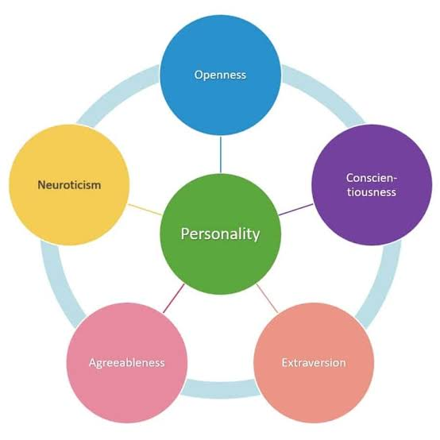
Figure 5: Trait Theory
(Source: as inspired from Linnéusson et al., 2022)
Nevertheless, the trait theory can also be excessively individualistic and ignore organisational factors. The significance of the systems perspective is that the result of any healthcare is due to interconnected people, processes and structures and not the leadership personality (Linnéusson et al., 2022). The lecture includes silo effects as one of the systems issues, in which the action taken in one section of healthcare has an unwanted impact in the second section. This is seen in the case of Len: the process of prescribing, dispensing and administration at the home were different, yet, their combination led to negative effects.
Behavioural Leadership Theory
The behavioural theory focuses on the actions of the leaders but not their personalities. A clear communication, surveillance and safety, consultation with personnel, analysis of one incident and the establishment of mechanisms of feedback would be among the leadership behaviours (Irayani Irayani et al., 2025). This applies as the right dosage of morphine was written on a dispensing label but Len and his wife failed to read it. Another issue discovered by HSSIB was that the provided syringe was unable to precisely measure the lowest recommended dose of 1.25 ml. Leaders are thus expected to institute teach-back communication, medication reconciliation, measurement device checks and high risk medication audits.
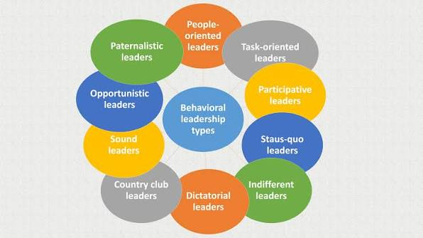
Figure 6: Trait Theory
(Source: as inspired from Kinnula et al., 2024)
Helping to justify this systems-based approach to behaviour, singles out stakeholder collaboration, collective brainstorming, conceptualizing effects and adapting interventions as steps in systems thinking (Kinnula et al., 2024). Managers ought to therefore provide environments where the frontline staff are able to detect risks and participate in redesign.
Effectiveness of leadership and supporting data
The magnitude of medication harm evidences why the performance of leaders should be measured using outcomes. According to WHO, the harmful events on patients during healthcare are reported in the range of one out of ten, and those associated with medication are reported at one out of thirty. Such statistics show that leadership should stop responding to instances and be proactive in risk management.Another indicator is staff engagement. A survey of staff conducted by NHS England in 2025 was registering an overall staff-engagement score of 5.91, which was 6.47 the previous year, and motivation dropped to 5.96 and advocacy to 5.11 (Onumonu, 2026).
Critical Assessment and Secondary Method
In Len, the leadership seems to have been more of a response than proactive since learning opportunities had been created after the medication error. A more powerful combination would be transformational vision, leadership traits and behavioural safety practices. The concept of distributed leadership would be beneficial since it would be desirable to distribute the responsibility among GPs, pharmacists, nurses, patients, carers, manufacturers and regulators (Carstensen, Kjeldsen and Nielsen, 2023).
A leadership with emotional intelligence must be cognisant of the abilities and situations of the elderly patients and carers. Leaders might have needed counselling, confirmation of understanding and measuring equipment. In general, the best solution is a complex model of a transformational purpose, responsible character of leadership, and safety behaviours. This would transform leadership to go more towards continuous learning, shared responsibility and prevention as opposed to incident response (Lyubykh et al., 2022).

2.4 Improvement, and Lessons Learned
The case of Len shows that leadership and governance existed but were disconnected across the medication path. Prescribing expectations were set by governance, and leadership locally; transformed them into administration. HSSIB discovered that the GP had made a decision in line with national advice to prescribe morphine and the 1.25-2.5 ml dose had been properly cut-down to suit Len and kidney impairment. But the manufacturer stated 10 mg/5 ml strength, which the manufacturer understood to be the dose required and prescribed 5 ml two or four times the prescribed dose, as the dose given by Len and his wife. The dispensing label on the outer box contained the correct dose which they did not notice. This illustrates a lapse in governance between a proper prescription and administration.
Week 7 explicates that centralised governance aids regulation; and decentralisation can provide response to the individual needs. Local officials managed it with national guidance giving an outline. Proper leadership must therefore link the global standards to local patient situations.
Problem 1: The gap of Communication and Accountability.
The big issue was a lack of communication along the medication pathway. HSSIB were unable to determine what advice Len was given about taking morphine, what were the side effects or warning signs of overdose based on the GP records. The dose label was changed to be on a marked outer box as opposed to being placed on the bottle (patient safety learning , 2022). The family thus resorted to the apparent statement of strength by the manufacturer. That was particularly problematic since even the smallest amount of 1.25 ml dose could not be measured with the given 5 ml syringe. HSSIB advised manufacturers to make sure that measuring machines were able to measure the entire range of potential doses.
Learnings
Leaders must implement a system where medication may be administered through a compulsory medication concept of a teach-back, a concept where patients or carers cannot exit the pharmacy or consultation without demonstrating a clear understanding of the medication dose that has been provided (Talevski et al., 2020). Patient specific dose information should be visible about the medicine container and must have a suitable measuring device with high-risk liquid medicines.
Problem 2: Reactive, not Proactive Leadership.
The leadership in the case was rather reactive. It was the safety weakness that was revealed when Len was getting serious symptoms instead of it being proactively identified. HSSIB concluded that the prescription was suitable as such, that is, the lack of opportunity was the failure to consider the interpretation of the instructions to packaging and measurements by an older patient and a carer (Dresti, 2024). Inflaws in medication systems and human factors that WHO identifies as causing medication errors include the undertaking of prescribing, dispensing, administration and monitoring. Leadership needs to concentrate on a prevention strategy instead of harm waiting.
Learning
Beneficial Organisations ought to perform prospective medication-risk assessments during older patients with decreasing dexterity or communication struggle (Terhi Toivo et al., 2018). Incidences data, near-miss reporting and patient feedback can be used by leaders to discover the risks in the earlier stage.
Issue 3: Low Cross-Organisational Learning.
The other opportunity that was misused was professional cross-professional learning. Primary care, community pharmacy, hospital services were all a part of the care that Len received with the patient and his wife. The systems-thinking lecture highlights the importance of interdependencies, feedback loops and the risk of silo decision-making (Maidment et al., 2020). Responsibility was shared and learning was not incorporated.
Learning
GP practices and pharmacies should review incidences of opioid, near misses and patient complaints of opioid. Results must be translated into uniform recommendations and advice to employees (Biancuzzi et al., 2022). This can be supported by Integrated Care Systems that provide integration of hospitals, GPs, community and social care to minimize fragmentation.
Connection between System Structure, Leadership and Feedback
In general, the situation experienced by Len was an outcome of the combination of a hybrid centralised-decentralised organisation, a lack of leadership skills and poor feedback. There was centralised direction on how an appropriate prescription should be done and there was decentralised execution where the elements of communication and measurement could have been weakened (Ding, Shen and Wang, 2024). The misinterpretation of information to get to the feedback loop and the overdose that will lead to deterioration and hospital treatment, however, was not the correct way to get risk identified and thus it was not done through intervention, learning and redesign.
It can be viewed to other healthcare organisations that policies are not the origin of creating safety. Standards should be provided as governance and then those standards should be made operational in actual patient settings by leaders. Medications should be used continuously as evidence based on medication-error data, near miss reports, staff engagement survey, patient feedback and audit (Mutair et al., 2021). This enhances responsibility, constant enhancement and active patient safety throughout the system.

3. Recommendations
- An organisation of choice must implement a proactive, distributed and emotionally intelligent medication-safety improvement programme that is based on a system-wide perspective on leadership. To start with, a compulsory safety check should be performed prior to dispensing of high-risk liquid medicines including morphine (Pollock et al., 2021). Based on the prescribed dose, concentration, volume, measuring device and patient/carer comprehension, the pharmacist must verify the details. The dose prescribed 1.25-2.5 ml was not understood in the case of Len but the 10 mg/5 ml label on the bottle added to the error. Another safety weakness that HSSIB identified was the measuring device. Hence, it is essential to put information on dose specificity of the patient in high places on the container and provide a syringe that will be able to measure the entire range of dose to be given. This is a direct response to the opportunity missed in the case.
- Transformational and behavioural approaches should be intertwined. Transformational leadership is capable of creating a shared safety vision and promoting the ongoing improvement whilst behavioural leadership can translate the shared safety vision into checking, communication, audit and feedback. Pharmacists, nurses, patients and carers are to be engaged in redesigning medication processes with the involvement of distributed leadership (NIH, 2020). This identifies decentralised decision-making as possibly closer to local needs, but aware of issues of coordination. It is also crucial to have emotional intelligence since leaders should be able to identify the communication, physical, and cognitive abilities of patients and carers.
- There ought to be central standards and local accountability in governance. Minimum conditions to meet opioid prescribing, labelling, counselling and measuring equipment as well as the compliance with these conditions should be determined at national and organisational levels and be reported by local teams. The IC Systems can help enhance the communication between hospitals, GPs, community services and social care and curb fragmentation and silo working (Tahsin et al., 2022). The source points out such common digital systems, real-time information and collaborative decision-making as the processes of enhancing communication and responsiveness of systems.
- Electronic prescribing, standardised dose-and-volume instructions, barcode or pharmacy verification (where possible) and the use of an appropriate measuring device should increase technical efficiency. The allocative efficiency implies the need to allocate resources to interventions that yield the highest safety benefit, especially, high-risk medicines and vulnerable patients (Fraser-Hurt et al., 2021). Pharmacist counselling, medication reconciliation, staff training and digital safety systems should also be given priority over relying primarily on retrospective incident response use of resources.
- Incident reports and near misses, patient feedback, pharmacy audit and frequent reviews by groups of workers should be utilized as a continuous learning. The organisation ought to develop quantifiable measures such as the percentage of high risk prescriptions with counselling, provision of correct measuring-devices, documented teach- back, dispensing errors and medication related incidents. Results need to be disseminated within teams by means of feedback. Co-productions should be undertaken with patients and carers involving selection of medications by reviewing them and testing labelling and instructions. The method transforms the experience of a lonely tragedy of Len and into organisational learning.
- The introduction of the change should be conducted in steps: in three months, standardise the opioid labelling and counselling; in six months, audit compliance and staff training; in one year, assess trends of incidents and reform the programme. Top management needs to appoint a person in charge of every activity and report outcomes to governance boards. This brings about obligation and flexibility on the front line. A dashboard of performance must compare performance and uncover variation so that aid is provided in the area where compliance is the weakest, and lapses of performance are not allowed to flourish within the organisational walls. at any governance review.

4. Conclusion
The case of Len illustrates that medication damage might occur due to the erosion of clinically appropriate prescribing by the communication breakdowns, inappropriate measurement devices, patient susceptibility and fragmented accountability. The discussion reveals that centralised governance may offer standards and uniformity, whilst decentralised delivery will require a high level of coordination and local accountability. It is in leadership, too, that policy has to be linked with frontline practice.
Transformational leadership is able to offer a sense of shared commitment to safety, and behavioural leadership and distributed leadership can uphold that idea that staff can actively communicate, report and rectify risky behaviour. The reason why the system thinking is so important is that the end result was due to relationships between the GP, the pharmacy, the patient, the carer, the medicine wrapping as well as the broader governance systems not the result of a single error.
It is crucial to understand that healthcare organisations must cease to react to issues and shift to proactive prevention. The most effective ways to establish more powerful barriers of safety are the use of clear communication of doses, appropriate tools of measuring, teach-backs, multidisciplinary learning, and the digital exchange of information and patient engagement. Sustainability of the improvement can be observed by constant attention to safety indicators and feedback provided by staff and patients. Finally, proper governance, good leadership and systems thinking should work in concert to bring safer, efficient and accountable healthcare to the people always.

Reference List

Alqenae, F.A., Steinke, D., Carson-Stevens, A. and Keers, R.N. (2023). Analysis of the nature and contributory factors of medication safety incidents following hospital discharge using national reporting and learning system (NRLS) data from England and Wales: A multi-method study. Therapeutic Advances in Drug Safety, 14(18), p.204209862311543. doi:10.1177/20420986231154365.
Baker, T. (2023). A changing view on patient safety: How the Healthcare Safety Investigation Branch has brought system-focused investigations to the fore. Future Healthc J, [online] 10(1), pp.10–13. doi:10.7861/fhj.2023-FR101.
Biancuzzi, H., Dal Mas, F., Brescia, V., Campostrini, S., Cascella, M., Cuomo, A., Cobianchi, L., Dorken-Gallastegi, A., Gebran, A., Kaafarani, H.M., Marinangeli, F., Massaro, M., Renne, A., Scaioli, G., Bednarova, R., Vittori, A. and Miceli, L. (2022). Opioid misuse: A review of the main issues, challenges, and strategies. International Journal of Environmental Research and Public Health, [online] 19(18), p.11754. doi:10.3390/ijerph191811754.
BMJ (2020a). 237+ Million medication errors made every year in England - BMJ Group. [online] BMJ group. Available at: https://bmjgroup.com/237-million-medication-errors-made-every-year-in-england/ [Accessed 11 Aug. 2026].
BMJ (2020b). Report for: Economic analysis of the prevalence and clinical and economic burden of medication error in England. [online] altmetric. Available at: https://bmj.altmetric.com/details/83874610 [Accessed 11 Aug. 2026].
Canada, H. (2018). Good label and package practices guide for non-prescription drugs and natural health products - Canada.Ca. [online] Canada.ca. Available at: https://www.canada.ca/en/health-canada/services/drugs-health-products/reports-publications/medeffect-canada/good-label-package-practices-guide-non-prescription-drugs-natural-health-products-guidance.html [Accessed 11 Aug. 2026].
Carstensen, K., Kjeldsen, A.M. and Nielsen, C. (2023). Distributed leadership in health quality improvement collaboratives. Health Care Management Review, 49(1), pp.46–58. doi:10.1097/hmr.0000000000000385.
Damti, S. and Hochman, G. (2022). Personality characteristics as predictors of the leader’s ethical leadership in regular times and in times of crisis. Sustainability, 14(16), p.9800. doi:10.3390/su14169800.
Ding, X., Shen, W. and Wang, S. (2024). Centralized or decentralized? Communication Network and collective effectiveness of PBOs—A task urgency perspective. Buildings, [online] 14(2), pp.448–448. doi:10.3390/buildings14020448.
Dresti, S. (2024). Medication not given: Administration of time critical medication in the emergency department. [online] HSSIB. Available at: https://www.hssib.org.uk/patient-safety-investigations/medication-related-harm/investigation-report / [Accessed 11 Aug. 2026].
Fraser-Hurt, N., Hou, X., Wilkinson, T., Duran, D., Abou Jaoude, G.J., Skordis, J., Chukwuma, A., Lao Pena, C., Tshivuila Matala, O.O., Gorgens, M. and Wilson, D.P. (2021). Using allocative efficiency analysis to inform health benefits package design for progressing towards universal health coverage: Proof-of-concept studies in countries seeking decision support. PLOS ONE, 16(11), p.e0260247. doi:10.1371/journal.pone.0260247.
Gutterman, A.S. (2023). Definitions and conceptions of leadership. [online] ResearchGate. Available at: https://www.researchgate.net/publication/371169414_Definitions_and_Conceptions_of_Leadership [Accessed 11 Aug. 2026].
Halil, A. (2024). Decentralization and its impact on improving public services. International journal of social sciences, [online] 7(2), pp.45–53. doi:10.21744/ijss.v7n2.2278.
Harris, R., Fletcher, S., Sims, S., Ross, F., Brearley, S. and Manthorpe, J., 2022. Developing programme theories of leadership for integrated health and social care teams and systems: a realist synthesis. Health and Social Care Delivery Research, 10(7), pp.1-118. https://www.journalslibrary.nihr.ac.uk/hsdr/WPNG1013
Health Services Safety Investigations Body (2021). Investigation report: Weight-based medication errors in children. [online] HSSIB. Available at: https://www.hssib.org.uk/patient-safety-investigations/weight-based-medication-errors-in-children/investigation-report/ [Accessed 11 Aug. 2026].
Hejazi, M.E., Alizadeh-Dizaj, G., Khoshsirat, S., Raoofi, S. and Javan Biparva, A., 2026. Exploring collaborative strategies to improve patient safety in healthcare organizations: A qualitative study. Plos one, 21(1), p.e0341022.
Hodkinson, A., Tyler, N., Ashcroft, D.M., Keers, R.N., Khan, K., Phipps, D., Abuzour, A., Bower, P., Avery, A., Campbell, S. and Panagioti, M. (2020). Preventable medication harm across health care settings: A systematic review and meta-analysis. BMC Medicine, [online] 18(1). doi:10.1186/s12916-020-01774-9.
Irayani Irayani, Frecilia Nanda Melvani, Amrillah Azrin and Msy. Mikial (2025). Behavioral theory and organizational culture: The interplay of transformational leadership, team dynamics, and motivation in driving change at Tridinanti University of Palembang. The Eastasouth Management and Business, [online] 3(02), pp.220–229. doi:10.58812/esmb.v3i02.375.
Islam, T. and Noor, A., 2025. Transformational vs. transactional leadership. Asian Journal of Research in Economics and Finance, 2(1). https://www.aarbss.org/ajref/article/view/100
Kinnula, M., Eva Durall Gazulla, Noora Hirvonen, Malmberg, J. and Lotta Haukipuro (2024). Nurturing systems thinking among young people by developing business innovations on sustainable AI. International journal of child-computer interaction, 18(12), pp.100656–100656. doi:10.1016/j.ijcci.2024.100656.
Learning, P.S. (2021). IHI global trigger tool for measuring adverse events (second edition, 2009). [online] Patient Safety Learning - the hub. Available at: https://www.pslhub.org/learn/improving-patient-safety/ihi-global-trigger-tool-for-measuring-adverse-events-second-edition-2009-r6373/ [Accessed 11 Aug. 2026].
Linnéusson, G., Andersson, T., Kjellsdotter, A. and Holmén, M. (2022). Using systems thinking to increase understanding of the innovation system of healthcare organisations. Journal of Health Organization and Management, 36(9), pp.179–195. doi:10.1108/jhom-01-2022-0004.
Lyubykh, Z., Gulseren, D., Turner, N., Barling, J. and Seifert, M. (2022). Shared transformational leadership and safety behaviours of employees, leaders, and teams: A multilevel investigation. Journal of Occupational and Organizational Psychology, 95(2), pp.431–458. doi:10.1111/joop.12381.
Maidment, I. D, Lawson, S., Wong, G., Booth, A., Watson, A., McKeown, J., Zaman, H., Mullan, J. and Bailey, S. (2020). Findings. [online] Nih.gov. NIHR Journals Library. Available at: https://www.ncbi.nlm.nih.gov/books/NBK558345/ [Accessed 11 Aug. 2026].
Mutair, A. Al, Alhumaid, S., Shamsan, A., Zaidi, A.R.Z., Mohaini, M. Al, Al Mutairi, A., Rabaan, A.A., Awad, M. and Al-Omari, A. (2021). The effective strategies to avoid medication errors and improving reporting systems. Medicines, [online] 8(9), p.46. doi:10.3390/medicines8090046.
NHS England (2023). Medication safety management. [online] NHS. Available at: https://www.england.nhs.uk/long-read/medication-safety-management/ [Accessed 11 Aug. 2026].
NIH (2020). Transformational leadership and evidence-based management. [online] Nih.gov. National Academies Press (US). Available at: https://www.ncbi.nlm.nih.gov/books/NBK216194/ [Accessed 11 Aug. 2026].
Nordholm, D., Wermke, W. and Jarl, M., 2023. In the eye of the storm? Mapping out a story of principals’ decision-making in an era of decentralisation and re-centralisation. Journal of Educational Administration and History, 55(4), pp.420-440. https://www.tandfonline.com/doi/pdf/10.1080/00220620.2022.2104823
Notarnicola, I., Duka, B., Lommi, M., Grosha, E., Maria, De, Iacorossi, L., Mastroianni, C., Ivziku, D., Rocco, G. and Stievano, A. (2024). Transformational leadership and its impact on job satisfaction and personal mastery for nursing leaders in healthcare organizations. Nursing Reports, [online] 14(4), pp.3561–3574. doi:10.3390/nursrep14040260.
Onumonu, M. (2026). NHS England reports drop in staff engagement and morale in 2025 survey - workplace journal. [online] Workplace Journal. Available at: https://workplacejournal.co.uk/2026/03/nhs-england-reports-drop-in-staff-engagement-and-morale-in-2025-staff-survey/ [Accessed 11 Aug. 2026].
Owsiany, M., Hawley, C., Triantafylidis, L. and Paik, J. (2019). Opioid management in older adults with chronic kidney disease: A review. The American Journal of Medicine, [online] 132(12), pp.1386–1393. doi:10.1016/j.amjmed.2019.06.014.
Parri, N., Silvagni, D., Chiarugi, A., Cortis, E., D’Avino, A., Lanari, M., Marchisio, P.G., Vezzoli, C., Zampogna, S. and Staiano, A. (2023). Paracetamol and ibuprofen combination for the management of acute mild-to-moderate pain in children: Expert consensus using the nominal group technique (NGT). Italian Journal of Pediatrics, [online] 49(1). doi:10.1186/s13052-023-01445-4.
patient safety learning (2022). New HSIB report highlights liquid morphine safety concerns. [online] Patient Safety Learning. Available at: https://www.patientsafetylearning.org/blog/new-hsib-report-highlights-liquid-morphine-patient-safety-concerns [Accessed 11 Aug. 2026].
pharmmaceutical (2026). Principles of effective prescription writing for pharmacist prescribers. [online] The Pharmaceutical Journal. Available at: https://pharmaceutical-journal.com/article/ld/principles-of-effective-prescription-writing-for-pharmacist-prescribers [Accessed 11 Aug. 2026].
Pollock, K., Wilson, E., Caswell, G., Latif, A., Caswell, A., Avery, A., Anderson, C., Crosby, V. and Faull, C. (2021). Family and health-care professionals managing medicines for patients with serious and terminal illness at home: A qualitative study. Health Services and Delivery Research, 9(14), pp.1–162. doi:10.3310/hsdr09140.
Ramsay, A.I., Tomini, S.M., Gandhi, S., Fulop, N.J. and Morris, S. (2025). Centralisation of specialised healthcare services: A scoping review of definitions, types, and impact on outcomes. Health and Social Care Delivery Research, 18(18), pp.1–70. doi:10.3310/remd6648.
Scarffe, A.D., Coates, A., Evans, J.M. and Grudniewicz, A. (2022). Centralization and innovation: Competing priorities for health systems? The International Journal of Health Planning and Management, [online] 37(5), pp.2534–2541. doi:10.1002/hpm.3531.
Shardeum Content Team (2022). Advantages and disadvantages of decentralization | shardeum. [online] EVM compatible sharded blockchain. Available at: https://shardeum.org/blog/advantages-and-disadvantages-of-decentralization/ [Accessed 11 Aug. 2026].
Sharma, L., Prakash, A. and Medhi, B. (2024). Ensuring medication and patient safety for better quality healthcare. Indian Journal of Pharmacology, [online] 56(6), pp.375–378. doi:10.4103/ijp.ijp_109_25.
Slåtsveen, R.E., Wibe, T., Halvorsrud, L. and Lund, A., 2023. Interdisciplinary frontline teams in home-based healthcare services—paradoxes between organisational work structures and the trust model: a qualitative study. BMC Health Services Research, 23(1), p.715. https://link.springer.com/content/pdf/10.1186/s12913-023-09695-y.pdf
Statistics (2025). Statistics » quarter 4 2025/26 (january, february, march 2026). [online] England.nhs.uk. Available at: https://www.england.nhs.uk/statistics/statistical-work-areas/patient-safety-data/2025-26/q4/ [Accessed 11 Aug. 2026].
Tagscherer, F. and Carbon, C.-C. (2025). The role of transformational leadership in navigating digital servitization. Sustainable Technology and Entrepreneurship, 4(2), pp.1–12. doi:10.1016/j.stae.2025.100098.
Tahsin, F., Armas, A., Kirakalaprathapan, A., Kadu, M., Sritharan, J. and Breton, M. (2022). Information and communications technologies enabling integrated primary care for patients with complex care needs: Scoping review. Journal of Medical Internet Research, 25(1), pp.e44035-e44035. doi:10.2196/44035.
Talevski, J., Wong Shee, A., Rasmussen, B., Kemp, G. and Beauchamp, A. (2020). Teach-back: A systematic review of implementation and impacts. PLOS ONE, [online] 15(4), pp.1–18. doi:10.1371/journal.pone.0231350.
Tariq, R., Scherbak, Y., Vashisht, R. and Sinha, A. (2024). Medication dispensing errors and prevention. [online] National Library of Medicine. StatPearls Publishing. Available at: https://www.ncbi.nlm.nih.gov/books/NBK519065/ [Accessed 11 Aug. 2026].
Taylor, J. and Staniszewska, S., 2023. Leadership for patient-centred care. In Research Handbook on Leadership in Healthcare (pp. 351-366). Edward Elgar Publishing. https://www.elgaronline.com/edcollchap/book/9781800886254/book-part-9781800886254-28.xml
Terhi Toivo, Maarit Dimitrow, Juha Puustinen, Savela, E., Katariina Pelkonen, Valtteri Kiuru, Suominen, T., Kinnunen, S., Uunimäki, M., Kivelä, S.-L., Saija Leikola and Marja Airaksinen (2018). Coordinating resources for prospective medication risk management of older home care clients in primary care: Procedure development and RCT study design for demonstrating its effectiveness. BMC Geriatrics, [online] 18(18), p.74. doi:10.1186/s12877-018-0737-z.
Thapa, A., Gyawali, P. and Kalauni, D., 2026. Leadership strategies to foster innovation in healthcare organizations of the UK: a systematic review. BMC Health Services Research, 26(1), p.222. https://link.springer.com/content/pdf/10.1186/s12913-026-14017-z.pdf
WHO (2022a). Medication without harm. [online] World Health Organization. Available at: https://www.who.int/initiatives/medication-without-harm [Accessed 11 Aug. 2026].
WHO (2022b). Medication without harm. [online] World Health Organization. Available at: https://www.who.int/initiatives/medication-without-harm [Accessed 11 Aug. 2026].
World Health Organization (2023). Patient safety. [online] World Health Organization. Available at: https://www.who.int/news-room/fact-sheets/detail/patient-safety [Accessed 11 Aug. 2026].
Ystaas, L.M.K., Nikitara, M., Ghobrial, S., Latzourakis, E., Polychronis, G. and Constantinou, C.S. (2023). The impact of transformational leadership in the nursing work environment and patients’ outcomes: A systematic review. Nursing Reports, [online] 13(3), pp.1271–1290. doi:10.3390/nursrep13030108.

