
MSc Public Health and Social Care in Practice
LCHS7003 Community Care and Management of Longer-term Conditions

Component 1 Information Booklet of Long-term Condition Management (Mental Health)

Student Name: Shivaniben Pulkitbhai Patel
Student ID: 2537051

Lecturer: Muhammad Khan

Words: 3300

Table of Contents
1. Introduction, Prevalence and Burden 4
1.1 Definition of Mental Illness 4
1.2 Purpose of the Booklet 4
2. Prevalence and Burden on Public Healthcare 5
2.1 Worldwide Prevalence 5
2.2 UK Prevalence 5
2.3 Burden on Public Healthcare 6
3. Aetiology and Risk Factors 6
3.1 Biological Factors 6
3.2 Psychological Factors 7
3.3 Social Determinants 7
4. Impact on Individuals, Families and Society, and Evidence-Based Treatments and Services 7
4.1 Biological impacts 8
4.2 Psychological impacts 9
4.3 Social impacts 9
4.4 Evidence-Based Treatments and Services 10
4.4.1 Psychological Therapies 10
4.4.2 Pharmacological 11
4.4.3 Services 11
5. Models and Frameworks for Improved Outcomes 12
5.1 UK Model 12
5.2 International Model 13
5.3 Comparison 14
6. Local and National Policy Implications 14
6.1 National Policy Implications 14
6.2 Local Policy Implementation 15
6. Recommendations 16
7. Conclusion 16
References 17

1. Introduction, Prevalence and Burden

1.1 Definition of Mental Illness
M
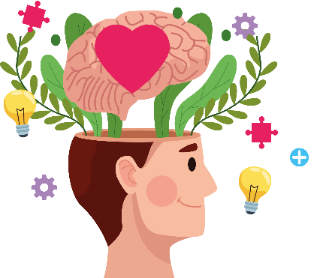
ental illnesses are a group of long-term health conditions characterised by clinically significant disturbances in an individual's thinking, emotional regulation, behaviour, or mood that impair “daily functioning” and “quality of life” (WHO, 2022). Various common mental health disorders, especially depression and anxiety, are known for being long-term conditions that are characterised by persistent disturbances in thinking, behaviour, in addition to mood. These are able to significantly impair daily functioning (WHO, 2022). Depression is often known for involving a “persistent feeling of sadness” and “loss of interest” (Chand and Arif, 2023). People with anxiety disorders, on the other hand, are often known for experiencing fear and worry that is both intense and excessive (WHO, 2025). These are considered chronic conditions that are able to fluctuate over time, rather than being transient states, as these require ongoing management similar to physical long-term conditions such as diabetes.

1.2 Purpose of the Booklet
This booklet will focus on aiming to provide accessible and evidence-based information on both anxiety and depression. It will also focus on empowering individuals, along with supporting carers, in addition to guiding professionals towards holistic and recovery-focused approaches. It will also be promoting early intervention, along with various self-management strategies, in addition to integrated care for improving quality of life and reducing stigma. Furthermore, the booklet discusses the prevalence, risk factors, biopsychosocial impacts, evidence-based treatments, models of care, and relevant UK policies that support the long-term management of common mental health conditions.

2. Prevalence and Burden on Public Healthcare

2.1 Worldwide Prevalence
According to a statistical survey by Elflein (2024), mental health was the biggest health problem in 2025. Globally, around 1.2 billion people are presently living with mental disorders, and the numbers have been growing significantly (Rogers, 2026). This increasing global prevalence highlights mental illness as a major public health concern, placing considerable pressure on healthcare systems, economies, and communities worldwide through rising demands for long-term treatment and support services.

2.2 UK Prevalence
In the United Kingdom, around 1 in 5 adults, which is 20.2%, experience a common mental health condition (NHS England, 2025). The rates are higher in women, at 24.2%, compared to men, at 15.4%. It is also essential to note that overall prevalence has increased, which is particularly evident among younger adults (NHS England, 2025). The rising prevalence of common mental health conditions in the UK demonstrates the growing need for timely access to mental health services, early intervention, and integrated community-based support to improve long-term health outcomes.
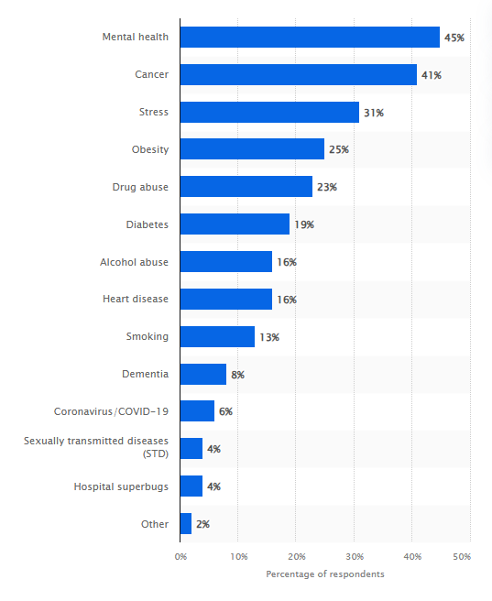
Leading Health Issues Among Adults
(Source: Elflein, 2024)

2.3 Burden on Public Healthcare
Such conditions are known for imposing a substantial economic burden. It is essential to note that mental ill health is known to have cost the UK economy £300 billion in 2022 (Centre for Mental Health, 2024). Such expense is mainly generated through lost productivity, healthcare, along with welfare. According to the Government of the UK (2026), investment in NHS mental health services is projected to reach a historic £16.1 billion, reflecting a real-terms increase of around £140 million over the previous year's allocation. However, demand for community services is still growing, with rising referrals and pressures on various services.
This results in giving rise to an urgent need for holistic, person-centric and integrated care. The “Biopsychosocial Model” by George L. Engel is a required medical model for explaining psychiatric disorders. The framework consists of three factors, which are biological, psychological and social factors, that are known for interacting dynamically (Tripathi, Das and Kar, 2019). Mental illness is known for arising and persisting through their interplay, not from isolated causes. This model is also able to support comprehensive assessment, along with tailored interventions beyond just symptom reduction. It is also essential to note that early recognition, along with community-based support, is able to mitigate burden and foster quicker recovery.

3. Aetiology and Risk Factors
The aetiology of common mental health disorders, particularly depression and anxiety, can be best understood through the Biopsychosocial Model, which proposes that mental illness results from the combined influence of biological, psychological, and social factors rather than a single underlying cause (Bolton and Gillett, 2019).

3.1 Biological Factors
Biological factors are known for including genetic predisposition. This is able to increase heritability risk (Raffagnato et al., 2025). It is also essential to note that neurochemical imbalances that involve serotonin, dopamine, along with norepinephrine are known for playing essential roles (Teleanu, 2022). There are also chronic physical illnesses such as thyroid disorders or persistent pain and inflammation, in addition to structural brain changes that are responsible (Lekurwale et al., 2023).

3.2 Psychological Factors
Psychological factors are known for encompassing trauma, adverse childhood experiences, along with prolonged stress, in addition to maladaptive coping strategies, including rumination or even avoidance (Al-Mamun et al., 2025). Such psychological experiences may negatively influence emotional resilience and coping capacity, making individuals more vulnerable to the onset and persistence of common mental health disorders.

3.3 Social Determinants
There are also social determinants, such as poverty, unemployment, discrimination, along with housing insecurity, in addition to substance misuse. These are also responsible for significantly increasing risk, along with impeding recovery, as these amplifies stress and also limit resources (Brandt et al., 2022). Consequently, addressing these wider social determinants through community support and public health interventions is essential for reducing mental health inequalities and promoting long-term recovery.
Such domains are known for interacting synergistically. As an example, it can be said that genetic vulnerability, if combined with childhood trauma and present unemployment, is able to precipitate illness. On the other hand, strong social support, along with resilience skills, is also able to buffer overall effects (Upasen et al., 2024). Such integrated understanding results in underpinning personalised prevention, along with early intervention, in addition to holistic treatment strategies that are tailored to individual circumstances. Therefore, effective prevention and long-term management of common mental health disorders require interventions that simultaneously address biological vulnerabilities, psychological wellbeing, and the wider social determinants influencing mental health.

4. Impact on Individuals, Families and Society, and Evidence-Based Treatments and Services
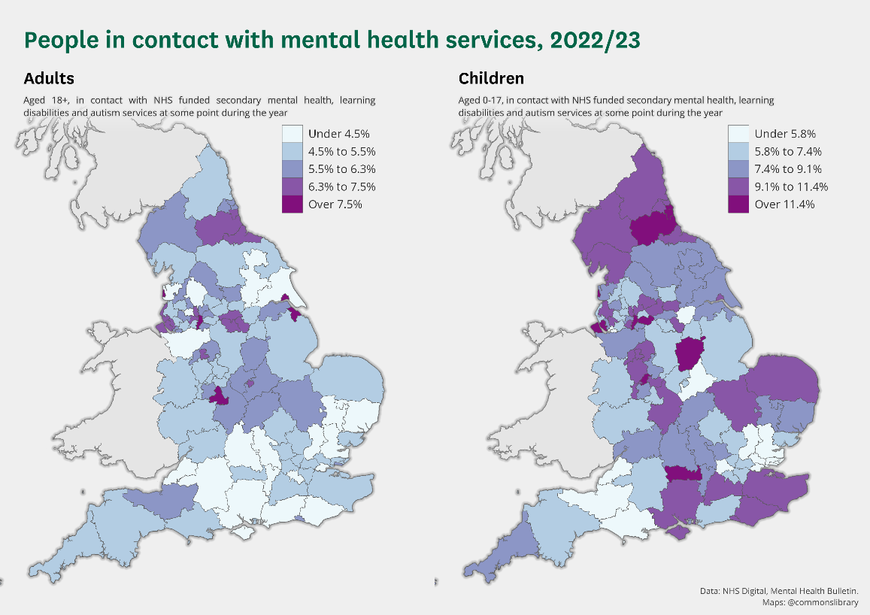
The “Biopsychosocial Model” provides a comprehensive framework to understand how common mental health disorders affect not only the individual but also families, communities, and wider society. Accordingly, the impacts of depression and anxiety can be examined across biological, psychological, and social domains. Mental illness, especially depression and anxiety are known for exerting profound effects across various biological, social and psychological domains, which is framed by the Biopsychosocial Model.

4.1 Biological impacts
Biological impacts are known for including disrupted sleep patterns, along with chronic fatigue, appetite and weight changes, in addition to compromised physical health (Figorilli, Velluzzi and Redolfi, 2025). These physical manifestations often reduce individuals' ability to perform daily activities, thereby negatively affecting their overall quality of life and long-term wellbeing. Individuals are often known for facing elevated risks of cardiovascular disease, in addition to other comorbidities (Wu et al., 2026; Balcerowska and Kwaśnik, 2025). This results in the development of a bidirectional cycle in which poor physical health exacerbates mental symptoms.
(Source: House of Commons Library, 2024)

4.2 Psychological impacts
Psychological impacts are known for manifesting as persistent low mood, along with overwhelming anxiety and lowered self-esteem. There are also other impacts such as feelings of hopelessness, along with cognitive difficulties, including difficulty concentrating (NIMH, 2024). It is also essential to note that in severe cases, poor mental health can lead to suicidal ideation or even self-harm, which also significantly underscores the urgency of timely support (Harmer et al., 2024). Such psychological consequences may also reduce treatment adherence, impair decision-making, and delay recovery if appropriate interventions are not provided at an early stage.

4.3 Social impacts
Social impacts are equally significant, as several individuals are known for experiencing disrupted employment or even education due to prolonged sickness absence or dropout. This results in leading to financial hardship, in addition to reduced career prospects (Alshammaa, Al-Taie and Mujbel, 2024). It is also essential to note that various relationships are also known for suffering due to social withdrawal, dependency or even irritability, which often leads to isolation (Kim, Jang and Park, 2025). There is also discrimination and stigma, which are responsible for further compounding exclusion from community life (Ahad, Gonzalez and Junquera, 2023).
It is also essential to note that family members, alongside carers, are also known for experiencing significant emotional burden, stress, along with their own mental health challenges. They are often known for providing unpaid support while at the same time also navigating systems (Phillips et al., 2022).
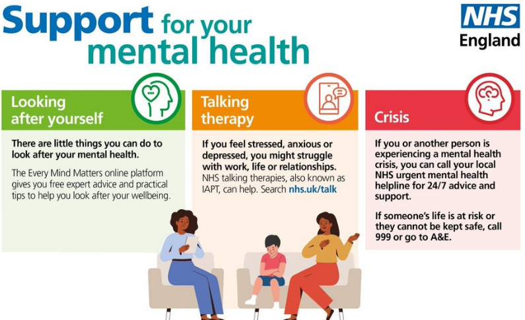
According to the recovery model, it encourages individuals with mental illness to create meaningful lives by developing personal aspirations, social connections such as friendship or other relationships, participating in activities, even though they are facing challenges associated with their condition (Jacob, 2015).
On the other hand, through a personalised approach, self-management interventions help individuals build the confidence, knowledge, and behavioural capabilities necessary to take an active role in managing their health and living well with their condition. “Self-management” interventions are usually known for involving education and exercise prescription, promoting skills for daily management, building confidence and autonomy (Benzo, 2024). These wider social consequences demonstrate that recovery from mental illness extends beyond symptom management and requires coordinated support from healthcare professionals, families, employers, and community organisations.

4.4 Evidence-Based Treatments and Services
NICE is known for recommending evidence-based treatments for individuals with depression and anxiety by following a stepped care approach. This model is known for starting with least intensive and restrictive interventions and further escalates support according to the need of the individual. This results in ensuring efficient and person-centred care (Jeitani et al., 2024).

4.4.1 Psychological Therapies
Cognitive–behavioural therapy is able to help individuals to eliminate “avoidant and safety-seeking behaviours” that prevent “self-correction of faulty beliefs”, which further facilitates stress management. This results in reducing stress-related disorders and enhancing mental health (Nakao, Shirotsuki and Sugaya, 2021). Counselling, on the other hand, is known for being associated with significantly greater clinical effectiveness in short-term mental health outcomes when compared to usual care. However, it does not provide any additional advantages in the long-term. It is able to provide a supportive space for exploring emotions and life experiences, in addition to personal difficulties (Bower et al., 2011). Lastly, “Behavioural Activation” is known as an intervention approach, which is most commonly associated with the treatment of depression. This method is easily able to be adapted for non-clinical populations, along with focusing on encouraging engagement in rewarding and meaningful activities for counteracting withdrawal and low motivation (Mazzucchelli, Kane and Rees, 2010).

4.4.2 Pharmacological
Pharmacological treatments are often used alongside various psychological approaches in the case of moderate to severe cases. For individuals with moderate to severe depression, “Selective Serotonin Reuptake Inhibitors (SSRIs)”, including sertraline, are generally recommended as first-line antidepressants owing to their established efficacy, acceptable safety profile, and good patient tolerability (Chu and Wadhwa, 2023). Medication is usually known for being combined with therapy for gaining better outcomes, while at the same time also regularly monitoring for any kind of side effects, efficacy, and safe discontinuation.

4.4.3 Services
Community Mental Health Teams are usually comprised of several disciplines, such as nurses, occupational therapists, psychiatrists, psychologists and social workers. They are known for providing multidisciplinary, community-based assessment and ongoing care (Roth et al., 2021). NHS Talking Therapies services are known for providing “psychological interventions” for adults in England who are struggling with depression or anxiety disorders or both. These are known for offering timely access to various evidence-based psychological interventions (NHS England, 2023). Crisis Resolution Teams are known for providing rapid assessment in mental health crises. Other than that, if feasible, they also offer intensive home treatment as an alternative to hospital admission (Lloyd-Evans et al., 2019). Early Intervention Services are known for focusing on prompt assessment, in addition to supporting to improve long-term prognosis. Tollan et al. (2023) reported that early intervention services contribute to improved mental wellbeing and functioning by identifying mental health needs promptly and delivering appropriate support at an early stage. Lastly, a Recovery College is known for being run by peer trainers and mental health practitioner trainers. They offer “peer-led” and “coproduced psychoeducational courses” to support people to have meaningful lives (Fox et al., 2026).
It is essential to note that effective care significantly relies on multidisciplinary working as it involves various individuals such as “psychiatrists”, “psychologists”, “mental health nurses”, “social workers”, among many more. Such a collaborative approach helps in ensuring holistic attention to social, psychological and also biological needs (Bates et al., 2025).
All of the above interventions are increasingly known for being aligned with the “NHS Comprehensive Model of Personalised Care”, alongside recovery-oriented practice (NHS England, 2021). “Shared decision-making”, “personalised care” and “support planning”, in addition to strong emphasis on individual goals and preferences are considered to be central to all of this. Furthermore, supported “self-management”, “social prescribing”, and “community-based services” empower individuals to actively participate in their recovery while improving confidence, independence, and long-term wellbeing. It is possible for such services to empower people for achieving sustainable recovery, along with improving wellbeing by integrating clinical expertise with already lived experience and various community resources.

5. Models and Frameworks for Improved Outcomes

5.1 UK Model
The “NHS Comprehensive Model of Personalised Care” is known for adopting whole-population approaches to supporting people of all ages and their carers. The model helps to deliver by bringing six evidence-based components or programmes, which are “shared decision-making”, “personalised care and support planning”, “supported self-management”, “social prescribing”, “enabling choice”, and “Personal Health Budgets”. Each of those is known for being defined by a standard set of practices (NHS England, 2021).
There is also the “House of Care” framework for a coordinated service model that is known for enabling patients with long-term conditions, in addition to clinicians, to work together (Coulter et al., 2016). At the heart of the model, there is a collaborative care planning conversation that happens between the person and practitioner, which is also supported by trained staff and various community resources. It is known for being especially valuable for embedding personalised planning in primary and community settings.
“Recovery-oriented care”, on the other hand, is known for representing a fundamental shift in both practice and culture. The ‘recovery-oriented practice’ incorporates “self-determination” and “person-centred care”, and emphasises “hope”, “social inclusion”, “community participation”, “goal setting”, and “self-management”. Central to this are recovery colleges, peer support, along with trauma-informed approaches (Pany, Rawat and Muliyala, 2025).

5.2 International Model
The “WHO Comprehensive Mental Health Action Plan 2013–2030” is known for providing a global framework that has four main objectives: “more effective leadership and governance for mental health”; “the provision of comprehensive, integrated mental health and social care services in community-based settings”; “implementation of strategies for promotion and prevention”; and “strengthened information systems, evidence and research” (WHO, 2021). It is known for setting ambitious targets for universal health coverage, suicide reduction, along with protection of human rights. The Action Plan also promotes person-centred, recovery-oriented, and community-based mental healthcare while encouraging countries to strengthen early intervention, reduce stigma, and improve equitable access to evidence-based mental health services.
The WHO Innovative Care for Chronic Conditions framework, on the other hand, is known for being comprised of fundamental components within the “patient”, “health care organisation”, and “community, and policy levels”. It is known for promoting person-centred and integrated care regarding long-term health conditions. It also emphasises partnerships between individuals, families, communities and also health systems (Alkenizan, 2004).

5.3 Comparison
It can be stated that the UK models are well integrated into NHS systems with various practical tools, such as social prescribing. These components enable individuals with common mental health disorders to actively participate in their care while improving continuity of services and recovery outcomes. The WHO, on the other hand, is known for providing global strategic guidance that also emphasises equity, along with prevention. The primary strengths of the UK models include local adaptability, along with funding commitments. WHO, on the other hand, has a significantly wider rights focus.
On the other hand, limitations of the UK models include resource variability, along with several implementation gaps. The limitations of the WHO include various challenges in low-resource settings. It is also essential to note that both are known for promoting continuity, recovery, and community integration, with the UK offering more operational detail for high-income contexts.

6. Local and National Policy Implications

6.1 National Policy Implications
UK national and local policies are known for providing a strong foundation regarding supporting individuals who are living with depression and anxiety. The policies are known for emphasising accessible, integrated and also recovery-oriented care.
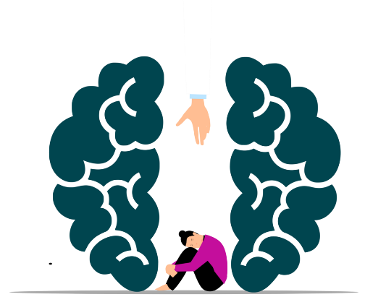
The “NHS Long Term Plan” is known for committing to developing ‘fully integrated community-based health care,’ which will also involve the development of various ‘multidisciplinary teams’, including ‘GPs’, ‘pharmacists’, ‘district nurses’, and ‘allied health professionals’ working across primary care and hospital sites (Charles et al., 2019). Such substantial investment to expand community-based services, psychological therapies, and integrated primary and specialist care is also committed by the “Community Mental Health Framework”, aiming to reduce overall reliance on acute hospital services (NHS England, 2019).
There are also “NHS Talking Therapies” services that are known for providing psychological interventions for adults in England who are struggling with anxiety disorders or depression or both (NHS England, 2023). It is also essential to note that the “depression guideline of NICE” is known for being arranged in a ‘stepped-care model’, recommending that the intensity of treatments should be guided by the severity of depression (Gyani et al., 2012).
There are also various legal frameworks, such as the “Mental Capacity Act”, which is designed for protecting and empowering people who might be lacking the mental capacity for making their decisions regarding the care and treatment (NHS, 2024).

6.2 Local Policy Implementation
It is also essential to note that social prescribing connects people to activities in their community to improve their well‐being, which has also been implemented in NHS primary care. This helps people to connect with non-clinical community resources, along with addressing wider social determinants such as ‘housing’, ‘employment’ and also ‘social connection’ (Westlake et al., 2022).
At the local level, Community Mental Health Teams, Primary Care Networks, Recovery Colleges, NHS Talking Therapies services, and multidisciplinary mental health professionals work collaboratively to implement these national policies. Through integrated assessment, personalised care planning, early intervention, social prescribing, and community-based support, local services help individuals manage their mental health while promoting recovery within their own communities.
Combined together, such policies align closely with the “NHS Comprehensive Model of Personalised Care”, as they are able to promote integrated working, along with early intervention, in addition to recovery-focused support and various community-based solutions. Such alignment results in helping in the reduction of inequalities, along with improving access, in addition to supporting the long-term wellbeing of the people who are affected by common mental health conditions.

6. Recommendations
- It is recommended to expand early intervention, along with NHS Talking Therapies access. On the other hand, it would also be beneficial to improve overall continuity across primary, community, in addition to specialist services.
- Another suggestion is to improve recovery-focused and personalised care planning, in addition to increasing social prescribing and digital mental health options.
- Expanding supported self-management, along with Recovery Colleges, will also be beneficial, while also focusing on reducing overall stigma via various awareness campaigns.
- Lastly, it is recommended to improve family carer support, as often times they are neglected and require similar support. Additionally, it would also be beneficial to promote multidisciplinary collaboration under personalised care models.

7. Conclusion
It can be stated that early intervention, alongside integrated care is considered essential for addressing both depression and anxiety. Person-centred, along with recovery-oriented approaches, are able to empower individuals to live a meaningful life. With the emphasis of the NHS Comprehensive Model of Personalised Care on shared decision-making, along with self-management, in addition to community integration, it is possible to turn it into a key to improving the quality of life, reducing burden, and supporting long-term wellbeing for all affected.

References
Ahad, A., Gonzalez, M. and Junquera, P. (2023). Understanding and Addressing Mental Health Stigma Across Cultures for Improving Psychiatric Care: A Narrative Review. Cureus, [online] 15(5). doi:https://doi.org/10.7759/cureus.39549.
Alkenizan, A. (2004). Innovative care for chronic conditions: building blocks for actionWorld Health Organization (WHO). 2002, 112 pages [English; French, Spanish and Arabic in preparation]. ISBN 92 4 159017 3. Annals of Saudi Medicine, 24(2), pp.148–148. doi:https://doi.org/10.5144/0256-4947.2004.148.
Al-Mamun, F., Habib, A.A., Almerab, M.M., Soraci, P. and Mamun, M.A. (2025). Adverse childhood experiences and mental health: the mediating role of perceived social support and coping strategies. BMC psychiatry, [online] 25(1), p.836. doi:https://doi.org/10.1186/s12888-025-07262-9.
Alshammaa, H.I., Al-Taie, R.H. and Mujbel, A.M. (2024). Impact of Long-Term Depression on Employment Outcomes: A Systematic Review and Case Series From Iraq on Career Trajectory and Job Stability. Cureus. doi:https://doi.org/10.7759/cureus.70755.
Balcerowska, M. and Kwaśnik, P. (2025). The multifaceted impact of stress on immune function. Molecular Biology Reports, 52(1). doi:https://doi.org/10.1007/s11033-025-11134-6.
Bates, S.M., Lin, J., Allen, L.N., Wright, M. and Kidd, M. (2025). Can multidisciplinary teams improve the quality of primary care? A scoping review. eClinicalMedicine, [online] 88, p.103497. doi:https://doi.org/10.1016/j.eclinm.2025.103497.
Benzo, R.P. (2024). Self-Management Programs and the Pursuit of Behavior Change. Respiratory Care, [online] 69(6), pp.678–685. doi:https://doi.org/10.4187/respcare.11987.
Bolton, D. and Gillett, G. (2019). The Biopsychosocial Model 40 Years On. [online] www.ncbi.nlm.nih.gov. Palgrave Pivot. Available at: https://www.ncbi.nlm.nih.gov/books/NBK552030/.
Bower, P., Knowles, S., Coventry, P.A. and Rowland, N. (2011). Counselling for mental health and psychosocial problems in primary care. Cochrane Database of Systematic Reviews, 9. doi:https://doi.org/10.1002/14651858.cd001025.pub3.
Brandt, L., Liu, S., Heim, C. and Heinz, A. (2022). The effects of social isolation stress and discrimination on mental health. Translational Psychiatry, [online] 12(1), pp.1–11. doi:https://doi.org/10.1038/s41398-022-02178-4.
Centre for Mental Health (2024). The economic and social costs of mental ill health. [online] Centre for Mental Health. Available at: https://www.centreformentalhealth.org.uk/publications/the-economic-and-social-costs-of-mental-ill-health/ [Accessed 30 Jun. 2026].
Chand, S. and Arif, H. (2023). Depression. [online] National Library of Medicine. Available at: https://www.ncbi.nlm.nih.gov/books/NBK430847/ [Accessed 30 Jun. 2026].
Charles, A., Ewbank, L., McKenna, H. and Wenzel, L. (2019). The NHS Long-term Plan Explained. [online] The King’s Fund. Available at: https://www.kingsfund.org.uk/insight-and-analysis/long-reads/nhs-long-term-plan-explained [Accessed 1 Jul. 2026].
Chu, A. and Wadhwa, R. (2023). Selective serotonin reuptake inhibitors. [online] PubMed. Available at: https://www.ncbi.nlm.nih.gov/books/NBK554406/ [Accessed 30 Jun. 2026].
Coulter, A., Kramer, G., Warren, T. and Salisbury, C. (2016). Building the House of Care for People with long-term conditions: the Foundation of the House of Care Framework. British Journal of General Practice, [online] 66(645), pp.288–290. doi:https://doi.org/10.3399/bjgp16x684745.
Elflein, J. (2024). Leading health problems worldwide 2023. [online] Statista. Available at: https://www.statista.com/statistics/917148/leading-health-problems-worldwide/ [Accessed 30 Jun. 2026].
Figorilli, M., Velluzzi, F. and Redolfi, S. (2025). Obesity and Sleep Disorders: A Bidirectional Relationship. Nutrition Metabolism and Cardiovascular Diseases, 35(6), pp.104014–104014. doi:https://doi.org/10.1016/j.numecd.2025.104014.
Fox, G.C., West, J., Rhodes, T., Poland, F., Birt, L., Handley, M., Wong, G., Moniz-Cook, E., Wolverson, E., Teague, B., Hackmann, C., Litherland, R., Hague, L., Alam, J., Sams, K. and Mills, R. (2026). Recovery Colleges for post-diagnostic dementia support: The DiSCOVERY realist evaluation synopsis. Health and social care delivery research, [online] 14(19), pp.1–36. doi:https://doi.org/10.3310/GJCF2730.
Government of the UK (2026). Key target hit with 8,500 extra mental health workers in the NHS. [online] GOV.UK. Available at: https://www.gov.uk/government/news/key-target-hit-with-8500-extra-mental-health-workers-in-the-nhs [Accessed 30 Jun. 2026].
Gyani, A., Pumphrey, N., Parker, H., Shafran, R. and Rose, S. (2012). Investigating the use of NICE guidelines and IAPT services in the treatment of depression. Mental Health in Family Medicine, [online] 9(3), p.149. Available at: https://pmc.ncbi.nlm.nih.gov/articles/PMC3622907/.
Harmer, B., Lee, S., Duong, T. vi H. and Saadabadi, A. (2024). Suicidal ideation. [online] PubMed. Available at: https://www.ncbi.nlm.nih.gov/books/NBK565877/ [Accessed 30 Jun. 2026].
House of Commons Library (2024). Mental health statistics: prevalence, services and funding in England. [online] House of Commons Library. Available at: https://commonslibrary.parliament.uk/research-briefings/sn06988/0/ [Accessed 1 Jul. 2026].
Jacob, K.S. (2015). Recovery Model of Mental illness: a Complementary Approach to Psychiatric Care. Indian Journal of Psychological Medicine, [online] 37(2), pp.117–119. doi:https://doi.org/10.4103/0253-7176.155605.
Jeitani, A., Fahey, P.P., Gascoigne, M., Darnal, A. and Lim, D. (2024). Effectiveness of stepped care for mental health disorders: An umbrella review of meta-analyses. Personalized Medicine in Psychiatry, [online] 47-48, p.100140. doi:https://doi.org/10.1016/j.pmip.2024.100140.
Kim, S., Jang, Y.S. and Park, E.-C. (2025). Associations between social isolation, withdrawal, and depressive symptoms in young adults: a cross-sectional study. BMC Psychiatry, 25(1). doi:https://doi.org/10.1186/s12888-025-06792-6.
Lekurwale, V., Acharya, S., Shukla, S. and Kumar, S. (2023). Neuropsychiatric Manifestations of Thyroid Diseases. Cureus, 15(1). doi:https://doi.org/10.7759/cureus.33987.
Lloyd-Evans, B., Christoforou, M., Osborn, D., Ambler, G., Marston, L., Lamb, D., Mason, O., Morant, N., Sullivan, S., Henderson, C., Hunter, R., Pilling, S., Nolan, F., Gray, R., Weaver, T., Kelly, K., Goater, N., Milton, A., Johnston, E. and Fullarton, K. (2019). Crisis resolution teams for people experiencing mental health crises: the CORE mixed-methods research programme including two RCTs. [online] www.ncbi.nlm.nih.gov. Available at: https://www.ncbi.nlm.nih.gov/books/NBK540029/ [Accessed 30 Jun. 2026].
Mazzucchelli, T.G., Kane, R.T. and Rees, C.S. (2010). Behavioral activation interventions for well-being: A meta-analysis. The Journal of Positive Psychology, 5(2), pp.105–121. doi:https://doi.org/10.1080/17439760903569154.
Nakao, M., Shirotsuki, K. and Sugaya, N. (2021). Cognitive–behavioral Therapy for Management of Mental Health and stress-related disorders: Recent Advances in Techniques and Technologies. BioPsychoSocial Medicine, [online] 15(1), p.16. doi:https://doi.org/10.1186/s13030-021-00219-w.
NHS (2024). Mental Capacity Act - Social Care and Support Guide. [online] nhs.uk. Available at: https://www.nhs.uk/social-care-and-support/making-decisions-for-someone-else/mental-capacity-act/ [Accessed 1 Jul. 2026].
NHS England (2019). The Community Mental Health Framework for Adults and Older Adults. [online] Available at: https://www.england.nhs.uk/wp-content/uploads/2019/09/community-mental-health-framework-for-adults-and-older-adults.pdf [Accessed 1 Jul. 2026].
NHS England (2021). Comprehensive model of personalised care. [online] NHS England. Available at: https://www.england.nhs.uk/personalisedcare/comprehensive-model-of-personalised-care/ [Accessed 30 Jun. 2026].
NHS England (2023). NHS talking therapies, for anxiety and depression. [online] www.england.nhs.uk. Available at: https://www.england.nhs.uk/mental-health/adults/nhs-talking-therapies/ [Accessed 30 Jun. 2026].
NHS England (2025). Adult Psychiatric Morbidity Survey: Survey of Mental Health and Wellbeing,. [online] digital.nhs.uk. Available at: https://digital.nhs.uk/data-and-information/publications/statistical/adult-psychiatric-morbidity-survey/survey-of-mental-health-and-wellbeing-england-2023-24/common-mental-health-conditions?__cf_chl_f_tk=H7DcGhQBEvMVqGM05qLE4o7_QU.r5w8RqzKoXrVF3tw-1782836522-1.0.1.1-29MLL2sF.r41lIKzp4o6jBhX_HFuNILrIBnCyrc.XRU [Accessed 30 Jun. 2026].
NIMH (2024). Depression. [online] National Institute of Mental Health. Available at: https://www.nimh.nih.gov/health/publications/depression [Accessed 30 Jun. 2026].
Pany, S., Rawat, V.S. and Muliyala, K.P. (2025). Recovery orientation of services - Narrative review. Future Health, 3, pp.93–102. doi:https://doi.org/10.25259/fh_88_2025.
Phillips, R., Durkin, M., Engward, H., Cable, G. and Iancu, M. (2022). The Impact of Caring for Family Members with Mental Illnesses on the caregiver: a Scoping Review. Health Promotion International, [online] 38(3). doi:https://doi.org/10.1093/heapro/daac049.
Raffagnato, A., Raicich, A., Paiusco, L., Coser, G., Bonemazzi, I., Gazzin, A., Pelizza, M.F., Ancora, C. and Toldo, I. (2025). Genetic Predisposition and Genetic Resilience Factors in Stress-Related Disorders During the Developmental Age: A Narrative Review. Genes, 16(11), p.1362. doi:https://doi.org/10.3390/genes16111362.
Rogers, K. (2026). Nearly 1.2 billion people worldwide are living with mental disorders. The number has been growing. [online] CNN. Available at: https://edition.cnn.com/2026/05/21/health/mental-disorder-rate-worldwide-study-wellness [Accessed 30 Jun. 2026].
Roth, C., Wensing, M., Kuzman, M.R., Bjedov, S., Medved, S., Istvanovic, A., Grbic, D.S., Simetin, I.P., Tomcuk, A., Dedovic, J., Djurisic, T., Nica, R.I., Rotaru, T., Novotni, A., Bajraktarov, S., Milutinovic, M., Nakov, V., Zarkov, Z., Dinolova, R. and Walters, B.H. (2021). Experiences of healthcare staff providing community-based mental healthcare as a multidisciplinary community mental health team in Central and Eastern Europe findings from the RECOVER-E project: an observational intervention study. BMC Psychiatry, [online] 21(525). doi:https://doi.org/10.1186/s12888-021-03542-2.
Teleanu, R.I. (2022). Neurotransmitters—Key factors in neurological and neurodegenerative disorders of the central nervous system. International Journal of Molecular Sciences, [online] 23(11), pp.1–24. doi:https://doi.org/10.3390/ijms23115954.
Tollan, K., Jezrawi, R., Underwood, K. and Janus, M. (2023). A Review on Early Intervention Systems. Current Developmental Disorders Reports, [online] 10(2). doi:https://doi.org/10.1007/s40474-023-00274-8.
Tripathi, A., Das, A. and Kar, S. (2019). Biopsychosocial model in contemporary psychiatry: Current validity and future prospects. Indian Journal of Psychological Medicine, [online] 41(6), pp.582–585. doi:https://doi.org/10.4103/ijpsym.ijpsym_314_19.
Upasen, R., Saengpanya, W., Awae, W. and Prasitvej, P. (2024). The influence of resilience and social support on mental health of older adults living in community: a cross-sectional study. BMC psychology, 12(1). doi:https://doi.org/10.1186/s40359-024-01892-6.
Westlake, D., Elston, J., Gude, A., Gradinger, F., Husk, K. and Asthana, S. (2022). Impact of COVID‐19 on social prescribing across an Integrated Care System: A Researcher in Residence study. Health & Social Care in the Community. doi:https://doi.org/10.1111/hsc.13802.
WHO (2021). Comprehensive Mental Health Action Plan 2013 - 2030. [online] www.who.int. Available at: https://www.who.int/publications/i/item/9789240031029 [Accessed 1 Jul. 2026].
WHO (2022). Mental Disorders. [online] World Health Organization. Available at: https://www.who.int/news-room/fact-sheets/detail/mental-disorders [Accessed 30 Jun. 2026].
WHO (2025). Anxiety disorders. [online] World Health Organization. Available at: https://www.who.int/news-room/fact-sheets/detail/anxiety-disorders.
Wu, J., Tian, Z., Qi, Z., Liu, X. and Yu, P. (2026). Cardiovascular disease and depression: a bidirectional relationship and its clinical implications. Frontiers in Psychiatry, [online] 16. doi:https://doi.org/10.3389/fpsyt.2025.1675680.

