Spelling and Grammar Exercise
Step 1: Open the Review Menu.
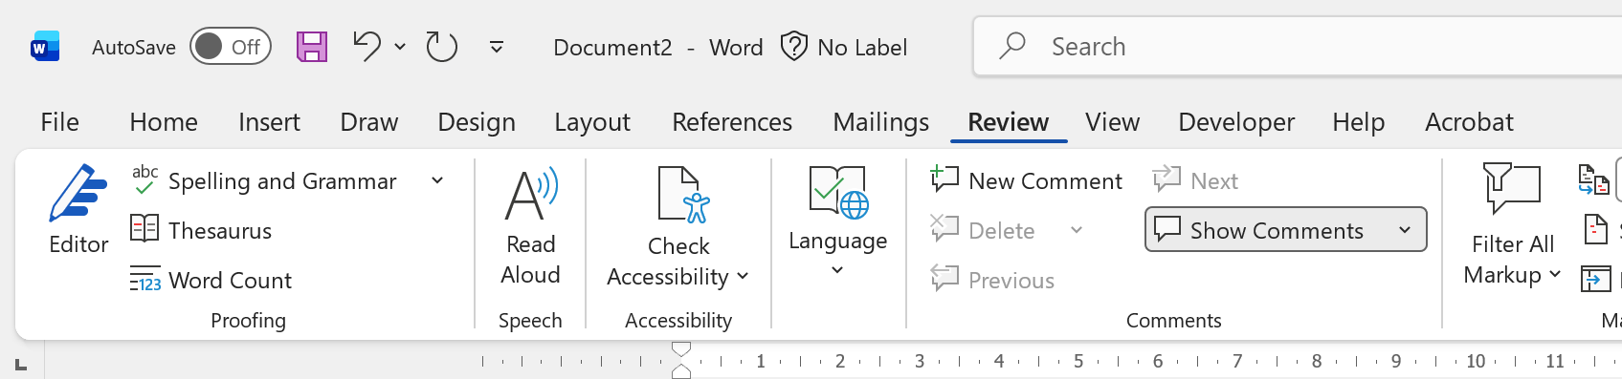
Step 2: Open Spelling and Grammar Editor.
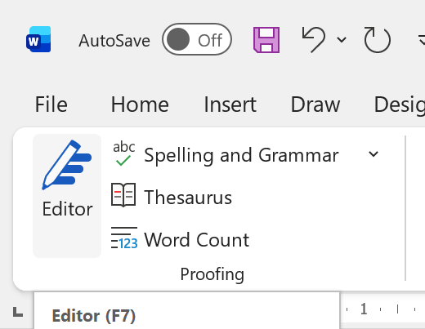
Step 3: Change Editor to Professional Writing in the side display.
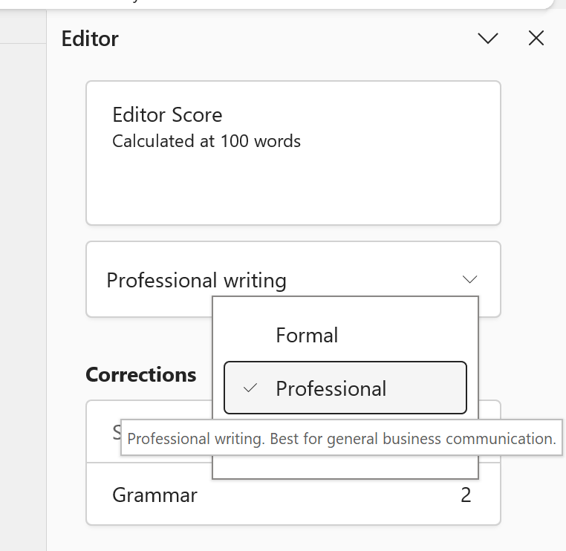
Step 4: Check the Editor suggestions for the text below and review them.
The team are reviewing the recent customer feedback and have noticed a few problem that needs attention. Many customers said they was happy with the service, but some mentioned that reply times was slow and information was not always clear. This feedback have been shared with managers and actions is being planned to improve communication.

