Party Hard

INTENDED PLATFORMS | PC

TARGET AGE / DEMOGRAPHIC OF PLAYERS
The target age of this game will be 16+. The demographic of players will be players who enjoy puzzle games that use tactics and skill to complete. This game will also be catered to players that enjoy a challenge.

INTENDED PEGI / ESRB RATING
PEGI 16+

CONTRIBUTING TEAM MEMBER: | CHLOE NASH

SECTION 2: GAME OUTLINE

GAME STORY SUMMARY
The Story of this game will change with the character you choose to play. The main story of the game with the main character will be about a boy that just wants to get some sleep, but his neighbours won’t stop partying (relation to title). As he just wants to get some sleep, he decides to kill everyone at the party so he can finally get the peaceful sleep that he really wants. He must complete the task of killing everyone at the party without getting caught by anyone at the party or getting arrested by the police.

As the game progresses different characters will be introduced such as a girl who kicks people and knocks them out before killing them.

GAME FLOW
A puzzle game where you play as a boy that just wants to sleep where you need to kill everybody at the party without getting caught.

CONTRIBUTING TEAM MEMBER: | Chloe Nash

SECTION 3: MAIN CHARACTER(S)
& PLAYER CONTROLS

CHARACTER APPEARANCE
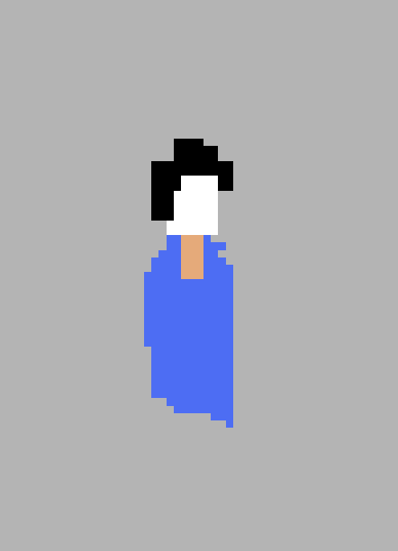

(2)

CHARACTER DOSSIER / DETAILS (Add/adjust categories as appropriate) in order of art left to right
NAME: | Darius
GENDER: | Male
SPECIES: | Human
AGE: | Unknown
FACTION: | Killer
KNOWN ASSOCIATES: | Katie
(Extra categories)
(Extra categories) |  | CHARACTER’S BACKSTORY
Character backstory | Darius is just a college kid who wants to get some sleep. His neighbours are having a party and Darius just wants peace and quiet to be able to get to sleep peacefully. Darius feels like his only resort to get this party to stop is by killing everybody at the party so there is no way the party can go on.
CHARACTER’S BACKSTORY

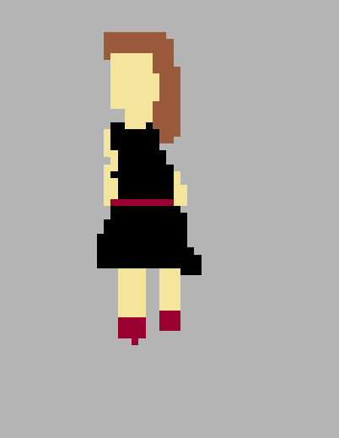
Darius: Default protagonist. Boy that just wants to get some sleep. (no special movements)

CHARACTER APPEARANCE
(2)

CHARACTER DOSSIER / DETAILS (Add/adjust categories as appropriate) in order of art left to right
NAME: | Katie
GENDER: | female
SPECIES: | Human
AGE: | Unknown
FACTION: | Killer
KNOWN ASSOCIATES: | Darius
(Extra categories)
(Extra categories)
CHARACTER’S BACKSTORY
Katie is the police officer’s daughter who doesn’t come into the game until later. She is found to admire Darius’ work and therefore follow his footsteps. She then starts killing people herself joining Darius’ side but the police officer doesn’t want to snitch up his own daughter, so the story gets pretty messy from then on out. Her special movement is that she knocks people out before killing them which gives the player the opportunity to move the body to a more discreet place before killing them.

CHARACTER APPEARANCE
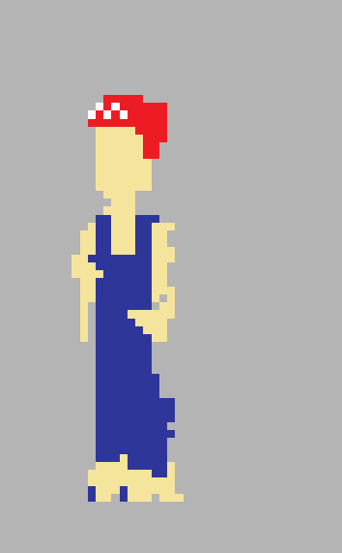

CHARACTER DOSSIER / DETAILS (Add/adjust categories as appropriate) in order of art left to right
NAME: | plumber
GENDER: | male
SPECIES: | Human
AGE: | Unknown
FACTION: | NPC
KNOWN ASSOCIATES: | none
(Extra categories)
(Extra categories)

CHARACTER’S BACKSTORY
This character doesn’t have a backstory, but he does have a purpose. When you use a rap door or exit to escape the police he will come and board up the exit or trap door, so you are unable to use it again. The only time that exit will become usable again is if you restart the game.

CHARACTER APPEARANCE
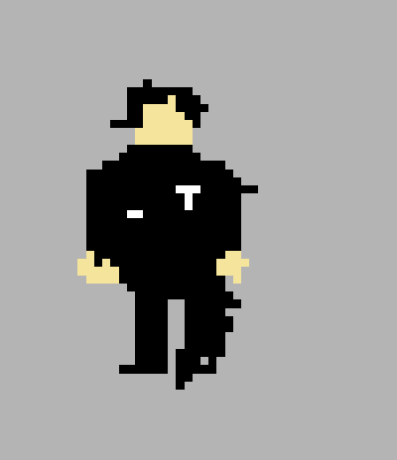

(2)

CHARACTER DOSSIER / DETAILS (Add/adjust categories as appropriate) in order of art left to right
NAME: | Body guard
GENDER: | male
SPECIES: | Human
AGE: | Unknown
FACTION: | Killer
KNOWN ASSOCIATES: | none
(Extra categories)
(Extra categories)

CHARACTER’S BACKSTORY
Again, this character doesn’t have a backstory but does have a purpose. If you go too close to this character or act suspicious around him he will beat you to death.

CHARACTER CONTROLS / PLAYER CONTROLS
(1)

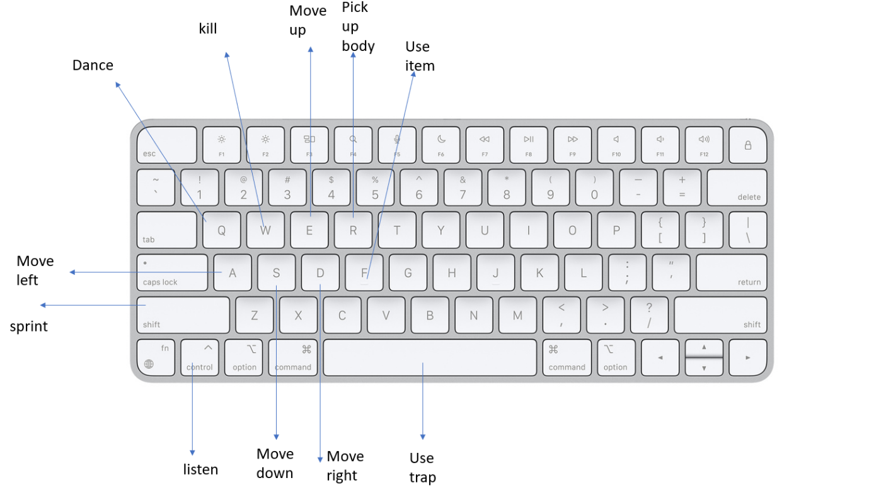

CONTRIBUTING TEAM MEMBER: | Chloe Nash

SECTION 4: GAMEPLAY

SEQUENCE OF PLAY
There will be multiple levels in this game, but they will also be followed by cut scenes showing the story of finding the killers. Each level will be unique and feature new ways of being able to kill the party goers. For example, methods such as throwing party goers into the fire. there will also be chances for other beings to kill party goers such as zombies (party goes will not be alarmed if you harm party goers that have been turned into zombies) and aliens that can abduct party goers and this will not be traced back to you. There will be many other ways such as getting party goers eating by a bear or using traps such as the oven speakers and other objects around the level exploding.

Some of the levels are near impossible to complete which adds to the challenge and thrill of the game. Using these aids makes the game more interesting and adds a level of thrill and difference to each level keeping the player engaged.

There are also cut scenes that will add thrill and mystery to the game. Such as a cut scene showing the investigator/police officer talking about how Katie is his daughter and has been dragged into all of this as she admires Darius’ work. This will get the player asking questions such as why has Katie been dragged into this? and why the investigators daughter of all people? It makes the game more exciting making the player want to keep playing to unlock more cutscenes to uncover the full story and solve the mystery while also playing challenging levels in between.

UNIQUE SELLING POINTS (USPs)
This game will have many unique selling points. First, with the type of game it is. There are not many mystery puzzle games on the market with this type of structure. Its unique with simple controls and simple scenarios but still manages to engage with the player as much as possible.

It’s a game to be played when you want an easy fun exciting game that still has a unique interesting story. There will be cutscenes in between every level so it isn’t like your average puzzle game and will have a whole story to go along with it which is unlocked as you complete every level. When u complete them all you unlock the whole story and there will be a feature where you can go back and look through each cut scene.

PLATFORM-SPECIFIC FEATURES
This game will have a Youtuber mode on PC: this mode changes the music to royalty free music so people can upload the videos to YouTube without and copyright claims.

CONTRIBUTING TEAM MEMBER: | Chloe Nash

SECTION 5: GAME WORLD

GAME WORLD
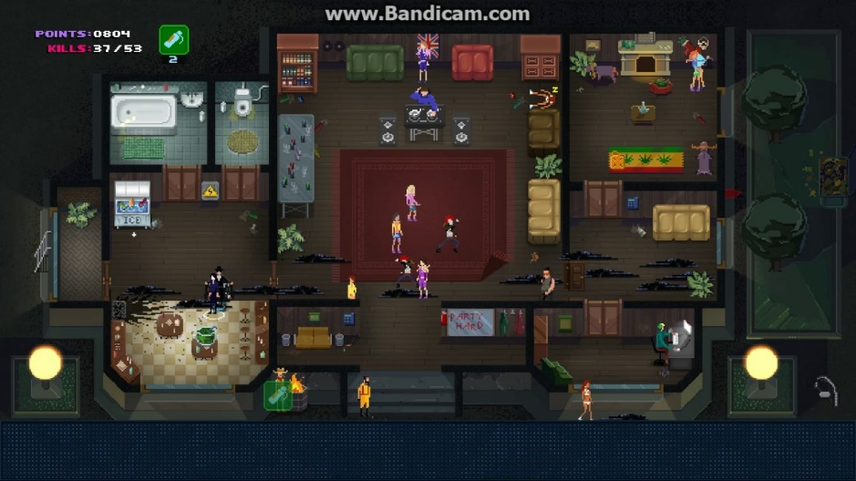

LOCATION DETAILS
NAME: | Barbeque party
WHAT DOES IT LOOK LIKE? | Dark gloomy (like a family get together)
WHAT MOOD IS BEING INVOKED IN THIS LOCATION? | Dark but also a party environment
WHAT KIND OF MUSIC WILL BE USED FOR THIS LOCATION? | Party /dance music
HOW ARE THE LOCATIONS CONNECTED IN THE GAME WORLD? | The locations are unlocked by killing everybody in each level (completing each level.

(NOTE: Copy-paste the table in this section as necessary for each location you wish to feature.)

GAME FLOW
(Scott Rogers suggests that a simple map or flow chart diagram should be provided to indicate how the player will navigate the game world.)

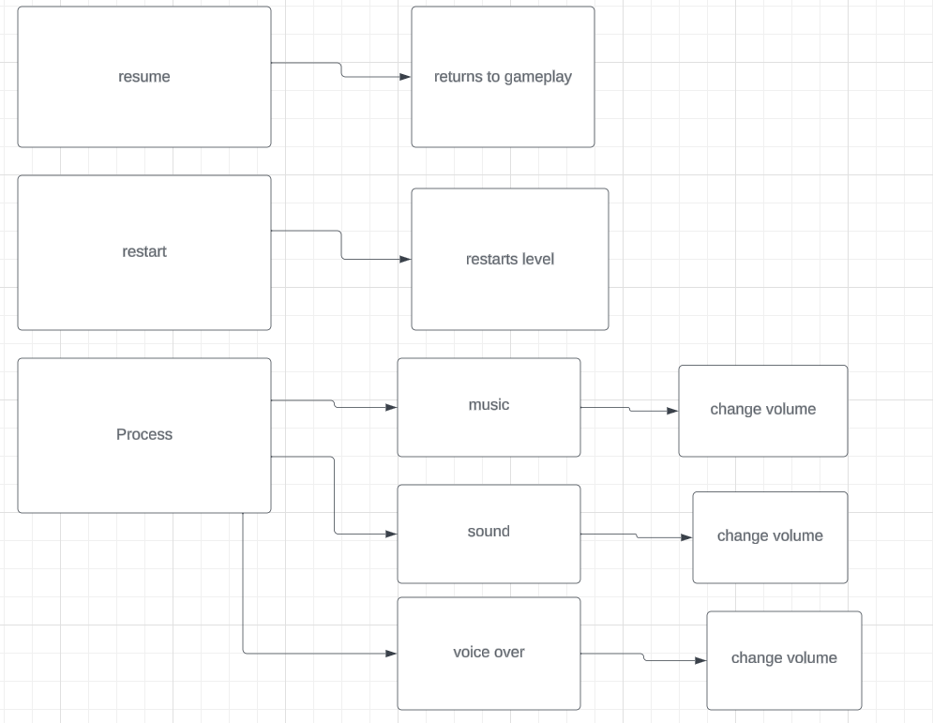

CONTRIBUTING TEAM MEMBER: | Chloe Nash

SECTION 6: GAME EXPERIENCE

GAME EXPERIENCE
The overall theme of the game will be Violent, Mystery, Puzzle

HOW IS THIS FEELING GOING TO BE PRESENTED TO THE PLAYER?
The levels will have a feeling that is sort of off. Like it’s a party but something is not quite right. They will be gloomy while also playing dance music and sometimes set in eerie locations.

ARE THERE ANY SPECIAL MODES OR INTERFACES FOR GAMEPLAY?
There won’t be any special modes unless the DLCs are purchased for the game.

WHAT DOES THE PLAYER FIRST SEE WHEN THEY START THE GAME?
(Rough sketches / images can be used here to help convey this.)

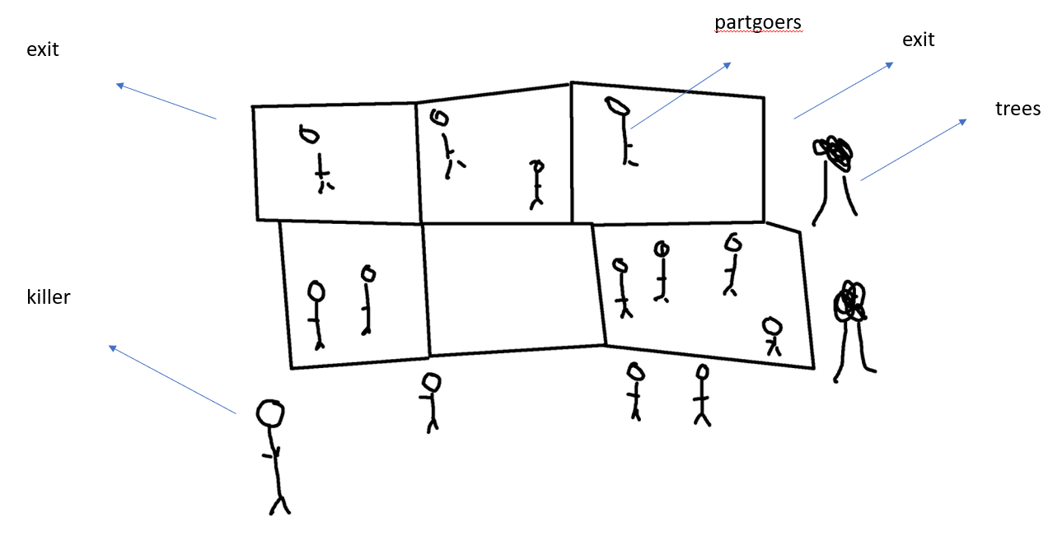

WHAT EMOTIONS ARE MEANT TO BE INVOKED BY THE GAME?
There are many emotions that are supposed to be evoked by this game for example making the player feel uncomfortable in different maps and situations. A sense of challenge is also going to be important for this game that increases with each level. The higher the level the bigger the challenge which also causes a feeling of frustration as the levels get more impossible to complete without using the extra traps and features.

HOW ARE MUSIC AND SOUND GOING TO BE USED?
The way music will be used in this game is by using music that relates to the time and setting. As this is a party setting, I will be using old style party music sort of set in the 80s/90s. I think this would give a great feel to the game as the surroundings it will be set in will be very retro styled and dark and gloomy so using an older style of music could be affective. There will be sounds of people screaming etc when people find the bodies to give the feeling that you are still a killer, and it will give the player a sense of fear.

HOW DOES THE PLAYER NAVIGATE THE SHELL MENUS/ SCREENS OF THE GAME?
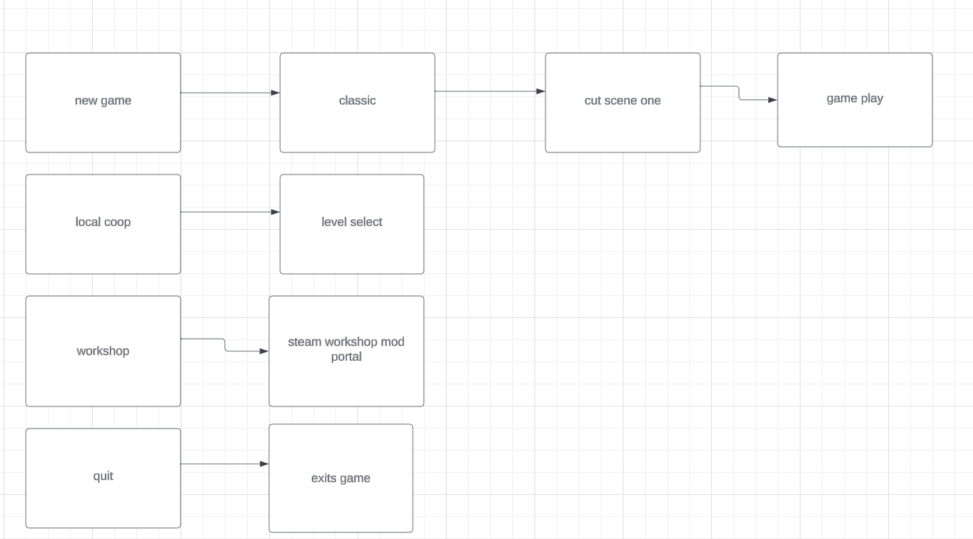

CONTRIBUTING TEAM MEMBER: | Chloe Nash

SECTION 7: GAMEPLAY MECHANICS

GAMEPLAY MECHANICS
There will be a few different mechanics in this game such as, ability to exit through windows and finding cases with different items.

There are many hazards in this game such as bodyguards and the police officers and even angry partygoers.

There isn’t powerups in this game but there is definitely aids such as using extra-terrestrial beings to aid you.

MECHANIC DETAILS
NAME: | Exiting through windows
WHAT DOES IT LOOK LIKE? | simple icon appears and click of the E key to exit the room quietly through a window.
EFFECT ON PLAYER: | Helps player escape from the police and partygoers without getting caught.
WHEN WILL IT FEATURE IN THE GAME? | Levels that feature windows and trap doors which feature an icon.
MECHANIC DETAILS
NAME: | Picking up cases with items
WHAT DOES IT LOOK LIKE? | A small silver case with a prompt to pick up
EFFECT ON PLAYER: | Helps player kill people faster by poisoning them and also get away from police by switching clothing etc.
WHEN WILL IT FEATURE IN THE GAME? | Features in some levels of the game in a randomly generated area.

HAZARD DETAILS
NAME: | Police officer
WHAT DOES IT LOOK LIKE? | Blue police uniform sometimes carrying bodies.
EFFECT ON PLAYER: | If player is caught killing somebody the police will arrest them and the game will be over, and the player will have to restart.
WHEN WILL IT FEATURE IN THE GAME? | When the player is caught killing party goers.

HAZARD DETAILS
NAME: | Body guard
WHAT DOES IT LOOK LIKE? | Bulky man wearing black uniform.
EFFECT ON PLAYER: | If player gets in their line of sight or is standing near them for too long they will get knocked out and sometimes killed.
WHEN WILL IT FEATURE IN THE GAME? | On certain levels where there is more challenge involved.

COLLECTIBLE ITEMS
Collectible items can be shown as the cases.

COLLECTIBLE DETAILS
NAME: | Cases
WHAT DOES IT LOOK LIKE? | Silver brief case
BENEFIT FOR PLAYER: | Able to kill party goers faster.
WHEN WILL IT FEATURE IN THE GAME? | When the case is found
CAN IT BE USED AS CURRENCY? | At any point in the level which it was found.
WILL IT EARN PLAYERS AN ACHIEVEMENT? | If used in the right way for example if you use the poison from the case and you poison someone 20 times.

CONTRIBUTING TEAM MEMBER: | Chloe Nash

SECTION 8: ENEMIES

LIST OF ENEMIES
There will be 2 main enemies in this game one being the bodyguard and one being the police officer. Both do a very similar thing but in different ways.

 | ENEMY DETAILS
 | NAME: | Bodyguard
 | WHAT DOES IT LOOK LIKE? | Bulky man wearing black uniform.
 | ATTACKS: | Beating player to death
 | WHEN WILL IT FEATURE IN THE GAME? | When player is in line of sight acting suspicious.
 | HOW DOES THE PLAYER DEFEAT IT? | Kill them from behind or when they’re knocked out.
 | WHAT DOES THE PLAYER EARN FOR DEFEATING THEM? | The level becomes easier to complete with less challenges getting in the way.
ENEMY DETAILS
NAME: |  | Police officer
WHAT DOES IT LOOK LIKE? |  | Male wearing blue police uniform.
ATTACKS: |  | Arresting player.
WHEN WILL IT FEATURE IN THE GAME? |  | When the player has been caught killing somebody.
HOW DOES THE PLAYER DEFEAT IT? |  | Use traps and items to help escape the police.
WHAT DOES THE PLAYER EARN FOR DEFEATING THEM? |  | There are achievements such as killing a police officer and escaping a police officer.

LIST OF BOSS CHARACTERS
There isn’t going to be any boss characters in this game but there is going to be a character you must defeat and that is the police officers.

BOSS CHARACTER DETAILS
NAME: | Police
WHAT DOES IT LOOK LIKE? | Blue uniform male
ATTACKS: | Arrests killer
WHEN WILL IT FEATURE IN THE GAME? | When the killer is caught with a victim
HOW DOES THE PLAYER DEFEAT IT? | Try and hide trick/ kill the police with traps.
WHAT DOES THE PLAYER EARN FOR DEFEATING THEM? | You can earn different types of achievements involving the police

(NOTE: Copy-paste the tables in this section as necessary for each enemy / boss you wish to feature.)

CONTRIBUTING TEAM MEMBER: | Chloe Nash

SECTION 9: CUTSCENES

CUTSCENES
A short story board showing the cut scene of inspector john west sitting opposite a man telling him about the party hard killings. It then pans to the killer leaving a house.

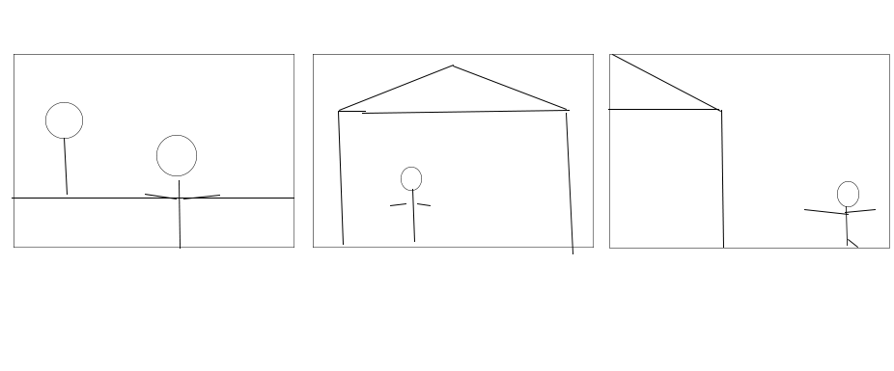

CUTSCENE DETAILS (use this table for each unique cutscene you include)
VISUAL STYLE: | 2D pixel style cut scene
BRIEF DESCRIPTION OF SCENE: | Inspector john west talking about how he was officer on command for the party killings and explaining what they were.
WHEN WILL IT FEATURE IN THE GAME? | At the beginning
PURPOSE: | This scene is there to give the player an idea of a backstory to the game and why this guy is killing all these people

(NOTE: Copy-paste the tables in this section as necessary for each cutscene you wish to feature.)

CONTRIBUTING TEAM MEMBER: | Chloe Nash

SECTION 10: BONUS MATERIALS

BONUS MATERIALS
Bonus materials include different DLCs for example there are many different DLCs. There is one DLC made specifically for higher crime rates and other DLCs including unlockable levels such as the dark castle. Other than these two DLCs there won’t be other bonus content.

REPLAY VALUE
The replay value for the game will be quite high for example you can use many different characters with different abilities to try and complete the levels for example you could use Hinter and try and complete all the levels with limited time which would also earn you an achievement.

CONTRIBUTING TEAM MEMBER: | Chloe Nash

- Keyboard https://www.google.com/url?sa=i&url=https%3A%2F%2Fwww.apple.com%2Fuk%2Fshop%2Fproduct%2FMK2A3LB%2FA%2Fmagic-keyboard-us-english&psig=AOvVaw2ktJqpko2sJWN8b-GtGxwZ&ust=1702464429907000&source=images&cd=vfe&opi=89978449&ved=0CBQQjhxqFwoTCJDB867ciYMDFQAAAAAdAAAAABAL
- Used to create the images https://www.pixilart.com/draw

