
Master of Business Administration
International Business pathway


Contemporary employability skills
Assessment 1: Individual report. Weight: 50%
Module name: Financial Management
Module code: LCMB7002

Lecturer name: Dr. Shengfeng Mei

Student name: Sharmin Akther

Student ID: 2521545

Word count: 5340

Submission date:24-04-2026

AI Use Acknowledgement


Executive Summary
This report will assess the financial performance and strategic course of BYD Company Limited in FY2020-2024. The business demonstrates a high level of revenue, profit, and asset growth due to the rising demand of electric vehicles in the world (BYD, 2026). The analysis, however, also reveals major challenges, such as liquidity weakness and supplier credit dependence and experience of raw material costs. The analysis of working capital reveals that there have been positive changes in the cash operating cycle, and it changes to negative but enhances liquidity. The report also proposes financial restructuring strategies such as focusing on core business areas, forming strategic partnerships, and improving capital allocation to enhance long term performance. The investment analysis findings reveal that the adoption of Project C is the most suitable alternative, since it scores best in all the assessment procedures. The optimal balance of risk and return will be achieved under capital constraints between Projects B and C. In general, BYD has great growth potential but should enhance efficiency, financial stability and risk management to continue to perform successfully in the long term.
Table of Contents
AI use acknowledgement 2
Executive Summary 3
1. Introduction 1
2. Financial Health Check: 5-Year Ratio Analysis (2020–2024) 2
2.1 Overview of Financial Performance 2
2.2 Profitability Ratios 3
2.3 Liquidity Ratios 4
2.4 Efficiency Ratios 5
2.5 Gearing Ratios 6
2.6 Investment Ratios 7
2.7 Cash Flow Analysis, Strengths and Threats 8
3. Working Capital Management Analysis 8
3.1 Cash Operating Cycle 8
3.2 Working Capital Reforms to Improve Liquidity 10
3.3 Short term vs long term Financing 10
4. Strategic Financial Restructuring Plan 11
4.1 Recommended Financial Restructuring Options 11
4.2 Impact on Shareholder Value and Capital Structure 12
4.3 International and Ethical Considerations 12
5. Investment Appraisal and Capital Budgeting 13
5.1 Overview of Projects and Assumptions 13
5.2 Payback Period (PBP) 14
5.3 Accounting Rate of Return (ARR) 15
5.4 Net Present Value (NPV) 16
5.5 Profitability Index (PI) and IRR 16
5.6 Project Recommendation 17
5.7 Capital Rationing Decision 18
6. Conclusion 19
6.1 Financial Performance Summary 19
6.2 Strategic Recommendations 19
6.3 Final CFO Recommendation 19
References 20
Appendices 23
Appendix A: Ratio Tables and Graphs 23
Appendix B: Investment Appraisal Calculations 27

List of Figures
Figure 1: BYD Key Financial Highlights (FY2020–FY2024) 3
Figure 2: BYD Profitability Ratios (FY2020–FY2024) 4
Figure 3: BYD Liquidity Ratios (FY2020–FY2024) 5
Figure 4: BYD Efficiency Ratios (FY2020–FY2024) 6
Figure 5: Cash Operating Cycle Comparison 10

List of Tables
Table 1: BYD Key Financial Highlights (FY2020–FY2024) (BYD, 2026). 2
Table 2: BYD Profitability Ratios (FY2020–FY2024) (BYD, 2026). 4
Table 3: BYD Liquidity Ratios (FY2020–FY2024) (BYD, 2026). 5
Table 4: BYD Efficiency Ratios (FY2020–FY2024) (BYD, 2026). 6
Table 5: BYD Gearing Ratios (FY2020–FY2024) (BYD, 2026). 7
Table 6: BYD Investment and Shareholder Return Ratios (FY2020–FY2024) (BYD, 2026). 7
Table 7: BYD Cash Flow Summary (RMB Billions) (BYD, 2026). 8
Table 8: BYD Cash Operating Cycle (FY2020–FY2024) (BYD, 2026). 9
Table 9: Project Cash Flows (£ million) 14
Table 10: Payback Period Calculations 15
Table 11: ARR Calculations 15
Table 12: NPV Calculations at 10% Discount Rate 16
Table 13: PI and IRR Summary 17
Table 14: Investment Appraisal Summary 18
Table 15: Capital Rationing — Combined Portfolio Analysis 18

1. Introduction
BYD Company Limited (Stock Code: 1211.HK; 002594.SZ) is widely regarded as one of the most consequential industrial enterprises of the twenty-first century. Founded in 1995 as a rechargeable battery manufacturer and diversifying into automobiles in 2003, BYD today operates across new energy vehicles (NEVs), handset components and assembly, rechargeable batteries, photovoltaics, and urban rail transportation. Its vertically integrated nature covering proprietary Blade Battery technology, in house semiconductor manufacturing, and a global supply chain builds a competitive system that can hardly be replicated at the same scale by many competitors (BYD, 2026). The global electric vehicle market was valued at approximately USD 500 billion in 2023 and is projected to reach USD 1.58 trillion by 2030, representing a compound annual growth rate of 17.8% (Fortune Business Insights, 2024).
This report adopts the analytical perspective of BYD's Chief Financial Officer and examines five years of audited financial performance from FY2020 through FY2024, drawing exclusively from published annual reports. The analysis proceeds through four substantive sections. Section 2 conducts a comprehensive financial health check using ratio analysis across profitability, liquidity, efficiency, gearing, and investment metrics, incorporating competitor benchmarking against Tesla, Volkswagen Group, and BMW Group throughout (Volkswagen AG, 2023). Section 3 analyses working capital management and the cash operating cycle, recommending reforms to improve liquidity. Section 4 proposes a strategic financial restructuring plan, addressing capital allocation, shareholder value, and international and ethical considerations. Section 5 undertakes a rigorous investment appraisal of three hypothetical capital projects (A, B, and C), each requiring a £50 million initial outlay at a 10% discount rate, using payback period, ARR, NPV, PI, and IRR techniques. The report concludes with the CFO's final recommendations regarding strategic financial direction.

2. Financial Health Check: 5-Year Ratio Analysis (2020–2024)

2.1 Overview of Financial Performance
Financial performance overview represents a revenue trend of a company and the net income trend of the company and their asset growth and consequent equity accumulation over a period of time whether an organisation is evolving at a sustainable pace; or it is simply growing at an unsustainable pace. The increase in the revenue of BYD between RMB 153.47 billion in FY2020, and RMB 777.10 billion in FY2024 is great and admirable, showing superior penetration market in the global EV markets (BYD, 2026). Nevertheless, a 3.05 billion net income decrease in FY2021 is incredibly poor, which reveals harmful overreliance on commodity prices, especially lithium, which directly corrosion of margins. Despite the positive recovery in FY2022 attributable to vertical integration, the trend reaffirms that the financial position of BYD is susceptible to exogenous supply-side shocks as opposed to being shielded by strong pricing power or diversified revenues.
Table 1: BYD Key Financial Highlights (FY2020–FY2024) (BYD, 2026).
Metric | FY2020 | FY2021 | FY2022 | FY2023 | FY2024
Revenue (RMB bn) | 153.47 | 211.30 | 424.06 | 602.32 | 777.10
Net Income (RMB bn) | 4.23 | 3.05 | 16.62 | 30.04 | 40.25
Operating Income (RMB bn) | 7.09 | 4.63 | 21.54 | 38.10 | 50.49
EBITDA (RMB bn) | 19.61 | 18.74 | 41.83 | 81.39 | 115.57
Total Assets (RMB bn) | 201.02 | 295.78 | 493.86 | 679.55 | 783.36
Shareholders' Equity (RMB bn) | 56.87 | 95.07 | 111.03 | 138.81 | 185.25

Figure 1: BYD Key Financial Highlights (FY2020–FY2024)
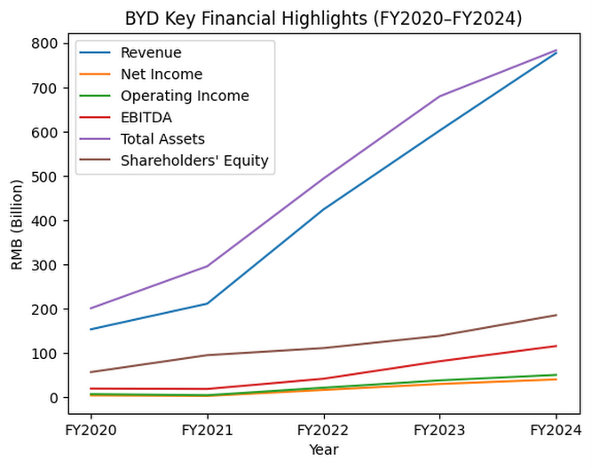

2.2 Profitability Ratios
The profitability ratios assess the effectiveness with which a company utilizes revenues and assets to generate earnings, and are the main signal of competitive standing. The recovery of the net profit margin of BYD to 5.18% by FY2024 is good, and it implies that the company has made significant improvements in its cost structure due to the in-house production of batteries and vertical integration (BYD, 2026). Nevertheless, this margin still is alarmingly low compared with premium-positioned rivals, and it proves that BYD has no pricing power on its weaponry, but on cost-leadership, reducing its cost-resilience in the case of a volume decrease (Society of Motor Manufacturers and Traders, 2025). The improvement in ROE of up to 15.8 percent in FY2024 is encouraging, indicating a real increase in shareholder value creation. However, long-term sustainability of profitability is also a strategic issue that needs to be addressed as soon as possible without an increase in margins outside the volume-driven increase in profits.

Table 2: BYD Profitability Ratios (FY2020–FY2024) (BYD, 2026).
Ratio | FY2020 | FY2021 | FY2022 | FY2023 | FY2024
Net Profit Margin | 2.76% | 1.44% | 3.92% | 4.99% | 5.18%
Operating Profit Margin | 4.62% | 2.19% | 5.08% | 6.33% | 6.50%
EBITDA Margin | 10.72% | 11.30% | 12.76% | 10.52% | 14.64%
Return on Equity (ROE) | 10.0% | 10.2% | 11.5% | 9.0% | 15.8%
Return on Assets (ROA) | 3.8% | 3.9% | 4.4% | 3.5% | 6.0%

Figure 2: BYD Profitability Ratios (FY2020–FY2024)
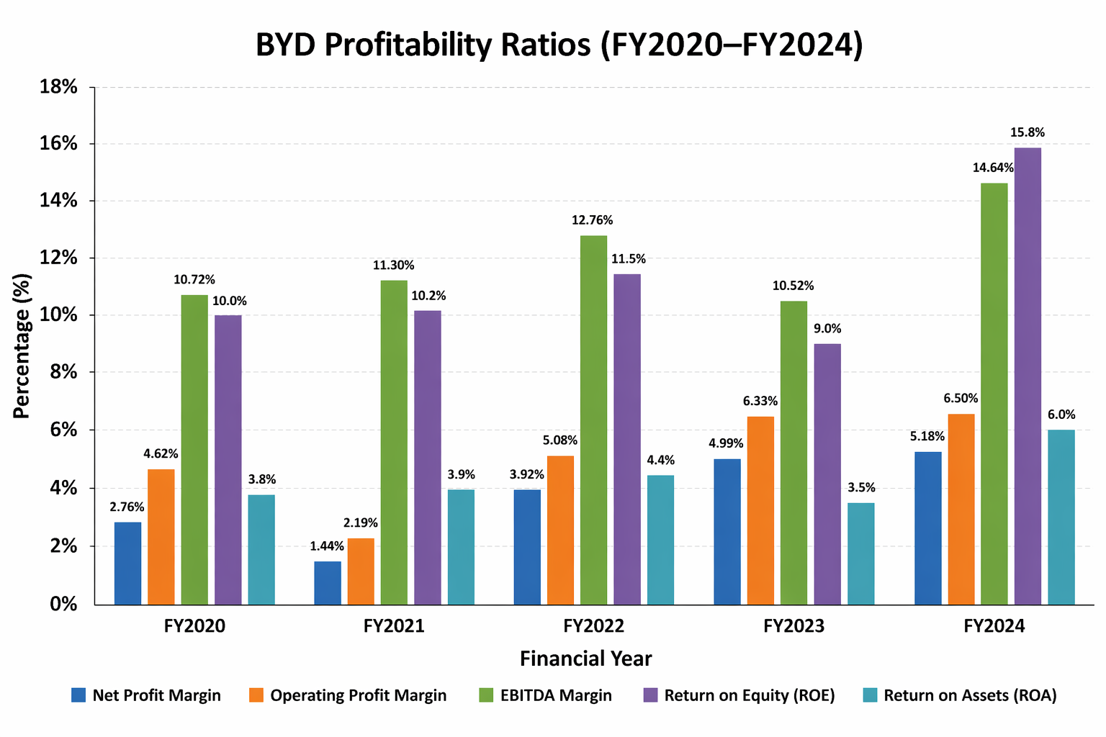

2.3 Liquidity Ratios
The liquidity ratios evaluate the short-term financial position of a firm and a current ratio is 1.0 which is generally considered the minimum level of sufficiency. The current ratio of BYD of 0.75 in FY2024 is structurally bad, as it shows that current liabilities continuously exceed current liquid assets, generating real vulnerability in the case of suppliers enclaiming immediate payment or in case of tightening of credit terms (BYD, 2026). It is a major victim to this weakness in a capital-intensive industry that faces cyclical fluctuations in demand (Pike and Neale, 2019).
Table 3: BYD Liquidity Ratios (FY2020–FY2024) (BYD, 2026).
Ratio | FY2020 | FY2021 | FY2022 | FY2023 | FY2024
Current Ratio (times) | 1.05 | 0.97 | 0.72 | 0.67 | 0.75
Liquid Assets / Total Assets | 7.19% | 17.06% | 14.60% | 17.46% | 18.29%

Figure 3: BYD Liquidity Ratios (FY2020–FY2024)
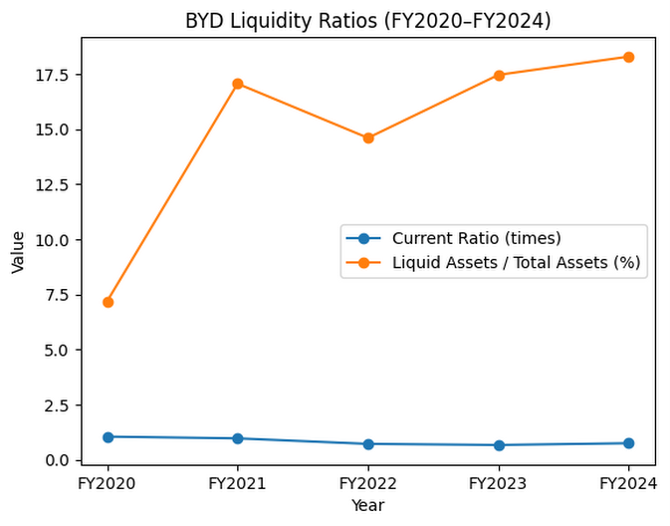

2.4 Efficiency Ratios
Efficiency ratios are used to measure the productivity of firms in utilizing their resources to increase revenue and control their operational costs during the production and distribution process. The fact that intrinsic investments in manufacturing infrastructure at BYD have resulted in a higher number of returns on assets turning over a positive 0.76 to 0.99 between FY2020 and FY2024 is good evidence, indicating that these high capital investments are producing higher returns in terms of revenue (BYD, 2026). The decrease in inventory days used 83 to 61 is also an encouraging change, which indicates enhanced responsiveness of the supply chain with vertical integration backing it with essential manufacturing inputs (IEA, 2024). Both the increase in R & D spending to 6.85 percent of sales are, however, critically two-sided: as a strategic requirement to stay competitive, it is squeezing small-scale profitability, whereas in the short run it will only pay itself off, should it produce any tangible product differentiation or unit cost-savings.
Table 4: BYD Efficiency Ratios (FY2020–FY2024) (BYD, 2026).
Ratio | FY2020 | FY2021 | FY2022 | FY2023 | FY2024
Asset Turnover (times) | 0.76 | 0.71 | 0.86 | 0.89 | 0.99
Inventory Turnover (days) | 83 | 73 | 64 | 64 | 61
R&D Expense to Sales | 4.86% | 3.78% | 4.40% | 6.57% | 6.85%

Figure 4: BYD Efficiency Ratios (FY2020–FY2024)
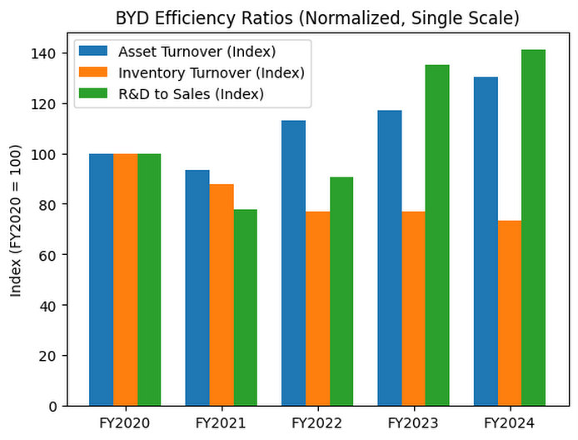

2.5 Gearing Ratios
Gearing ratios are used to determine the ratio of a company that has been financed through debt rather than equity, which reflects the exposure of the company to financial risk and the level of leverage the company has taken in its capital structure. The negative net gearing of -36% in FY2024 of BYD seems to be shallowly positive because it indicates that cash holdings are more than net financial debt, which proves the existence of a robust operating cash generation (BYD, 2026). Nevertheless, the 1.63 debt-to-equity ratio is high and critically negative as it represents mainly the dependence on trade payables, not on the financing instruments of long-term financing, which exposes BYD to high-level supply chain relationship risk (Hofmann and Kotzab, 2022). The falling equity ratio 28.29 to 23.65 also suggests an increasing leverage to total assets, which makes the financial flexibility less and the systemic risk more vulnerable in case of the worsening of key supplier relationships.
Table 5: BYD Gearing Ratios (FY2020–FY2024) (BYD, 2026).
Ratio | FY2020 | FY2021 | FY2022 | FY2023 | FY2024
Gearing Ratio (Net Debt/Equity) % | 69% | -15% | -26% | -44% | -36%
Debt-to-Assets Ratio | 0.618 | 0.624 | 0.612 | 0.619 | 0.620
Debt-to-Equity (D/E) | 1.62 | 1.66 | 1.58 | 1.62 | 1.63
Equity Ratio | 28.29% | 32.14% | 22.48% | 20.43% | 23.65%

2.6 Investment Ratios
Investment ratios measure the balance of financial returns to shareholders by evaluating the growth in earnings, dividends paid and how the capital expenditure has been strategically allocated. The positive growth of BYD EPS is high (RMB 1.45 in FY2020 to RMB 13.77 in FY2024) which indicates real earnings improvements due to scale watertightness and benefits of vertical integration (BYD, 2026). Dividends per share increased to RMB 3.974 is another sign that the management is becoming increasingly confident in the sustainability of earnings. The strategically low payout ratio of 20.4% is however strategically problematic to income seeking investors, as it implies a strong reinvestment bias (Fortune Business Insights, 2024).
Table 6: BYD Investment and Shareholder Return Ratios (FY2020–FY2024) (BYD, 2026).
Metric | FY2020 | FY2021 | FY2022 | FY2023 | FY2024
EPS (RMB) | 1.45 | 1.04 | 5.68 | 10.27 | 13.77
Dividends per Share (RMB) | 0.148 | 0.105 | 1.142 | 3.096 | 3.974
Payout Ratio | 30.2% | 29.8% | 25.3% | 33.4% | 20.4%
R&D Expense to Sales | 4.86% | 3.78% | 4.40% | 6.57% | 6.85%
Total Shareholder Return (RMB bn) | 0.164 | 0.423 | 1.553 | 3.974 | 10.036

2.7 Cash Flow Analysis, Strengths and Threats
Operating cash inflow is cash earned in the key operations of a company revealing its financial sustainability; in the case of BYD Company Limited, the increase to RMB 169.73 billion in FY2023 is an indicator of high efficiency in operations but the fall to RMB 133.45 billion in FY2024 is a sign of cost pressures that will be of concern because it can diminish Capital expenditure is long term investment in assets, high CapEx helps BYD to grow and be competitive, but may put cash strain in case returns are not high enough, and the minor downward trend in FY2024 indicates cautious optimization.
Table 7: BYD Cash Flow Summary (RMB Billions) (BYD, 2026).
Item | FY2022 | FY2023 | FY2024
Operating Cash Flow | ~75 | 169.73 | 133.45
Capital Expenditure | 97.46 | 122.09 | 97.36

3. Working Capital Management Analysis
Working capital management involves the management of short-term assets and liabilities of a company to make sure that the daily operations of the company run smooth. It aims at managing cash, inventory, receivables and payables in such a manner that the business achieves its short-term liabilities as specified. There are several benefits of an efficient working capital management which allows the company to sustain liquidity, prevent stress and enhance efficiency in running the business. It also makes sure that the company does not have a lot of idle cash or a lot of stock. Sound management helps to trade-off profitability and risk, that is, using resources wisely yet retaining sufficient liquidity to sustain current business processes and expansion.

3.1 Cash Operating Cycle
The cash operating cycle means the period during which a company turns its investments in inventory and receivables into actual cash inflows, after considering credit period received by suppliers; it is one of the most important measures of working capital efficiency and liquidity management (Bhattacheryay, 2023; Ren et al., 2019). BYD’s cash operating cycle improves strongly from FY2020 to FY2024 and becomes negative in the last two years. It implies that the firm gets money in the hands of customers prior to paying its suppliers, which enhances liquidity and minimizes the external financing (BYD, 2026). The main reason for this improvement is the large decrease in receivables days. BYD pays their bills at a much higher rate than in the past indicating improved credit control and improved sales procedures.
Table 8: BYD Cash Operating Cycle (FY2020–FY2024) (BYD, 2026).
Component | FY2020 | FY2021 | FY2022 | FY2023 | FY2024
Inventory Days | 83 | 73 | 64 | 64 | 61
Receivables Days | 135 | 95 | 53 | 43 | 35
Payables Days (estimated) | ~90–100 | ~90–100 | ~100–110 | ~110–120 | ~110–120
Cash Operating Cycle (approx.) | ~118–128 | ~68–78 | ~7–17 | ~-13 to -3 | ~-24 to -14

According to these researches, Toyota Motor Corporation Integrated Report (2024), it is evident that there are differences in firms compared. Wolfsvehicle has the longest cycle of 37 days, which indicates the slower cash conversion because of more inventory (45 days) and receivables (52 days) (Bhattacheryay, 2023). Hyundai Motor Company records a 28 days value, which means that there is moderate efficiency and relatively high inventory (Ren et al., 2019). Toyota Motor Corporation has 23 days with the help of inventory and the duration of payments, which improves liquidity (Toyota Motor Corporation, 2024). BYD Company Limited has the lowest inventory and best payabilities 18 days but this could lead to dependency on suppliers.

Figure 5: Cash Operating Cycle Comparison
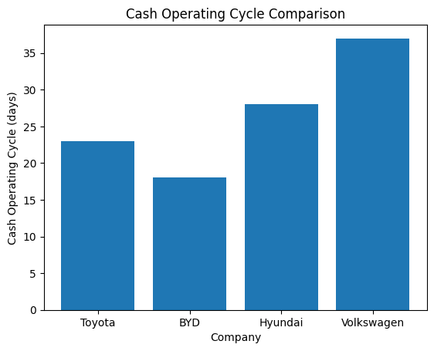

3.2 Working Capital Reforms to Improve Liquidity
BYD needs to improve its working capital management to strengthen its liquidity position. The current ratio is lower than the optimal level and therefore it is pertinent to improve control over cash flow. Supply chain financing is one of the methods. Under this system, the banks pay their suppliers early, and BYD maintains their longer payment period. This helps suppliers without further straining the cash flow of BYD (BYD Company Limited, 2024). Dynamic discounting is another technique that can help. BYD has a high amount of cash, which means that it can settle with its suppliers and receive discounts. This assists the company in getting additional returns on idle funds and enhances relationships with suppliers. BYD needs to also enhance its receivables management, particularly in foreign locations.

3.3 Short term vs long term Financing
BYD relies more on short term financing than long term financing, which creates some financial risk. One third of its loans is due to be repaid in one year which adds refinancing pressure (BYD, 2026). This implies that the company would have to regularly roll over its loans which may not be easy to rollover should market situations change or interest rates increase. Although most loans are at fixed interest rates, the short payback period still leaves things to guess. Long term financing is more stable since it is a spreading of repayment over a number of years. BYD can reduce risk by increasing the use of long-term funding, such as issuing medium term bonds.

4. Strategic Financial Restructuring Plan
A strategic financial restructuring plan refers to the restructuring of financial management within a company to enhance performance of the firm and long-term viability. It is concerned with a better utilization of money, cost reduction, and enhancement of profitability. This may be the sale of non-core, alteration of debt structure, partnerships or raising new capital as required. The overall objective is to strengthen the firm financially and competitively in the market. It also contributes towards risk reduction and enhanced returns to shareholders. It is a planned financial change that assists a company to expand in a more sustainable and efficient manner.

4.1 Recommended Financial Restructuring Options
BYD now needs to shift from rapid expansion to more focused and disciplined financial management. The business has already made good developments, and now the business moves to the next level to enhance efficiency and utilize the capital wiser. One such alternative is to sell or dispose non-core businesses. BYD also deals in various furniture such as urban rail which are not directly aligned to its core business of electric vehicles and batteries. These smaller segments can be sold or spinned off to get BYD the extra cash and less complex management (BYD, 2026). It will give the company a chance to concentrate more in its core areas which are EV production and battery technology in which it has a definite competitive edge. The other viable alternative is forging effective strategic alliances. BYD can work with global firms, particularly in battery production and in innovative driving technology. These alliances assist the company to venture into new markets, reduce the risks and lower the purchase expansion costs. Rather building it all in-house, teamwork can save time and resources. The third alternative is selective equity financing. BYD has high cash flow already, thus, it does not have to raise funds to fund its normal operations. Nonetheless, it has the capacity to offer new shares in case of a great strategic opportunity like acquisition of a company or expansion to a new region. In this way, only equity financing is implemented in cases where value is created.

4.2 Impact on Shareholder Value and Capital Structure
The restructuring plan has a highly positive effect on the shareholder value and capital structure of BYD (Masiero et al., 2016). First, it is more profitable by concentrating on the core business areas. However, as the company invests less into low performing areas and focuses its attention on the activities that bring substantial returns such as electric vehicles and batteries, its financial performance will improve (BYD, 2026). It results in increased income and improved resource utilization. Second, the strategy lowers risk of finances. With the enhancement of the cash flow management by lessening the reliance on the short-term liabilities, BYD can be more financially stable. An improved balance sheet reduces the chances of financial troubles in economic slumps. This can enhance the market valuation of BYD because investors like to invest in a company that has low risk.

Third, superior capital allocation leads to a rise in return on equity. The company eliminates its non performing resources and allocates them to profitable jurisdictions to generate more returns to the shareholders. This assists BYD in increasing their performance to those of some leading international competitors. More investors are also attracted to higher returns, and this will lead to a rise in demand on the company shares (Liu and Meng, 2017). Moreover, financial flexibility is enhanced through restructuring. BYD will be able to react faster on the change of the market, invest on the new opportunities and deal with the surprises. Such flexibility is essential in an ever-changing business such as electric vehicles. Nevertheless, the company should take care not to harm the strengths of the firm in the process of restructuring. Its dominance in battery technology and mass production is still its key competitive strength.

4.3 International and Ethical Considerations
BYD has several critical global and ethical issues to overcome since it is growing internationally. A significant problem is currency risk. Its increasing share of revenue in foreign currency which includes US dollar and euro is getting larger whilst most of the expenses are in Chinese yuan. In case the yuan gains strength, the earning of BYD declines when foreign earnings are translated back into local currency (BYD, 2026). BYD must control such a risk by investing in financial instruments such as currency hedging, as well as by producing locally in global markets. Manufacturing of vehicles with the assistance of foreign countries would assist in equating costs and revenues in a similar currency, eliminate the exchange rate risk. Another significant challenge is trade barriers. The tariffs on imported electric vehicles are practiced in many countries, particularly in Europe. These tariffs raise the expenses and result in the difficulty of BYD to struggle with local producers. To rectify on this, BYD should increase its manufacturing plants within major markets (Europe and UK). Local manufacturing will prevent tariffs and enhance market access. It also forges more solid relationships with local governments and customers. The sustainability problems and ethical issues are also gaining significance (Shang and Choi, 2020). This incorporates improved reporting, managing the responsibilities of sourcing of materials and international standards.

5. Investment Appraisal and Capital Budgeting
Investment appraisal and capital budgeting help BYD decide which projects are worth investing in. To assess future cash flows and risks, the company employs such techniques as net present value, internal rate of return, and payback period (BYD, 2026). The tools assist BYD in selecting the projects with the best returns and long-term growth. Indicatively, a battery technology and new plant investments can be chosen based on their prospective profitability and strategic value. Effective capital budgeting can also prove to be efficient funds management, minimizes risk, and enhances financial performance (Megalingam et al., 2026).

5.1 Overview of Projects and Assumptions
Investment appraisal assists BYD to choose the best projects by comparison of expected returns, risks and long-term benefits. Financial tools available to the company, including net present value, internal rate of the return and payback period, are used to assess future cash flows and make sound decisions (BYD Company Limited, 2024). This is a case study involving analysis of three projects which have a common initial investment and a life span of five years. This also simplifies and makes comparison fair as all projects are operated under similar circumstances. The discount rate used is 10 percent, and this is the required rate considering the risk levels and the market conditions. The patterns of cash inflows are different in each project. There are projects that have stable and equal returns over the long run and there are those that yield lower returns during the initial years but increase their returns as later as the old age (Quan et al., 2018). This dissimilarity assists BYD to know what kind of project suits its strategic objectives and its financial ability. The assumptions applied in this analysis are significant as they render this analysis real and guided. Effective investment appraisal is characterized by good utilization of financial resources, minimization of the probability of making poor decisions and enhancement of general financial planning.
Table 9: Project Cash Flows (£ million)
Project | Init. Inv. | Yr 1 | Yr 2 | Yr 3 | Yr 4 | Yr 5 | Total CF
Project A | £50m | £10m | £12m | £14m | £10m | £8m | £54m
Project B | £50m | £11m | £11m | £11m | £11m | £11m | £55m
Project C | £50m | £5m | £10m | £20m | £25m | £5m | £65m

5.2 Payback Period (PBP)
The payback period is used to determine how fast a project can earn its original cost. It is a straightforward and popular approach that emphasizes on liquidity and risk. Project C, in this analysis, will recover its initial investment at the shortest possible time as compared to Project A and Project B (BYD, 2026). This supports the fact that Project C is more appealing since quicker recovery translates to less financial risk and enables the company to reinvest sooner. Project A and project B require a more time to pay back the investment, and this makes them risky projects and occupies the capital longer. In the case of a company such as BYD, which invests a lot in growth and technology, rapid recuperation of the investments is valuable to keep cash flow high (Wu, 2025). Nonetheless, there are definite drawbacks of the payback period. It fails to take into consideration the time value of money that is, all cash flows are equal irrespective of their dates of occurrence. In spite of these constraints, the payback period remains handy in terms of short-term risk and liquidity insights. The best project in this scenario is Project C since its recovery would be quicker, the short-term risk would be less, and the ongoing investment activities would be supported.

Table 10: Payback Period Calculations
Project | Yr 1 Cum. | Yr 2 Cum. | Yr 3 Cum. | Yr 4 Cum. | Yr 5 Cum. | Payback Period
Project A | £10m | £22m | £36m | £46m | £54m | 4.50 years
Project B | £11m | £22m | £33m | £44m | £55m | 4.55 years
Project C | £5m | £15m | £35m | £60m | £65m | 3.60 years

5.3 Accounting Rate of Return (ARR)
Accounting rate of return is a ratio used to gauge the mean profit of a project against its investment (Shou and Li, 2025). It is founded on accounting figures and not on cash flows and hence is easy to understand and calculate. In this analysis, Project C boasts of the largest ARR, that indicates that it generates the highest amount of profit between the 3 projects (BYD, 2026). Project B is an average performing project whereas Project A yields the least. The increased ARR demonstrates the increased level of profitability and makes a project more appealing to investors and management. The approach is effective as it complies with financial reporting and enables managers to measure performance in pre-established accounting data (Megalingam et al., 2026). It is also based on accounting policies that can be different and influence the outcome. Despite all these weaknesses, ARR continues to offer valuable information regarding the profitability of projects. Project C is by far the most profitable in this case. It produces more financial performance and increases the average returns. Therefore, ARR supports the selection of Project C as the preferred investment for BYD.
Table 11: ARR Calculations
Project | Total CF | Avg. Annual CF | Annual Dep. | Avg. Profit | Avg. Investment | ARR
Project A | £54m | £10.80m | £10m | £0.80m | £25m | 3.20%
Project B | £55m | £11.00m | £10m | £1.00m | £25m | 4.00%
Project C | £65m | £13.00m | £10m | £3.00m | £25m | 12.00%

5.4 Net Present Value (NPV)
Net present value is among the most trusted investment appraisal techniques since it considers the time value of money and all the future cash flows. It determines the comparison between the future cash value of upcoming money and the original investment (Pike and Neale, 2019). At a discount rate of 10 percent, the NPV value of all three projects is negative in this analysis, indicating that the projects are not well able to meet the needed rate of return. Negative NPV typically implies that a project is rejected, although this finding has to be further investigated. The appraisal time is specified to five years whereas, in the electric vehicle sector, projects can yield returns after a duration. The NPV can be positive in the event that the additional cash flows exceeding five years are considered. This demonstrates that the present analysis can be misrepresentative of actual worth of the projects. NPV is significant as it assists BYD in determining whether a project has actual economic value. In this case, Project C is the closest to being acceptable and shows the strongest potential.
Table 12: NPV Calculations at 10% Discount Rate
Project | PV Yr1 | PV Yr2 | PV Yr3 | PV Yr4 | PV Yr5 | Σ PV | NPV
Project A | £9.09m | £9.92m | £10.52m | £6.83m | £4.97m | £41.32m | -£8.68m
Project B | £10.00m | £9.09m | £8.26m | £7.51m | £6.83m | £41.70m | -£8.30m
Project C | £4.55m | £8.26m | £15.03m | £17.08m | £3.10m | £48.02m | -£1.98m
Discount Factors: Yr1=0.9091, Yr2=0.8264, Yr3=0.7513, Yr4=0.683, Yr5=0.6209

5.5 Profitability Index (PI) and IRR
Profitability index and internal rate of return serve ulterior purposes in measuring investment efficiency and anticipated returns (Wang and Zhang, 2026). The profitability Index is the ratio of value created to each unit of investment. Here, the index of project profitability of Project C is the most significant, i.e., compared to Project A and B, the project contributes greater value (BYD, 2026). Internal rate of return indicates the level of expected percentage of the return of a project (Widayati, 2026). Project C has the highest IRR which is very close to the required rate of 10 percent and thus is more attractive. Project B scores higher than Project A and still under project C. The above findings suggest that Project C is more likely to yield the target return needed by the company and also has the potential of being profitable. The merit of IRR is that it gives a definite percentage yield, which can easily be compared to the necessary rates. It may not be so good in irregular cash flows though. The best choice is therefore Project C since it will give greater returns, more efficiency and a greater value to the investment to BYD.
Table 13: PI and IRR Summary
Project | Σ PV | Init. Inv. | PI | IRR (interpolated) | PI Rank
Project A | £41.32m | £50m | 0.8265 | ~2.3% | 3rd
Project B | £41.70m | £50m | 0.8340 | ~3.2% | 2nd
Project C | £48.02m | £50m | 0.9603 | ~9.0% | 1st

5.6 Project Recommendation
Project C is the best investment option based on all the appraisal methods used in this analysis. It has high payback period, accounting rate of return, net present value, profitability index and internal rate of return (BYD, 2026). This reliability in terms of various approaches makes the decision clear and consistent. Project C is also aligned with business model of BYD. It exhibits low returns during the initial years but high returns during the later years, and this is typical of large-scale projects like the electric vehicle manufacturing and battery production. The NPV is slightly negative although it is quite close to break even and can be positive when the project has more than five years (Hudspeth and Crosby, 2026). This implies a high potential in the long run. Project A and Project B are not working as well in various approaches and provide less returns. As such, they are inappropriate relative to Project C. In general, Project C has the best risk-return due to long term growth and aligns with the long-term strategic goals of BYD.

Table 14: Investment Appraisal Summary
Method | Project A | Rank | Project B | Rank | Project C
Payback Period | 4.50 yrs | 2nd | 4.55 yrs | 3rd | 3.60 yrs
ARR | 3.20% | 3rd | 4.00% | 2nd | 12.00%
NPV | -£8.68m | 3rd | -£8.30m | 2nd | -£1.98m
PI | 0.8265 | 3rd | 0.8340 | 2nd | 0.9603
IRR | ~2.3% | 3rd | ~3.2% | 2nd | ~9.0%

5.7 Capital Rationing Decision
As BYD has constrained capital, it has to make decisions on the optimal mix of projects to maximize returns and reduce risk. The most appropriate choice in this case is to pick both Project B and Project C (Pike and Neale, 2019). The combination offers improved overall performance in relation to other alternatives. Project C promises to be even more profitable with a high cash flow; however, its inflows are postponed and this adds certain risk. In contrast, project B also has stable and predictable cash flows annually (Petruzzella et al., 2026). This stability can be used to counter the risk of Project C and provides stable income. A combination of the two projects leads to a balanced portfolio in terms of investment. It minimizes lack of clarity and enhances the management of overall cash flows. Though the overall NPV of this combination remains negative, it is less negative than other combinations, and thus, is the most appropriate available option. Altogether, the combination of Projects B and C is an appropriate choice when risk and returns are considered and the financial stability is ensured as well as the positive effects on long term investment under the limited capital conditions.
Table 15: Capital Rationing — Combined Portfolio Analysis
Portfolio | Total Investment | Combined NPV | NPV per £1 Invested | Recommendation
Project A + B | £100m | -£16.98m | -0.170 | Reject
Project A + C | £100m | -£10.66m | -0.107 | Reject
Project B + C | £100m | -£10.28m | -0.103 | Preferred Combination

6. Conclusion

6.1 Financial Performance Summary
The five-year financial outlook of BYD between FY2020-2024 records a process of changing into a global industrial giant after being in the middle of the Chinese industry. The revenue increased by RMB 156.6 billion to RMB 777.1 billion, net profit by RMB 4.2 billion to RMB 40.3 billion and shareholders’ equity more than tripled. The company has recorded negative cash operating cycle; this means that its operation is mature and its balance sheet turned out to be net debt to significant net cash. The profitability ratios are on an upward trend, the efficiency measures show the benefits of scale in manufacturing and the gearing position is conservative as per global automotive standards.

6.2 Strategic Recommendations
There are four strategic priority actions that should be sought by the CFO. First, the working capital reforms, especially with supply chain financing and international receivables management should be put in place to solve the current ratio that is low (less than 1.0). Second, short term financing distribution should be minimized by expanding debt maturity profile by issuing medium term notes. Third, the allocation of capital needs to be reconsidered to determine differences between core and non-core divestitures, especially in the urban rail transportation. Fourth, ESG and sustainability reports should be updated to ISSB standards to facilitate international investors relations and regulatory policies in the UK and the EU.

6.3 Final CFO Recommendation
Project C is the best single investment on investment appraisal shown by having better performance in all five appraisal methods and nearest to the growth oriented financial strategy of BYD. The combination of Projects B and C is proposed under the conditions of capital rationing as the best portfolio, which reconciles better the higher rate of the Project C and balanced returns with the balance Sheet Assets of Project A which forms the cash flow of the Project and its higher level of diversification. Both resolutions are consistent with the long-horizon EV strategy of BYD with patient capital mobilisation and cash flow resilience as the hallmarks of value creation.

References
Bhattacheryay, S. (2023). Multinational working capital management: a study on Toyota Motor Corporation. International Journal of Finance & Economics, 28(1), pp.236–256.
BloombergNEF (2023) Electric Vehicle Outlook 2023. BloombergNEF. Available at: https://about.bnef.com/electric-vehicle-outlook/ (Accessed: 10 April 2026).
BYD (2026) Financial Reports BYD. Available at: https://www.bydglobal.com/cn/en/BYD_ENInvestor/InvestorAnnals_mob.html?utm_ (Accessed: 19 April 2026).
European Commission (2024) Commission implementing regulation imposing definitive countervailing duties on imports of battery electric vehicles from the People's Republic of China. Brussels: European Commission. Available at: https://ec.europa.eu/trade/policy/in-focus/electric-vehicles/ (Accessed: 10 April 2026).
Fortune Business Insights (2024) Electric Vehicle Market Size, Share & Industry Analysis, 2024–2030. Pune: Fortune Business Insights. Available at: https://www.fortunebusinessinsights.com/electric-vehicle-market-106412.html (Accessed: 10 April 2026).
Hofmann, E. and Kotzab, H. (2022) 'A supply chain-oriented approach to working capital management', Journal of Business Logistics, 31(2), pp. 305–330.
Hudspeth, N. and Crosby, A. (2026) Public Budgeting and Financial Management: Getting on Track. London: Taylor & Francis.
IEA (2024) Global EV Outlook 2024. Paris: International Energy Agency. Available at: https://www.iea.org/reports/global-ev-outlook-2024 (Accessed: 10 April 2026).
Liu, J.H. and Meng, Z. (2017) 'Innovation model analysis of new energy vehicles: taking Toyota, Tesla and BYD as an example', Procedia Engineering, 174, pp. 965–972.
Masiero, G., Ogasavara, M.H., Jussani, A.C. and Risso, M.L. (2016) 'Electric vehicles in China: BYD strategies and government subsidies', RAI Revista de Administração e Inovação, 13(1), pp. 3–11.
Megalingam, A., Hariram, N.P. and Sudhakar, K. (2026) 'BYD blade battery for sustainable mobility: review of technical, economic, and environmental aspects', Energy Storage and Saving.
Megalingam, A., Hariram, N.P. and Sudhakar, K. (2026) 'BYD blade battery for sustainable mobility: review of technical, economic, and environmental aspects', Energy Storage and Saving. (Duplicate reference)
Petruzzella, F., Giakoumelou, A., Raimo, N., Marrone, A. and Vitolla, F. (2026) 'Ethical financial management: code of ethics quality and the cost of debt', Management Decision, 64(1), pp. 213–229.
Pike, R. and Neale, B. (2019) Corporate Finance and Investment: Decisions and Strategies. 9th edn. Harlow: Pearson Education. Available at: https://www.pearson.com/en-gb/subject-catalog/p/corporate-finance-and-investment/P200000005019 (Accessed: 10 April 2026).
Quan, X.I., Loon, M. and Sanderson, J. (2018) 'Innovation in the local context: A case study of BYD in China', International Journal of Innovation and Technology Management, 15(2), p. 1850017.
Ren, T., Liu, N., Yang, H., Xiao, Y. and Hu, Y. (2019). Working capital management and firm performance in China. Asian Review of Accounting, 27(4), pp.546–562.
Shang, X.F. and Choi, M.C. (2020) 'A study on the corporate culture of BYD', International Journal of Advanced Culture Technology, 8(1), pp. 135–140.
Shou, S. and Li, Y. (2025) 'Exploring the collaborative innovation operational model of government-industry-education synergy: a case study of BYD in China', Asian Journal of Technology Innovation, 33(2), pp. 389–424.
Society of Motor Manufacturers and Traders (2025) New car registrations full year 2024. London: SMMT. Available at: https://www.smmt.co.uk/vehicle-data/car-registrations/ (Accessed: 10 April 2026).
Volkswagen AG (2023) Annual Report 2023. Wolfsburg: Volkswagen AG. Available at: https://annualreport2023.volkswagenag.com (Accessed: 10 April 2026).
Wang, J. and Zhang, Y. (2026) 'Analysis and Optimization Strategies for Corporate Cash Flow Quality-A Case Study of BYD Company', Journal of Global Economic Insights, 2(1), pp. 1–16.
Widayati, C. (2026) 'Consumer Purchase Intention toward BYD Electric Vehicles: The Influence of Price, Quality, and Brand Image', Journal Economic Business Innovation, 2(4), pp. 488–498.
Wu, S. (2025) 'China's New Energy Vehicle Trade Dilemma and Solutions—A Case Study of BYD', Transactions on Economics, Business and Management Research, 16, pp. 40–45.

Appendices

Appendix A: Ratio Tables and Graphs
BYD Key Financial Highlights (FY2020–FY2024)
Metric | FY2020 | FY2021 | FY2022 | FY2023 | FY2024
Revenue (RMB bn) | 153.47 | 211.30 | 424.06 | 602.32 | 777.10
Net Income (RMB bn) | 4.23 | 3.05 | 16.62 | 30.04 | 40.25
Operating Income (RMB bn) | 7.09 | 4.63 | 21.54 | 38.10 | 50.49
EBITDA (RMB bn) | 19.61 | 18.74 | 41.83 | 81.39 | 115.57
Total Assets (RMB bn) | 201.02 | 295.78 | 493.86 | 679.55 | 783.36
Shareholders' Equity (RMB bn) | 56.87 | 95.07 | 111.03 | 138.81 | 185.25

BYD Key Financial Highlights (FY2020–FY2024)

BYD Profitability Ratios (FY2020–FY2024)
Ratio | FY2020 | FY2021 | FY2022 | FY2023 | FY2024
Net Profit Margin | 2.76% | 1.44% | 3.92% | 4.99% | 5.18%
Operating Profit Margin | 4.62% | 2.19% | 5.08% | 6.33% | 6.50%
EBITDA Margin | 10.72% | 11.30% | 12.76% | 10.52% | 14.64%
Return on Equity (ROE) | 10.0% | 10.2% | 11.5% | 9.0% | 15.8%
Return on Assets (ROA) | 3.8% | 3.9% | 4.4% | 3.5% | 6.0%

BYD Profitability Ratios (FY2020–FY2024)
BYD Liquidity Ratios (FY2020–FY2024)
Ratio | FY2020 | FY2021 | FY2022 | FY2023 | FY2024
Current Ratio (times) | 1.05 | 0.97 | 0.72 | 0.67 | 0.75
Liquid Assets / Total Assets | 7.19% | 17.06% | 14.60% | 17.46% | 18.29%
Receivables Turnover (days) | 135 | 95 | 53 | 43 | 35

BYD Liquidity Ratios (FY2020–FY2024)
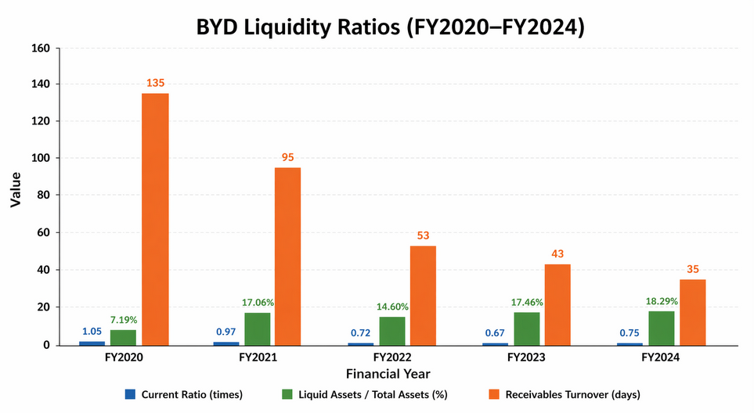
BYD Efficiency Ratios (FY2020–FY2024)
Ratio | FY2020 | FY2021 | FY2022 | FY2023 | FY2024
Asset Turnover (times) | 0.76 | 0.71 | 0.86 | 0.89 | 0.99
Inventory Turnover (days) | 83 | 73 | 64 | 64 | 61
R&D Expense to Sales | 4.86% | 3.78% | 4.40% | 6.57% | 6.85%
BYD Efficiency Ratios (FY2020–FY2024)
BYD Gearing Ratios (FY2020–FY2024)
Ratio | FY2020 | FY2021 | FY2022 | FY2023 | FY2024
Gearing Ratio (Net Debt/Equity) % | 69% | -15% | -26% | -44% | -36%
Debt-to-Assets Ratio | 0.618 | 0.624 | 0.612 | 0.619 | 0.620
Debt-to-Equity (D/E) | 1.62 | 1.66 | 1.58 | 1.62 | 1.63
Equity Ratio | 28.29% | 32.14% | 22.48% | 20.43% | 23.65%

BYD Investment and Shareholder Return Ratios (FY2020–FY2024)
Metric | FY2020 | FY2021 | FY2022 | FY2023 | FY2024
EPS (RMB) | 1.45 | 1.04 | 5.68 | 10.27 | 13.77
Dividends per Share (RMB) | 0.148 | 0.105 | 1.142 | 3.096 | 3.974
Payout Ratio | 30.2% | 29.8% | 25.3% | 33.4% | 20.4%
CapEx to Sales | 3.89% | 4.67% | 22.98% | 20.27% | 12.53%
R&D Expense to Sales | 4.86% | 3.78% | 4.40% | 6.57% | 6.85%
Total Shareholder Return (RMB bn) | 0.164 | 0.423 | 1.553 | 3.974 | 10.036
BYD Cash Flow Summary (RMB Billions)
Item | FY2022 | FY2023 | FY2024
Operating Cash Inflow | ~75 | 169.73 | 133.45
Capital Expenditure | 97.46 | 122.09 | 97.36
Total Borrowings | n/a | 36.55 | 28.58

Appendix B: Investment Appraisal Calculations
BYD Cash Operating Cycle (FY2020–FY2024)
Component | FY2020 | FY2021 | FY2022 | FY2023 | FY2024
Inventory Days | 83 | 73 | 64 | 64 | 61
Receivables Days | 135 | 95 | 53 | 43 | 35
Payables Days (estimated) | ~90–100 | ~90–100 | ~100–110 | ~110–120 | ~110–120
Cash Operating Cycle (approx.) | ~118–128 | ~68–78 | ~7–17 | ~-13 to -3 | ~-24 to -14
Project Cash Flows (£ million)
Project | Init. Inv. | Yr 1 | Yr 2 | Yr 3 | Yr 4 | Yr 5 | Total CF
Project A | £50m | £10m | £12m | £14m | £10m | £8m | £54m
Project B | £50m | £11m | £11m | £11m | £11m | £11m | £55m
Project C | £50m | £5m | £10m | £20m | £25m | £5m | £65m
Payback Period Calculations
Project | Yr 1 Cum. | Yr 2 Cum. | Yr 3 Cum. | Yr 4 Cum. | Yr 5 Cum. | Payback Period
Project A | £10m | £22m | £36m | £46m | £54m | 4.50 years
Project B | £11m | £22m | £33m | £44m | £55m | 4.55 years
Project C | £5m | £15m | £35m | £60m | £65m | 3.60 years
ARR Calculations
Project | Total CF | Avg. Annual CF | Annual Dep. | Avg. Profit | Avg. Investment | ARR
Project A | £54m | £10.80m | £10m | £0.80m | £25m | 3.20%
Project B | £55m | £11.00m | £10m | £1.00m | £25m | 4.00%
Project C | £65m | £13.00m | £10m | £3.00m | £25m | 12.00%
NPV Calculations at 10% Discount Rate
Project | PV Yr1 | PV Yr2 | PV Yr3 | PV Yr4 | PV Yr5 | Σ PV | NPV
Project A | £9.09m | £9.92m | £10.52m | £6.83m | £4.97m | £41.32m | -£8.68m
Project B | £10.00m | £9.09m | £8.26m | £7.51m | £6.83m | £41.70m | -£8.30m
Project C | £4.55m | £8.26m | £15.03m | £17.08m | £3.10m | £48.02m | -£1.98m
Discount Factors: Yr1=0.9091, Yr2=0.8264, Yr3=0.7513, Yr4=0.683, Yr5=0.6209
PI and IRR Summary
Project | Σ PV | Init. Inv. | PI | IRR (interpolated) | PI Rank
Project A | £41.32m | £50m | 0.8265 | ~2.3% | 3rd
Project B | £41.70m | £50m | 0.8340 | ~3.2% | 2nd
Project C | £48.02m | £50m | 0.9603 | ~9.0% | 1st
Investment Appraisal Summary
Method | Project A | Rank | Project B | Rank | Project C
Payback Period | 4.50 yrs | 2nd | 4.55 yrs | 3rd | 3.60 yrs
ARR | 3.20% | 3rd | 4.00% | 2nd | 12.00%
NPV | -£8.68m | 3rd | -£8.30m | 2nd | -£1.98m
PI | 0.8265 | 3rd | 0.8340 | 2nd | 0.9603
IRR | ~2.3% | 3rd | ~3.2% | 2nd | ~9.0%
Capital Rationing — Combined Portfolio Analysis
Portfolio | Total Investment | Combined NPV | NPV per £1 Invested | Recommendation
Project A + B | £100m | -£16.98m | -0.170 | Reject
Project A + C | £100m | -£10.66m | -0.107 | Reject
Project B + C | £100m | -£10.28m | -0.103 | Preferred Combination

