Game worlds
http://www.gameranx.com/features/id/6999/article/top-20-biggest-game-worlds-of-all-time/?utm_source=crowdignite.com&utm_medium=referral&utm_campaign=crowdignite.com

Top 20 Biggest Game Worlds of all Time

Twenty biggest open worlds in videogames you could very easily lose yourself in.
by Ian Miles Cheong on 27th May, 2012
Use your ← → (arrow) keys to browse
Previous1 of 21Next

Biggest Game Worlds
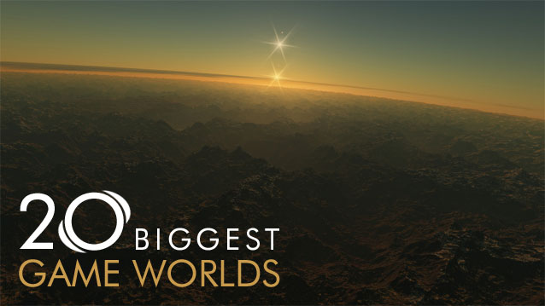
Digital worlds are part and parcel of the videogames we play. It is the geography in which the characters with whom we interact, and the places in which we go. It's where the magic happens, and we visit these lands every time we play a game.
While most games are made up of levels and static missions, some among them—like the ones this article is about—offer seamless transitions with wide open maps that provide the player with the illusion (or in some cases, the reality) that the world in which they walk is one of colossal proportions, comparable to the real world.
The only way one can measure the 'true' size of any game world with any amount of accuracy is through measurements provided by the game developers, because each game's geography has its own metric. Rather than to chart these worlds under the false pretense of square mileage, I've opted to chart these worlds based on how big they seem when one actually plays these games.
Furthermore, this list does not include any games which take place in space, which would by far exceed the scale of any terrestrial-based games. Given the relative emptiness of space, there wouldn't be much to see, anyhow.

#20 GTA 4
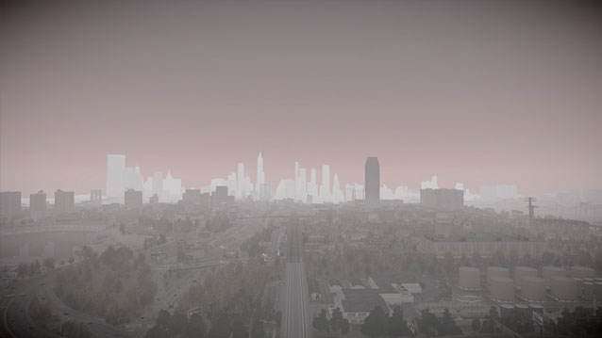
Grand Theft Auto 4 takes place in Liberty City, which is Rockstar's simulacrum of New York City—or Manhattan Island and its surrounding boroughs.
While many parts of the map have been scaled down for accessibility and gameplay purposes, it's hard to shake the feeling that you're driving around in New York City whenever you start up GTA 4. You can even catch a ride in a cab and tour the sights as he drives around the city.
And when you get tired of driving around peacefully, there's always the option to unleash hell and take on the entire police force.

#18 Burnout Paradise
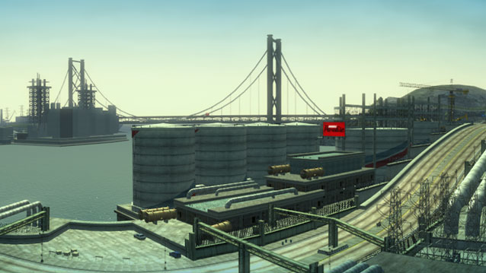
Burnout Paradise is widely regarded as Criterion Games' best title and with damn good reason. It's also one of the few racing games out there that manages to faithfully provide its players with the recreation of a city that not only feels real, but real enough to make you want to drive around just for the sake of driving around. That's pretty important for a game that's solely about racing.
As the game is set in an open world environment, so too are its tracks which are simply portions of the open world cordoned off for the purpose of racing. Drivers can even go online to participate in open world races or simply mess around with others.
Racing games just don't get any better than this

#16 Assassin's Creed Brotherhood
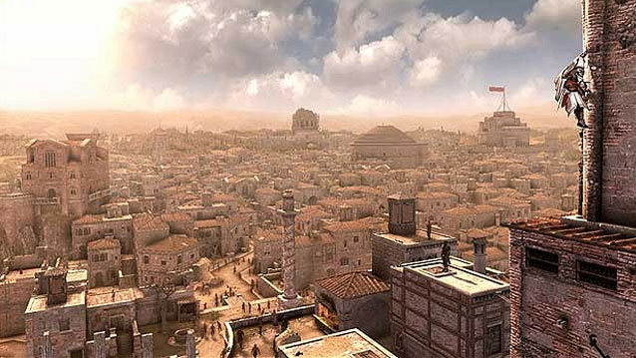
Assassin's Creed: Brotherhood is the third game in the Assassin's Creed series. Why it wasn't called AC3 is anyone's guess. Brotherhood expands upon the Italian setting of Assassin's Creed II and is set almost entirely in the city of Rome.
Instead of splitting the narrative into multiple parts made up of smaller cities to explore, Brotherhood's Rome allows you to traverse a full-sized city that's almost built to the scale of real world Rome. Missing are its countless streets that would undoubtedly bog down any experience the game has to offer, but all the monuments and famous buildings are definitely present—and they're located where they're supposed to be.
In defense of the game's reproduction of Rome, it makes sense that Ezio wouldn't bother remembering each of the nameless streets as his recollection is limited to the places he knows.

#15 Far Cry 2
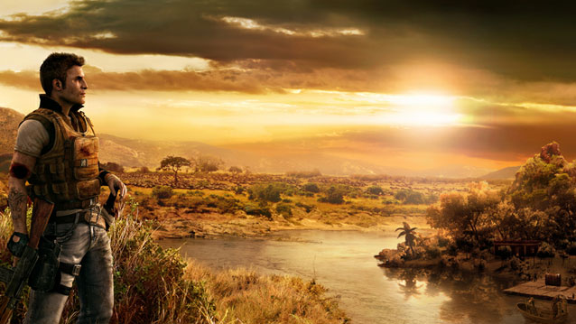
Far Cry 2 is set in a fictional and nameless central African state that offers a diverse range of geography including deserts, jungles, and savannas. It's populated by warring factions, mercenaries, and the civilians (and native wildlife) caught within the crossfire.
Touted as a realistic game, you'll have to navigate through the terrain with a map that you'll actually have to stare down at. There's no heads-up display to tell you where to go in this game, so exploration is as real as it gets.
I should add that the journey the player undertakes is not unlike Joseph Conrad's journey into the Heart of Darkness.

#13 Red Dead Redemption
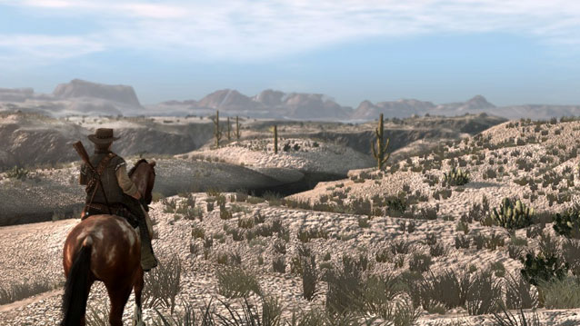
Few games accurately portray the Wild West—a time and a land where lives were cheap and bullets were even cheaper, both equally fleeting. Like the Grand Theft Auto series, Red Dead Redemption isn't set in anyplace that's real, and instead offers players with a world that's just seems real enough to be a place that actually exists.
You take on the role of John Marston, a former outlaw in service of the US government who seeks to bring to justice the lawless men he used to work with. Although the game is Marston's story, you'll have the freedom to roam through the game's various locales either as a man of peace, or as a man who shoots just about everything that gets in his way.
I opted for the latter, because there's no fun in being peaceful.

#7 Fallout 3
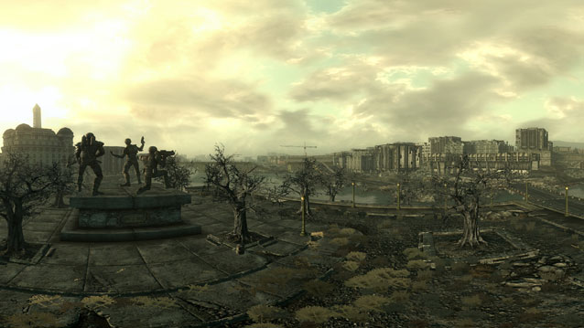
Fallout 3 is Bethesda's take on a post-apocalyptic Washington D.C. with much of its buildings reduced to rubble thanks to China's nuclear detonations on the capitol.
Washington D.C. is pretty much ground zero, but thanks to a couple of hundred years and the low nuclear yield of Chinese nukes (most of which went towards bombarding military facilities instead of political ones), a good portion of the city remains standing. Which is good, because without any architecture, Fallout 3 wouldn't be a very fun place to visit.
If you've ever been to D.C. or at least seen pictures of it, you'll notice that a good chunk of the monuments and buildings everyone knows remain standing. There's even a simulacrum of the D.C. metro in the game. But it's filled with ghouls, so bring a gun.

#2 World of Warcraft
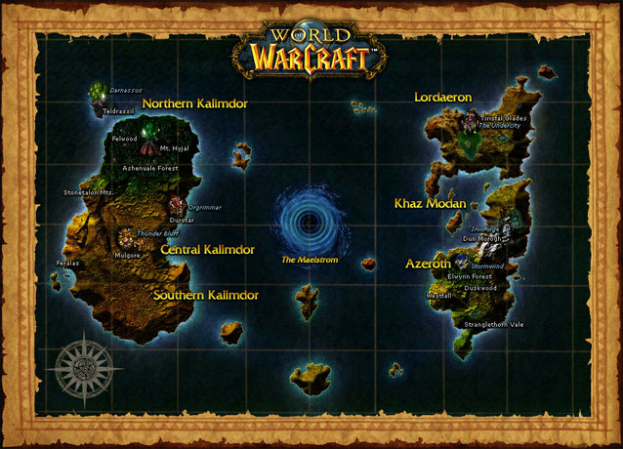
World of Warcraft never had any 'humble beginnings'. It was a game epic in scope since its inception, offering two vast continents: Kalimdor and the Eastern Kingdoms—the lands themselves based on the Warcraft series of real-time strategy games.
While we may never revisit Warcraft in the form of an RTS, we can certainly visit Azeroth in World of Warcraft, which has been expanded with the addition of Northrend and the Outlands—a whole different world—since its release. The most recent expansion, Cataclysm, even destroyed the lands of old to make them anew, and the upcoming Mists of Pandaria will add yet another land to visit.
It is difficult, if not impossible to compare the size of most other MMORPGs with Azeroth's world, as most of them are about as small as one of the larger areas in World of Warcraft.

#1 Minecraft
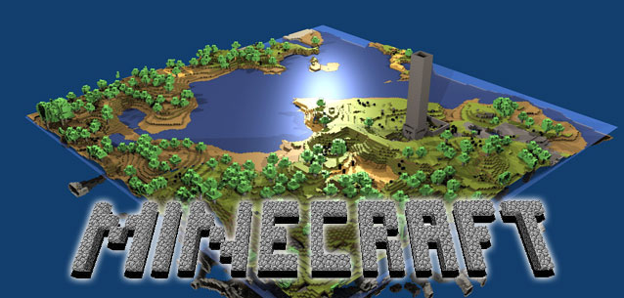
Minecraft is by far the largest world you could ever visit, thanks to its seeded (or procedurally generated) environment.
Every journey you take in Minecraft is an adventure seeded with numerous challenges (in the form of angry skeletons or exploding creepers) and rewards (like diamonds!). It's possible to adventure alone, or with a friend—or many friends, for that matter thanks to the game's flexibility.
Each of the adventures you have can be every bit as memorable as any in a pre-designed world.

