Copy files from my desktop onto the ubuntu running in VirtualBox
VirtualBox Shared Folder (Windows ↔ Ubuntu)
This gives you a permanent “bridge” between your Windows Desktop and Ubuntu.
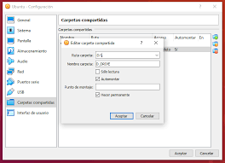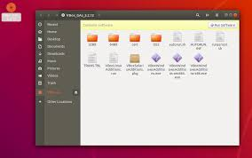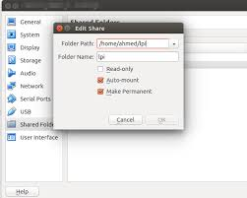

STEP 1 — Install Guest Additions inside Ubuntu
This is mandatory.
In Ubuntu VM:
sudo apt update
sudo apt install -y build-essential dkms linux-headers-$(uname -r)
Then from the VirtualBox menu (top of VM window):
Devices → Insert Guest Additions CD Image
Run:
sudo mount /dev/cdrom /mnt
cd /mnt
ls
You should see: VBoxLinuxAdditions.run
sudo ./VBoxLinuxAdditions.run
sudo usermod -aG vboxsf $USER
sudo reboot

✅ Ubuntu will restart

STEP 2 — Configure Shared Folder on Windows
On your Windows 10 / 11 host:
- Power OFF the Ubuntu VM
- VirtualBox → Settings → Shared Folders
- Click Add New
Use these settings:
- Folder Path:
C:\Users\<your-username>\Desktop
- Folder Name:
shared
- ✔ Auto-mount
- ✔ Make Permanent
Click OK, then start Ubuntu.

STEP 3
After reboot, your shared folder will be available at:
/media/sf_shared
🎉 You can now:
- Copy files from Windows Desktop → Ubuntu
- Edit code from Ubuntu directly
- Drop datasets, labs, reports, tools, etc.

🔍 “I don’t see the folder!”
Try:
ls /media/
If you see sf_shared, you’re good.
If not:
sudo mount -t vboxsf shared /media/sf_shared

🖱️ QUICK METHOD: Drag & Drop (optional)
Good for small files only.
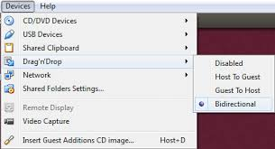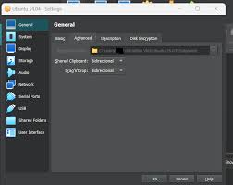
Enable:
VirtualBox → Settings → General → Advanced
- Clipboard: Bidirectional
- Drag’n’Drop: Bidirectional
⚠️ Not reliable for:
- Folders
- Large files
- ZIPs
- ISO images

📎 FALLBACK: USB Flash Drive
Useful if Guest Additions fail.
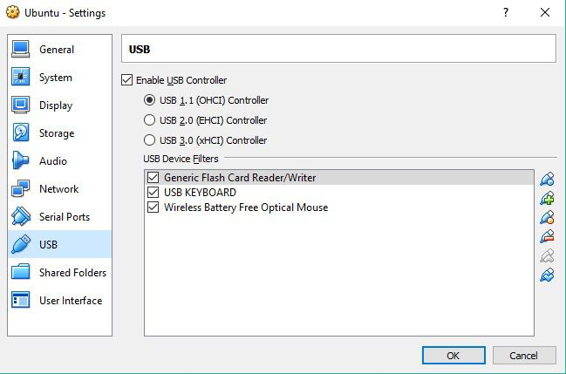

- Install VirtualBox Extension Pack (same version!)
- Plug in USB
- VM menu → Devices → USB → Select your USB
- Ubuntu mounts it automatically

