Name: Angsana Bunrueangtong

Student number: 2104532

Module: Vehicle Technology

Module code: ACHA4004

Lecturer: Paul Morrow

Assignment Title: Vehicle Structure & Aero

Steel Monocoque

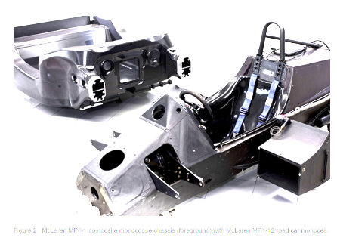
Monocoque is a shell that most cars have got today, it essentially supports the weight of the whole car of structure strength, it acted as shell material like an eggshell that holds the elements together and safe. The main advantage of the monocoque unibody is that the material is lightweight and most importantly they are safe since the metal framework extends to the furthest part of the vehicle’s body structure. Engineers originally used this material for boats as it demands to be strong, light, and water-resistant to keep the water from damaging the engines. It is ideal to use in weight-sensitive vehicles mainly on sports cars and airplanes.

Typically, they used wood or steel which can be covered with other materials such as fabric. The unibody can be produced using a variety of materials, depending on the intended function the vehicle needs. The unibody frames can be made from different materials such as steel carbon fiber, and aluminium normally used in formula one racing cars. This also gives the structural and more aerodynamic look, Monocoque construction integrated the frame into one single shell that significant improvements to strengths and weight, it also improves the safety and fuel economy.
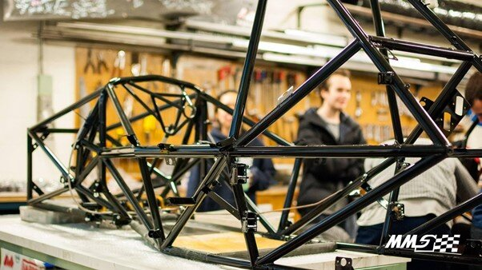

The advantages are improving the safety as the vehicle’s entire structure can absorb the forces of better impact. The most important thing in motor racing would be the safety of the driver depends on the car’s body that is the reason why they have strict regulations only a few cars have been built with monocoque structures.
The other advantage they are much easier to design and modify. It provides a better and more comfortable ride as the Monocoque chassis framework handles the road a lot better since the vehicle is lower to the ground reducing the centre of gravity which gives more benefit and increases the powertrain of the vehicle. The Monocoque makes the vehicle appear lighter generating it to move faster and giving a better drive. Not to mention that having this monocoque provide more of an extravagant ride as the chassis has a better grip with the tires thanks to the quality it has and how the frame has been produced. As the sound deadened and the suspension setup afforded to the monocoque chassis.

The lighter the body of the vehicle is the better lifespan of the tires, suspension, and other wear and tear suspension components. It will be less expensive as you don’t have to change the tires too regularly. They also offer better balance in emergency braking and changing directions when in situations.

The disadvantage of the Monocoque would be the costs, as the body parts are quite complex to develop. It is also very expensive to fix and repair in situations for example, during an accident due to advanced chassis technology, the parts are also expensive and the whole complete structure makes repairs more complicated. The body frame takes a long time to get repaired because of all the factors of the quality of the parts of the chassis. Unfortunately, the monocoque is more prone to rust and moisture damage being lower to the ground, it gets exposed to the water more often, like oil sumps and suspension components which are the main reason why it will take longer to repair. The body on frame construction has a very distinct advantage since it does not require the expensive process of laser welding service.

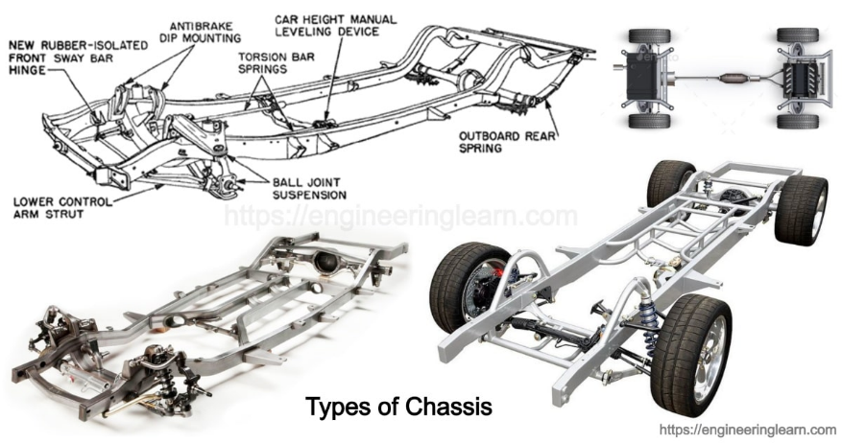

Generative Design (design & manufacture)

Generative design is essential to the design world. The ideas of the generative design deliver numerous and complex designs that are alternatively considered to be used once it has been developed and evaluated.

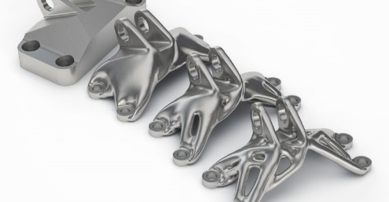
It is a design exploration tool that simultaneously generates different solutions that can use to gain to create strategic decisions and develop new ideas based on real-world design goals to meet the product performance requirements and manufacturing restrictions. The advantage of generative design is the ability to let the design team to acquainted with much more potential manufacturing aware solutions for specific designs and purposes. Generative design has the potential to expand the opinion from an early stage of progressing in designing. The generative design can be used as a tool that is beyond what the human mind can do, it helps us to develop and overcome creativity it helps to come up with highly creative solutions.

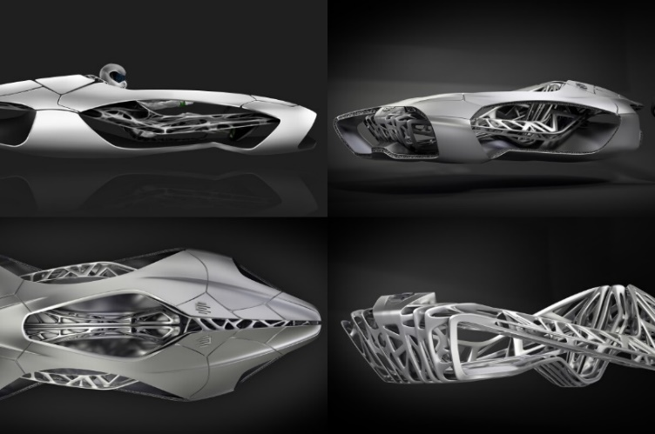
The generative design is the next step ahead of parametric modelling changing and adjusting the shapes and sizes to be more advanced to fit the criteria which helps to progress faster. The ability to solve more complex engineering challenges, which can be the ultimate way to help increase time to the market and helps to improve the product performance. The generative design empowers the designers to make decisions with a better and wider range of design alternatives to select the best outcomes thanks to the technologies there as many programs that can help cut down the designs based on earlier choices for the company. There are many benefits from saving time and energy if the designer has more experience and who can adopt the generative design. It really is a tool to use to help enhance the designer’s creative ideas.

Generative design can be challenging for both designers and engineers. The process creates an unlimited design that is basic specified restrictions and the technologies that are available. There are various variables to be considered for example the machine production schedules, and materials available and there are other factors that could impact the main business objectives. The disadvantage of the generative design could potentially be making humans redundant. There are AI and machine learning that potentially could take over. Generative design and reliance on artificial intelligence have elevated concerns in the design industry. Therefore, designers must expand their skills to be able to progress and come up with a more advanced outcome.

There is also another disadvantage of generative design, they could potentially create many outcomes which will be more challenging to choose as there are too many options which can be very overwhelming and a lot of pressure for designers, and not to mention it could take too much time to be filtering all the options. The disadvantage of generative e design is that it doesn’t need the designer to learn how to use the machine as there are other programs that are available to use. As the result, the final designs might not be as high quality as they expected to be.

Understanding of aerodynamics

When the car starts to accelerate, the air interacts with the vehicle, especially with the high speeds and intense wind the forces reacted when the moving objects by the air known as drag, as it increases the faster the object travels. The Aerodynamics are essential in designing when requires speeds. Drag is generated when a solid object moves through water or air.

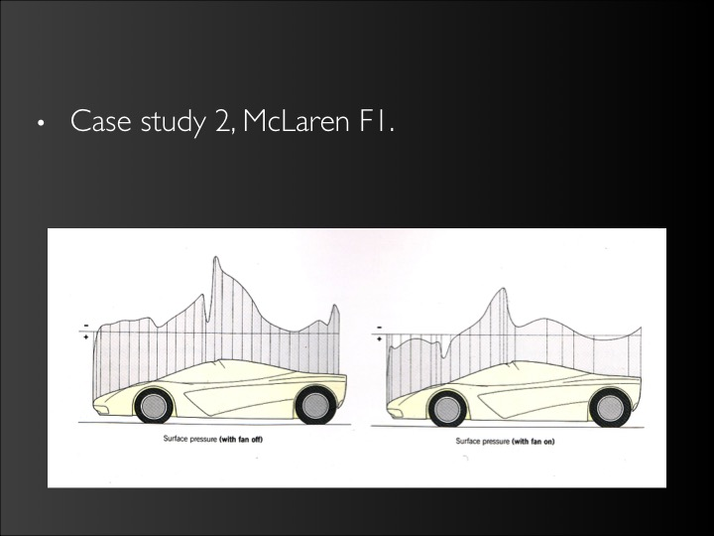
Aerodynamics is the forces in the resulting motion of objects through the air. For decades designers have been designing cars, high-speed trains, and ships even with constructure structures for example high buildings, and bridges with aerodynamics help to resistance to high winds. Consistently, designers and engineers have come up with different solutions and a variety of innovations that can solve breaking the wall of air to help improve the speed limitations and find less impact on driving. Cars that’s been designed with airflow mean it is better for accelerating and the best part of it all it is better fuel economy as the engine doesn’t have to work as hard to drive the car through the wall of air.

The aerodynamics can be measured by using the vehicle’s coefficient of drag. The lower the Cd, the more aerodynamic a car is. For example, more block-shaped cars like the Volvo from the 70s achieve a Cd of 36. The newer cars have lower Cd because of the way the cars have been designed as it has a curvier and sleeker look. The smoother and streamlined shapes are a lot more aerodynamic it is that is why it is important for the car to have certain shapes, like smoother and rounder surfaces which allow the air flows to reduce the wall of air against the body.

Engineers have been searching for solutions on how to find ways to develop better aerodynamics. They have researched and even observed flights of birds to examine their movements and to see what can be applied to the structures. It is important to consider the aerodynamics in designing automobiles, the more rounded shapes on the exterior of the vehicle are constructed to direct air to the flows around the car to resist the air as much as possible. There are some high-performance cars that even have add-on parts that can help move air flow smoothly across the underside of the car. Including a spoiler known as the rear wing that keeps the air from lifting the car’s wheels.

Racing cars have more downforce, because of the downward force that gets produced by air pressures, which generates more pressure between the tires and the surfaces on the road to retain traction through the tight and sharper turns when racing on small tracks. The power of the downforce is crucial as it helped the practice of car racing. Increasing downforce will develop aerodynamic drag more downforce means better handling on forceful turns as it gives a secure and balanced grip while on the track.
The engineers have used a tool from the aircraft industry to measure the aerodynamic effectiveness of the car in a realistic time to get the most accurate result using the wind tunnel which is very resourceful to study the way the aerodynamics works and how to improve.

Looking into more modern, curvier designs minimize the force that air creates against the car’s motion to give a better-looking and faster car. Speed is the main factor that’s why aerodynamics is a very crucial element in car design that can reduce air resistance that can be more aerodynamic. Automotive designers rely on aerodynamic theory to create enhancement in the power and better grip of the vehicle at high speeds. The design is changing more and more streamlining to allow the car to travel at the same speed using less horsepower and which can increase fuel efficiency.

Aerodynamic drag is the force of air as the car cut through the wall of air, it collides with the front bumper making a resistance. It flows along with the hood which creates another drag. The air that glides over the roof creates turbulence around the rear windows and goes behind the back of the car given the backward fore of the vehicle. The speed, air density, size, and shape of the car are the main factor in car drag force.
There is more to aerodynamics than just drag and there are many other factors as well such as lift. Lift is the force that opposes the weight of the objects that are opposite of the downforce. Formula one cars are built to generate as much downforce as possible, especially with the speed they’re traveling they need to be as exceptionally lightweight to get more speeds almost as they are taking off like a plane. That’s why it is important to also have a good downforce to keep the car on the ground at a high speed which means a high Cd is very much required.
Formula one cars also come with the add-on like the wings or spoilers that are mounted onto the front and the rear of the vehicle to also handle the flow of the currents air that presses the car to the ground which is basically known as downforce. There are also lots of other productions cars that have aerodynamic add-ons to generate the downforce like the Nissan GT-R as it has been designed to direct air over the car and back through the oval-shaped rear spoilers that create more downforce. The spoilers can add more aerodynamic looks but not so much with speed and it does depend on how the car is designed.

https://www.infurnia.com/blog/generative-design-pros-cons
https://4wheeldriveguide.com/ladder-frame-vs-monocoque-suv-chassis-pros-and-cons/
https://www.youtube.com/watch?v=gvgOVBVk3KE&ab_channel=Carfection
https://auto.howstuffworks.com/fuel-efficiency/fuel-economy/aerodynamics.htm

