BMIH6001 ASSIGNMENT ONE Contemporary Themes in the Hotel and Hospitality Sector
The hospitality and hotel industry are actively embracing technology to enhance guest experiences to streamline operations and experiences.

Module code: BMHI6001
Module Name: Contemporary Themes in the Hotel and Hospitality Sector
Assignment tile: Assignment one Conference research Paper
Lecture Name: Natalie Brailsford
Student Name: Abul Imran
Student Code: 2100029

Abstract
The hospitality and the hotel industry is increasingly adopting the advanced technologies in order to enhance the guest experiences and streamline operations. The paper focuses on industry responses such as the AI chatbots, mobile check-in, smart room technologies and the AR/VR experiences as well. With the help of PESTLE analysis, we examine the political, social, economic, technological, environmental and legal factors which is focusing on driving the transformation. The discussion also highlights the strengths and limitations of the technological innovations which includes improved efficiency and personalization versus security and accessibility challenges. Understanding of the dynamics is also essential for the hoteliers to effectively integrate technology and meeting the demands.
Contents
Abstract 1
Introduction 3
Overview of Literature 3
Application to hotel and hospitality sector 3
Evaluate future policy and management for technology adoption in hospitality sector 6
Conclusion 6
References 6

Introduction
The hospitality and the hotel industry is undergoing a significant transformation which is being driven by rapid adoption of advanced technologies. This evolution also aims to enhance the guest experience and streamline operational efficiencies. As the modern travellers increasingly demand seamless, personalized, and convenient services the hotels are leveraging innovations such as artificial intelligence (AI), mobile applications, smart room technologies and the immersive virtual reality (VR) experience. With the integration of these technologies helps in presenting both opportunities and challenges. This paper also explores various industry responses to the technology adoption along with critically assessing the strengths and weaknesses. With the implementation of PESTLE analysis in order to understand how the industry is impacted by the external factors and the need for technology with the help of examples as well. Understanding of the dynamics is important for the hoteliers s it helps in navigating the complexities of the technological integration and also achieve competitive edge in the increasingly digital landscape. Technology has been prevalent in the industry for long time however after the pandemic things have started to happen faster and with the faster transitions the industry has grown to new levels.

Overview of Literature
It has been found that the industries of hotels and hospitality is implementing a huge change due to the innovative technologies which are designed to improve the overall guest experiences. The focus of this study is on the implications of practical technology and trend which enhances the customer satisfaction, operational effectiveness and the quality of service provided by the hotels. According to the Roy et al. (2023) Artificial Intelligence are the leading way in developments in technology. Artificial Intelligence (AI) introduces AI chatbots and virtual assistants are becoming commonplace. They offer instant customer support and respond to inquiries and help with reservations. They provide the immediate response and reactions and data analytics driven personalized recommendations these technologies increase visitor engagement and happiness. According to Amoako et al. (2023) found that artificial intelligence (AI) can dramatically lowering operator costs while boosting client engagement and loyalty. With the use of chatbots, artificial intelligence (AI) and machine learning (ML) enable personalized services, such as customized recommendations and automatic responses. AI also analyses the guest preferences and provides them more suggestions. According to Pagaldiviti et al.(2023), mobile technology has become a crucial part of the visitor experience from reservation to check outs. With the help of mobile app visitors can order services online without speaking with staff members and use digital keys to access their rooms directly. Through the ease of controlling room settings using smartphones, Internet of Things (IoT) devices contribute to improving guest comfort. It is very convenient and this smooth integration of services via devices is in line with visitors increases the contactless which came particularly at time of COVID-19. According to Shin et al. (2022) who provides mobile services have more business and more satisfied customer. Virtual Reality and Augmented Reality are becoming the more effective methods for improving the visitor experiences. Technological developments in Virtual Reality (VR) and Augmented Reality (AR) facilitate the production of immersive experiences for visitors, including virtual tours of the hotel's amenities and nearby sites. McLean et al., (2022) has opined that the difficulty also resides in ensuring that these technologies are user-friendly and integrating them seamlessly into the current systems. Virtual Reality (VR) gives the customer a reality check and sneak peek of hotel accommodations before they can make a reservation. Virtual Reality and Augmented Reality can improve the onsite experiences by putting data like live maps and on-site navigation over the real world. These kind of technologies in the hotel industry improves the experience of the customers and interact more tourists. These technology helps growth of the industry. Big Data Analytics have altered their ways towards hotels and understand the need of the guests and serve them. According to Zarezadeh et al. (2022), hotels that used big data analytics has seen an increasing customer satisfaction and guest loyalty. Hotels can learn about the guest preferences and tastes and feedback of their guest by analysing the large number of datasets from various sources. With the help of this data hotels can provide a high-level service offerings and flexible pricing strategies like offers and discounts. And improvise the marketing campaign as per the visitor’s expectations.

Application to hotel and hospitality sector
Political factors- the political environment significantly influences the adoption of technology in the hotel and hospitality industry. Governments worldwide are also increasingly focusing on promotion of digital infrastructure and various smart tourism initiatives as well. There are policies supporting digital transformation such as subsidies for technology adoption and also tax incentives for tech investments which helps in implementing of advanced technologies in the hotels. For example, the countries such as Singapore and Japan have launched the smart tourism strategies which help in encouraging the hotels to adopt innovative technologies in order to enhance guest experiences (Park, et al., (2023). Furthermore, the data protection regulations such as General Data Protection regulation (GDPR) in Europe imposes stringent requirements on how the hotels manage and secure the guest data which impacts the deployment of certain technologies (Singh, et al., (2024).
Economic factors- Economic conditions play an important role in the hospitality industry’s capacity to invest in new technologies. During the periods of economic growth, the hotels are also more likely to allocate budget for upgrading of the technological infrastructure. Technologies such as the automated check-in systems, AI powered customer service and the smart room controls also require substantial investments. However, during the economic downturns, the focus often shifts to cost saving measures, which potentially slows down the technological adoption, and even in the challenging times technology can help in providing long term savings by improving operational efficiencies, reducing of labour costs, and increasing energy efficiency throughout the systems (Molina-Castillo, et al., (2023).
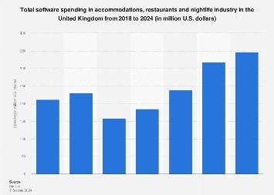
Fig: Software spending in UK hospitality sector (Molina-Castillo, et al., 2023)
Socio-economic factors- the social trends and customer behaviour significantly impact the hospitality industry’s technological factors. Modern travellers especially the Millennials and the Gen Z’s demand of seamless digital experiences from the booking to checkout and with the rise of social media and online reviews it compels the hotels to adopt technologies which enhance guest satisfaction and engagement. For example, the mobile apps for booking and service requests, personalized digital marketing and virtual digital concierge services which will be catering to the tech savvy guest preferences. Furthermore, the importance of health and safety post the pandemic has risen which has led to the adoption of contactless technologies such as the mobile room keys and the digital payment systems in order to meet the guest expectations for hygienic and safe ways (Ratna, et al., (2024).
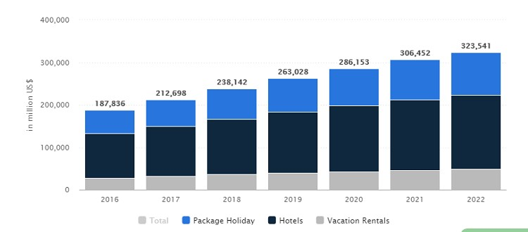
Fig: Smart Mobile app development for hotels in UK leading to revenue growth (Gangwar, & Reddy, 2023)
Technological factors- with the rapid advancement of technology provides numerous opportunities for the hospitality and the hotel industry to innovate and improve guest experiences. Artificial Intelligence (AI) and Machine Learning (ML) help in enabling personalized services from the tailored recommendations to the automated responses through the help of chatbots. The Internet of Things (IoT) devices help in enhancing the guest comfort and also the convenience of allowing of the control of room settings via smartphones. Block-chain technology is also emerging which helps in offering secure and transparent transaction process (Nikopoulou et al., 2023). Advancements in Virtual Reality (VR) and Augmented Reality (AR) help in creation of immersive experiences for the guests such as virtual tour of the facilities of the hotel and the local attractions as well. Furthermore, the challenge lies in the incorporation of these technologies seamlessly into the existing systems and ensuring that they are user-friendly as well.
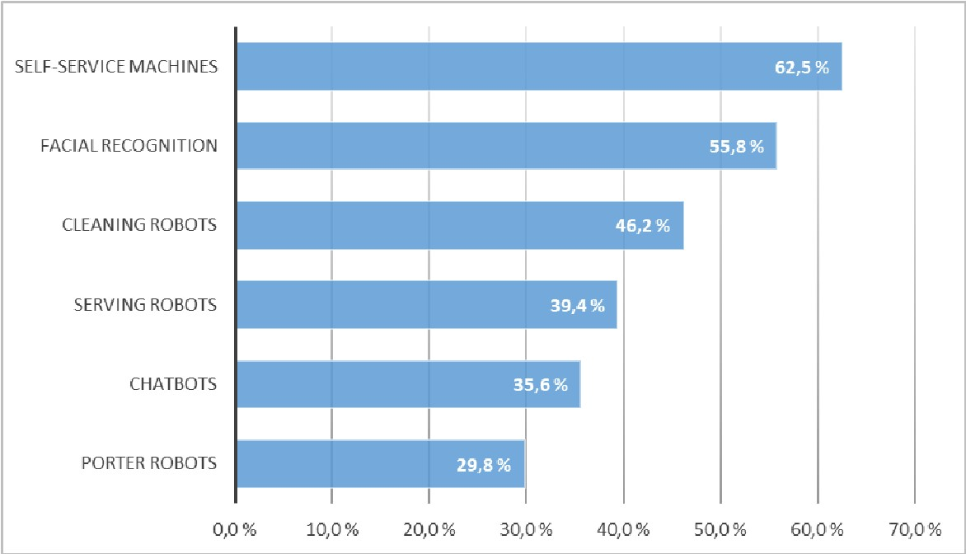
Fig: Opportunities of AI in hospitality Industry for innovative customer service (Nikopoulou et al., 2023)
Legal factors- the legal considerations surrounding the hospitality industry include the data privacy laws, cyber-security regulations and compliance with the international standards. The GDPR in the Europe and California Consumer Privacy Act (CCPA) in the United States are the examples of regulations which helps in mandating stringent data protection measures (Gangwar, & Reddy, (2023).
Environmental factors- Sustainability is increasingly important in the hospitality industry and technology has been playing a pivotal role in achievement of the environment goals. Smart energy management systems, automated lightning, HVAC controls, which helps the hotels to reduce the carbon footprint by optimizing of the energy use. Water conservation technologies and the waste management systems also help in contributing to the sustainable operations (Rasheed, et al., (2023). Furthermore, the hotels can make use of data analytics to monitor and improve on the environmental performance and the guests are also becoming environmentally conscious often times choosing the hotel which demonstrate a sense of commitment to sustainability with the help of technology driven initiatives.
Technology Adoption in the Hospitality and Hotel Industry: Strengths and Limitations
Implementation of AI and Chat-bots- Many of the hotels have adopted AI powered chatbots to handle customer inquiries, booking requests and the service orders. One example is that of Marriott international utilizes chatbots across its brands to assist guests with the booking and provide information about amenities. Efficiency and personalization are the strengths in which the AI chatbots will be providing 24*7 services and the AI can also analyze the guest preferences which helps in improving guest satisfaction (Chaudhuri, et al., (2024). Lack of Human touch and technical issues are the limitations as some of the guests may find the chatbots impersonal and often the AI can also misjudge to understand complex queries.
Mobile Check-in and Digital Room Keys- Hotels such as Hilton have introduced mobile check-ins and digital room keys through their app which also allows the guest to bypass the front desk and also go directly to their rooms. Convenience and safety are the strengths as the technology will help in streamlining of the check-in process, thus saving time for the guests and more. Technology Barriers and security concerns are the limitations as not all guests are comfortable in using the mobile apps and digital keys are often vulnerable to hacking which will necessitate robust cyber-security measures.
Smart Room Technology- Luxury hotels such as the Peninsula Hotels have integrated the smart room technologies which allows the guests to control lightning, temperature, and entertainment systems with the help of single device or voice commands (Zhang, et al., (2023). Customization and Energy efficiency are the strengths as the guests can personalize their rooms and the smart systems can also optimize the energy use to the sustainability efforts and cost savings. Complexity and Maintenance are the limitations of the technology as some guests may find the technology too complicated to use and high-tech systems require maintenance and updates which will lead to potential increase of operational costs.
The adoption of technology in the hospitality and the hotel industry brings in numerous advantages such as the enhanced guest satisfaction, operational efficiency, and safety, it also faces multiple challenges as well such as technology complexity, security concerns and the potential alienation of the less tech savvy guests (Nikopoulou, et al., (2023).

Evaluate future policy and management for technology adoption in hospitality sector
Currently the hospitality business is undergoing revolution driven by technology. Following are some of the technologies that will help technology to change the way hospitality sector does business -:
Using Chatbots: Using Chatbots can be proved as a valuable asset for potential guests. The guests can surf the internet anytime for information, providing instant and swift responses to their queries. Their easy availability throughout the day ensures that no query goes unanswered regardless of the time they have been asked. These chatbots can be used for a variety of purposes including Booking Assistance, making reservations, checking room availability, getting information regarding rates and facilities, feedback collection, answering common questions, etc (Bharwani, and Mathews, 2021). By offering instant support these chatbots not only improve the guest experience but also enhance hotel operations.
Use of Smart sensors in the guest rooms and smart predictive precaution managements: Embedding smart sensors or such artificial systems in the hotels marks a highly advanced approach in the hospitality sector. Such sensors can be used to monitor temperature, energy, usage environmental conditions based on occupancy of the room and preferences eventually allowing hotels to adjust settings to get optimal efficiency. Such sensors not only Improve guest satisfaction and reduce bills but are highly sustainable as well aligning with the emerging demand for eco-conscious hospitality. While these smart sensors help the hotel staff to monitor energy consumption these smart predictive maintenance devices can detect hazardous patterns within the hotel premises and alert the customers (Yang et al., 2021). Such methods provide a clear picture regarding the hotel operating conditions enabling the hotel staff to schedule maintenance activities and manage resources more effectively.
Use of AI and machine learning in managing database records: AI has been proven a great ally to humankind to optimize their work and perform tasks more effectively. AI can be used effectively to revolutionize guest experience in the hospitality sector. It is believed that in the next decade, hotels will be providing personalized and efficient guest services with the use of such advanced technologies. When AI and machine learning technology in the hospitality sector ensures the hotel staff analyses vast data allowing them to personalize the overall guest experience and pricing policies (Lee et al., 2021). Such technologies can also help in managing the workforce as they can be used to forecast demand, analyse employee performance, and training needs, and track employee engagement.
Use of contactless technology in the hospitality sector: It can be recommended that contactless technology can be used to make the overall guest experience better. These contactless technologies come with features like mobile check-in and check-out, digital payments, and mobile keys enabling the guest to make their stay seamless without any physical interaction. This also helps in eliminating long queues saving their precious time and managing their bookings seamlessly.
By emphasizing these areas, the hospitality sector can efficiently leverage technology to provide guests with exceptionally good experiences and maintain an edge within the industry. These technologies provide a variety of rewards enabling improved services, seamless guest experience and optimized and sustainable operations as well. As per various surveys conducted the hospitality sector has reported around more than 20% increase in guest satisfaction amidst technology driven efforts.

Conclusion
The hospitality and the hotel industry’s embrace of technology has reshaped the guest interactions and the operational processes, offering enhanced convenience, safety, and personalization. AI chat-bots and the smart room technologies along with the AR/VR experience will help in exemplify the sector’s innovative responses to the contemporary demands. The technologies provide substantial benefits such as improved efficiency, tailored services, and sustainable operations as well. Furthermore, they also present limitations which includes potential security vulnerabilities, necessity for ongoing updates and maintenance and more. The research paper also sheds light on the overview of the industry based on the current changes and updates as well as focusing on evaluating the current policies and management options for the theme as well. By striking a balance between the leveraging of technology and maintaining human touch, the hospitality sector will ensure that it will meet expectations of the tech savvy travellers of present generations and also fostering a secure and welcoming environment.

References
Bharwani, S. and Mathews, D., 2021. Techno-business strategies for enhancing guest experience in luxury hotels: a managerial perspective. Worldwide Hospitality and Tourism Themes, 13(2), pp.168-185.
Chaudhuri, R., Chatterjee, S. and Vrontis, D., (2024). Adoption of blockchain technology in hospitality and tourism industry and sustainability performance: impact of technological turbulence and senior leadership support. EuroMed Journal of Business, 19(1), pp.62-83.
Gangwar, V.P. and Reddy, D., (2023). Hospitality industry 5.0: Emerging trends in guest perception and experiences. Opportunities and Challenges of Business 5.0 in Emerging Markets, pp.185-211.
Lee, M., Ahn, J., Shin, M., Kwon, W. and Back, K.J., 2021. Integrating technology to service innovation: Key issues and future research directions in hospitality and tourism. Journal of Hospitality and Tourism Technology, 12(1), pp.19-38.
McLean, G. and Barhorst, J.B., 2022. Living the experience before you go... but did it meet expectations? The role of virtual reality during hotel bookings. Journal of Travel Research, 61(6), pp.1233-1251.
Molina-Castillo, F.J., Meroño-Cerdán, A.L., Lopez-Nicolas, C. and Fernandez-Espinar, L., (2023). Innovation and technology in hospitality sector: outcome and performance. Businesses, 3(1), pp.198-219.
Nikopoulou, M., Kourouthanassis, P., Chasapi, G., Pateli, A. and Mylonas, N., (2023). Determinants of digital transformation in the hospitality industry: Technological, organizational, and environmental drivers. Sustainability, 15(3), p.2736.
Park, H., Lee, M. and Back, K.J., (2023). A critical review of technology-driven service innovation in hospitality and tourism: current discussions and future research agendas. International Journal of Contemporary Hospitality Management, 35(12), pp.4502-4534.
Rasheed, H.M.W., He, Y., Khizar, H.M.U. and Abbas, H.S.M., (2023). Exploring Consumer-Robot interaction in the hospitality sector: Unpacking the reasons for adoption (or resistance) to artificial intelligence. Technological Forecasting and Social Change, 192, p.122555.
Ratna, S., Saide, S., Putri, A.M., Indrajit, R.E. and Muwardi, D., (2024). Digital transformation in tourism and hospitality industry: a literature review of blockchain, financial technology, and knowledge management. EuroMed Journal of Business, 19(1), pp.84-112.
Roy, B.K. and Pagaldiviti, S.R., 2023. Advancements in arena technology: Enhancing customer experience and employee adaptation in the tourism and hospitality industry. Smart Tourism, 4(1).
Roy, B.K. and Pagaldiviti, S.R., 2023. Advancements in arena technology: Enhancing customer experience and employee adaptation in the tourism and hospitality industry. Smart Tourism, 4(1).
Shin, H.H., Jeong, M., So, K.K.F. and DiPietro, R., 2022. Consumers’ experience with hospitality and tourism technologies: Measurement development and validation. International Journal of Hospitality Management, 106, p.103297.
Singh, R., Gehlot, A., Akram, S.V., Thakur, A.K., Gupta, L.R., Priyadarshi, N. and Twala, B., (2024). Integration of advanced digital technologies in the hospitality industry: A technological approach towards sustainability. Sustainable Engineering and Innovation, 6(1), pp.37-56.
Yang, H., Song, H., Cheung, C. and Guan, J., 2021. How to enhance hotel guests’ acceptance and experience of smart hotel technology: An examination of visiting intentions. International journal of hospitality management, 97, p.103000.
Zarezadeh, Z.Z., Rastegar, R. and Xiang, Z., 2022. Big data analytics and hotel guest experience: a critical analysis of the literature. International Journal of Contemporary Hospitality Management, 34(6), pp.2320-2336.
Zhang, X., Tavitiyaman, P. and Tsang, W.Y., (2023). Preferences of technology amenities, satisfaction and behavioral intention: The perspective of hotel guests in Hong Kong. Journal of Quality Assurance in Hospitality & Tourism, 24(5), pp.545-575.

