Certificate of Higher Education in Skills for the Workplace

Module name BMSW 4002

Effective team work and communication in Ignite Vitality
(Group Presentation and speaker notes)

Team Leader – Mariyka Ferreira ID 1905501
Team members:
KristianaAleksandrova ID 1909891
HristinaDeninska ID 1905508
VasilKamburov ID 1909879
Katya Georgieva ID 1906399

Lecturer:AfzalMunna

Table of content:
Introduction
1. Team and benefits of team (KristianaAleksandrova ID 1909891)
2. Stages of team development (HristinaDeninska ID 1905508)
3. Team roles (VasilKamburov ID 1909879)
4. Managing conflict (Katya Georgieva ID 1906399)
5. Successful team development techniques (Mariyka Ferreira ID 1905501)
Conclusion
References

Introduction:
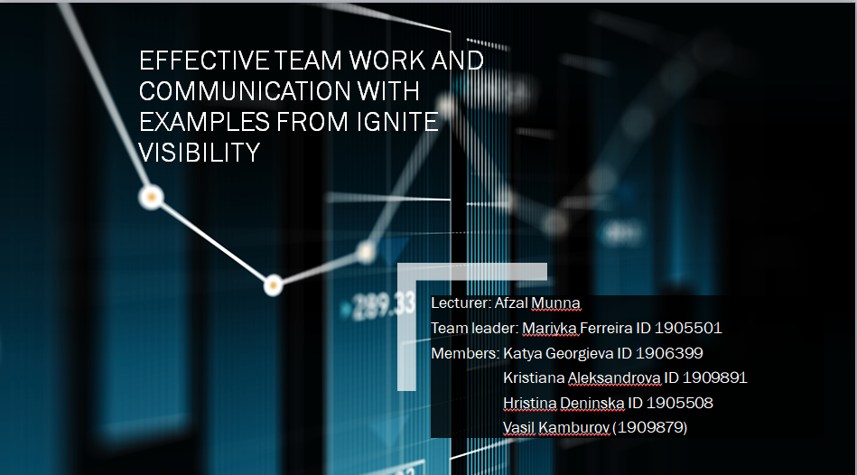

In this presentation our goal is to introduce strategies for effective team working, how to develop a team and any other integral skills required for producing a successful team. We will be looking for examples in Ignite Visibility (I.V.) a digital marketing service which comprises of various teams. We will analyse established methods of team development and how to tailor them to your specific needs. We will demonstrate a practical deployment of these methods, as well as what skills or attributes one needs for professional practice of these theories. We will begin by explaining what a team is and how it can benefit an organisation.

1. Team and benefits of team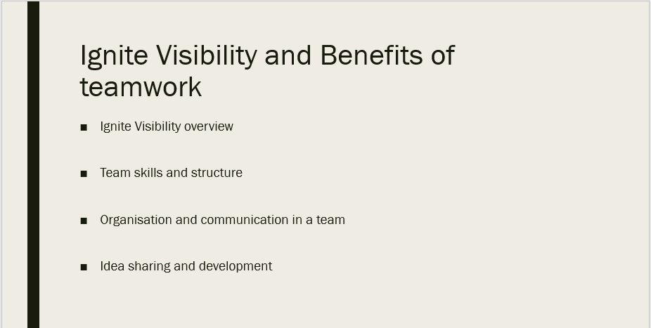
Team is a group of people, working together to achieve same goal. Every person from the team usually have different skills. Choosing the right members with different skills and straightness makes team successful. Another important thing in one team is the leader. That’s the person who take the lasts decisions, helping all team members improving themselves, taking the best from the ideas from all the team. One of the main roles of the leader is to support all the people in the group and to guide everyone involved into the target. How we all know working as a team and having a good communication goes hand by hand. Creating a strong team helps the company to succeed.
Ignite Visibility (I.V.) get started with two people. Currently the job is difficult, and it takes a lot of time to do it all. Later they create a big team which get the company to the level “one of the fastest growing companies in San Diego”. Every year the company achieve more goals and gets more clients by having this team and giving better services to the clients. Generating new ideas helps company to develop and expand its online business areas by constructing new projects. The works in (I.V.) are shared. All team members get a different kind of jobs in area which they are good such as social media marketing, email marketing, local and international search marketing and others.
Working as a team helps members to get faster and efficiently results by sharing ideas, talking and asking questions. Other benefit is that the employees in a team can help by supporting each other in difficult times, that makes the results get even better. The relationship between the team members can get even more deep by achieving their goals and realise that probably is not possible to complete the task alone. This makes people feel more motivated which help the members to communicate more openly. Work-life balance is also important so as a team every person can cover someone else with their tasks because they are trained for other`s skills as well. That allows every person to have spare time. There are many other benefits of working as a team but some of them are key ones. The final thing is the result-always incredible. (Midura and Glover, 2005)

2. Stages of Team Development
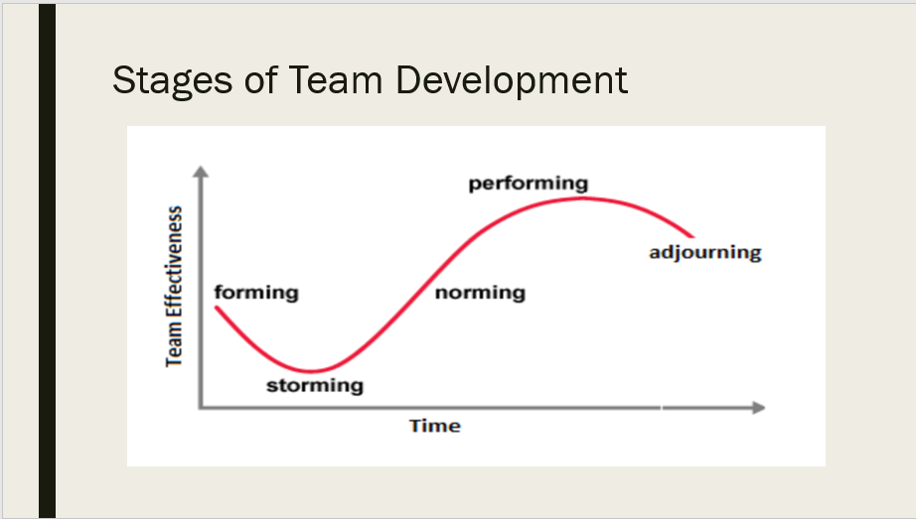According to Ignite Visibility’s (I.V.) website “values are at the core of everything we do... our process, service offerings and our company culture.” This is expressed in their “Meet our team” page. In the table above are the 5 steps I.V. use when adding new team members.(Lincoln, 2020)
Forming; at this stage, team members may be excited to venture into the task at hand, while others may feel unprepared or anxious, due to fear of the unknown. It is I.V.’s team leaders’ job to set tasks and objectives for the group and its members individually and practically guide them through initially.
Storming; after team members start to grasp their role in I.V. they must endure the most difficult stage of forming a collective. Conflict or demotivation may begin to arise due to a difference in work style, friend groups being formed and members feeling excluded etc. I.V.’s team leaders must reveal to the team the objective of these 5 steps of team development and why conflict is arising and how to solve it in the future. A team leader will provide the most well suited psychometric indicators to the team to help them define their process of work, understand other people’s styles, especially less secure workers will benefit from this. The team leader must be assertiveness and have good conflict resolution skills in order to build trust in their relationship with a team.
Norming; is where team leaders step back and let the team, having resolved their differences and adapted to working styles and structures in the previous step, explore the best way to the team goal. Team members are comfortable with each other, get to socialize more freely and even express or accept constructive criticism better. As much as the team leader should let the team take responsibility for their task, this is one of the best times for any team-building games or activities to solidify the common progress towards the team goal.
Performing; is very straight forward. Simply as a manager or team leader, delegate tasks which you know the team members can do and focus on developing new teams or individual members further, as well as personal work goals. Once the core of the team is established new members will be much easily integrated.
Adjourning; as with any team, it eventually exhausts its tasks or completes their goals and is disbanded. Team members must be celebrated and made to feel more comfortable with the conclusion of the task and team leaders must clarify their team members’ future in new roles.
(Tuckman, B. W. 1965)

3. Team Roles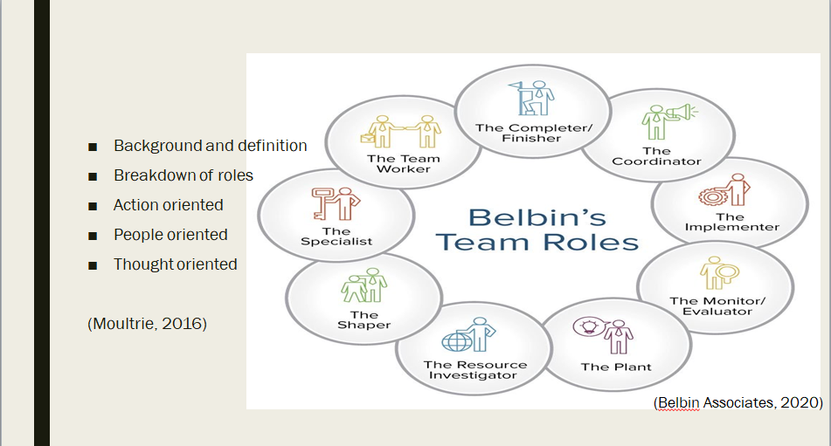

As previously mentioned, Tuckman's hypothesis builds around the forming of a team initialising from the underlying development of it, to the finalisation of a given venture. However when it comes to team roles this theory lacks clarity which is where another theory called "Belbin's team roles" comes in.

Belbin’s team roles were developed after nine years of research in 1981 by Meredith Belbin. Over the years it has proven to be the go to tool to improve team building. Simply put the best teams are more than capable when it comes to versatility and unique styles. For this to be possible, team roles were implemented based on the research which anticipate and determine achievements of that commanding team. Moultrie (2016)
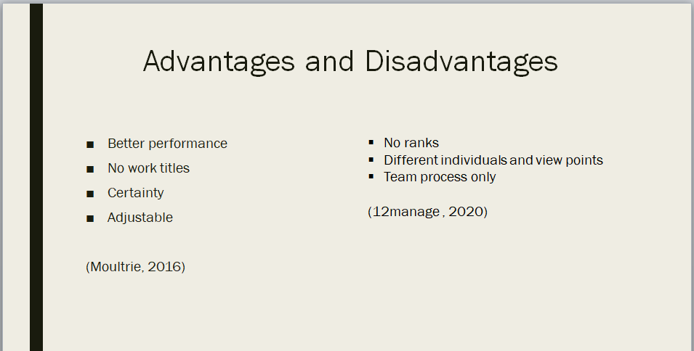
According to Belbin each team role has "a tendency to behave, contribute and interrelate with others in a particular way.” (Belbin, 2003)

Belbin’s theory consists of nine team roles which are:

• Resource Investigator- Acquires ideas by using their analytical quality
• Team worker- Encourages teamwork by recognising the company’s goals and aiding in completion in interest of the team.
• Co-ordinator- Expected to concentrate in the group's destinations, draw out col- leagues and administer work suitably.
• Plant- Exceptional and innovative at using whimsical manners to tackle issues.
• Monitor Evaluator- Using their impartial manner to make fair-minded decisions where needed and evaluate the team’s alternatives
• Specialist- Acquires solid information on a key region to the team.
• Shaper- Delivers the ever so crucial push to guarantee that the group continues im- proving and doesn't lose concentration or momentum.
• Implementer- Designing applicable techniques and conducting them as productively as could reasonably be possible.
• Completer (Finisher) - Most adequately utilised toward the finish of errands to clean and investigate the work for mistakes, exposing it to the best expectations of value control.

Just because there are nine team roles, this doesn’t imply that each team must have nine individuals. The vast majority of members will have a few of Belbin’s team roles that they are generally complacent with, which over time can change. Each role has its qualities and shortcomings. However it’s important to note that every role has equivalent significance. This is why it’s essential that all groups have access to every role’s practices, as this improves the team’s performance level. Belbin (2020)
Similar to Tuckman’s theory, Belbin’s Team Roles also has advantages and disadvantages.

Advantages
Utilising this theory more or less provides:
• Better-performing groups each of which is filled with perfect for the assigned under- takings individuals.
• Adjusted groups dependent on conduct commitments as opposed to work titles
• Certainty when settling on choices involving individuals
• Mindful workers who are open to adjusting their practices adequately to the circum- stance and business aim. Belbin (2020)

Weaknesses
• When it comes to bigger tasks, it’s often possible for group exercises to be gathered into team processes.
• Unlike other models no ranked associations between individuals is considered.
• Particular individuals might not be able to cooperate due their mutual disliking.
• There might be more than one plant expected to bring thoughts and viewpoints into a group. 12manage (2020)

Taking into account all this information it’s vivid that in order for a team to be really eﬃ- cient and successful it requires both theories to work side by side. This is because a team needs to be formed based on a project (Tuckman’s theory) as well as it needs to be cor- rectly managed in order to complete the aforementioned project (Belbin’s Team Roles).

4. Managing conflict
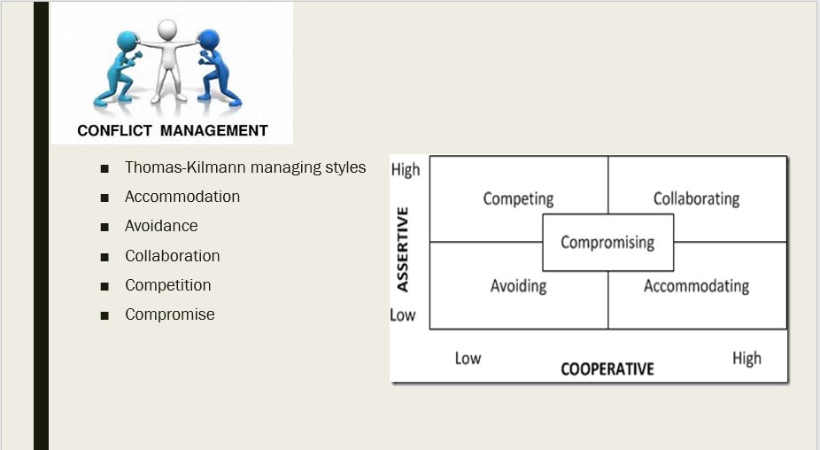(Thomas, K. W., and Kilmann, R.H. , 1974)
Above is a figure of the widely accepted and effective Thomas-Kilmann managing styles for solving conflict in the work place. As you can see they are viewed through two “prisms” the first being cooperative management conflict solving and the other being assertive. After explaining the methods, I will give an example of a former Ignite Vitality employee and his experience with conflict.

Accommodation; is a highly cooperative mean of resolving conflict, where you back down completely in the conflict. This style of resolving conflict is mostly used by team members with a lesser role in the company, as usually in a conflict they are the not the expert on the subject and may need to preserve their relations with the other party that holds a higher position in the company.
Avoidance; is a low cooperative, low assertive short-term tactic for resolving conflict, as you do not help the other party or yourself in pursuit of resolving, but rather simply avoiding the issue. It is mostly accepted that this tactic is successful when issues resolve themselves, without input from either party, however that is extremely rare, unless it is a trivial issue or you never had a chance of winning the disagreement to begin with.
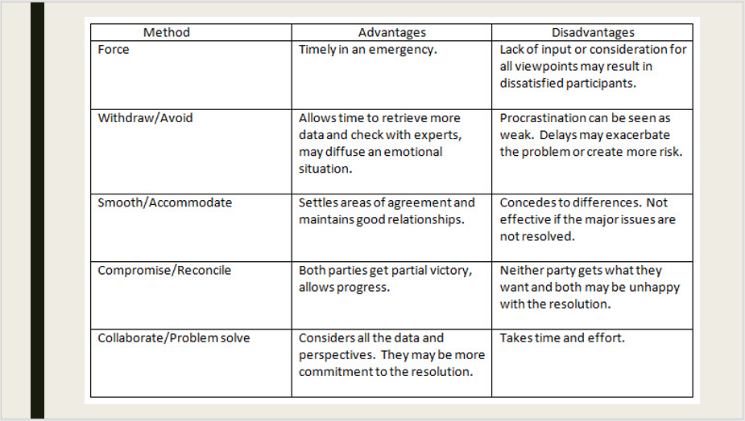Collaboration; is a highly cooperative and assertive method, but difficult to apply due to the human factor. In order to resolve a conflict through this method both parties must join forces to create a novel solution to the problem and aim for a “win-win” outcome. This can be achieved through a lot of time and a very high degree of trust between the parties. In order to resolve the conflict both parties must feel like they have contributed and their input is satisfactory in relation to what they are looking to achieve. No method of managing conflict will work without mutual respect and a willingness to disagree and resolve disagreements
Competition; is a low cooperative and highly assertive method of resolving conflict. Unlike the above, this is a “win or lose” scenario where asserting dominance of mind and possibly profiting off the other parties’ downfall. It is not well received in I.V. and is better for resolving external conflict rather than inside the company
Compromise; is the ultimate “lose to win” scenario. Where a conflict arises between two parties with equally important issues a moderate level of assertiveness and cooperation is needed. It is important to distinguish when it is better for I.V. to compromise rather than cooperate. The lines between the two are vaguely defined, but exist.
For example, in the case of this former employee of Ignite Visibility compromise was not reached, due to avoidance of the issue and competition, no accommodation and minimal collaboration lead to him leaving (Anonymous, 2020)
“- Lack of structure or accountability in the leadership team. - When things go wrong, there's more finger-pointing than there is understanding or solution-oriented action, both top-down and laterally. - Obvious favouritism in promotions, account assignment, and training opportunities. - There's an obsessive emphasis on "inherent talent", resulting in many people and opportunities being overlooked. Goes hand in hand with the favouritism in a bad way. - Lack of support for employees who raise their hands and ask for it. - General cattiness between the departments and even among teams. There's a fair amount of internal competition, which works for some people and really doesn't for others. - Lots of knee-jerk reactions from management that makes navigating rules and policies an ongoing challenge.
Advice to Management
Listen to the people who've shown that they care more about the company and the people than they do about themselves. Sometimes, it's nice to chase a vision, but work with what you have instead of trying to force square pegs into round holes.”

5. Successful team development
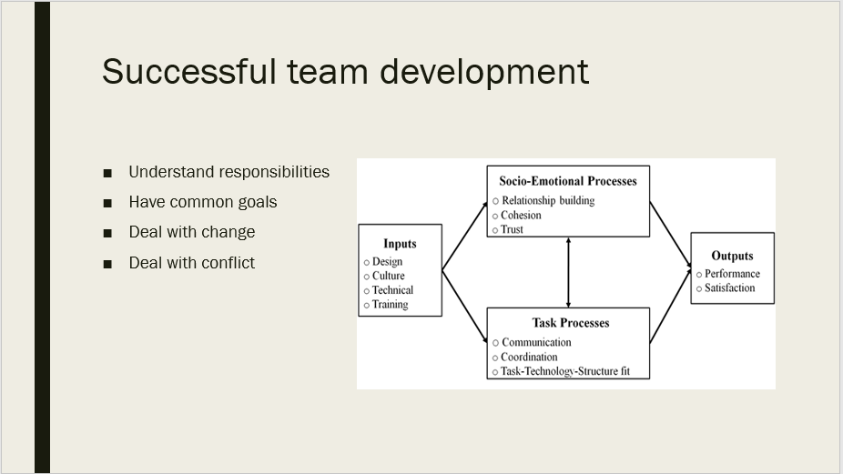
Team work is grounded in communication. As we have seen with Bruce Tuckman’s 5 easily identifiable stages of a team’s development, individual team members can overlap stages and stunt growth. It is easy to identify this in Ignite Visibility (I.V.) as it is a small company and employee’s habits can be analysed deeper by management and more time spent on developing a successful team based on Belbin’s team roles. It is a team leader’s job to make sure his team have all the tools to develop easily.

To ensure a team develops well they must respect these 8 steps for a strong starting base from which to grow. (Watkins, 2020)
Understand responsibilities; team leaders must set clear objectives and affirm which process is best used to achieve them, this helps streamline a team’s work load and helps with time and quality for any task.
Have common goals; team leaders should set objectives in a way that requires team cooperation. By solving a common issue, two or more members of a team develop a relationship of trust towards each other and that means their goals will be shared and so their work development will be quicker and their team roles more easily defined.
Deal with change; change is good for any of us, but it is vital to be prepared for any scenario, including the worst, following this change and plan ahead to keep the developing team in their stride, so they can carry on in spite of the changes.
Deal with conflict; it is vital to deal with conflict as early as possible. However, no conflict can be solved without both parties listening to their view points, acknowledge them and respond with value as opposed to maliciously. One can plan only for these 4 steps during a disagreement as it is mostly unpredictable, but it is key to stop the conflict happening again in the future, after getting to the bottom of it. (Leitch, C. 2016)
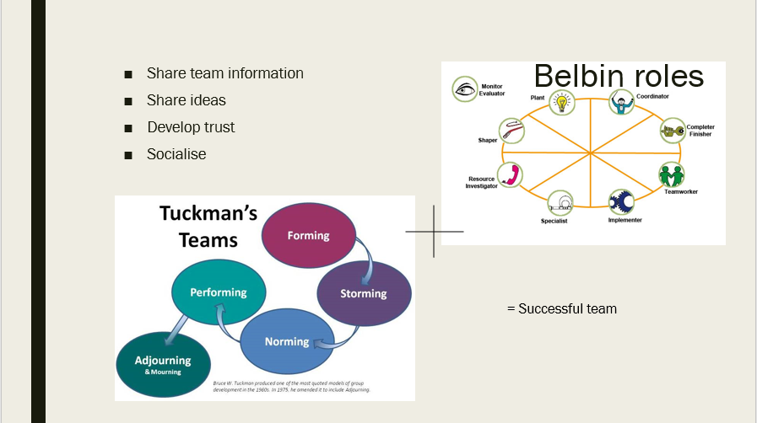
Share team information; make sure team members don’t find out important information which concerns them from a source different then their higher ups, as it builds massive mistrust and insecurity, which stop an individual’s development. An effective way to measure development here is to apply Belbin’s team roles theory and make sure team members are sticking to their roles strictly.
Share ideas; Innovation may seem unnecessary sometimes; however in the case of a developing team, it is vital in order for them to keep developing. In order for this to be facilitated, team leaders must instruct the members on how to communicate with each other, what their role is and how to put forward a new idea without upsetting the already established processes.
Develop trust; all of the above leads to a feeling of camaraderie, which ensures the development of the team, as members focus their entire mind capacity on the task in hand and not watching their back for any back-stabbing colleagues. The morality of the people on your team can be influenced, but are more of an initial recruitment problem.
Socialise; In order to maintain the trust in office, some people need to get to know their colleagues outside of their work environment in order to later, thrive in it. This is encouraged as long as it does not interfere with work communication.

Conclusion:
In conclusion we have shown you all the main theories relating to group dynamics, team working, communication and supplied examples of these in real life practice through the company Ignite Visibility.
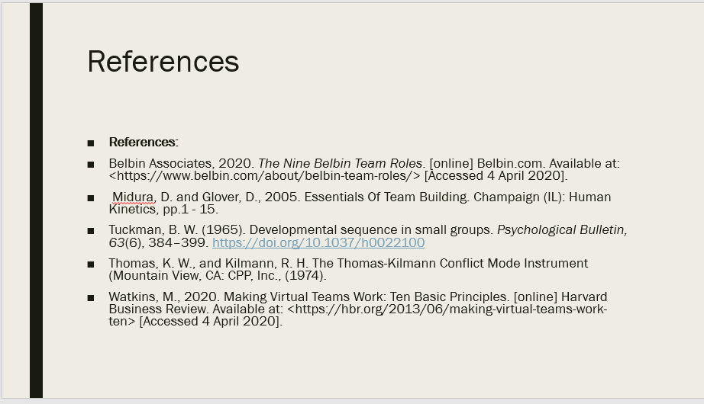

References:
Anonymous, E., 2020. I Worked At Ignite Visibility Full-Time For More Than 3 Years. [online] Glassdoor.co.uk. Available at: <https://www.glassdoor.co.uk/Reviews/Ignite-Visibility-Reviews-E928199.htm> [Accessed 15 April 2020].
Belbin Associates, 2020. The Nine Belbin Team Roles. [online] Belbin.com. Available at: <https://www.belbin.com/about/belbin-team-roles/> [Accessed 4 April 2020].
12manage (2020) WHAT ARE THE BELBIN TEAM ROLES? DESCRIPTION [Online] Available at: https://www.belbin.com/about/why-use-belbin/ (Accessed: 28 April 2020)
Belbin Associates (2020) The Nine Belbin Team Roles [Online] Available at: https://www.- belbin.com/about/belbin-team-roles/ (Accessed: 25 April 2020)
Belbin Associates (2020) Why Use Belbin Team Roles? [Online] Available at: https:// www.belbin.com/about/why-use-belbin/ (Accessed: 26 April 2020)

Belbin, M. (2003) Management Teams – Why They Succeed or Fail-Second Edition [On- line] Available at: https://www.businesscoaching.co.uk/files/belbin_team_role_theo- ries.pdf (Accessed: 26 April 2020)
Leitch, C. (2016). https://www.careeraddict.com
Lincoln, J., 2020. The 2019 Ignite 100: The Results Are In! - Ignite Visibility. [online] Ignite Visibility. Available at: <https://ignitevisibility.com/the-2019-ignite-100-the-results-are-in/> [Accessed 7 April 2020].
Lincoln, J., 2020. Best SEO & PPC Agency, Integrated Social, Email Services - Learn More. [online] Ignite Visibility. Available at: <https://ignitevisibility.com/> [Accessed 8 April 2020].
Midura, D. and Glover, D., 2005. Essentials Of Team Building. Champaign (IL): Human Kinetics, pp.1 - 15.
Moultrie, J. (2016) Belbin’s team roles [Online] Available at: https://www.ifm.eng.- cam.ac.uk/research/dmg/tools-and-techniques/belbins-team-roles/ (Accessed: 25 April 2020)
Tuckman, B. W. (1965). Developmental sequence in small groups. Psychological Bulletin, 63(6), 384–399. https://doi.org/10.1037/h0022100
Thomas, K. W., and Kilmann, R. H. The Thomas-Kilmann Conflict Mode Instrument (Mountain View, CA: CPP, Inc., (1974).
Watkins, M., 2020. Making Virtual Teams Work: Ten Basic Principles. [online] Harvard Business Review. Available at: <https://hbr.org/2013/06/making-virtual-teams-work-ten> [Accessed 4 April 2020].

