

Understanding And Engaging in The Customer Experience.
(BMSW5103_LON)
Organisation’s quality systems and customer relationship management

Ivanovitch Bumba Girao Paiva (1916038)
Nandish Patel
Table of Contents
Executive Summary 2
Introduction 3
1-Company Background and Problem 4
2-Models Evaluation 5
2.1- IDIC Model 6
2.2- The QCI Model 7
2.3- Payne’s Five Process Model 9
2.4- SEVQUAL 10
2.5- VCM 11
3-Model Selection 12
4-Model Application 13
5-Recommendation 15
6-Conclusion 16
7-References 17
Bibliography 17

Executive Summary

This report will underpin the basics understanding of CRM giving definition based on data and explaining the best model to use in various situation giving example with real problem that my company is facing and was facing with the covid-19 pandemic, providing solution addressing CRM models and analyse the benefits of it. I will present 3 or 4 model explain and analyse each of them, stablishing some difference between them and show why we can nor apply all model in CRM and select the best that can fit to my problem providing the reason and from there on applying critically and leaving my recommendation and conclusion.

Introduction

This report will cover the strategy of CRM in how It can improve the experience and engagement of customers facing the pandemic situation, explaining how the organization is dealing with the internal and external factors and how they are dealing and preparing with upcoming situations, I will apply and discussing within my workplace reality giving real examples and situations that I faced during the time.
Gail’s Bakery will be the organization that I will underpin in this report because I current work for this organization for 3 years now, and the data that I will provide will be more realistic because I am familiar with the system and the customer values. Gail’s bakery is an organization based in retail service located in London with the vision to expand all around England with current 70 shops open now the mission is to provide the best coffees and ready to eat food for all local neighbourhood selling also the artisan breads, there will be a discussion in how CRM can be applied in my organization helping identifying the current system and explaining the theories based in real situations in my workplace, definition will be provide based in my point of view. CRM is the customer relationship management that helps transform customer to loyal customer to increase quality of service and sales, along with the models and process that I will underpin in this report explaining the benefits that can result of applying the models, explaining each of the models assessing critically in my workplace context.
I will present my workplace problem and discussing briefly how did I identify, and why is important to follow the process of CRM to find the best ways to solve the problem, the models will be compared and reviewed to find which is the best to use in different situation, from this point I will apply the model that suit to my situation and explain step by step the outcomes leaving recommendations and conclusion.

Company Background and Problem

Gail’s Bakery was founded by Tom Molnar and his business partner Ryan Avidan in 2005 after the meeting with Gail Mejia the founder of the bread factory, she was struggling financially the sustain the business and Tom Molnar seeing the opportunity to enter in the bread market offered the help to buy it. Tom Molnar was aware that it was a gap in the bread market to bring high quality breads, and he had the vision to start open bakeries in local neighbourhoods so that everyone could have access to breads early in the morning, but it results in a high demand, so he needed to implement more products transforming the company in Bakery and Coffee shop. They choose Gail’s as a name in honour of Gail Mejia the founder of the bread factory that they bought, opening the first store in Hampstead selling breads, coffees, and ready to eat products. Now Gail’s have more than 75 stores in London with the mission to expand more all over UK and became the best bakery.
The pandemic of covid-19 the company was considered as essential shop, that means that the stores could remain open during the crisis, facing a lot of difficulties the CRM of the company was operational, but they changed to strategic to focus more on the customers and create relationship, the goal was to engage with profitable customers and have a comprehensive view. With less competitors on the market because most of them were closed the demand in the company was very high increasing the sales to 20% making the company increase the products to create more options for the customers satisfaction but the problem is that they could not separate the profitable customers from the unprofitable creating problem with the loyalty from the customers. The CRM system that controls and keeps the customer satisfaction, retention and information was not executed properly leading to problems with product oriented and sales oriented, because of the high demand, the company was only focusing in increasing the products and price without knowing what the customer want and need the marketeers did not conduct the customer research properly and with the shortage of supplier they could not do the products with the right quality, so they kept like this with the same price, leading to the customer not trusting the honesty and competence of the company they did not act in the interest of the customer.
With the end of restrictions everything started to open, and we were noticing the sales decreasing finding out that we as a company could not keep the profitable costumers establishing the problem as a customer loyalty.
Analysing the data of the customer’s need the service was following goods standards, with covid-19 crisis people wanted to feel secure leading the company studying ways for the best interactions to solve this problem analysing and exploring the company implemented an online website where they could see the new products, and interact if they need to send suggestions and complain helping the company creating customer profile to start creating database for improve the marketing and the customer satisfaction.
The change of the marketing team we could notice some improvement they started figure it out how they could meet the customer satisfaction during and after the covid-19 crisis, this critical thinking was leading them solving this problem in the long term exploring the customer expectations, costumers wanted to feel safe in the crisis and after the crisis with the costumer so they implemented online orders and Deliveroo with the costumer profile we could separate the service from those that could feeling safe in the store and those who wanted just to order online. Becoming customer centric improved a lot the relationship with the customers the strategic CRM set the value of follow the mission and vision focussing on the customers.

Models Evaluation

CRM is the establishment of the relationship between the business and customer that helps understand the difference between what they need and what they want to satisfy and value the costumer behaviour to create profit. (Buttle, 2008)
Customer is the foundation of the company effective sales, marketing and service and they are target through the web mining that is focused on the customer characteristic, occupation position, education, and salary and through that companies can divide the types of costumers, (profitable and unprofitable) and can also find out information of interest and habit that will help them direct to the right product and service that is why certain models are not suitable to CRM problem solving.
CRM is used as system to understand the comprehensive view of the customers and create strategy to target them, based on the data retention that allows the marketing department to be aware of the behaviour, values, and beliefs to provide the best service and product and approach the management to the costumer connection and to use model for predictions. (Lei Zhang, 2013)

2.1- IDIC Model

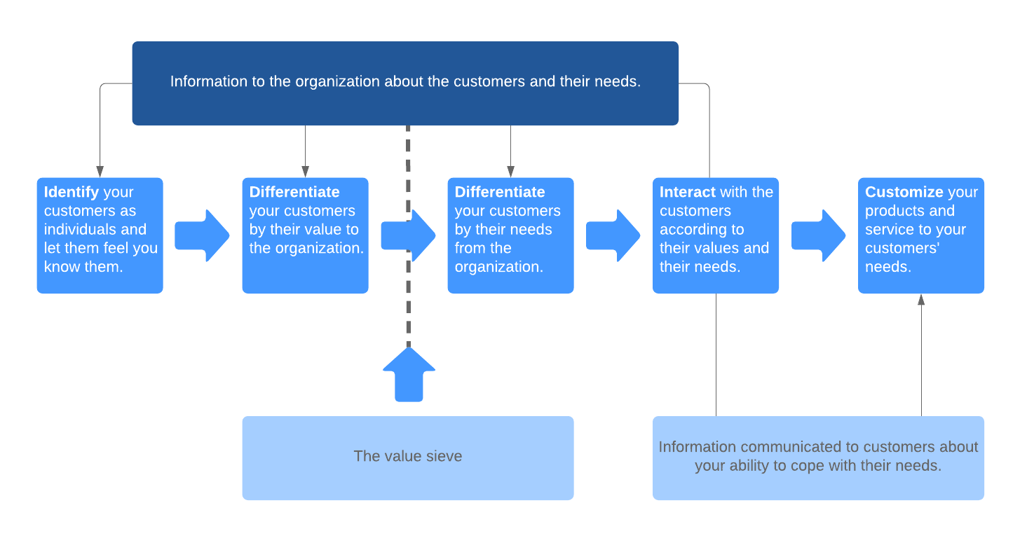
(Team, 2019)

IDIC is a model created for implementing CRM in various situation to identify, stablish the difference, and create relation and customize, this model follows four stages. (Team, 2019)

- Identify

This step is to deep study your customer target collecting all data needed to learn their beliefs, attitude, and behaviour. The objective in this step is to figure it out with the help of the data collection what the customers wants, what they need and what will make them buy the products.

- Differentiate

This step is to set which customer have more value for the company, because not every customer will spend a lot of money in the company, is to help differentiate the profitable from the unprofitable customer. This difference will help the company understand who needs to be prioritize and increase the interaction to stablish the relationship.

- Interact

This step is knowing as the apply stage because here after you understand your customers and categorized them is the time to apply the CRM to meet the customer expectations. The objective in this stage is ensure that the company retain the customer encouraging them to keep spending.

- Customize

This step is to meet customer needs and expectations, is here where you put all the data that you collected and analyse everything to satisfy your customer target, the objective is to make sure that interaction is appropriated and that they are happy with the expectation and needs

2.2- The QCI Model

QCI model or quality competitive index was created with the objective to put people and technologies together is known as a customer relationship model that the focus is acquisition, retention, penetration to give importance to impulse buyers.
This model is to understand if the customer is ready to buy studying their external environment, the suggestion is that if you know what the customer influence are you can make them buy making him talk with the sales advisor to affect his preposition and retain offering what they expect, they believe that technology is important but the interaction between people is crucial, this model helps to analyse the current strategy and create new approaching to improve the customer management process.

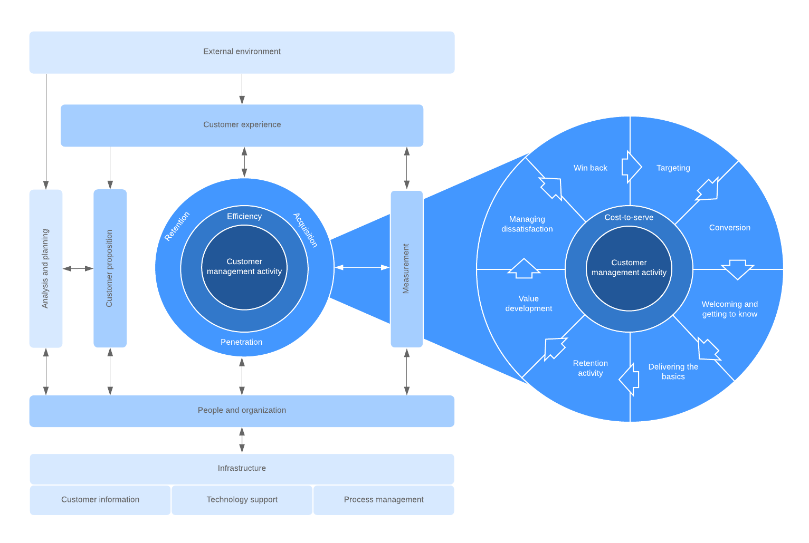
(Team, 2019)
This model was developed with 8 stages:

1-Analyse and Plan that is the stage that you evaluate the customer behaviour and start to plan the value of the company, based in the customer management activities for engagement for efficiency, penetration, and acquisition.

2-Proposition is the process to lead an effective plan to attract new customers evaluating their needs and expectations to enhance the customer experience and engagement strategies.

3-Information and technology is the database that helps to deliver critical customer information to the company, and this information is constantly updated to make the management of customer and people efficiency.

4-People and Companies this is the process of maintenance that needs to be done between the customers and the organization based in feedback queries and concerns providing training task segregation and role identification.

5-process Management is the marketing, sales, and customer support according with this model is important to provide management support to the customers.

6-Customer Management Activities is the stage of acquisition, retention, and penetration, it includes targeting customer to be aware of their needs to meet the expectations of product and service, also understand the customer through the collection of information to create the best customer base helping customers connecting with the business objective this can be done through value development.

7-Mesuaring the effects is the assessment to make sure that the improvement is increasing it also helps understanding in which level of performance the company is and create roles for the best customer management success.

8-Customer Experience this process is to stablish the connection with the customer giving the appropriate interaction and customer management and believes that external environment impacts the customer experience understanding that this impact can be negative for various reasons by applying the CRM process.

2.3- Payne’s Five Process Model

This model was invented by Adrian Payne and Pennie Frow, to help increase the customer relationship management this model is a process to build and keep relationship with customers. (Shruti Thakur, 2019)
Payne and Frow developed five processes:
- Strategy to develop
- Values process
- Various channels for Unification process
- Assessment of production process
- Information process in CRM

The objective of this process is to increase the efficiency of the CRM implementation, the strategy development process is to help understand two parts first the business strategy and the second customer strategy the purpose of this is to understand that they are related but analysing different aspect, the business strategy is focus on which interaction is appropriate to offer which relationship is worth to maintain for the business and the customer strategy that is to understand what are they expecting and what they in service and products. The objective of this process is to identify the choice of the customer for develop efficiency in products and service and take different future actions for the customer needs.
The values process is to identify the value of the customer because the company needs to see which customer is value and vice-versa evaluating through the process of value preposition. To create an effective value assessment, you need to obey 3 steps, first know which process can create a value for the customer, second identify which customer can bring value for the organization, third study ways how to increase values in customers that the company desire. (Abdul-Muhmin, 2012)
The channel for unification process is the collection of data that will help the company make decision converting the insights into real attitude to understand the customer perspective and keep them for more years, this process helps the company make sure that the customer experience is positive to help in the CRM implementation.
Assessment process is important because it helps understand how the value proposition of the business is going looking at the customer interest conducting the best business performance, this process is also included customer monitoring and satisfaction and performance indicators.
Information process in CRM is the part of the model that suggest how to collect, organize, and use the information related with the customer to understand the consumer behaviour it also helps the company create the right marketing and increase the value preposition.

2.4- SEVQUAL

Sevqual is a tool that helps prevent the customer needs providing the quality service that they are expecting, this model was developed by American authors Parasuraman, Valarie Zeithaml and Len Berry with the purpose to measure the quality of the service and find predictably which problem is affecting the quality of the service. They reached the conclusion that using 5 stages they could find and fix the main problems of the service quality

1-Reliability this dimension is to make sure that the company can ensure that they will do what they promise to do and provide de service that they promise to provide.
2-Assurance is the stage that you have the right person performing the right role, because the efficiency of the employee will bring more confidence to the customer reflecting the right behaviour.
3-Tangibles this dimension is to make sure that you have the right tools to provide each task, such as equipment you cannot promise to do a good cleaning if you don’t have the right products and equipment, so this stage will assure you to be more realistic.
4-Empathy is the dimension to understand what the customers is feeling and act accordantly, starting to question themselves how I would like to be treated if me in this situation was.
5-Responssiveness this stage is very important to understand that customers are assets for the company ensuring that employees will be there to assist them when they need, showing responsibility in their performance. (Peter Hernon, 2010)
The developers of this model in 1988 they got the conclusion that they could transform this model to be more efficient adding more dimensions such as
6-Competence is the skills to execute the right role or task with wisdom knowing the purpose of what you are doing.
7-Courtesy is the exchange of money for the service and depending on what the company is offering which service is available to offer customer will pay to be treated with respect, politeness.
8-Security this dimension is to help you understand that more secure your business is more loyal customer you will have because people like the feel far from the danger.
9-Acess customers like to be aware of everything the company needs to have channel of communication to help keep them informed.
10-Communication is the necessity to find the appropriate way to make all the customers understand all information like changing language or having more idiom making sure that the online service is accessible for everyone and understandable.
Sevqual is the right tool to use when you want to find gaps on the service that you provide because this model was also developed for this reason find gaps to understand where the problem is coming from, and normally is coming from the knowledge that the employees has, not following the standards that the company provided, the fact of the language be a barrier and bringing lack of communication and not deliver the right intentions to them normally the beliefs plays a big part. (Peter Hernon, 2010)

2.5- VCM

Value Chain Management was developed by Michael Porter in 1985 with the purpose to establish the relationship between customer and the company to identify what could be changed to create more value. VCM can give strategy to maximize customer value development and find relevant activities that can identify competitive advantages to execute these activities better and with low prices than the competitors.
Value chain is the management process that control all the activities to satisfy the customer and the stakeholders involved making the service easier helping identifying solutions quicker. The requirement of VCM is to identify customer values, the key success factors, and create competitive advantage.
Michael porter divided these activities in two parts

Primary that the way they analyse their customer portfolio is similar as IDIC model, the analyse stage is to help the company understand their customer so they can predict customer needs and expectations and find ways to keep the relationship for more years. Create relationship with the customer to collect data to help dealing and provide the right service and product to retain their trust for long term, network development to optimize the customer experience informing each network system section the objective is to work together. With this information will facilitate to target customers that is the value proposition that the goal is focussing on the product and service and reduce cost, managing this lifecycle will help the company evaluate the business process and create a solid structure to retain customers.

Secondary is a supporting stage that is crucial if you want to implement all primary process strategy, leadership and culture, Human resources, information, and technology (IT) organization design.

Model Selection

Selecting this model I evaluated how it could solve the problem in my company in order to bring more benefit and long term solutions, my company problem is the loyalty of the customers that means to solve this problem I need to select a model that is more focus on customer relationship having in consideration the type of my company, VCM is more appropriated In order of this problem because all the process is to retain the customer meeting their needs and expectations the fact that is divide in two stages will bring more organizational structure to the company as well the supporting stage that will help implement the primary stage is essential will bring long term solutions.
Customer portfolio, customer intimacy, relationship management these three primary stages will help solve the problem with more efficiency because with the customer portfolio you can understand their beliefs attitudes and behaviour once you have all those data you can start creating customer intimacy collecting data and provide the service accordingly to the customer and the support stage will integrate IT data management to help with this process.
VCM has the objective to develop service and product for the customer, to create a closer relationship and is what I’m looking for solve this problem and maintain the customer loyalty.

Model Application

Model: VCM
Problem: Customer Loyalty

The pandemic changed a lot of strategy in my company and with that we could see a lot of gaps we could find out that the relationship with our customer was short term because when the government announced the end of the restriction more stores started to open and we noticed that we lost some customers most of them profitable customers, if we could implement the VCM model to solve this problem we could apply the first stage:

- Customer portfolios analyse, this stage is to understand each customer that we have, helping with the separation of the ones that like the service and product and the one that were using the company because of the restriction that could help us prevent increase the ordering and forecast or analyse ways to retain them improving our service to meet their expectations. This stage was made for that to help companies understand their costumers and meet their needs and prioritizing this could save my company to lose a lot of customers.
- Customer intimacy, nowadays customers want to feel comfortable with the service to get to the store and buy the usual products but creating some intimacy allowing them to talk would help improve a lot the loyalty because they will feel free to talk about their suggestions and engaging with them would be perfect to know and create information collecting important data because better you know them you will adjust your product and service accordantly, with the support stage VCM has leadership and culture and providing this training the team members it would bring benefits such as how to perform with the customers to retain their trust for long term.
- Network Development, is very important that all department works together and with the same vision, sharing the information and work towards the same goal, the human resource department needs to know about the IT database to be aware about the customer behaviour beliefs and attitudes so they can provide activities that will meet their needs and with covid-19 if the network were efficient they could optimize the customer experience providing safety in the way that they expect.
- Value preposition development, save money with products that the customers don’t need to reduce the expenses because with all information we knew it already what they were looking for and organizing everything we could put on the menu just the demand products helping us with the suppliers and maintain the quality and avoid increase the prices, because of the external factors was difficult to get all the products from the suppliers and the company could avoid this.
- Relationship management, with all information in place providing the right service now is the stage to control the customer lifecycle understand what they expect, what they usually buy every day to improve the organizational structure to keep the customers satisfaction.

The second stage is the support stage, the departments that will help implement the primary stage such as IT department Human resource organization design, those departments will ensure that the company follows the steps they have an extreme importance.

5-Recommendation

Models are essential for the business and to apply the CRM, is very crucial to be aware about the challenges and principally find the real problem, just when you identify the problem you can start finding the solutions choosing the best suitable model for your organization size and type, understand the stages follow the stapes looking to the reality of your problem identify which CRM your company is using and implement always in the realistic way. Provide training, provide changes to make change make it simple but not so simple.

Conclusion

This report is structured in the way that the reader will understand my thoughts the overview is to make sure that the benefits of understand customer relationship management is important, I talked about my company in the pandemic situation and after I presented the problem that we were facing over that time, identifying the CRM and finding the problem, I started to talk about the models explaining each of them and select the best to solve my company problem, giving explanation step by step and critically analysing the challenge and benefits I left my recommendation and my conclusion is that for the business is important to apply CRM and the appropriate model customers are assets for the company is important to study and understand their needs and expectations to maintain their loyalty and value the business.

References

Bibliography
Abdul-Muhmin, A. G., 2012. CRM technology use and implementation benefits in an emerging market. Journal of Database Marketing & Customer Strategy Management, 82-97(19), pp. 50-62.
Buttle, F., 2008. Customer relationship management: concepts and technologies. 2nd Edition ed. s.l.:Butterworth-Heinemann.
Lei Zhang, Y. G., 2013. Information System and Cumputing Technology. 1st Edition ed. Chennai: CRC Press/ Balkema.
Peter Hernon, E. A., 2010. Assessing Service Quality. 2nd Edition ed. Chicago: American Library Association .
Shruti Thakur, P. C., 2019. Project Guru. [Online]
Available at: https://www.projectguru.in/paynes-five-process-model-crm-strategy/
[Accessed 01 September 2021].
Team, L. C., 2019. Lucidchart. [Online]
Available at: https://www.lucidchart.com/blog/crm-models
[Accessed 26 August 2021].

