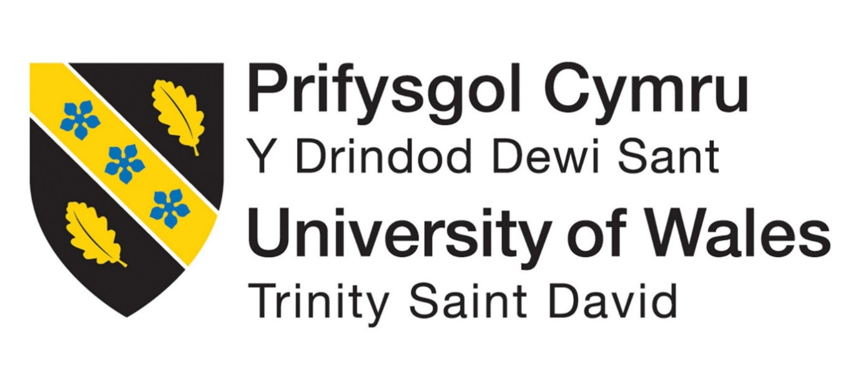

Student Name : ANKITABEN SHAILESHKUMAR THAKOR

Student Id : 2541590

Master of Business Administration (MBA)

Module Name : Human Capital management

Module code : LCMB7023

Table of Contents
Introduction 3
Task A: Socialisation, Identity and Business Activism 3
1. Traditional Onboarding versus Strategic Organisational Socialisation 3
2. Structured Socialisation Framework for Helios Urban Mobility 4
Pre-Boarding Stage 5
First 90 Days 5
Year One Development 5
3. Developing Organisational Identification, Ethical Professionalism and Business Activism 6
Organisational Identification 6
Ethical Professionalism 6
Business Activist Mindset 6
Task B: Innovative Job Design Strategy 7
1. Innovative Job Design for Helios Urban Mobility 7
Job Characteristics Model 7
Job Crafting Theory 8
Skills-Based Architecture and Internal Talent Marketplace 8
2. Stimulating Intrinsic Motivation and Supporting Innovation 9
Task C: Reflective Report 10
1. Responsible Use of AI in Decision-Making 10
2. Personal Capability Development Plan 10
Conclusion 11

List of figures
Figure 1: Strategic Organisational Framework for Helios Urban Mobility 4

Introduction
The human capital architecture is crucial in helping organisations to orient their workforce, culture and talent management practices towards their long-term strategic goals (Shaikh, 2022). In knowledge-intensive organisations that are in fast-paced industries, management of human capital requirements is necessary to enhance employee engagement, innovation, as well as organisational performance. With its rapid expansion, but an immense workforce issue of ineffective organisational socialisation, decreased employee engagement and high turnover of high-potential graduates, Helios Urban Mobility (HUM) is a European smart-transport start-up focused on AI-enabled smart mobility systems and smart infrastructure analytics.

Task A: Socialisation, Identity and Business Activism

1. Traditional Onboarding versus Strategic Organisational Socialisation
While the induction process is effective in getting policies and compliance requirements across in an efficient manner, the transactional nature of it tends to have limited psychological engagement (Mitrofanova, 2023). The other challenge for rapidly growing organisations is the need for more commitment and resources from the management team to implement structured socialisation. Thus, socialisation strategically is a favourable approach for Helios because the benefits of implementing socialisation are greater than its costs.
On the contrary, strategic organisational socialisation refers to a long process, which helps employees to transform into organisational members. The socialisation theory by Van Maanen and Schein focuses on the relevance of organised organisational practices which influence employee attitudes, employee behaviours and expectations (Saks, Uggerslev and Fassina, 2007). Their model indicates that uncertainty may be minimised and adaptation speeded up by collective, formal and sequential tactics of socialisation, especially in organisations that are fast-growing like Helios.
According to Rousseau (1995), the psychological contract Theory also emphasises the significance of managing employees' expectations. Employees are hired in organisations with preconceived notions about career and career building in terms of support and recognition. With such expectations met, commitment and engagement are boosted. Violation of the psychological contract, though, may lead to discontentment and turnover. The fact that the number of graduate employees at Helios has a high rate of attrition could result in the company not meeting its expectations of employees in terms of career development and organisational facilitation.
Identity Construction Theory states that the interaction between employees and organisational members and experiences helps employees to create their professional identity. Through strategic socialisation, people can identify with the organisational values by aligning their personal values, thus forming stronger organisational identification.

2. Structured Socialisation Framework for Helios Urban Mobility
Helios needs to adopt a three-phase strategic socialisation model to maximise the employee ramp-up time and enhance involvement and reinforcement.
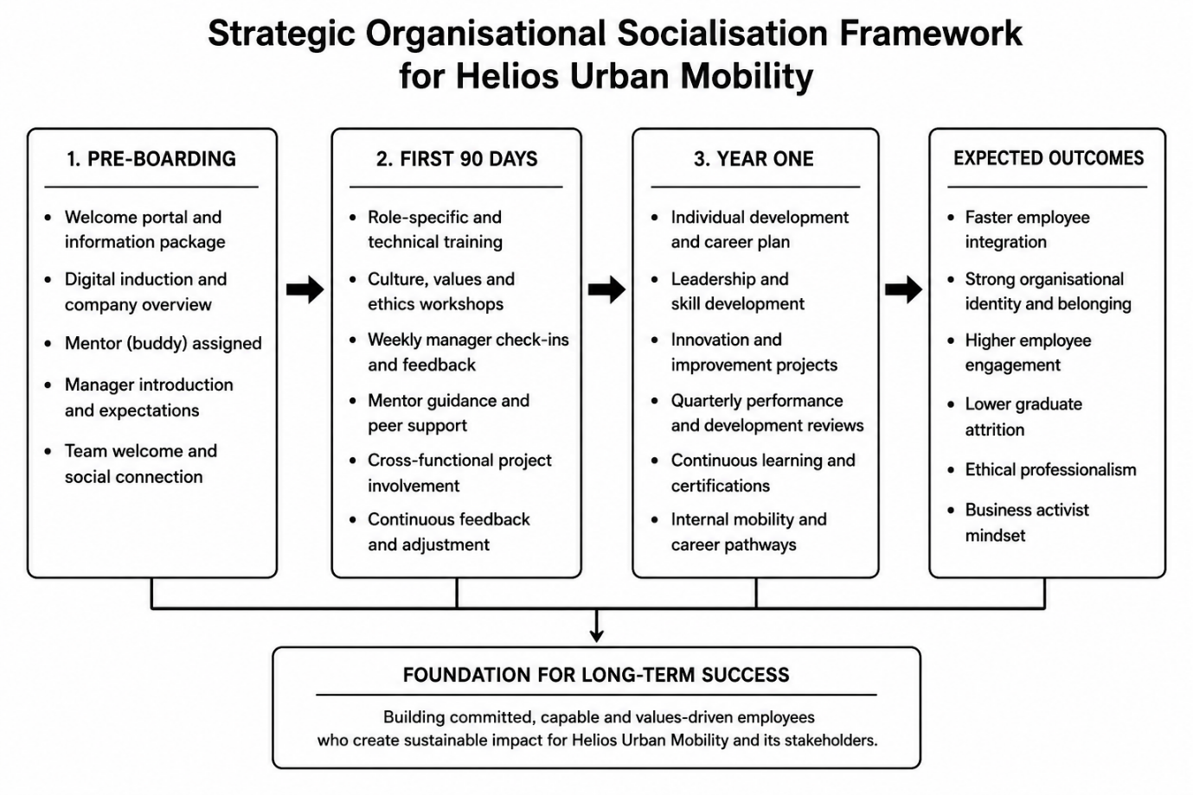
Figure 1: Strategic Organisational Framework for Helios Urban Mobility
Source: Self-created

Pre-Boarding Stage
The process of socialisation should commence prior to employees being enlisted to join the organisation (Pečiūra, 2024). This information should be made available to the new hires by providing them with access to a digital onboarding platform with information on the mission, culture, sustainability goals and strategic priorities of Helios. The manager should personally welcome each employee by assigning a mentor and providing a personalised welcome package. It is also possible to reduce anxiety by a virtual introduction of the team members and achieve an early relationship.
This phase helps to form the psychological contract and manifest the organisational commitment and formation of positive expectations before the employment is started.

First 90 Days
The initial three months are to be devoted to role integration, immersion into the culture and the support of culture and performance. This is because, together with mentoring techniques, structured technical training during the initial 90 days is likely to help boost productivity and confidence of the graduate recruits, while Helios' ramp-up period requires 8 months on average. Guidance, feedback and reflection should be offered by holding weekly meetings with managers and mentors.
The use of cross- functional project involvement should also be implemented to enable the employees to learn the role played by various departments towards organisational goals (Ahmad, Boit and Aakula, 2023). This will foster quicker learning and an improved organisational bond and minimise the long eight-month adjustment period people have experienced in Helios.

Year One Development
The first year is the time when employees are to switch to long-term development. Each person has to have individual career plans, which you reinforce with continuous learning opportunities, workshops on leadership development and implementation, and innovation projects. The development reviews should be conducted quarterly and assess their progress, involvement and career goals.
This level strengthens organisational commitment through showing commitment to employee growth as well as providing them with clear career development. These programs are especially vital towards keeping the high potential graduates in the organisation who may want to gain development prospects and meaningful career advancement.

3. Developing Organisational Identification, Ethical Professionalism and Business Activism

Organisational Identification
Organisational identification arises when the employees feel to be a part of the organisation, and they identify their own success with the success of the organisation (Aitken and von Treuer, 2021). The strength that Helios can create to build identity is to communicate its intentions in a way that can create sustainable urban mobility solutions that enhance city infrastructures and environmental outcomes.
The shared sense of belonging can be further strengthened by recognition programmes, joint working projects and constant communication of senior leaders. There are higher chances that employees who know how their input contributes to greater organisational goals are committed and engaged.

Ethical Professionalism
Being an organisation within the sphere of AI-enabled transportation systems, Helios should ensure encouragement of high ethical standards. Ethical professionalism may be cultivated with the assistance of obligatory training in ethics, responsible AI governance policies, and open-minded decision-making (Passlack, Hammerschmidt and Posegga, 2025). Workers are to reflect on the social impact of their work and the professional standards that are set.
Making ethical values a part of the recruitment process, performance management, and leadership development processes will help ensure that ethical behaviour becomes organisational culture and not an isolated compliance activity.

Business Activist Mindset
The development of the HR Business Partner role by Ulrich implies that employees should no longer be focused on operations and instead be strategic players who develop value that is highly valued by various stakeholders. As a stakeholder capitalism, organisations have to strike a balance between employees', customers', government, community and investors' interests.
Helios would build a business activist attitude by engaging the employees in sustainability programs, forums of innovation and strategic decision-making discussions. By enabling employees to contribute towards organisational and societal achievement, Helios will be in a position to pool together a workforce that is not only motivated, but also determined to influence positive change and the ultimate organisational success.

Task B: Innovative Job Design Strategy

1. Innovative Job Design for Helios Urban Mobility
In response to the waning employee engagement levels, the high level of graduate turnover, as well as the necessity of seeking constant innovation, Helios Urban Mobility needs to utilise a combination of the Job Characteristics Model (JCM), Job Crafting Theory, and Skills-Based Architecture with the use of an Internal Talent Marketplace. This method will help workers advance a variety of skills instead of adhering to a fixed job description so that they can work in meaningful context and adjust to the highly changing AI-enabled mobility sector.

Job Characteristics Model
According to Sashkin (1982), the Job Characteristics Model (Hackman and Oldham) suggests that five fundamental dimensions of a job, namely, skill variety, task identity, task significance, autonomy and feedback, are what affect the intrinsic motivation as well as work performance of employees.
The employees at Helios would be advised to take up multidisciplinary projects in which software development is integrated with analytics and smart mobility solutions using AI, which would help in enhancing their level of skills (Cotič et al., 2025). Task identity can be enhanced by enabling employees to work through a complete project life cycle, from the development of a concept to the implementation, so that they can realise the effect of their efforts. It is necessary to communicate the task significance by stating how AI-enabled systems of transport will enhance the sustainability of cities, human safety and quality of life.
It should also be given more autonomy by letting the employees decide on their project, time allocation and resolve technical issues on their own. Ongoing learning and professional growth should be done through regular performance discussions, mentoring sessions and real-time feedback about the project. All these job characteristics added up to provide more meaningful work experiences as well as mind ownership, accountability and long-term engagement.

Job Crafting Theory
Job Crafting Theory identifies employees as key contributors in determining their work experiences instead of subjects receiving job roles as pre-established jobs (Katlego, 2024). To achieve enhanced satisfaction and better performance, employees adjust the colouring of their work, the relationships and their attitudes towards work.
Helios needs to promote task designing by giving employees chances to engage in innovation initiatives other than their core functions. The cross-functional teamwork between the engineering, data science, human resources and customer engagement departments can be encouraged to foster relationship crafting. The cognitive crafting may be realised through making employees understand their contribution to sustainable urban mobility and environmental responsibility.
An employee empowered with the ability to make parts of his or her work personal enhances psychological ownership and flexibility in the workplace whilst allowing creativity.

Skills-Based Architecture and Internal Talent Marketplace
With the high rate of technological change, career development within organisations and the flexibility of the organisational structure might be limited by traditional role-based career structures (Mollet and Kaudela-Baum, 2022). Helios should thus apply a skills-based architecture that is backed by a talent marketplace within the company.
Projects rather than employees should be assigned based on available job titles; projects should be assigned based on confirmed skills, competencies and career aspirations. They would be digital in nature, and employees would have digital skills profiles that determine technical expertise, leadership and emerging competencies. Managers could then pair employees with one-off innovation initiatives, overseas assignments or cross-functional initiatives that demand certain skills.
This system helps in continuous learning and allows employees to experience new things without having to get out of the organisation. It is also known to give high-potential graduates visible career development opportunities and lessens the chances of voluntary turnover and enhance internal talent retention.

2. Stimulating Intrinsic Motivation and Supporting Innovation
The suggested integrated job design approach positively impacts intrinsic motivation directly by addressing the psychological factors of competence, autonomy and meaningful contribution of employees. The Job Characteristics Model provides an appealing job that involves higher responsibility, diversity of work and positive feedback. Job Crafting Theory gives employees the ability to create their working experiences, which brings more sense of ownership as well as commitment (Kardas, 2023). In the meantime, the skills-based architecture allows employees to learn and take a career path according to their unique capabilities and desires.
More collaboration and knowledge sharing also enhance innovation. The cross-functional projects facilitate cross-functional exposure and promote creativity in problem-solving and transfer of technical knowledge throughout all departments. The internal talent marketplace allows quick mobilisation of specialised work to strategic projects, enhancing the responsiveness of organisations in the highly competitive AI and smart mobility space.
In the case of Helios, with this as a combination strategy, the main concern now is that the organisation will be solving its current problems in the sense that the workers will be less likely to lack motivation to work at the time and this will also mean that it will be able to retain talents among graduates in the workforce and it will also enhance a culture of innovation in the organisation. Instead of looking at jobs as pre-determined posts, employees can be moulded as versatile participants, and their skills can change in tandem with the requirements of organisations (Malik et al., 2025). The suggested job design strategy therefore not only contributes to the well-being of employees but also to their long-term organisational performance, which places Helios in a well-placed position to maintain its competitive edge in an ever-changing, techno-driven competitive environment.

Task C: Reflective Report

1. Responsible Use of AI in Decision-Making
As a future human resource expert, I am aware of the possibility of artificial intelligence (AI) enhancing organisational decision-making by processing vast amounts of data about the workforce, uncovering patterns and providing evidence-based HR activities. I will not rely on AI to substitute human judgement but as a decision-support tool. To give another example, AI can be used to help analyse employee engagement surveys, forecast turnover risks and learning and development requirements. Nonetheless, hiring, promotion, performance management and employee relations decisions should be left to the tasks of the HR practitioners because such decisions demand ethical justifications, feeling and situational insights.
I am also aware of the dangers of overtrusting AI and the existence of algorithmic bias, data leaks and the risk of overlooking individual situations. Thus, I will be critical towards AI-generated suggestions, confirm them in numerous sources of evidence and make their decisions transparent, just and in accordance with the organisational values. Having AI capabilities available coupled with critical thinking and professional judgement, I will be able to aid in effective and ethical human resource management.

2. Personal Capability Development Plan
I will continuously upgrade my knowledge and skills necessary to practice strategic HR to make me more employable in the future. First, I will prepare my data literacy by enhancing my skills in data analysis of the workforce, as well as the skills to interpret HR metrics and use data visualisation tools to make managerial decisions. These abilities will empower me to work on an evidence-based organisational approach.
Second, I will become skilled in the field of AI augmentation in HR by studying how I will be able to use emerging technologies to enhance recruitment, talent management, workforce planning and employee development through ethical practices. My secondary goal is also to enhance my influencing skills through better communication, negotiation and stakeholder management capabilities to come out as an evidence-based recommendation maker to the top management.
Lastly, I will become more aware of global mobility through the knowledge of international employment practices, trends in cross-cultural management and global labour markets. These competencies will enable me to deal with various workforces as organisations continue to cross national boundaries (Steers, Osland and Szkudlarek, 2024). I will be a strategic human resource professional who can integrate technological innovation and reasonable human judgment to promote sustainable organisational success through constant professional growth, training in the industry and life-long learning.

Conclusion
In this report, a strategic human capital architecture was suggested to deal with organisational challenges in Helios Urban Mobility. It showed the effectiveness of an organised socialisation system in enhancing the integration of employees, organisational commitment and retention. Moreover, an innovative approach to job design, based on using a combination of the Job Characteristics Model, Job Creation Theory and a skills-based architecture, was suggested to become more motivated, engaged, and innovative. Overall, the proposed human capital architecture will enable Helios to implement an integrated strategy to boost employee integration, engagement and retention, while promoting innovation and ethical leadership. The recommendations would enhance organisational resilience and contribute to sustainable competitive advantage in the fast-changing smart mobility industry.

Reference list
Ahmad, T., Boit, J. and Aakula, A. (2023). The Role of Cross-Functional Collaboration in Digital Transformation. [online] Available at: https://www.researchgate.net/profile/Tanzeem-Ahmad-3/publication/389744145_The_Role_of_Cross-Functional_Collaboration_in_Digital_Transformation/links/67d098b3d7597000650803c2/The-Role-of-Cross-Functional-Collaboration-in-Digital-Transformation.pdf.
Aitken, K. and von Treuer, K. (2021). Leadership behaviours that foster organisational identification during change. Journal of Organizational Change Management, [online] 34(2), pp.311–326. Available at: https://www.emerald.com/jocm/article/34/2/311/249696.
Cotič, L.P., Man, M.M.K., Soga, L.R., Konstantopoulou, A. and Lodorfos, G. (2025). Job Characteristics for Work Engagement: Autonomy, Feedback, Skill Variety, Task Identity, and Task Significance. Global Business and Organizational Excellence. [online] Available at: https://onlinelibrary.wiley.com/doi/pdf/10.1002/joe.22295.
Kardas, J.S. (2023). Job Crafting and Work–Life Balance in a Mature Organization. Sustainability, [online] 15(22), p.16089. Available at: https://www.mdpi.com/2071-1050/15/22/16089.
Katlego., L. (2024). Investigating the Interplay Between Job Crafting, Work Role Performance, and Job Satisfaction - ProQuest. [online] Proquest.com. Available at: https://search.proquest.com/openview/b57e2cbba4106a48eb9b49ae2b0cbd68/1?pq-origsite=gscholar&cbl=2026366&diss=y.
Malik, A., Wankhade, P., Patnaik, S. and Budhwar, P. (2025). Renegotiating HRM Practices and Delivering Service Transformation of Frontline Workers: Insights From the UK’s NHS Ambulance Trust During a Significant Disruption. Human Resource Management. [online] Available at: https://onlinelibrary.wiley.com/doi/pdf/10.1002/hrm.70001.
Mitrofanova, E. (2023). Value in Onboarding: Designing the New Employee Onboarding Procedure for Hybrid Working Environment. [online] Available at: https://www.theseus.fi/bitstream/handle/10024/812305/Mitrofanova_Elena.pdf?sequence=2.
Mollet, L.S. and Kaudela-Baum, S. (2022). Critical HR capabilities in agile organisations a cross-case analysis in swiss SMEs. Review of Managerial Science, [online] 17. Available at: https://link.springer.com/content/pdf/10.1007/s11846-022-00570-4.pdf.
Passlack, N., Hammerschmidt, T. and Posegga, O. (2025). With Great Power Comes Great Responsibility: What Shapes AI Literacy for Responsible Interactions of Knowledge Workers With AI? Information Systems Frontiers. [online] Available at: https://link.springer.com/content/pdf/10.1007/s10796-025-10648-5.pdf.
Pečiūra, Ž. (2024). Post-entry Experiences of Newcomers Through the Perspective of Gamification: The Relationship Between Socialization Context and Socialization Outcomes. [online] Available at: https://epublications.vu.lt/object/elaba:199536912/199536912.pdf.
Rousseau, D. (1995). Psychological Contracts in Organizations. [online] Available at: http://books.google.co.in/books/about/Psychological_Contracts_in_Organizations.html?id=-ZU5DQAAQBAJ&redir_esc=y.
Saks, A.M., Uggerslev, K.L. and Fassina, N.E. (2007). Socialization tactics and newcomer adjustment: A meta-analytic review and test of a model. Journal of Vocational Behavior, [online] 70(3), pp.413–446. Available at: https://www.sciencedirect.com/science/article/abs/pii/S0001879106001205.
Sashkin, M. (1982). WORK REDESIGN J. R. Hackman and G. R. Oldham Reading, MA: Addison-Wesley, 1980, xxvii + 330 pp. Group & Organization Studies, [online] 7(1), pp.121–124. Available at: https://journals.sagepub.com/doi/10.1177/105960118200700110.
shaikh, I. (2022). Strategy and human resource management. [online] Industrial & Labor Relations …. Available at: https://www.academia.edu/download/7827996/Strategy_and_Human_Resource_Management.pdf.
Steers, R.M., Osland, J.S. and Szkudlarek, B. (2024). Management Across Cultures: Challenges, Strategies, and Skills. [online] Google.com. Available at: https://books.google.com/books?hl=en&lr=&id=f9pqeaaaqbaj&oi=fnd&pg=pr1&dq=these+competencies+will+enable+me+to+deal+with+various+workforces+as+organisations+continue+to+cross+national+boundaries&ots=ldeetn7mnw&sig=vbruzuyqiyxzyux7ahjvvc9_jkk.

