School of Engineering
Daniel Richards
1704430
Motorcycle Engineering

Motorcycle geometry analysis and dynamic handling investigation

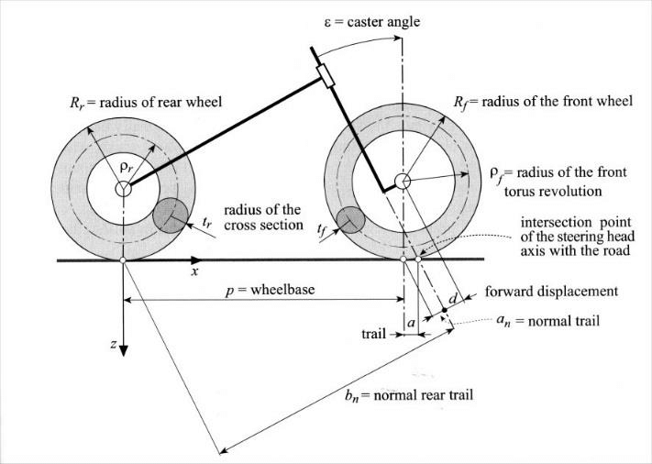
Contents

1 Introduction ii
1.1 Aims ii
1.2 Objective ii
2 Geometry iii
2.1 Offset iii
2.2 Rake and Trail iv
2.3 Wheelbase Length v
2.4 Swingarm length and Anti-squat v
2.5 Centre of gravity vi
3 Methodology and calculations vii
3.1 Determining the Centre of Gravity vii
3.2 Trail Calculation xii
4 Resistance to Motion xiii
4.1 Aero Drag Force xiii
4.2 Rolling Resistance xiv
4.1 Gear Ratios xv
4.2 Top speed xv
5 Results xvii
6 References xviii

Introduction
When first looking at motorcycles you could think that they are a simple thing to understand but when you look deeper into the motorcycle the overall geometry is very different in different styles of machine. In essence they are all the same two wheels, engine, frame and suspention but depending on all the different variations of their components are set up depends on how the motorcycle behaves and handles for example a Harley Davidson is a laid back riding style machine compared to a moto gp bike where your body is a forward position and the bike is stiffer and faster reacting to inputs.

Aims
The main aim of the assignment is to acquire a knowledge of behaviours in different motorcycle styles and how also riding styles also affect the behaviours and handling. We can acquire this knowledge from extensive research into how different motorcycles and comparing them to one other from data that was collected from some of the motorcycles in the university workshop. Also, from motorcycle manuals, different design, technology and dynamics books and web sources of how motorcycles behave in different settings and conditions.

Objective
Upon developing a knowledge of motorcycle dynamics and geometry and how it affects the handling of a motorcycle in different settings. Acquiring data for two different motorcycles from the university workshop measuring, weighing and analysing the chosen motorcycles for my assignment is a Honda crf 450 and a Ducati panigale 1199 these two are very different in the way they behave in there considering one is designed to be ridden off road on the dirt, and the other to be ridden on the road fundamentally thay have the same components that make up a motorcycle but handle their chosen terrain very differently.

Geometry
Looking at the way a motorcycle handles there are a few different things that we need to understand the geometry of a motorcycle can be very complex. The style of the motorcycle for example a cruiser can handle in a very different manner to the next style for example a motocross bike they have totally different stances the cruiser has a longer wheel base which makes it more stable at high speed but the motocross bike has a shorter wheel base this enables it to turn faster and be more agile but is less stable at high speed.

Offset
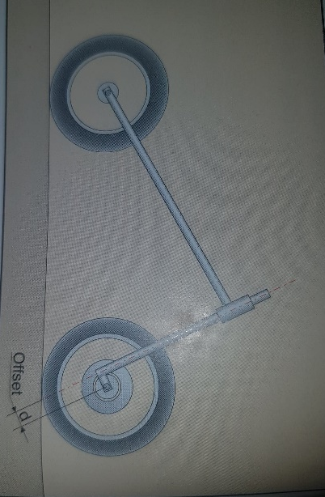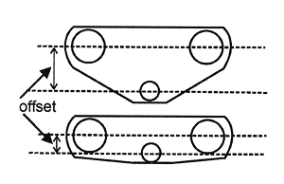
Offset is the distance between the headstock and the centre of the forks this can alter the trail. Increasing the offset reduces the trail whilst maintaining the rake angle which helps the motorcycle turn.

Rake and Trail
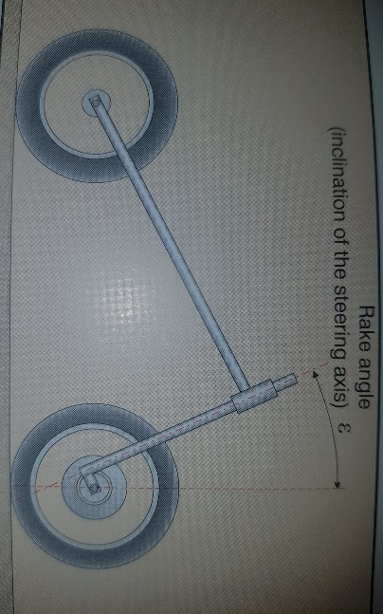
Rake angle is the angle measured by the headstock of the motorcycle and an imaginary vertical line through the centre of the front wheel. A smaller angle means the bike is more agile. And a bigger rake angle is less agile but a more stable motorcycle.

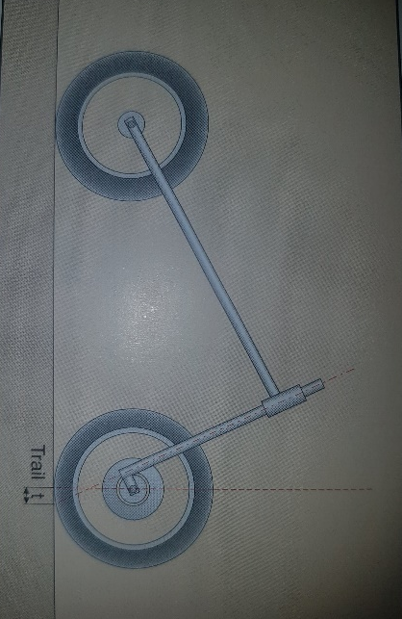
The trail of a motorcycle is the distance measured form the centre of the front tire ‘s contact patch with the ground where an imaginary line passing through the centre of the headstock. The trail is affected by rake angle as you increase the rake the trail also increases. Trail also affects how the motorcycle will handle as having too much trail will make the bike slow to steer.

Wheelbase Length
The motorcycle wheelbase can have a large impact on the handling. Small changes in length can alter how a bike changes direction brakes and accelerates. Motorcycles with a longer wheelbase are more stable and motorcycles with a shorter wheelbase will turn faster and with less input.

Swingarm length and Anti-squat
The swingarm plays a big role in how the motorcycle behaves as a bike accelerates the mass due to the forward motion will move to the rear of the bike this will make the rear shock compress this is called (Squat) one of the other things to happen is the front of the bike will lift making the steering light. There are certain thing motorcycle manufactures can do to counteract this and when they do so they call it (anti squat) there is a squat ratio where the centre of the rear wheel is below the pivot point of the swing arm and a certain distance from the pivot point although this can be changed for different bike set up it can help with mechanical grip.

Centre of gravity
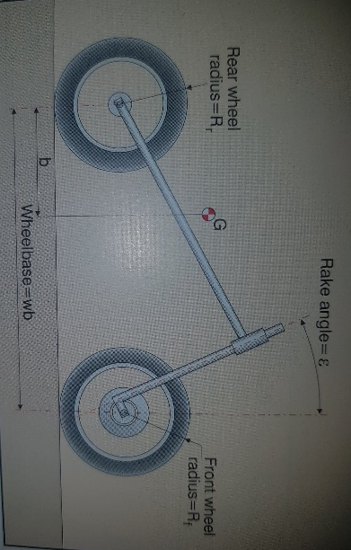
The centre of gravity of a motorcycle is important to know as we can make sure a machine is well balanced, There are many things that alter the centre of gravity even down to she smallest thing like tyre brand there will be differences in height shape tread this will move the cog, this is more predominately done by changing the suspention front or rear will have an big effect. the other biggest thing that changes the cog is the rider especially when cornering.
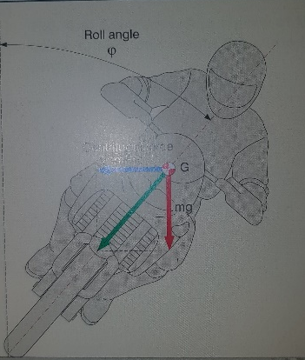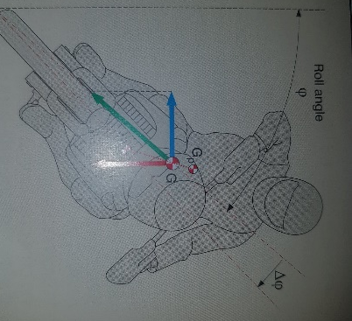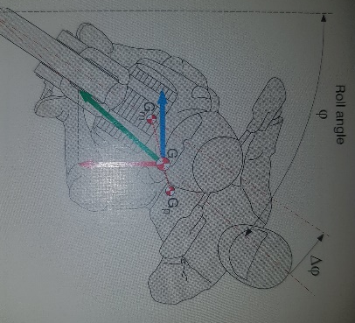

Methodology and calculations

Determining the Centre of Gravity
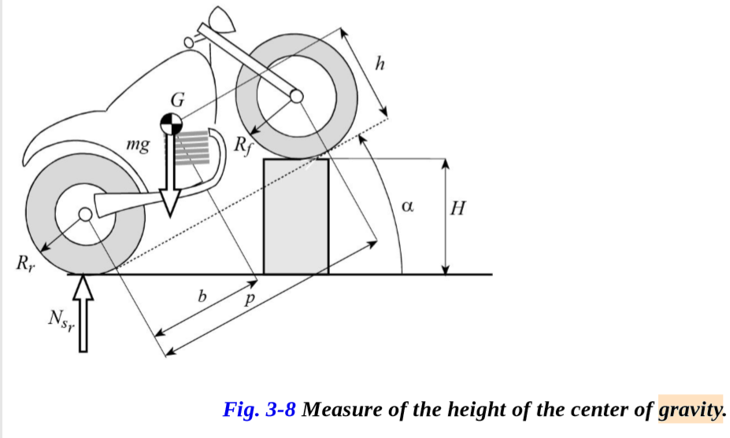
To calculate the centre of gravity on a motorcycle we need the wheelbase, front and rear weight of the motorcycle and the wheel radius. Weighing the motorcycle using a set of scales on a level surface. It is then weighed again but with the rear of the motorcycle lifted on to a stool this allows to gather data that can be used to draw a 2d sketch and to create a table of content to analyse.
The x axis centre of gravity position can be calculated from the following formula:
X COG = $\frac{\left(Wr x L\right)}{Wt}$
Where;
Wr = rear wheel measured weight (kg)
Wt = total measured weight of motorcycle (kg)
L = wheelbase (m)

The y axis centre of gravity position can also be calculated using the formula:
Y COG = $\left[\frac{L x \left(Wr-Wrlifted\right)}{Wt x tanѲ}\right]+Rav$
Where;
L = wheelbase (m)
Wr = front wheel measured weight (kg)
Wrlifted = rear wheel measured weight when lifted - stool weight (kg)
Wt = total measured weight of motorcycle (kg)
Ѳ = angle to horizontal of lifted motorcycle; calculated using Ѳ = Sin^-1 (stool height / L)
Rav = the average radius of both wheels; calculated using$Rav=\left(\frac{R1+R2}{2}\right)$ where R1 is the radius of the front wheel and R2 is the radius of the rear wheel.
Tyre sizes for the Ducati panigali 1199 are shown as 120/ 70/17 front and 200/55/17 rear. The first number (120) is the tire width in mm, the second number (70) is a percentage of the tyre width when compared to the tyre height e.g. 70% of 120mm equals 84mm depth, and the third number (17) is the wheel diameter in inches. I calculated the Rav to be 305.4mm based on the total diameter of the front wheel rim being 431.8mm (17”) and the tyre being 84mm on both sides of the wheel and the total diameter of the rear wheel rim being 431.8mm with a tyre depth of 110mm on both sides of the wheel, giving R1 as 299.8mm and R2 as 651.8mm. From this, I calculated the X cog to be at 325.9mm and the Y cog to be 299mm.
RAV Ducati panigali 1199
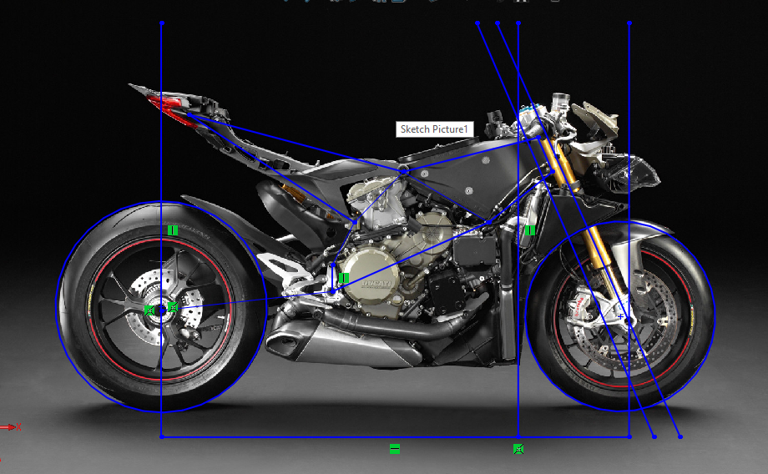
431.8mm (17”) rim diameter with 84mm tyre depth at each side = 4331.8 + (2x84) = 599.8mm total diameter. 599.8 / 2 = 299.90mm R1
Rear wheel
431.8mm (17”) rim diameter with 110mm tyre depth at each side = 4331.8 + (2x110) = 651.8mm total diameter. 651.8/ 2 = mm R2
Rav = (299.90+325.9)625.8/ 2 =312.9 mm (0.313m)

Honda crf 450 tyre sizes are 80/100/21 front and 110/90/19 rear. This means the front tyre has a depth of 80mm (100% of 80), and the rear tyre has a depth of 99mm (90% of 110). The Rav to be 343.5mm. This was based on the total diameter of the front wheel rim being 533.4mm and the tyre being 80mm deep on both sides of the wheel and the total diameter of the rear wheel rim being 482.6mm with a tyre depth of 90mm both sides of the wheel, giving R1 as 215.9mm and R2 as 331.3mm. From this, I calculated the X cog to be 340.3mm and the Y cog to be 346.7mm

Rav for Honda crf 450
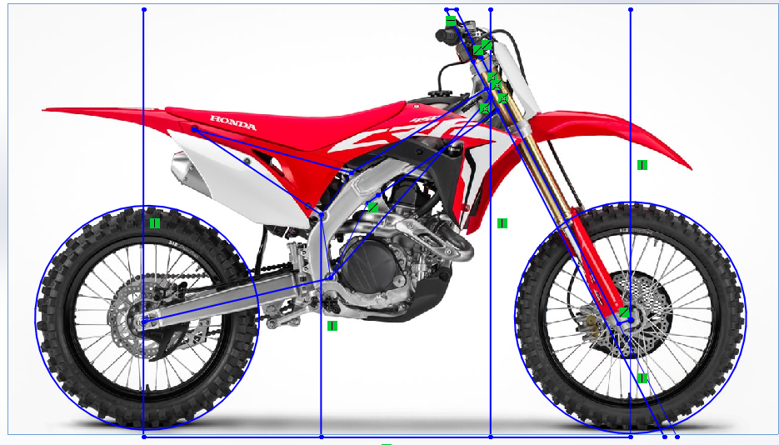
533.4mm (21”) rim diameter with 80mm tyre depth at each side = 533.4 + (2x80) = 693.4mm total diameter. 693.4 / 2 = 346.7mm R1
Rear wheel
482.6mm (19”) rim diameter with 90mm tyre depth at each side = 482.6 + (2x99) = 680.6mm total diameter. 680.6 / 2 = 340.3mm R2
Rav = (346.7+340.3)/ 2 = 343.5mm

Trail Calculation
Trail can be calculated using the formula:
$$Trail =\frac{R x Sin \left(Ѳ\right) – o}{CosѲ}$$
Where;
R = Wheel radius
O = Triple clamp offset
Ѳ = Rake angle

Resistance to Motion

Aero Drag Force
The average frontal area (A) of a superbike is 0.3 – 0.35m^2. With a typical drag coefficient (Cd) of 0.55 – 0.65 for faired motorcycles. - (Cossalter, 2006)
This can be calculated with the following formula:

Fd = $\frac{1}{2}p x Cd x A x V^{2}$
Where;
P = density of air (1.167 kg/m^3 at 20°C)
Cd = drag coefficient
A = frontal area
V = velocity
Average Aero Drag for faired superbike at 180 mph (80.47m/s) =
Fd = $\frac{1}{2} x 1.167 x 0.60 x 0.325 x {80.47}^{2}=$ 736.79

Average Aero Drag for faired superbike at 100 mph (44.70m/s) =
Fd = $\frac{1}{2} x 1.167 x 0.60 x 0.325 x {44.70}^{2 }$ = 217.55

Rolling Resistance

using the formula:
Fw = 0.02 x m x g
Where;
Fw = force (N)
m = total mass (kg)
g = gravity (9.81 m/s^2)

Gear Ratios

Honda crf 450 Ducati panigali 1199

Gear Ratio 1st 15/27 1.800 15/37 2.467
Gear Ratio 2nd: 17/24 1.470 16/30 1.875
Gear Ratio 3rd: 18/22 1.235 18/27 1.500
Gear Ratio 4th: 21/23 1.050 20/25 1.250
Gear Ratio 5th: 23/23 0.909 22/24 1.091
Gear Ratio 6th: 26/24 0.923 24/23 0.958
overall Reduction: ( 1st-6th 48.7% ) ( 1st-6th 61.2% )
Transmission 6 speed 6 speed

Results

Honda CRF 450 2009 Center of gravity
front tyre size | 80/100/21
rear tyre size | 110/90/19
front rim size | 21inch / 533.4mm
rear rim size | 19 inch / 482.59mm
wheel base length (L) | 1485mm
rider weight | 56.5kg
stool weight | 3.95kg
stool hight | 301mm
front wheel weight without rider | 47.4kg
rear wheel weight without rider | 49.4kg
total bike weight without rider | 49.8kg
front wheel weight with rider | 63kg
rear wheel weight with rider | 90kg
total bike weight with rider | 153kg
front wheel lifted on a stool weight without rider | 50kg
rear wheel lifted on a stool weight without rider | 50kg
total bike on stool weight without rider | 100kg
front wheel lifted on a stool weight with rider | 68kg
rear wheel lifted on a stool weight with rider | 84kg
total bike on stool combined weight with rider | 152kg

Ducati Panigale 1199s 2017 Center of gravity
front tyre size | 120/70/17
rear tyre size | 200/55/17
front rim size | 17 inch / 431.79mm
rear rim size | 17 inch / 431.79mm
wheel base length | 1430mm
rider weight | 56.4kg
stool weight | 3.95kg
stool hight | 301mm
front wheel weight without rider | 96.5kg
rear wheel weight without rider | 87.1kg
total bike weight without rider | 183.6kg
front wheel weight with rider | 115.2kg
rear wheel weight with rider | 124.2kg
total bike weight with rider | 239.4kg
front wheel lifted on a stool weight without rider | 100kg
rear wheel lifted on a stool weight without rider | 88kg
total bike on stool weight without rider | 188kg
front wheel lifted on a stool weight with rider | 119.5kg
rear wheel lifted on a stool weight with rider | 124.95kg
total bike on stool combined weight with rider | 244.45kg

References

Bibliography
cocco, g., n.d. motorcycle design and technology. In: motorcycle design and technology. s.l.:giorgio nada editore, p. 215.
Cossalter, V., 2006. Motorcycle Dynamics. s.l.:s.n.

