Student name:
Agnieszka Janina Wilkosz

Student ID number: 2115098

Programme: BA (Hons) Management and Leadership – Skills for the Workplace

Module: Developing Innovation and Creativity for Business Advantage
Module code BMSW6102

Lecturer:
Olu Adegbite

Assignment Title:

Innovative Service Plan.

Table of Contents
Introduction 3
Product or Service Offerings 4
Innovation's Influence 5
SCAMPER Model for Innovation 6
Conclusion and Recommendations 10
References 11

Introduction

High street stores have long struggled to maintain their place in the market as online shopping is faster, easier, and more practical. The Covid-19 pandemic has made the internet an even more preferred method for consumers (Chesson, 2020). One of the larger stores that went out of business was Debenhams (Pilkington, 2019).
This project plan will focus on the Debenhams, which, after 242 years, left the high street and closed 124 stores (BBC, 2020).
The product and service will be presented, and then it will be shown how the innovation had a positive and negative impact. The next part will present the SCAMPER model, suggesting how Debenhams could innovatively meet the challenges. Then, a conclusion, recommendations, and references support the work.
The retail sector generated approximately 5.2% of GDP in 2020. The retail industry has been recognized as one of the most diverse, competitive, and innovative business sectors. Many retailers in England experience financial difficulties, with some going out of business (Faseluka, 2022). "According to the Centre for Retail Research, the high street lost 5,214 stores in 2020, the highest figure on record since 2009" (Gregory, 2022, p3).

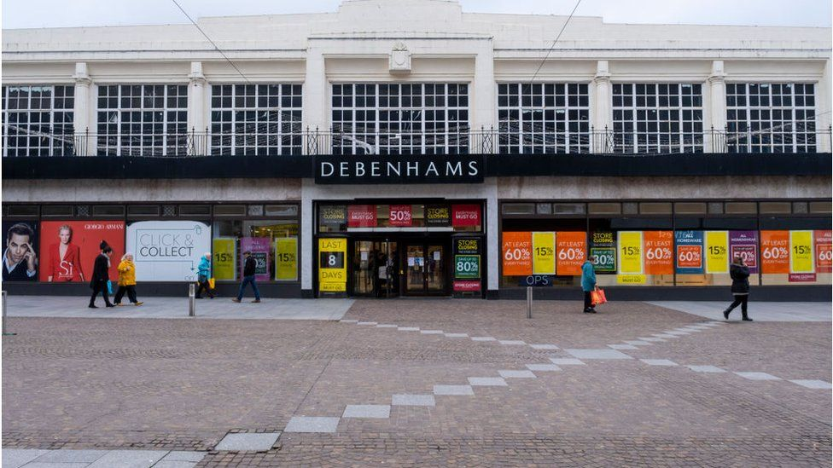
(Source: BBC, 2020)

Product or Service Offerings

Debenhams was a widely known brand in the UK. It was founded in 1778 (Claridge, 2021) when Thomas Clark and William Debenhams partnered to operate retail stores in London. The business has grown to include multiple retail outlets across the UK. The Company also started activities related to clothing production (MarketLine, 2022). Debenhams offered branded clothing, high-end household products, cosmetics (No date, Blue Martini Software Customer Case Study - Stanford University), furniture, toys, and electronic products. The Company had a mix of private labels, international brands and concessions sold through an online platform and stores. Debenhams also offered data on the latest trends, fashion blogs and style guides for occasional styling. More than 19 million customers shopped at Debenhams every year. The Company integrated online and in-store shopping to provide customers with greater convenience, choice, and experience. It also provides in-store pickup and home delivery services for online shoppers and allows in-store shoppers to place orders online (MarketLine. 2021).
Debenhams' problem was the limited scale of its operations compared to its competitors. The Company operated a chain of department stores (MarketLine, 2022), of which there were around 124 (BBC,2020). However, its main competitor, Next Plc, operates 498 stores, and Marks and Spencer Group plc operates over 1,519 stores in the UK and 62 international markets (MarketLine, 2022).
Experts say Debenhams has lagged behind fashion trends for the past decade. In the 1990s, they had designers at Debenhams, where designers such as Ted Baker and Jasper Conran created their collections for them. Debenhams also needed to adapt more quickly as more and more shopping moved online, but there is no point in having a good website if the product is unsuitable. Competing with newer clothing retailers such as Boohoo and Asos made it more accessible. The bigger problem was that the brand needed to be more relevant (Thomas, 2020).
Over the years, Debenhams grew at a rapid pace. At the same time, shopping habits have changed, and consumer spending has been reduced due to Brexit uncertainty and the pandemic. Debenhams had several underperforming stores, which resulted in high costs. These liabilities became more difficult to cover as revenues began to decline, and in 2018, the debt reached a record high of £491.5 million. The Company had a debt of £720 million in 2020 (Thomas, 2020). On December 1, 2020, Debenhams announced that it was going into liquidation (MarketLine, 2020)
January 25, 2021, Boohoo Group Plc, an online clothing and accessories retailer, acquired the Debenhams brand for £55 million (Development of online marketplace and extension of target addressable market, 2021). Boohoo is a British online clothing retail company expanding its business by acquiring struggling brands in the UK and US (Ahmed, 2023).

Innovation's Influence

While technological innovations have increased the culture and convenience of online shopping, the UK high street has been on a downward trend for over a decade, disrupting the retail sector (Rapo, 2019). "Innovation is based on a fundamental point: generating new ideas and looking at things from a different concept, defined as thinking outside the Box. Nevertheless, this generation of knowledge precedes another, essential part of innovation, the implementation of this idea is often the most difficult to achieve" (Moya Rodrigo, 2015, p.18).
Consumer shopping trends are constantly evolving, and with the growing popularity of online shopping, stationary stores need help. In the era of dynamically developing online sales, running an online store is much cheaper than running a stationary store. Even though most stores, like Debenhams, had the opportunity to shop online, its profits were lower than those of an online store because the costs of running a store are higher. (Kumar, 2017).
The share of online retail sales has increased during the Covid-19 pandemic. During the pandemic, Boohoo is a British company that recorded an increase in revenue by approximately 40% in the last quarter of 2020 (Ahmed,2023). Similarly, Jeff Bezos (Amazon) increased his enormous fortune by another $24 billion (Chesson, 2020).
Debenhams, a pioneer of the Internet channel, launched its first information and transaction service in the late 1990s. Then, in 2001, Debenhams launched a new website powered by Blue Martini Software's intelligent sales systems. In addition, the new website offered Debenhams key benefits, online trading capabilities, centralized marketing functions and the ability to interact with customers.
The business intelligence suite had many options, such as tracking:
unfinished purchase rate, average sales per customer, percentage of new visitors, and time spent by the customer on the website. The metrics were immediately available and helped Debenhams better understand its customers, profile them in greater detail and predict their behaviour more accurately. This innovation had a positive impact because it helped the company expand beyond physical stores and reach more customers. (Blue Martini Software Client Case Study – Stanford University, undated). The company's online platform has recorded over 300 million visits. This type of innovation also positively impacted business operations because it allowed them to reach more customers (MarketLine, 2021). Debenhams had to adapt more quickly to the rapid shift to online retailing. The UK online retail sector generated total revenues of $62.0 billion in 2018. Although Debenhams has an e-commerce site, it has yet to adapt quickly enough to ensure the rapid growth in popularity of online shopping among British consumers. Where Debenhams failed, new online-only competitors (ASOS and Boohoo) took full advantage of the online shopping trend. They have invested heavily in creating websites with improved speed and visual appeal that have become a hit with consumers. Despite attempts to create an engaging and effective e-commerce website, the main problem for the company was the need for greater consumer demand for its products (MarketLine, 2020). Debenhams has struggled to keep up with fashion trends for a long time, and has had to adapt more quickly as more shopping moved online. Debenhams was not innovative in changing fashion trends; it had outdated collections. The brand itself has become irrelevant (Thomas, 2020).
Boohoo bought Debenhams because they believed it was a long-standing and leading UK clothing and beauty retailer with high brand awareness and an established online platform, with approximately 300 million visits to websites annually. It ranks in the top ten most popular retail websites in the United Kingdom in terms of traffic (Developing the Online Marketplace and Expanding Your Target Addressable Market, 2021).
Innovations in brand collaborations and exclusive collections also played an important role. Debenhams has worked with well-known designers and celebrities to create exclusive ranges that have created buzz and attracted customers looking for unique products. This innovative approach helped the company stand out in a crowded market but later abandoned it (Thomas, 2020).
While Debenhams has shown innovation in some areas, such as early adoption of e-commerce and exclusive collaborations, it has faced challenges to keep pace with the rapidly changing retail landscape. The company's inability to fully leverage technology and adapt to changing consumer behaviour ultimately played a role in its demise. This highlights the importance of continuous innovation and adaptability in the highly competitive retail industry, where consumer preferences and technology constantly change.

SCAMPER Model for Innovation

SCAMPER is a technique of asking focused questions that help solve problems or stimulate creativity during brainstorming meetings (Sirbiladze, 2017). This technique was initially used by Eberle (1971) to enhance students' creativity (Toraman, 2013). The name SCAMPER comes from the 7 techniques presented below (Sirbiladze, 2017).

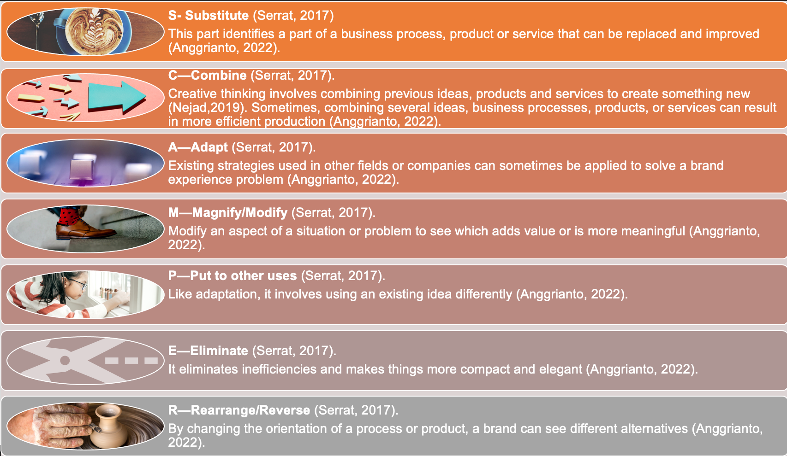

The advantage of the SCAMPER technique is that it promotes creative thinking when analysing a problem and generates new ideas (Lopes, 2020). The SCAMPER model for Debenhams will be presented below.

• S – Substitute

The fashion industry has traditionally relied on brick-and-mortar stores and runway shows to showcase its latest collections. However, with the development of e-commerce and online shopping, the industry has had to adapt to changing consumer behaviour (LinkedIn. 2023).
Debenhams could replace traditional fitting rooms with advanced augmented reality technologies, allowing customers to virtually try on different clothes in different settings and use this method when shopping online. Replace conventional photos with the opportunity to try on clothes. This substitution effectively addresses the challenges of online shopping, such as discrepancies in size and style and whether a customer will look good in an item, which often leads to high return rates.
One of the most promising innovations is using virtual and augmented reality to create more immersive and interactive shopping experiences, as online shopping comes with limitations. When shopping online, consumers often need help finding the proper cut, colour, or clothing style. It can lead to many returns. Augmented reality (AR) and virtual reality (VR) can enhance the online shopping experience and provide new opportunities for sustainable fashion. One of the advantages of VR and AR technology is that it allows for a high level of personalisation. Buyers can create their avatars and try on clothes virtually without having to leave home, and in a virtual fitting room, they can try on clothes without having to undress. With VR and AR, customers can get a more immersive and interactive shopping experience. They can browse virtual stores, view clothes from different perspectives, and even see their appearance in other settings.
H&M and Sephora have implemented virtual try-on technology on their mobile apps and websites. Customers can use their smartphone camera to virtually try on clothes and make-up to see how the product will look on them before making a purchase (LinkedIn, 2023).

• C-Combine

Debenhams could combine shopping in a stationary store with the services of a beauty salon, offering customers beauty treatments, hairdressing, and make-up advice. It fits perfectly with the cosmetic products they offer. From time to time, customers could do their make-up, nails, and hair, get information about the products they want to buy, or have them professionally examined.
Combining shopping with beauty salon services could create a comprehensive experience for customers. With this approach, Debenhams would increase the attractiveness of its stores and offer customers additional benefits such as personalised beauty and make-up advice. It would contribute to an increase in sales and build greater loyalty among customers.

• A-Adapt

Implementing an 'Adapt' strategy by offering alterations and repair services is an excellent way for Debenhams to improve customer service. It often happens that trousers are too long, or the dress does not fit perfectly, so Debenhams has been able to adapt its offer by offering alterations and repair services. Because customers often give up shopping if they must go to a seamstress. Debenhams offered a quick turnaround time for changes, emphasising convenience. By providing these offers, Debenhams has been able to differentiate itself from the competition and position itself as a one-stop shop for all fashion needs, fostering longer-lasting customer relationships and encouraging repeat business. Customers would associate such a store with convenience and time-saving.

• M- Modify

Implementing a 'Modify' strategy by expanding its product offering to buy and sell used clothing is a fantastic way for Debenhams to serve a broader customer base.
The store could modify its offer to include the purchase/sale of used clothing. Customers often buy a dress or suit and wear it only once. The store could buy clothes lying in customers' closets and then sell them to the customer. The general rule when purchasing clothing should be that it is in good condition and purchased from Debenhams. A receipt can confirm this. It would be an excellent solution for customers who cannot afford new clothes; they can buy used ones at a lower price, and customers who have purchased expensive clothes can resell them in the store and use the money they earn to buy another product. This solution will also work in connection with environmental protection and recycling. All lovers of ecological life would be happy with such a solution.

• P- Put to other uses

The company could put another use in its huge store spaces, renting out parts of its stores for cafes, events, workshops or fashion or beauty product launches, creating additional sources of revenue. Debenhams wanted to open gyms in 2018 to attract younger customers, but it was not a sports store (MarketLine, 2021). In addition, Debenhams partnered with local businesses or well-known brands to organise product presentations or exhibitions, further establishing the stores' position as dynamic and multi-functional spaces. It can improve the overall shopping experience and strengthen Debenhams' position as a lifestyle destination, not just a place where customers shop. Customers coming to an event or for coffee with friends could also see something interesting in the store and make a purchase. This strategy can generate additional revenue and improve brand perception and customer loyalty.

• E-Eliminate

Debenhams had an extensive product offer, thanks to which it could eliminate unpopular product categories (those with the lowest sales rates) and focus on promoting more profitable assortments sought by customers. Debenhams can improve the shopping experience by improving its product range, enabling customers to navigate the store more efficiently and quickly find the products they need. This approach could contribute to maximising profitability and optimising the allocation of innovatory in the company.

• R—Rearrange/Reverse

Debenhams' implementation of the "Reorganize/Reverse" strategy focused on reorganising the platform into an interactive platform offering fashion and lifestyle products and content. This platform could include blogs, vlogs, styling guides and interviews with fashion industry experts and famous influencers. Debenhams would also be able to engage its customers by running competitions with prizes.
With this approach, Debenhams could attract customers' attention by offering products and valuable content related to fashion and lifestyle. It could also increase brand awareness and build a stronger online presence.

Conclusion and Recommendations

High street stores are struggling, just as Debenhams went out of business after 242 years. It was a store selling clothes, furniture, home products, cosmetics and toys that was positively and negatively impacted by innovation. The main problem was that the brand had become irrelevant due to the need for more innovation in the store range. Even though the company tried to keep up with trends related to online shopping, companies such as Boohoo or Asos, with lower maintenance costs, could better cope with innovative development. Using the SCAMPER model for innovation, ideas were presented that Debenhams and other businesses could use to increase sales, build customer loyalty, improve customer shopping experiences, better allocate inventory, increase brand awareness, make a more substantial online presence, and increase income.
Debenhams and other high-street retailers are encouraged to follow innovation and trends. A great way is to have AR and VR methods in fitting rooms and websites where the customer can see what they look like without trying on the clothes physically. It helps to increase purchases and reduce the number of returns. It is also worth it for stores to offer additional services that distinguish them from the competition. A great way is to have a clothes alteration service because the customer can receive comprehensive service in one place and decide to purchase. With the growing environmental protection trend, Debenhams and other stores should consider buying and selling second-hand clothes. That could attract more customers and improve the brand's image. Large stores may also consider renting their space for additional services, contributing to more frequent customer visits.

References

- Anggrianto, C. (2022). Proposing SCAMPER: Approach to reach brand strategy equipoise during the COVID-19 pandemic. In Embracing the Future: Creative Industries for Environment and Advanced Society 5.0 in a Post-Pandemic Era (pp. 256-260). Routledge.

- Ahmed, J.U., Rahman, U., Ahmed, A. and Sharif, R. (2023). Marketing Strategies for the UK-Based Online Fashion Retailer Boohoo. SAGE Publications: SAGE Business Cases Originals.

- Chesson, E. (2020). Will Coronavirus finally kill Britain’s high street?.

- Debenhams set to close putting 12,000 jobs at risk. (2020). BBC News. [online] Available at: https://www.bbc.co.uk/news/business-55142724 [Accessed 28 Sep. 2023].
- Debenhams: Over 200 years of history. (2020). BBC News. Available at: https://www.bbc.co.uk/news/in-pictures-55147787 (Accessed: 28 September 2023).
- ‌Development of online marketplace and extension of target addressable market. (2021). [online] boohoo group plc. Available at: https://www.boohooplc.com/sites/boohoo-corp/files/all-documents/result-centre/2021/strategic-acquisition-release-jan-2021.pdf [Accessed 30 Sep. 2023].
- Development of online marketplace and extension of target addressable market’. (2021).[online] Boohoo group plc. Available at: https://www.boohooplc.com/sites/boohoo-corp/files/all-documents/result-centre/2021/strategic-acquisition-release-jan-2021.pdf [Accessed 30 Sep. 2023].
- Elahe Safi Nejad et al. (2019) ‘Evaluation of creativity pragmatics in the design of gowns of the 2nd International Fashion and Clothing Festival of Iran based on the Scamper Technical Pattern’, Dilemas contemporáneos: educación, política y valores, VI(Special).
- Faseluka, J.T. (2022). A Critical Analysis of the Effectiveness of Corporate Rescue in Retail Sector Insolvency Cases (Doctoral dissertation, University of Leeds).

- Gregory, C., Sonderland Saga, R. and Parker, C. (2022). Booksellers as placemakers: the contribution of booksellers to the vitality and viability of high streets.

- Kumar, N. (2017). M&S and Debenhams Online retail to continue its surge while retail outlets continue to close. [online] MarketLine. Available at: https://advantage-marketline-com.ezproxy.uwtsd.ac.uk/Analysis/ViewasPDF/ms-and-debenhams-48595 [Accessed 30 Sep. 2023].
- LinkedIn. (2023). The Metaverse and Fashion: How VR and AR Could Transform the Way We Shop for Clothes. [online] LinkedIn. Available at: https://www.linkedin.com/pulse/metaverse-fashion-how-vr-ar-could-transform-way#:~:text=VR%20and%20AR%20technology%20can%20enhance%20the%20shopping%20experience%20by [Accessed 15 Oct. 2023].

- Lopes, R., Malta, P., Mamede, H. and Santos, V., 2020. A Creative Information System Based on the SCAMPER Technique. In Information Systems: 17th European, Mediterranean, and Middle Eastern Conference, EMCIS 2020, Dubai, United Arab Emirates, November 25–26, 2020, Proceedings 17 (pp. 595-606). Springer International Publishing.
- Moya Rodrigo, J., 2015. Knowledge networks, innovation and its application on a small business.
- MarketLine. (2022). COMPANY PROFILE Debenhams plc. [online] Available at: https://web-s-ebscohost-com.ezproxy.uwtsd.ac.uk/ehost/pdfviewer/pdfviewer?vid=2&sid=5b58ebf2-8b40-4e6f-9b14-826a944b6572%40redis [Accessed 30 Sep. 2023].
- ‌ MarketLine. (2020). The demise of Debenhams What went wrong for the iconic British retailer. [online] Available at: https://advantage-marketline-com.ezproxy.uwtsd.ac.uk/Analysis/ViewasPDF/the-demise-of-debenhams-what-went-wrong-for-the-iconic-british-retailer-112265 [Accessed 28 Sep. 2023].
- ‌ MarketLine. (2021). Debenhams plc SWOT Analysis. [online] Available at: https://web-s-ebscohost-com.ezproxy.uwtsd.ac.uk/ehost/pdfviewer/pdfviewer?vid=2&sid=e614d513-2d51-489a-b4ca-737898007dad%40redis [Accessed 30 Sep. 2023].
- Pilkington, M. (2019). Retail Therapy: Why The Retail Industry Is Broken–And What Can Be Done to Fix It. Bloomsbury Publishing.

- Rapo, N. (2019). Marketing the high street: a solution to the British retail crisis?

- Serrat, O. (2017). The SCAMPER Technique. Knowledge Solutions, [online] pp.311–314. doi: https://doi.org/10.1007/978-981-10-0983-9_33 [Accessed 30 Sep. 2023].

- Sirbiladze, K. (2017). SCAMPER technique for creative thinking.
In Economics, Finance, and Management in the 21st Century: Analysis of Trends and Prospects for Development (pp. 37-40). Financial Council of Ukraine.

- Thomas, D. (2020). What went wrong at Debenhams? BBC News. [online] Available at: https://www.bbc.co.uk/news/business-55144922 [Accessed 28 Sep. 2023].

- Toraman, S. and Altun, S. (2013). Application of the Six Thinking Hats and SCAMPER Techniques on the 7th Grade Course Unit ‘Human and Environment’: An Exemplary Case Study. Mevlana International Journal of Education, 3(4), pp.166–185. Doi: https://doi.org/10.13054/mije.13.62.3.4

