

Individual report Development of a plan by meeting the identified PDP needs and expectations of individual employees in IOC Office Image Cleaning Company.

Programme: BA (Hons) Leadership and Management Skills for the Workplace
Code: BMSW 5102
Module: Developing Relationships and Workplace Achievements
Lecturer: Charlie Nwaogwugwu
Student: Diego Armando Torres Betancourt
Student ID: 2133739

2023

Index

1. Introduction………………………………………………………………………………1

2. Main Body……………………………………………………………………………..…2

2.1 Performance management……………………………………………………………2

2.2.0 Performance Management Cycle………………………………………..…………2

2.2.1 Planning……………………………………………………………...…………3

2.2.2 Monitoring……………………………………………………………...……….3

2.2.3 Reviewing………………………………………………………………...…….3

2.2.4 Rewarding………………………………………………………………………3

3. Critically evaluate 3 drivers……………………………………………………….……4

3.1 360-Degree Feedback…………………………………………………..……….……5

3.2 540-degree feedback…………………………………..………………………………5

3.3 Management by Objectives (MBO).......................................................................5

3.4 Further Performance and Pay (PRP)....................................................................6

4. Project Title: Enhanced Cleaning Services Development…………….…..…………6

5. Recommendations………………………………………………………………………10

6. Conclusion..............................................................................................................11

7. References…………………………………………………………………….…………12

8. Appendix…………………………………………………………………..………………15

1. Introduction
As I progress through my role as an HR trainee at the IOC image office company, my line manager wants me to help him engage staff in a new project called "Enhanced Development of Cleaning Services" to enhance teamwork and operational efficiency. Despite the enthusiasm of the staff, there is still ambiguity and confusion about the project's goals and required participation. This has led to a need for an ongoing and open communication plan. Performance management software is essential for managers to evaluate staff performance and align their efforts with company objectives. 360-degree feedback is more effective in identifying strengths and shortcomings. Performance and Pay (PRP) and Management by Objectives (MBO) programs boost output and compensation. A company must prioritize the health and happiness of its employees, as well as diversity, inclusiveness, and flexibility to adapt to changing times. Overall, an ongoing and open communication plan is crucial for ensuring the success of the initiative. (Mason, 2019)

2. Main body

2.1 Performance management is an essential tool utilised by managers to oversee and assess the performance of employees. Its purpose is to establish an environment that enables individuals to achieve their maximum potential and align their efforts with the objectives of the organisation. It promotes establishing objectives, responsibility, openness, and a thorough comprehension of anticipated outcomes. Performance management facilitates continuous feedback to employees, cultivating a more productive and streamlined work environment. (Tardi, 2022), (Andreev, 2020)

2.2.0 The Performance Management cycle is a structured process of employee development that allows management and employees to better achieve organizational goals. It is a part of the performance management process or strategy, and it is shorter and utilises a continuous four-step procedure of planning, monitoring, reviewing, and rewarding. (Vulpen, 2019)
The four main stages of the cycle are:
2.2.1 Planning: In this stage, the groundwork for success is laid down. Before management talks to the employee, the management team should meet and decide the organization’s goals and objectives for the year. This involves the business's overall strategy and personal objectives for all employees and teams, including development goals, specific tasks, targets, actions, and behaviours. Once the management team knows the details of what they want the employee to achieve, it is time to meet with the employee and make a strategic plan for the year. (Vulpen, 2019)
2.2.2 Monitoring: In this stage, the employee’s progress is monitored throughout the year. This involves regular check-ins with the employee to ensure that they are on track to meet their objectives. It is important to provide feedback to the employee during this stage to ensure that they are aware of their progress and any areas that need improvement. (Vulpen, 2019)
2.2.3 Reviewing: In this stage, the employee’s performance is reviewed at the end of the year. This involves a formal performance review where the employee’s progress is evaluated against the objectives set out in the planning stage. The employee’s strengths and weaknesses are identified, and a plan is developed to address any areas that need improvement. (Vulpen, 2019)
2.2.4 Rewarding: In this stage, the employee is rewarded for their performance throughout the year. This can include bonuses, promotions, or other incentives. It is important to reward employees for their hard work to ensure that they remain motivated and engaged. (Vulpen, 2019)
3. Critically evaluate 3 drivers:
3.1 360-Degree Feedback
In an office cleaning company, 360-degree feedback technique is a valuable tool in office cleaning companies for gaining insights from diverse perspectives. It helps employees understand their strengths and weaknesses, enabling targeted development and overall growth. However, it may need improvement in implementation and interpretation due to a lack of clear criteria, constructive feedback, and cultural factors influencing the process. To enhance the reliability and effectiveness of the technique, continuous refinement, addressing potential biases, ensuring confidentiality, and providing effective training on feedback delivery and reception can be implemented. This approach can help employees focus on areas for improvement, ultimately contributing to overall efficiency and growth in their roles. (Boogaard, 2023)
- Advantages:
- Offers a thorough comprehension of performance from various viewpoints.
- Facilitates managers' comprehension of subordinates' behaviours and achievements.
- Reduces the influence of internal power dynamics.
- Promotes growth and progress through impactful conversations.
- Promotes productive dialogues regarding the raised concerns.
- Improves self-awareness by collecting input from various sources.
- Sheds light on aspects of behaviour and performance that are often ignored when receiving feedback on an individual level.
- Provides insight into an employee's competencies and constraints.
- Encompasses input from colleagues, subordinates, and personal evaluation. (Boogaard, 2023)

- Disadvantages:
  - May lack informed feedback.
  - May distort data and yield deceptive performance outcomes.
  - May discourage honest feedback as a result of excessive managerial supervision.
  - Can be either anonymized or attributed to align with the company's culture.
  - May become detached from incentive programmes.
  - Requires the support and approval of senior executives.
  - Demands the participation of all individuals.
  - Must be connected to performance enhancement and a system of incentives. (Boogaard, 2023)
3.2 540-degree feedback: is a technique employed to assess employee performance and obtain a competitive edge by comprehending customer perception. It encompasses various parties and external evaluators, such as customers or clients. This feedback assists organisations in identifying their strengths and weaknesses, aligning their training modules, and enhancing customer satisfaction. For instance, a salesperson's differential conduct towards customers can result in the loss of potential customers, damage to the brand, and reduction in revenue. By implementing 540 Degree Feedback, organisations can address these behaviours or terminate employees, thereby ensuring a conducive work environment. (Human Resources Terms by MBA Skool Team, 2023)
3.3 Management by objectives (MBO): is a strategic methodology aimed at improving organisational performance by clearly defining and communicating the goals of the organisation to its members. It entails the surveillance and assessment of the performance and advancement of every employee about the predetermined objectives. By actively engaging employees in goal-setting and decision-making, they are more inclined to fulfil their responsibilities. The MBO process encompasses the establishment of organisational goals, the definition of employee objectives, ongoing monitoring, performance evaluation, feedback provision, and performance appraisal. (CFI Team, 2023)
The advantages of MBO encompass enhanced collaboration and communication, a distinct comprehension of roles and obligations, and a feeling of allegiance towards the organisation. Nevertheless, the drawbacks of MBO encompass disregarding the organization's established values and working environment, excessively prioritising goal setting, and neglecting the circumstances in which objectives are established. To address these constraints, managers should establish a set of specific objectives that both employees and the organisation strive to achieve in the near term, and then proceed to work towards attaining them. The MBO approach guarantees that employees possess a lucid comprehension of their designated roles and responsibilities, as well as the expectations placed upon them. Furthermore, they grasp the correlation between their activities and the overarching triumph of the organisation. (CFI Team, 2023)

3.4 Further Performance and Pay (PRP): plans have been found to significantly enhance productivity and remuneration in Finnish companies. The study uses data from various sources, including the Confederation of Finnish Industries (EK) compensation surveys, Asiakastieto, the wage statistics database, and Statistics Finland's business register. The findings suggest that PRP schemes can be effective in improving both productivity and remuneration, but their effectiveness may be affected by firm characteristics like superior management practices or a forward-thinking corporate culture. Group incentive pay (PRP) plans are essential for improving both productivity and compensation, with some schemes focusing on profitability or alternative metrics. However, the study suggests that the effectiveness of PRP may be overestimated due to unaccounted variations in firm characteristics. The study emphasizes the importance of employing multiple performance indicators in PRP and demonstrates that the effectiveness of incentives remains strong over time. (Takao and Antti, 2018)

4. Project Title: Enhanced Cleaning Services Development
4.1 Objective 1: Conduct individual skills assessment: The priorities for performing a skills assessment for an employee, it is necessary to identify the crucial job skills, select suitable assessment tools, establish explicit expectations, carry out the assessment, deliver feedback, and formulate a development plan. This procedure facilitates the identification of deficiencies in knowledge, areas of expertise, and opportunities for enhancement, thereby offering a strategic plan for the advancement and development of employees. Measuring the employee's knowledge, skills, and abilities is a crucial component of effectively managing a productive team. To carry out such evaluations, it is necessary to establish the objective, select suitable evaluation instruments, establish explicit criteria, administer the evaluation in a regulated setting, analyse the outcomes, and offer feedback. Periodic evaluations facilitate the identification of areas requiring enhancement and provide employees with the essential competencies, to improve employee evaluations, we will share feedback documentation, regularly take note of performance and focus on positive events. (Buckner, 2023)
The competence and expertise of an employee are pivotal for their job performance. To accurately evaluate these skills, it is advisable to utilise platforms such as Upwork, Randstad, Training Industry, DeakinCo, and Indeed. Upwork provides a guide for beginners on how to effectively conduct evaluations, while Randstad offers a guide for recruiters on administering successful skills assessment tests. Training Industry provides an article on evaluating the proficiency of IT personnel, while DeakinCo elucidates the process and mechanics of workplace skills assessments. These resources can facilitate the identification of areas for enhancement and assist employees in enhancing their work performance. An employee can improve their skills by taking advantage of mentorship opportunities, conforming to industry standards, and employing objective criteria to assess their performance metrics and pinpoint areas for growth. (Raymond, 2020)

4.2 Objective 2: Customize Training Modules: To tailor training modules for a specific employee, adhere to the following instructions: Determine the specific goals for learning, develop a thorough plan for training, allocate resources to acquire appropriate learning materials, establish well-defined paths for training, evaluate employee involvement and effectiveness, solicit employee input to ensure training aligns with their needs and expectations, and adapt training to address emerging requirements. This will help guarantee that the training plan maintains its relevance and effectiveness, enabling employees to advance through the process. It is crucial to customise the training plan to accommodate the specific requirements and obstacles of each individual. (Hiter, 2023)
Customize training modules for individual employees by addressing communication obstacles, promoting transparent information exchange, and utilizing advanced technology. Foster a constructive workplace atmosphere and actively solicit input. Target language or psychological barriers to enhance communication and trust. Use resources like Continu Blog, SkillsUp, Jemini, and Training Journal for effective employee training modules. These resources cover identifying needs, organizing content, integrating interactive elements, and ensuring measurable outcomes. We offer personalized learning resources, hands-on opportunities, experiential learning, and factual information. Personalized training for each employee is essential for their personal growth and greater efficiency. Effective strategies encompass involving learners in online discourse, employing online evaluation instruments for feedback, and gauging engagement through login frequency, self-directed learning achievement, and inquiry. These strategies guarantee that the training programme is customised to meet the specific needs and objectives of each employee, leading to enhanced performance. (Skill Up Technologies, 2020)

4.3 Objective 3: Implement Mentorship Programs: An effectively organised mentorship programme can facilitate the growth and enhancement of employees' skills, thereby cultivating a hospitable corporate culture. To execute a programme, establish its objective, delineate the process of guidance, choose participants according to their competencies and areas requiring enhancement, deliver mentorship training, and consistently assess the program's efficacy. This methodology guarantees that the programme achieves its intended goals and objectives, thereby cultivating a supportive and advantageous work environment. (Carruthers, 2023)
An effective mentorship programme in the workplace is essential for fostering learning and development. The approach should encompass all individuals, have a specific duration, and require the participation of top-level executives. Essential elements for a successful mentoring relationship include clear communication, equitable support, the exchange of knowledge, and the encouragement of personal development and learning. Periodic assessment and modification of the programme are essential. The programme should also be capable of adjusting to remote work environments. The program's success is contingent upon the essentiality of top management support. Evaluating the program's performance and outcomes aids in assessing its efficacy and return on investment. Through the implementation of these factors, a mentorship programme can yield advantageous outcomes for both employees and the organisation. (Carruthers, 2023)

4.4 Objective 4: Regular Feedback and Performance Reviews: are crucial for fostering employee growth and development within all types of organisations, including office cleaning companies. Priorities include aligning individual and organizational goals, identifying strengths and weaknesses, setting clear expectations, focusing on the future, providing constructive feedback, and motivating employees through timely rewards. The primary objective is to facilitate employee growth and enhance performance, necessitating active engagement from both evaluators and employees. This reciprocal process can be observed in diverse sources. (Stange, 2021)
Regular performance evaluations and feedback are essential for maintaining high work standards and promoting staff development. Consistent meetings between management and employees can help identify and resolve issues. Employees can evaluate their performance, pinpoint areas of concern, and receive progress reports. The organization's goals must align with its departments and personnel objectives. Targeted assessments and 360-degree feedback can provide a comprehensive evaluation of an employee's performance. Factsheets and the CIPD report provide recommendations for delivering effective constructive criticism. (Gifford, 2022)
Performance feedback and performance reviews are essential for ensuring the success of employees in an office cleaning company. The process must adhere to principles of fairness, relevance, constructiveness, credibility, and goal-setting. The significance of feedback lies in its quality, rather than the quantity, frequency, or timing. Before providing feedback, managers should ensure that goal-setting has taken place and that the frequency and timing of the feedback are mutually beneficial for both parties involved. Positive feedback is more efficacious than negative feedback in enhancing performance. The bilateral consultative process is advantageous for both employees and the company. (Gifford, 2022)

4.5 Objective 5: Offer Career Development Opportunities, Office cleaning companies provide a range of opportunities for career growth, such as training and professional development, maintaining a healthy work-life balance, promoting inclusivity, facilitating career progression, embracing diversity and inclusion, and staying up-to-date with industry trends. To achieve success and foster a positive work environment, companies should give top priority to employee wellbeing, diversity, inclusion, and the ability to adapt to industry trends. The companies provide a wide range of career advancement prospects, such as training and development, a healthy work-life balance, inclusivity, job stability, flexibility, opportunities for both career beginners and those seeking a change, and diverse career options in sectors such as cleaning, security, catering, guest services, and environmental services. Researching these opportunities is crucial when contemplating employment with a particular company. Essential factors encompass comprehending industry trends, pursuing training and skill enhancement, formulating a career development strategy, comprehending employee motivations and requirements, and adhering to health and safety regulations. Employers ought to engage in discussions and employ suitable methodologies to ascertain the optimal action for diverse individuals and teams. (Tennant Company, 2023)

.

5. Conclusion
Performance management is a crucial tool for managers to assess employee performance and align efforts with organizational goals. It involves planning, monitoring, reviewing, and rewarding. 360-degree feedback helps identify strengths and weaknesses, while 540-degree feedback helps align training modules. Management by objectives (MBO) and Performance and Pay (PRP) plans enhance productivity and remuneration. Prioritizing employee wellbeing, diversity, inclusion, and adaptability to industry trends is essential.

6. Recommendations

• It is recommended to hold regular meetings for problem-solving.
• It is recommended to evaluate employee performance to identify areas for improvement.
• The harmonization of the company's goals with departmental and personal objectives is recommended.
• It is recommended that evaluations be directed at job performance issues.
• The use of the 360-degree feedback system is recommended for comprehensive performance evaluation

7. References

Andreev, I. (2023). Performance Management Cycle. [online] Valamis. Available at: https://www.valamis.com/hub/performance-management-cycle [Accessed 28 Dec. 2023].
Boogaard, K. (2023). Your Guide to 360-degree Feedback. Work Life by Atlassian. [online] 10 Apr. Available at: https://www.atlassian.com/blog/communication/360-degree-feedback [Accessed 28 Dec. 2023].
Buckner, L. (2023). How to Conduct an Effective Assessment for Employees. [online] Indeed Career Guide. Available at: https://www.indeed.com/career-advice/career-development/assessment-for-employees [Accessed 30 Dec. 2023].
Carruthers, R. (2023). How to Build a Mentorship Program for New Employees | Together Mentoring Software. [online] www.togetherplatform.com. Available at: https://www.togetherplatform.com/blog/new-employee-mentoring.
CFI Team (2023). Management by Objectives (MBO). [online] Corporate Finance Institute. Available at: https://corporatefinanceinstitute.com/resources/management/management-by-objectives-mbo/ [Accessed 28 Dec. 2023].
Cohen, T. (2021). Training for Cleaning Staff: 10 Onboarding Tips. [online] Connecteam. Available at: https://connecteam.com/training-for-cleaning-staff/ [Accessed 29 Dec. 2023].
Gifford, J. (2022). CIPD | Performance Reviews | Factsheets. [online] CIPD. Available at: https://www.cipd.org/uk/knowledge/factsheets/appraisals-factsheet/ [Accessed 30 Dec. 2023].
Hiter, S. (2023). How to Create a Training Program for Effective Employees. [online] TechnologyAdvice. Available at: https://technologyadvice.com/blog/human-resources/training-program/ [Accessed 30 Dec. 2023].
Human Resources Terms by MBA Skool Team (2023). 540 Degree Feedback - Definition, Importance & Example | HRM Overview. [online] MBA Skool. Available at: https://www.mbaskool.com/business-concepts/human-resources-hr-terms/17835-540-degree-feedback.html#:~:text=540%20degree%20feedback%20is%20an%20employee%20performance%20appraisal [Accessed 28 Dec. 2023].
Indeed Editorial Team (2022). What Are Training modules? (Plus How to Create one). [online] uk.indeed. Available at: https://uk.indeed.com/career-advice/career-development/training-modules [Accessed 30 Dec. 2023].
Juneja, P. (2015). Employee Grievance - Effective Ways of Handling Grievance. [online] www.managementstudyguide.com. Available at: https://www.managementstudyguide.com/employee-grievance.htm [Accessed 28 Dec. 2023].
Kazankov, V. (2021). Suitability, Acceptability, Feasibility (SAF) Framework to Score Strategic Options - MarketingForIT. [online] marketingforit.com. Available at: https://marketingforit.com/strategy/suitability-acceptability-feasibility-saf-framework#:~:text=%E2%80%9CSuitability%E2%80%9D%20assesses%20whether%20a%20strategy%20addresses%20key%20strategic [Accessed 28 Dec. 2023].
Mason, H. (2019). How to Progress in Your HR Career. [online] People Management Jobs. Available at: https://pmjobs.cipd.co.uk/article/how-to-progress-in-your-hr-career/ [Accessed 29 Dec. 2023].
RAYMOND, D. (2020). Identifying Success Criteria for Your Project. [online] ProjectManagers.NET. Available at: https://projectmanagers.net/identifying-success-criteria-for-your-project/ [Accessed 30 Dec. 2023].
Skill Up Technologies (2020). Building a Customized Training Program: Here’s What You Need to Know. [online] Skill-Up Technologies. Available at: https://skillup.tech/building-a-customized-training-program-heres-what-you-need-to-know/ [Accessed 30 Dec. 2023].
Stange, J. (2021). 13 Performance Review Tips That Actually Improve Employee Performance. [online] Quantumworkplace.com. Available at: https://www.quantumworkplace.com/future-of-work/13-performance-review-tips-that-actually-improve-employee-performance [Accessed 30 Dec. 2023].
Takao, K. and Antti, K. (2018). Performance Pay and Enterprise productivity: the Details Matter. [online] www.proquest.com. Available at: https://www.proquest.com/docview/2447266928/8FB092EBA84C44F9PQ/14?accountid=130472&sourcetype=Scholarly%20Journals [Accessed 30 Dec. 2023].
Tardi, C. (2022). Performance Management. [online] Investopedia. Available at: https://www.investopedia.com/terms/p/performance-management.asp [Accessed 29 Dec. 2023].
Tennant Company (2023). Challenges and Opportunities Facing Cleaning Businesses. [online] www.tennantco.com. Available at: https://www.tennantco.com/en_us/resources/resource-center/white-papers/cleaning-business-challenges-and-opportunities.html [Accessed 30 Dec. 2023].
The Mind Tools Content Team (2023). MindTools | Home. [online] www.mindtools.com. Available at: https://www.mindtools.com/ahtq7qq/management-by-objectives-mbo [Accessed 28 Dec. 2023].
Vulpen, E. van (2019). What Is the Performance Management Cycle? [online] AIHR. Available at: https://www.aihr.com/blog/performance-management-cycle/ [Accessed 28 Dec. 2023].

8. Appendix A
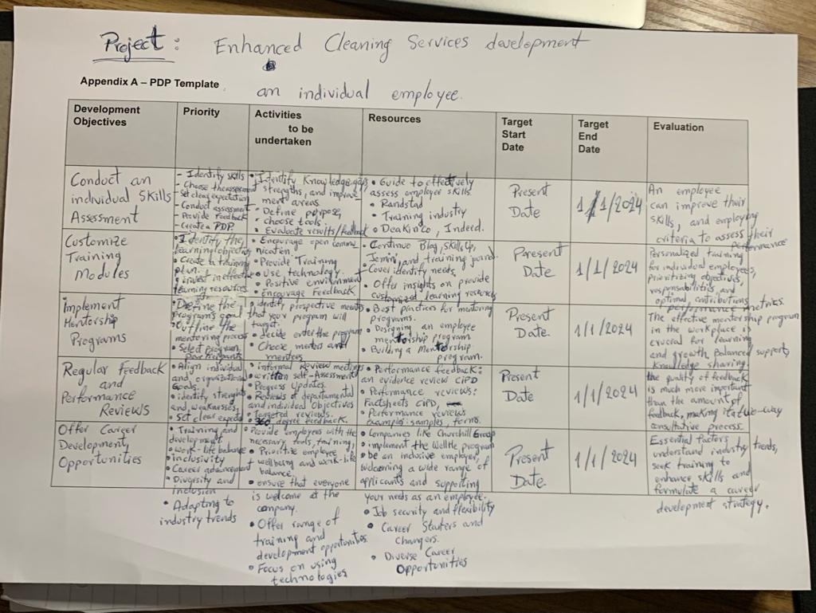
Project name: Enhanced Cleaning Services Development (PDP) of an Individual Employee

