

The Impact of Virtual Learning Environment on Student Learning Experience

Name: Mariana-Larisa Neagoe

Student ID: 1921885

Lecturer: Olusoyi Ashaye

Contents
Introduction 2
Background 3
Aims and Objectives 5
Method 5
Results 7
Discussion 19
Conclusion 21
Appendix 22
References 27

Introduction

Peter Drucker said: ,,The new information technology… Internet and email… have practically eliminated the costs of communication’’.
In the end this is all about, people are trying to find better ways to acquire information, to progress and make their life easier.
According to Margaret Rouse a Virtual Learning Environment (VLE) is a process that is meant to improve students learning experience by the help of instruments like computers, tablets etc and of course the most important aspect, the use of internet. All the activities are taking place in the online medium, there are platforms that are especially created to enhance the process of teaching or learning, electronic mail boxes, chat rooms, virtual libraries, means to inform and to assess the students.
The times we are living are difficult ones, we had to adapt and make so many changes in our life in order to cope with the pandemic reality. Most of the learning process was done through an online platform these days as a result of the lock down period and as a measure of maintaining the population safe.
This report is actually a research based on secondary and primary data collection and its purpose is to analyse and see the impact of VLE over the students learning experience.

Background

Amanda Dean (2020) considers that secondary research is based on collecting data that were gather by other people, for their own work. It is a method that does not imply the use of many resources like: money, time, people. It has a broad utilization in fields like medicine, marketing, sociology and politics and is presented under the form od essays, books, encyclopaedias, treaties. The main disadvantages result in data too old to be used or of low quality in regards with the researcher expectations.
For my secondary research a used an interview completed by Jisc, a not-for profit organisation that analyse and offers solutions for digital environment for universities, and colleges.
According to Zac Gribble and John Sumpter (2020) the research was conducted on more than 600 people involved in the academic activities, from this there were more than 200 students.
From the report, it is noticeable that the respondents were more than happy to contribute to the interview and share their honest opinion about online learning.

Jisc prepared a set of questions, that had to be answered by the students:

- How important is VLE in the learning process?
Most of the students considered VLE as essential for their learning. Here, the students considered as very important their capabilities to access the online platform, to take part in the online classes. Also, the unlimited access to an online library, to the classes that were introduced to them, the files with the lessons that allows them to prepare before the assignments or exams or to recover any missed class.
- How the content is transmitted through VLE? Do they have access to the files?
Majority of the students said that is cheaper to access the VLE platform from a desktop or a laptop. If they access it from phone and they don’t have WIFI access it might end up too expensive. Also, quality of the learning resources is higher when accessing from a laptop or a computer.
- What is the route that they access VLE?
There are some colleges and universities that have a designated hub, other have access through organisational web sites. Many students did not receive a proper training on how to access an online learning program and this was frustrating for them.
- What is the advantage of using VLE?
The best feature of VLE is the fact that they can have access on it from any place, they are in permanent contact with the University. All the study resources are in one place and they can always contact their classmates or the teachers.
- What is missing from VLE?
A big number of students considered that online platform should be more motivating, more interactive, they could improve their feed-back system.
- There are any challenges or barriers in using the VLE?
Many students believed that the experience of the teacher, the way the information is structured, the fact that they might lose time trying to find the proper lesson or lack of interaction between the teacher and the students, all together they created barriers or challenges in VLE’s use.

The conclusions of the interview were that most of the student felt that VLE is an efficient instrument for their learning, even if some of them did not have access to on online learning platform.
The easy access to learning resources, the way you can submit the assignments, were positive aspects of VLE usage.
The students have higher expectation regarding the improvement of VLE, to the extent that they will be capable to see their information from any digital device.
Learners are waiting to see a consistency of VLE, with no technical issues when they access the platform and also, they expect more support from universities.

Aims and Objectives

As a student of UWTSD, active user of VLE, I experienced the use of an online platform and also its utility. The aim of this report, especially the purpose of the primary data research I am conducting is to identify the impact of VLE on student learning, to emphasize the best practiced used in VLE and if there are measures that we can take in order to improve this process. Students learning experience has been really challenged due to the pandemic, so moreover, the Universities needs to put in place a system that satisfies the students need and boost their performance in the process of learning.

Method

There are few data collection tools that we can use to conduct a primary research: a survey, an interview, a questionnaire, on observation.
For my report I will use as a primary research data collection a questionnaire.
People started to use questionnaires almost two hundred years ago. First questionnaire used as a way to gather information was designed in London, in 1838.
Questionnaires have been used since the 19th century. Often used as a method for collecting information, the questionnaire was first developed in London in 1838.
The purpose of a questionnaire is to gather information from subjects, in order to conduct studies or surveys, using questions with more than one answer. (Reddy, n.d.).
For my primary research I used a structured questionnaire, formed by 19 close-ended questions:
- Leading questions -
- Dichotomous questions
- Likert scale questions
In order to analyse the answers, I used the quantitative method based on charts: pie charts, bar charts.
The design of the questionnaire was simple, split in three main categories:
- Personal information
- Access to online platform and use VLE
- Personal experience using VLE resources
The questions were simple, not too long, to make sure that the respondents will be willing to answer to my questions.
I used a sample of 50 people, males and females, with the age range between 18-55 years. They are all living on the United Kingdom but they are not necessarily born here.
They had to sign a consent form according to the Data Protection Act 1998.
Due to the pandemic, they received the questionnaires via email and I collected it in the same way.

Results

The dominant age range of the students is 18-24%.
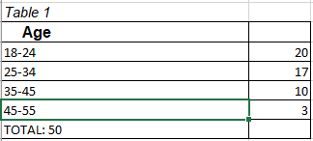
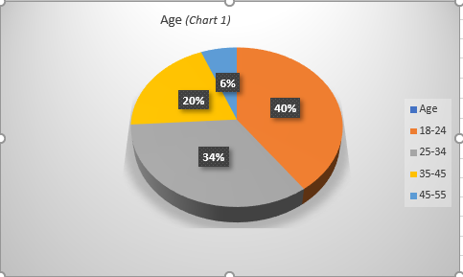

Both categories, man and women are almost equally participants to the VLE studies.
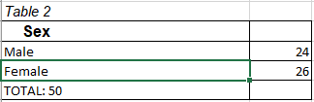
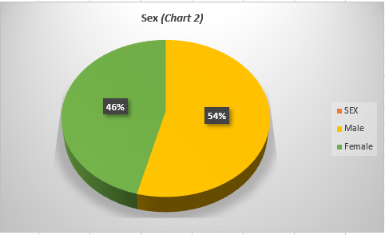

Over 60% of the respondents declared that English is not their first language.
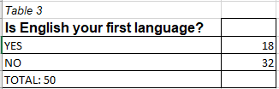
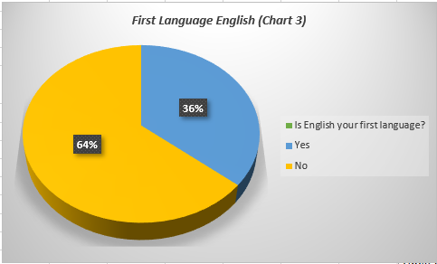

Almost 100% students have a computer at their residency address.
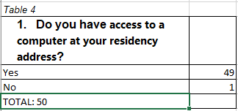
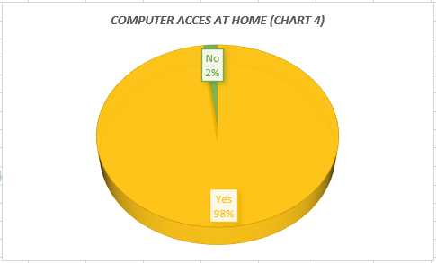

A large number of students use a broadband connection when they access the VLE.
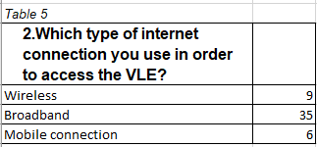

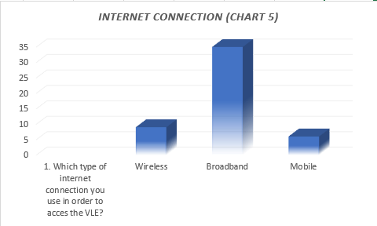
According to the below chart most of the students are using computers to access the VLE.
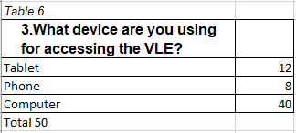
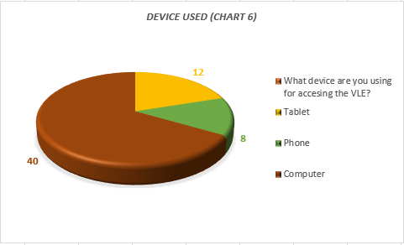;l;

Most of my questionnaire subjects did not use VLE before this course.
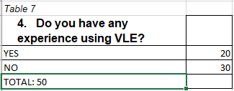
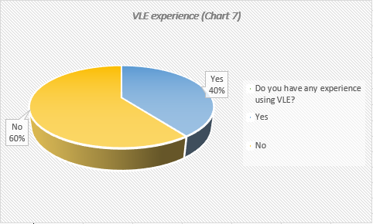

The majority of learners are quite confident in using VLE.
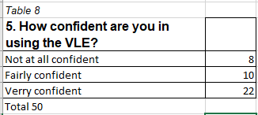
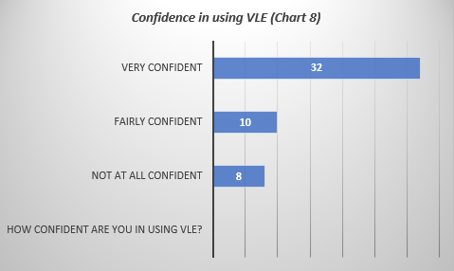

From the below chart the conclusion is that 27 students are accessing the VLE from home.
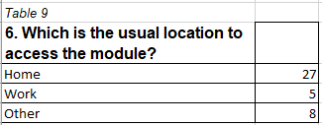
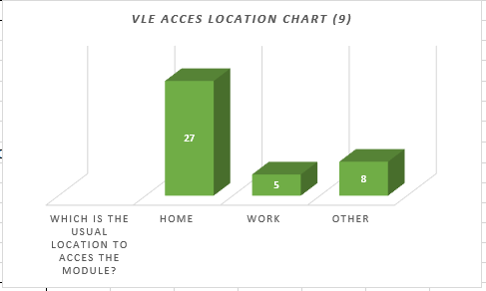

There is a small percent of students that confronts with technical issues when they access VLE.
Table 10
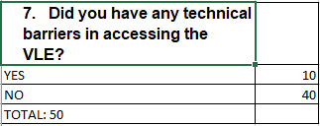
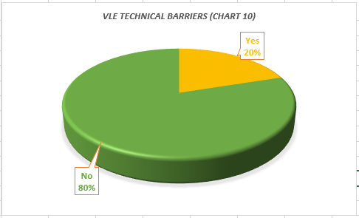
35% students are accessing the VLE with the purpose of study, every other day.
Table 11
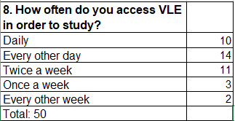
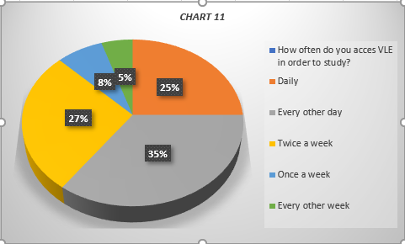
60% of the questionnaire participants consider VLE very helpful and only 4% see VLE as an unhelpful platform.
TABLE 12
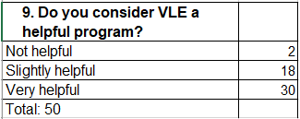
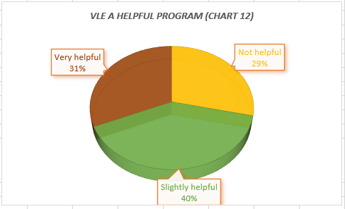
50% of students declared that face-to-face communication is not at all important.
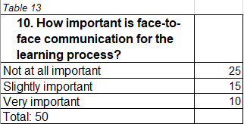
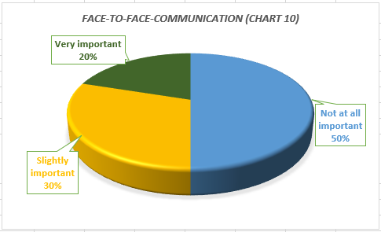

From the below chart it is notticed that interaction between group members are not really great, most of them communicate once a week.
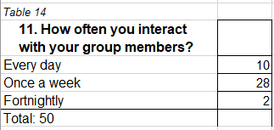
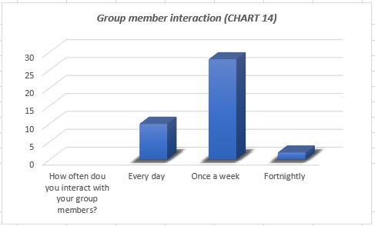

Observing the below chart, time savings is the most positive aspect of VLE learning.
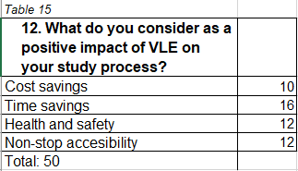
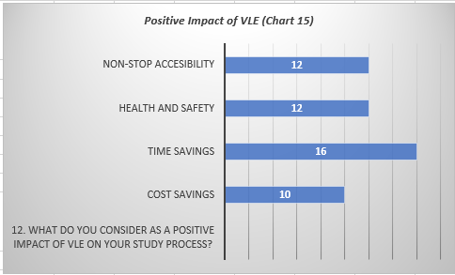

Poor Communication is considered as the most negative characteristic of VLE.
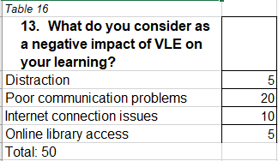

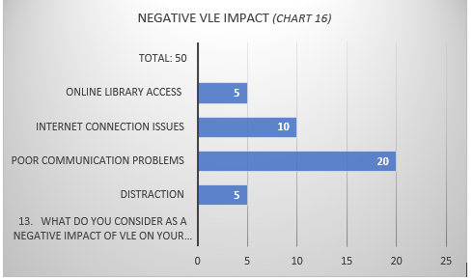

Analysing the Likert Scale table, overall, the satisfaction of the students regarding the use of VLE platform it is most of the time over 50%.
Table 17
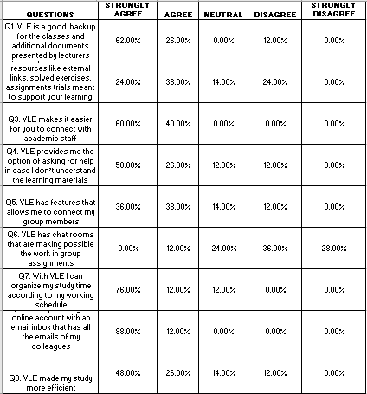

Discussion
Now that both data researches, the secondary and the primary one, has been conducted what are the results regarding the VLE impact on the student learning experience?
The secondary research showed us that a majority of students considered VLE as an efficient platform that improves a lot the learning process for the students. Even though there are few shortcomings like the restricted access in some of the case, there are improvements that can be brought, especially regarding the technical issues and the interactivity of the platform, VLE is definitely going to have a powerful impact on students learning experience.
There are few considerations to be made analysing the data collected by the help of the questionnaire.
The majority of the students that are using VLE are aged between 18-24. The number of men versus women’s attending VLE classes is slightly minor.
As we could see in Table 3, 80% of respondents declared that English is not their first language. This means that they might have difficulties during the classes, so the academic staff need to put in place programs that are meant help this student.
A positive aspect is the fact that most of the students have a computer at home, as it is showed in Table 4. This will make the VLE learning process easier and accessible for most of the learners.
Table 5 and Table 6 are providing details about the internet connection and the device they are using in order to access the online platform. Most of them are using the broadband, thing that makes the study process cheaper as they don’t have to pay for a mobile internet provider and also, their learning experience is enhanced by the use of computer, the performance is way better as the computer enables the access of more documents than an iPad or a phone.
Another positive aspect that Is shown in Table 8 and Table 9 is the fact that even though the majority of the students did not use VLE before this course, they are confident and in their capabilities of accessing the platform.
After analysing the data from all the tables my opinion is that the interaction between colleagues is not great. It is a big challenge for the University to improve this aspect, giving the fact that the times that we are living does not allows a direct interaction. And this social interaction is indeed a problem as it is mentioned in more than one place (Table 16).
Analysing the Likert scale table, areas that should be improved are again the ones that facilitate student’s communication, especially when they are forming study groups.

Conclusion
All this research has emphasized the importance of VLE in this new era that we are living. It is a field that is constantly developing and we need to keep up with times. At the end of the day is just another tool that will make our life easier. All we have to do is to be curious, make enquiries and stay tuned to the progress.

Appendix

The Impact of Virtual Learning Environment on
Student Learning Experience
This questionnaire is a quantitative research created with the academic purpose of analysing the effect of Virtual Learning Environment (VLE) on UWTSD student’s learning experience.
Please fill in this questionnaire and try to be as precisely as possible.

Data Protection
All the information we collect will be treated as confidential: it will not be released to third party. According to the Data Protection Act 1998 you need to sign the consent form:
I agree that this information, and the data collected from me, may be held and processed by the research team for the purpose of research.
Signature: | Date:

I. Information about yourself

Age:
18-24  25-34  35-45  36-55
Sex:
❑ Male  Female
Is English your first language?
❑ Yes  No

II. Your access to a networked computer and the use of Moodle
- Do you have access to a computer at your residency address?
Yes
No
- Which type of internet connection you use in order to access the VLE?
Wireless
Broadband
Mobile connection
- What device are you using for accessing the VLE?
Tablet
Phone
Computer
- Do you have any experience using VLE?
Yes
No
- How confident are you in using the VLE?
❑ Not at all confident  Fairly confident  Very confident
- Which is the usual location to access the module?
Home
Work
Other
- Did you have any technical barriers in accessing the VLE?
No
Yes
Sometimes
- How often do you access VLE in order to study?
Daily
Every other day
Twice a week
Once a week
Less than once a week
Occasionally
- Do you consider VLE a helpful program?
Not helpful
Slightly helpful
Very helpful
- How important is face-to-face communication for you?
Not at all important
Slightly important
Very important
- How often you interact with your group members?
Every day
Once a week
Fortnightly

- What do you consider as a positive impact of VLE in your study process?
Cost savings
Time savings
Health and safety
Accessible any time
- What do you consider as a negative impact of VLE on your learning?
Distraction
Poor communication problems
Internet connection issues
Online library access

C. Your experience of using the resources
Indicate your opinion regarding VLE resource using the following statements: statements about using it (please circle your response)
1= Strongly agree; 2 = Agree; 3 = Neutral; 4 = Disagree and
5 = Strongly Disagree

 | Q1. VLE is a good backup for the classes and additional documents presented by lecturers | 1 | 2 | 3 | 4 |  | 5
 | Q2. VLE provides lots of resources like external links, solved exercises, assignments trials meant to support your learning | 1 | 2 | 3 | 4 |  | 5
 | Q3. VLE makes it easier for you to connect with academic staff | 1 | 2 | 3 | 4 |  | 5
 | Q4. VLE provides me the option of asking for help in case I don’t understand the learning materials | 1 | 2 | 3 | 4 |  | 5
 | Q5. VLE has features that allows me to connect my group members | 1 | 2 | 3 | 4 |  | 5
 | Q6. VLE has chat rooms that are making possible the work in group assignments | 1 | 2 | 3 | 4 |  | 5
 | Q7. With VLE I can organize my study time according to my working schedule | 1 | 2 | 3 | 4 |  | 5
 | Q8. VLE is providing an online account with an email inbox that has all the emails of my colleagues | 1 | 2 | 3 | 4 |  | 5
 | Q9. VLE made my study more efficient | 1 | 2 | 3 | 4 |  | 5

Please mark all the answers.
Thank you for your collaborations and if you are willing to take part on further research project please provide the below:

Email address: …………………………………………………… Mobile/Tel no: …………………………………………………………

References

Rouse, M. (n.d.), Virtual learning environment (VLE) or managed learning environment (MLE), Available at: https://whatis.techtarget.com/definition/virtual-learning-environment-VLE-or-managed-learning-environment-MLE, (Accessed on 16DEC20)
Dean, A. (2020), What is Secondary Research? Available at: https://www.wise-geek.com/what-is-secondary-research.htm , (Accessed on 16DEC20)
Gribble, Z., Sumpter, J. (2018). VLE review report 2020, Available at: https://repository.jisc.ac.uk/8101/1/vle-review-report-2020.pdf (Accessed on 21DEC2020).
Reddy, C. (n.d.) Questionnaires: types, advantages and disadvantages. Available at: https://content.wisestep.com/questionnaire-types-advantages-disadvantages/, (Accessed on 16DEC20)

