Appendices

- Ethics Form……………………………………………. Appendix 1
- Learner Interview Questions…………………………. Appendix 2
- Learner Interview Responses………………………...Appendix 3
- Staff Questionnaire Questions………………………. Appendix 4
- Staff Questionnaire Responses……………………...Appendix 5
- Information Sheet……………………………………...Appendix 6
- Consent Form…………………………………………. Appendix 7

Appendix 1

Appendix 2

Interview schedule

- Do you feel happy in school? Why is that? Can you tell me more about that?, Is this always the case?..

- What is your favourite part of school? Why is that?.. Is there any particular reason for your answer?

- What activities or subjects do you enjoy the most? Why?..

- Does sir/miss often ask how you are feeling? how does she do this>

- Do you use a daily check in? how does this work?

- Do you always put your name next to how you are really feeling?

- Is there any other way that miss checks if your okay? Any games ?

- What do you like about the check in?

- What do you not like about the check-in? How would you change it?

- What happens if you put sad on the check in?

- Is there anything else you’d like to tell me about it?

Appendix 3
Interviewer- do you feel happy in school ?
Child A,B,C - yes
Interviewer - great ,so you're all saying yes, Josh can you tell me why you feel happy in school?
Child A - I don't know
Interviewer- does anyone want to help Jack why do they feel happy ? go on!
Child B – umm I feel happy because I get to go on action stations
Interviewer- waw, that does sound fun
Child C- I know , I know I’m so happy in school because they take care of everyone and look out for us to make sure were all okay
Interviewer- awh, that is lovely!
Child A- oh I know now, because I can see my friends!
Interviewer, that’s a good reason ! These are all very good answers!
Child B- oh wait, I have another one- because you get to learn more!
Interviewer - that’s very true!
Child B – and they just love us !
Interviewer – im sure of that! Now then, can anyone tell me what is your favourite part about school?
Child C- well, on Friday we get golden time
Interviewer – is golden time fun?
Child C- Yes
Child B- its like a really long action station
Child C- and ive got one more answer, I love my teachers they just help me with stuff and make sure I’m okay
Interviewer- aw , that is lovely I am so pleased to hear that!
Child B- yeah they do!
Interviewer – that’s brilliant! Right, my next question for you all is , does miss often ask how you are feeling?
Child A- no , we use buckets and they have our faces on it then we put a stick in the bucket of how we are feeling
Child B- no, we have a hook with our faces on like a little branch and its either drust,grac,cyffroes or hapus and we just put it on a tree with a hook now the teachers know how were feeling
Child A – yeah, we do the same but with buckets !
Interviewer – I think I saw them actually when I came for a little walk to your classes! Are they called check-ins?
Child A,B,C – yes
Interviewer- so, say for example you were sad so you put your face in the sad bucket what happens then?
Child c- Miss will come to speak to us
Child A- and she asks us why we are sad
Interviewer – that’s good! So do you always put your face on the right emotion that you’re feeling?
Child B- yes
Child C- I do
Child A – no
Interviewer – why is that ?
Child A – I don’t know
Interviewer- well its good for Miss to know how your feeling so that she can help you
Child A- most of the time I do feel happy
Interviewer- well that’s good then!
Interviewer- Is there any other way that Miss asks if your okay? Weve spoken about the check-in system but is there anything else
Child A,B,C – no
Interviewer – so you just do the check in?
Child A- yep,
Interviewer- okay, so what do you like about the check-in ?
Child C- Nothing
Interviewer- nothing at all?
Child b- I don’t like it because I have to find my name and it takes ages then I just put my name in the same tub as everyone else
Child C- yeah some of them flip over and it’s hard to find
Child A- it’s boring!
Interviewer- so you don’t like anything about the check-in system?
Child A- no
Child C- nothing at all
Interviewer- would you prefer to do something else about showing your emotions to miss instead of the check-in?
Child A,B,C – yes!
Interviewer- Okay, so like what?
Child A- Maybe play a game.
Child C – Yeah
Child B- And we can say our feelings in a game
Interviewer- that is a brilliant idea, I love it!

Appendix 4

1. How effective would you deem the use of a ''check-in'' system in line with supporting wellbeing?

Very effective
Somewhat effective
Somewhat ineffective
Very ineffective

2. In terms of curriculum design how essential would you deem wellbeing?

Most important
Relatively important
Not important

3. How would you deem the resources available to students to support wellbeing within the school?
.
Highly effective
Somewhat effective
Relatively effective

4. Have you faced any challenges whilst employing any wellbeing strategies/interventions?
Yes
No

5. How often is wellbeing implemented within your classroom as a primary focus?
Daily
Weekly
Monthly

Appendix 5

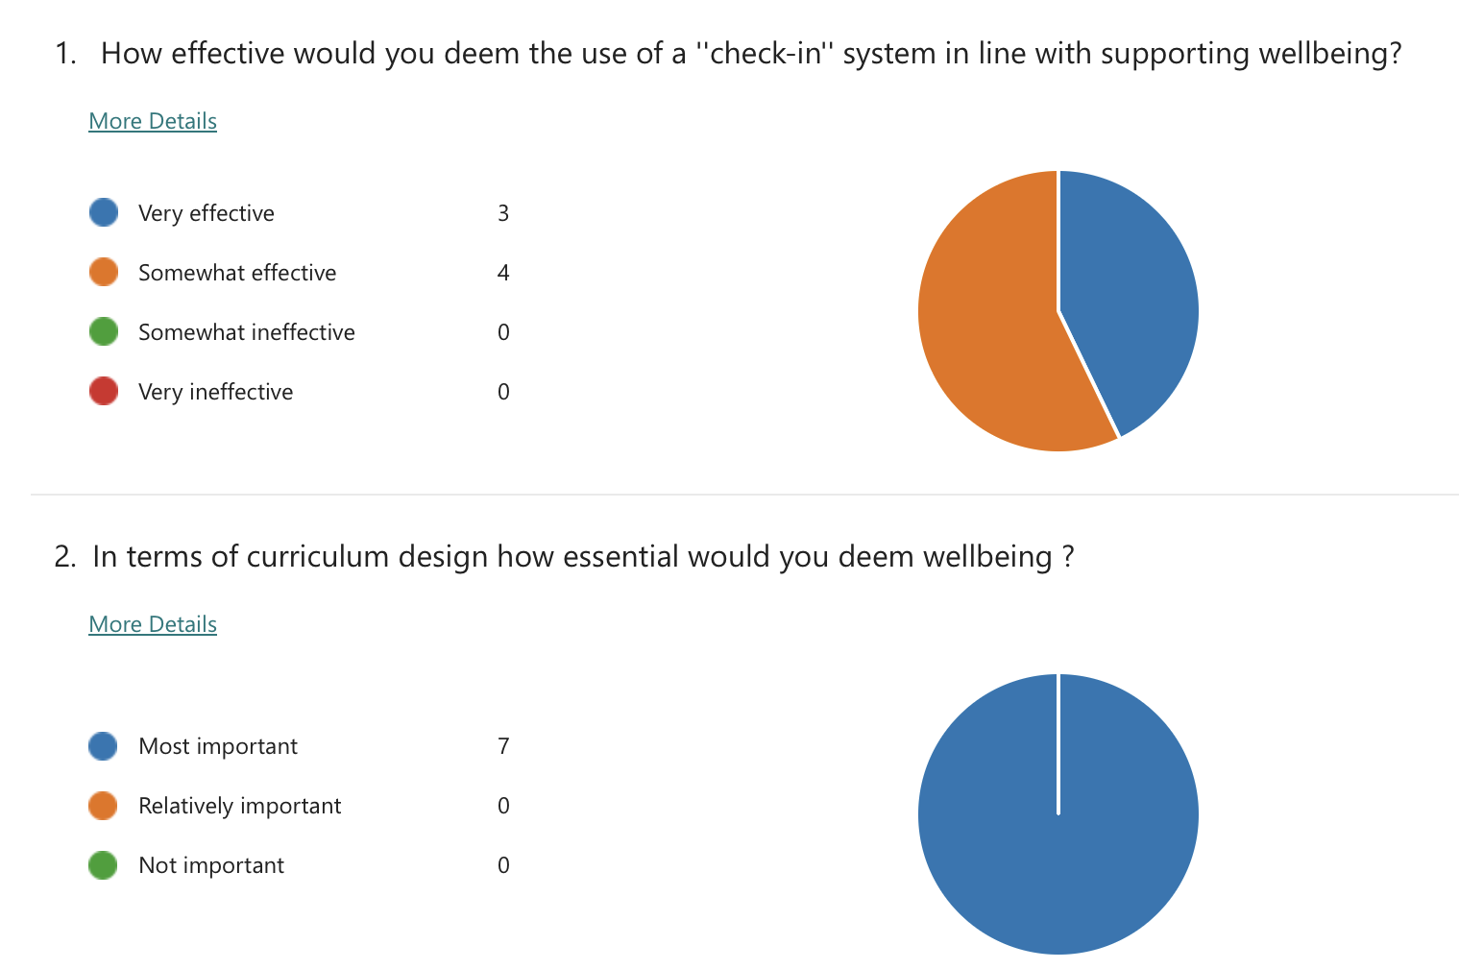

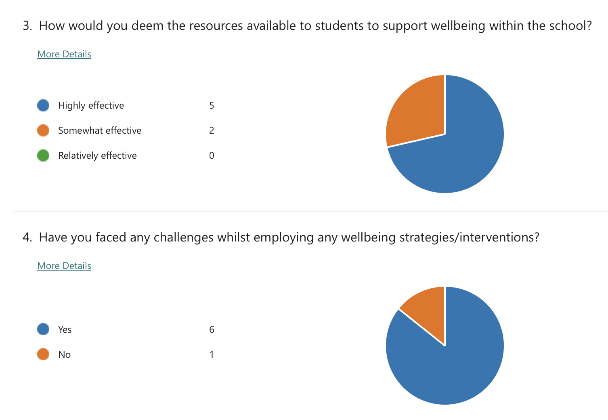

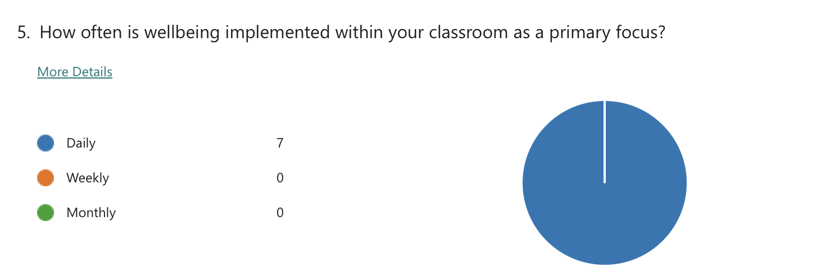

Appendix 6

Dear Parent / Guardian,

My name is Gwen, and I am studying for a BAEd qualification at Yr Athrofa, University of Wales Trinity Saint David.

I would like to invite your child to participate in my research project. The title of the project is ‘’what are staff and learners’ perception of the resources and support available to the schools youngest learners in relation to wellbeing?’’. Through your child’s participation, I hope to gather their thoughts and opinions on this topic and devise a presentation at the end of the week to outline my findings, these will be discussed with stakeholders within the school.

The process of my research project will include interviewing children in focus groups and observing whole-class activities. All names will be kept strictly confidential and will only be known by myself, the researcher. Your child’s participation in this study is completely voluntary so you or your child can withdraw from the study at any stage. Your child will also be asked to give their assent before the beginning of the study.

After careful and precise analysis of the data obtained from the lesson observation and group interview, I would be happy to provide you with a copy of the findings at your request. The results of the research will be discussed in a university assignment that will contribute to my QTS course. The results of this study will be stored on a one drive through HWB which is encrypted with a password and all raw data will be destroyed once the assessment has been marked.

I thank you in advance for your time.

Yours sincerely,

Gwen Quick Hughes

Appendix 7

Name of Researcher: Gwen Quick Hughes

Please initial box

1.I confirm that I have read and understand the information sheet dated 27.11.23 for the above study. 

2.I understand that my child’s participation is voluntary and that I am free to withdraw my child from the study at any time, without giving any reason.

3. I understand that my child can choose to withdraw at any time, without giving a reason.

4. I understand that the information given by my child will be used in a university assignment
.

5. I understand that my child’s name will not appear at any time.

6. I agree for my child to take part in the above study.

_____________________ _____________________________ __________
Child’s name Parent signature Date

When completed, please return this slip to the school by the 27th of November 2023

