Developing Professional Practice

Name: Nicole Phillips

CIPD Membership Number: 48885302

Date: 16/11/2017

Word count (max: 2600 words)

I declare that this assignment is my own work and that any information obtained from books and other sources have been appropriately referenced.

Signed: N Phillips Date: 16/11/2017

Table of Contents
Activity 1 2
1.1: What it means to be a HR professional 2
1.2: The CIPD Profession Map 2
1.2.1: Ten Professional Areas 3
1.2.2: Eight Behaviours 3
1.2.3: Four Bands of Professional Competence 3
Activity 2 5
2.1: Group Dynamics 5
2.2: Conflict Resolution 6
Activity 3 7
3.1: Project Management 7
3.1.1: Problem-Solving 7
Activity 4 8
4.1: CIPD Profession Map – Self Assessment 8
4.2: Professional Development Plan (PDP) 10
4.3: Reflective Summary 11

Activity 1

1.1: What it means to be a HR professional
There has been significant changes and development to the HR function over recent years, with HR professionals moving from a role that was traditionally seen as administrative with very basic and limited contribution to the overall organisation success, to HR professionals that personally contribute to organisational success through efficient and effective HR management (Perkins, 2016).
“A key difference between traditional personnel management and what is required of a successful, contemporary HR function can be summed up by the phrase ‘adding value’” (Perkins, 2016 p. 69) and it is becoming increasingly important for HR professionals to be ‘thinking performers’, consciously contributing to an organisation’s objectives by applying expert knowledge, challenging others and introducing an effective people-management and people-leadership culture (Perkins, 2016). According to a CIPD Twitter Poll, ‘being an expert on people’ is the most important characteristic of a HR professional, with ‘being business savvy’ the second most important (CIPD, 2016).
It is key to note that Continuous Personal Development has become significantly important in sustaining HR professionalism and credibility. Continuously updating skills and knowledge is essential in an ever-changing business world (Woodhams, et al., 2016). This has recently become particularly relevant in my own career, where I am facing a company restructure with the HR function moving from store based People Managers to centralised ‘People Partnering’. On evaluating my own ability to progress to the new role of ‘People Partner’ it soon became clear to me that CPD has not been a priority and focus for me in the past and something I needed to act on immediately. By enrolling on to CIPD qualification, I soon recognised that although I have extensive experience as a HR manager in retail for over 20 years, my role has been very much administrative and that of an implementer of HR policies and practices and that in fact, my own skills and knowledge have become somewhat out of date. This self-recognition has inspired me to build on my experience and develop my skills and knowledge to that of a HR professional.
The CIPD’s HR Profession Map (Woodhams, et al., 2016) which details the competencies HR professionals need now and in the foreseeable future, is a tool I will use to help prioritise my areas of development now and continuously during my professional and career progression.

1.2: The CIPD Profession Map
Launched in 2009, the CIPD profession map was developed following extensive research and collaboration with organisations across the world. The map describes activities, knowledge and behaviours that are demonstrated by the most successful HR professionals (CIPD, 2015).
The map can be used by individuals, teams and organisations to understand ‘what good looks like’ as a benchmark for HR professionalism. It can be used as a development tool to identify areas for improvement or as an opportunity to build professional capability. The map is continuously refreshed and updated to ensure it remains focussed and relevant to the future of HR (CIPD, 2015).
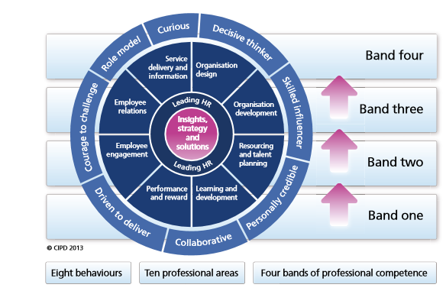
Figure 1 shows ten professional areas, eight behaviours and four bands of professional competence (CIPD, 2015).

1.2.1: Ten Professional Areas
The heart of the map contains two core areas (Woodhams, et al., 2016);
Insights, strategy and solutions: This details the knowledge, skills and behaviours needed to develop understanding of the business and identify strategies and solutions to meet organisational needs now and for the future.
Leading HR: This area details the need for HR professionals to act as role model leaders, maximising the contribution that the HR function makes to the organisation through individual effort as well as the development of others across the organisation.
These two core areas underpin the direction of HR professionalism and are applicable to all HR professionals, regardless of specific role or stage of career (CIPD, 2015). Alongside the two core areas, are an additional eight functional areas. The relevance of these areas is dependent on the specific role being carried out within the HR function and the organisation’s business agenda (Woodhams, et al., 2016).

1.2.2: Eight Behaviours
Eight behaviours are defined within the map. These are the behaviours that HR professionals need to demonstrate when carrying out their activities. These behaviours are relevant to all HR professionals.

1.2.3: Four Bands of Professional Competence
The ten professional areas and eight behaviours within the map are supported by four bands of professional competence. These demonstrate that for each activity and behaviour there are four levels of professional competence (Table 1). As an example, individuals working at Band One level would ‘keep in mind the organisation’s issues and priorities in all activities’, whereas individuals working at Band 2 level would ‘act with a commercial mindset and sound point of view on the organisation and what can drive continuous improvement’ (CIPD, 2015). It is important to note here that the map not only defines the behaviours and activities in HR professionalism, but it also highlights the progression across four levels of professionalism. This can be used as a key tool to help professionals develop and progress through different levels of competence, in line with career and organisation progression (Woodhams, et al., 2016).
Area of  Competence | Band One | Band Two | Band Three | Band Four
Personal Leadership and professional impact | 2.1.1 Keep in mind the organisation’s issues and priorities in all activities. | 2.1.2 Act with a commercial mindset and sound point of view on the organisation and what can drive continuous improvement. | 2.1.3 Act with a commercial mindset and strong point of view of the organisation and what will most likely drive sustained organisation performance. | 2.1.4 Act as a business leader with a strong sense of purpose and a dynamic vision for HR/specialist area and the wider organisation.
TABLe 1 shows an extract from the professional competence bands included in the CIPD’s HR profession map (CIPD, 2015)
This is an example of a competency used to inform my own professional development plan (Activity 4), in my development to HR Leader, progressing from Band 1 to Band 2.

Activity 2
Effective teamworking is crucial to the success of an organisation and is dependent on individuals being able to work with one another and in groups. HR professionals are no exception to this and must work with individuals within their function, as well as teams and individuals across the organisation and externally in the business world. Not only will HR professionals work in various teams within an organisation, it is crucial that they understand the effectiveness of team situations, particularly focussing on group dynamics and conflict resolution (Perkins, 2016).

2.1: Group Dynamics
The Oxford Dictionary defines group dynamics as {The study or use of the processes involved when people in a group interact} (Dictionary).
In 1965, Bruce Tuckman published his ‘Performing Team – Development Model’ describing the theory behind group development stages and behaviours (Tuckman, 1965).
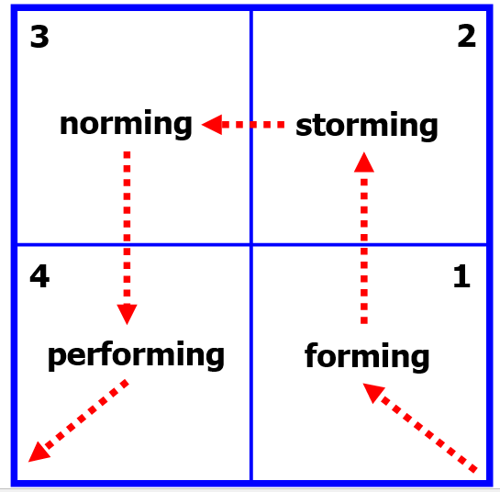
Figure 2 Bruce Tuckman's 1965 'Performing Team – Development Model' (Tuckman, 1965)
The model explains that as a team develops, it’s progression moves through four stages;
- Forming
- Storming
- Norming
- Performing
Stage | Team Behaviours | Team Leader’s Style
Forming | Polite  Watchful  Avoid Issues | Clear instructions  High direction  Structures the team
Storming | Arguing  Interrupting  Challenging the leader  Withdrawal  Resistance | Allows conflict  Brainstorms problems
Norming | Active listening  Participation by all  Self-disclosure  Socialising | Encourage  Looks for consensus  Keeps focus  Feedback
Performing | Synergy  High performing team | Takes a back seat
Table 2 summarises the team behaviours and team leader’s style seen at each stage of the developing team as described in Tuckman’s model (Tuckman, 1965)
This model relates to a recent career experience I have encountered when I was asked to be part of a leadership team that was to replace the leadership team running a store in our Company; a store that was renowned for underperformance and being problematic from a business and HR perspective.
A key point from Tuckman’s theory is that when there are changes to a team, the team will revert back to the ‘forming stage’. In my experience, being part of the replacement leadership team in this store, I can relate to this Tuckman theory.
Initial weeks instore showed signs of the team in the forming stage, with team managers being particularly polite, helpful and somewhat wary of our agenda as a leadership team. The store manager demonstrated the styles of clear instructions and high direction.
The next stage of our team development I would clearly link to the storming stage, as team managers started to show distrust and resentment to the team situation. Here we saw signs of disengagement, disagreement and negative challenge to the leadership team, with some team members showing little effort and interest in team and individual performance
It was at this stage, I could relate to the skills of conflict resolution;

2.2: Conflict Resolution
In any business environment, where different individuals with different personalities and agendas work together, conflict is inevitable, and it is important that HR professionals recognise this and understand the skills of collaborative working and conflict resolution (Perkins, 2016).
Conflict is natural and can be positive when faced in to quickly and professionally. Through clear and open communication, dealing with conflict is an opportunity to fully explore the issues and views of individuals and can be used to build relationships and strengthen the team unit (Berkeley).
This was the approach I took in store, initially applying the skill of ‘Active Listening’ to gather information from the team to understand and get to the true cause of the conflict. This was achieved through focus groups, one-to-one meetings and a cultural review (Appendix 1 in E-Portfolio).
Information gathered showed that resentment and distrust was a key contributor to the conflict within the team and it became clear that it was necessary to build relationships between team managers and the leadership team by re-focussing and agreeing the team goals.
An opportunity was identified here to deliver a ‘Team Building’ exercise as a way to influence and negotiate with all team members to engage with the business plan of improving the store’s business and cultural performance.
The teambuilding exercise was a lever to take the team from the storming stage to the norming stage of team performance, with the ultimate goal of moving to the performing stage, working as a high performing team. I therefore built the agenda for the teambuilding day with this objective in (Appendix 2 in E-Portfolio).

Activity 3
The ability to manage and prioritise time spent on activities and tasks is a skill that all HR professionals need to demonstrate. In every-day working life, HR professionals are faced with many activities and tasks to prioritise and the ability to plan a structured approach to project management is key to the successful delivery of such tasks (Perkins, 2016).

3.1: Project Management
A project can be split in to five basic steps (Perkins, 2016);
- initiation
- planning and design
- execution
- monitoring and controlling
- completion
This approach was followed in a recent project I managed in my own Company; The festive recruitment process,
At the initiation stage I took the opportunity to review the store’s approach to festive recruitment last year, to help identify benefits and opportunities to build into this year’s plan. It became evident that the store had not achieved the required recruitment targets in previous years which had put a strain on resourcing at the busiest trading time of the year. It was also apparent that the store team had faced many barriers and problems throughout the recruitment process which prevented them achieving the required targets.
I quickly identified that the same approach to the recruitment process had been applied for many years with team managers taking an individual, unplanned approach to try and achieve recruitment targets for their own areas, often working in conflict with other managers as there was no overall store recruitment plan and no team objectives agreed. There was also no monitoring or review of progress to support the achievement of targets and improvement of process.
One significant change I proposed at this stage, was to introduce a dedicated recruitment team to plan, execute and complete a recruitment plan for the store. I was soon met with much resistance from the management team as they were very much used to taking charge of their own recruitment and appeared somewhat nervous to allow a separate team to do this on their behalf.
At that point, I quickly identified the need to take a team problem-solving approach as a way of negotiating, influencing and gaining team buy-in before finalising and executing this year’s recruitment plan.

3.1.1: Problem-Solving Together
At Tesco, a seven-stage process is used as part of our ‘Problem Solving Together’ process (figure 3).
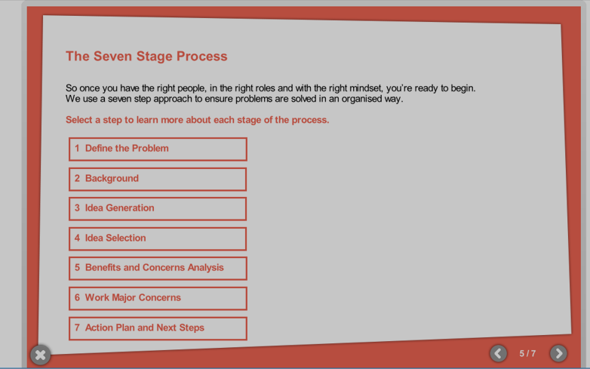
Figure 3 shows an abstract from Tesco’s ‘Problem Solving Together’ process (Tesco)

This process was applied by inviting all managers to a problem-solving meeting where the ‘brainstorming’ technique was used. This is a powerful technique for generating ideas, ensuring all team members can share their views and ideas and be part of building the plan. This motivates teams and increases team buy-in and engagement (Businessballs).
I took the role of facilitator at the meeting and used the learning’s identified from last year’s recruitment report as a background to the problem and ensured that the team were clear on this year’s recruitment objectives, with the aim of the meeting to generate ideas and solutions to help build this year’s plan.
At the end of the brainstorming session, the ideas were evaluated and prioritised to create next steps and actions for this year’s festive recruitment plan (Appendix 3 in E-Portfolio).
The agreed activities for the plan were then put together in a ‘Gantt chart’ (Table 3), a tool that is used to manage timescales and workload, monitor progress and help identify when plans need correction or review (Perkins, 2016).
I reviewed the chart at a weekly meeting with the recruitment team and it proved to be an invaluable tool in reviewing performance against our objectives and for keeping the management team updated on progress.
Actions were identified, and corrections and additions made to the plan when it was found that things were off track (Table 4).
Tesco Week Number | What’s Gone Well | What’s Not Gone Well | Action Needed
32 | Recruitment team on board and trained.  Plan to achieve weekly recruitment numbers is in place by team. | Low applicant numbers | More presence of recruitment team on shop floor, promoting vacancies and how to apply.
33 | Recruitment team focus ensures applicants are being responded to quickly. | Still low applicant numbers | Network with local stores to arrange contact with applicants from surrounding  areas.
34 | Applicants are being looked after throughout the process with timely communication | Applicant numbers are slowing down and do not fulfil needs for vacancies remaining | Network with local job centres and work providers e.g. Remploy
TABLE 4: EXAMPLES OF ACTIONS IDENTIFIED AT WEEKLY REVIEW MEETINGS
To further support the execution of the plan, the recruitment team set out their own weekly activity planner (Appendix 4 in E-Portfolio), to ensure their specific actions and weekly targets were planned and achieved. Again, this proved to be an invaluable tool in keeping measures on track and by making it a focal point and visible to all, the management team were constantly able to review the progress of their own areas which gave them further confidence and buy-in to the plan.
This year, festive recruitment targets were achieved, and timescales met. Feedback from applicants describes that they were looked after in terms of timely communication and induction process. Feedback from the management team was extremely positive that they had felt fully updated and involved, giving them confidence in the plan while they were able to focus on adding value to the daily routines of their departments at a very busy trading time and the success of the plan means that they are fully resourced in time for the festive period ahead.

Activity 4

4.1: CIPD Profession Map – Self Assessment
On completing a CIPD profession map self-assessment (figure 4), I focussed on the two core professional areas along with the area of Organisational Development. The reason for focussing on the latter is that this ties in with my current career challenge of moving to ‘People Partnering’ and the desire to progress to a HR professional. Both require the need for my skills to be more commercially aware and aligned to business priorities.
In addition to the three professional areas, I chose to assess myself against the behaviours of; Curious, Decisive Thinker and collaborative. These link to skill gaps I have identified from feedback in my current role as well as seeing them as a priority linked to the above-mentioned career challenge,

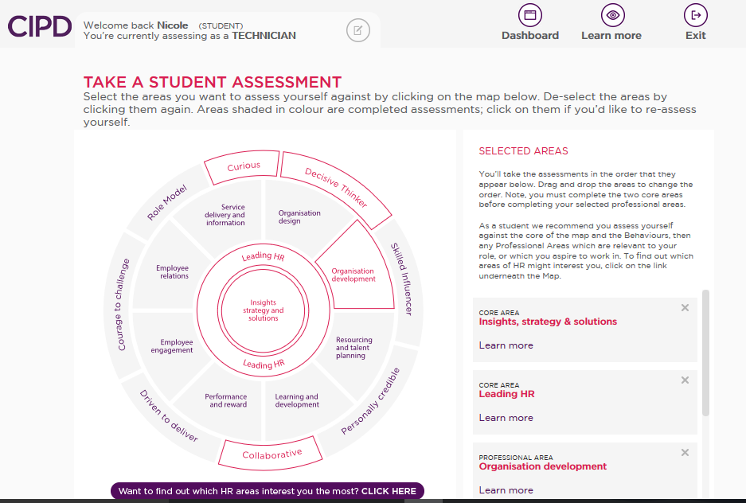
Figure 4: Screenshot of CIPD Profession Map self-Assessment tool (CIPD)

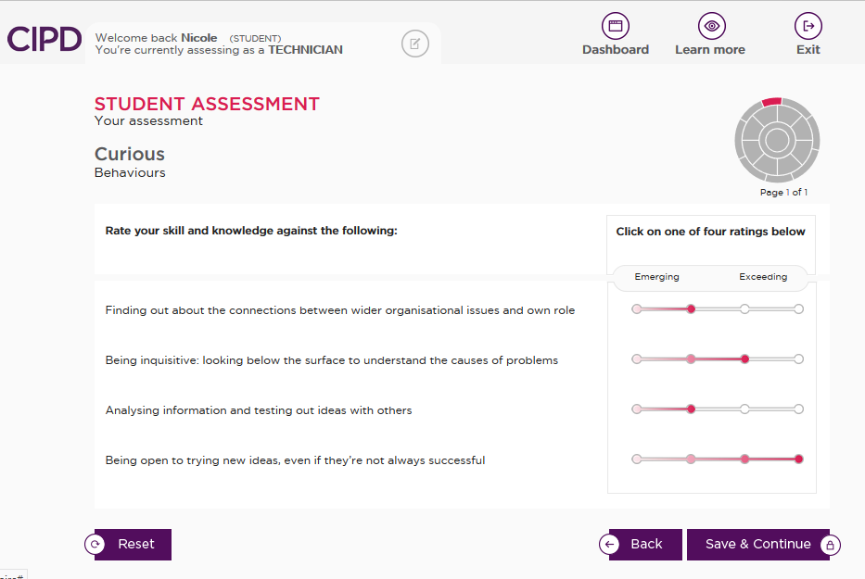
Figure 5 The self-assessment requires you to rate yourself against competency statements for each area of assessment. There are four ratings, ranging from ‘Emerging’ to ‘Exceeding’.

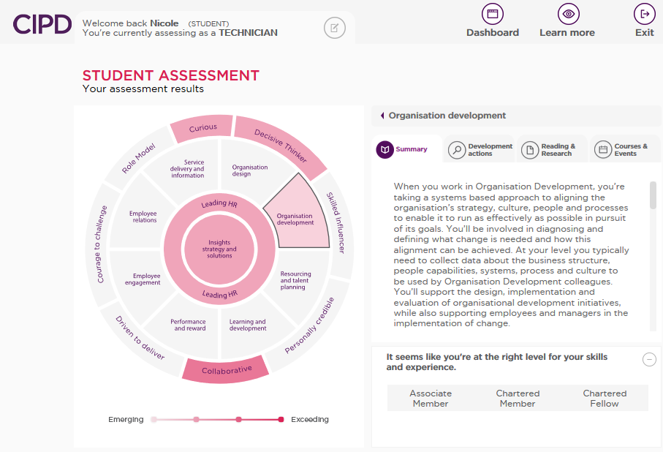
Figure 6: On completion of the self-assessment, a heat map and advice summary is generated which is invaluable in informing personal professional development and progression.

4.2: Professional Development Plan (PDP)
The following information was used to inform my Professional Development Plan (Appendix 8, E-Portfolio):
The summary of my strengths, competence and skill gaps generated from my heat map (Appendix 5 in E-Portfolio).
Recommended development actions, reading and learning, and courses and events generated from my heat map (Appendix 6, E-Portfolio).
Finally, by referring to the map’s bands of professional competence, I can further understand development opportunities to support my professional and career progression (Table 1 shows an extract from the professional competence bands included in the CIPD’s HR profession map)
In addition to these sources, I completed a ‘Learning Styles’ questionnaire to ensure the development actions incorporated in my PDP appropriate in supporting my development (Appendix 7, E-Portfolio).

