The Transformation of Service Methods -
Bala Jewelry Chain Store

MODULE NAME : Change and Stability Management(BMMB7000)
NAME : Zefeng Zhang
STUDENT NUMBER : 2217959

Contents

Executive Summary 3
1. Introduction 3
2. Planned Change 4
3. Models and driving factors for change 5
3.1 Driving force 5
3.1.1 Leadership 5
3.1.2 Force Field Analysis 6
3.2 Identify and address resistance factors to change-Stakeholder Analysis 7
3.3 Freezing and refreezing Model 9
4. Kotter's Eight Step Model for Leading Change--Change Strategies 10
5. Conclusion and Recommendations 13
Reference 15

Executive Summary
This article introduces the transformation process and principles of Bala Jewelry Company. Many people believe that organizational change is caused by serious problems within the objective environment and organization. In fact, enterprise managers also play a significant and even decisive role in organizational change. The author deeply recognizes the important role of leadership in the process of change by studying the course of enterprise change and combining it with the example of change at Bala Jewelry Company. This article also utilized Lewin et al.'s organizational change model to conduct in-depth analysis and evaluation of the company's change situation, and further understood the theoretical significance of the change model through examples.

- Introduction
Bala Company is a jewelry chain company located in Guangzhou, China. The company was founded in 2001. The founder of Bala Company is a person who enjoys innovation and product research. Through years of operation, it has expanded multiple branches. The COVID-19 in 2019 has brought a heavy blow to the company. After the impact of the epidemic for nearly three years, the company's senior management clearly felt that the company and its own suppliers are changing, and the styles and samples of the raw material market are no longer as fast updated and rich as before the epidemic(Chuprov S V., 2015).. Performance growth is turning rapidly, and bad news is coming one after another. Everyone is in the midst of it, with poor expectations for the future and anxiety about reality. The three-year epidemic has almost caused the company to lose more than half of its performance. During the epidemic, senior management of the company also attempted to lead the team in online live sales and online sales, but the results were not very good and there was no truly effective sales channel strategy formed. The founder of the company realizes that the crisis has arrived, and if the company is not prepared to take measures, it will enter an irreversible situation.
- Planned Change
This is a plan that has been brewing for two or even three years, which is a global plan made by the company's senior management after comprehensive and systematic research on the diagnosed problems. The senior management of the company will plan to hold multiple meetings, conduct investigations and research, and come up with the best action plan. Then, the plan will be implemented step by step, and the changes will be carried out simultaneously with the adjustment of organizational policies, work systems and management methods, and personnel training. Because from the moment of the outbreak of the epidemic, at the end of the Chinese lunar calendar in 2019, on the Chinese New Year's Eve, military doctors from Shanghai were urgently deployed to Wuhan, which also has a branch of the company! At that time, the senior management of the company had already sensed that things were not going well. Three long years have passed, and the CEO of Bala Jewelry Company has never relaxed his nerves. Every day, his expenses and revenue hover at the financial critical point(Jeffrey Schwartz, Pablo Gaito, Doug Lenick, etc., 2013).. Although online sales also generate some revenue, the management understands that the end of the epidemic is the beginning of change.
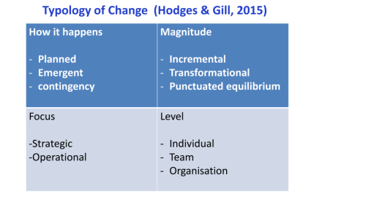
Therefore, from Hodges and Gill's model, this change belongs to planned change. From the perspective of the focus of change, it belongs to operational change. From the level of change, this change is a comprehensive change for the entire organization. From the perspective of the breadth of change, it still belongs to a transformational change.
- Models and driving factors for change
  - Driving force

3.1.1 Leadership
The driving force behind organizational development and innovation progress is not the size and market share of the organization, but the power of leadership. Since its establishment in the 1980s, transformational leadership has become one of the most concerned leadership theories. The author believes that the reason why Barra Jewelry Chain Company has been able to withstand 20 years of market turmoil and develop rapidly is largely due to the excellent leadership of the company's senior management in transformation. Whether in a stable stage of enterprise development or in times of crisis, the company's senior management may not be able to tell every employee what specific work to do, but they always ensure that all employees are aware of the company's vision and goals, which is to make every woman who enters the store leave with a smile, and even become more beautiful due to the store's products. From regional managers to store managers, and then to store managers and employees, everyone focuses on this determination and vision, ultimately enabling each store to achieve organizational change in a flexible and constantly changing manner (El Sherif H M., 2013).. The interaction and daily management of processes also revolve around this vision to provide services, and the entire company operates with a value orientation, which has become the soul of the enterprise. In this change, the leadership's power collaborates from the company's development direction, organizational culture vision, personal development, and organizational change strategy, playing a leading role in organizational change(Frank Bronte, 2012).
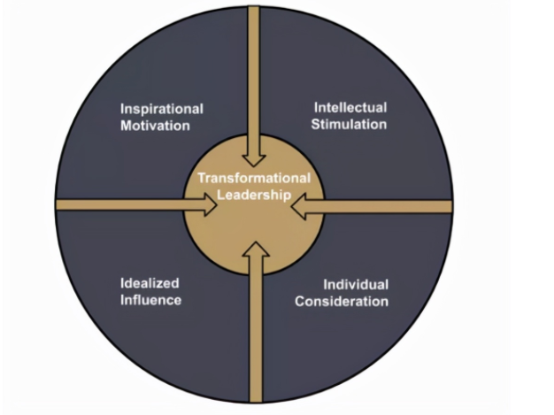

3.1.2 Force Field Analysis
Lewin (1947) proposed the field theory, where the force field analysis method is the core content of the field theory. After analyzing the process of company change, we have identified the following factors that encourage and inhibit change：

Drivers for Change | Resisters of Change
COVID-19 Dynamic | Employee do not want to change
Change of consumer behavior | Employee do not adapt the new principle
Intense market competition
Revenue decreased
Digital Trends

The occurrence of the COVID-19 has directly led to a sharp decline in the number of consumers. At the same time, more consumers are willing to shop through the Internet, The digital marketing model has gradually become the mainstream of the market. These negative effects have directly led to the reduction of the company's income. As a profit making organization, it will have a strong overwhelming force to pursue profits, and ultimately lead to the proposal of reform.
  - Identify and address resistance factors to change-Stakeholder Analysis
The manifestation of resistance to change is divided into open and direct resistance, as well as potential or delayed resistance. Direct and public resistance is relatively easy to detect, and managers can instantly recognize it. Addressing potential or delayed resistance to change will face greater challenges (AM Garcíacabrera, ÁlamoVera, Francisca Rosa, F Garcíabarba Hernández.,2010). The potential resistance is very subtle, as it may reduce employees' loyalty to the organization, lose work enthusiasm, increase error rates, and increase absenteeism due to illness. Managers need to observe carefully to discover. Similarly, when a change first appears, it may only produce a small reaction, but after a few weeks or months, the resistance is exposed. Managers can only strengthen their awareness of risk prevention and reduce the accumulation of various problems during the change process. The resistance structure of Bala Jewelry Company is mainly shown in the following figure(Gaylor T K ., 2001):
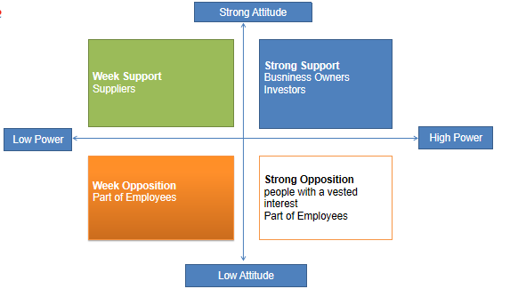
Business Owners and investors strongly agree with the change, we should protect these group of people well; For the suppliers, company should make sufficient negotiation and tell them the real sense of change, so that they could fully support the change of the company; For the people with a vested interest, company will enroll a professional system to improve the management system of the company. For all the employees, The company not only strengthens communication and unity, but also utilizes the power of external experts and consultants to rectify the company and provide training for employees and managers.
Finally, Bara's jewelry store has made changes despite numerous obstacles. After several rounds of expert training and planning, the store staff began to complain. The reason is simple. Now, experts require employees to develop standards, procedures, and norms. Although employees feel good, they find it difficult to operate. Most employees say that the new theories and methods proposed by experts are too difficult for them to implement. But they have a rational and determined decision-maker. No matter how employees complain, they cannot shake the decision-maker's decision(Hay P., 2000). If someone fails to comply with the requirements and regulations of the consultant, they will also be punished. Decision makers still firmly support the new standards of experts, and Bara Jewelry Management Company remains firmly on the path of change and has achieved success. The entire process is not easy, as shown in the following figure:
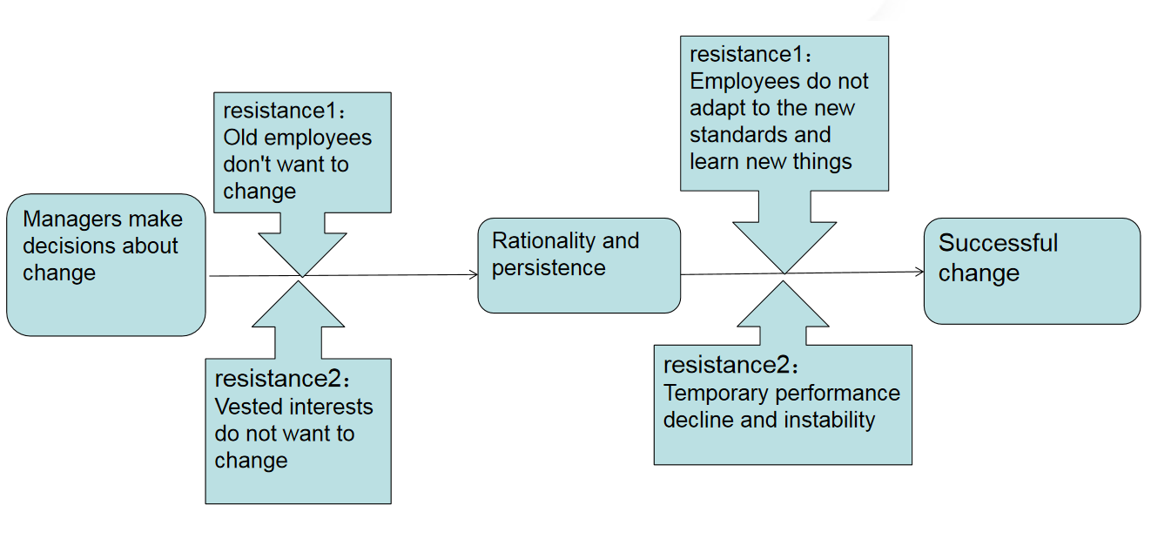
Through literature review, the author has also identified different coping strategies that managers can implement in response to different resistance to change(Hussain S T, Lei S, Akram T, et al., 2016).:
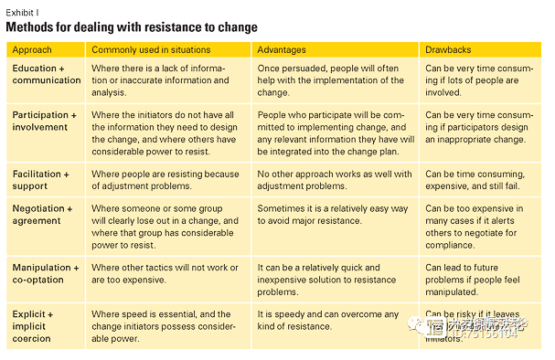

3.3 Freezing and refreezing Model
Lewins proposed that the three important components of change are thawing, change, and refreezing(Meredith, Minkler., 2016).. According to the plan of the senior management of Bala Jewelry Company, the company will have all employees understand and accept the reason for the change during the "thawing" stage. Do a good job in ideological work, communicate clearly with employees about the current situation, vision, gaps, and how to change the company. Only when subordinates fully understand and believe can change achieve twice the result with half the effort, otherwise it will be laborious and thankless. After the thawing process is completed, the company will undergo changes. The company will propose a new plan and have all employees and teams execute it according to the plan. In the stage of "re freezing", the company will realize that everyone has inertia. Therefore, in the process of transforming new and old behaviors, the company will use methods such as rewards and punishments to solidify the new behavior patterns generated by employees according to the new system and plan, ensuring that the change will not recur. That is to say, make the outcome of this change a habit for everyone in the company, and the company will undergo a change instead of an event. Lewins' theoretical model of change not only provides theoretical support for the transformation of Bala Company, but also serves as a theoretical driving force in the transformation process of Bala Company(Chang C C., 2011).


- Kotter's Eight Step Model for Leading Change--Change Strategies
The company uses Kotter's "Eight Steps for Leading Change" process model, which is often referred to as an extension of Lewin's three-step approach(Alhaderi S M ., 2021). The basic idea of this model is to stimulate a sense of urgency for change and maintain this momentum. This guideline is very suitable for the current situation of Bala Company, and senior management needs an effective action plan that can adapt the company to the current market environment. This action plan should be formed under the guidance of this model(Grant M T., 2016).
The first step of the Kotter model is to create a sense of urgency in the company's change plan. Bala company has done a great job in promoting this aspect, and every employee is aware of the current market situation of the company. During the nearly three years of the epidemic, the company's senior management has continuously promoted the importance of change and the change plan to employees. The second step of the model is to establish a guiding alliance. According to the plan, the company's senior management held multiple meetings, investigations, and studies to make the best action plan, which was unanimously approved by all department managers at the grassroots, middle, and senior levels. In addition, the company founder hired a completely independent change consultant specifically responsible for the execution of change plans. In addition to helping the company provide the best change plan and design draft, the change consultant will spend most of their time conducting relevant employee training work with the human resources department(Cai Tejin, Zhou Wencheng, Yao Tingting, etc, 2017).
The third step of the Kotter model is the formation of strategic ideas. The company will undergo changes in three aspects. Firstly, the company will further upgrade its stores and improve their service levels. The advantage of a store comes from its uniqueness. When asked about the reason for going to physical stores for shopping, consumers often respond with "being able to see, touch, and use the product", "being able to get the product immediately", and "I am more certain if the product is suitable". The proportion of these answers reached 60%, 53%, and 33%, respectively. It is worth noting that these factors are usually unique advantages of physical stores that e-commerce cannot meet. When we examine the reasons why consumers shop online, there are only two that are unique to e-commerce and cannot be replicated in physical stores. They are "shopping online 24 hours a day" to attract "no need to go to physical stores". This indicates that physical stores will still have an irreplaceable position, at least for the foreseeable future. People often use the term 'showroom phenomenon' to describe the awkward position of stores, and survey data confirms the existence of this phenomenon: up to 68% of respondents said they would deliberately visit physical stores to view products and ultimately complete their purchases online. But another piece of data confirms that the "reverse showroom phenomenon" also exists: 70% of respondents said they would deliberately view products online, but ultimately go to physical stores to complete consumption. That is to say, there is no subordinate relationship between the online and offline channels. In the eyes of consumers, the boundary between digital and physical channels has become insignificant, and they are more accustomed to switching back and forth between the two channels. Therefore, the company's storefront must be upgraded, and the decoration of storefronts in various regions should be vivid and consistent. Not only should the storefront be consistent with each other, but the store style should also be consistent with that of online stores. At the same time, the salesperson's sales and service methods should also have the unique characteristics and characteristics of the company. The company's change consultant will provide training specifically for both online and offline employees(JN Kamau., 2010).
Second, the company needs to deepen the Digital transformation. The Digital transformation of the jewelry industry is accelerating its migration from the demand side to the supplier side. The company needs to establish digital stores as soon as possible, increase efforts to carry out live broadcast, community marketing, cross-border e-commerce, online exhibition and other activities, and promote the complementary advantages of multiple channels and platforms. At the same time, driven by digitization, continuously improving the collaborative capabilities of upstream and downstream supplies chains. This requires efforts from both hardware and software aspects, with hardware settings mainly focused on digital labor tools, online store design, and offline store adjustment measures; In terms of software, it requires the joint efforts of all employees. In addition to using powerful digital platforms for product trading, sales strategies such as customer management, membership management, and market development should also be emphasized. These strategies should be translated into work regulations and code of conduct among employees, identifying customers from both online and offline perspectives, establishing customer profiles, managing customers, and increasing product exposure in front of customers. During this process, employees need to recognize the significant role that social media plays in the shopping experience. More than half of consumers acknowledge that interacting with their favorite brand through social media can enhance their purchasing desire and lead to more purchasing behavior. Among them, the "digital generation" (respondents aged 18 to 24) showed more enthusiasm for social media. For example, 49% of young people will follow their favorite brands or retailers, while this proportion is only 31% in other age groups; Young people have more significant customer lifecycle value(Doroshenko M V , Kudryashova I A., 2020).. Therefore, the company will increase investment in in in store technology and social media. The third point seems simple: the company will further improve its reward and punishment system. This is a means of motivation and the determination of senior management to implement the reform system (Guseva O Y., 2014).
The fourth step of the Kotter model is to mobilize more people to support change, forming a source of strength within the organization. The fifth step of the Kotter model is to use different methods to eliminate obstacles in the change process. When it comes to the sixth step of the Kotter model, the company needs to put the change into action. In order to maintain the enthusiasm of all employees for change, managers can identify some short-term achievements in this process and reward relevant personnel to ensure their enthusiasm and motivation. Subsequently, the company will enter the steps of maintaining a state of change and accelerating the process of change. In the end, the company will complete the change and make the changed state a work habit for everyone(J Nebojša., 2012). .
- Conclusion and Recommendations
It is easy for companies to evaluate and judge the success of changes in enterprise hardware. Whether the company's online sales platform has taken on a new look, whether there is a cooperative link between offline physical stores and online storefronts, whether the store decoration style is consistent, whether the supply chain can provide products to the sales and logistics ends in real-time on demand, and whether cross-border sales business is smooth can be detected through daily observation. However, the evaluation of software changes still requires professional change consultants and professional assessments from the human resources department, and even requires further evaluation through weeks or even months of sales performance. Fortunately, one of the transformation projects of Bala Jewelry Company is the upgrade of the human resource assessment system. The company not only intuitively affirmed the results of the hardware management reform, but also utilized the latest company assessment system to fully understand the changes in personnel service level and service awareness, confirming that the company's transformation was relatively successful(Aristova O M &Bachurin E I ., 2014).

Reference
Aldemir E. 2010. Models and Tools of Change Management: Kotter's 8 Steps Change Model. 2010.
Alhaderi S M. 2021. Kotter's Eight Step Change Model for Employees' Intentional, Cognitive and Emotional Readiness for Change and Developing Regional Economy in Saudi Banking Sector's, Role of Homologous Communication, Learning Demand and Job Involvement[J]. Allied Business Academies, 2021.
AM Garcíacabrera, ÁlamoVera, Francisca Rosa, F Garcíabarba Hernández. 2010. Antecedents of resistance to change: personality and context factors.
Antonakis J, Avolio B J, Sivasubramaniam N . 2003. Context and leadership: an examination of the nine-factor full-range leadership theory using the Multifactor Leadership Questionnaire[J]. Leadership Quarterly, 2003, 14(3):261-295.
Aristova O M, Bachurin E I .2014. Tools of improvement of the enterprise activity for goods and service promotion.
Bolan P, Williams L .2010. The role of image in service promotion: focusing on the influence of film on consumer choice within tourism[J]. International Journal of Consumer Studies, 2010, 32(4):382-390.
Cai Tejin, Zhou Wencheng, Yao Tingting, etc(2017). Analysis on the evaluation of the change management ability of listed companies [J] Human Resources Management, 2017 (8): 3
Chang C C.2011.Well-being on the Impact of Attitudes toward Organizational Change and Psychology Contract Breach-Take T Bank for Example[J]. 2011.
Chuprov S V.(2015). Industrial Enterprise Stability Management in Competitive Environment of the Global Economy[C]// Northeast Asia Academic Forum 2015.
Cuesta C, Ruesta M, Tuesta D, et al..(2015). The digital transformation of the banking industry[J]. Oriental Art, 2015.
Day S, Hughes A..(2012). P102A highly cost-effective and targeted service promotion campaign using the social media site Facebook[J]. Sexually Transmitted Infections, 2012, 88(Suppl 1):A44.1-A44.
Doroshenko M V, Kudryashova I A .(2020). Process approach to enterprise management as a factor of the increase in economic stability[J]. WORLD OF ECONOMICS AND MANAGEMENT, 2020, 20(1):67-85.
El-Sherif H M ..(2013). Leadership Model. 2013.
Flew T .(2012). The digital transformation of 21st century news journalism.2012.
Frank Bronte(2012). Five elements of leading company change [J] Modern State-owned Enterprise Research, 2012 (Z1): 8.
Gaylor T K.(2001). Factors Affecting Resistance to Change: A Case Study of Two North Texas Police Departments[J]. University of North Texas, 2001.
Grant M T.(2016).Managing Change in IT projects: Using Kotter's Eight Step Process to Examine Lewin's Unfreeze-Move-Refreeze Theory. 2016.
Guseva O Y. (2014).Rationale for the enterprise change strategy based on system dynamics modelling. 2014.
Hay P , .(2000).CEJ Härtel. Toward Improving the Success of Change Management Efforts: Modeling the Factors Contributing to Employee Resistance During Change Implementation[C]// SUNY Empire State College. SUNY Empire State College, 2000.
Hussain S T, Lei S, Akram T, et al. (2016). Kurt Lewin's process model for organizational change: The role of leadership and employee involvement: A critical review[J]. Journal of Innovation & Knowledge, 2016.
Jeffrey Schwartz, Pablo Gaito, Doug Lenick, etc(2013). Use brain science to guide company reform [J] Business Review, 2013.
J Nebojša.(2012). The influence of organizational culture on organizational preferences towards the choice of organizational change strategy[J]. Economic Annals, 2012, 57(193):25-51.
JN Kamau.(2010). The relevance of Kotter's eight-step model in understanding organisational change at Nokia Siemens Networks (Kenya)[J]. University of Nairobi Kenya, 2010.
Kobayashi E, Kerbo H R..(1990). Punishment for Noncompliance and Reward for Compliance: A Comparison of Japanese and American Workers[J]. Social sciences, 1990.
Lichtenthaler U(2017). Shared Value Innovation: Linking Competitiveness and Societal Goals in the Context of Digital Transformation[J]. International Journal of Innovation & Technology Management, 2017, 14(4):1750018.
Lin, H.-F.(2007). Effects of extrinsic and intrinsic motivation on employee knowledge sharing intentions[J]. Journal of Information Science, 2007, 33(2):p.135-149.
Malmelin N, Villi M ..(2017). Media work in change: Understanding the role of media professionals in times of digital transformation and convergence[J]. Sociology Compass, 2017, 11(7):e12494.
Meredith, Minkler..(2016). "Unfreezing" Lewin: The Case for Alternative Change Strategies in Health Education[J]. International Quarterly of Community Health Education, 2016, 1(2).
Nosenzo D, Sefton M..(2012). Promoting Cooperation: the Distribution of Reward and Punishment Power[J]. Discussion Papers, 2012.
Oreg S, Michel A, By R T. .(2013). The Psychology of Organizational Change: Reactions to organizational change: an integrated model of health predictors, intervening variables, and outcomes[J].2013, 10.1017/CBO9781139096690(4):65-92.
Oreg S, Michel A, By R T. .(2013).The Psychology of Organizational Change: The interplay between change and the organization[J]. 2013, 10.1017/CBO9781139096690(7):145-172.
Pang Peifeng, (2022).Sun Weipeng Corporate transformation and transformation: Q Group faces the challenges and opportunities of the changes in the new asset management regulations and policies [J] Vitality, 2022 (10): 3.
Podsakoff P M, Bommer W H , .(2006). Podsakoff N P , et al. Relationships between leader reward and punishment behavior and subordinate attitudes, perceptions, and behaviors: A meta-analytic review of existing and new research[J]. Organizational Behavior & Human Decision Processes, 2006, 99(2):113-142.
Sarros J C, Santora J C..(2001). The transformational-transactional leadership model in practice[J]. Leadership & Organization Development Journal, 2001, 22(8):383-394.
Stepanek C, Costa J.(2007).PROCESS MANAGEMENT AS A STRATEGY FOR MANAGING ORGANIZATIONAL CHANGE[C]// Annual ASEM(American Society for Engineering Management) National Conference; 20071107-10; Chattanooga,TN(US). Aerospace Testing Alliance, 2007.
Sullivan, Dan. (2003). "Supporting Compliance Efforts with Enterprise Change Management." Dm Review 12(2003):74.
Sun, A.Y.(2007). A research on the impact of corporate culture on the choice of enterprise control mechanism. Economic Survey.
Sun Xiaodong(2013).Research on human resource management strategy in the transformation of NF Company [D] Tianjin University, 2013.
T Ayalew.(2015). The Factors of Resistance to Organizational Change Management Process: A Case Study at Ethiopian Revenue & Customs Authority (ERCA). 2015.
Xu Z. (2009).The Enterprise Organizational Structure Change Strategy in Internet Times[J]. International Business Research, 2009, 2(4).

