BMIH5004 - Management and Organisational Behaviour

Student Name: Diana Valerica Paul
Student number :2221008
Submission Date: 08/11/2024

AI Statement
“I confirm that I have not used any Al tools in the research and creation of this assignment. I confirm that I have not presented any Al generated materials as my own work. I confirm I have copies of my drafts, notes, and other resources I used, which I may be asked to provide in evidence.”
Table of Contents
Introduction 4
Organisation Structure, Culture, and Goals 5
Hyatt Hotels Corporation organisational structure. 5
Corporate culture and its influences on Hyatt operations. 6
Goals of the organisation 6
Recent Change Initiatives 8
Recent change initiatives undertaken by Hyatt Hotels Corporation 8
Strategic Direction 9
Examine the strategic direction of the organisation. 9
Strategies implemented to achieve their long-term objectives. 9
Recommendations 11
Conclusion 11
References 12

Introduction
Hyatt Hotels Corp is one of the companies with a global presence in the hospitality industry. The company franchises as well as manages and develops hotels, residential properties and resorts.
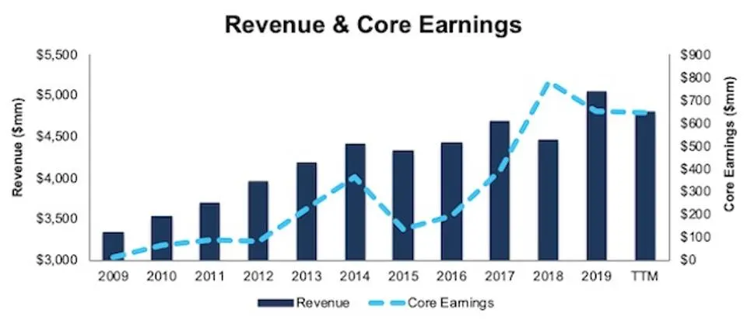
Figure 2. Hyatt Profitability Growth (Since 2009)
Source: (Trainer, 2020)
The Hyatt company operated under a portfolio of several brands such as "Unbound Collection by Hyatt", "Destination by Hyatt", "Alila", "Hyatt House", "Hyatt Place" but also other brands such as "Park Hyatt", "Grand Hyatt ", but also "Hyatt Ziva" among many other brands, according to (GlobalData Plc, 2022). Founded in 1957 by Jay Pritzker when he bought the Hyatt House motel near the Las Angeles International Airport (Hyatt, 2015), thus Hyatt became a very well-known hotel in the hospitality industry. Hyatt Hotels Corporation aims to go far beyond the typical hotel experience for its guests. The company's mission is to offer the most authentic hospitality that makes a difference in people's lives (Hyatt, 2021).
This report analyses and evaluates the organizational structure of Hyatt Hotels Corporation as well as the corporate culture and the way it influences the operations. This report will also discuss the organization's objectives at the corporate level but also at the individual unit level.
The second part of this report will identify the recent change initiatives undertaken by the organization by analysing the impact of the initiatives on the organization as well as by evaluating how well these changes were managed. The last part of this report directly examines the organization's strategy and also by analysing the strategies that have been implemented to achieve the organization's long-term objectives

Organisation Structure, Culture, and Goals
According to Kenton (2024), an organizational structure represents a system that highlights the way some activities are directed to achieve the goals of an organization. All these activities can include roles, rules and responsibilities and also determine how information circulates between levels within the company (Kenton, 2024).
Organizational culture, on the other hand, is composed of both expectations and beliefs that are shared by all members of a certain organization (Kava et al., 2018). Organizational culture consists of both values ​​and common norms and beliefs of all individuals in a group

Hyatt Hotels Corporation organisational structure.
Hyatt has a hybrid organizational structure with this structure combining in a harmonious way the elements of the functional type of structure as well as elements of the divisional type structure. However, Hyatt imposed a different structure in America saying that this structure allows companies to support hotel teams and their owners in much more personalized ways. In its new sub-regional structure, three essential roles are included that are newly created within the functions of financing as well as commercial services and operations (Perkowsky, 2024).

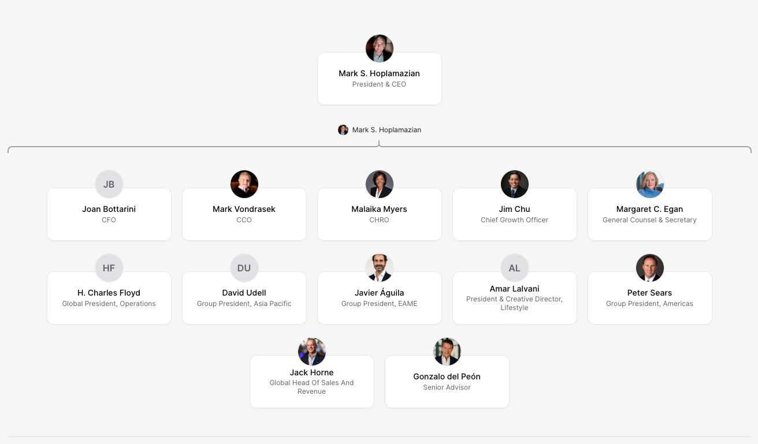
Figure 1. Hyatt Organisational Structure Illustration
Source: (Hyatt, 2024)

Corporate culture and its influences on Hyatt operations.
Hyatt strives to create a sense of communication and belonging by valuing relationships with guests and at the same time with the community. Hyatt values ​​respect, creativity, integrity, humility, fun and empathy (Hyatt, 2024a). Hyatt's commitment to diverse cultures also includes ensuring a sense of belonging for all employees. The approach that Hyatt imposes is very much human-centred and this approach focuses on four pillars of involvement, diversity, learning but also retention, which can thus create a much more motivated workforce. Hyatt's holistic talent focuses largely on cultivating a culture of care but also a culture of empowerment. This type of culture has a positive impact on Hyatt's bottom line by improving service and guest satisfaction (TMI, 2024)

Goals of the organisation
Hyatt's objectives thus include caring for people, caring for the planet, caring for responsible business, authentic hospitality as well as being the most preferred brand. The first purpose of companies and that of taking care of people is an important purpose that encourages people to be better by creating an inclusive culture where everyone is welcome and feels as if they belong to that place (Hyatt, 2021). The second goal and that of taking care of the planet is an important goal for Hyatt through Hyatt World of Care, which includes goals and commitments on taking care of the planet. A clear example that proves this goal is the fact that Hyatt works to reduce food waste per square meter by 50% until 2030 compared to 2019 (Hyatt, 2019).
Taking care of responsible businesses is the third goal of the company and the World of Care platform also includes these objectives and commitments of companies to take care of such responsible businesses (Hyatt, 2023).
The fourth goal, which is also part of the company's mission, is to offer authentic hospitality, thus making a major difference in people's lives (Hyatt, 2019), and the last goal is to become the most preferred brand in the sector.

Recent Change Initiatives

Recent change initiatives undertaken by Hyatt Hotels Corporation
One of Hyatt's most recent initiatives was Climate Change and Water Conservation by increasing efficiency measures and giving a higher priority to water conservation. Another important initiative is the increase in the use of renewable energy and gray water. The hotel thus evaluates the best practices in order to be able to continuously advance these efforts (Hyatt, 2024).
Hyatt announced a series of progress in terms of environmental and social impact initiatives. These initiatives include for example strengthening hotel engagement around renewable electricity opportunities. Along with the evolution of the surrounding world, new challenges appear, and Hyatt has advanced its global environmental strategy, but also its social and governance (ESG) strategy. This was possible through World of Care, which was thus derived from listening much more carefully to its customers, guests, colleagues or investors and hotel owners or the community (Hyatt, 2023b)
On climate change, the hotels that are currently owned by the hotel chain from the United States, for example, have adopted a strategy of 100% renewable electricity through renewable energy certificates that are thus certified by "Green-e Energy" (Hyatt, 2023a)
A new initiative represented an extremely important step in Hyatt's global sustainability program but at the same time underlined the company's commitment to well-being. Providing faster access to water stations in all its hotels around the world so its guests can have hydration options that align with their well-being and sustainability priority during their trip. Also, other recent initiatives have included both alternative options on demand and the elimination of plastic straws. The increase in compostable and recyclable packaging for food containers thus represented major moves and initiatives for Hyatt (Hotel Business, 2019)

Strategic Direction

Examine the strategic direction of the organisation.
Hyatt Hotels Corporations has completed an acquisition of "Standard International" which represented the mother of lifestyle hospitality brands. This was due to an entire strategic effort to consolidate and diversify the hotel's presence at the global level. This purchase was made at a price of 335 million dollars and thus signifies the opportunity and commitment Hyatt has to expand its lifestyle hotel segment even more. Hyatt Hotels Corporation thus revealed a series of plans to increase the scale of the agreement space in Europe, the Middle East and Africa, which highlighted a record year of agreement signings in 2023. Also, Hyatt's strategy to increase its profile or leisure as well as tripling its stations as well as adding a larger number of hotel rooms are important plans in its direction strategy. These strategies allow Hyatt to remain one of the largest hotel brands in the world. Hyatt's record global pipeline was more than 127 thousand rooms for the end of 2023 (Lee, 2024)
Hyatt Hotels Corporation has achieved a successful strategic transition towards an "asset-light" model that focuses more on management and the franchise than on its own properties (Hyatt, 2023). Since 2017, the Hyatt company has sold over 4 billion dollars for real estate assets. The company made major investments in luxury brands but also in lifestyle and this represented a strategic move to improve its portfolio. The most notable acquisitions thus represented Apple Leisure Group, Dream Hotel Group and Two Roads Hospitality (Fox, 2022)
This change of the company improved the reduction of capital expenses and operational risks. Hyatt's strategy also placed a major emphasis on geographic expansion, especially in Europe but also in Latin America, in order to capture the opportunities of the emerging market. By adopting all these approaches with reduced values, the Hyatt company proposes a stronger position for the purpose of a more sustainable growth as well as for the purpose of leveraging the power of the brand.

Strategies implemented to achieve their long-term objectives.
Some of the key employee engagement initiatives thus included empowerment as a prime example. Hyatt gives massive power to employees at all levels to solve problems and make decisions as well as provide care services. This fosters a major sense of involvement and ownership. Learning and development is also another important strategy for Hyatt. It encourages the improvement of skills through extensive training and tuition reimbursement programs, and this helps progress in the career but also in involvement. His commitment to a diverse culture but also includes thus ensuring feelings of belonging for all employees (TMI, 2024).
A fundamental aspect underlying his company involvement strategy is to offer a special empowerment to employees. They trust their employees to be able to act on opportunities or even on problems arising from their day-to-day operations. This approach not only leads to a faster resolution but also greatly improves the involvement of employees in this because they feel that their work contributes in a significant way.

Recommendations
In increasing Hyatt's position in the hospitality industry, a series of recommendations can thus strengthen its strategic direction. One of the recommendations is that Hyatt should focus on expanding its "asset-light" model in emerging markets (Poretti & Blal, 2020). This approach may involve a major increase in its franchise agreements but also its management agreements more than direct ownership. In terms of sustainability, Hyatt can continue to lead by example in all of its green initiatives, such as eliminating all single-use plastics. Also, the implementation of more efficient technologies regarding electricity in its properties may involve training staff on sustainable practices (Celestin et al., 2024). At the same time, this creates incentives for properties that meet ambitious environmental goals. In involving employees, Hyatt must thus develop its skill and training programs further thus promoting a culture where employees can feel motivated and appreciated (Oanh & Tho, 2024).

Conclusion
In conclusion, Hyatt's strategic focus on more sustainable growth, involving a lot for its employees but it also involves the customer-centric experience. Hyatt can thus continue its mission of offering the most authentic hospitality. The use of the best practices in sustainability and technology at the same time increases the activity of its brand or even operational efficiency. The recommendations provided in this report support Hyatt's long-term growth goals, but also to be able to satisfy guests and promote an environment where employees and guests feel valued.

References
Celestin, M., Vasuki, M., Sujatha, S., & Kumar, A. D. (2024). Enhancing Employee Satisfaction and Engagement to Boost Productivity: The Role of Leadership, Culture, and Recognition Programs. International Journal of Computational Research and Development, 9(2), 67-74.
Fox, J.T. (2022). Hyatt buys Dream Hotel Group. [online] Hospitality Investor. Available at: https://www.hospitalityinvestor.com/brands/hyatt-buys-dream-hotel-groups-portfolio [Accessed 8 Nov. 2024].
GlobalData Plc (2022). Hyatt Hotels Corp Company Profile - Hyatt Hotels Corp Overview. [online] Globaldata.com. Available at: https://www.globaldata.com/company-profile/hyatt-hotels-corp/ [Accessed 8 Nov. 2024].
Hotel Business (2019). Hyatt Launches Three Global Sustainability Initiatives - hotelbusiness.com. [online] hotelbusiness.com. Available at: https://hotelbusiness.com/hyatt-launches-three-global-sustainability-initiatives/ [Accessed 8 Nov. 2024].
Hyatt. (2015). Hyatt History. [online] Available at: https://about.hyatt.com/en/hyatthistory.html [Accessed 8 Nov. 2024].
Hyatt (2019). World of Care. [online] Available at: https://www.hyatt.com/world-of-care/en-US/caring-for-the-planet [Accessed 8 Nov. 2024].
Hyatt (2021). ADVANCING OUR PURPOSE OF CARE: Diversity, Equity and Inclusion at Hyatt. Available at: https://about.hyatt.com/content/dam/hyatt/woc/DEIReport.pdf
Hyatt (2023). About Hyatt. [online] Available at: https://about.hyatt.com/ [Accessed 8 Nov. 2024].
Hyatt (2023a). Hyatt Hotels Corporation. [online] Available at: https://newsroom.hyatt.com/news-releases?item=124404 [Accessed 8 Nov. 2024].
Hyatt (2023b). Hyatt Shares Environmental and Social Impact Reporting, Eclipses Critical DE&I Goals and Sustains Momentum with Key 2023 Initiatives. [online] Available at: https://investors.hyatt.com/news/investor-news/news-details/2023/Hyatt-Shares-Environmental-and-Social-Impact-Reporting-Eclipses-Critical-DEI-Goals-and-Sustains-Momentum-with-Key-2023-Initiatives-08-02-2023/default.aspx [Accessed 8 Nov. 2024].
Hyatt (2024). Hyatt 2023 World of Care Highlights. Available at: https://about.hyatt.com/content/dam/hyatt/woc/2023WOCHighlights.pdf
Hyatt (2024). Hyatt | The Org. [online] THE ORG. Available at: https://theorg.com/org/hyatt [Accessed 8 Nov. 2024].
Hyatt. (2024a). Corporate Culture | Hyatt World of Care. [online] Available at: https://about.hyatt.com/en/world-of-care/caring-for-people/culture.html#:~:text=We%20strive%20to%20create%20a,Empathy%2C%20and%20Fun%20every%20day.&text=Hyatt%20is%20not%20only%20a,place%20where%20careers%20are%20built. [Accessed 8 Nov. 2024].
Hyatt.com. (2023). Hyatt Investor Day to Highlight Asset-Light Transformation and Expectations for Significant Expansion in Free Cash Flow. [online] Available at: https://investors.hyatt.com/news/investor-news/news-details/2023/Hyatt-Investor-Day-to-Highlight-Asset-Light-Transformation-and-Expectations-for-Significant-Expansion-in-Free-Cash-Flow-05-11-2023/default.aspx [Accessed 8 Nov. 2024].
Kenton, W. (2024). Organizational Structure for Companies With Examples and Benefits. [online] Investopedia. Available at: https://www.investopedia.com/terms/o/organizational-structure.asp#:~:text=An%20organizational%20structure%20is%20a,between%20levels%20within%20the%20company. [Accessed 8 Nov. 2024].
Kava, C. M., Parker, E. A., Baquero, B., Curry, S. J., Gilbert, P. A., Sauder, M., & Sewell, D. K. (2018). Organizational culture and the adoption of anti-smoking initiatives at small to very small workplaces: An organizational level analysis. Tobacco Prevention & Cessation, 4.
Lee, I. (2024). High-end hotels and asset light model suit Hyatt strategy. [online] Hospitality Investor. Available at: https://www.hospitalityinvestor.com/hotels/high-end-hotels-and-asset-light-model-suit-hyatt-strategy [Accessed 8 Nov. 2024].
Oanh, T. T. T., & Tho, A. (2024). The impact of service quality on student retention: The mediating roles of student satisfaction and switching barriers in private universities. Science and Technology Development Journal, 27(1), 3315-3332.
Perkowsky, A. (2024). Hyatt reveals new Americas organizational structure - hotelbusiness.com. [online] hotelbusiness.com. Available at: https://hotelbusiness.com/hyatt-reveals-new-americas-organizational-structure/ [Accessed 8 Nov. 2024].
Poretti, C., & Blal, I. (2020). The asset-light strategies and the dividend puzzle: International evidence from the hospitality industry. International Journal of Hospitality Management, 91, 102639.
TMI (2024). How Hyatt Creates a Culture of Belonging Through Their Talent Strategy. [online] Available at: https://www.tmi.org/blogs/how-hyatt-creates-a-culture-of-belonging-through-their-talent-strategy#:~:text=Employee%20Engagement%20%2D%20The%20Cornerstone%20of%20Hyatt's%20Strategy&text=Some%20of%20their%20key%20employee,sense%20of%20ownership%20and%20involvement. [Accessed 8 Nov. 2024].
Trainer, D. (2020). Welcome Hyatt, A Hospitality Leader, To Your Portfolio. [online] Forbes. Available at: https://www.forbes.com/sites/greatspeculations/2020/06/05/welcome-hyatt-a-hospitality-leader-to-your-portfolio/ [Accessed 8 Nov. 2024]

