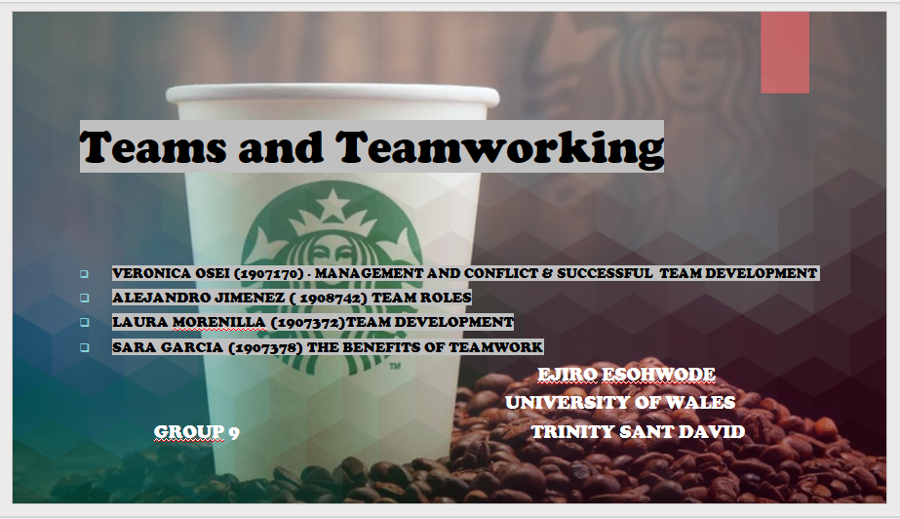

- Veronica Osei (1907170) - Management and Conflict & Successful Team Development
- Alejandro Jimenez ( 1908742) Team Roles and Situational Leadership s.2
- Laura Morenilla (1907372) Team Development
- Sara Garcia (1907378) The Benefits of Teamwork and Situational Leadership s.1

GROUP 9 TERM 2
EJIRO ESOHWODE

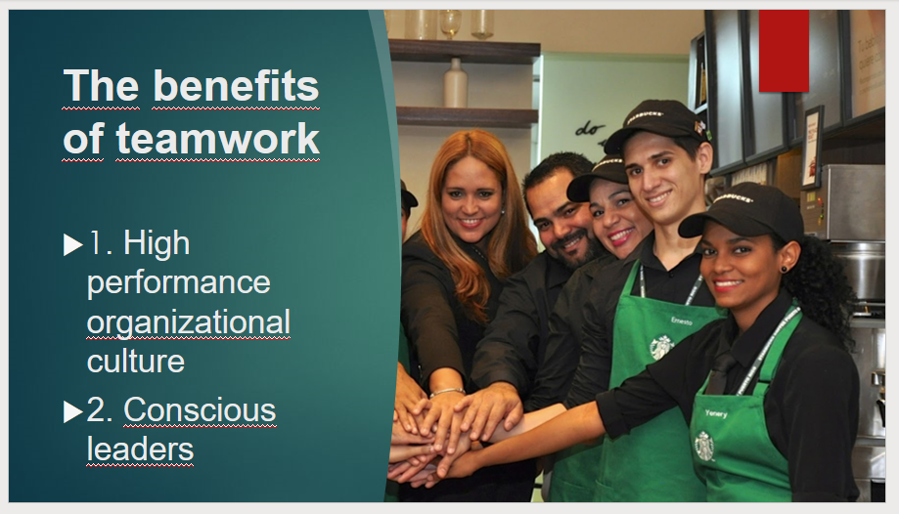

Starbucks uses different pillars for better leadership and better teamwork, what they want is to form high-performance teamsand that each one of them is prepared to work collaboratively inorder to achieve their objectives in an easier way.
The axes that Starbucks decided to put into practice:

1. High performance organizational culture:
They decided that the leaderships had to be improved and, in this way, make them more empathetic and conscious. For this reason hey began to evaluate and analyze the behaviors of the staff inorder to know their employees and know which are the strongestand weakest points of each one of them and form teams with thetasks distributed in such a way that no one is overburdened withtasks or responsibilities and thus be able to achieve the commonobjective of the group more effectively.

2. Conscious leaders:
The company's goal was to increase and maintain the emotionalintelligence of the leaders. Now they have more accessible leaderswho know how to use leadership correctly and guide the rest ofthe team, since they overcame fear before facing constantevaluations so they managed to have more confidence inthemselves.

Starbucks (2020) a helpful source of information.
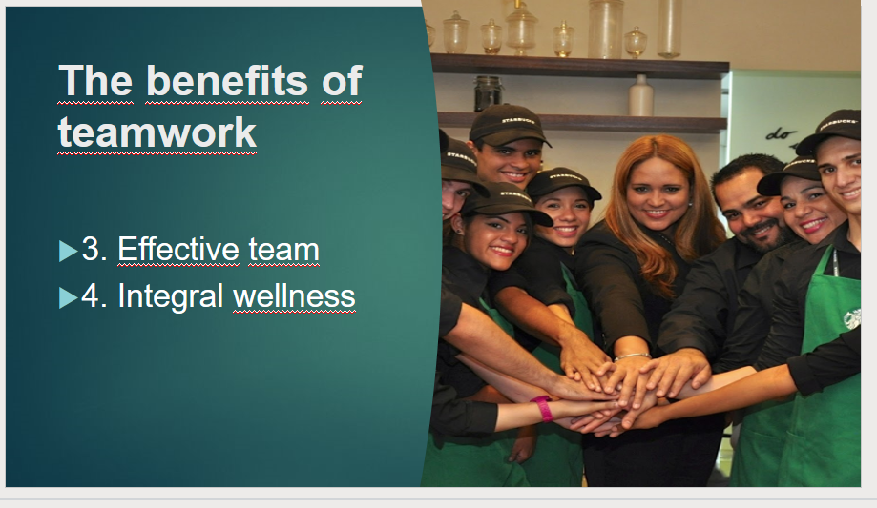

​
​

3. Effective teams:
They improved collaborative work, interpersonal relationships andcommunication between them since they are aware of thestrengths of each one of them due to the first analysis andevaluation they undergo upon entering the company. They prepare the staff in a way that each of them is aware that they have todo their part, thus allowing the talents of each team member tocomplement each other, achieving a final result impossible to achieve individually. Starbucks is a company that believes thatgood teamwork is achieved with good communication, coordination, complementarity, trust and commitment.

4. Integral wellness:
They also began to carry out surveys to find out how the leadershave influenced the collaborators. They consider work and tasks toimprove depending on how employees are being led, and trained bytheir leaders. This company is very aware of how important it is how their employees are treated so they do not allow disrespect orthat any employee is mistreated. If a company wants to create agood working environment, it is important that they train eachteam member creating trust, always seeking understanding, having good communication, establishing common goals andobjectives, involving the entire team in the tasks and ensuringthat everyone feels part of the project.

Peeps (2018) Good tips for effective team working

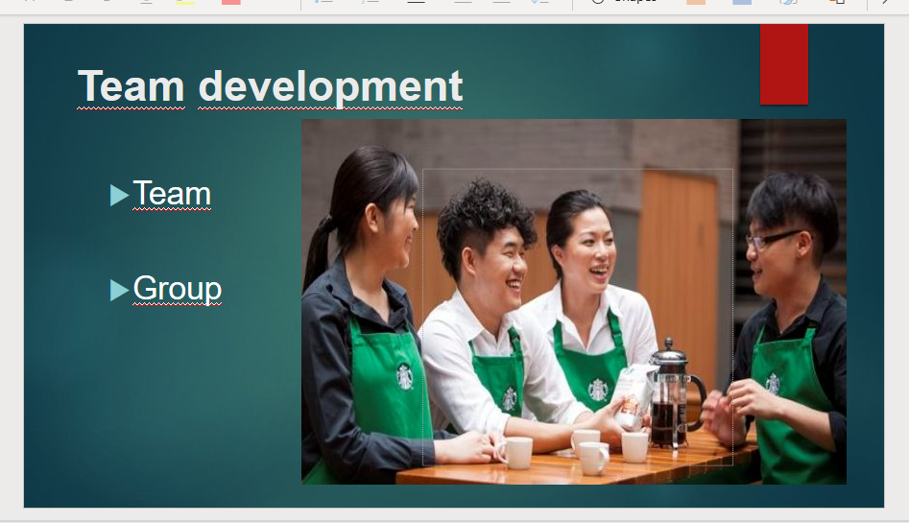
A team will always be stronger than groups being that they collaborate dividing the tasks in a smart order in order to achieve a common goal, grow together and always being aware of other team members. ​
​
Differences between a group and a team: ​
TEAM: ​
- Interdependence and mutual support ​
- Greater sense for ownership and work together​
- Trust is high between members​
- Share a common goal​
- Awareness of each other weaknesses​
- Share responsibilities​
- Try to solve problems​
GROUP ​
- Member are together for a common activity​
- No trust between the team members​
- May not share a common goal​
- Not aware of others weaknesses​
- Don’t share responsibilities​
- No process of conflict resolution​
Being a team is really important as it will make the tasks easier, the goals will be accomplished faster, smarter and the team will be happier which will make them be more efficient. ​
Starbucks would be a team instead of a group being that the got all the qualities of it, and they always try to work together using understanding and mutual collaboration between
team leaders and team members and they are constantly improving to develop the best of their team.​

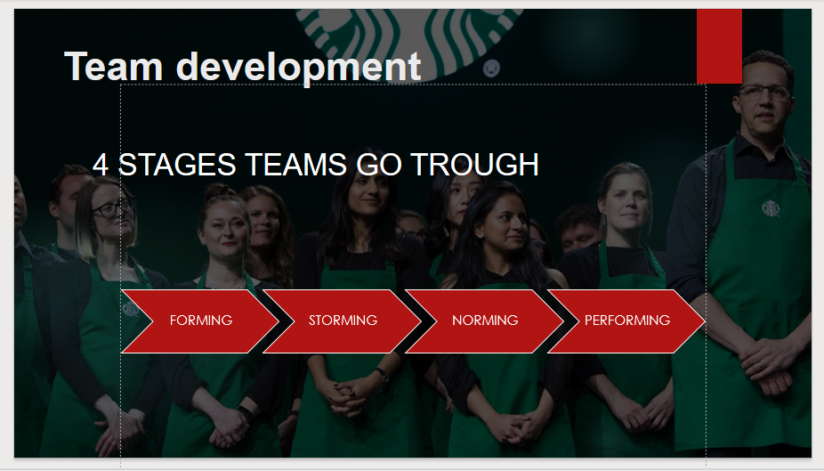
Every group goes through different situations when creating a new team before getting to understand each other and accomplish their objectives. Stages teams go through:
- Forming: team member met for the first time, there are no relationships between them, people don’t know yet how to behave, communication normally brief and there is no leadership yet.
- Storming: at this point team members are in a competition for leadership and there is no understanding in the way to split the tasks and responsibilities which leads to a conflict and undo some tasks.
- Norming: after discussing how to solve different situations and an exchange of views, there are norms applied, team development starts and conflicts are discussed positively in order to be solved with team work and understanding.
- Performing: Team work is achieved and roles become more flexible and supportive, team finds solutions for the possible issues and starts to work smart and efficient, also external leadership is minimized as the team is able to manage their selves.
For example, Starbucks believes that team members are not simple workers and their development will create a good customer service. Also, they are creative with training lessons and they develop a mission that matters so the team works together in order to solve problems creating an atmosphere of understanding and efficiency.

Tuckman (1965) FORMING, STORMING, NORMING AND PERFORMING. AVAILABLE AT: https://www.mindtools.com/pages/article/newLDR_86.htm (ACCESSED 29 APRIL 2020)

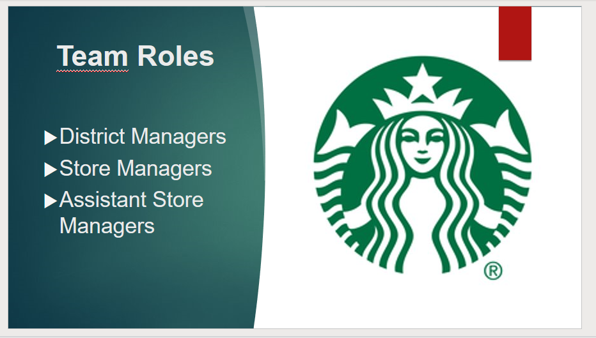
Each employee has an important role within the company. These positions are positions of office that require great responsibility to meet business expectations, both economically and territorially. Here an analysis based on Belbin Team Roles:
- District Managers, lead a portfolio of multiple stores and are responsible for the performance of the store in their district by evaluating the business, creating meaningful plans to drive results. They are leaders of leaders who train and develop future talents, share the company's vision and goals, and constantly inspire their teams to create meaningful connections for and with customers. According to Belbin team roles this position would cover the role of Plant.
- Store Managers, from managing daily operations to taking responsibility for financial results. Managers are front-line leaders, they have to identify ways to generate results. The role requires recruiting and welcoming new partners and future leaders to your store.
In accordance with Belbin team roles this position would cover the role of Monitor Evaluator and Resource Investigator.
- Assistant Store Managers, Assistant Managers inspire customers as they develop management skills on their journey to run a store on their own. The role provides the opportunity to manage store operations, drive business results, lead a team, and develop talent. According to Belbin team roles this position would cover the role of Co-Ordinator.

Starbucks (2020) described how team roles are in their company.

​
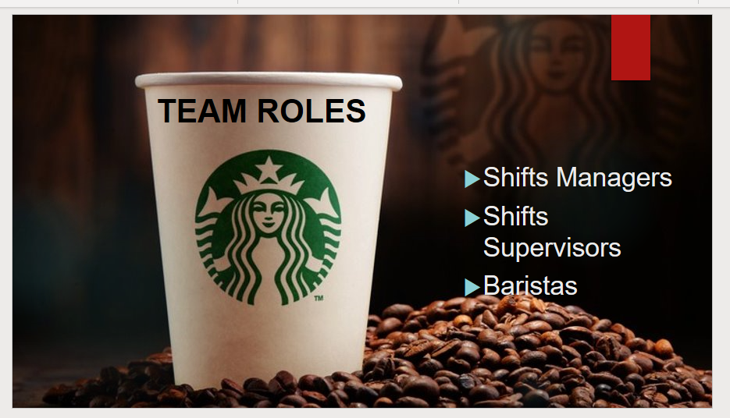
​
They are in charge of a proper organization during working hours and in every working day in the store.
work for effective teamwork to provide customers with the best service. Here analysis based on Belbin Team Roles.
- Shift Managers, Shift managers work in partnership with the store manager to create store plans and ensure the team works together to make every moment right for our customers.
In accordance with Belbin team roles this position would cover the role of Shaper.
- Shift Supervisors, Shift supervisors create great experiences for partners and customers alike. They run shifts, lead the store team, and make decisions that affect store operations. In accordance with Belbin team roles this position would cover the role of Implementer and Completer-Finisher.
- Baristas, They are an important part of the days of clients and experts in the artisan elaboration of delicious and perfect drinks. Baristas connect personally and work together to create a cozy shop atmosphere. In accordance with Belbin team roles this position would cover the role of Team worker and Specialist.

Starbucks (2020) described how team roles are in their company.

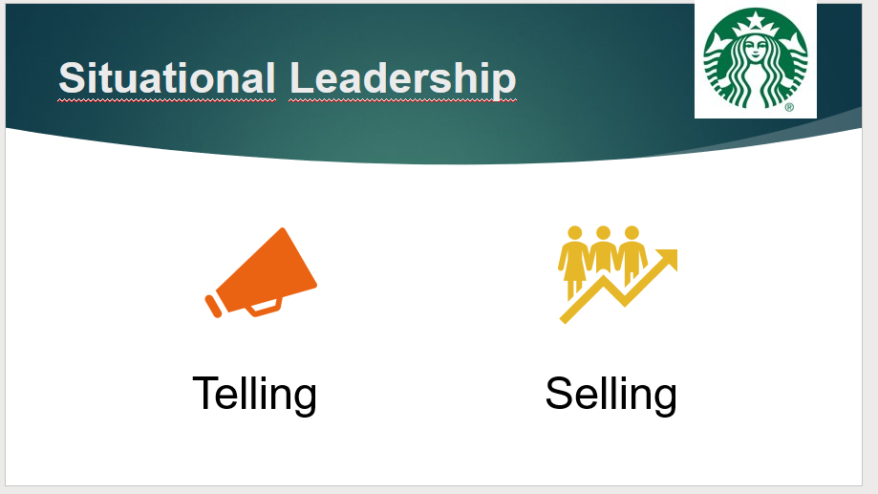
​
SITUATIONAL LEADERSHIP BY KEN BLANCHARD AND PAUL HERSEY​
​
- Telling It is when the Team leader must be in charge of organizing the group and must tell each member of the team which task belongs to them and in what way they must do it.​

- Selling It is when the Team Leader has to resort to leading and setting an example for his team members to do their job in a certain way.​

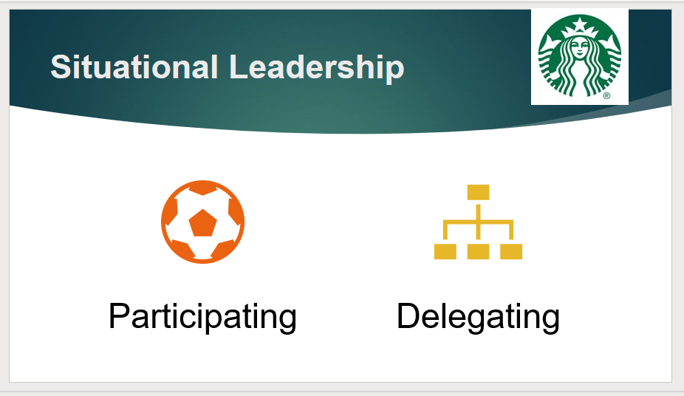
SITUATIONAL LEADERSHIP BY KEN BLANCHARD AND PAUL HERSEY​
​
- Participating It is largely a democratic leadership approach, as the leader allows more leeway to the subordinates. The amount of direction from the leader remains limited and the subordinates have an active role in making decisions.​

- Delegating Hersey and Blanchard decidieron darle a hands-off approach to leadership. The style means the leader is less involved in how decisions are made, allowing subordinates to make them and to take most of the responsibility in getting the job done.​

Luenendonk, M. (2016) Very useful source for understanding of the subject.​

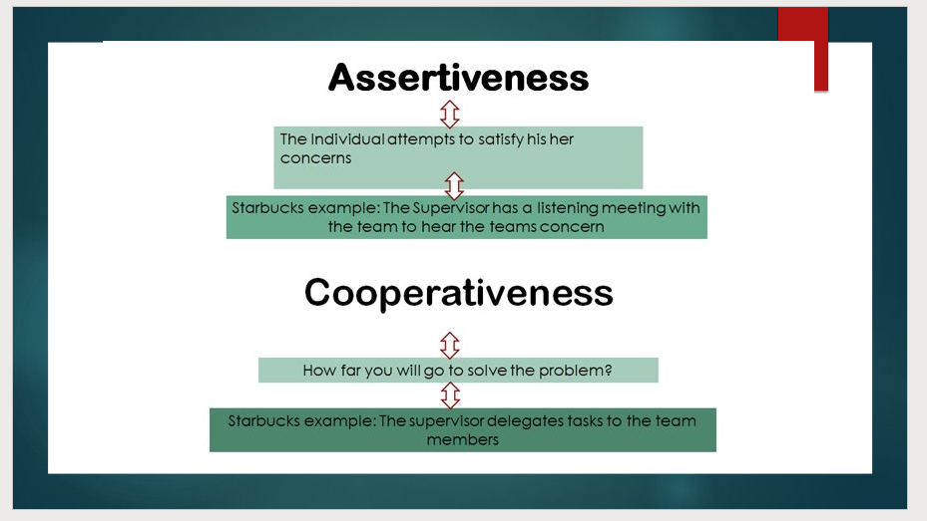

This is a consultation presentation introducing team working within Starbucks Coffee Shop. I will be covering Management and Conflict using Thomas Kilmann theory. ​
​
•According to Patel. H, 2016 the Kilmann conflict mode assess individual’s behavior in conflict situations where two individuals seem to be incompatible. ​
​
•These are described in two simple dimensions which are Assertiveness and Cooperativeness. As shown in the PowerPoint slide. Assertiveness is when the individual attempts to satisfy his/her concerns. ​
​
•Cooperativeness is the extent to solve the other persons concerns. Please see Starbucks example. Implementing this theory is a great way to help to tackle and solve the problems you face within your team. ​
​

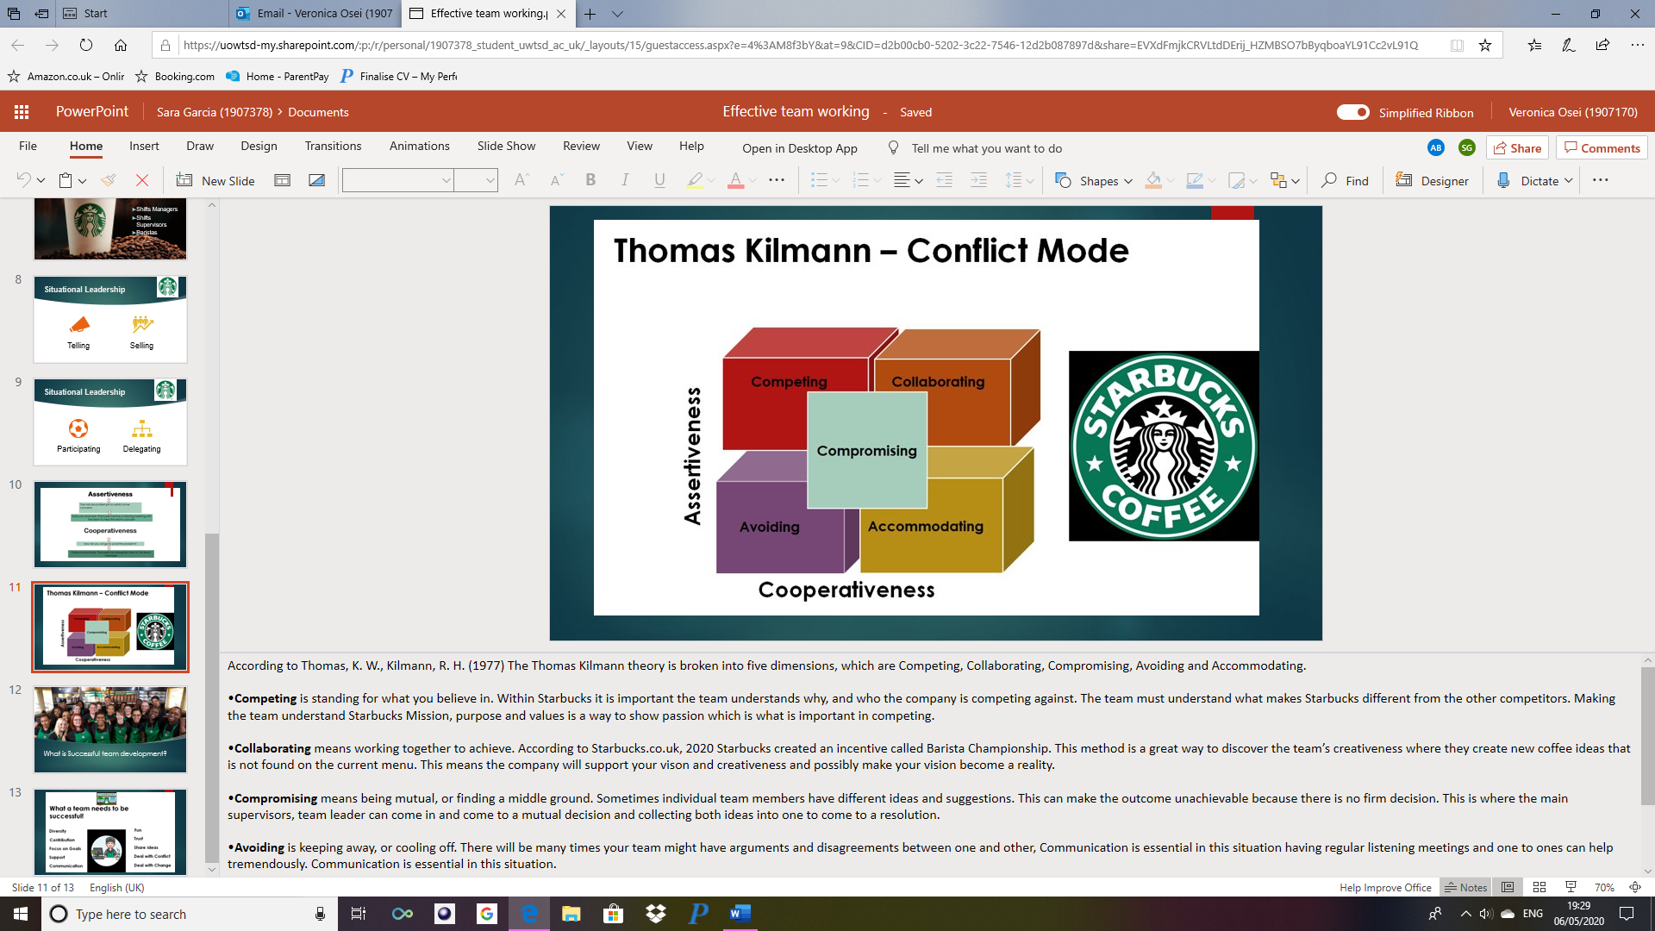
According to Thomas, K. W., Kilmann, R. H. (1977) The Thomas Kilmann theory is broken into five dimensions, which are Competing, Collaborating, Compromising, Avoiding and Accommodating. ​
​
•Competing is standing for what you believe in. Within Starbucks it is important the team understands why, and who the company is competing against. The team must understand what makes Starbucks different from the other competitors. Making the team understand Starbucks Mission, purpose and values is a way to show passion which is what is important in competing. ​
​•Collaborating means working together to achieve. According to Starbucks.co.uk, 2020 Starbucks created an incentive called Barista Championship. This method is a great way to discover the team’s creativeness where they create new coffee ideas that is not found on the current menu. This means the company will support your vison and creativeness and possibly make your vision become a reality. ​
​•Compromising means being mutual, or finding a middle ground. Sometimes individual team members have different ideas and suggestions. This can make the outcome unachievable because there is no firm decision. This is where the main supervisors, team leader can come in and come to a mutual decision and collecting both ideas into one to come to a resolution. ​
​•Avoiding is keeping away, or cooling off. There will be many times your team might have arguments and disagreements between one and other, Communication is essential in this situation having regular listening meetings and one to ones can help tremendously. Communication is essential in this situation.​
​•Accommodating is when the individual neglects their concerns to accommodate the other individual. This can be merged in with company policy following an order or setting rules, even if individuals disagree. Sometimes there can be generosity by the other can also helpful to solving conflict within the team.​
In closing the Thomas Kilmann theory is a useful resource to help to guide you through different scenarios within your organization. ​
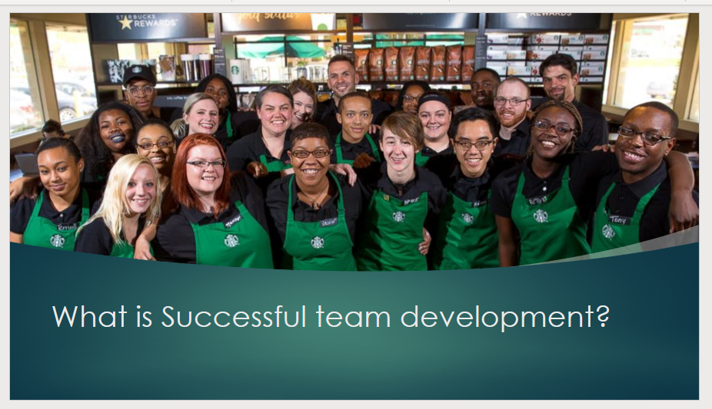
​
​
- According to reed.com, (2019) having good teamwork is a great benefit to success. Starbucks values are to deliver the very best service. ​

- Good organizations like Starbucks need a team that are high performers, and communicate effectively, while serving customers​
- In order to follow this, the team needs to be in sync and trained to be the best baristas and make every customer experience memorable, valued and happy. The team has to learn to work together in order to be a great success. ​

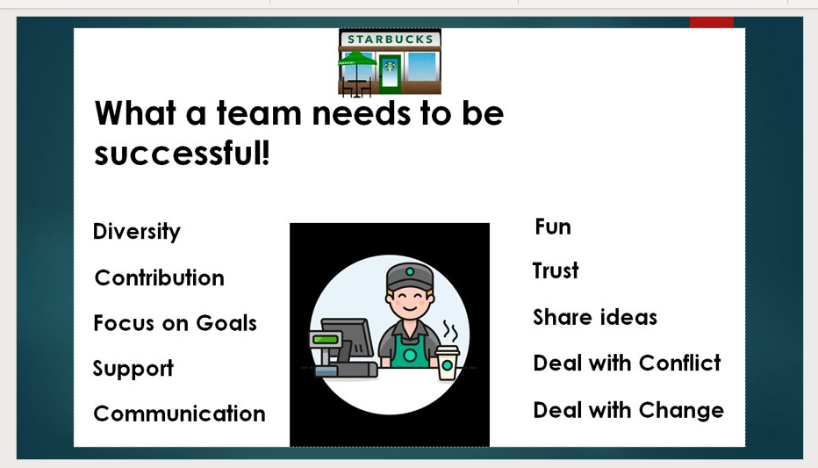
In order for a team to be successful you must have a combination of key elements. ​
​
- Diversity – is a good way of sharing different cultures and showing respect for all genders and ethical backgrounds​
- Contribution – each team members contribution is important and can help to bring different ideas to the table to complete the task quicker. ​
- Focus on goals -the team should always aim for the same objectives ​
- Support – having a team you can rely on with the tasks, can be challenging. Support really helps especially when an individual within the team is really struggling to accomplish their specific task. ​
- Communication – this is a key strategy within a team. You cannot organize a plan, rectify a plan, give instructions, or feedback without communicating. ​
​
- Fun- sometimes the team deserves praise when being successful with a service or task. Having social meet ups for example bowling, is a great way to do this! It also helps with getting to know the team. ​
​
- Trust – is very essential to have between all individuals. You have to trust your colleagues to do the Job!​
​
- Share ideas - helps to bring together everyone’s creativity. ​
​
- Dealing with conflict – setting boundaries, rules, and policy helps to keep the team in line with respecting the individual and to prevent conflict situations. ​
​
- Dealing with change – Things might not always go to plan or sometimes might have to take another approach to getting to your objective. The structure of leadership might also change to meet the needs of the business, so the team must be willing to deal with change!
REFERENCES

• Belbin (2020) Belbin Team Roles [online] Available at: http://www.belbin.com/about/belbin-team-roles/ [Accessed 5 March 2020]
• Indeed.com. 2020. 8 Steps To Building A Successful Team | Indeed.com. [online] Available at: <https://www.indeed.com/career-advice/career-development/steps-to-building-a-successful-team> [Accessed 1 May 2020].
• Kilmann, R. H., Thomas, K. W. Developing a forced-choice measure of conflict-handling behavior: the “MODE” instrument. Educational and Psychological Measurement, 1977, 37, 309–325.
Starbucksemeacareers.com. 2020. Starbucks Jobs. [online] Available at: <https://www.starbucksemeacareers.com/en/working-at-starbucks> [Accessed 1 May 2020].
• Luenendonk, M. (2016) Situational Leadership Guide: Definition, Qualities, Pros & Cons, Examples. (Online) Available at: https://www.cleverism.com/situational-leadership-guide/ (Accessed 10 March 2020)
• Peeps (2018) Our top 10 tips for effective teamwork (Online) Available at: https://www.peepshr.co.uk/resource-centre/our-top-10-tips-for-effective-teamwork/ (Accessed 23/04/2020)
• Patel, H., 2016. My Thomas-Kilmann Conflict Mode Instrument (TKI). [online] Honeybpatel.blogspot.com. Available at: <http://honeybpatel.blogspot.com/2016/03/my-thomas-kilmann-conflict-mode.html?m=1> [Accessed 5 April 2020].
• Reference. 2020. What Are Starbucks' Goals And Objectives?. [online] Available at: <https://www.reference.com/business-finance/starbucks-goals-objectives-eeafdfe1a606c921> [Accessed 1 May 2020].
• Starbucks (2020) Teams (Online) Available at: https://starbucksrohan.wordpress.com/teams/ (Accessed 23/04/2020)

• Starbucks (2020) Careers [online] Available at: https://www.starbucks.com/careers/find-a-job/retail [Accessed 7 March 2020]

• Tuckman (1965) FORMING, STORMING, NORMING AND PERFORMING. AVAILABLE AT: https://www.mindtools.com/pages/article/newLDR_86.htm (ACCESSED 29 APRIL 2020)

